REPUBLIQUE DU CAMEROUN  Paix- Travail- Patrie  ---------------  MINISTERE DE LA SANTE PUBLIQUE  ---------------  SECRETARIAT GENERAL  ---------------  DIRECTION DE LA LUTTE CONTRE LA MALADIE  LES EPIDEMIES ET LES PANDEMIES  --------------- |  | REPUBLIC OF CAMEROON  Peace- Work- Fatherland  ---------------  MINISTRY OF PUBLIC HEALTH  ---------------  SECRETARIAT GENERAL  ---------------  DEPARTMENT FOR THE CONTROL OF DISEASES,  EPIDEMICS AND PANDEMICS  ---------------
REPORT ON ON-SITE TRAINING FOR INFLUENZA SENTINEL SURVEILLANCE WORKERS IN CAMEROON
AT ST BLAISE CATHOLIC HOSPITAL
North-West region,
25to 27, January 2024

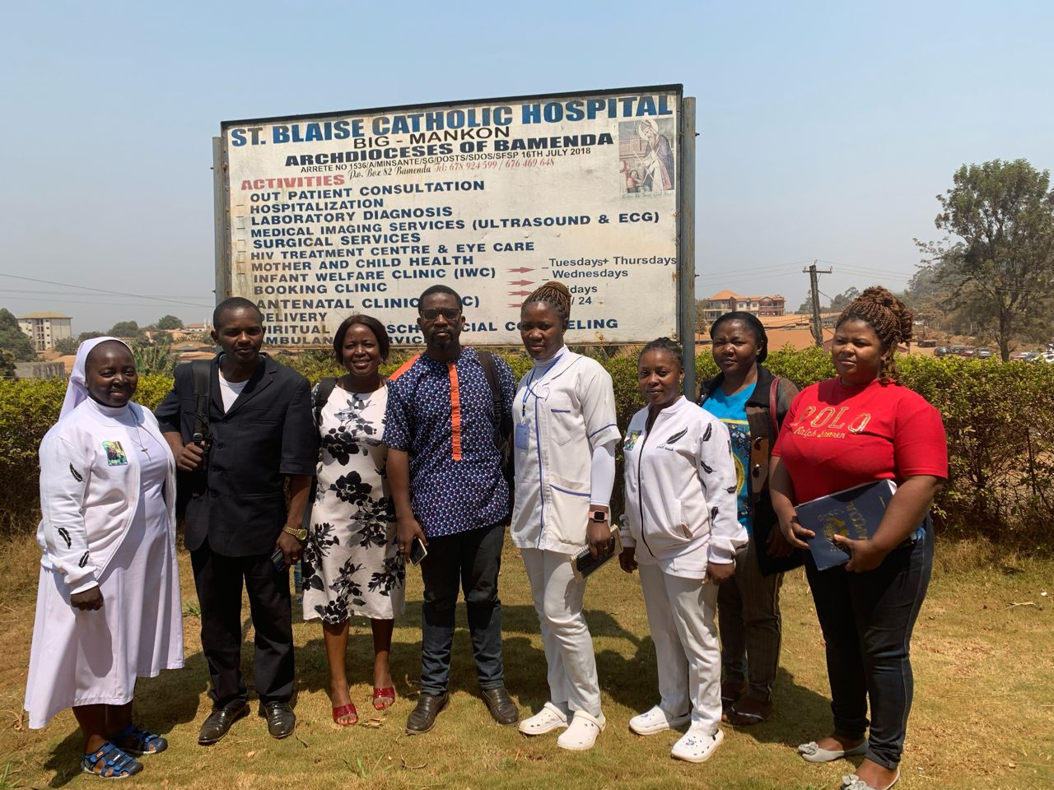

By

Mrs Belle Ajong
Mr Ntamack Theodore

The training of actors on the influenza sentinel surveillance took place on the 25 to 27 of January, 2024, in the St Blaise Catholic Hospital, North West region. Participants included staff from the St Blaise Catholic Hospital and the Bamenda Health District Service and they had the following profiles; data manager, hospital influenza focal point, surveillance focal point and laboratory personnel, medical doctor.

- Introductory remarks by the head of the St Blaise Catholic Hospital
In her introductory remarks, the Head of the St Blaise Catholic Hospital opened the workshop. She welcomed all the participants and urged them to be attentive to learn all that is needed and put into practice the skills learned to improve the influenza surveillance in the community.
This was followed by a family photo. Followed by the appointment of the reporting team for the sessions. The floor was then given to the participants to introduce themselves.
The presentations covered the following topics:
- The context and justification of the training
  - Module 1: IDSR introductive module
  - Module 2: Detect and record cases of priority diseases, conditions and public health events
  - Module 3: Notification of diseases, priority conditions and public health events
  - Module 4: Collecting, packaging and transporting samples
  - Module 5: Presentation on entering flu data into DHIS2
  - Module 6: DHIS2 practical session
  - Module 7: Surveillance strategies for respiratory diseases
  - Module 8: Epidemiological situation of Sentinel Influenza Surveillance in Cameroon
- Discussion
- Recommendations
- Photo gallery

- The context and justification of the training
Influenza is a common and contagious infectious disease caused by certain RNA viruses of the orthomyxoviridae family: influenza A, influenza B, influenza C and influenza D2. It affects birds and certain mammals, including pigs, seals and humans. Since the middle of the 20th century, the extreme variability of influenza viruses and their exceptional capacity to spread, amplified by the development of ever faster means of transport, have led national and international health authorities to set up and develop 'close' virological, epidemiological and clinical surveillance of influenza. This makes it possible to assess the epidemic risk as accurately as possible and adapt the annual vaccination schedule.
In Africa, Central Africa has already taken the lead on the potential threat of influenza pandemics by bringing together the 10 countries of the Economic Community of Central African States (ECCAS), plus Senegal, in Yaoundé on 07 November 2007. The WHO Resident Representative in Cameroon then invited the countries of the world in general, and Africa in particular, to set up effective sentinel influenza surveillance systems, with particular emphasis on laboratory research into new strains that could endanger human organisms unprepared to resist them.
From 6 to 10 November 2023, a delegation from CDC-Atlanta visited a number of sites in Yaoundé in the company of the central level. During the visit, it was noted that there were not enough trained staff at the sites, that there was little collaboration between the influenza focal point and the DHIS2 data officer, and that there were some pertinent comments about the quality and transport of samples to the laboratory.
To remedy this, it was strongly recommended that all sites receive on-site training.
It was for this reason that the training took at the St Blaise Catholic.

OBJECTIVES
General objective
The general objective is to strengthen the capacities of those involved in influenza sentinel surveillance in Cameroon on-site level.

Specific objectives
More specifically, this involves:
- Training staff on certain hospital modules of the IDSR
- Training on the DHIS2 with an emphasis on influenza
- Training in the collection, packaging and transport of samples
- Identify ways of improving the existing system.

  - Module 1: IDSR introductive module
This module started with the definition of integrated disease surveillance and importance in public health, which is the systematic and ongoing identification, collection, analysis and interpretation of disease occurrence and/or public health events data, for the purpose of timely, effective and appropriate action which was aimed at improving disease surveillance and data collection. Two surveillance approaches which are passive (System by which a health facility receives routinereports from public and private health facilities (religious and secular), from the community or other sources, No active search for cases). And active surveillance which is the oongoing search for cases in the community or in health facilities and regular contact with key reporting sources through:phone calls to health personnel at a health facility or laboratory, physical movement to the notification sites, review of medical records.
Types of surveillance was also discussed on of which the influenza sentinel surveillance was spoken of largely.
A summary of the information flow, the use of multiple surveillance tools for efficient disease surveillance and involving all clinicians was part of the conclusion of this module.

  - Module 2: Detect and record cases of priority diseases, conditions and public health events
The next presentation was on how to detect cases using passive and active surveillance as approaches on Event-base surveillance and indicator-Base surveillance (EBS & IBS) at facility level which was our point of concern. Here events are to be reported on time for quick interventions. Any event potential of creating diseases must be reported. It could be through the patient, community and media. In this case the general supervisor was recommend to paste case definition in all entry points of the hospital to create awareness and ease the work of staff, fill all individual report when the client is still present with identification number, review the information before reporting. The participants were advised to share the acquired knowledge with the entire laboratory staff as well as other staff members of the hospital not forgetting the community as far as surveillance is concern. Sharing and creating awareness of disease surveillance facilitates implementing control strategies. Discussions followed suit for example controlling the water that causes water-borne diseases, educate the public on how they treat their water, report disease surveillance and response are reported immediately from the community, laboratory and consultation from the hospital service.

  - Module 3: Notification of diseases, priority conditions and public health events
The period of reporting was also part of the discussion, it was said cases are supposed to be reported based on the type of diseases, for priority disease within the 24 hours to the hierarchy to avoid the spread of the infection and the community should be alert to asymptomatically identify those disease. Report case weekly, monthly and according to age and sex so that at the end of the month will be easy to do analyses. Then enter those statistics into the DHIS2 which be accessible at all level for good decision making. The data is then verified and validated at all level, district, regional and central level.

  - Module 4: Collecting, packaging and transporting samples
The laboratory module was on the sample collection and there was a complain that swap used for the sample collection of influenza is too big, the Regional Delegation of Public Health was asked place a request for new swab stick which conforms to the that used for COVID-19 samples.
  - Module 5: Presentation on entering infuenza data into DHIS2 and Module 6: DHIS2 practical session
A module on DHIS2 was done alongside a practical session. Discussion on data synthesis or aggregate, individual cases, diseases with star are to be reported immediately and data forms for weekly and monthly reporting were presented.
This very interactive practical session enabled participants to understand:
- How to enter data into the DHIS2
- How to modify the data entered
- How to delete data.
In addition to this, the Epidemic-Prone Disease (EPD) form was shown and how to fill it. The different aspects on the form and the newly added laboratory section.

  - Module 7: Surveillance strategies for respiratory diseases
The presentation of history of the influenza pandemic was part of this module. Organization of the functional laboratoriesunder influenza surveillance was demonstrated. It was also ask why Saint Blaise during the month of December did not send samples, and the response gotten was that samples were sent very late, another reason being that theinfluenza focal person who was trained was on leave, hence no one to fill in. the participants were then encouraged to fill others shoes in their absence to avoid such a gap in the system. Team work was encouraged. The strength, challenges of the strategy followed suit. It was discussed that St Blaise was chosen based on high influx of patients into the facility.

  - Module 8: Epidemiological situation of Sentinel Influenza Surveillance in Cameroon
The highlight of this module was on the sentinel influenza surveillance in Cameroon, which was made with 19 site selected in the country and the reason for such surveillance was the reoccurring cases of pneumonia, influenza, COVID-19. The strategy was made to diagnose those disease in the community in order to differentiate which respiratory diseases is affecting the population. The Incidence management system is a body which manages health emergencies and divided into offices and sections create during COVID-19 pandemic has now been built at regional levels to be activated when need be. The performance of St Blaise Catholic hospital on influenza surveillance was presented and itshowed that the facility reported for 52 epiweeksin 2023, with a total of 133 samples in instead of 208 samplesthe same year. Participants were encouraged to enter data into the system DHIS2 for proper decision making.

RECOMMENDATIONS
The following recommendations were drawn up during the training course;
Recommendations | Persons responsible | Observations
To make available IDSR guide to all staff in the HF | DLMEP/RDPH | Done
Reinforce collaboration amongst laboratories | St Blaise Lab head
Paste case definition at all entry points in the HF. | St Blaise surveillance focal person
Need COVID-19 swap sticks for collection in the HF | RDPH
Share EBS codes booklets | RDPH | Done

Photo Gallery
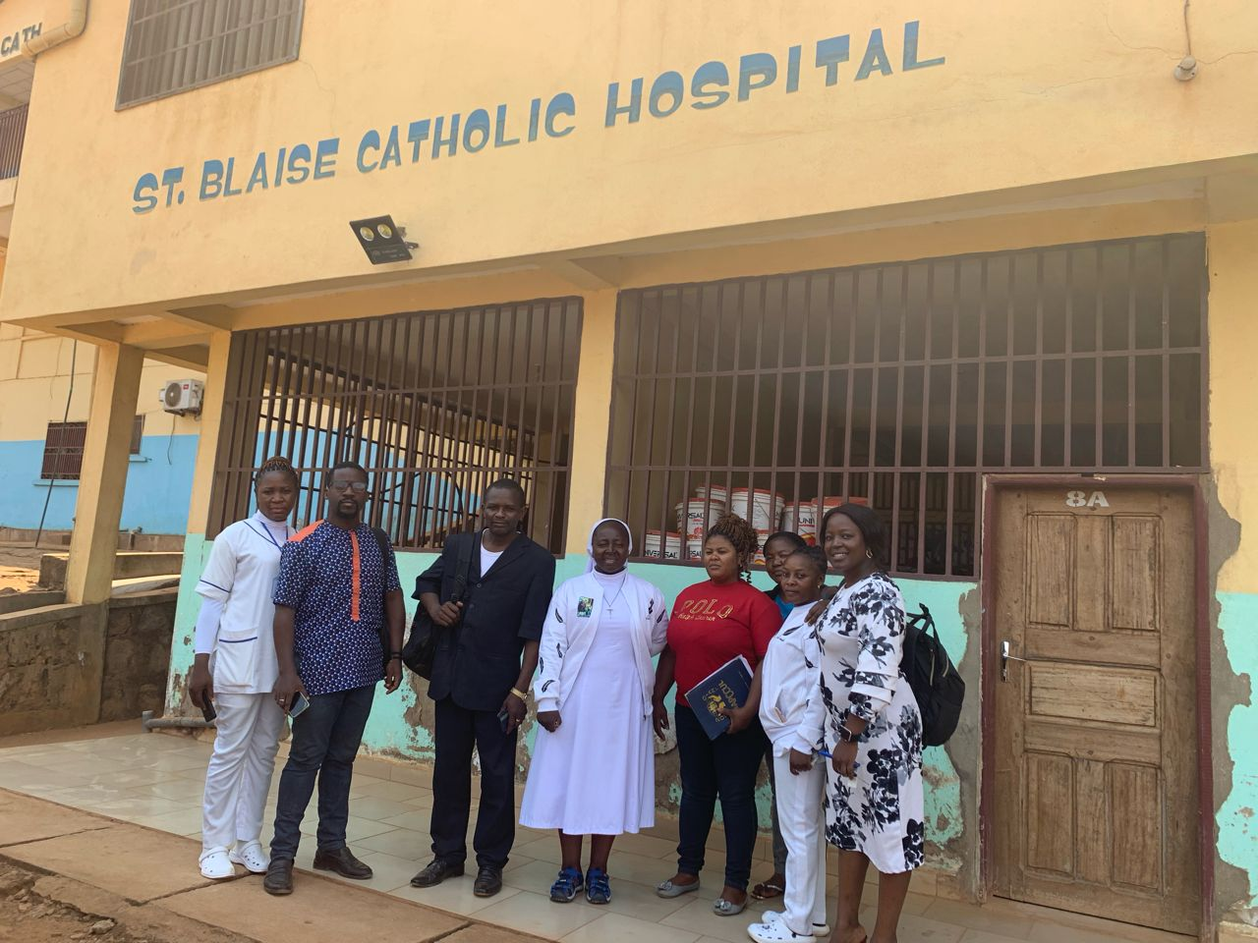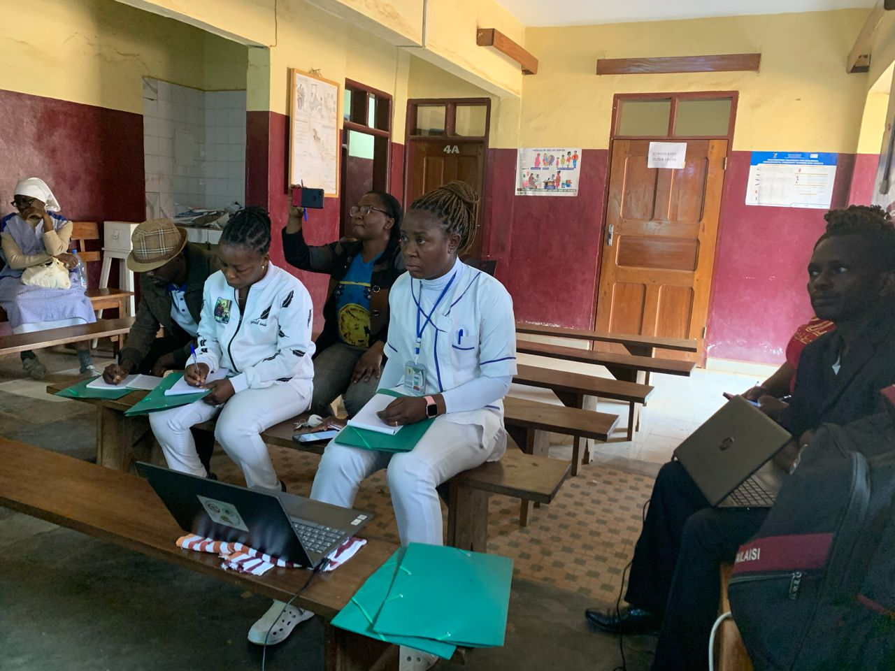
Photo 1: A general photo with the Director of St Blaise catholic hospital, 25/01/2024
Photo 2:Participants during the training at St Blaise catholic hospital, 25/01/2024

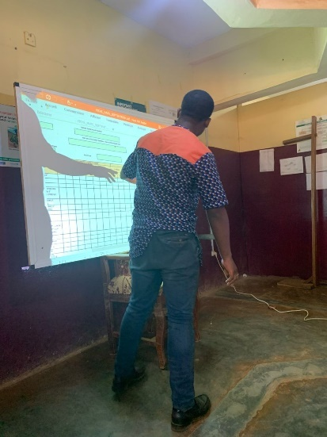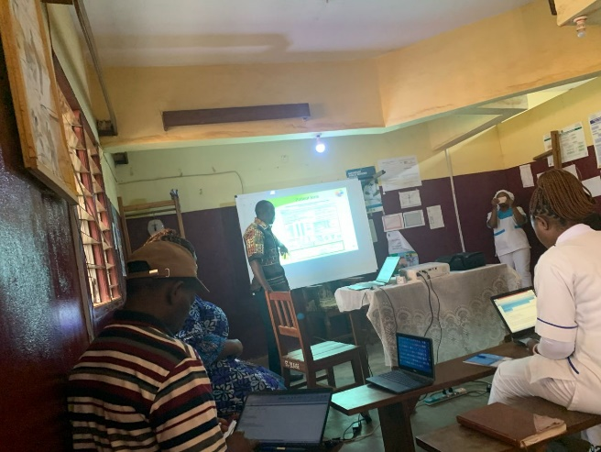
Photo 4:Presentation of the laboratory module, 26/01/2024
Photo 3:Presentation of the EPD sheet, 25/01/2024

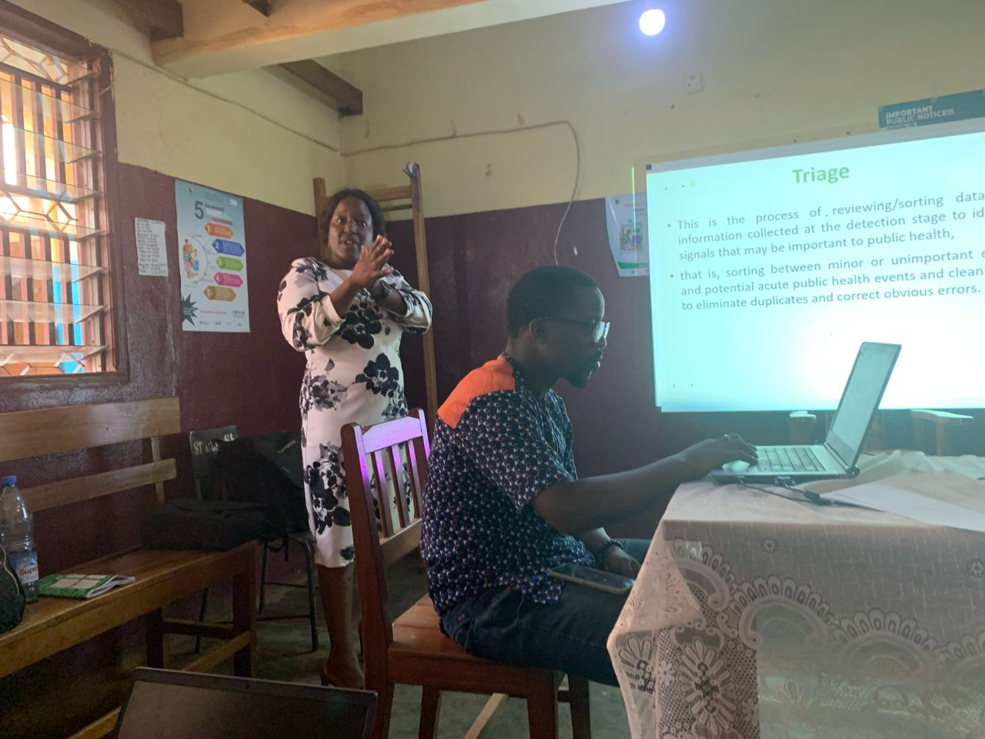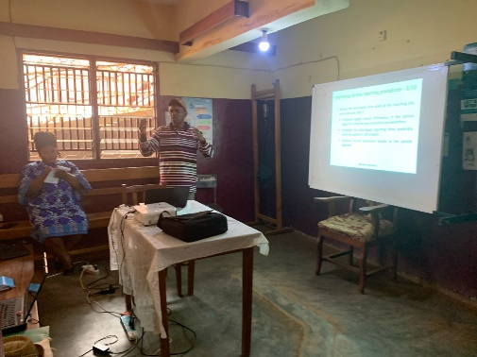
Photo 5: Presentation of the sentinel surveillance system, 27/01/2024
Photo 5: Presentation of the Event-base surveillance steps, 25/01/2024

