Good morning Dr, I have and issue with the portal regarding Batibo HD. Some of my health facilities that are found on the data entering page are not found on the individual billing page on the portal and thus their bills do no factor out on the consolidated invoice. Both for PBF and HIV Free User fees Dr.

For second quarter the health facilities include:

Anjake IHC which is a subcontract of Olorunti IHC. And

For the third quarter we have:

1. Anjake IHC a subcontract under Olorunti IHC

OK

2). Kugwe IHC a subcontract of Ewai IHC

OK but there are two others subcontracts under Ewai as from T2 ; Do you mean we must remove those facilities and just keep kugwe as subcontract ?

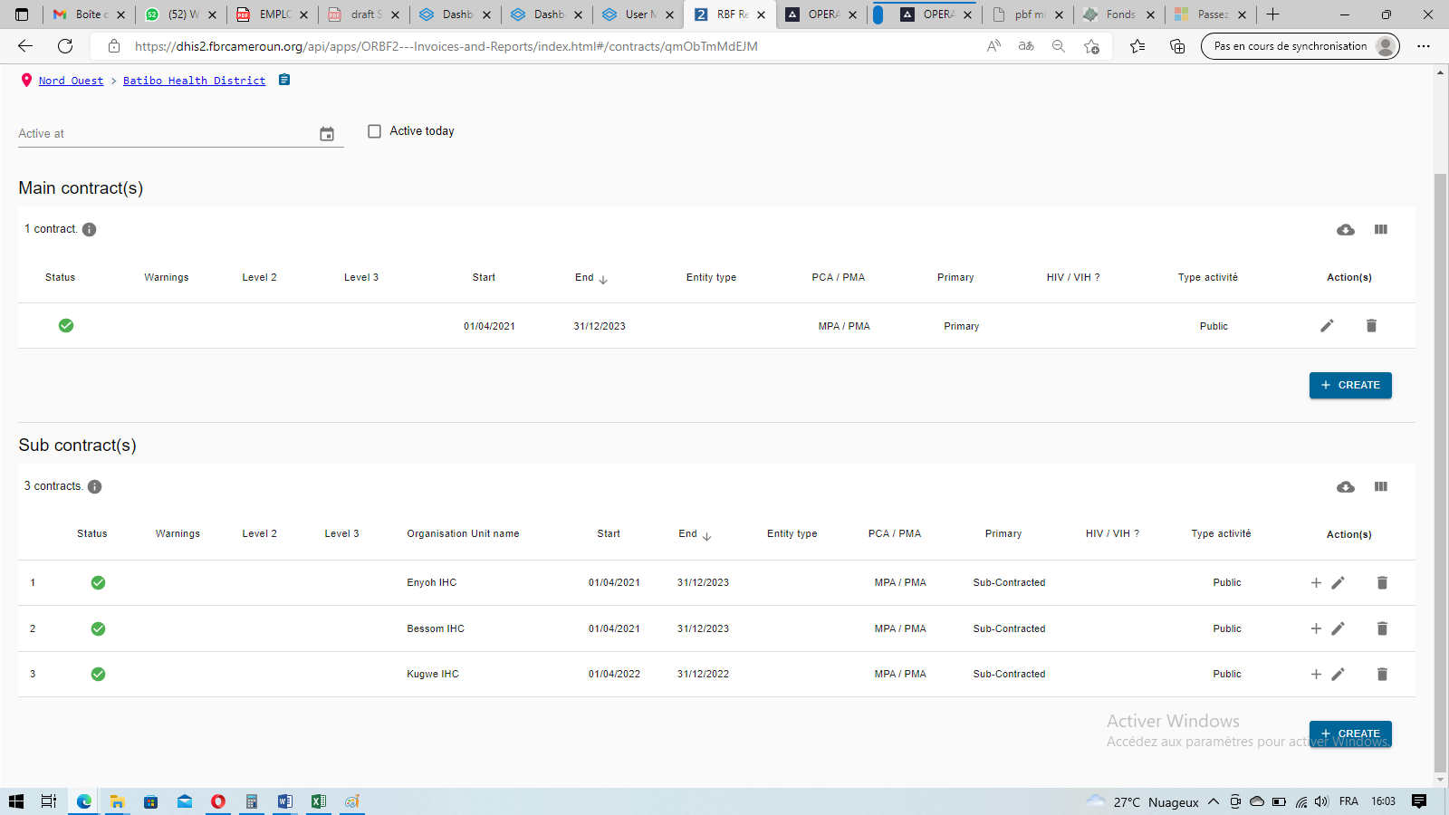

1. Ewoh IHC a MAIN contract OK done
2. Tiben IHC a subcontract of Ewoh IHC OK done
3. Gwofon IHC a subcontract of Batibo Urban IHC ok done
4. St. John Grande Elum a subcontract of St John of God OK done

7) St. Raphael Health Center a subcontract of St John of God. And finally, OK done

8) Mbi and Co Clinic a subcontract under CMA Widikum, OK done

As a result of these Dr, consolidated bills for Batibo HD are not generating correctly and thus can not be printed for onward transmission. Thus I pray the portal manager rectify this soon Dr. Thank you so much sir and you have a blissful day at work.