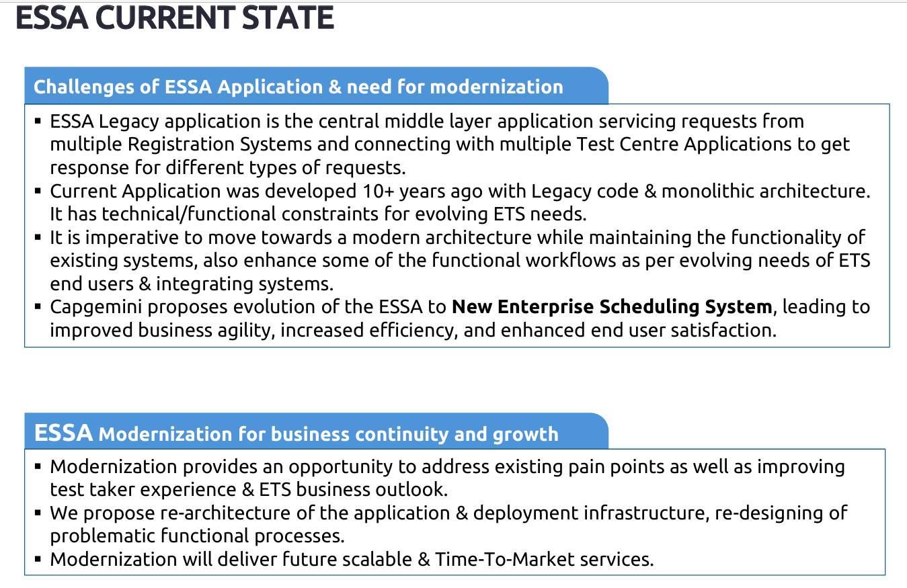

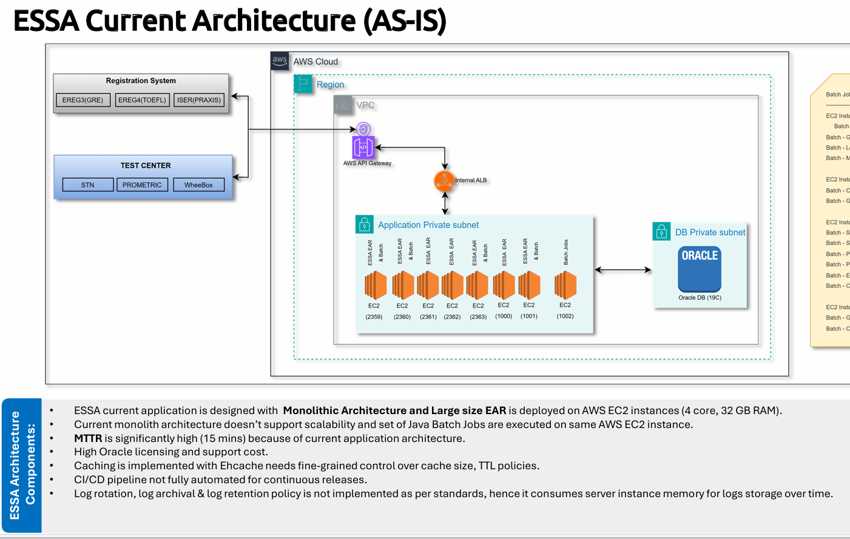

As discussed please find the Phase-1 problem statement and existing architecture . Existing project is a scheduling Middleware System developed using Java 11 + Spring Non Boot ( Configuration Based ) + Spring Batch + Spring Rest API ( 13 APIs are there ) + ehCache + JMS for async + JBOSS and Oracle - Deployed as a EAR on 8 AWS EC2 instances in which 1 EC2 is dedicated for batch job and 7 EC2 dedicated for APIs. You can see same existing architecture in attached document. Now the plan is to migrate ( AWS EC2 → ECS, ehCache → Redis, Oracle → PostgreSQL and Log Improvement ).

