Current Architecture

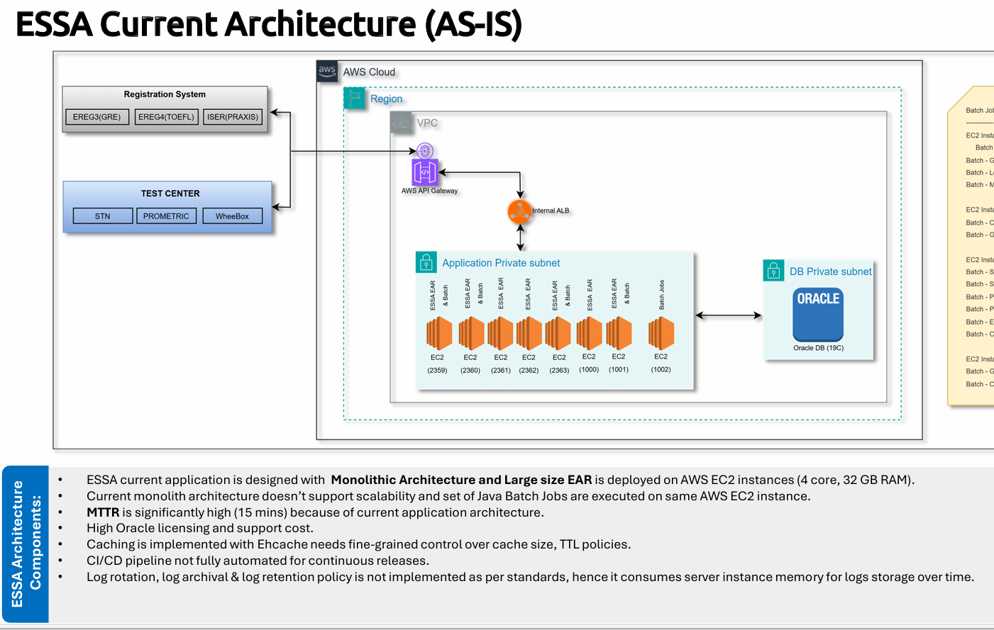

My Query
ESSA current application is designed with Monolithic Architecture and Large size EAR is deployed on AWS EC2 instances (4 core, 32 GB RAM). Current monolith architecture doesn’t support scalability and set of Java Batch Jobs are executed on same AWS EC2 instance. MTTR is significantly high (15 mins) because of current application architecture. High Oracle licensing and support cost. Caching is implemented with Ehcache needs fine-grained control over cache size, TTL policies. CI/CD pipeline not fully automated for continuous releases.
Log rotation, log archival & log retention policy is not implemented as per standards, hence it consumes server instance memory for logs storage over time.
Current Technology Stack: Java 11, Spring (Non-Boot, Config-based), Spring Batch, Spring REST APIs (13 APIs) ehCache for caching JMS for asynchronous messaging JBOSS application server Oracle DB Current Deployment: o
Packaged as a large EAR file o Deployed on 8 AWS EC2 instances: ♣ 7 EC2 for APIs ♣ 1 EC2 dedicated for batch jobs Issues: o Monolithic → poor scalability o High MTTR (15 mins) Architecture Change I want to install my EAR File and Batch separately in ECS container ECS container should use EC2. Suggest better approach and architecture to stablise this application.

Requirement - client does not want to change anything on code and they don't want spring boot and not need microservice. Currently give solution only how to containerise the EAR. later we can talk about database, ehcache and ci/cd

