|  |  |
| --- | --- |
|  | **[Year]** |
|  | Njay  Neeraj |

|  |
| --- |
| **[Leave register]** |
| Leave register will help you to maintain attendance of all employee as well as leave status. In this application we have given very good functionality for centralized News |

Contents

Overview 2

Sprint 1 2

Admin Employee 2

Admin and Normal Employee 3

Sprint 2 3

Requirement 3

How to use 3

# Overview

Leave Register is application here I have done as a single page application. This application is done for just to get confident on C#, Web Services, ADO.NET, SQL 2008, jQuery, HTML5, Bootstrap CSS and Jquery data table.

Here I have taken care coding standard and comments. Identifier is understandable by reading itself.

As in this document I am giving brief introduction of application along with how to use first time and what are all the things require to use in the respect of hardware & software.

# Sprint 1

In sprint 1, I have covered most of the functionality which I have mentioned below

## Admin Employee

1. Add/Edit Employee information’s
2. Add/Edit/Remove company leave
3. Add/Edit/Remove company news
4. Edit Employee’s attendance by admin at any time
5. Check/Validate employee attendance
6. Get worked time of each employee in a day
7. Approve/Reject applied leave by employee
8. Set/Edit working hours
9. Set/Edit total leaves

## Admin and Normal Employee

1. Fill their daily attendance
2. Employee will get prompt if employee hasn’t filled their attendance.
3. Employee cal apply any type of leave
4. Employee can see their leave status
5. Employee can see how many leave is left with corresponding leave
6. Employee can see all company leave which is added by admin. So accordingly employee can apply leave
7. Employee can change their password at any time
8. Employee can edit their personal information like date of birth
9. Employee can check their previous date attendance by selecting of date
10. In application itself has been described how employee can use this application easily
11. All controls are having tooltip, so by hover the mouse it tells what and why?

## Sprint 2

Sprint 2 is outstanding, I will release soon. In this release I am including

1. Monthly attendance report (It can be download by any type of employee) in excel format. This report will have info only logged employee.
2. Yearly attendance report with all employees’ record.
3. Employee can se t their profile picture
4. Mail functionality is also being there.

# Requirement

You must be have

1. SQL 2008
2. Visual studio
3. IIS

# 

# How to use

Please follow the below steps to use Leave Register application

1. Visit my git hub site <https://github.com/njay26/>
2. Download Leave Register solution
3. Open with Visual studio
4. First time open LeaveRegisterSetup page

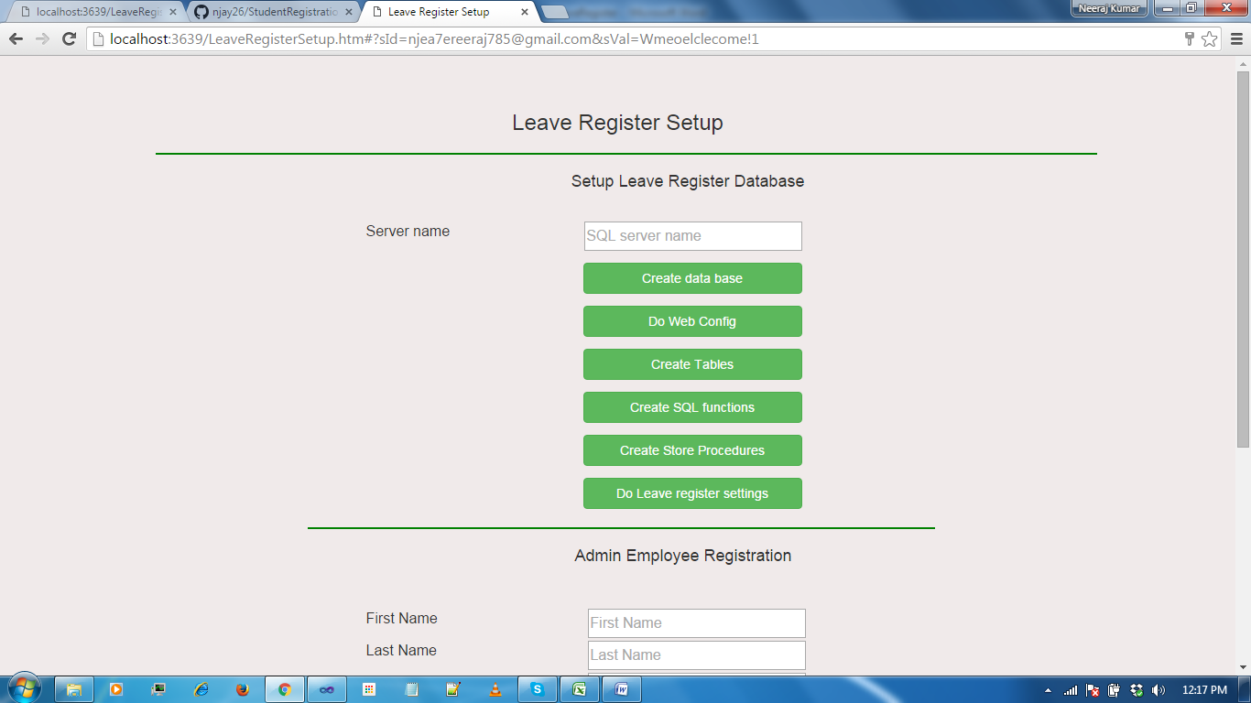

1. Give your SQL object name in the SQL server name text box
2. Then click on **Create Data Base** button
3. After that click on **Do We Config** button
4. Click on **Create Tables** button
5. Click on **Create SQL Function** button
6. Click on **Create store Procedure** button
7. After that click on **Do Leave Register Setting bbutton**
8. Add admin employee with entering the all information’s

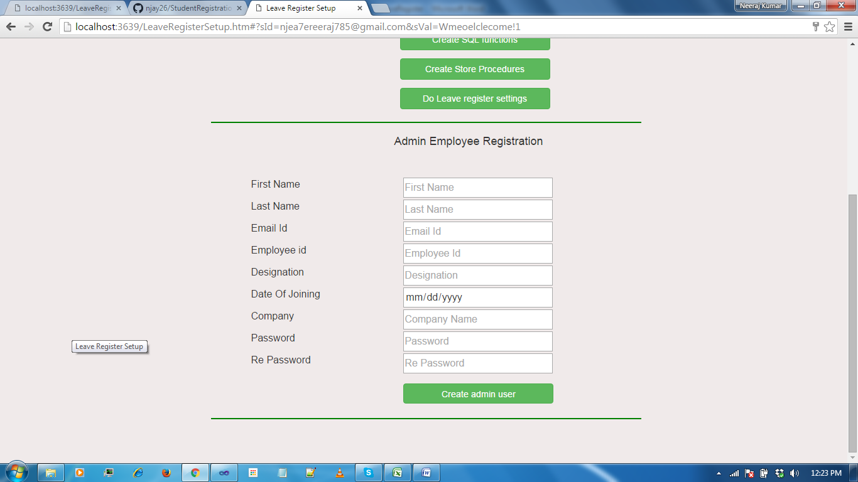

Once you got success message. Then open main page LeaveRegister.HTM

There Admin employee can login with their credentials

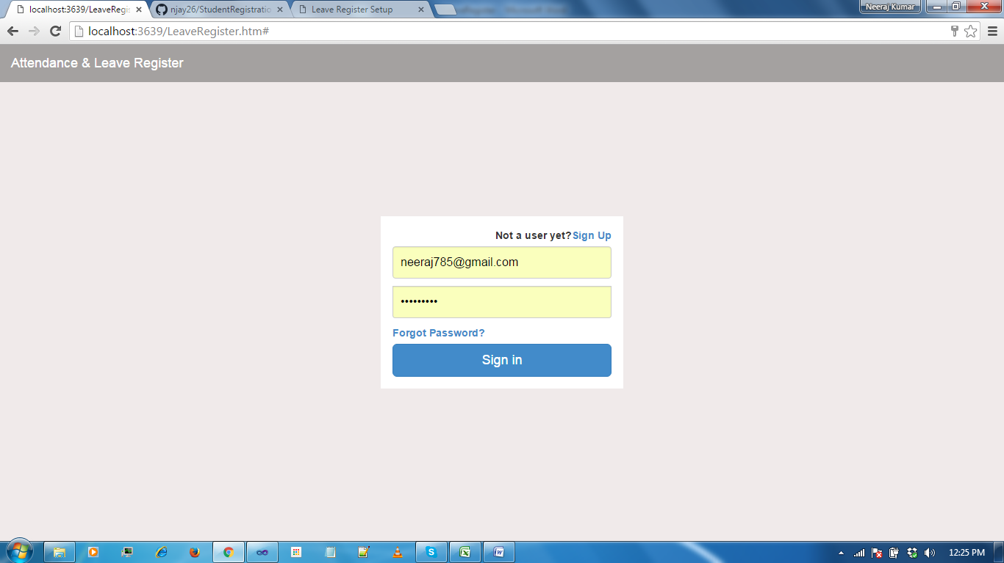

After login he will land in the home page (Updates, Attendance and News).

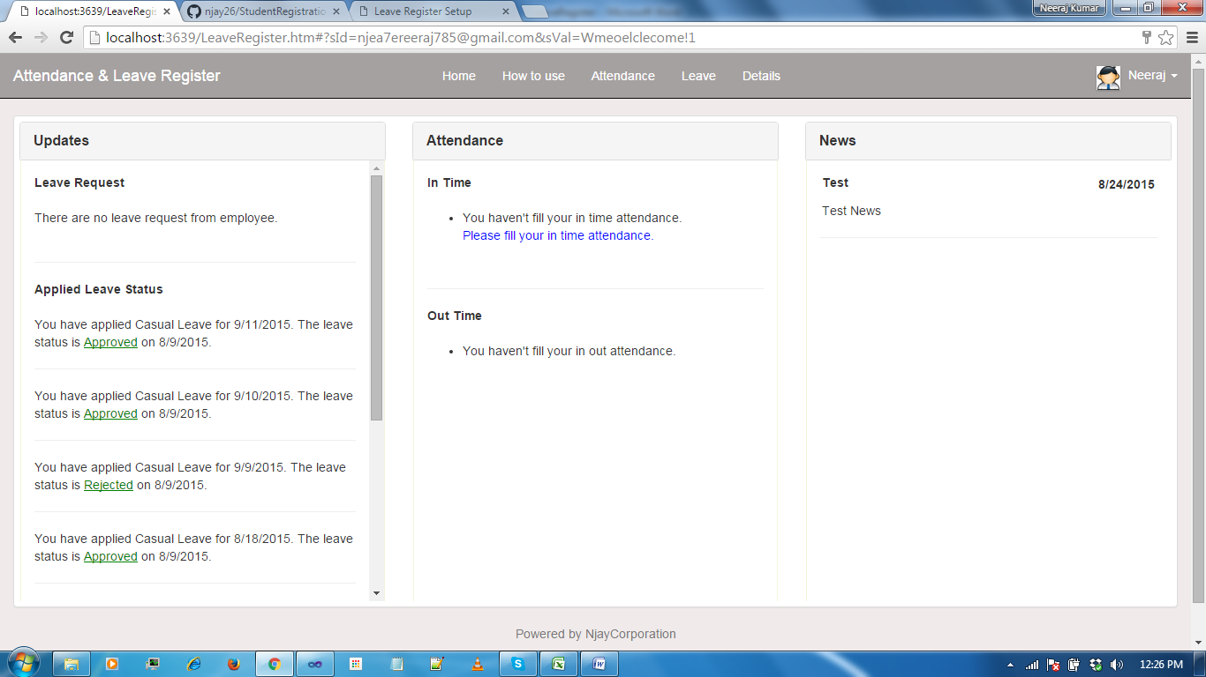

**In Update section**

* If admin employee has logged in then he can see requested leave by employee. From there he can approve/Reject same leave
* Also admin employee can see their applied leave status
* If normal employee has logged in then he can see only their applied leave status

**In attendance Modal**

It just shows have submitted your attendance or not?

**In News Modal**

Here all employees can see news which is being loaded by admin.

**Attendance Tab**

To fill the attendance you need to click on attendance tab from there you can fill your in and out time attendance.

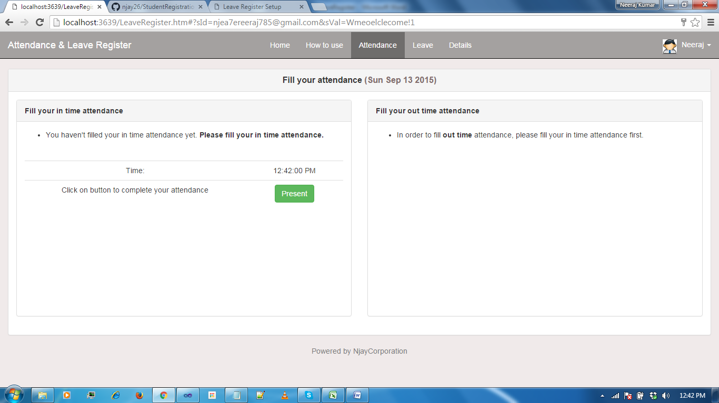

**Leave Tab**

To apply the leave you need to click on Leave tab. Here you can see loaded company leave.

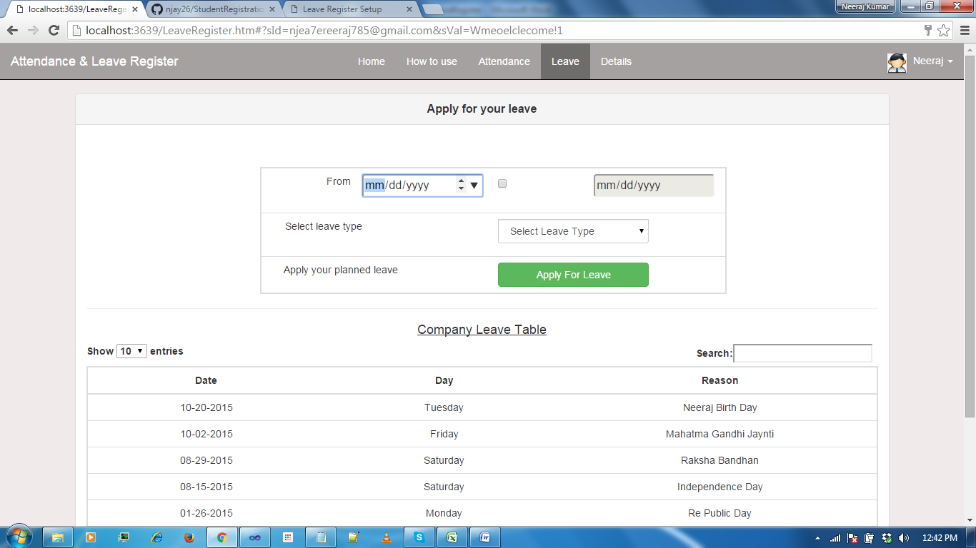

**Details Tab**

Here employee can see their details in respect to attendance and leave even he can download their monthly attendance sheet.

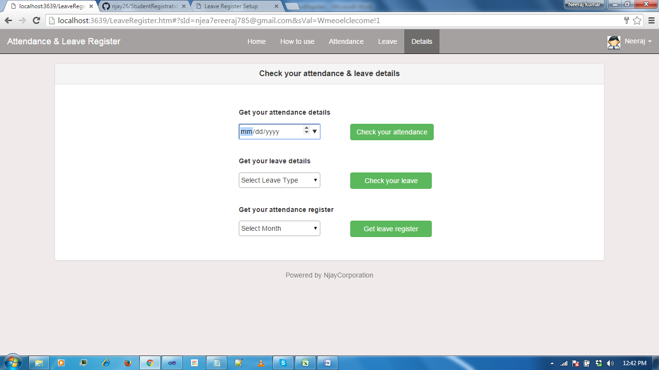

**Click on Carat** then you will be able to see Admin link (only if you are admin employee)

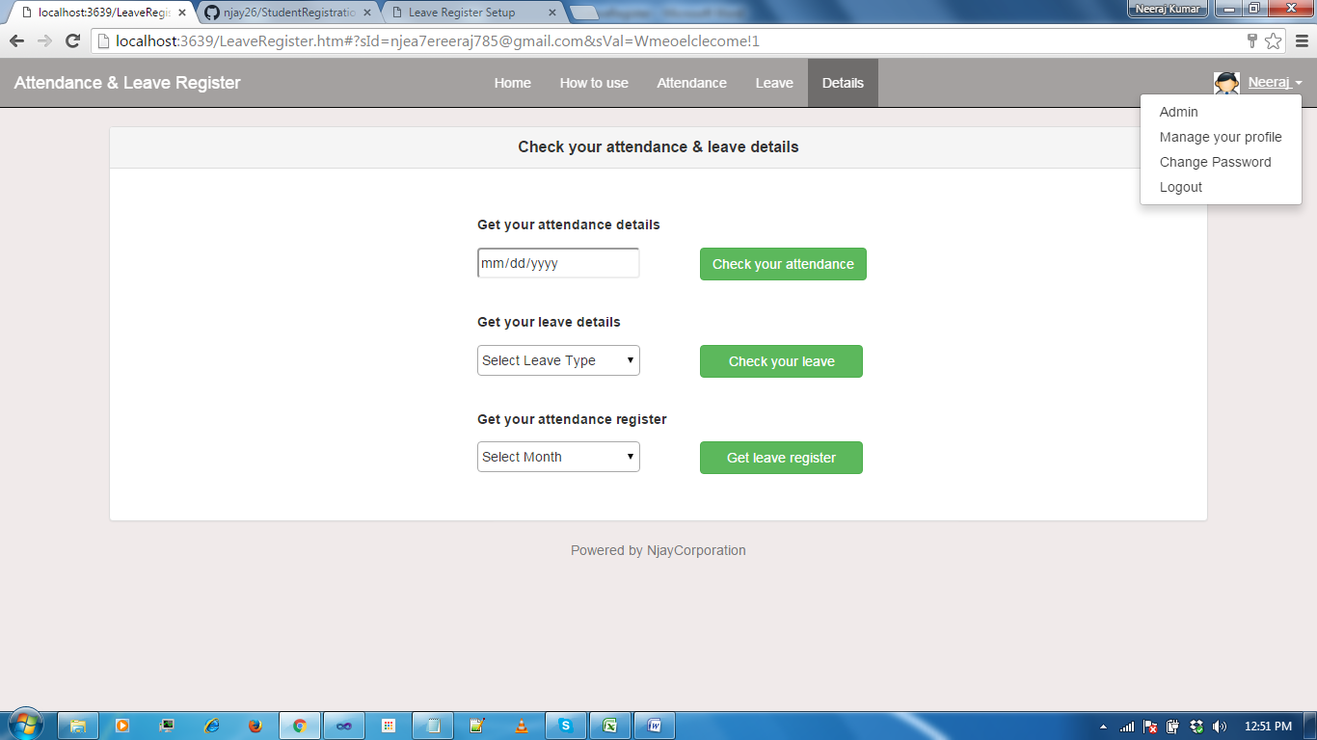

If you are admin employee you can perform action

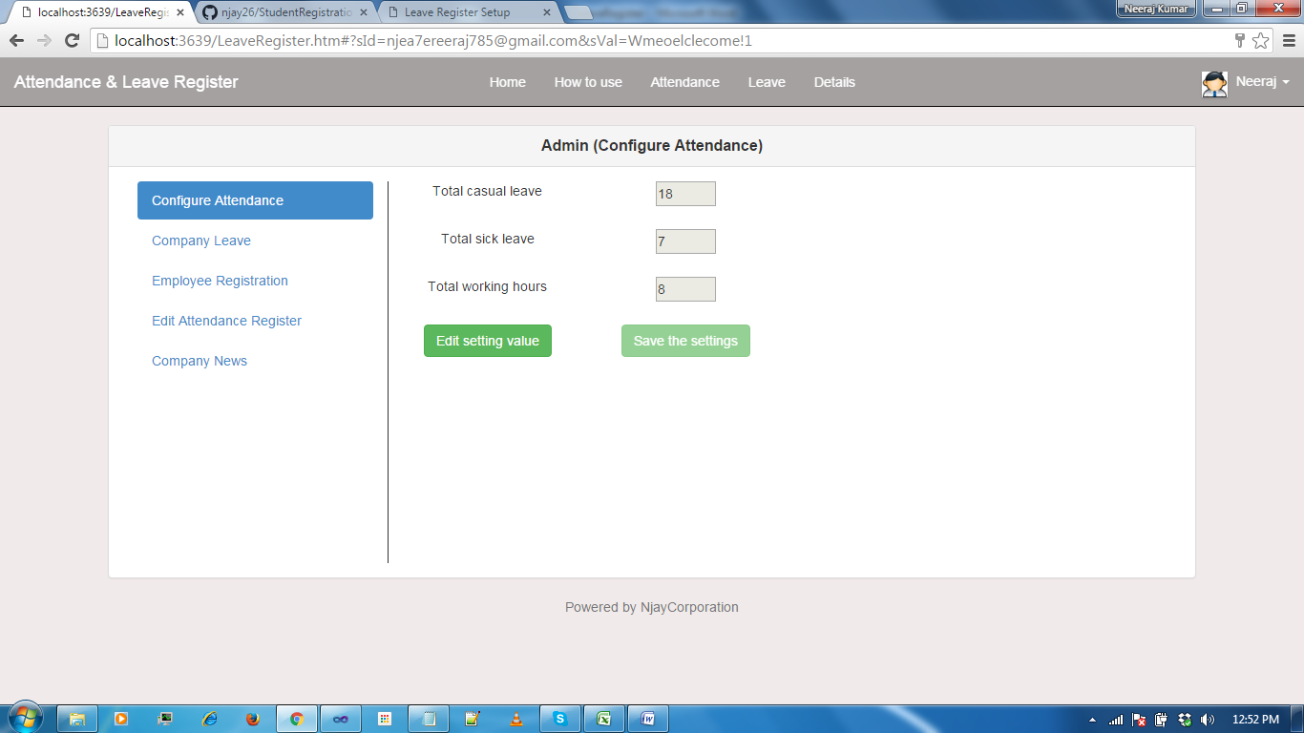

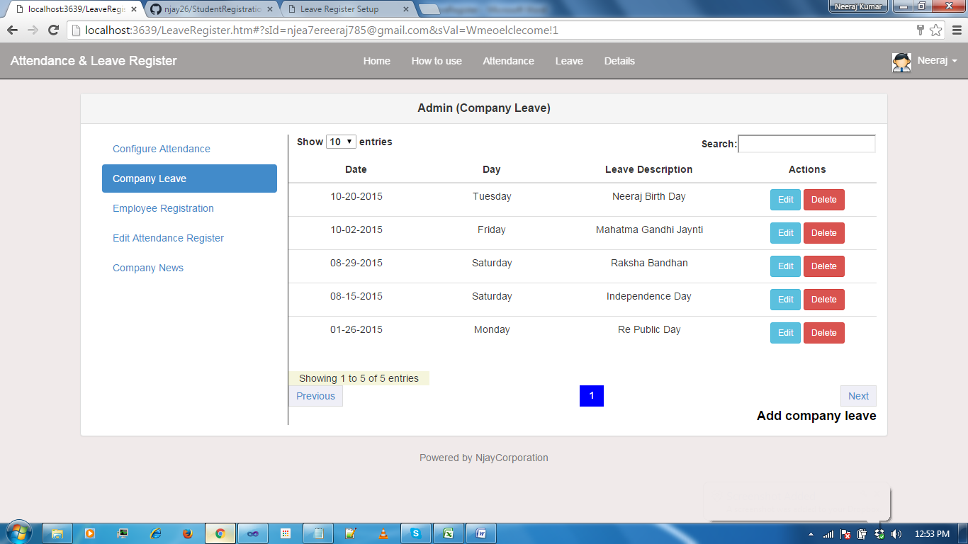

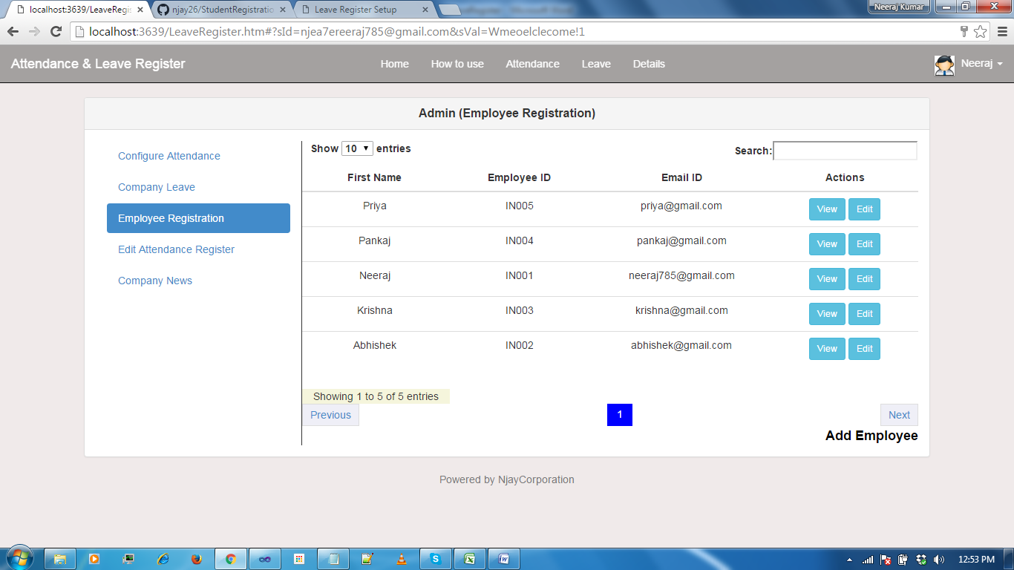

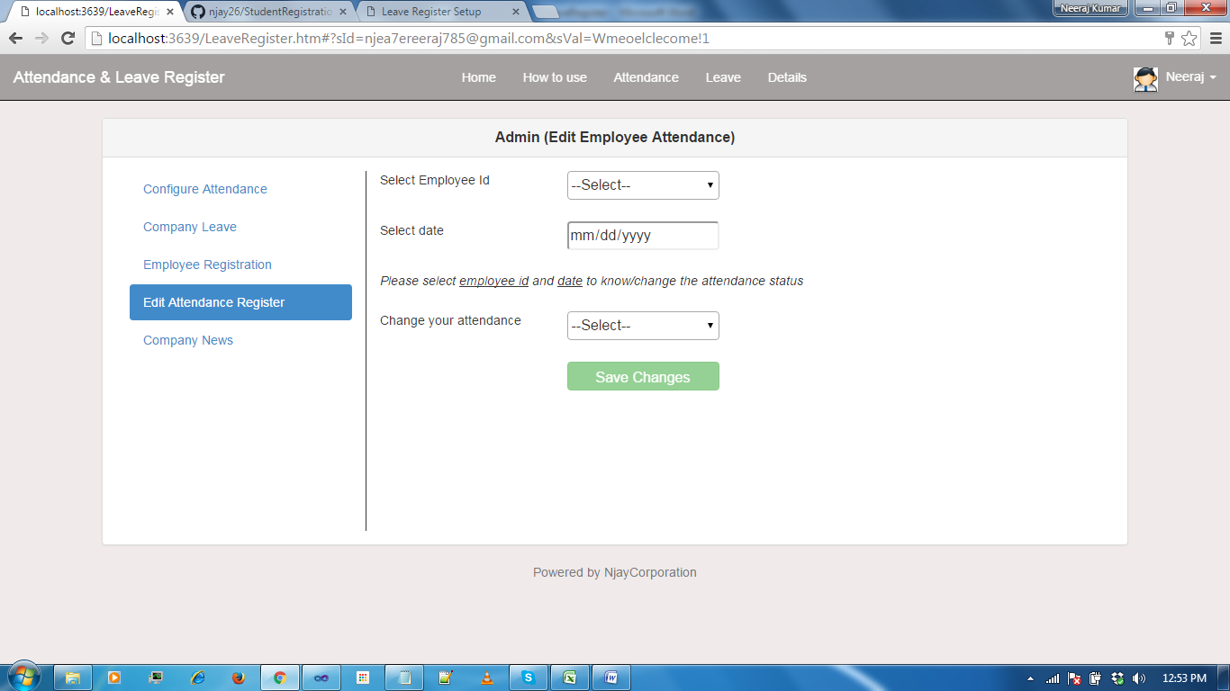

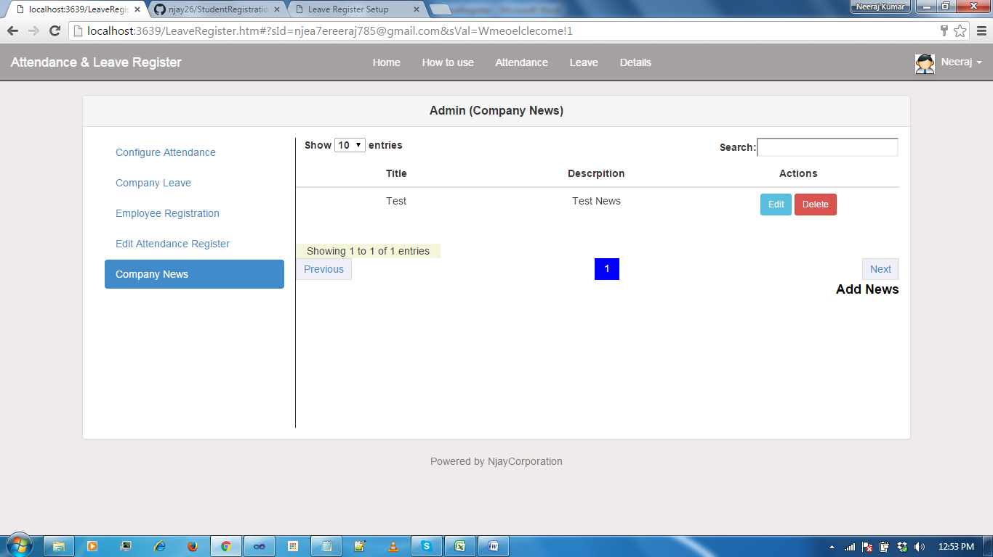

**Note:**

Suppose admin has added new employee. Please follow the below steps to access the leave register by normal employee.

1. Click on **Sign Up** button

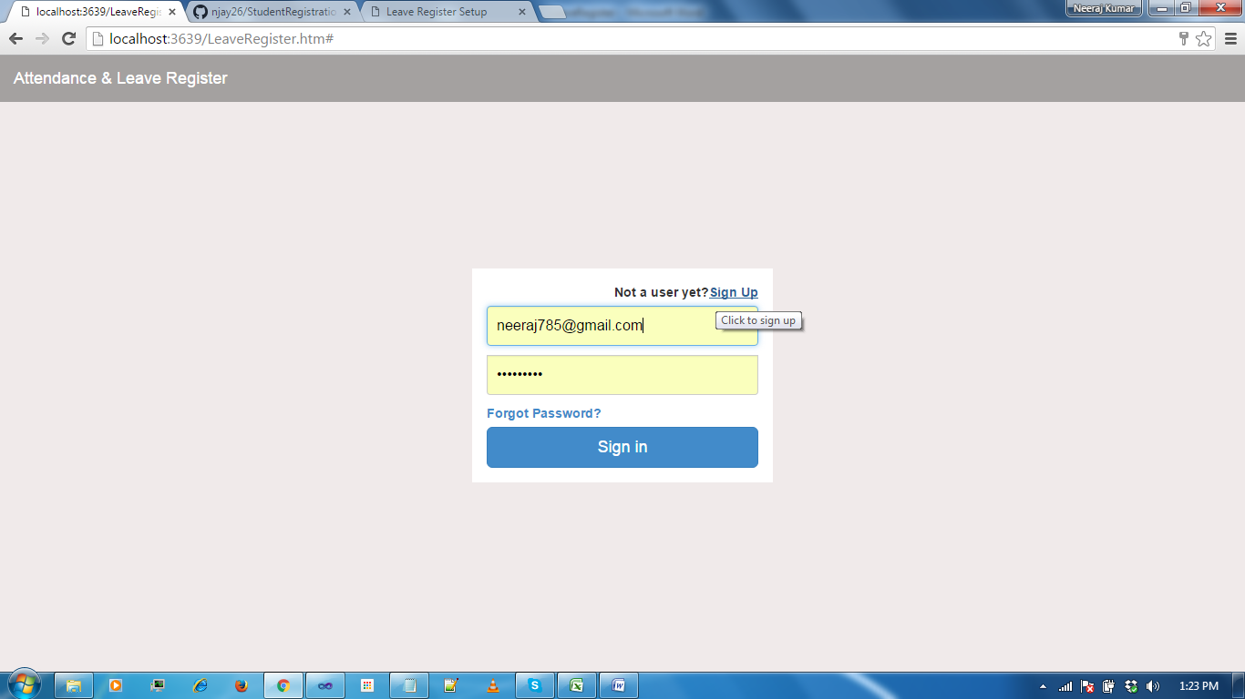

1. Enter your company email id and employee id
2. Then you need enter password and re password
3. Click on Sign UP button.

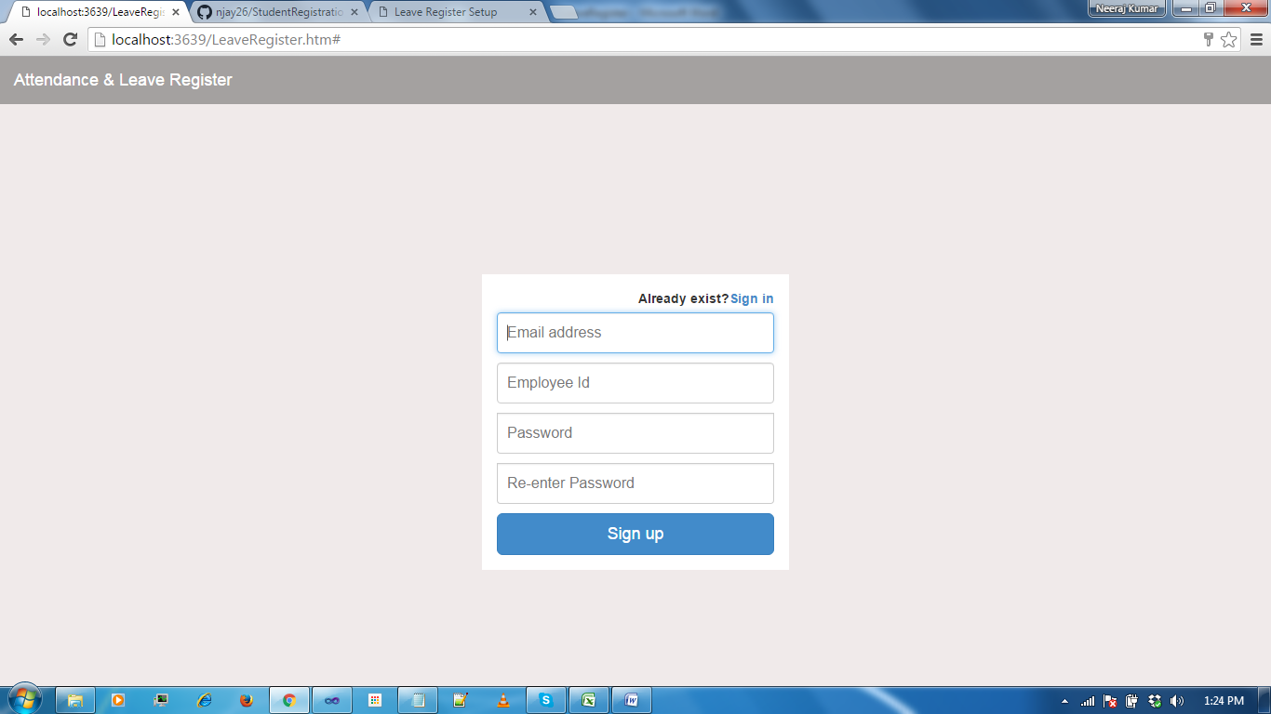

1. After that you can sign in from sign in farm.