**InstaMeme**

**Specifications Document**

**Ver. 1.0**

**Application Name:**

System Metaphor:

Photobooth/Caption Contest

Authors:

Curtis Schumacher

Niklas Bauer

**Use Case Diagram:**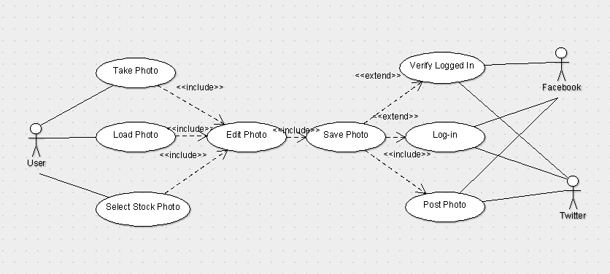

**User Stories:**

Pre-alpha Release 0.1:

* As a user, I want the product to be easy and simple. The interface should be clean and coherent.

Pre-alpha Release 0.2:

* As a user, I want the product to be easy and simple. The interface should be clean and coherent.

Alpha Release 0.1

* As a user, I want to easily select any image. I want it to be of any file type, and of any size.

Alpha 0.2 Release

User Story: I would like to be able to take pictures from inside of the application.

User Story: I would like to be able to select stock memes from the application.

* User Story: I do not want the camera to be able to rotate, it should be locked 90 degrees.

Beta 0.1 Release:

* I want to choose between stock photographs or images from my device’s gallery
* I want to my camera to be simple to use
* I want my camera to save my images to the device’s Gallery
* I want to easily put text on the image

Release Candidate:

* I want to be able to post to Twitter
* I want to save my Edited pictures

Final Release:

* I want to have a feature-complete application

**Test Plan:**

To save space, there is a separate Test Plan Doc (excel file) in the ~/docs folder

**Test Status:**

|  |  |  |
| --- | --- | --- |
| **Release Name** | **Percentage Junit Passed** | **Percentage System Level passed** |
| Release Candidate | 100% | 93.90% |