DETECTRA
Bot Review and Coordinated Campaign Detection
Technical Report
Course | DA5402W — Machine Learning Operations
Project | Bot Review Campaign Detection
Repository | github.com/njchathura-boop/Bot-Review-Campaign
Evaluation Branch | main
Team ID | 28
Team Members | Chathura N J (DA25M558), Likitha, Karthik

Abstract
Detectra is a production-style MLOps platform for ecommerce review intelligence. The design intentionally separates individual review-risk estimation from coordinated campaign-risk detection. A fine-tuned DistilBERT model scores the linguistic risk of individual reviews, while a separate hybrid campaign model combines semantic review representations with temporal and behavioral evidence. The end-to-end lifecycle covers data engineering, leakage-safe preprocessing, distributed model training, experiment tracking, versioning, online streaming, API serving, containerization, monitoring, logging, CI/CD, and Kubernetes deployment.
The implemented stack includes Git/GitHub, DVC, Apache Airflow, Apache Kafka, Apache Spark Structured Streaming, Ray Tune, MLflow, FastAPI, Docker, Prometheus, Grafana, Elasticsearch/Kibana, GitHub Actions, and Kubernetes/Kustomize. The promoted review-risk DistilBERT training run recorded validation PR-AUC 0.9353, ROC-AUC 0.9215, F1 0.8308, precision 0.8005, recall 0.8635, Brier score 0.1305, and log loss 0.4443. Campaign results are interpreted separately because the available public behavioral data does not provide verified real-world coordinated-abuse labels.

1. Problem Statement and Project Objective
Online marketplaces rely heavily on reviews for product discovery and customer trust, yet review manipulation can occur both as isolated deceptive reviews and as coordinated campaigns. A text classifier can identify suspicious linguistic patterns in one review, but it cannot by itself establish coordination across users, products, ratings, and time. Detectra therefore models two distinct decisions.
- Review risk: estimate whether one review should be inspected by a moderator based primarily on its text.
- Campaign risk: identify groups of reviews that exhibit coordinated semantic, behavioral, temporal, account, product, and rating patterns.
- Human-in-the-loop governance: model outputs provide evidence for moderation rather than automatic proof of bot activity.
The MLOps objective is not only to train accurate models, but to make the complete lifecycle reproducible, testable, observable, deployable, and traceable from source data to a serving prediction.

2. End-to-End System Architecture
The platform is organized into an offline training path, an online streaming inference path, a serving layer, and an operations/delivery layer. Kafka topics act as asynchronous boundaries in the live path; Airflow schedules bounded ETL and training workflows; Ray executes distributed training; MLflow records experiments and model versions; FastAPI exposes review and campaign APIs; monitoring and CI/CD span the runtime.
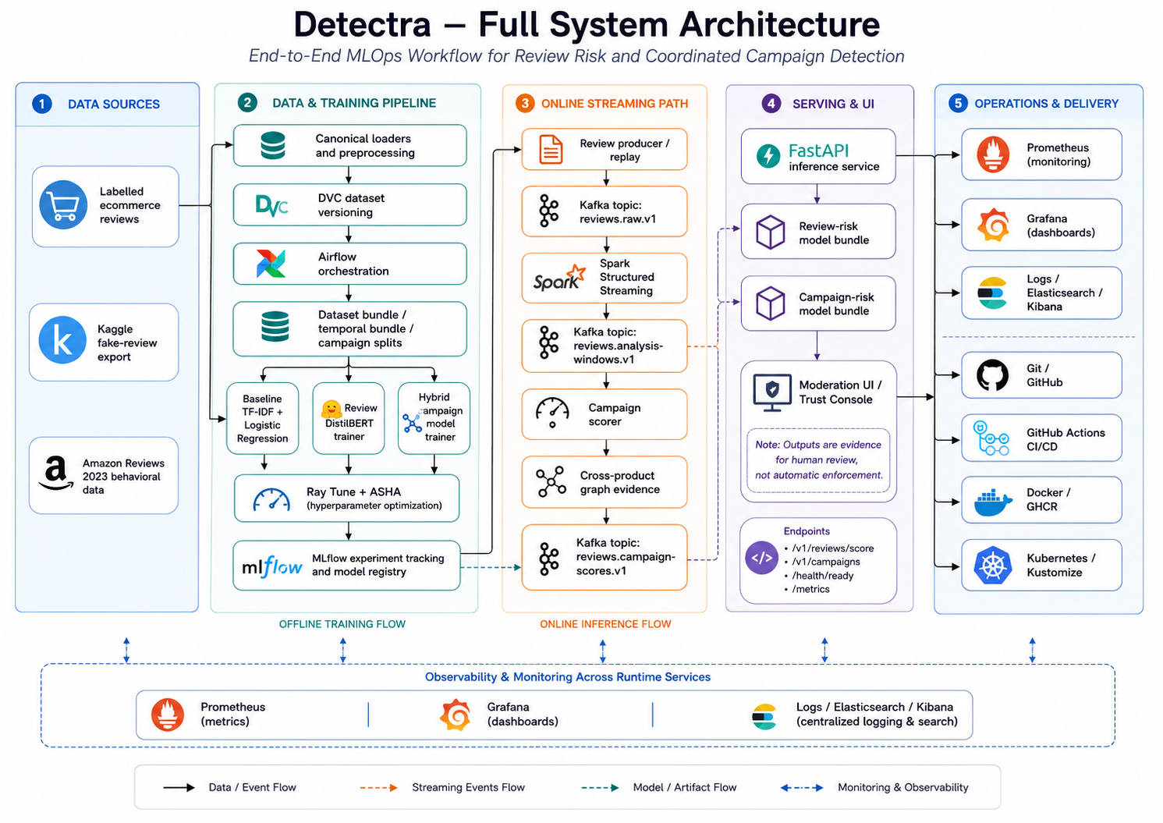

Figure 1. Detectra full-system architecture showing data sources, offline training, online Kafka/Spark campaign inference, serving, monitoring, and delivery.

3. Data Sources, Provenance, and Processing
Labelled ecommerce review datasets provide supervision for individual-review modeling, while Amazon Reviews 2023 supplies behavioral and temporal signals without being assigned fabricated fake-review labels. Canonical loaders normalize text, identifiers, ratings, language, timestamps, verification metadata, helpfulness information, and source provenance.
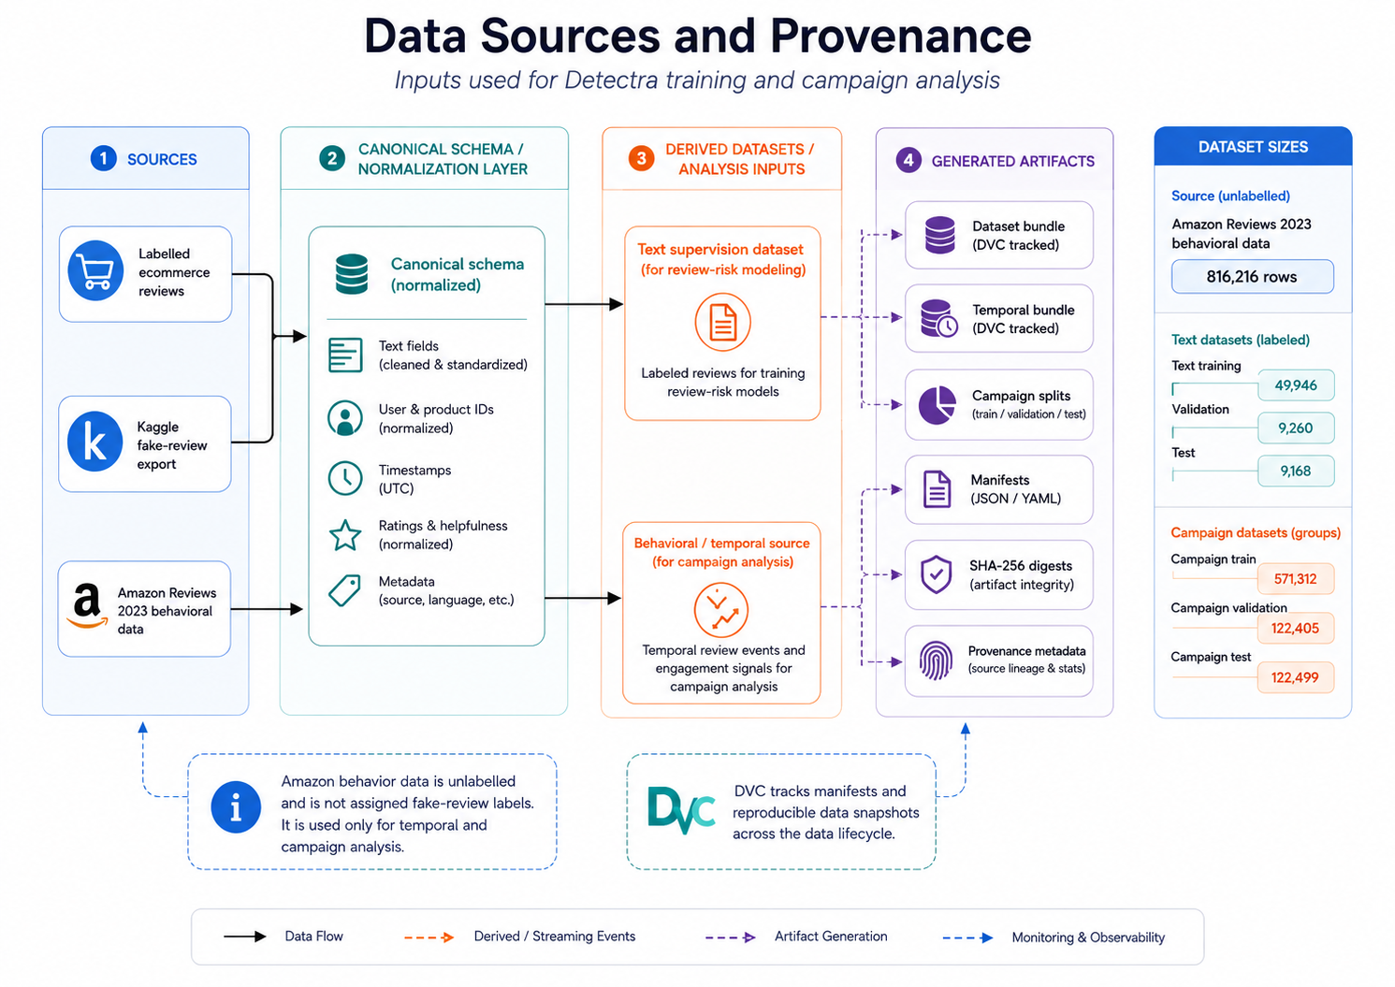

Figure 2. Data-source and provenance architecture separating labelled text supervision from unlabelled behavioral/temporal evidence and DVC-tracked outputs.

3.1 Data Cleaning, Quality Control, and Leakage Prevention
The processing flow canonicalizes heterogeneous inputs, handles missing values using deterministic safe defaults, rejects malformed or duplicate records, constructs historical features from past observations only, and applies leakage-safe splitting. Normalized review text is guarded across splits, campaign groups remain intact, and future-derived information, scenario identifiers, labels, and provenance fields are excluded from model inputs.
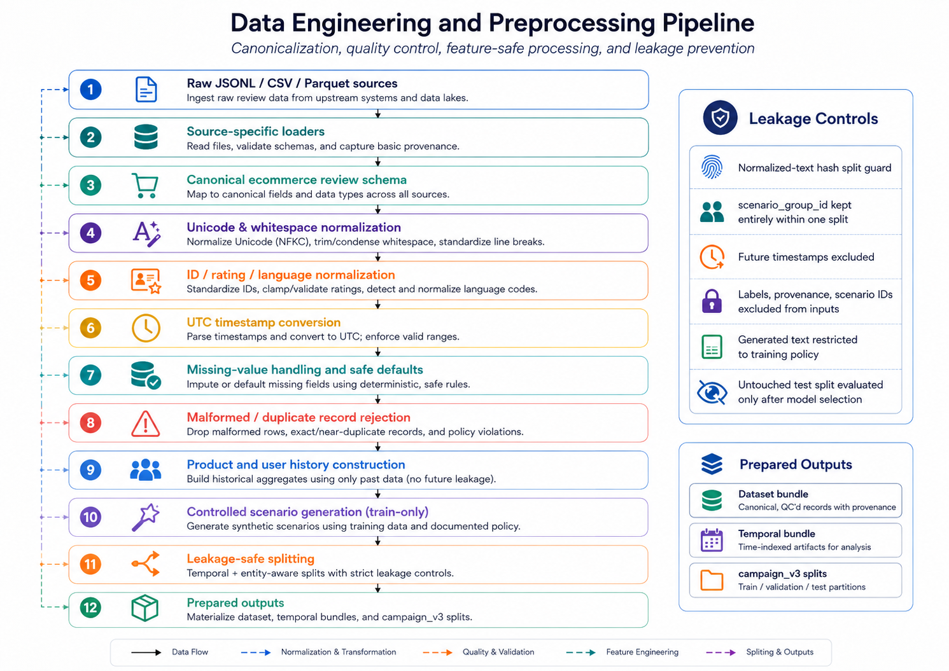
Figure 3. Data engineering and preprocessing pipeline with explicit quality controls, temporal safeguards, leakage-safe splitting, and prepared outputs.

4. Workflow Orchestration and Distributed Training
Apache Airflow is used as the outer scheduler for finite ETL and model-training workflows. Rather than performing heavyweight training inside an Airflow worker, the DAG submits work to Ray and waits for job completion. This keeps workflow orchestration separate from distributed compute scheduling.
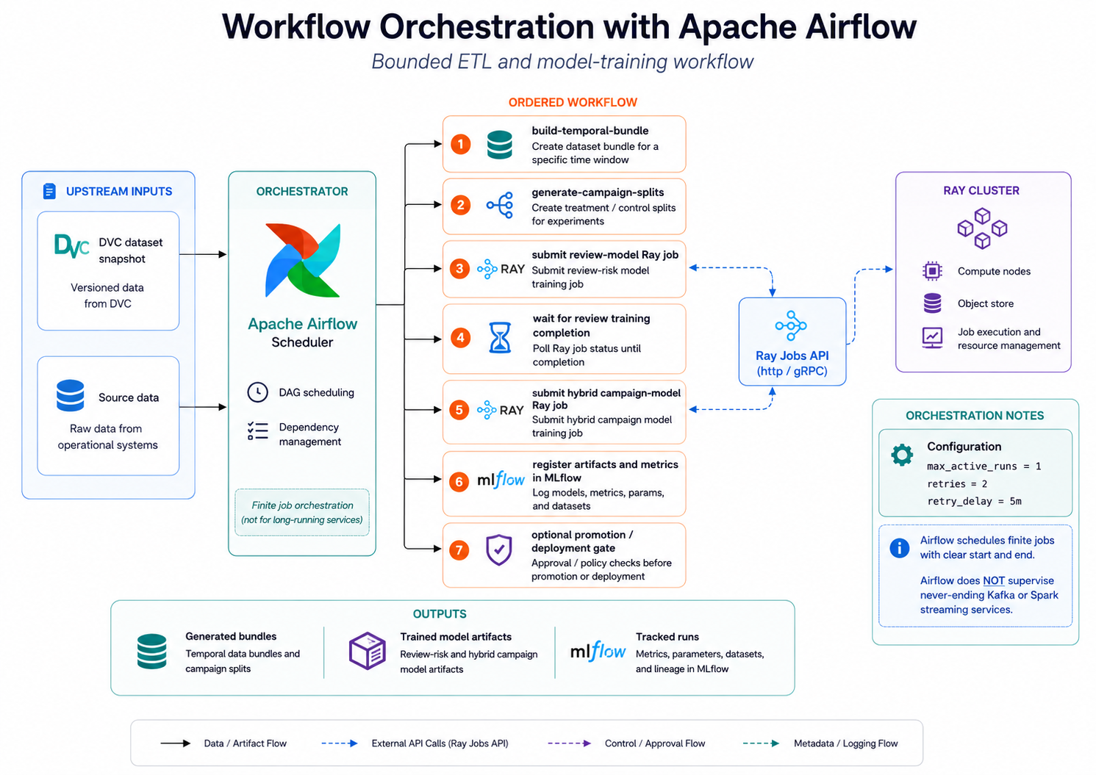
Figure 4. Conceptual Airflow orchestration flow for bounded data preparation and Ray-based model-training jobs, with MLflow used for durable experiment tracking.

4.1 Actual Ray Execution Evidence
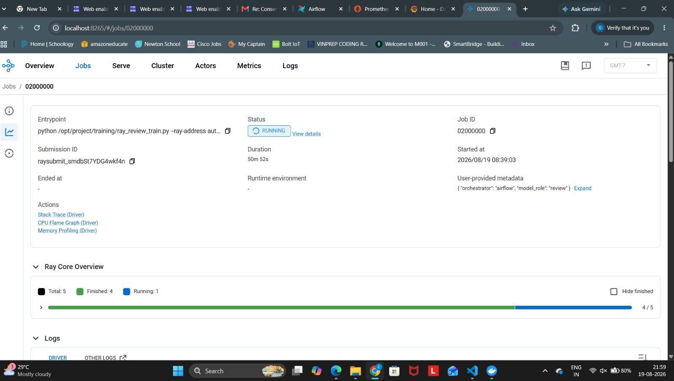
Figure 5. Actual Ray job view showing the review-model training entry point running with user-provided metadata identifying Airflow as the orchestrator.
Actual project screenshot; reproduced unmodified and scaled proportionally.
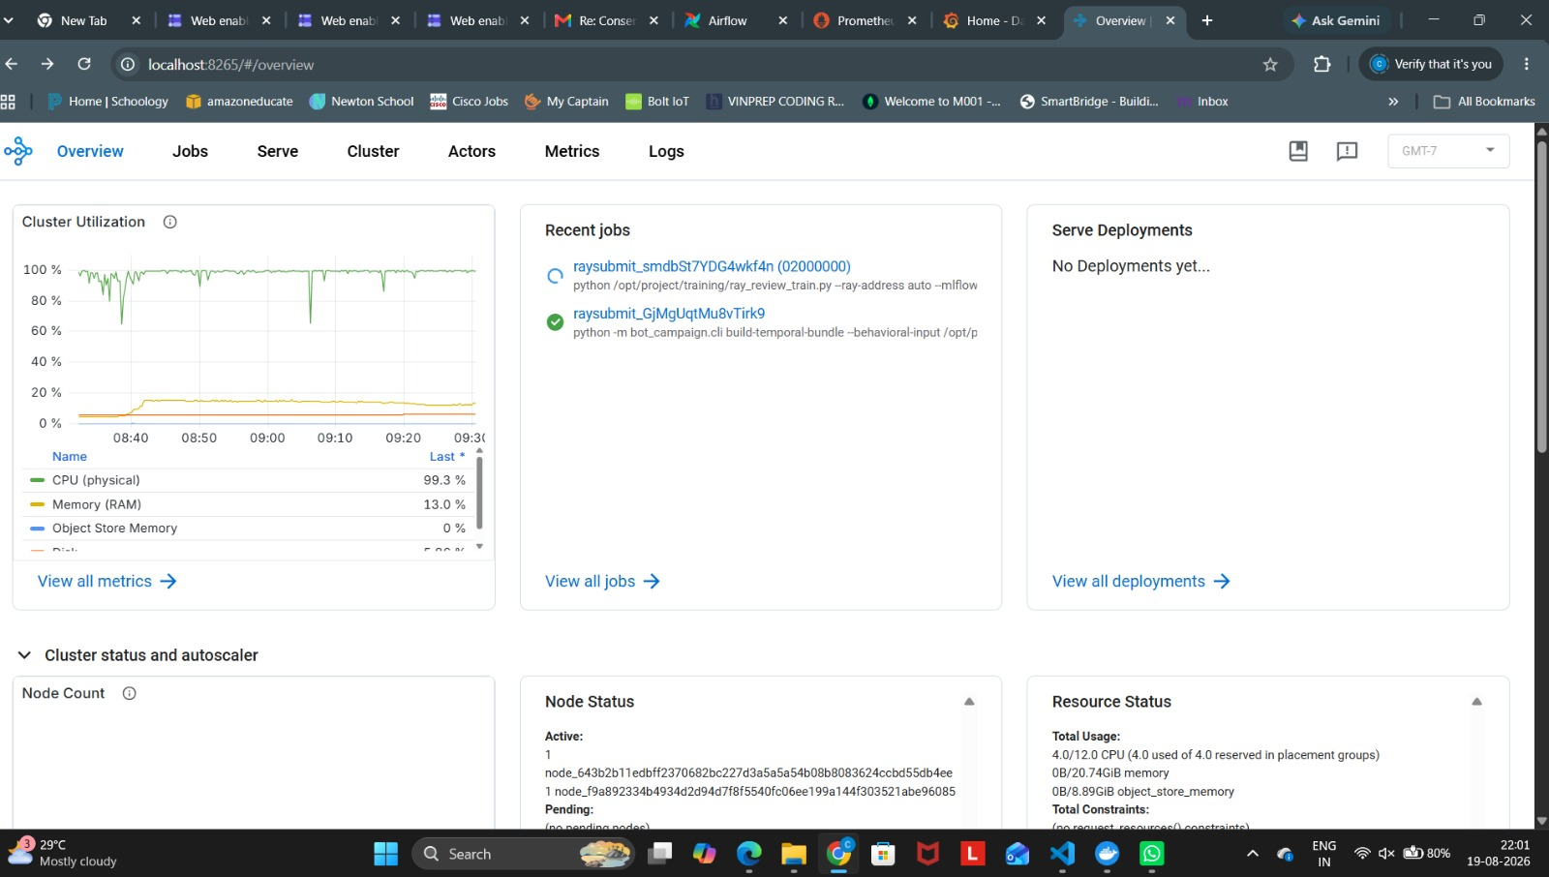
Figure 6. Actual Ray cluster overview showing recent jobs, cluster utilization, node status, and resource status during project execution.
Actual project screenshot; reproduced unmodified and scaled proportionally.

5. Online Streaming Pipeline with Kafka and Spark
The online path decouples ingestion, event-time aggregation, campaign analysis, and serving. Kafka provides durable event transport and replay; Spark Structured Streaming performs schema-aware event-time processing and windowing; downstream campaign logic consumes the resulting analysis windows.
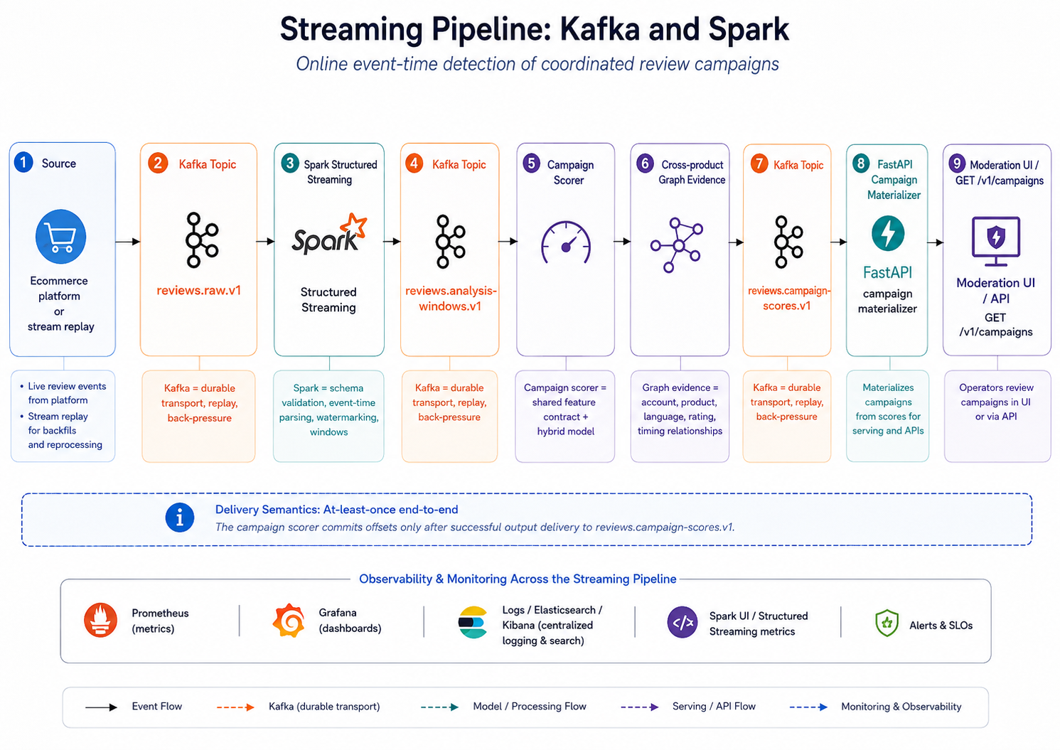
Figure 7. Online Kafka and Spark pipeline for review-event ingestion, event-time windowing, campaign analysis, score publication, and moderation access.

5.1 Actual Kafka and Spark Execution Evidence
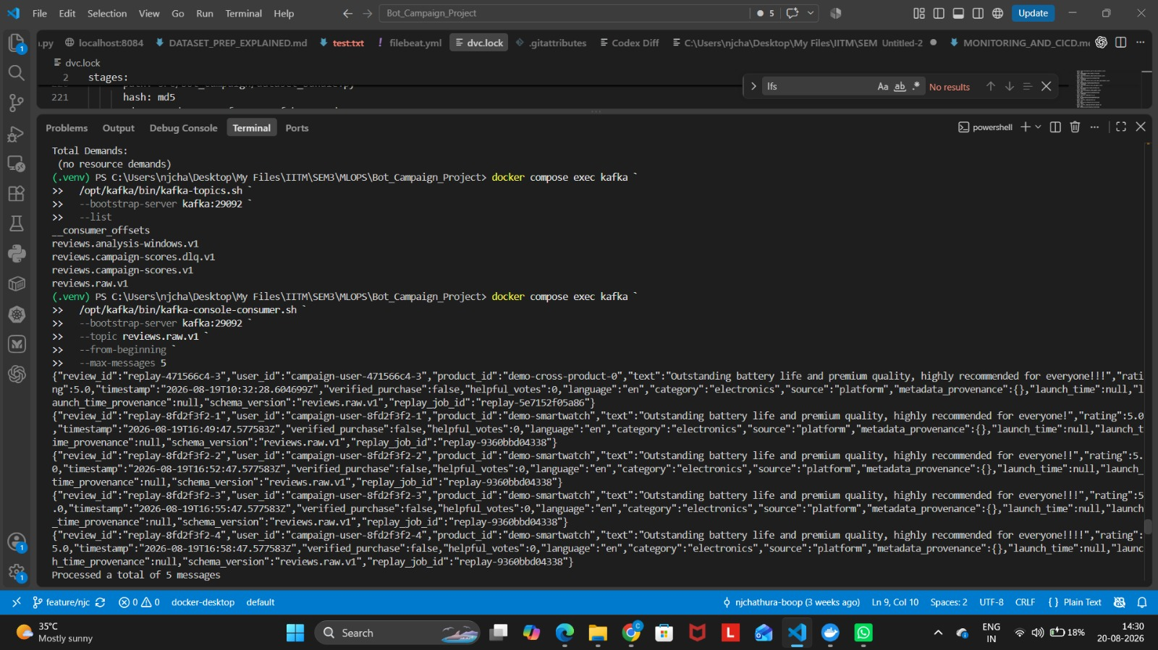
Figure 8. Actual terminal evidence listing Detectra Kafka topics and consuming records from reviews.raw.v1 during a campaign replay.
Actual project screenshot; reproduced unmodified and scaled proportionally.
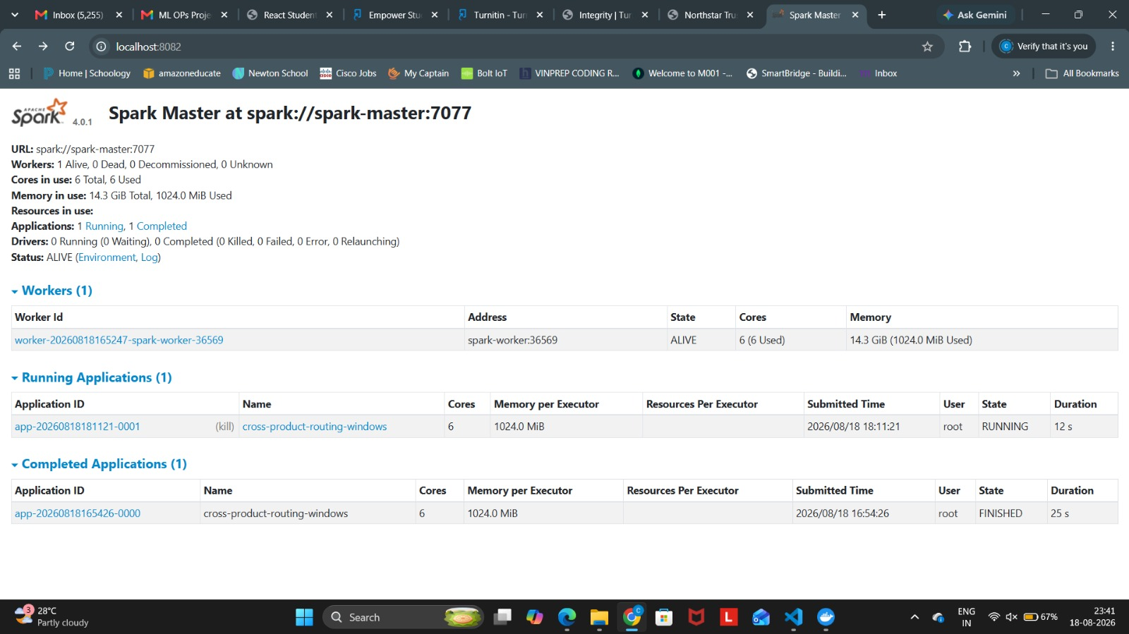
Figure 9. Actual Spark Master interface showing an active worker and the cross-product-routing-windows streaming application.
Actual project screenshot; reproduced unmodified and scaled proportionally.

6. Feature Engineering and Model Development
The campaign model uses a shared train/serve feature contract so that the same aggregation logic is reused during model development and streaming inference. The text branch produces semantic representations from review text, while the numeric branch captures volume, user/product spread, timing, ratings, verification/helpfulness, temporal context, and recent activity.
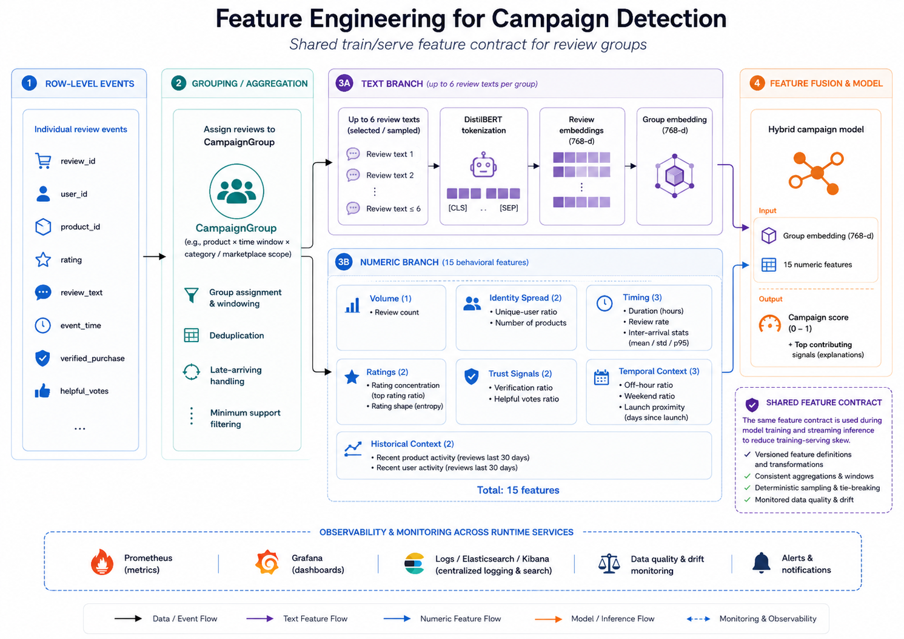
Figure 10. Campaign feature-engineering architecture combining a DistilBERT text branch with 15 behavioral features under a shared training-serving feature contract.

6.1 Model Tracks and Hyperparameter Optimization
Three model tracks are maintained: a TF-IDF/style Logistic Regression baseline, a DistilBERT review-risk classifier, and a hybrid campaign model. Ray Tune with ASHA supports hyperparameter optimization, while MLflow records parameters, metrics, artifacts, and selected model versions.
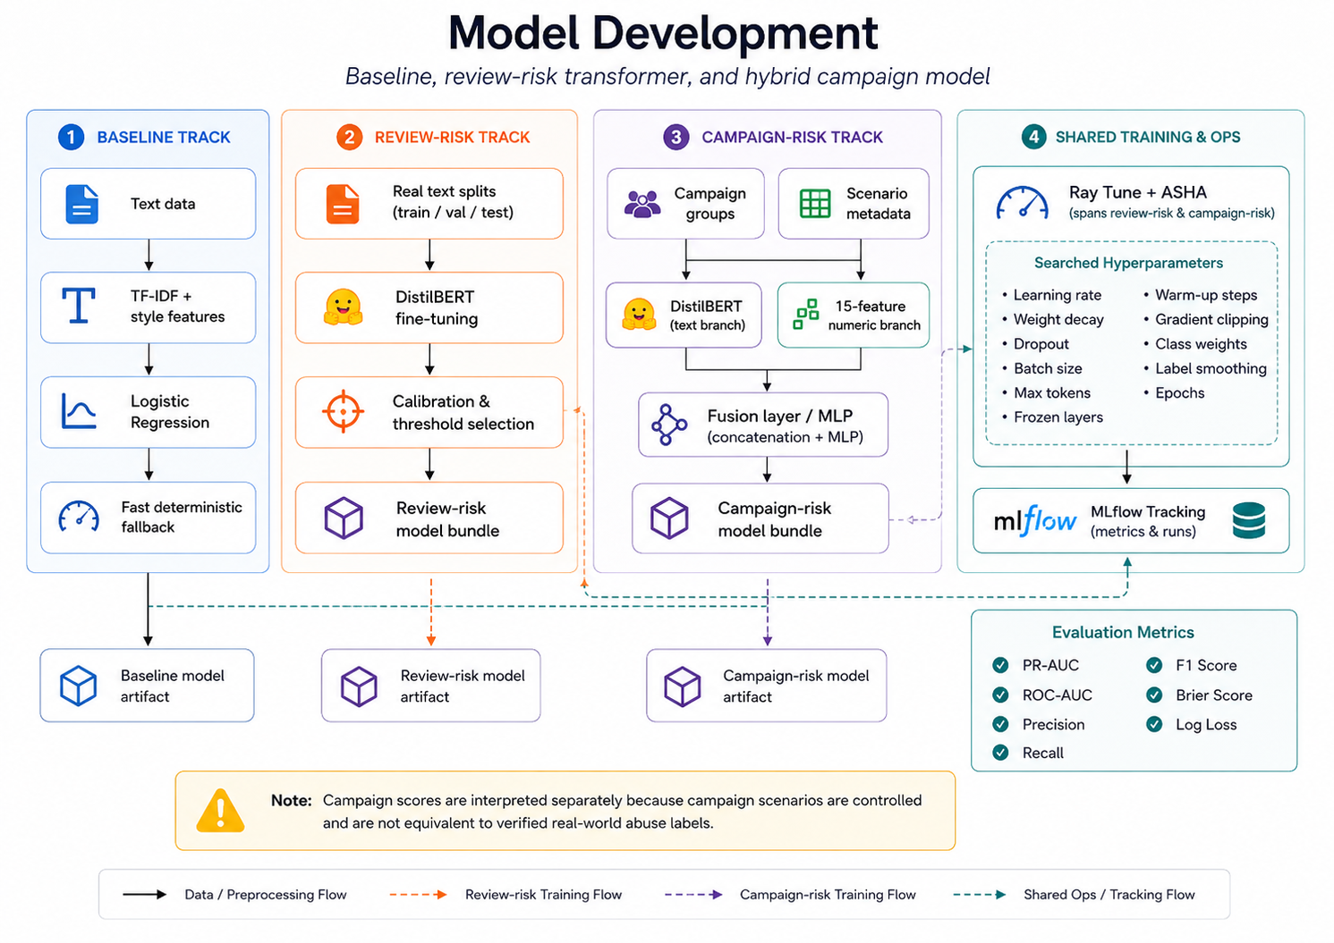
Figure 11. Model-development architecture showing the baseline, review-risk DistilBERT, hybrid campaign model, Ray Tune/ASHA, MLflow tracking, and evaluation metrics.

6.2 Actual MLflow Experiment Evidence
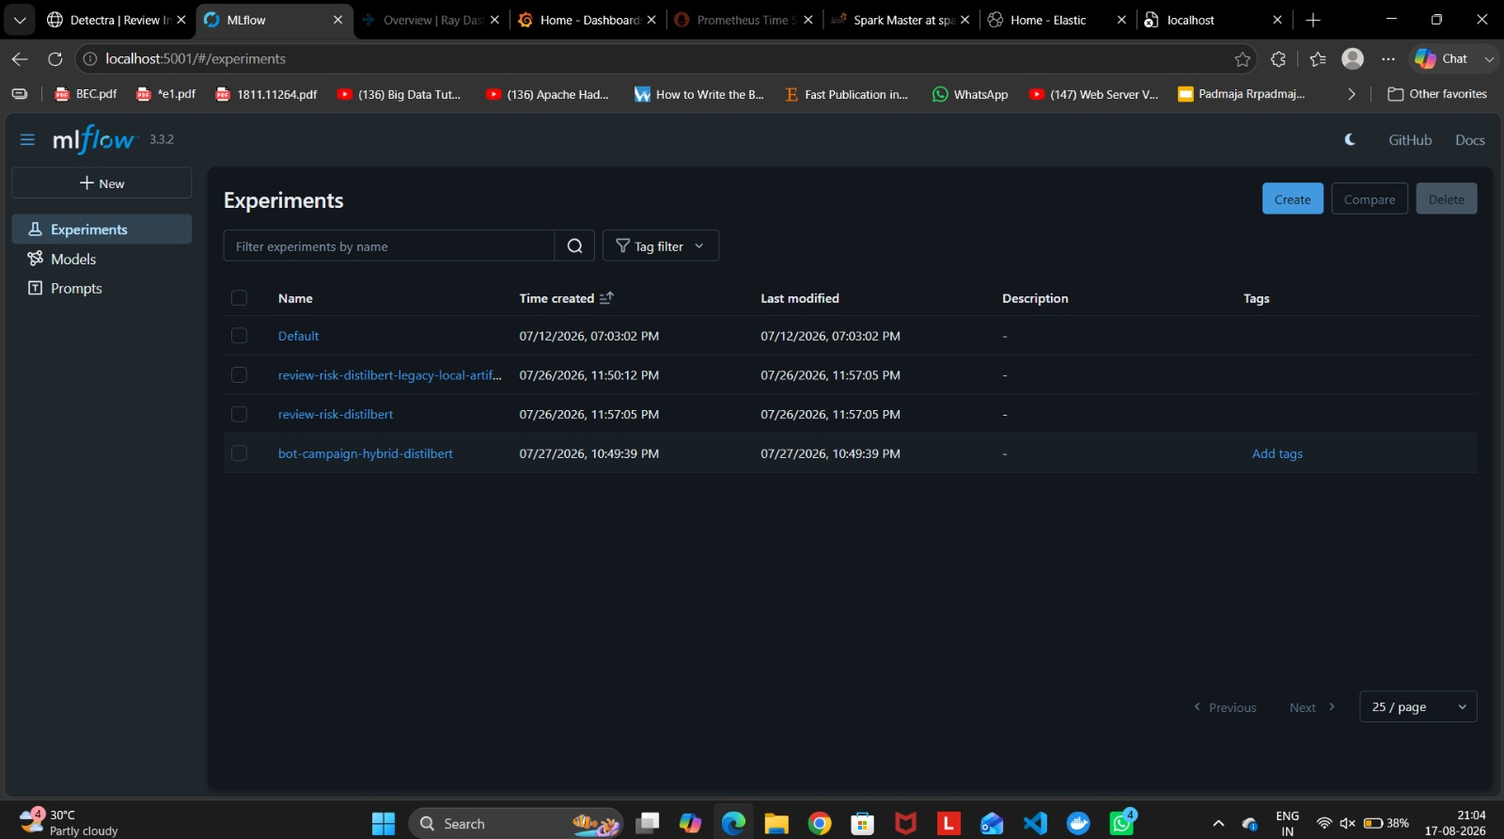
Figure 12. Actual MLflow experiment view showing separate review-risk DistilBERT and bot-campaign hybrid DistilBERT experiments.
Actual project screenshot; reproduced unmodified and scaled proportionally.

7. Versioning, Lineage, and Reproducibility
Detectra separates ownership of lifecycle artifacts: Git versions source and configuration, DVC versions dataset snapshots and pipeline outputs, MLflow versions experiments and registered models, and GHCR/Docker images identify executable runtime artifacts. This enables a prediction to be traced back through code, data, model, and container versions.
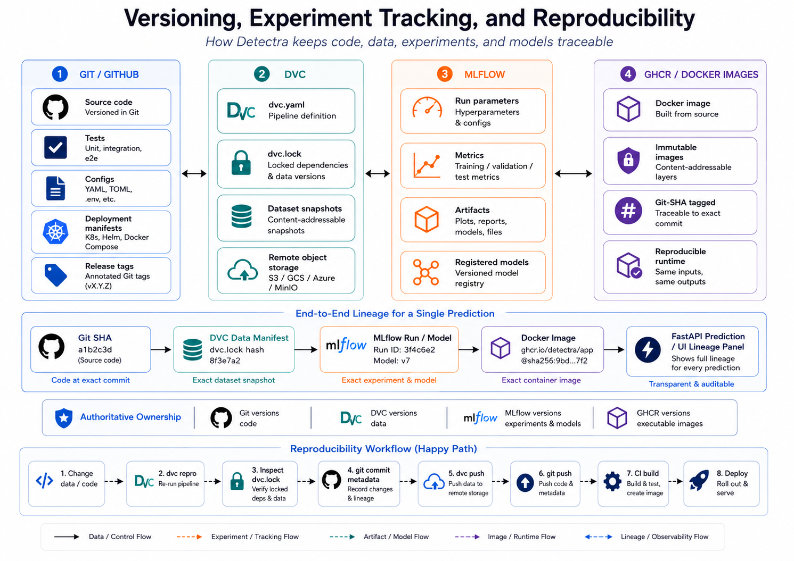
Figure 13. Versioning and lineage model linking Git, DVC, MLflow, and immutable container images to a traceable prediction and reproducible workflow.

8. Serving and Deployment Strategy
FastAPI exposes versioned review, campaign, trust, lineage, health, and metrics endpoints. Docker Compose provides the integrated local runtime, while Kubernetes/Kustomize provides a production-style deployment path with readiness/liveness checks, resource controls, persistent storage, and immutable image references.
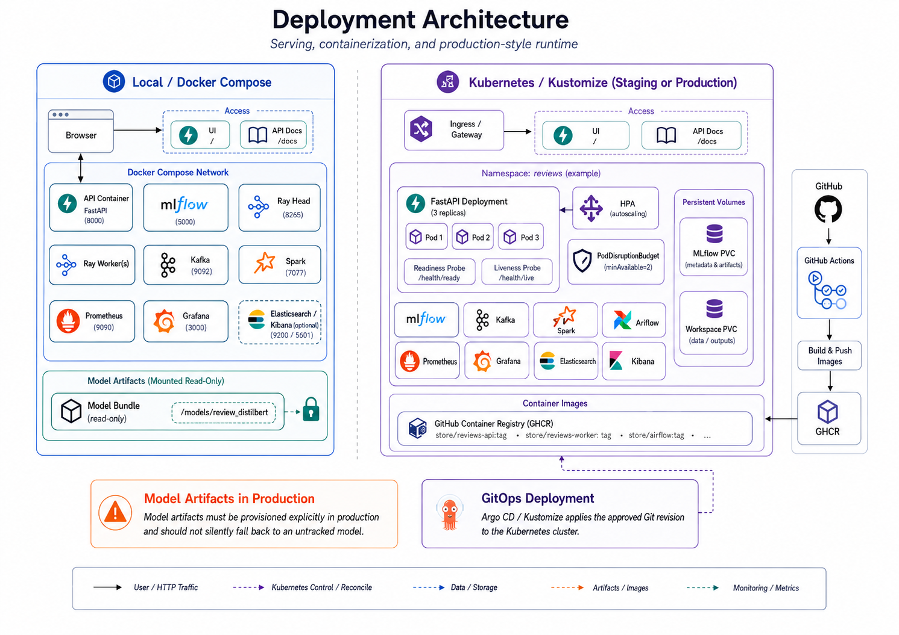
Figure 14. Deployment architecture contrasting the local Docker Compose runtime with the Kubernetes/Kustomize staging or production-style environment.

8.1 Actual FastAPI and Trust Console Evidence
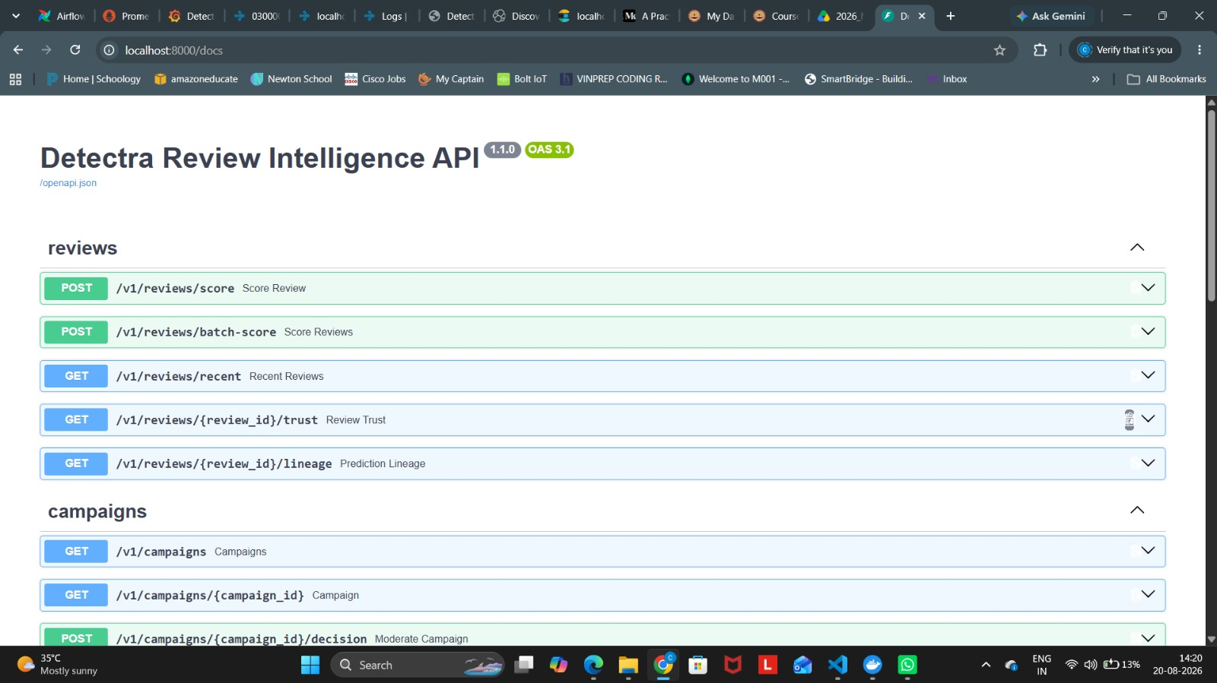
Figure 15. Actual FastAPI OpenAPI interface for the Detectra Review Intelligence API, exposing review scoring, batch scoring, trust, lineage, and campaign endpoints.
Actual project screenshot; reproduced unmodified and scaled proportionally.
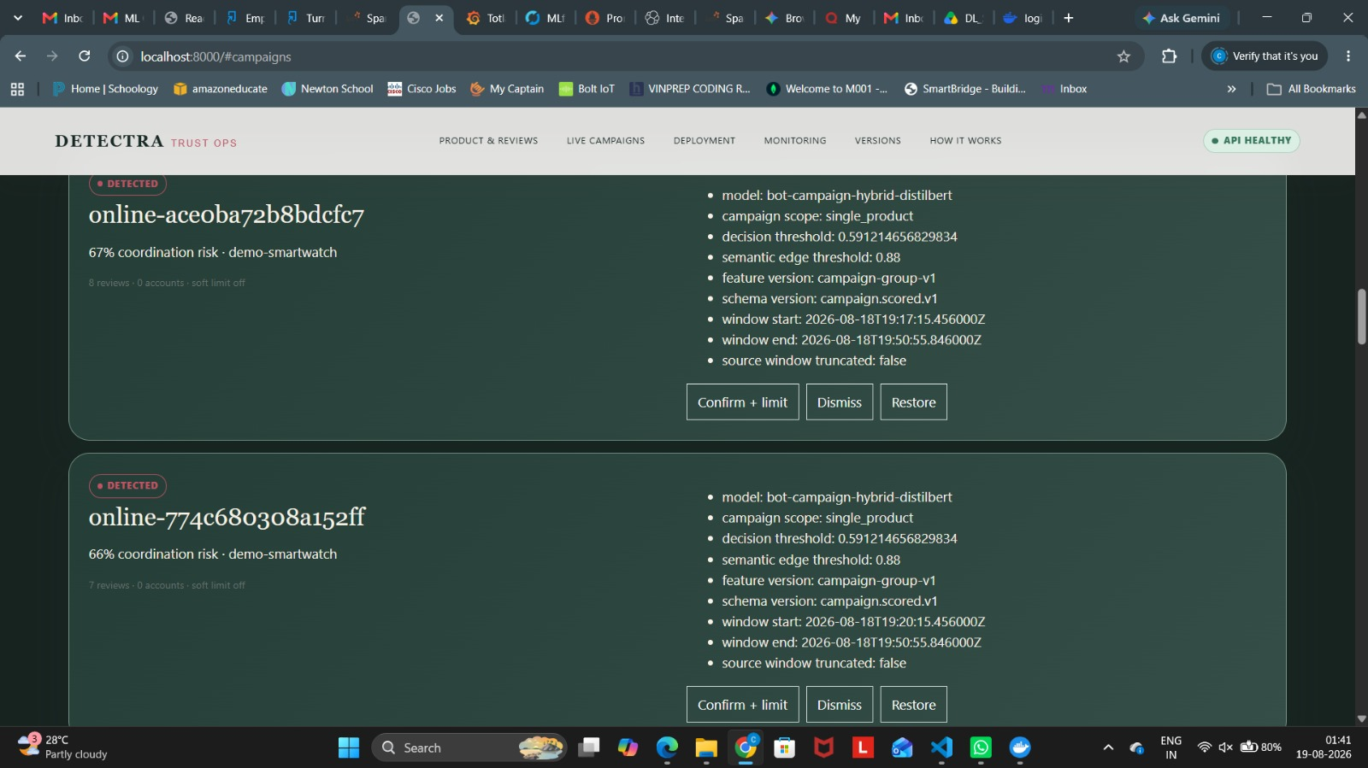
Figure 16. Actual Detectra Trust Ops campaign view showing coordination-risk evidence, model/threshold information, feature and schema versions, and moderator decision controls.
Actual project screenshot; reproduced unmodified and scaled proportionally.

8.2 Actual Container and Kubernetes Evidence
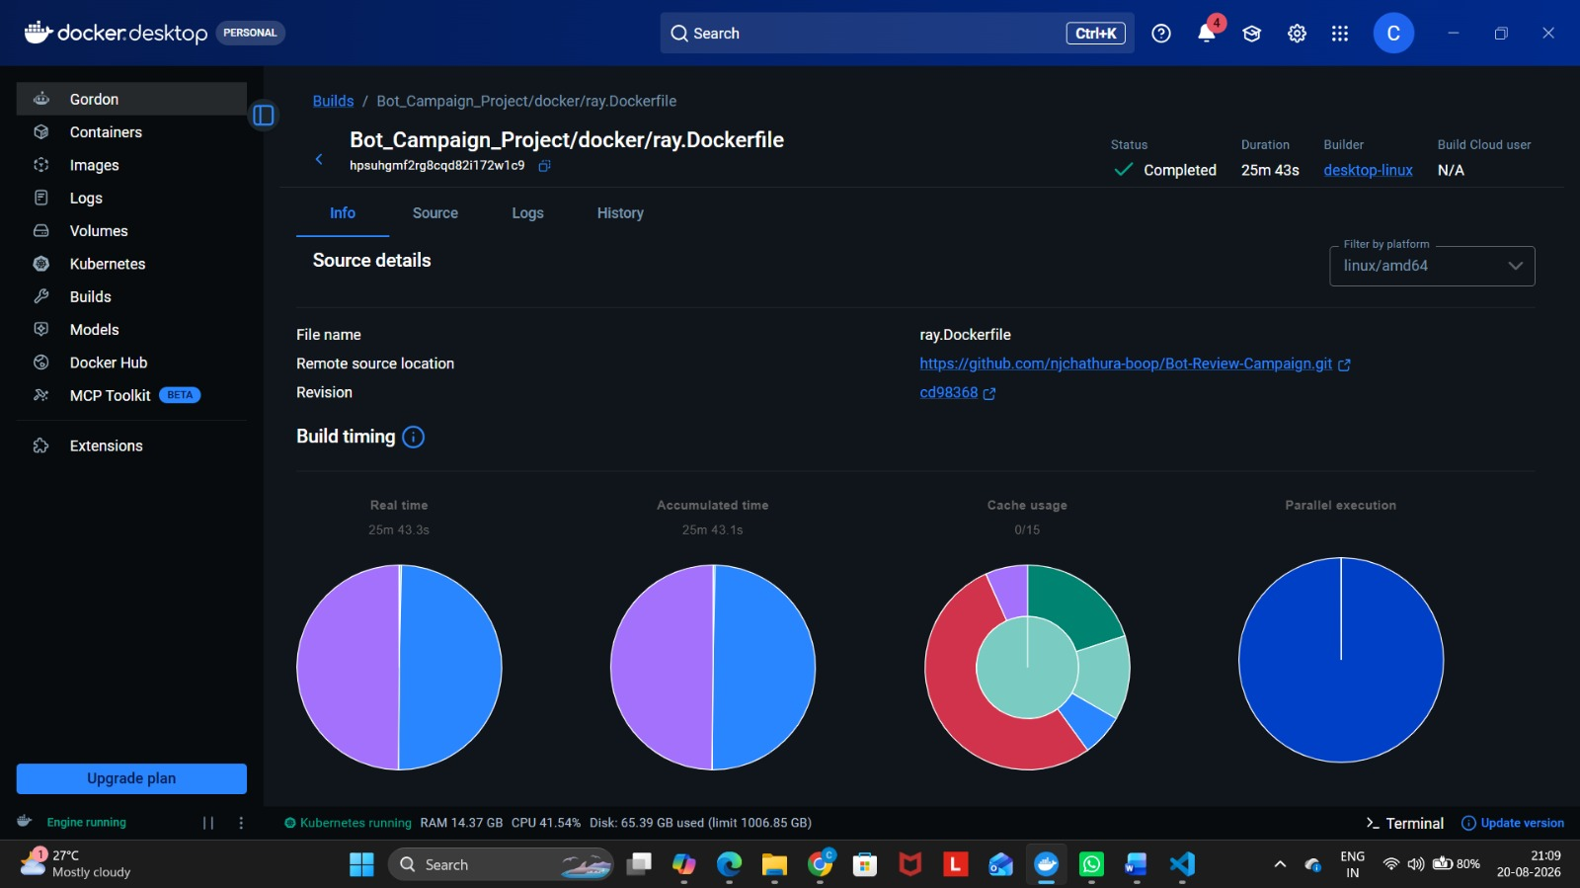
Figure 17. Actual Docker Desktop build view showing a completed build of the project Ray Dockerfile from the GitHub repository revision.
Actual project screenshot; reproduced unmodified and scaled proportionally.
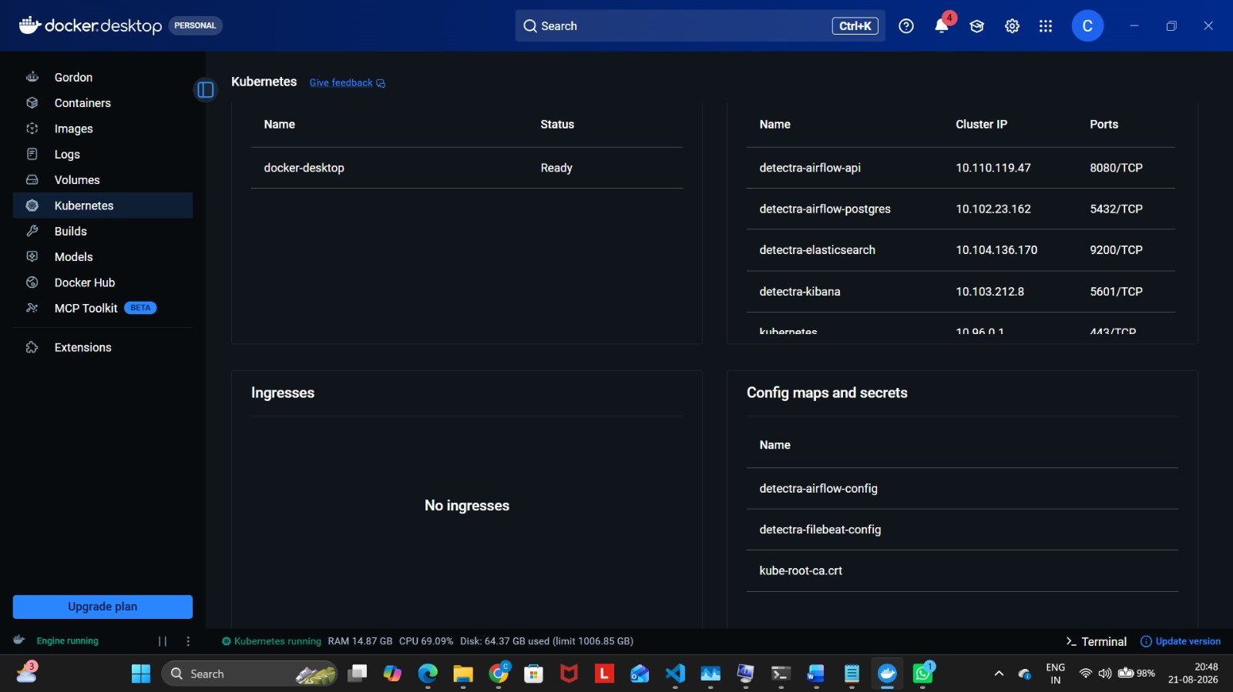
Figure 18. Actual Docker Desktop Kubernetes view showing the local cluster in Ready state and deployed Detectra services including Airflow, Elasticsearch, and Kibana.
Actual project screenshot; reproduced unmodified and scaled proportionally.

9. Monitoring, Logging, and CI/CD
Prometheus collects application and runtime metrics, Grafana visualizes operational signals, and Filebeat/Elasticsearch/Kibana provide centralized log search. The monitoring strategy covers throughput, latency, errors, model availability, campaign volume, stream health, feature/prediction drift, and moderator outcomes. GitHub Actions implements quality gates, container builds, vulnerability scanning, and release/deployment checks.
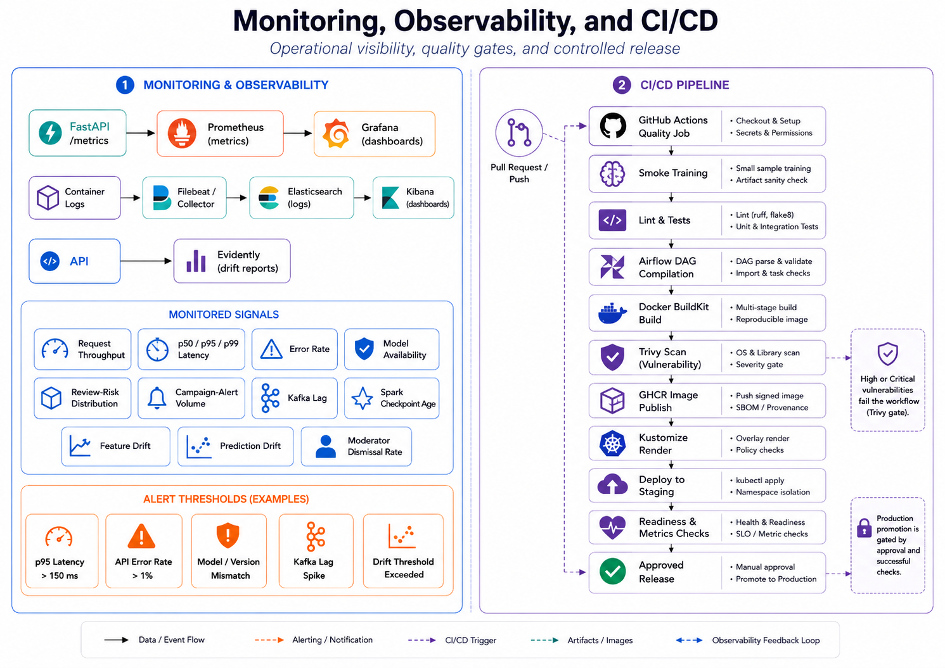
Figure 19. Monitoring, observability, and CI/CD architecture linking FastAPI metrics, Prometheus/Grafana, centralized logging, drift reporting, GitHub Actions, BuildKit, Trivy, GHCR, and staged release gates.

9.1 Actual Grafana Monitoring Evidence
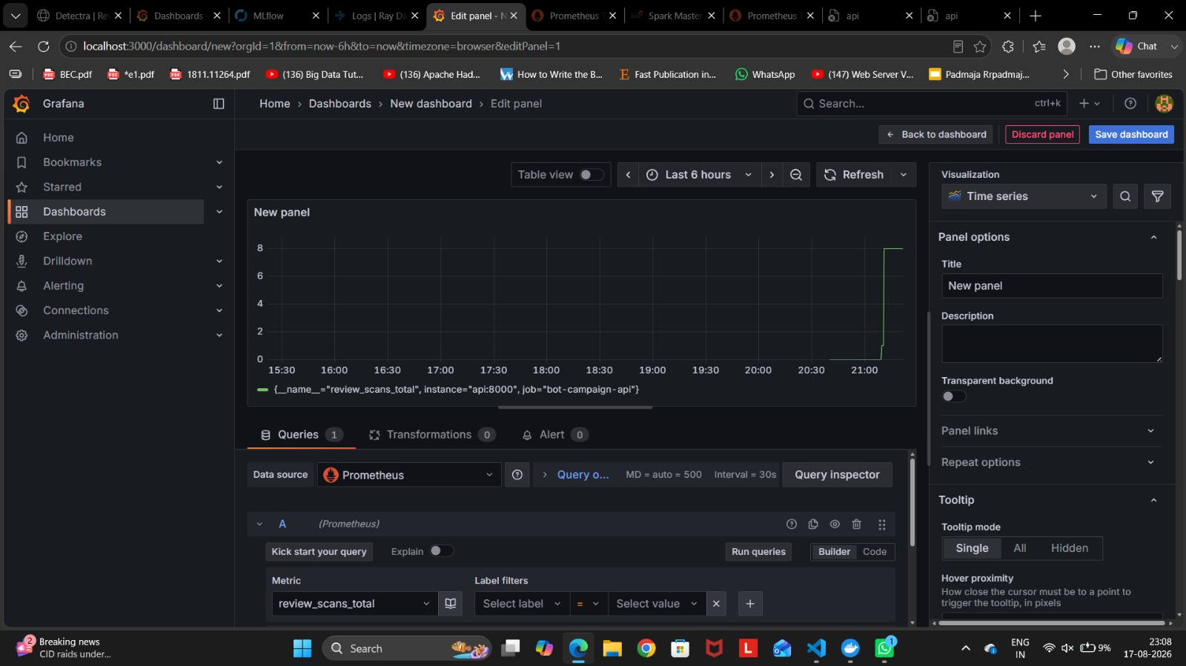
Figure 20. Actual Grafana panel configuration using Prometheus metric review_scans_total as a time-series signal.
Actual project screenshot; reproduced unmodified and scaled proportionally.
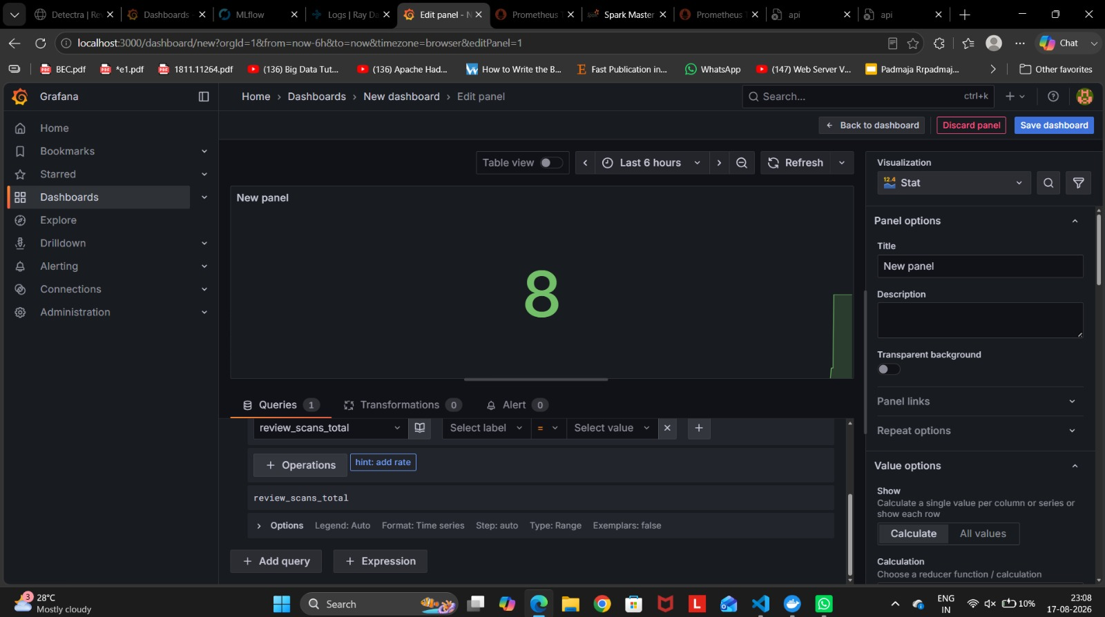
Figure 21. Actual Grafana stat visualization for review_scans_total, showing the metric being materialized as a single operational value.
Actual project screenshot; reproduced unmodified and scaled proportionally.
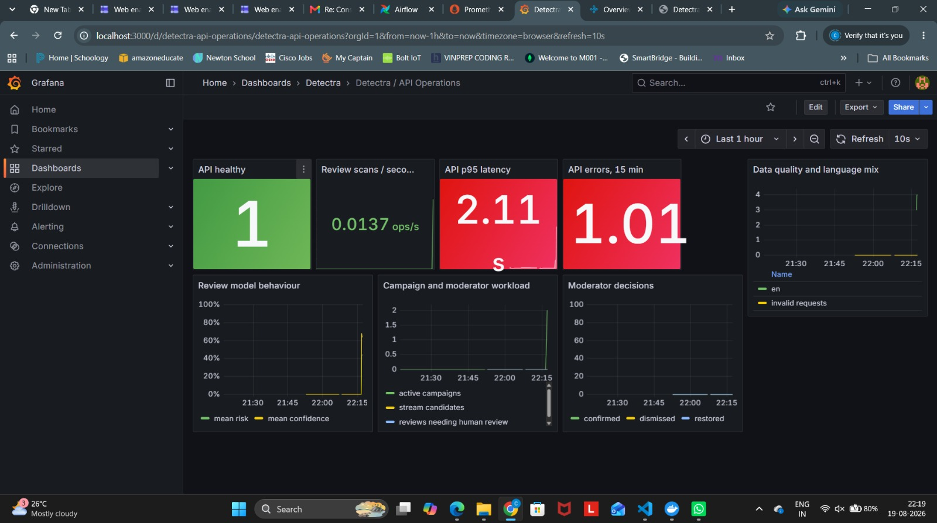
Figure 22. Actual Detectra API Operations Grafana dashboard showing API health, review-scan throughput, p95 latency, API errors, review-model behavior, campaign/moderator workload, and data-quality/language signals.
Actual project screenshot; reproduced unmodified and scaled proportionally.

9.2 Actual Centralized Logging Evidence
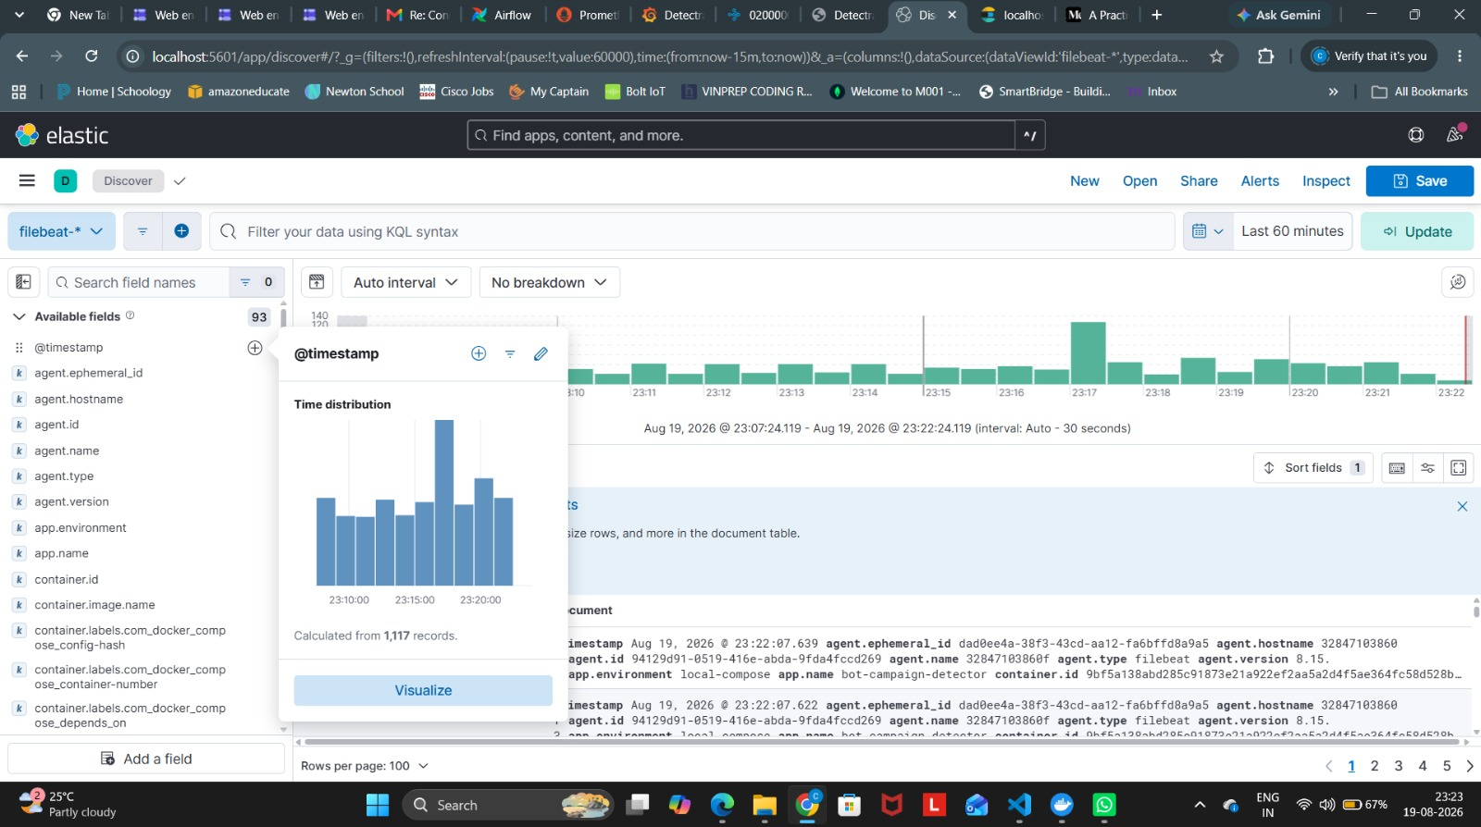
Figure 23. Actual Kibana Discover view showing Filebeat-indexed project logs and a populated time distribution over the selected interval.
Actual project screenshot; reproduced unmodified and scaled proportionally.

9.3 Actual GitHub Actions CI Evidence
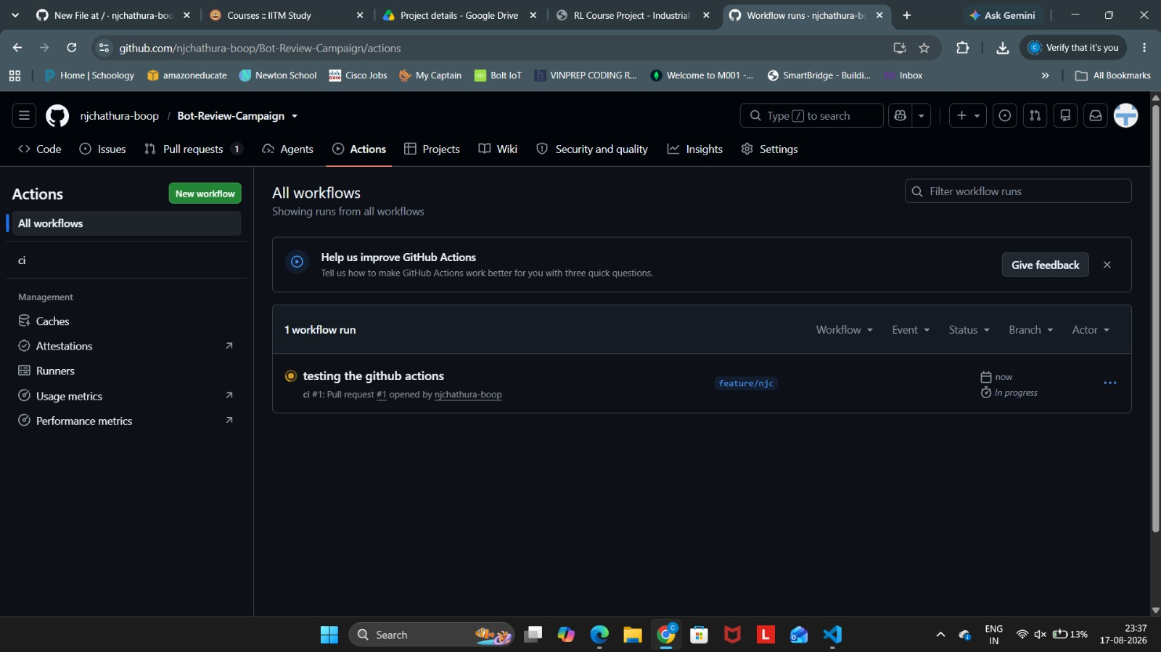
Figure 24. Actual GitHub Actions view for a pull-request-triggered CI run, showing quality and container jobs during execution.
Actual project screenshot; reproduced unmodified and scaled proportionally.
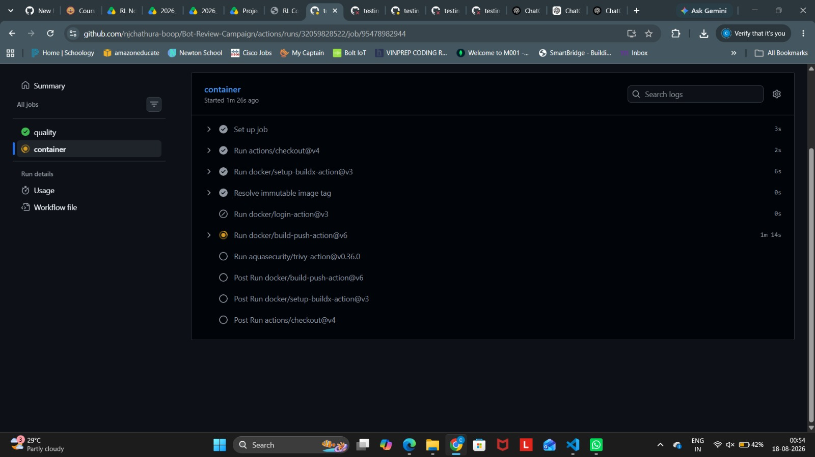
Figure 25. Actual GitHub Actions container job showing checkout, Buildx setup, immutable image-tag resolution, Docker build/push execution, and the configured Trivy vulnerability-scan step.
Actual project screenshot; reproduced unmodified and scaled proportionally.
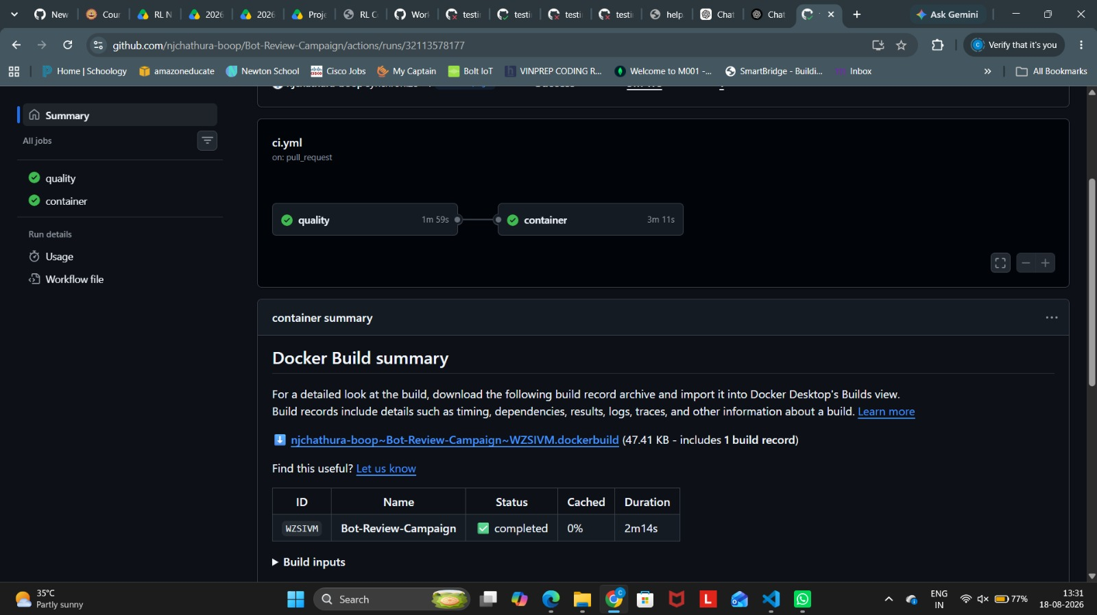
Figure 26. Actual completed CI workflow summary showing successful quality and container jobs and a completed Docker BuildKit build record.
Actual project screenshot; reproduced unmodified and scaled proportionally.

10. Results and Discussion
The promoted review-risk DistilBERT trial is evaluated using precision-recall and calibration-aware metrics because the operational task is minority-class screening rather than raw accuracy maximization. The strongest recorded figures available in the project documentation are held-out validation metrics; they should not be relabeled as untouched-test results.
Metric | Recorded value
PR-AUC | 0.9353
ROC-AUC | 0.9215
F1-score | 0.8308
Precision | 0.8005
Recall | 0.8635
Brier score | 0.1305
Log loss | 0.4443
Encoder | distilbert-base-uncased
Maximum tokens | 192

The existing tiny baseline smoke artifact is not treated as a meaningful generalization result. Likewise, controlled campaign scenarios are used to validate pipeline wiring and coordination-feature behavior, not to claim verified real-world bot-campaign accuracy. This distinction prevents smoke or simulated evidence from being presented as production performance.

11. Challenges, Limitations, and Future Improvements
Key engineering challenges include large review datasets and disk pressure, temporal leakage, memory pressure during transformer trials, model cold-start latency, training-serving consistency, and distinguishing service health from model quality. The implementation addresses these through reproducible data snapshots, past-only features, group-safe splits, controlled Ray concurrency/checkpointing, lazy model loading, shared feature contracts, and separate operational/ML-quality monitoring.
- Collect moderator-confirmed campaign labels and evaluate on a genuine chronological real-world holdout.
- Regenerate the baseline on the same complete real-only test split used for the final review-risk comparison.
- Add multilingual encoders and language-specific calibration.
- Introduce a privacy-reviewed online feature/graph store with freshness monitoring.
- Add shadow-mode canary evaluation, stronger rollback gates, and cost-sensitive thresholding based on moderator workload.

12. Conclusion
Detectra demonstrates a complete production-style MLOps workflow rather than a standalone classification notebook. It combines reproducible data engineering, two distinct risk decisions, distributed training, experiment tracking, online streaming, API serving, containerization, monitoring, logging, CI/CD, and Kubernetes deployment. The strongest aspect of the design is the explicit separation between individual review risk and coordinated campaign evidence, together with traceability from code and data through model and runtime. The implementation screenshots in this report provide direct evidence that the major platform components were executed rather than only described conceptually.

13. Course Requirement Compliance Matrix
Course requirement | Detectra implementation / evidence
Git / GitHub | Repository, pull-request workflow, GitHub Actions runs
Apache Airflow | Bounded ETL/model-training orchestration and Ray job submission
Additional data tool | Kafka event transport + Spark Structured Streaming
Data processing | Canonicalization, missing values, cleaning, leakage-safe preprocessing
At least two models | TF-IDF Logistic Regression baseline + DistilBERT; additional hybrid campaign model
MLflow | Experiment tracking and separate review/campaign experiments
DVC | Dataset/pipeline versioning and lock-based reproducibility
FastAPI | Review, batch, trust, lineage, campaign, health and metrics endpoints
Docker | Containerized API/training/services and verified build execution
Monitoring | Prometheus/Grafana metrics + Filebeat/Elasticsearch/Kibana logging
CI/CD | GitHub Actions quality/container jobs, BuildKit, Trivy configuration
Deployment | Docker Compose locally and Kubernetes/Kustomize production-style path
Documentation | Technical report, architecture figures, screenshots, README/runbooks

Appendix A. Figure Inventory and Evidence Notes
Figures 1-10 are architecture/system diagrams created to explain the project structure. Figures 11 onward are actual project screenshots supplied by the project team. No screenshot content was edited. The screenshots were embedded as supplied and only scaled proportionally to fit the report page.
One supplied file (grafana_ray_metrics.jpeg) is byte-for-byte identical to ray_local2.jpeg. To avoid presenting the same screenshot twice as separate evidence, the duplicated image is represented once in Figure 6.

