**Scenarios**

All the different scenarios start the same. The game will start with a screen prompting the user to input a name for the high scores. The game will then wait for the first player to select one of the given menu options. Depending on the option the player selects, the player will play either single player or multiplayer. The player(s) will then play through the game with a set number of lives, depending on the mode selected. Here is a scenario for each game mode. Note that I replaced the illustrations with real in-game screenshots.

**Scenario for Single Player Time Trial:**

Our story starts with a young space cadet named Billy. He had always dreamed of racing across the stars and finally, now was his chance. Billy was set to race his ship through the course, aiming for the best possible time. He even hoped to blaze through the course faster than many of the famous adult racers that he knew. Therefore, raring to go, Billy sped off as soon as the timer started. He accelerated as fast as possible, hoping to blast through the course at max speed. This was working really well for him until he reached the first obstacle. Going way to fast to have effective control over his ship, poor little Billy crashed head-first right into the obstacle. His ship was obliterated instantly.

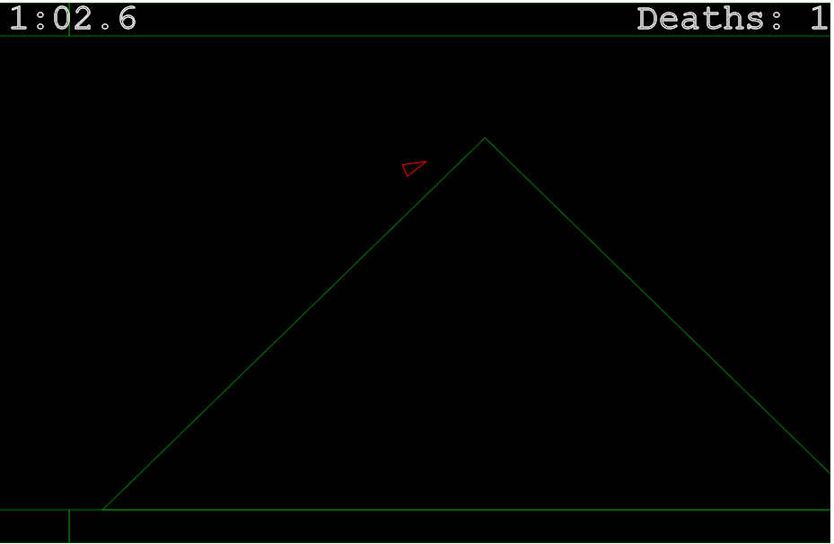

Luckily for Billy, advanced technology not only allowed him to survive, but it allowed his ship to reappear at the start of that level. Billy was extremely relieved. From then on, he was easy on the accelerator, making sure to maintain strong control over his spacecraft. Billy had learned his lesson. He continued to slowly navigate the obstacles avoiding further death and destruction until he saw the finish line ahead. Accelerating constantly, he passed over the finish line and completed his first time trial race. Billy was beyond excited! He exploded in a burst of joy and happiness. This was slightly diminished when he saw his time of twelve minutes and forty-nine seconds; however, he knew that it was his first time and that with much practice he could get his time down below a minute like the expert racers. Billy really enjoyed his race and was itching to get back on the track to go again.

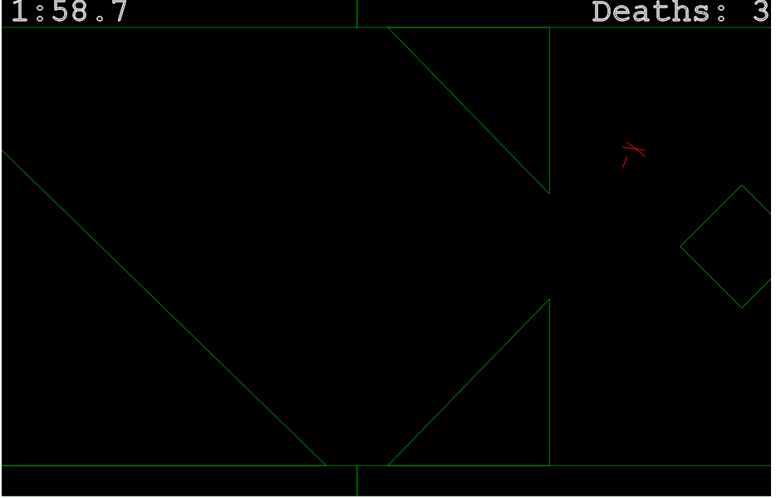

**Scenario for Single Player Challenge Mode:**

This story begins with an experienced space racer who goes by the name Bob. He had been racing in this part of the galaxy for decades. Everyone who was anyone knew of Bob. He was *the* Bob. By that I mean that despite the high number of people named Bob, this was the guy everyone thought of when they heard the name.

Anyway, this was Bob’s big day. He was going to take on the roughest, toughest challenge course on this side of the galaxy. He was very nervous, after all over half of the known galaxy would be watching. Bob pulled his ship up to the starting line and mentally prepared himself for the course ahead of him. The course was randomly generated, so he had no idea what awaited in store for him.

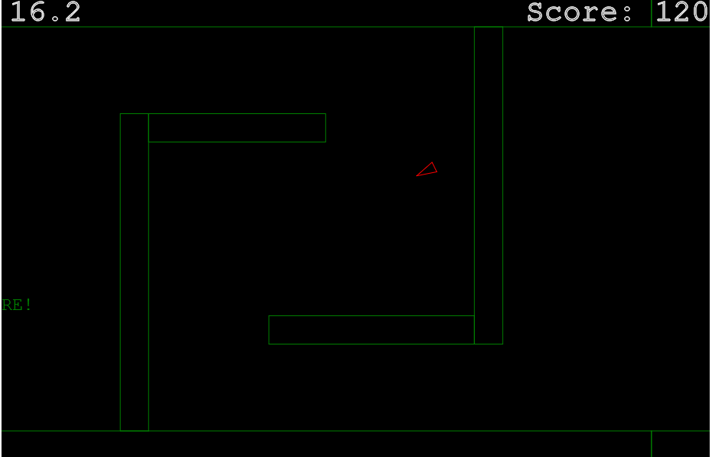

Once he was ready, Bob raced off and the challenge began. He expertly dodged obstacles and twisted and turned his way through the course. One level, two levels, three levels….he just kept gracefully flying through everything the course had to throw at him. Unfortunately, this would not last. Bob soon came across a level that he had never seen before. Mistaking it for a different level that he did know, Bob fell for a trick in the level design and rammed into a slanted obstacle. His ship exploded in a flash of bright light.

That was the end of Bob’s day. He was so disappointed. Today was his day and he had blown it. Everyone watching had been disappointed. Countless people lost entire life savings that they had bet on Bob reaching certain points in the course. It was a grim day indeed. All Bob could hope for was to get it behind him and try to do better next time.

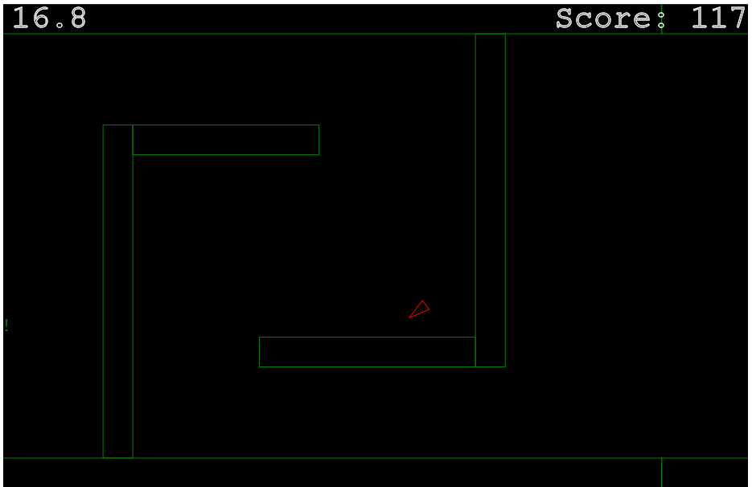

**Scenario for a Multiplayer Game:**

Our multiplayer story starts with two experienced space racers both in their late twenties. Their names are Tom and Sam. This wasn’t the first time these two pilots had gone face to face. In fact, there was quite the rivalry between the two. Tom was the slight favorite, having won the last encounter. Therefore, this was a very important match for both of them.

Without further to-do, the race got under way. Sam took a quick lead right off the bat. Despite this, the two were neck-in-neck. One level after another and the two stayed very close. One obstacle after another passed by. The race remained super close. Sometimes Tom was in the lead and sometimes Sam was. Everyone watching was on the edge of their seat.

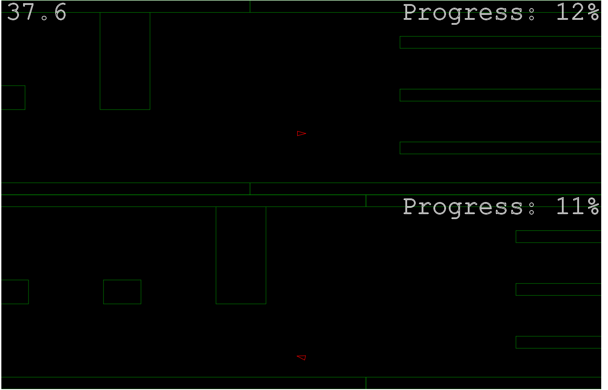

As the race came close to the end, Tom had a very small lead. In one last ditch effort to salvage a victory, Sam tried a risky move to pass Tom, but he bumped the side of a nearby obstacle and went spinning out of control. This allowed Tom to cruise across the finish line and maintain his upper hand in the rivalry. It was a great race nonetheless and everyone thoroughly enjoyed watching. One can only imagine how tense the next race will be between Tom and Sam.