Hands Across the Water

An analysis of The Beatles and their impact on the counterculture and fall of the USSR

Noah C Jenrich Jr

HIST 390

Professor Jeff Nichols

May 6, 2024

**Chapter 1 – An Introduction**

The mid-1960s saw a pop music craze never before seen, nothing like Elvis, who came before, or any other similar artist. In February of 1964, starting in New York City, the world exploded into “Beatlemania.” As we know it today, the concept is essentially a hysterical obsession but to an extreme extent—a mass wave of positive hysteria, if you will—with four working-class musicians from a recovering post-WW2 Liverpool and everything they created. This is such a huge cultural changing phenomenon that it’s now apart of the furniture of human culture history in the sense that everyone knows it and will know it for the rest of time.

The reasons for this cultural movement vary and are debated by historians constantly. In the United Kingdom, the rebuilding years from the Second World War were coming to a close, and society was undergoing a change driven by the youth, of which the Beatles are a major product. People were upset with the older generations, especially coming out of the war, and The Beatles were saying what many people were thinking. In late 1963, The Beatles played a show at the Royal Variety Performance in London with the Royal family in attendance. Before their last number, John Lennon addressed the crowd by saying, “Would the people in the cheaper seats clap your hands? And the rest of you, if you’ll just rattle your jewelry.” Lennon's original plan was to say: “rattle your fucking jewelry,” but nerves got the best of him.[1] However, this was a direct attack against the higher class, something a public figure had never done before, but it was what plenty of people were thinking, as their success grew they were invited several more times to perform on the show but denied every request. Lennon would later get in trouble for this same line of thinking in the United States by claiming the band was bigger than Jesus, further challenging the status quo.

The Beatles, both as a band and as individuals, were the leaders of this Western pop-culture craze, which would lead to bootleg recordings being smuggled into the country to subvert the censorship laws in the USSR. It was the beginning of a youth counterculture movement that would eventually lead to official government releases and the gradual thaw of censorship in the USSR. Their influence on the culture and even the policy of the USSR is something no other artist from the West was able to achieve. For many young people in the East, the Beatles represented something different from the life they were living; in a way, they symbolized freedom and youthful rebellion.

In the United States, the country was experiencing the same youth-led change. However, just a few months before their arrival in New York City and the beginning of American Beatlemania, the country was in mourning after the assassination of President Kennedy. In many ways, Kennedy started a revolution for the young people of the United States. He was the youngest president in history, a charismatic leader who attempted to understand the relations between East and West. He was part of several civil rights rulings and inspired the country to be excited about the moon, overall generating enthusiasm for what America had going for it. After his assassination, all the excitement of being a young American dwindled. The one figure who was doing anything about the problems in the world was now gone in a traumatic event, and people were left living in a mourning nation with nothing else to be excited about.

It's interesting to consider how the social and political landscape of the time influenced the Beatles' success not just in America but also in the United Kingdom and even in the USSR. The need for joy and excitement and an overabundance of social stagnation, coupled with a desire for youth to break societal norms, seems to have been a crucial factor in the Beatles' equation for success. In societies seeking change, the Beatles' music and message resonated deeply, making their impact significant wherever they "made it.

The Beatles played a significant role in bringing America out of that period of mourning and back to the ongoing youth revolution. Their arrival provided something to be excited about again, and it wasn’t scary to be young and exist. While older people didn’t adopt the same newfound positive attitude, there was a widespread recognition of the Beatles as symbols of youth and excitement. President Johnson's daughter, Lynda, had an idea to bring the Beatles to the White House since they had become such youth symbols, but Johnson shut it down out of fear that it was too soon after the assassination of Kennedy to celebrate something like that. After all, Kennedy had died in November, and the Beatles only arrived in February the following year.

In the UK, the US, and the majority of the rest of the world, the Beatles were embraced as the forerunners of the youth revolution. They combined the rock sounds of Elvis and Chuck Berry with the rhythms and melodies of Motown artists to create a version of pop music that was able to be enjoyed by anyone. The Beatles were arguably the biggest thing to happen to pop music ever. Prior to The Beatles, the largest venue a band could hope to play was an amphitheater or a concert hall. However, The Beatles were selling out baseball stadiums in the United States, and soccer stadiums in Europe and South America. Venues of this size were so inconceivable for musicians at this point that the technology to make playing the venue possible wasn’t even thought up yet. The company that produced the amplifiers The Beatles used for their guitars and microphones had to create new higher voltage amplifiers just for them to make it possible for them to be heard over the crowds. And even then, it wasn’t enough.[2]

One of the most common groups for a young person at this time to identify with was being a Beatles fan. However, behind the Iron Curtain, being a Beatles fan was one of the more unfortunate hobbies you could have, there wasn’t a lot of people to widely discuss it with since on paper the discussion wasn’t supposed to be occurring but, nature found a way. Government censorship and the banning of Western culture made it essentially illegal to be a Beatles fan in the Soviet Union.

"We always thought that we were on the right side, that if we were dangerous, we were dangerous to the Russian authorities, and to us that said they're not that good. That was how we felt, and I think it was true to a large extent that they were trying to suppress this Western influence”[3] – Paul McCartney (2023)

The Beatles were aware of their influence behind the Iron Curtain, and the Soviet leadership was aware that they were able to influence their youth. A Soviet art critic, Art Trotskii, recorded his thoughts on the entirety of the concept of the Cold War and the Beatles in a few choice sentences:

“In the big bad west, they've had whole huge institutions that spent millions of dollars trying to undermine the Soviet system. And I'm sure the impact of all those stupid cold war institutions has been much, much smaller than the impact of the Beatles."[4]

The end of the Soviet Union is a common story: the Berlin Wall falls, and then the bloc itself follows later until in 1991, there’s no more Soviet Union. People cite a bunch of reasons for what finally killed the Soviet Union. Some credit Ronald Reagan and various Western government campaigns and defense spending for dealing the death blow to the Soviets, others say it was other westen culture pieces like Levi jeans and the like. However, as Trotskii suggests, pop culture did more to dissolve the Soviet Union than any multi-million-dollar government-backed plan.

The Beatles led a Western pop-culture craze that prompted bootleg recordings to be smuggled into the USSR, challenging censorship laws. Their influence sparked a youth counterculture movement, leading to government releases and a thaw in censorship. They symbolized freedom and rebellion for many young people in the East.

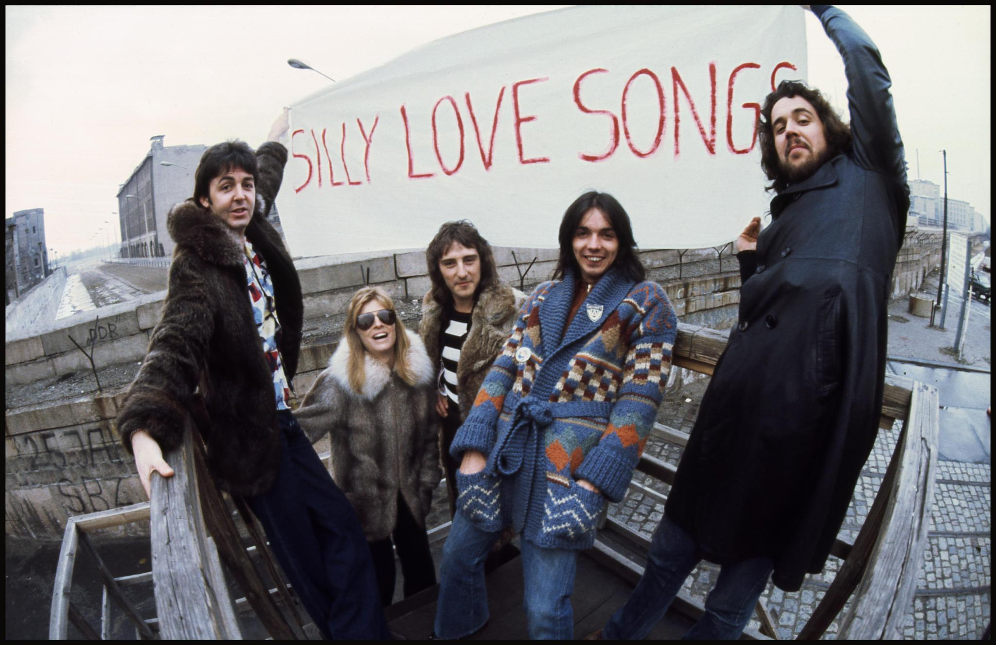Paul McCartney and Wings at Checkpoint Charlie (1976)[5]

**Literature Review**

Burley, Leo, (2008) Before discussing their impact on the Soviet Union, it's crucial to establish how relevant they were in the West and the global impact they were creating on people freely permitted to listen to this type of music. Numerous scholars have highlighted the Beatles' global impact as cultural icons during the 1960s, emphasizing their role in shaping the counterculture movement and fostering a sense of individualism, which would later influence youth in the East.

Ryback, Timothy (2016) Various sources from scholars explain the Beatles' influence exclusively on the Soviet Bloc and how they led to youth dissonance. Academics like Timothy Ryback and William Risch extensively write about the subject, researching how the Beatles and other Western music influenced youth culture, pushing for less censorship and thereby advancing the dissolution of the Soviet Union.

Brady,Kate. (2020) Youth groups in the Soviet Bloc were the main consumers of this Western music, creating a counterculture movement through activities such as Beatles fan clubs and meetups, especially after significant events in the band's history, such as the death of John Lennon in 1980.

Troitsky (1986) , Troitsky’s book “Back in the USSR” provides one of the best and most extensive looks at life in the USSR and the development of rock and roll and the youth cultures along with it, and his writings have been my primary source for most infornmation on Soviet life

**Chapter 2: the Beatle’s influence on Soviet Society**

In the early '60s, the average Soviet citizen was familiar with some Western artists; however, these artists were big band, crooners, and jazz musicians. The first "Western pop star" in the East was Robertino Loretti a 14-year-old crooner whose first record was released in 1961. Loretti, an Italian big band singer, enjoyed only a few years of popularity in the West, but he and other Italian artists remained relevant in the USSR for decades.[6] Loretti paved the way for an increased interest in Western music right at the start of the '60s, setting the stage for the Beatles to come in and take the scene by storm in the mid-'60s.

While other non-Russian music groups were able to see small amounts of success, it was The Beatles who were able to fully capture thethe nation with their influence and eventually inspire them to desire change.

Alexander Gradsky, a Soviet era musician, took heavy inspiration from The Beatles “I was in a privileged position- my uncle was a dancer and travelled abroad often he brought back real albums. I studied music at school and sang along with some American hits, until 1963, when I first heard the Beatles I went into a state of shock, total hysteria. They put everything into focus. All the music I’d heard up to that time was just a prelude.”[7]

Gradsky's story is a common one among music fans of the era. People like Gradsky would likely have been referred to by other Russians as a "Stilyagi," which roughly translates to "stylish" or "style hunters." They were a youth subculture that emerged in the late '50s after the Stalin years, it’s thought that other youth groups existed before then but Stalinism made it so they didn’t even appear in any meaningful capacity. Stilyagi’s main aim at least in a simplified version was to dress more stylishly, which in this context basically meant more westernized. It was more of an underground subculture, with not a lot of people identifying with it. Troitskii quotes his mother on the topic, which essentially sums up how these people were viewed. “We despised stilyagi because it was felt that they were people without any spiritual interests for, whom style or form was everything.”[8]

Stilyagi were dying off in the early '60s. Troitskii says it’s due to the fact that the youth were just becoming excited over different things: Yuri Gagarin made it to space, and it was more entertaining to be captivated by that and other things happening internally in the Soviet Union than what was going on outside the USSR. Stilyagi caused a “moral panic” in the Soviet Press due to the fact that it was attempting to westernize the young. Some outlets referred to them as “folk devils” and they were often mocked in magazines and journals, especially the *Krokodil* [The Crocodile] which was a satirical journal that started publishing in the early 20’s, during the 50’s stilyagi were often the butt of the joke for many of the satirical pieces they put out. The label Stilyagi itself was given by people who saught to suppress the group by calling them simple style hunters and often creating an unpleasant depiction of them, often comparing them to zoo animals.

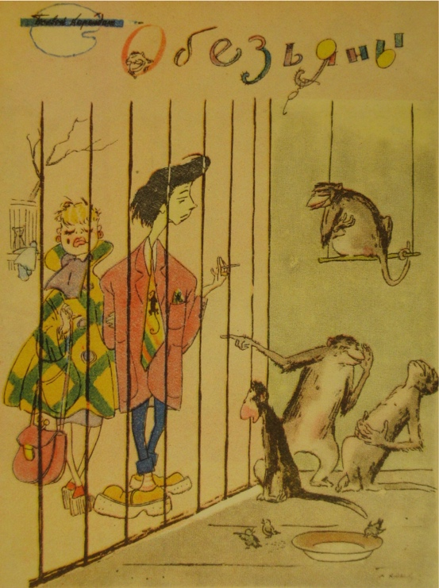

Khudyakov “The Monkeys.” *Krokodil (1957)[9]*

Then, it suddenly became mainstream to be a Stilyagi. Troitskii, in his own words, says, “It was no longer an isolated gang of hipsters, but an enormous mass of children.” The Beatles came along, and young people became invested, and the desire to style yourself both in clothing and lifestyle became popular. The Stilyagi grew so big they turned into something else entirely creating other groups like the Shtaniki and Beatnicki.

Why The Beatles caught on first and not other enormous acts like Elvis is a mystery to most people. People speculate it’s because rock music was too much for Russians, in the same way it was too much for a lot of people in the world when it came out; it was too different and seen as violent or provocative, and it may inspire people to commit sexual or violent acts, there was also a racial component at play at least for rock music in the United States, in Russia however, standard rock and roll was just too much for the palette but the Beatles were able to fit the niche of being rock and also pop and other aspects of other genres to create this unique genre that seemed to resonate with the masses. Now that it was more popular to be a part of this craze, new youth cultures emerged: the Shtankiki and Beatnicki. Beatnicki is basically a Beatnik for all intents and purposes, which is someone who experiments with aspects of the counterculture like drugs, literature, art, music, sexuality and anything else deemed subversive and Shtaniki comes from the Russian word for state, “shtan”. These people were enamored with all things America: clothes, music, culture, all of it. The younger Russians consumed Western music culture, the more they wanted to be like the people in the music.[10] Western music wasn’t able to be brought into the USSR via official means. This prompted young people who didn’t have the necessary connections to acquire official versions like the scenario with Gradsky to head to the black markets to get their music.

**Chapter 3: Bootlegging and Smuggling in the Soviet Union**

At the end of the Second World War, Russian citizens got to experience an influx of Western products due to the Allied army’s presence in Europe, including food and clothes other and other items. But more importantly, music, however it was music of the era so a lot of it was ‘40s acts like Bing Crosby and others. Trade and ownership of these materials also weren’t the crime that it would later become in the '60s and beyond. The East and West were basically in a transition period experiencing more communication than pre-WW2, but they would also soon experience less communication in the coming years.Relations between the West and Russia were calm until the start of the Cold War, theres no real date to mark the start of it but one of the most noteworthy examples is on March 5, 1946, when Winston Churchill gave his “Sinews of Peace” speech, more famously known as the “Iron Curtain Speech.” In a quick oversimplified summary, it basically accused the Soviet Union of seeking domination in Europe and urged the United Kingdom and United States to “act as the guardians of peace and stability against the menace of Soviet Communism.” The speech, delivered in Fulton, Missouri, also sparked a new fear of Communism in the United States. Other actions like The Truman Doctrine which aided countries “threatened by Soviet or Communist forces” also didn’t help relations as well as several other micro-events making the root cause of the Cold War difficult to actually pin down. This scenario of freezing relations resulting in the Cold War was inevitable, with or without Churchill’s speech. The West had been at odds with the Soviets ever since they backed the White Army during the Russian Civil War, even with their uneasy alliance against the Nazis just a few years previous. However, both ideologies emerged from the war as social and military powers, essentially forcing their interaction. The Soviets were also literally closer to the West at this point due to all the land gained from the war, sparking fears of further spread of communism to Europe.[11]

While Western media wasn’t free-flowing and readily available in this early post-war period, it wasn’t necessarily a crime to own this material. People were able to listen to classic American artists like Sinatra, Crosby, and others via foreign radio stations like Radio Free Europe or Radio Luxembourg, or from the limited supply of records that had found their way into the country. However, that came to an end after the Iron Curtain speech. It now became a crime to own these materials, forcing the entire Western music market underground.

Without any legal method for Beatles music to enter the country, a smuggling system began to form in the USSR. Due to the banning of the importing of recordings, people began to get creative and make their own recordings. Many of these recordings were taken from radio stations like Radio Luxembourg, but others were ripped from official recordings of the music. Soviets faced the issue of having lathe cutters to produce vinyl records but a shortage of vinyl to put them on. The lathe is part one of a multistep process to make a disc recording. Basically, the lathe is used to create a stamp disc out of the recording. Records are made out of the grooves that sound vibrations make, so it's easy to create a stamp. Then, the stamp record, which is a positive imprint of these grooves, is pressed into a blank record to create a negative imprint. This is usually done on vinyl, but it can be done on anything that's easy to melt and is thick enough to hold the grooves. So, without any vinyl to use, they used other means like X-ray sheets purchased from hospitals for a small fee. In Poland, they put recordings on thick postcards or pieces of flexi, which was essentially a bendable plastic.

Authentic recordings weren’t impossible to come by; however, there were relatively fewer numbers of them. The ones that were in circulation were being sold for large sums of money that were unobtainable by the average Soviet citizen. However, the cheaper bootlegs proved to be a popular choice for the average citizen. Flexi disc recordings of Beatles songs were often seen around Poland and other parts of the USSR. Bootleggers would disguise the flexi as an ordinary postcard, and they would appear with all of the usual postcard hallmarks; however, they were playable on a turntable, albeit the quality was usually terrible due to the format. Often, the songs selected to be bootlegged weren’t the band’s greatest hits.[12]

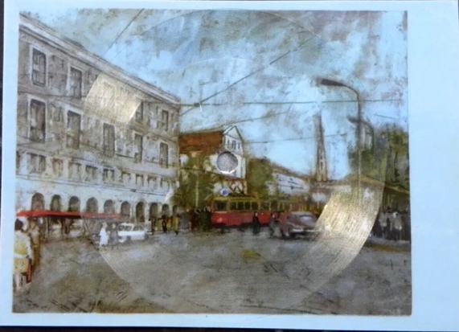

Polish flexi postcard of The Beatles song “You won’t see me.”

Flexi discs weren’t necessarily exclusive to the East; they were found everywhere. Essentially, the Soviet Union actually mass-produced them from 1964 to 1991, and they’d appear often in the teen magazine Krugozor, often in a signature vivid blue color. The Soviets turned to flexi discs due to the shortage of material available to produce vinyl records. That’s also a reason why x-ray prints were often used as well. The bootlegs being on these formats were more of a necessity rather than a covert way to distribute contraband.

The people doing this could really be anyone. It wasn’t necessarily a hard thing to begin doing. Getting a recording of the song was sometimes a process though, most people were able to record signals from stations far away like the BBC Kolya Vasin remembers the first time hearing the Beatles via a recorded radio broadcast: “a friend came to me and asked if I’d heard about the new sensation, the Beatles and put on a tape-recorded form a BBC broadcast. It was something heavenly. I felt blissful and invincible. All the depression and fear ingrained over the years disappeared. I understood that everything other than the Beatles had been oppression.”

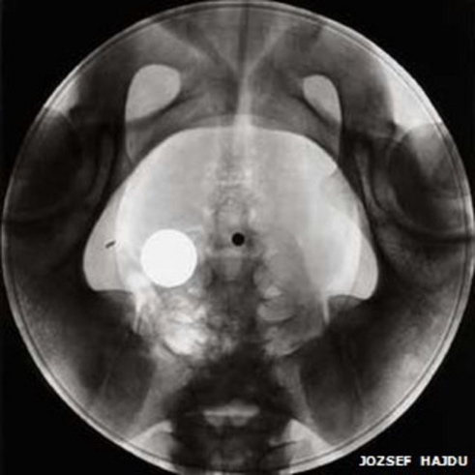 Rudy Fuchs, a former Soviet citizen, did an interview with the Guardian where he talks about giving blood to earn cash to buy a recording lathe to make his own records. Lathes weren’t impossible to buy, and they were accessible enough that an average person could, in theory, buy one without too much effort. However, there was also a skill aspect included in operating the device that the average person probably couldn’t acquire without some trial and error or prior learning.[13]

Bootleg Beatles X=ray recording

Despite flexi discs being the more common format for bootleg recordings, it’s usually the X-ray discs that get the most recognition, mainly due to how striking they are. People collected discarded x-ray films from Soviet hospitals or, in some cases, bought them under the counter, and they pressed music onto them and modified them to be played on a standard turntable. Most illegal purchases were arranged over the telephone, however, there were physical markers that sprung up near music shops and community centers as well. Artemy Troitsky writes about a well-known location to buy bootleg recordings in a Moscow Metro station. Troitsky says the cost of the music really depended on what was being sold. “English and American vinyls cost a lot, French and Italian less,” he later says. “A new Beatles album cost 50, 60, 70 roubles. It all depended on how greedy the seller was.”[14] It’s worth noting that in 1959 the average soviet citizen was only making around 80 rubles a month.[15] Sellers often invented a system to determine if the buyer was indeed a genuine customer and not a police informant. In some cases, a buyer would be tested on their knowledge of rock music, and if the person did not pass the test, then the seller would refuse to 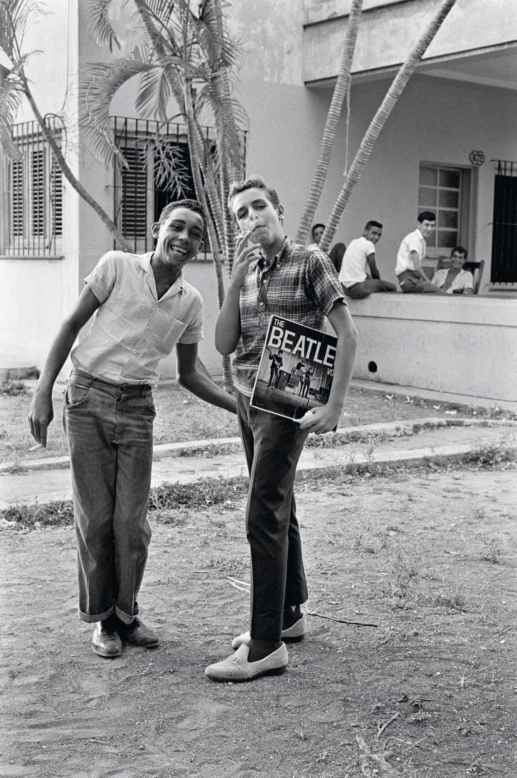deal with them. Troitskii says, “This was common practice”.[16]

*Cuban Children holding an illegally acquired Beatles Record - 1965*

To get caught dealing these bootleg recordings would result in serious consequences. Albums were confiscated, the police wrote letters to their workplaces, schools, and political parties, and their reputation in these groups would be essentially ruined because they were now seen to be a societal deviant. Despite it being an illegal practice and officials' attempts to crack down on it, it still occurred all across Soviet society, from the top heads of government to the secret police in the KGB. Firsthand accounts from major Russian figures like Vladimir Putin or Mikhail Gorbachev prove that they were listening to the Beatles music at the time it was looked down upon, however in their position they were probably able to receive authentic copies. The Beatles' massive legacy after the fall of the Soviet Union also proves how widespread this illegal trade was, it was so widespread that people to this day in Russia still bother to talk about it and how good the music made them feel, one of the compelling reasons that this paper researches the Beatles specifically is how strong peoples emotions are when looking back on them, there was no other band in former Soviet accounts that were remotely close to the Beatles related accounts.[17] Ironically enough, the bootleg vinyl market would die right around the same time that vinyl records started to decline in the rest of the world. It was infinitely cheaper, easier, and safer to buy a cassette tape and put several songs on it than to contact a shady person on the phone and pay a month's income to purchase a handful of songs.

**Chapter 4: A Nation of Beatles Tribute Bands**

The new music they were hearing excited the Soviets, and they had the desire to make their own. Around 1961, we see the first Soviet rock group emerging out of Russia. Troitskii says that they were called ‘The Revengers,’ but he wasn’t sure what they were avenging exactly. Similar groups appeared throughout the Eastern Bloc, such as in East Germany, where people were making their own versions of “Beat Musik.”[18]

Since the idea of rock music was socially taboo, the demand for electric guitars was limited up until this point. Your best hope at getting one prior to the late '60s was to buy one of the few expensive ones that existed or to know someone in a neighboring country who could sell you one through the black market. People made it work, and there are even some accounts where people would make homemade instruments, such as a bass, which they crafted by putting piano strings onto the body of a bass guitar. Eventually, though, things would change, at some point, for what can only be theorized as manufacturers seeing the increased demand and not seeing the guitars themselves as a threat.

This new business venture didn’t start out well for Russian guitar makers. Prior to this, they had only been making classical Russian instruments, and now they had to play catch up to the rest of the world. The first electric guitar was manufactured in 1969 and was, at the very least, a botched attempt. The *Tonika* model guitar is regarded by anyone who has ever played it as the worst guitar ever built. Not only was it an ugly-looking guitar, but it was also unreliable: the strings sat too high off of the guitar, the electronics were hit or miss, and the finish would wear away with little use. Its unique shape also made it nearly impossible to replace parts on it if anything had broken. The guitar would cost 130 rubles, which was nearly two months' salary, but surprisingly, it was very popular considering the only alternative was the unaffordable black market. Yuri Shishkov, a Belarusian guitar maker, writes about the difficulty of finding a decent guitar in Russia."Since buying a Soviet-made electric guitar was not an option I was willing to consider, I was left with only one possible solution: the black market. Everything from keyboards, amplifiers, and electric guitars could be purchased from the underground dealers. The only problem was the astronomical price on these items, rendering them impossible for me to afford. To pick up a Japanese or American guitar through these sources was also not so easy, as there were few options to choose from and limited availability.[19]"

The budding Soviet musician now had the first problem out of the way and faced a new problem: what were they going to play? Most early acts mimicked what they heard from the records they bought. Essentially, it was a country full of Beatles tribute bands dotting the country. Sometimes, the methods needed to gather all the lyrics and instrumentals needed to cover certain songs were unconventional. People like Kolya Vasin figured out how to make it work. “We got information mainly from the radio. I wasn’t a member of the Revengers, but we were friends and worked together. They didn’t know English, and it was my task to ‘decode’ the tapes and attempt to write out the song's lyrics."

From this point, the most a Soviet rock band could achieve was playing a couple of underground shows that only a handful of people would ever attend. This all changed in the mid-80s after 20 years of building momentum underground when the Leningrad Rock Club was created, a 600-seat theater where rock bands could play and be seen by an audience. However, the catch was: they were watched by the government. "There was a KGB agent who had an idea: why not create a place where all alternative culture could be gathered together and controlled?" explains Alexander Titov, who was a bassist playing with several different Leningrad Rock Club bands. While the club was monitored by the KGB, it was actually run by a committee of musicians who were elected by local bands. These elected people organized concerts and helped negotiate on behalf of other bands. The 1982 elected club president, Nikolai Mikhailov, talks about the KGB-club relations in an interview with NPR: "I dealt with three KGB agents regularly," says Mikhailov. "We'd meet and talk about twice a month.[20]" Usually, relations were good, and everything ran smoothly, but Mikhailov also mentions having to kick bands out of the club because they were playing from a list of unsanctioned songs. Musicians often found a workaround for this policy by saying the lyrics were a critique of the United States and its politics or something to that effect. The music venue itself was, by all accounts, pretty poor; however, it allowed artists to be formed and led to more groups for young people. By this point in the 80s, punk groups were forming, and bands like *Situatsiya*, an all-female punk group, were becoming the center of attention. Punk is a far cry from the Beatles, but music wouldn’t have been able to be at that point without them. The Leningrad Rock Club also wouldn’t exist without some key policy changes leading up to it.

**Chapter 5: It’s Getting Better All The Time (Can’t Get Much Worse)**

The seeds of discontent from the younger population were starting to become known in the later part of the '70s and '80s, and officials were starting to take notice. Dissidents were finally starting to be heard. Some young people took more active methods of revolution, like the Velvet Revolution in Czechoslovakia in 1989. The interesting name comes from the fact that the rebellion was so peaceful, but people also say it was influenced by the band "The Velvet Underground." Frank Zappa, of all people, also became an odd participant in this revolution. Zappa was appointed as the cultural adviser and ambassador by the president of Czechoslovakia himself until eventually being forced by the United States to remove Zappa. This was enacted and done away with after the revolution, but during the revolution, people would listen to Zappa and the like as a form of protest and to defy the norm. There are cases where the government attempted to censor such music as well.[21] The rebellion resulted in a complete change of power and eventually their integration into the European sphere. This was an entire movement kickstarted by youth, and they even used Western music as a form of protest against the establishment. Obviously, if you're the proud beacon of socialism that is the USSR, then you would attempt to prevent an event like that from happening, and prevent they did.

The wheels were slowly falling off for the government by this point in the late 1970s. People were tired of the old and archaic leaders that came before, and eventually, a new generation of Soviet leaders came about that promised to be different. Most notably, the last President of the USSR, Mikhail Gorbachev, someone considered great only because he failed in his ultimate goal, which was his belief that he was going to revitalize socialism and re-legitimize the Soviet system. Ironically, this eventually led to the dissolution of the system.[22] Before the end, Gorbachev would bring some major policy changes to the table. Gorbachev recognized the need to address the pressing social, economic, and political challenges facing the future of the country. He embarked on a bold agenda of Perestroika in 1985, which was an attempt to end the "Era of Stagnation" caused by Leonid Brezhnev, which had halted the progress of the country. To accomplish this, Perestroika reformed the economy and made some aspects of it "market-like" and capitalist.[23] This impacted the black-market economy and the buying and selling of music greatly. Previously, all record stores were government-supported and thus only stocked classical Russian hits and government speeches, things no one wanted to buy. But now, record stores were on their own to turn a profit and keep the lights on. Paired with easing embargoes, this caused stores to begin selling Western recordings, and by later that decade, Western music was starting to be produced in Eastern factories.[24] Melodiya, Amiga, and other government-controlled production companies were starting to open communications with Western artists in order to get official recordings onto Russian vinyl or even tape by this point. Apple Records and EMI sent their master recordings east, and by the mid-1980s, brand new Soviet-flavored Beatles records were appearing on the shelves of every St. Petersburg music shop.

In tandem with Perestroika, Gorbachev also introduced the concept of Glasnost, or "openness," which meant the policy of promoting openness in the government “within the framework of perestroika.” Essentially, they both were working in tandem to create something new. Glasnost is a term that’s been used since the mid-'60s in the Soviet Union in a bunch of civil rights protest movements starting with the Glasnost Rally in 1965, which sought to allow admission of foreign and independent observers and journalists into the country and stated that judicial hearings should be held in public. Nothing really came of these policies until Glasnost, which would implement all of them and would also allow for things like civil protests and other forms of gatherings like rock concerts and massive festivals.

One of the most notable examples was an aid concert in Moscow put on after the Chernobyl disaster in 1986. The event was so well-attended that the Russians were now facing the issue that the West was facing when Beatlemania started: there was no place large enough to have this concert, so they resorted to doing it in their Olympic stadium, where over 30,000 people attended. The Chernobyl benefit concert is thought to have paved the way for Western benefit concerts in the future, which means it could have also led to “We Are The World.’ So, make of this whole story what you will.[25]

While the Beatles were either knowingly or unknowingly inspiring social and cultural change in the far-off East, they were also involved in cultural movements more local to them and served as a catalyst for change. This rebellion against the status quo is what made this band so appealing to so many who also wanted to see change as well.

Chapter 6: The Beatles on Socialism and Political Activism

By the late 60’s were beginning to dip themselves into the political atmosphere of the time, by this point the Beatles were being exposed to and influenced by socialist ideas. In early 1968, the media coverage in the aftermath of the Tèt Offensive sparked increased protests against the war in Vietnam, mostly among university students in the United States. However, protests were also seen across Europe. In London, on the 17th of March, over 25,000 demonstrators marched on the American embassy in Grosvenor Square, leading to a violent clash with the police.[26] The spring of 1968 also saw other protests in places like Poland and France. Large groups of young people, The Beatles core audience were engaged in politics more than they’ve ever been and there was demand for the Beatles to take a stance.

After the Summer of Love that had occurred the previous summer, students and activists were becoming increasingly more politically involved and pushed for more societal change.

By this point in the Beatles' career, the band had mostly avoided expressing their political opinions. The most political the band had gotten was with the George Harrison song "Taxman" off of the "Revolver" album from two years previous.[27] The band, by this point in the 60s, had become viewed as one of the leaders of the counterculture movement. The band, more particularly John Lennon, was under pressure from various leftist groups to support revolutionary causes. The four may have had supported the concept of socialism in private. On the 1967 album "Sgt. Pepper's Lonely Hearts Club Band," a picture of Karl Marx was included in the albums cover amongst the collage of other figures standing behind the Lonely-Hearts Club Band.[28] All of the members of the band submitted names of people to appear on the album cover. It's not known who included Marx. Paul McCartney said the idea was to include people who "inspired them," including Marx. While this didn't spark much controversy, several other figures were left out, such as Gandhi and even Hitler who was cut out right before the release leading to an odd gap being seen on the cover where something had been airbrushed out. This was done because there was a fear of it creating too much backlash.

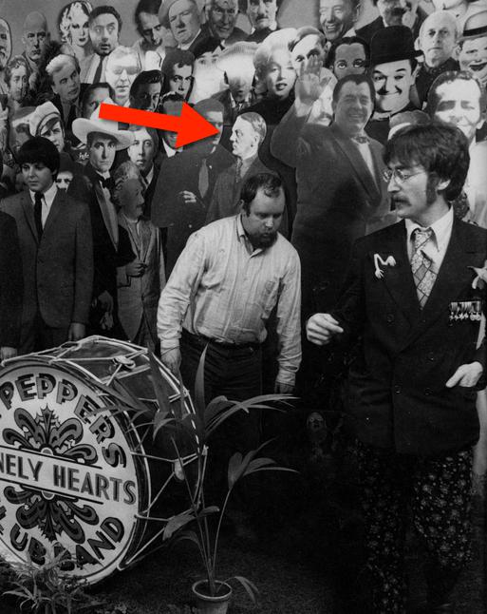Hitler and Karl Marx on the album cover of Sgt Pepper’s Lonely Hearts Club Band – 1967[29]

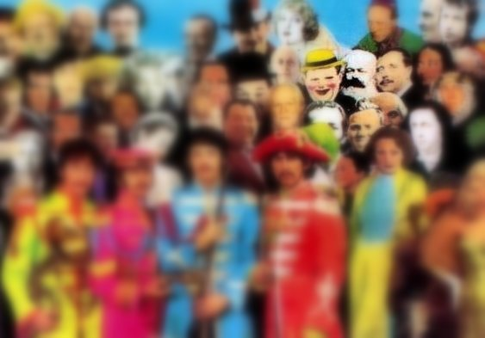

In the beginning of 1968, the Beatles traveled to Rishikesh, India, and while there, Lennon was inspired to write "Revolution." Lennon began the song in India and later finished it in May back home in England. Despite the anti-war feelings Lennon had, largely avoided making many anti-establishment statements after the infamous “bigger than jesus” situation. His lyrics advocated for a peaceful movement and "wanting to see the plan."

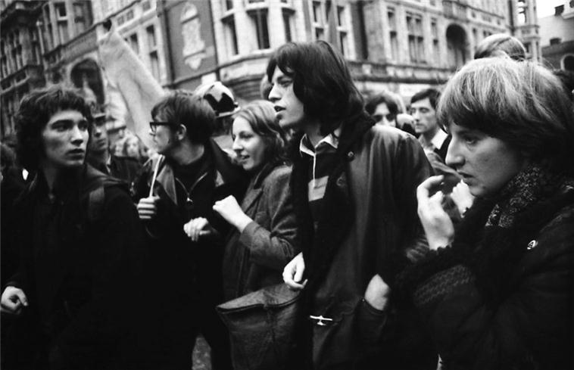After the release of the “Revolution/Hey Jude” single, Time magazine, for the first time in its history, devoted an entire article to discussing "Revolution." The writers said the song was "exhilarating hard rock," and the message of the song would "surprise some and disappoint others." The "others" were upset by Lennon's use of sarcasm in the song's lyrics, specifically Lennon saying things would be "all right." Many people thought Lennon failed to engage with the activist movement and they thought the message of "Street Fighting Man," which was written after Mick Jagger attended a rally at Grosvenor Square, more closely aligned with their beliefs.[30]

Mick Jagger of The Rolling Stones at Grosvenor Square – 1968[31]

People among the political right, like conservative William F. Buckley Jr., wrote approvingly of the song in the John Birch Society's magazine, only to later retract those statements. The Beatles, before this point, were practically immune from the law due to their MBEs. After the release of "Revolution," their immunity status faded away. In October of 1968, Lennon and his girlfriend at the time, Yoko Ono, were arrested by Officer Norman Pilcher on charges of drug possession, to which Lennon claimed that the drugs had been planted by the London Drug Squad8. Pilcher, at this point in his career, had arrested several other London musicians, including Mick Jagger, Eric Clapton, and even George Harrison, to name a few. So, Lennon's arrest could also be looked at more as unfortunate timing as opposed to a direct response to "Revolution." Pilcher would later take a reputation hit in the 1970s after being accused and convicted of planting drugs and received four years in prison.[32]

Lennon, feeling that his political stance had been challenged, began to exchange open letters with John Hoyland, a student from Keele University, in the Black Dwarf magazine. Holland wrote the first open letter in late October of '68 and hoped that Lennon's recent drug bust would prompt him to respond. Holland wrote in his letter that "Revolution" was "no more revolutionary than a radio soap opera" and criticized the Beatles' "All You Need Is Love" ideology. On the third of December, Lennon wrote an open letter in response where he criticized Hoyland's destructive approach to societal change and condemned the far left's entire "extremes than thou" beliefs. Lennon added that if extremists ever truly organized and unified, he and the Rolling Stones would "probably be the first ones they'll shoot." Lennon countered many of Hoyland's further open letters, saying that Hoyland was "on a destruction kick." In his last open letter, Lennon said, "you smash it, and I'll build around it."

On the Beatles' self-titled album, Lennon would once again record "Revolution," but Lennon was now calling it "Revolution 1." The song changes the line "you can count me out" to "you can count me out – in," reflecting a change in mindset during the later part of 1968.

Lennon, after the Beatles, would become more radical with songs like "Power to the People" and call "Revolution" "a mistake."[33] Then, shortly before his assassination in 1980, he would go back to his original stance on the song and say it was based on his true beliefs of cultural change.[34]

"Revolution" showed a sign of the times for pop music and had musicians and pop critics becoming involved in politics. This change would shape the music that the latter half of 1960 would produce and inspire even the most bubblegum pop groups such as "The Monkees" to put out politically charged tracks. All four members had public political opinions, but no one came as close as John Lennon with how vocal he was, He was a big source of controversy for the band since its early years starting with the infamous “bigger than jesus” comment he made in an interview in 1966.[35]

Chapter 8: Parting thoughts – “The End”

Former President of the USSR, Mikhail Gorbachev, has a quote where he says, “More than any ideology, more than any religion, more than Vietnam or any war or nuclear bomb, the single most important reason for the diffusion of the Cold War was… The Beatles.” This same sentiment is even echoed by the current President of the Soviet Union, Vladimir Putin, who says, “[The Beatles brought] a taste of freedom, a window on the world.[36]”

It's often said that the Beatles had the ability to spread any message they wanted and could influence the masses; however, they chose to use their power for good and spread a message of love. "All you need is love" is the shortest way to sum up the entire idea of the Beatles, and this concept was able to transcend language, cultural barriers, and even suppression of its message.

The Beatles came along at the exact time they were needed for the world, especially for the Soviet Union and the young people who desired something new. Without the influence of the Beatles, other cultural waves of Western culture like jeans would have never arrived and been able to claim the title of "end of the Cold War." For the youth, the Beatles brought something to be excited about and inspired them, creating a generational defining fan base.

Groups like the Stilyagi would have become defunct 50’s social clubs and never been seen again, but they grew, and in time, the growth was seen by the government, and change began. People were being heard, and they were able to feel like the rebellious figures they idolized. Ultimately, it was youth rebellion that dealt the death blow to the Soviet Union, but without the Beatles to ignite the movement, it wouldn’t have existed. The same could be said for many youth movements globally at this point, like the hippie movement. The Beatles made the 60s for an entire generation spanning the entire globe, and their effects still linger today in all those who seek something exciting.

Bibliography

* “2003 Special report Paul McCartney goes to Russia.” YouTube video, 5:36, posted by “TMZ” Jul 29, 2022, <https://youtu.be/50JosiHchgM?si=arnwlrlWGHLze7f2>
* A Troit︠s︡kiĭ. 1988. Back in the USSR : The True Story of Rock in Russia. Boston: Faber And Faber.
* Brady, Kate. “‘All You Need Is Love’: How the Beatles Brought a Couple on Two Sides of the Berlin Wall Together.” The Local Germany, November 9, 2020.
* Duncan Campbell. “Detective Who Busted John and Yoko Lifts the Lid on Corrupt 1960s Policing.” The Guardian, October 18, 2020. https://www.theguardian.com/books/2020/oct/18/norman-pilcher-detective-who-busted-john-and- yoko-grasses-up-1960s-coppers-beatles-rolling-stones.
* Goodman, Joan (December 1984). "Playboy Interview with Paul McCartney". Playboy. p. 110..
* “Gorbachev and Perestroika - Short History - Department History - Office of the Historian.”
* Great Soviet Encyclopedia, 3rd edition, volume 16, p 54. Moscow, Sovestskaya Publusher, 1974.
* History.state.gov. https://history.state.gov/departmenthistory/short-history/gorbachev.
* John Lennon, and Jann Wenner. Lennon remembers: The Rolling Stone interviews by Jan Wenner. Harmondsworth, New York : Penguin, 1972.
* Lennon-McCartney, Back in the USSR. UMC Universal. 1968, Digital recording.
* Leo Burley. “Jagger vs Lennon: London’s Riots of 1968 Provided the Backdrop to a.” The Independent, March 9, 2008. https://www.independent.co.uk/arts- entertainment/music/features/jagger-vs-lennon-london-s-riots-of-1968-provided-the-backdrop-to- a-rock-n-roll-battle-royale-792450.html
* McCartney, Paul, Choba b CCCP, 1988, MPL Communication, Digital recording.
* Poiger, Uta G. 2009. Jazz, Rock, and Rebels : Cold War Politics and American Culture in a Divided Germany /Berkeley, Calif. Univ. Of California Press.
* Ryback, Timothy “Leninism versus Lennonism” Ethnomusicology Journal Pg 3-8, 2018
* Risch, William. 2016. Youth and Rock in the Soviet Bloc. S.L.: Lexington Books.
* Steve Turner, A Hard Day's Write: The Stories Behind Every Beatles Song. London: Carlton, 1994.
* Simon Philo, British Invasion: The Crosscurrents of Musical Influence. Lanham, MD: Rowman & Littlefield, 2015.
* Taubman, Philip, and Special To the New York Times. 1986. “MOSCOW ROCK CONCERT AIDS CHERNOBYL VICTIMS.” The New York Times, May 31, 1986, sec. World. https://www.nytimes.com/1986/05/31/world/moscow-rock-concert-aids-chernobyl-victims.html.
* The Beatles, “Sgt. Peppers Lonely Hearts Club Band”, 1967, EMI, LP.
* The Beatles, “Taxman,” track 1 on Revolver, EMI, 1966, LP.
* Time Magazine “The Beatles”, 1968, Various contributors, New York, New Yor

1. “‘Just Rattle Your Jewellery’ | the Beatles.” Www.thebeatles.com. Accessed May 6, 2024. https://www.thebeatles.com/just-rattle-your-jewellery.
2. Vox Company. “The VOX Superbeetle.” The Vox showroom - The Super Beatle and Beatle amplifiers, 2007. https://www.voxshowroom.com/us/amp/beat.html#:~:text=Most%20of%20the%20major%20British,100%20watt%20tube%20amplifier%20circuits. 
3. Muldoon, Paul. McCartney: A Life in Lyrics. Pushkin Industries. Podcast Audio. Episode 2, “Back in the USSR.” Oct 3, 2023.
4. Art Trotskii, 1983
5. “Wings at Checkpoint Charlie” March 23, 1976, Robert Ellis
6. Flavio, Villani. 2021. Review of How Italian Pop Music Conquered the Soviet Union. New East Digital Archive. July 21, 2021. https://www.new-east-archive.org/features/show/12974/italian-pop-music-soviet-union-ciao-2020-roberto-loreti.
7. A Troit︠s︡kiĭ. 1988. Back in the USSR: The True Story of Rock in Russia. Boston: Faber And Faber.
8. A Troit︠s︡kiĭ. 1988. Back in the USSR: The True Story of Rock in Russia. Boston: Faber And Faber.
9. Krokodil, NN 29, 1957
10. A Troit︠s︡kiĭ. 1988. Back in the USSR: The True Story of Rock in Russia. Boston: Faber And Faber.
11. Churchill, Winston. 2017. “The Sinews of Peace (‘Iron Curtain Speech’) - the International Churchill Society.” The International Churchill Society. Churchill. April 13, 2017. https://winstonchurchill.org/resources/speeches/1946-1963-elder-statesman/the-sinews-of-peace/.
12. Aksenov, Pavel. “Beatles for Sale: The Vinyl Underground in the USSR.” BBC News, October 5, 2012. https://www.bbc.com/news/entertainment-arts-19827438. 
13. Paphides, Pete. 2018. “Bone Music: The Soviet Bootleg Records Pressed on X-Rays.” The Guardian. The Guardian. December 3, 2018. https://www.theguardian.com/music/2015/jan/29/bone-music-soviet-bootleg-records-pressed-on-xrays.
14. Aksenov, Pavel. “Beatles for Sale: The Vinyl Underground in the USSR.” BBC News, October 5, 2012. https://www.bbc.com/news/entertainment-arts-19827438. 
15. NASH, EDMUND. “Purchasing Power of Workers in the Soviet Union.” Monthly Labor Review 94, no. 5 (1971): 39–45. http://www.jstor.org/stable/41838278.
16. Pavel, BBC, 2012
17. Bright, Terry. “Soviet Crusade against Pop.” Popular Music 5 (1985): 123–48. http://www.jstor.org/stable/853286.
18. A Troit︠s︡kiĭ. 1988. Back in the USSR: The True Story of Rock in Russia. Boston: Faber And Faber.
19. Yuriy Shishkov. 2012. If Guitars Could Talk. Yuriy Shishkov.
20. Maynes, Charles. 2021. “A Haven for Soviet Rock and Roll Is Long Gone but Its Music Still Resonates.” NPR.org. August 14, 2021. https://www.npr.org/2021/08/14/1027689237/russias-iconic-leningrad-rock-club-celebrates-its-40th-anniversary.
21. Mitchell, Tony. “Mixing Pop and Politics: Rock Music in Czechoslovakia before and after the Velvet Revolution.” *Popular Music* 11, no. 2 (1992): 187–203. http://www.jstor.org/stable/852939.
22. Pdxscholar, Pdxscholar. https://pdxscholar.library.pdx.edu/cgi/viewcontent.cgi?params=/context/younghistorians/article/1224/&path_info=Research_Paper_The_Reforms_of_Mikhail_Gorbachev_and_Their_Effect_on_the_USSR_2.pdf.
23. “Gorbachev and Perestroika - Short History - Department History - Office of the Historian.” History.state.gov. https://history.state.gov/departmenthistory/short-history/gorbachev.
24. A Troit︠s︡kiĭ. 1988. Back in the USSR: The True Story of Rock in Russia. Boston: Faber And Faber.
25. Taubman, Philip, and Special To the New York Times. 1986. “MOSCOW ROCK CONCERT AIDS CHERNOBYL VICTIMS.” The New York Times, May 31, 1986, sec. World. https://www.nytimes.com/1986/05/31/world/moscow-rock-concert-aids-chernobyl-victims.html.
26. Philo 2016, pp. 138-139
27. Taxman, Harrison, 1968 “Revolver”
28. Turner 2012, p. 191
29. Sgt Pepper’s Lonely Hearts Club Band Album shoot, 1967, Cooper Michael. Blake Peter
30. Burley, Leo, March 9, 2009. Jagger vs Lennon: London’s riots of 1968
31. Mick Jagger, Grosvenor Square Demonstration, Cooper Michael, 1968
32. Campbell. Duncan 2020. “Detective Who Busted John and Yoko” The Guardian
33. Lennon Remebers, 1971, Jann Wenner
34. Wenner Ad bib
35. “How Does a Beatle Live?” John Lennon interview: London evening standard 3/4/1966 - how does a Beatle live? Maureen Cleave - “we’re more popular than jesus now” - beatles interviews database, 2009. https://www.beatlesinterviews.org/db1966.0304-beatles-john-lennon-were-more-popular-than-jesus-now-maureen-cleave.html. 
36. Medd, James. “How the Beatles Destroyed Communism.” Express.co.uk, September 5, 2009. https://www.express.co.uk/expressyourself/125219/How-the-Beatles-destroyed-communism. 