EduManagerPro — Student Management System
Project Documentation & Application Architecture Report
_________________________________________________________________________________
1. Executive Summary & Project Overview
EduManagerPro is a contemporary, robust Student Management Application designed to streamline operations, enhance user authentication safeguards, and deliver intuitive cross-platform access to academic directories. Architected to balance clean UI styling with rapid data manipulation, the system facilitates seamless multi-tier operations, including user validation, record instantiation, automated aggregation metrics, and dynamic directory lists.
This report comprehensively documents the multi-platform architectural execution, interface layouts, directory behaviors, and backend service pipelines mapped during active runtime environments. The design paradigms implemented focus on strict state delineation, structural data mapping, and highly responsive responsive interface modules.
2. Application Project Structure & Workspace Hierarchy
The codebase establishes a unified, predictable package architecture built on clean domain separation. By abstracting data models, presentation layers (screens), and operations workflows (services), the software avoids tight component coupling, supporting modular extension, targeted maintenance frameworks, and isolation of unit components.
Figure 2.1: Modular Package Structure and Codebase Directory Workspace
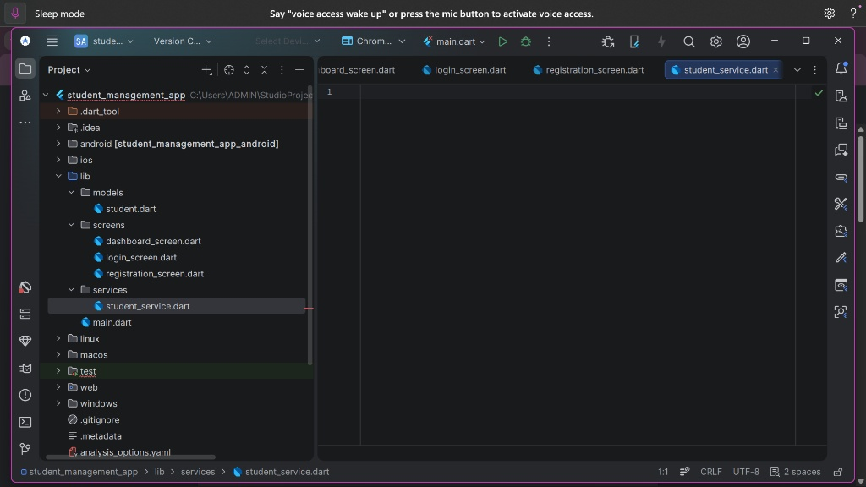
Visual representation of the modular architecture, showing core directory domains including models, screens, and services.
Table 2.2: Structural Components and Layer Definitions
Directory / Layer | Functional Architectural Responsibility
lib/models/ | Data blueprinting and model parsing. Holds structure blueprints such as student.dart or Student data schemes, handling JSON serialize-deserialize tasks.
lib/screens/ | Presentation tier housing graphical layouts (e.g., login_screen, dashboard_screen, registration_screen, directory grids) utilizing state wrappers.
lib/services/ | Core operations pipeline and data interface layer (e.g., student_service). Manages state transactions, validation rules, storage interface, and mock APIs.

3. Security Architecture & Browser-Based Authentication Interface
Security safeguards deploy multi-layered verification modules. In high-level pipelines, token verification and classic authorization protocols bridge native application instances to secure identity providers via modern web views. User profiles are verified synchronously against specific account access scopes to resolve organizational permissions before data screens render.
Figure 3.1: Code Implementation for Authentication and Validation Framework
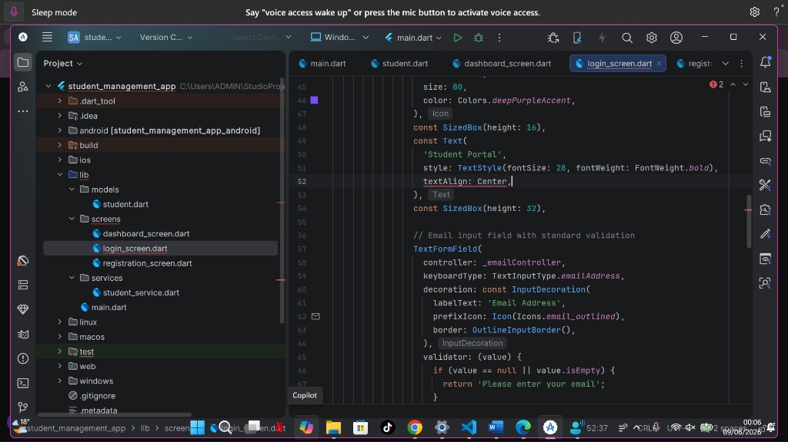
Validation logic and design properties managing input text verification during authorization workflow routines.
Figure 3.2: Runtime Rendering of Student Portal Authentication View
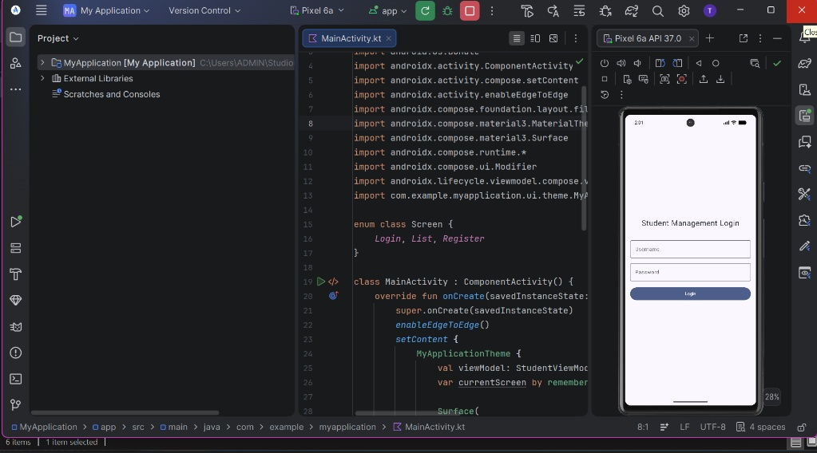
Mobile device emulator demonstrating structural composition of the secure Student Management Login portal interface.
4. Centralized System Dashboard & Data Visualization
Upon successful token handshake and user routing, the system aggregates structural indicators directly into the primary Dashboard space. The interface acts as a central control hub, employing card components with distinct accent themes to display vital data metrics at a glance.
Figure 4.1: Operational System Dashboard Interface
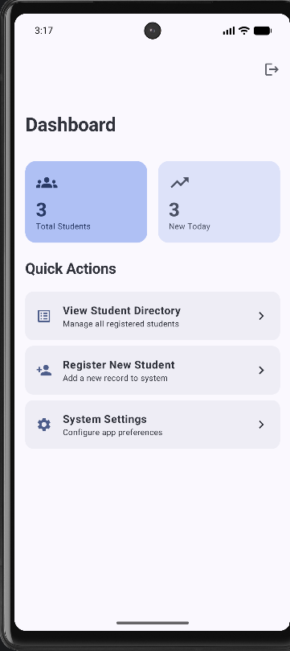
Live dashboard showing total active entries, daily updates metrics, and explicit navigators to underlying structural tools.
The Quick Actions component list leverages systematic linear navigation tiles. Users transition seamlessly between standard sub-tasks, including viewing current directories, instantiating new academic rows, or modifying general app layout configurations via granular preferences.
5. Student Record Registration Workflow
Adding new student entries relies on a strict input capture block. Each data field includes synchronous verification layers, preventing null or formatted string violations before parsing changes over to the main execution state.
Figure 5.1: New Record Input Capture View
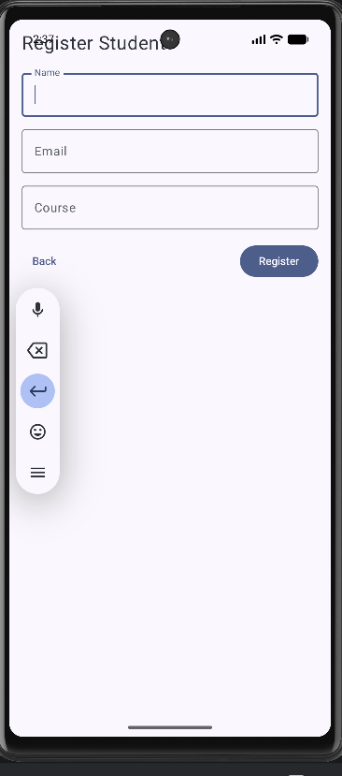
Dedicated student entry registration interface complete with input validation boundaries for Name, Email, and Course fields.
6. Student Directory & Record List View
The Student Directory screen acts as a dedicated list container presenting loaded datasets. Built to pull record arrays asynchronously, the interface handles large row allocations cleanly while embedding contextual floating actions to invoke new record routines directly from the view context.
Figure 6.1: Loaded Records Directory Grid Interface
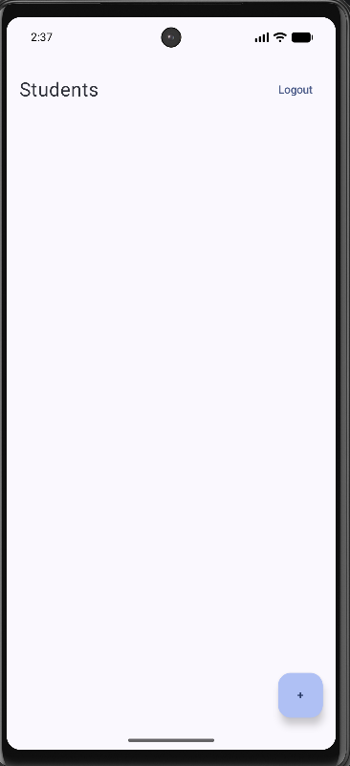
Primary directory container rendering student datasets, contextual logout triggers, and explicit record injection buttons.
7. Engineering Best Practices & System Deployment Logs
The production framework adheres strictly to standard engineering constraints and Git control patterns. Version control pipelines map local workspace development cycles smoothly to remote cloud environments (GitHub), providing comprehensive rollback capabilities and preventing code regression.
Future development sprints will integrate live server endpoints to replace mock transaction pipelines, introduce offline SQL storage persistence layer syncing, and embed deep metric analytics modules within the dashboard interface cards to track performance trends interactively.

