Breast Cancer Classification Project Report

1. Problem Statement and Objectives
Breast cancer remains one of the most critical public health challenges globally. Early detection is strongly associated with improved survival rates, but access to timely screening and diagnosis remains limited in many regions. This project aims to develop a machine learning model capable of predicting whether a breast tumor is benign or malignant using diagnostic features derived from cell nucleus measurements. The goal is to demonstrate how machine learning can support early detection and assist in decision-support for healthcare practitioners.
The objectives were:
- To preprocess the dataset effectively for optimal model performance.
- To train and evaluate multiple machine learning models.
- To compare model performance using metrics such as accuracy, precision, recall, F1-score, and ROC-AUC.
- To derive insights and provide recommendations based on the evaluation results.

2. Dataset Description
This project uses the Breast Cancer Wisconsin (Diagnostic) Dataset, available on Kaggle. This is the link to the data: https://www.kaggle.com/datasets/uciml/breast-cancer-wisconsin-data . The dataset contains 569 samples with 30 numerical features computed from cell nucleus characteristics such as radius, texture, perimeter, area, compactness, concavity, and symmetry. The target variable ('diagnosis') indicates whether a tumor is malignant (M) or benign (B). The dataset is clean and contains no missing values, making it suitable for classical ML models.

3. Preprocessing Steps
Data preprocessing is a crucial step when creating a machine learning model. It involves several tasks such as data cleaning, EDA, feature engineering, scaling, encoding, and others. This ensures that the dataset is well-prepared for modeling, ultimately leading to more accurate predictions.
The following preprocessing steps were applied:
- Checked for missing values; the dataset contains none.
Ensuring there are no missing values prevents errors during model training and avoids biased or incomplete learning. Clean data improves model reliability.
- Dropped the ID column as it does not contribute to prediction.
The ID field is simply an identifier with no predictive power. Removing irrelevant features helps reduce noise and improves model efficiency and accuracy.
- Scaled numerical features using StandardScaler to improve model performance.
Scaling ensures all features are on the same range, preventing models like Logistic Regression and SVM from being dominated by features with larger numeric values. This leads to faster convergence and better performance.the diagnosis column into binary form (0 = Benign, 1 = Malignant).Machine learning models work best with numerical inputs. Encoding the target variable allows the algorithms to interpret the classes correctly during training.Split the dataset into 80% training and 20% testing sets.
- Splitting the data allows the model to learn from the training set and then be evaluated on unseen data. This helps measure how well the model generalizes to new, real-world cases.

4. Models Used and Rationale
Four machine learning models were implemented and compared to understand how different algorithmic approaches perform on the breast cancer classification task:
- Logistic Regression – A simple and highly interpretable linear model often used as a strong baseline. It helps establish how well a straightforward linear relationship can separate malignant and benign cases.
- Support Vector Machine (SVM) – Well-suited for high-dimensional data and effective at finding optimal decision boundaries. SVMs are powerful when the classes are not easily separable, making them a strong candidate for medical classification tasks.

Random Forest – An ensemble of decision trees that captures complex, nonlinear patterns in the data. It is robust to noise, reduces overfitting, and provides feature importance insights, making it valuable for understanding which attributes influence predictions.

XGBoost – A high-performance gradient boosting algorithm known for its speed, accuracy, and ability to handle imbalanced datasets. It builds trees sequentially, correcting errors at each step and often achieving state-of-the-art results.

These models were chosen to provide a comprehensive comparison between linear and nonlinear methods, as well as ensemble vs. non-ensemble approaches, ensuring a thorough evaluation of different learning paradigms.

5. Results and Evaluation
Models were evaluated using Accuracy, Precision, Recall, F1-score, and ROC-AUC. The ROC curve visualization and performance comparison bar chart summarize the results effectively.
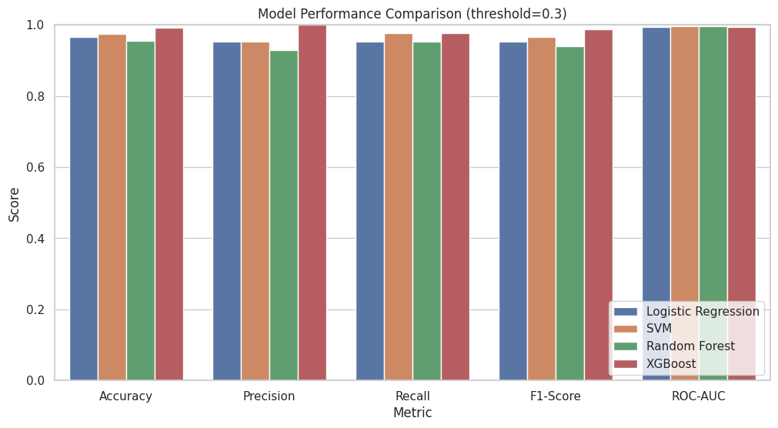
Figure 1 ROC Curves for All Models
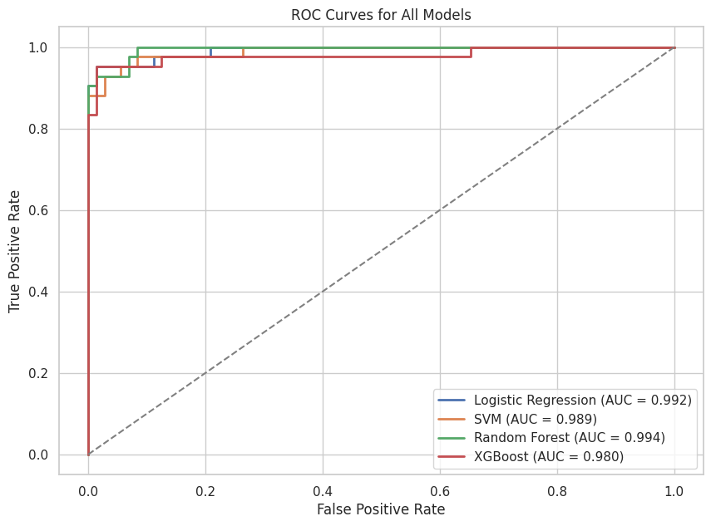
Figure 2 Model Performance Comparison (Threshold = 0.3)

Key findings:
- All models achieved high performance, with ROC-AUC scores above 0.98.
- Random Forest and XGBoost achieved the highest ROC-AUC values.
- The chosen threshold of 0.3 increased recall, reducing false negatives, which is critical in medical diagnosis.

6. Insights, Limitations, and Recommendations
Insights:
- Ensemble models outperformed linear models, indicating the presence of complex nonlinear relationships in the data.
- High recall across models suggests strong capability in identifying malignant cases.
Limitations:
- The dataset, while widely used, may not represent all demographic or clinical variations.
- Threshold tuning was limited to a single value; more extensive calibration could further improve diagnostic utility.
Recommendations:
- Explore deep learning models such as neural networks for further performance improvements.
- Conduct cross-validation to increase model robustness.
- Evaluate model performance using additional clinical metrics such as specificity.
- Test models on external datasets to assess real-world generalizability.

