BIOS
- Jim Oduor.
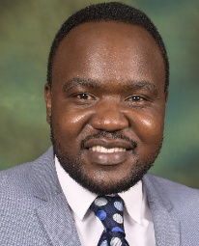
Jim Oduor is a climate change adaptation and city resilience specialist who brings rigorous social research to the frontlines of Africa's development challenges. Across international development, M&E, and evidence-informed decision-making, Jim turns complex fieldwork into insight that shapes policy and practice. Jim designs and leads research on climate adaptation, food security to environmental justice, disaster preparedness, and gender equality.
He's led research end-to-end spanning from designing methods and tools, training and managing field teams, running surveys and focus groups, and driving data from raw collection through to sharp, decision-ready analysis. His Environmental, Gender, and Social Impact Assessments (GESIA) work reflects the same instinct; translating evidence into action that holds up on the ground.
- Paul Byamugisha
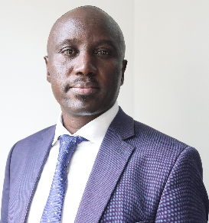
Paul Byamugisha is a PhD Candidate in Climate Change and Sustainable Development at the University of Dar es Salaam, with over 15 years of experience in banking, development finance and climate finance. He holds an MSc in Development Finance from the University of Ghana and an MA in Financial Services from Makerere University. He is currently a consultant with UNIDO as an Energy and Climate Finance Expert, supporting GCF, Adaptation Fund and GEF project pipeline development, grounded in proposal structuring and financial modelling. His research focuses on innovative financing mechanisms, particularly green bonds for climate adaptation in Uganda and Kenya. He has worked with governments, UN agencies, MDBs, DFIs, challenge funds, and the private sector in resource mobilization to tackle climate change in the region.

- Sani Saidu Muhammad
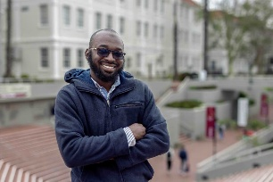
Sani Saidu Muhammad is a researcher and development practitioner whose work spans climate finance, climate adaptation, development economics, and public policy. He is a PhD researcher at Ahmadu Bello University, Nigeria, focusing on technology, governance, and community intelligence for climate adaptation and resilience. His research interests include climate finance, locally led adaptation, climate governance, digital technologies, and evidence-informed policy in Africa. He works across research and development practice to examine how finance, knowledge, and technology can strengthen inclusive and climate-resilient development, particularly in vulnerable and underserved communities.
- Esther Appah

Esther Appah is a climate researcher focused on water scarcity, gender, and livelihoods. She is an MPhil researcher in Informatics for Climate Change at the West African Science Service Center on Climate Change and Adapted Land Use (WASCAL), University Joseph Ki-Zerbo. Her work combines geospatial and climate informatics methods, such as climate disaster risk profiling and precipitation trend analysis, with qualitative research on gender, natural resource access, and social inclusion. Her career is dedicated to advancing evidence-based approaches to gender-responsive climate resilience, tracing how climate-induced water scarcity reconfigures gendered vulnerability, adaptive capacity, and livelihood strategies.
- Dr. Owen Mafongoya
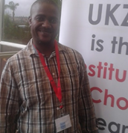
Owen Mafongoya is a social scientist, an academic and senior lecturer at Great Zimbabwe University. He holds BSc Hons in Sociology and MSc in Sociology and Social Anthropology from the University of Zimbabwe. He is also a holder of PhD in Agricultural Extension and Rural Resource Management from the University of KwaZulu-Natal, Republic of South Africa. His areas of focus and interests are on IKS, Climate change vulnerability, resilience and anticipatory action to disasters (AA) and DRR. He is also a consultant who have worked with government line departments and NGOs.
- Frank George Mgungwe
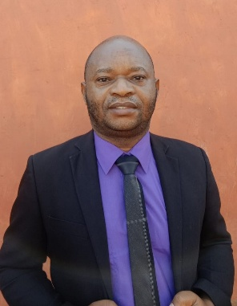
Frank George Mgungwe is a legal scholar with a concentration in human rights law and transformative development. He combines these as lens for studying African Indigenous Knowledge System (AIKS). His research spans women’s empowerment, youth justice, rural development, and the intersection of traditional knowledge and sustainability. He advances community-driven development and social justice in Africa through transformative policy-focused research. Aside from teaching human rights law and development at the University of Livingstonia, Malawi, he also engages in development initiatives addressing climate change, human rights, and gender equity.
- Dr Albert A. Arhin
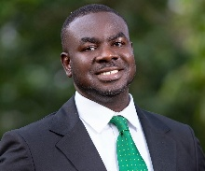
Dr Albert A. Arhin is a Research Fellow at the Bureau of Integrated Rural Development, Kwame Nkrumah University of Science and Technology (KNUST), Ghana. He is a development and sustainability scholar with expertise in rural development, climate change, climate finance, sustainability, and monitoring and evaluation. He holds a PhD in Geography from the University of Cambridge and has over 15 years of experience in research, teaching, policy analysis, evaluation, and development practice. His work focuses particularly on climate resilience, sustainable rural livelihoods, cocoa-sector sustainability, gender-responsive adaptation, and evidence-informed approaches to inclusive rural transformation in Africa.
- Nuwahereza Nelson
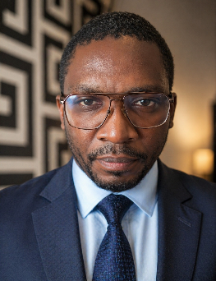
Nuwahereza Nelson is a Climate Governance Specialist, Director of the Mandera Climate Resilience Institute (CRIM), and Research Fellow at the Africa Research and Impact Network (ARIN). He has over eight years of experience in climate policy, climate finance, environmental governance, REDD+, carbon markets and climate adaptation. He previously worked with Uganda’s National REDD+ Secretariat and the UNFCCC Secretariat’s Adaptation Division. Nelson is a PhD Candidate in Environmental Management and Control at the University of Nigeria, Nsukka. His research focuses on climate adaptation governance, climate finance, NDC implementation, nature-based climate Action and Africa’s adaptation self-reliance.
- Eman El Garhy
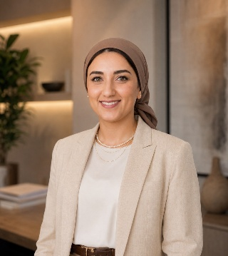
Eman El Garhy is the Founder & CEO of Ecothentic Sustainability Consultancy. With 17 years of experience, she specialises in sustainable development, green buildings, the green transition and sustainability strategies across the MENA region. She is an IFC EDGE Expert and has worked with international and national financial institutions, including the World Bank and the National Bank of Egypt, supporting green finance and sustainable investment. Eman holds a Master’s degree in Architecture Engineering from Cairo University and brings a multidisciplinary perspective connecting the built environment, private-sector development and climate action. Her work focuses on translating sustainability objectives into practical solutions supporting the green transition.
- Dr. Merham Keleg
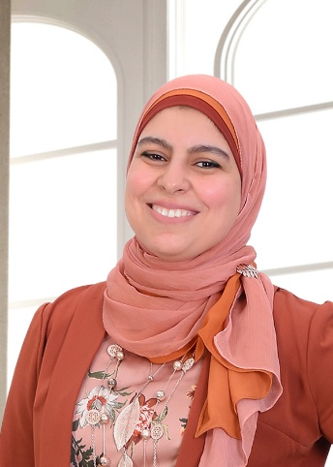
Merham Keleg is Assistant Professor of Urban Design and Planning at Ain Shams University. She is Trustee and Research Coordinator of the Landscape Research Group and Associate Editor of Landscape Research Journal. Since 2025, she has served as the African Research and Impact Network (ARIN) Focal Point for North Africa and was awarded the 2025 ARIN–UCL Accountable Adaptation Research Mini-Grant. Her research focuses on placemaking, green infrastructure, and landscape governance in under-studied urban contexts, particularly in Cairo and across Africa. Her work explores participatory climate action, people–nature relationships, and public space, with a focus on connecting communities, landscapes, and policy in rapidly transforming cities.

- Anas Mghar
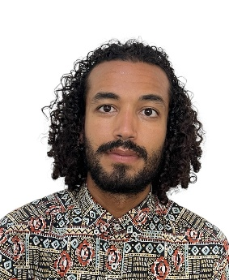
Anas Mghar is a PHD researcher at the Department of Law, Economics, Politics and Languages at LUMSA University (Rome, Italy) and Department of Land Resource Management and Environmental Protection, Mekelle University (Tigray, Ethiopia). Anas’s research interests are climate adaptation governance, environmental justice, and accountability mechanisms in fragile and conflict affected situations in Sub-SaharanAfrica.
- Vayanga DONZO

