# **Design Focus (team)**

# **Architecture and System Design Process**

**Group 2**: Naga Ramya Bhamidipati, Nicholas Engelhard, Xiaoyi Li

**Date**: 09/18/2019

----------------------------------------------------------------------------------------------------------------

Table of contents

1. Use Case Diagram 1

a. Use Case Description 1

a) Title 1

b) Caption 1

c) Who contributed to diagram 1

2. Activity Diagrams 1

a. Student provide a comment----Naga Ramya Bhamidipati 1

a) Title 1

b) Caption 1

c) Who contributed to diagram 1

b. Student submit files----Nicholas Engelhard 1

a) Title 1

b) Caption 1

c) Who contributed to diagram 1

c. Instructor add/remove TAs----Xiaoyi Li 1

a) Title 1

b) Caption 1

c) Who contributed to diagram 1

3. Class Diagram 1

a. Title 1

b. Caption 1

c. Who contributed to diagram 1

4. Entity Relationship Diagram 1

a. Title 1

b. Caption 1

c. Who contributed to diagram 1

5. Sequence Diagram 1

a. Title 1

b. Caption 1

c. Who contributed to diagram 1

6. Stata Machine Diagram 1

a. Title 1

b. Caption 1

c. Who contributed to diagram 1

7. Member division 1

1. **Use Case Diagram**

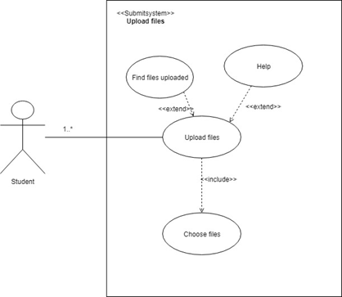

1. Use Case Description
2. **Title**
3. **Caption**
4. **Contribution**
5. **Activity Diagrams**
6. **Title**: Student can select assignment they want to submit

**Activity**: Student can select assignment they want to submit

**Description**: This diagram gives details about how a student submits an assignment if its open.

**Contribution**: Naga Ramya Bhamidipati

1. **Title:** Student submitting files

Student Submission System

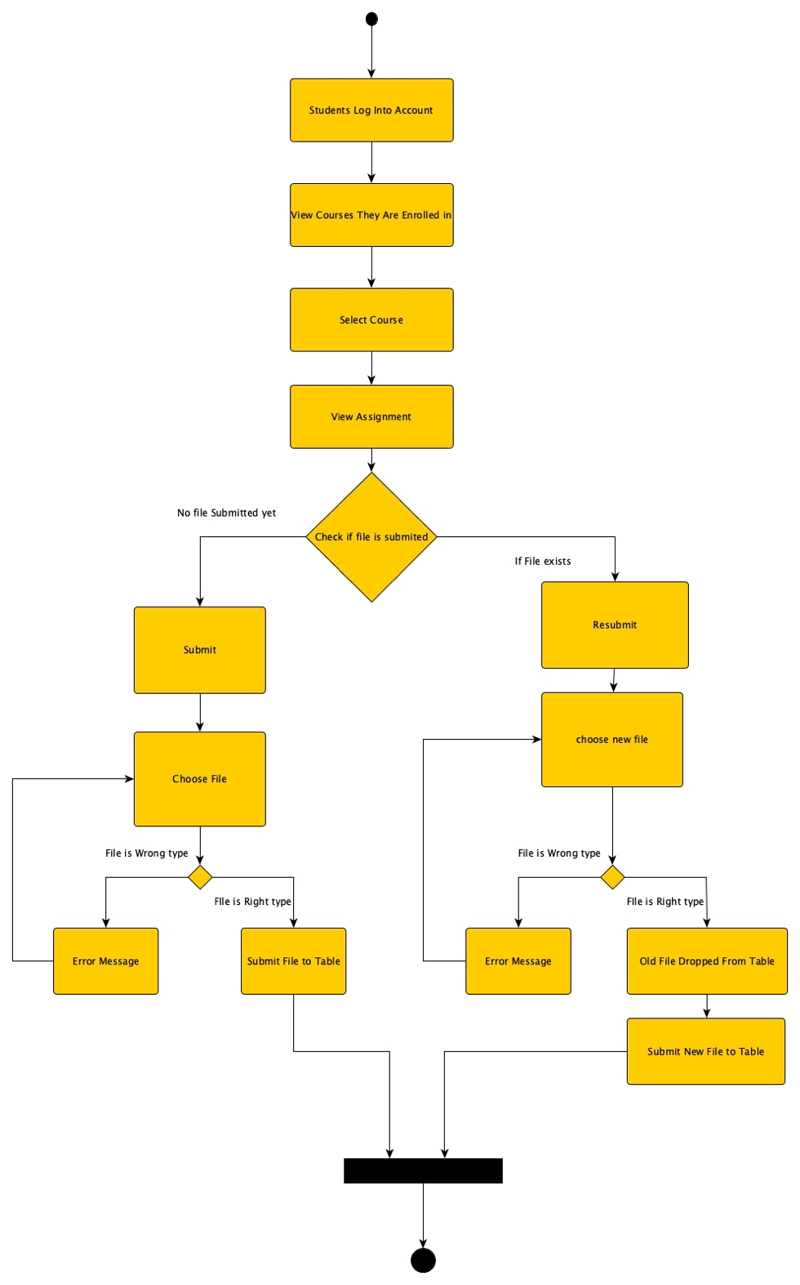

**Activity:** Student submitting files

**Description**: This diagram is meant to showcase how a student would go about submitting an assignment. It includes file type checking for both the submit and resubmit functions and will give error messages if it is of the wrong type.

**Contribution**: Nicholas Engelhard

1. Instructor add/remove TAs

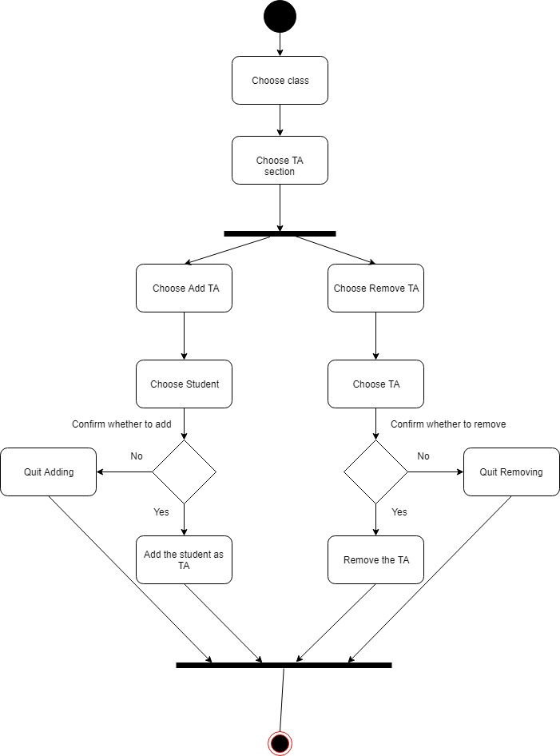

1. **Title:**
2. **Caption:**
3. **Contribution:** Xiaoyi Li
4. **Class Diagram**



1. **Title**

Login/Logout

1. **Caption**

This diagram is for showcasing the class diagram for the activity of Student,TA and professor login/logout.

1. **Contribution:** Naga Ramya Bhamidipati
2. **Entity Relationship Diagram**

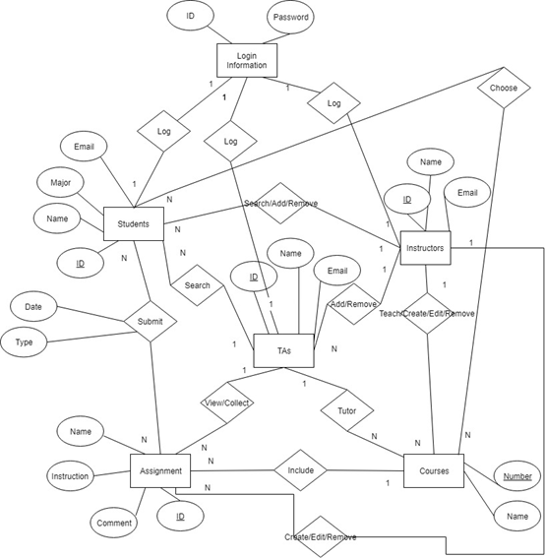

**Description:** Our entity relationship diagram shows what each of the users of the system can do, along with the attributes that they call upon.

**Contributions**: Nicholas Engelhard, Xiaoyi Li

1. **Sequence Diagram**
2. **Title:** Student should be able to read assignment instructions

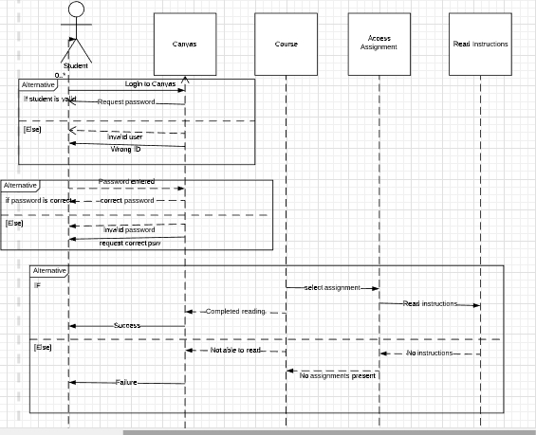

1. **Caption:** Student should be able to read assignment instructions
2. **Description:** Activity Diagrams to illustrate the flow of control in a system
3. **Contribution:** Naga Ramya Bhamidipati
4. **Stata Machine Diagram**

**Title:** State Machine Diagram of Login/Logout

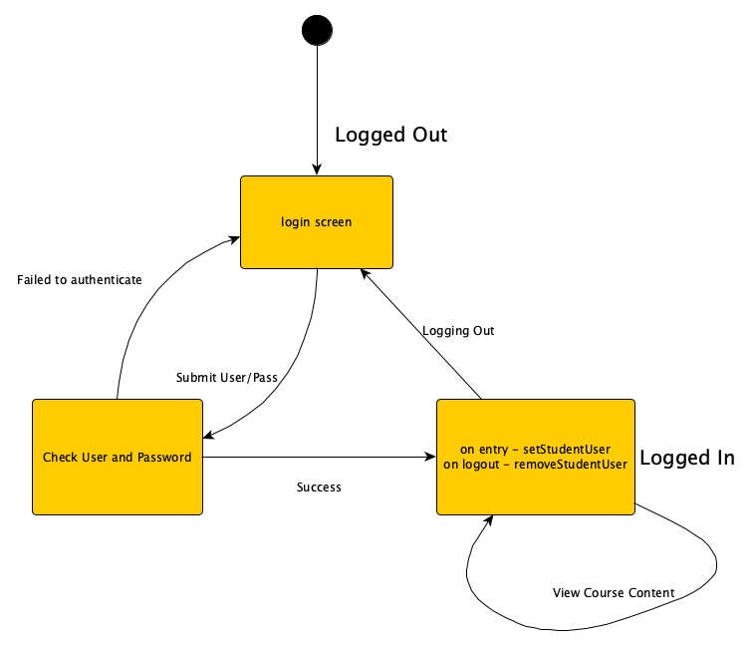

**Description:** This state machine diagram details what happens during the login process and how the system plans to take on the actions of the users.

**Contributions:** Nicholas Engelhard