<https://go.heartlandpaymentsystems.com/rsp>

1. The blue bar is missing from the top of the page, causing the “Entrepreneurs Respectfully Serving Entrepreneurs” statement to disappear since it’s white text on a white background:

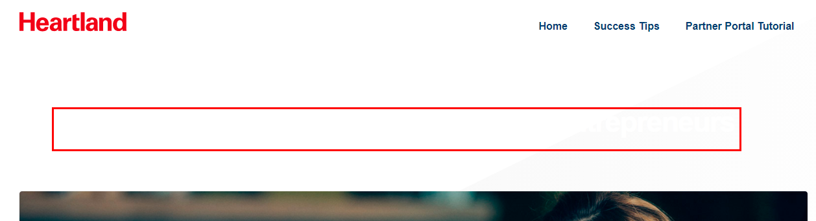

2. At the bottom of the page under Partner rePortal, delete the word “that” from the first sentence:

“Our Partner reporting tool ~~that~~ helps you analyze and track the status and compensation related to your Heartland referrals.”

3. Change the paragraph under Partner Marketing Resources to:

Upload your logo to order co‐branded printed materials and/or download free digital marketing collateral about Heartland products, services and solutions. You’ll find email content, web and social media assets, product sell sheets, brochures, images and more in this site.