|  |  |
| --- | --- |
| Name | What they do |
| no-referrer | When sending requests, no referrer information will be sent with it. |
| no-referrer-when-downgrade | When the protocols stay the same, the URL is sent as a referrer. |
| strict-origin | If the protocol stays the same, only send the origin document as the referrer |
| strict-origin-when-cross-origin | Send a full URL when performing a same-origin request, only send the origin when the protocol security level stays the same |
| same-origin | A referrer is sent for same-site origins but do not have referrer info for cross origin requests |
| origin | Only send the origin of the document as the referrer in all cases. |
| origin-when-cross-origin | Send a full URL when performing a same-origin request, but only send the origin of the document for other cases. |
| unsafe-url | Send a full URL when performing a same-origin or cross-origin request. |

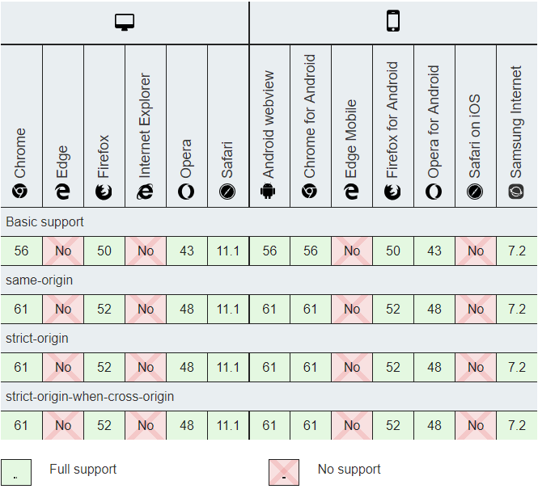

I found all this information at <https://developer.mozilla.org/en-US/docs/Web/HTTP/Headers/Referrer-Policy>