A.T.L.A.S. (AUTOMATED TIMETABLING AND LOCATIONS ALLOCATION SYSTEM): A WEB-BASED ACADEMIC SCHEDULING APPLICATION

A Capstone Project Presented to the
Faculty of the College of Computer Studies
Carlos Hilado Memorial State University
Alijis Campus, Bacolod City

In Partial Fulfillment
of the Requirements for the Degree
Bachelor of Science in Information Technology

By
Josh Nathan I. Curio
Rowena G. Gilera
Nehje John S. Gromea

January 2027
Chapter 1
INTRODUCTION
Background of the Study
Educational institutions globally are digitizing core functions like timetabling to improve efficiency, as traditional manual scheduling is highly prone to human errors, double-bookings, and misallocated resources (Nsulangi, P. T., et. al., 2024). This has driven a shift toward automated optimization, seen in institutions like Indonesia's SMPN 1 Jombang (Prakasa, T. A. D., et. al., 2024). Because automated systems reduce errors and easily adapt to dynamic changes (Nsulangi, P. T., et. al., 2024), they are increasingly viewed as a promising, long-term solution to administrative bottlenecks worldwide (Shomoye, M. A. & Mosaku, A. O., 2025).
While international institutions utilize fully automated systems, many Philippine schools still rely on computerizing manual processes via Microsoft Excel and Google Sheets, as seen in the timetabling models of the University of Baguio (Tayong, A. A., & Roma, G. M., 2023) and the City College of Angeles (Yee, B. E. D., et. al., 2024). Although studies confirm that systematized timetabling optimizes resource allocation (Romaguera, D., et. al., 2024), spreadsheet tools remain anchored in manual processes. They successfully computerize data but fail to independently optimize scheduling, still requiring tedious manual input to generate new timetables.
These national administrative bottlenecks directly impact local public Junior High Schools (JHS) specifically Enriqueta Montilla de Esteban Memorial High School - Main and Hinigaran National High School. At these institutions, class allocation requires balancing complex physical parameters, such as room capacities. It also involves crucial soft constraints often ignored by manual methods, such as minimizing faculty travel time and preventing teacher burnout. Students are also impacted as without real-time communication, last-minute room changes go uncommunicated, causing missed classes. Furthermore, the deployment of automated systems in local public schools is frequently hindered by unstable internet infrastructure. This renders purely cloud-dependent solutions unreliable during connectivity drops. The critical research gap lies in the rigidity of existing automated systems, which are typically hardcoded for a single school. Therefore, there is a clear need for a configurable, centralized algorithm tailored for the JHS level that adapts to diverse priorities while addressing physical logistics and human well-being.
To address this gap, this study proposes A.T.L.A.S. (Automated Timetabling and Locations Allocation System). This is a generic, mobile-responsive web application designed to balance competing scheduling goals for Junior High Schools. Deploying the system simultaneously at Enriqueta Montilla de Esteban Memorial High School and Hinigaran National High School as pilot sites will validate its configurable, non-hardcoded architecture. A.T.L.A.S. features a priority management module for administrators to dynamically configure rules, such as balancing specialized room matching against faculty workload limits. The core engine automatically generates conflict-free timetables, while a visual drag-and-drop interface allows for seamless manual review and fine-tuning. Finalized schedules are then deployed to a real-time, synchronized dashboard for faculty and students, bridging the communication gap. Finally, the software will undergo rigorous ISO 25010 evaluation to ensure reliability, performance, and stakeholder trust.
Too many ka problems nde ma point out diin ang main issue gd. List nyo lng like 3 ka main problem then ang iban supporting issues nlng

Objective of the Study
The general objective of the study aims to design and develop a mobile-responsive web application titled "A.T.L.A.S. (Automated Timetabling and Locations Allocation System): A Web-Based Academic Scheduling Application”.
Specifically, this study aims:
1. to design and develop a web and mobile application with the following technical features:
1.1. web-based administrative portal with drag-and-drop scheduling interface.
1.2. configurable scheduling priority management module.
1.3. mobile faculty authentication with schedule preference submission.
1.4. automated timetable generation system.
2. to test the functionality of the features mentioned above
3. to evaluate the system using ISO 25010 standardize evaluation tool in terms of Functionality Suitability, Performance Efficiency, Usability, Compatibility, Reliability, Security, Maintainability, and Portability.

Significance of the Study
The A.T.L.A.S. (Automated Timetabling and Locations Allocation System): A Web-Based Academic Scheduling Application is designed to be significant and beneficial to the following groups:
The Academic Schedulers (Persons-in-Charge). This study provides a practical, automated solution that directly resolves the administrative bottlenecks of manual timetabling. By replacing spreadsheet data entry with an algorithmic engine and a visual drag-and-drop interface, the research demonstrates how automated priority management can instantly generate conflict-free schedules, saving schedulers weeks of productivity.
The School Faculty and Teachers. The implementation of this system proves the critical importance of integrating human-centric "soft constraints" into educational technology. Instead of randomized schedules, the system actively minimizes physical travel time between distant classrooms and prevents consecutive, heavy teaching loads, providing a working model of how digital tools can protect faculty well-being and prevent burnout.
The Junior High School Students. Students benefit directly from the system’s real-time, synchronized, mobile-friendly dashboard. The study demonstrates how eliminating uncommunicated, last-minute room changes fosters a more organized academic environment, ensuring that students are consistently and accurately allocated to appropriately sized, specialized learning facilities.
The Educational Institutions (Schools). For the participating pilot institutions, Enriqueta Montilla de Esteban Memorial High School - Main and Hinigaran National High School, this research serves as a strategic blueprint for institutional digital transformation. It offers a tested framework showing how implementing "hard constraints" in a centralized algorithm guarantees that physical facilities, specialized laboratories, and room capacities are maximized efficiently without double-bookings or wasted space.
Add researchers here
Future IT and Computer Science Researchers. This study serves as a valuable literature reference for future researchers exploring multi-objective optimization algorithms. By detailing a generic, highly configurable architecture and subjecting it to the rigorous ISO 25010 software quality framework, this research provides a foundational academic baseline for expanding automated scheduling solutions into Senior High School or Tertiary educational levels.

Scope and Limitation of the Study
This study covers the design, development, and evaluation of A.T.L.A.S. (Automated Timetabling and Locations Allocation System), a mobile-responsive web application designed to automate academic scheduling for Junior High Schools. Pilot testing will be conducted exclusively at Enriqueta Montilla de Esteban Memorial High School - Main and Hinigaran National High School. The system features a web-based administrative dashboard where schedulers can set specific priorities such as room capacities, laboratory requirements, and teacher well-being, and use a visual, interactive grid with drag-and-drop capabilities to manually fine-tune room allocations. To ensure the schedule is accurate, teachers are provided with a mobile-friendly portal to directly submit their availability and health preferences before the algorithm runs. Using this collected data, the system automatically generates a conflict-free timetable to prevent double-bookings. Finally, students can access a synchronized, mobile-responsive platform to view real-time updates of their finalized schedules and easily download them as images.
Despite its automated capabilities, the system operates strictly within specific boundaries and is not intended to replace the human administrator. Rather, it serves as a supportive tool to make their work more efficient, reliable, and productive. Recognizing that stable internet access cannot always be guaranteed in school environments, A.T.L.A.S. is designed to function fully offline by default, with internet connectivity serving as an enhancement rather than a requirement. This ensures the application loads from local device storage by default, remaining fully accessible without an active connection. The system requires no installation or download and is accessed entirely through a web browser. Upon a user's first visit, the browser automatically saves a working copy of the system on the device, and from that point forward, all respective user portals load directly from the device first on every visit, regardless of whether an internet connection is present. Any actions completed offline, such as a teacher submitting their preferences or an administrator adjusting a schedule, are saved on the device and automatically sent to the main server once a connection is restored. Schedules that have been viewed at least once are similarly stored on the device for offline access. However, generating the automated timetable and receiving published schedule updates both require an active internet connection, as these processes depend on the central server where all school data is stored. Functionally, the system's ability to generate a conflict-free schedule still relies entirely on complete and accurate data entry. If the administrator enters conflicting rules or if teacher inputs are missing, the algorithm's performance will be compromised. Furthermore, it strictly functions as a scheduling tool and does not process student enrollment, grades, or attendance, nor does it factor in student preferences, as the student portal is strictly a view-only interface without chat or editing features.

Definition of Terms
For a clearer understanding of the study, the following terms are defined both contextually based on existing literature and operationally as they are used in the context of A.T.L.A.S.
Automation. Contextually, this refers to the use of intelligent algorithms and computerized systems to automatically construct schedules, resolve overlaps, and allocate resources with minimal human intervention (Shomoye & Mosaku, 2025).
Operationally, in this study, it refers to the system’s ability to utilize a computational algorithm to independently generate conflict-free academic schedules, replacing the traditional manual data entry in spreadsheet software.
Background Data Synchronization. Contextually, it refers to an automated process in modern web architecture where an application temporarily stores user actions locally while offline and seamlessly uploads them to a central server without requiring manual user intervention once network connectivity is restored (Venzano Rodriguez, 2022).
Operationally, it is the capability of A.T.L.A.S. to safely save teacher preferences or administrative schedule adjustments locally on the device during an internet outage, and automatically upload that data to the main database the moment the connection returns.
Drag-and-Drop Interface. Contextually, this is a graphical user interface (GUI) interaction technique where users select a virtual object by "grabbing" it and moving it to a different location, facilitating intuitive and semi-automated data adjustments within web-based administrative systems (Garcia-Yañez et al., 2024).
Operationally, it is a visual, interactive dash Guia board feature that allows the school administrator to manually click, move, and seamlessly adjust computer-generated room allocations and time slots for fine-tuning purposes.
Hard Constraints. Contextually, in optimization and educational timetabling problems, these are rigid, essential conditions that must be strictly satisfied for a schedule to be considered valid and mathematically feasible; violating them renders the solution unacceptable (Bulley, Petrovic, & Burke, 2023).
Operationally, these are the absolute, non-negotiable physical rules the scheduling algorithm must satisfy to prevent logistical errors, such as strictly adhering to maximum room capacities, matching subjects to specialized laboratories, and preventing double-bookings of rooms or teachers.
ISO 25010. Contextually, it is the international software engineering standard widely adopted in recent academic research to rigorously evaluate the functional suitability, performance efficiency, and usability of newly developed educational web applications (Canlas et al., 2021).
Operationally, it is the standardized software quality framework used by the researchers to rigorously evaluate the final system’s reliability, performance efficiency, and overall usability during the pilot testing phase.
Mobile-Responsive. Contextually, it is a modern web development architecture that dynamically adjusts a system’s layout and functionalities depending on the device's screen size, ensuring seamless accessibility across smartphones and desktops without requiring native application installation (Venzano Rodriguez, 2022).
Operationally, it refers to the technical design architecture of the web application that allows it to automatically adapt and function optimally on smartphone screens for teachers and students, eliminating the need to download a native mobile application (APK).
Parameters. Contextually, these are the measurable factors, variables, or input data sets that define the operating conditions of a heuristic algorithm and guide its computational process to find an optimal scheduling solution (Chen et al., 2023).
Operationally, it represents the specific set of rules, physical room limits, and inputted teacher preferences that dictate the boundaries within which the algorithm must operate to generate a valid schedule.
Priority Management Module. Contextually, this represents a multi-objective weighting mechanism where administrators can assign mathematical significance to different scheduling goals, guiding the algorithm to prioritize certain soft constraints over others during generation (Oyelere et al., 2024).
Operationally, it is a configuration feature within the administrative portal that allows the scheduler to dynamically set and rank the importance of different scheduling rules, ensuring the algorithm aligns with the specific needs of the pilot schools.
Real-Time Synchronization. Contextually, it is the automated process of continuously coordinating and updating data across a distributed system simultaneously, ensuring immediate consistency across all viewing interfaces and preventing data silos (Yee et al., 2024).
Operationally, it is the capability of the system to instantly update the faculty and student view-only dashboards the exact moment an administrator finalizes a schedule or makes a manual room adjustment.
Soft Constraints. Contextually, these represent highly desirable preferences in an optimization problem that are not strictly mandatory; violating them does not invalidate the timetable mathematically, but satisfying them significantly improves the overall quality and human acceptance of the schedule (Bulley, Petrovic, & Burke, 2023).
Operationally, these are the highly desired, human-centric conditions the algorithm attempts to satisfy to protect teacher well-being, such as minimizing physical travel time between distant classrooms and preventing heavy, continuous teaching loads without breaks.
Timetabling. Contextually, it is defined as the allocation, subject to specific physical and human constraints, of given resources to objects being placed in space-time, arranged in such a way as to satisfy a set of desirable educational objectives as nearly as possible (Bulley, Petrovic, & Burke, 2023).
Operationally, it is the complex administrative process of plotting and allocating teachers, junior high school students, subjects, and physical classrooms into specific time slots without encountering logistical conflicts.

Chapter 2
REVIEW OF RELATED LITERATURE AND STUDIES
This chapter presents the related literature and studies from both local and foreign sources. Those were included in this chapter helps in familiarizing information that are relevant and similar to the present study.

Visual Interactive Interfaces and Drag-and-Drop Functionality in Scheduling
While algorithmic generation successfully resolves the heavy computational burden of academic scheduling, strict mathematical models often lack the nuanced flexibility required by human administrators. To bridge this gap, modern educational technology emphasizes pairing automatic engines with intuitive, visual interfaces. Research indicates that integrating drag-and-drop grids with color-coded alerts allows administrators to dynamically refine schedules, reducing overall scheduling time by up to 75% compared to conventional methods (Ghazal et al., 2025). This deployment of interactive interfaces is a recognized standard across leading commercial and open-source platforms; systems like SchoolTracs, Lantiv Timetabling Turbo, and the FET Timetable Explorer rely heavily on drag-and-drop functionality to empower users to effortlessly adjust classes, resolve edge-case conflicts, and finalize generated schedules without manual data input (SchoolTracs, 2025; Lantiv, 2026; FET, 2025).
Although these existing platforms validate that visual drag-and-drop functionality is an essential industry standard, they frequently present severe architectural and financial limitations for local institutions. Commercial solutions like SchoolTracs and Lantiv function as expensive, generalized cloud-based products requiring continuous subscriptions, while utilities like FET require complex desktop installations. A.T.L.A.S. integrates this proven interactive methodology to ensure maximum administrative control but applies it within an offline-capable, locally adapted web architecture. Following the automated generation phase, the system provides a specialized drag-and-drop grid that empowers administrators to manually override allocations and fine-tune room assignments. This ensures the critical visual interface remains accessible, cost-effective, and precisely tailored to the target institution's operational constraints without relying on unstable internet connections or external commercial licenses.

Configurable Priority Management and Human-Centric Soft Constraints
The transition from rigid algorithmic scheduling to adaptable, human-centric priority management is essential for institutional fairness and faculty well-being. Recent literature emphasizes that modern timetabling must extend beyond merely preventing spatial conflicts to strategically incorporate soft constraints, such as minimizing idle periods and balancing teaching loads. Studies evaluating complex high school scheduling models demonstrate that mathematically prioritizing these human parameters results in timetables that are significantly more practical and sustainable for educators (Sun & Wu, 2023). Furthermore, by formally defining pre-determined teaching load limits and faculty skills, administrative tools can generate objective assignments that successfully eliminate administrative bias and reduce workplace grievances (Khorbotly & White, 2024).
Within the Philippine educational context, the effectiveness of these automated systems relies heavily on an administrator's ability to control and customize these exact logistical parameters. A recent local evaluation highlighted that empowering administrators to dynamically configure scheduling criteria—rather than relying on rigid, hardcoded constraints—ensures the software successfully meets the specific, evolving needs of an institution (Keh & Sarmiento, 2025). A.T.L.A.S. directly applies this proven standard through its configurable priority management module. By providing a centralized, dynamic dashboard, the system allows school administrators to independently adjust the mathematical weights of various soft constraints, such as maximum teaching hours and department-level rules. This ensures the algorithmic engine consistently adapts to the school's unique policies while maintaining absolute systemic fairness and respecting teacher well-being.

Secure Faculty Portals and Decentralized Data Collection
Beyond secure authentication, the primary function of a dedicated faculty portal is the accurate, decentralized collection of scheduling parameters. Algorithmic timetabling models rely heavily on precise data inputs to maximize the alignment between course offerings and faculty capabilities. Recognizing the time of qualified instructors as a highly valuable academic resource, research argues that directly integrating faculty preferences into the scheduling engine is critical for optimal assignment (Khorbotly & White, 2024). Furthermore, recent technological deployments in higher education demonstrate that providing professors with web-based portals to autonomously enter their availability—such as preferred days, hours, and subjects—drastically reduces academic programming errors and logistical bottlenecks. By decentralizing this data-entry process, institutions eliminate administrative conflicts and save significant man-hours previously wasted on manual transcription (Garcia Yañez et al., 2024).
A.T.L.A.S. directly addresses these operational necessities by incorporating a secure, mobile-responsive faculty portal linked seamlessly to its central timetable generator. This architecture empowers faculty members to safely and independently submit their teaching availability, preferred schedules, and soft constraints. Once submitted, the system automatically processes these variables during schedule generation to maximize resource efficiency. By ensuring the automated engine is fed accurate, real-time data directly from the instructors, A.T.L.A.S. completely removes the administrator as the middleman for data entry, fulfilling the objective of accurate, error-free constraint gathering and preventing the logistical bottlenecks of manual scheduling.

Automated Timetable Generation and Algorithmic Optimization
Educational timetabling is universally classified as an NP-hard problem, meaning the sheer volume of logistical constraints makes it mathematically infeasible to resolve manually without exhausting administrative resources and consuming hundreds of man-hours (Tan et al., 2021; Yavuz et al., 2023). As secondary education curricula grow in complexity, modern decision support systems must transition from manual plotting to advanced algorithmic optimization to manage escalating workloads. Recent literature demonstrates that utilizing stacked metaheuristic models, such as simulated annealing, particle swarm optimization (PSO), and two-phase tabu search algorithms, significantly outperforms traditional heuristic methods by rapidly processing complex variables like faculty loading and room capacities (Prakasa et al., 2024; Sun & Wu, 2023; Tassopoulos et al., 2023; Uysal et al., 2025). These computational approaches effectively eliminate redundant calculations and resolve systemic bottlenecks, successfully compressing weeks of manual trial-and-error into a fraction of the execution time.
To navigate the most severe constraints of academic resource allocation, highly scalable automated engines frequently utilize biology-inspired Evolutionary Algorithms, specifically Genetic Algorithms (GA), as their computational backbone. International research and advanced hybrid frameworks prove that by applying computational crossover and mutation techniques, GA excels at iteratively refining complex matrices of room assignments and teacher eligibility, gracefully resolving dense bottlenecks where traditional models fail (Katore et al., 2024; Ranolo et al., 2025; Uma et al., 2024). Furthermore, recent local evaluations validate this architecture, demonstrating that enhanced genetic algorithms successfully optimize spatial resources and eliminate schedule conflicts within the Philippine educational context (Romaguera et al., 2024). A.T.L.A.S. integrates these proven local and international mathematical principles into its core generation engine. By leveraging the adaptive optimization of genetic algorithms, the system systematically processes strict institutional constraints to instantly output a mathematically feasible, conflict-free schedule tailored specifically for the logistical realities of Junior High Schools.

Table 1.
Matrix of Related Literatures and Studies
RRL | Features
Studies/System | web-based administrative portal with drag-and-drop scheduling interface. | configurable scheduling priority management module | mobile faculty authentication with schedule preference submission | . automated timetable generation system
Real-Time Modular Scheduling System for Educational Operations – Ghazal et al. (2025) | ✓ | ✗ | ✗ | ✗
Timetabling Turbo 2026 [Computer software] – Lantiv (2026) | ✓ | ✗ | ✗ | ✗
FET Timetable Explorer [Computer software] – FET (2025) | ✓ | ✗ | ✗ | ✗
Easy drag-and-drop scheduling [Computer software] – SchoolTracs (2025) | ✓ | ✗ | ✗ | ✗
A Preference-Based Faculty-Assignment Tool for Course Scheduling Optimization – Khorbotly & White (2024) | ✗ | ✓ | ✓ | ✗
AUTOMATED CLASS SCHEDULING SYSTEM FOR AEMILIANUM COLLEGE INC. – Keh & Sarmiento (2025) | ✗ | ✓ | ✗ | ✗
Two-phase tabu search algorithm for solving Chinese high school timetabling problems under the new college entrance examination reform – Sun & Wu (2023) | ✗ | ✓ | ✗ | ✓
A Preference-Based Faculty-Assignment Tool for Course Scheduling Optimization. 2024 ASEE Annual Conference & Exposition – Khorbotly & White (2024) | ✗ | ✓ | ✓ | ✗
Development of a Web-Based Timetabling Software for a Mexican University – Garcia Yañez et al. (2024) | ✗ | ✗ | ✓ | ✗
A Course Timetabling Problem for Classroom Usage Minimization – Yavuz et al. (2023) | ✗ | ✗ | ✗ | ✓
A Web-based Decision Support System for Managing Course Timetabling in Online Education – Uysal et al. (2025) | ✗ | ✗ | ✗ | ✓
A survey of the state-of-the-art of optimisation methodologies in school timetabling problems – Tan et al. (2021) | ✗ | ✗ | ✗ | ✓
Two-phase tabu search algorithm for solving Chinese high school timetabling problems under the new college entrance examination reform – Sun & Wu (2023) | ✗ | ✓ | ✗ | ✓
An Effective Local Particle Swarm Optimization-Based Algorithm for Solving the School Timetabling Problem – Tassopoulos et al. (2023) | ✗ | ✗ | ✗ | ✓
Automating School Timetabling: An Intelligent System Application Using Simulated Annealing – Prakasa et al. (2024) | ✗ | ✗ | ✗ | ✓
Dynamic Timetable Generator Using Genetic Algorithm – Katore et al. (2024-2025) | ✗ | ✗ | ✗ | ✓
Automated timetable generation for academic institutions – Uma et al. (2024) | ✗ | ✗ | ✗ | ✓
Development of a Web-based Course Timetabling System based on an Enhanced Genetic Algorithm – Romaguera et al. (2024) | ✗ | ✗ | ✗ | ✓
A Hybrid Approach to Automatic Timetabling Using Self-Organizing Maps, Secure Convex Dominating Sets, and Metaheuristics – Ranolo et al. (2025) | ✗ | ✗ | ✗ | ✓
Design and implementation of a cross-platform Student Management System app using OOP principles – Pujan (2025) | ✗ | ✗ | ✗ | ✗
A Web-based Decision Support System for Managing Course Timetabling in Online Education – Uysal et al. (2025) | ✗ | ✗ | ✗ | ✓
User Experience Design and Evaluation of a Multi-Role School Management Platform – Li (2025) | ✗ | ✗ | ✗ | ✗
EffiESGen: A User-centric Web Application for Efficient Exam Scheduling and Collaboration in Education – Dahlan et al. (2024) | ✗ | ✗ | ✗ | ✗
Campus Genie: A Secure, Offline NLP-Powered Assistant for College Students – Vadivel et al. (2025) | ✗ | ✗ | ✗ | ✗
Design and implementation of a cross-platform Student Management System app using OOP principles – Pujan (2025) | ✗ | ✗ | ✗ | ✗
Automated Time-Table Management System – Padshetty et al. (2025) | ✗ | ✗ | ✗ | ✗

Synthesis
The review of related literature and systems establishes academic timetabling as a highly complex, NP-hard logistical challenge that consistently exceeds the capacity of manual, heuristic methodologies. To resolve the dense matrix of spatial limitations and human-centric variables, modern educational institutions necessitate advanced computational frameworks; consequently, A.T.L.A.S. employs Evolutionary and Genetic Algorithms as its central generation engine to achieve mathematical optimization in resource allocation. However, current literature emphasizes that algorithmic efficacy is intrinsically dependent on accurate, decentralized data collection. The system fulfills this requirement by integrating secure faculty portals for direct availability input alongside a configurable priority management module, empowering administrators to mathematically weigh institutional soft constraints. Acknowledging that strict computational models cannot invariably anticipate real-world edge cases, A.T.L.A.S. bridges the divide between machine calculation and human oversight through an interactive drag-and-drop grid tailored for manual schedule refinement. Ultimately, the synthesis of these theoretical models and applied systems validates A.T.L.A.S. as a comprehensive, mathematically sound, and highly efficient solution to the modern academic timetabling dilemma.

RRL does not validates anything, your evaluation sa Chapter 3 validates it later. The RRL only supports the design rationale. Also, ang my mga terms kmo na ga claim that your SYSTEM is like the BEST solution sa problem. Again, it sounds pitching but not as a reseach paper. Your discussions in your RRL should be like, these existing studies support the design decisions used in ATLAS.

Chapter 3
DESIGN AND METHODOLOGY
Research Design
This study utilizes a combined Descriptive and Developmental Research Design to facilitate the creation, implementation, and evaluation of A.T.L.A.S. (Automated Timetabling and Locations Allocation System).
The Descriptive Research Design is employed to conduct a thorough qualitative needs assessment prior to system construction (Creswell & Creswell, 2018). As described by Purdy and Popan (n.d.), descriptive research allows for the detailed examination of situations and outcomes by prioritizing the subjects' authentic experiences without manipulating the research context. By analyzing the existing scheduling protocols of the pilot schools, the researchers can identify critical parameters, such as teacher availability preferences, room capacity constraints, and institutional priorities. Understanding the what, why, and how of the current manual scheduling process provides the foundational logic required to accurately configure the automated timetable generation algorithm. Furthermore, the specific scheduling problems and limitations observed during the interviews will be translated into practical testing scenarios through the formulation of a Test Case Questionnaire. These scenarios are based on actual, past scheduling conflicts that the schools have faced. The A.T.L.A.S. system must be able to successfully solve these real-world situations, which will serve as the primary standard to measure if the software works correctly.
Concurrently, the Developmental Research Design is integrated, as the primary objective of this study is the actual design, construction, and deployment of a functional software solution (Richey, 1994). The scope of developmental research explicitly encompasses the creation and evaluation of both instructional and non-instructional products and tools (Ibrahim, 2016). Therefore, the introduction of the A.T.L.A.S. system serves as a technological intervention—specifically, a non-instructional administrative tool—integrated into the current manual scheduling processes of the participating educational institutions. By deploying the system and conducting rigorous Beta Testing alongside ISO 25010 standard evaluations, the researchers will track the resulting changes and improvements in the schools' scheduling workflows. This approach allows the researchers to formally observe how the software intervention develops and enhances the efficiency, accuracy, and overall operational capacity of the system's users over the duration of the study.

System Development Life Cycle
For the design and engineering of A.T.L.A.S. (Automated Timetabling and Locations Allocation System), the researchers selected the Rapid Application Development (RAD) model as the primary Software Development Life Cycle (SDLC) methodology. RAD supports an agile, iterative development process, allowing developers to quickly build, demonstrate, and refine prototypes based on direct user feedback. This flexibility ensures that specific system features and goals are reached without the need to restart the entire development lifecycle when requirements change (Salesforce, n.d.). Furthermore, RAD emphasizes a short, component-based software development cycle. This approach aligns significantly with the developmental objectives of A.T.L.A.S., enabling the successful delivery of full system functionality within a strict 60 to 90-day timeframe (Subhiyakto et al., 2019).
The architectural complexity of educational timetabling—which requires resolving NP-hard mathematical constraints while simultaneously providing an intuitive user interface—demands this highly iterative approach. Recent literature focusing on the automation of academic timetables strongly supports the use of the RAD model to navigate these specific challenges. Research indicates that RAD is uniquely suited for constraint-based scheduling software because it prioritizes structural flexibility, rapid adaptability to evolving institutional requirements, and the successful delivery of complex modules (Techie-Menson & Nyagorme, 2021).
By adopting this proven methodology, the development of A.T.L.A.S. prioritized iterative prototyping over rigid planning. This allowed the researchers to rapidly construct the core generation algorithm and the drag-and-drop visual interface, present these functional prototypes to the administrators at the participating pilot schools, and immediately integrate their feedback. Consequently, the RAD approach ensured that the final system continuously evolved to meet the practical, real-world constraints of the end-users without causing severe delays in the development schedule.

Figure 1.
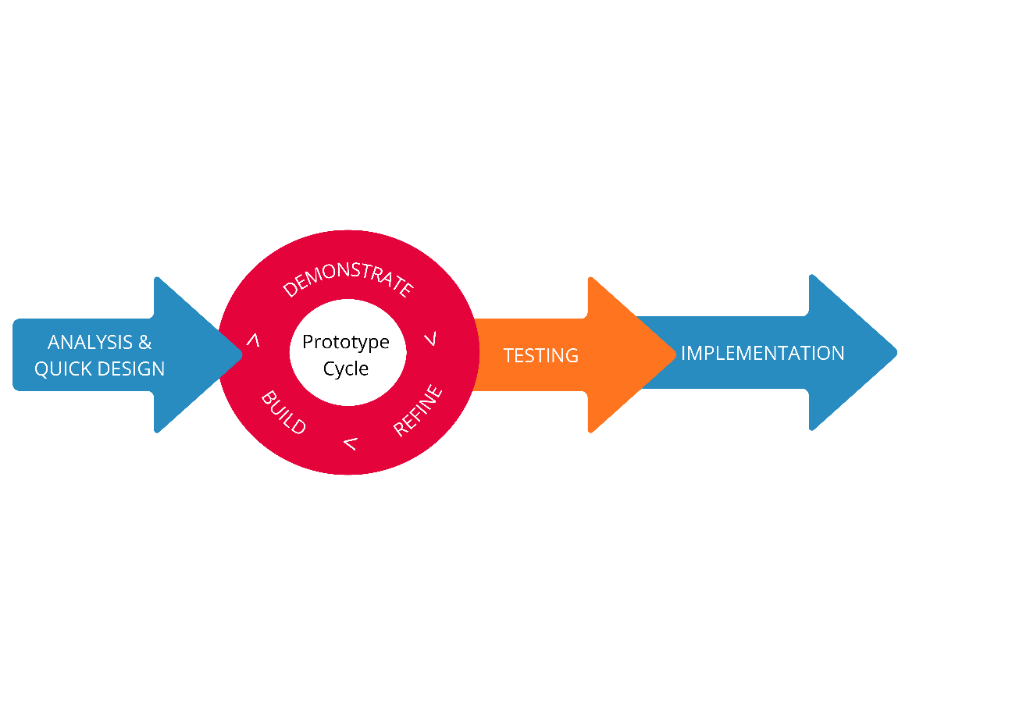
Rapid Application Development

a. Analysis and Quick Design
The researchers directly collaborated with the beneficiaries to introduce the proposed system and gather essential insights to formulate the objectives and scope of the study. In this phase, the focus was on gathering qualitative information to establish an initial development plan, which served as the foundational basis for the system's architecture. Furthermore, the school's current manual workflow for creating timetables was analyzed to identify the significant parameters required for designing the automated timetabling algorithm, specifically subject allocations, room capacities, and major distributions.

b. Prototype Cycle (Build, Demonstrate, Refine)
After gathering the qualitative data, the development team started building the initial visual skeleton and functional prototype of the scheduling module. This early model was immediately shown to the beneficiaries, specifically the school administrators and Master Teachers, to gather their direct feedback on how the system operated. The researchers then used this feedback to carefully improve the backend logic and user interface. This established the core repeating loop of the phase: building, demonstrating, and refining. This continuous cycle was repeated until the automated timetabling algorithm fully met the research objectives and perfectly matched the end-users' actual workflow.

c. Testing
Once the prototype cycles are finished, the developed system is ready for testing. First, the system will undergo Alpha Testing, where the researchers will rigorously test the software to find and fix any hidden bugs or errors. Afterward, the system will undergo Beta Testing. During this stage, the actual beneficiaries, specifically the Master Teachers and administrators, will test the system using real school data to find any remaining issues. To evaluate how well the software solves their scheduling problems, the users will answer the Test Case Questionnaire. Finally, to measure the overall quality of the software, the researchers will use the standardized ISO 25010 questionnaire.

d. Implementation
The final step of the methodology is the Implementation phase, where A.T.L.A.S. (Automated Timetabling and Locations Allocation System) will be officially deployed at the designated beneficiaries. To ensure high system availability and eliminate dependency on external internet service providers, the system will be deployed using a localized on-premises architecture and will not be hosted via cloud-based web hosting or a VPS.
The beneficiary institution will allocate a dedicated laptop or small on-prem server to act as the central local host for the system. This local host will use a Linux operating system and run the complete A.T.L.A.S. stack, including the web application and its supporting backend services, with a local PostgreSQL database for data persistence. End-users will access the web application through the school Local Area Network (LAN), allowing the system to operate at high speed within the campus network without requiring connectivity to the wider internet for core scheduling operations.
Following the technical installation, the researchers will conduct comprehensive user training sessions for administrative personnel, schedulers, and faculty. Training will emphasize how to configure the priority management module and how to use the drag-and-drop interface for fine adjustments during manual schedule refinement. Faculty will also be shown how to securely submit schedule preferences and view their synchronized schedules on mobile devices while connected to the school network. By establishing this localized, self-sustaining monolithic infrastructure, the goal is to make scheduling more efficient and manageable without recurring cloud hosting costs or latency associated with internet-based operations.

Research Respondents
The research respondents who are involved in this study are divided into two distinct groups. First group is tasked with system functionality testing, while the second group is task for the software quality evaluation.
The system functionality testing focuses in evaluating the core features outlined in the study’s objectives, namely the web-based administrative portal and drag-and-drop interface (Objective 1.1), the configurable priority management module (Objective 1.2), the mobile faculty authentication and preference submission (Objective 1.3), and the automated timetable generation system (Objective 1.4). For this phase, the researcher purposively selected five (5) IT professionals who would act as major participants. These participants were selected for their specialized expertise in the software architecture, application development, and system analysis, ensuring that the quality of the evaluation will be aligned and be validated in both academic and industry standards.

Table 2
Test Case Respondent’s Profile
Respondents | Age | Sex | Occupation | Device Used | Experience Level
R1
R2
R3
R4
R5

Based on the data presented in Table 2, the group for functionality testing are composed of IT faculty members and industry technical experts. These respondents possess high level of proficiency in technology-based learning. As shown in the table, [replace if experience level is filled out]. Their collective expertise ensures a highly reliable technical evaluation of the system’s backend and logic components.
For the second group that will be responsible for the software quality evaluation using the ISO/IEC 25010 model, it will consist of actual end-users from the beneficiary school. There will be eight (8) Head Teachers, eight (8) Master Teachers, two (2) Principal, and seven (7) Regular Teachers.
These specific stakeholders were selected because of their understanding of academic scheduling and administrative processes and workflows. The Principal oversees the policy alignment of the schedules; the Head teacher inspects the set schedules of the Master teachers; the Master teacher organizes the time-tabling and scheduling of the teacher, student, subject, facilities and class; and the Regular Teacher utilizes the resulting schedules via mobile-responsive dashboard. Their real-world input will be highly valuable in verifying that the system maintains the institutional logic required in the scheduling flow by the Department of Education.

Table 3
Respondent’s Profile for ISO/IEC 25010 Evaluation
Respondent Category | No. of Respondents | Percent
School Principals | 2 | 8%
Master Teachers & Head Teachers (Schedulers) | 16 | 64%
Regular Teachers | 7 | 28%
TOTAL | 25 | 100%

Table 3 illustrates the distribution of respondents for the software quality evaluation using the ISO/IEC 25010 model. There is a total of 25 respondents that participated in the evaluation. The largest group of respondents comprises the primary schedulers, which is the Head and Master Teachers, at 64%, followed by Regular Teachers at 28%, and the School Principal at 8%. This distribution will ensure the quality of the system evaluated not only from the administrative perspective in overseeing the scheduling policy, but also by the end-users who will interact with the application daily. The involvement of the specific stakeholders will allow the researchers to acquire comprehensive feedbacks on the system’s usability and functional usability for real-world secondary school environment.

Sampling Technique
The study utilizes the non- probability purposive sampling for the selection of the respondents. This method was selected because of the specialized nature of the target population and the specific technical requirements necessary for evaluating the system. According to Ahmad and Wilkins (2024), purposive sampling remains one of the top- tier choice for qualitative and major technical assessments, providing a “framework for the entire journey” of the research flow and processes. Since the study focuses on resolving academic scheduling conflicts and ensuring the developed system meets the standards of ISO/IEC 25010 software quality model, it was necessary to obtain input from participants who could offer substantial, technically well-informed insights.
For the Functionality Testing, the respondents were purposively selected base on their backgrounds on how technical they are in software development and IT infrastructure. This guarantees a rigorous quality testing of the core features of the system, specifically the automated timetable generation and the configurable priority management module.
For the Software quality Evaluation, the respondents will be the end-user purposively selected from the beneficiary school. This includes the principal, head scheduler, and regular teachers. Their deep, practical understanding of the school’s administrative sequence and DepEd scheduling rules will be significantly necessary to ensure that the feedback on the system’s functionality and usability is based on the real-life administrative experiences of local Junior High Schools. This approach guarantees a highly accurate and institutionally valid assessment of the system's strengths and weaknesses.

Data Gathering Instrument
The researcher will utilize a research-made Test Case Questionnaire for assessing the algorithm’s operational logic and the ISO/IEC 25010:2011 Questionnaire for evaluating the overall software product quality. These data gathering instruments will help comprehensively evaluate the Automated Timetabling and Locations Allocation System (A.T.L.A.S.)
Test Case Questionnaire. To ensure that each core technical feature of A. T. L. A. S. functions correctly and meets the specified system requirement, the researchers developed a standardized functional test case document. Instead of utilizing a subjective observational checklist, this testing instrument strictly follows the established AAA (Arrange, Act, Assert) software engineering principle. This ensures the system is rigorously tested against both expected user behaviors (positive testing) and unexpected or invalid inputs (negative testing).
The Test Case Questionnaire consists of ten (10) distinct testing scenarios that are aligned with the study’s objectives. These scenarios evaluate the system’s critical functionalities, specifically Admin Authentication and Drag-and Drop Interface, the Priority Management Module, Faculty Authentication and Preference Submission, and the Automated Timetable Generation Engine. Furthermore, the performance of each test case is objectively measure using binary status. A scenario is marked as “Pass” only if the actual system response perfectly matches the predefined expected result, ensuring strict functional reliability prior to the system’s deployment. Table 4 presents the verbal interpretations, providing a clearer understanding of how each system function performed during evaluation.

Table 4
Test Case Result with Verbal Interpretation
Pass Rate (%) | Verbal Interpretation | Description
91-100% | Excellent | The system fulfills its functional  requirement with very few problems.
81-90% | Very Good | The system operates effectively but has  some areas that could be enhanced.
71-80% | Good | The system is operational but needs  several adjustments.
61-70% | Fair | The system has significant issues that  impact its performance.
Below 60% | Poor | The system does not fulfill most of its  intended functions.

ISO/IEC 25010:2011 Questionnaire. A local research of Keh and Sarmiento (2025) utilized the ISO 25010 industry standard questionnaire for evaluating their automated scheduling system, and it demonstrated an efficiency in testing the software product quality of the system. It measures the quality attributes such as functional suitability, performance efficiency, and usability, which will allow researchers to quantitatively verify that a scheduling system successfully streamlines operations and will meet the administrative expectations. Consequently, A.T. L. A. S. will adopt the ISO 25010 framework for its evaluation phase. This standardized metric will be used to systematically validate the system’s reliability, security, and operational effectiveness during its deployment.
The standardized questionnaire will consist of thirty-one (31) questions measuring eight (8) primary software characteristics, which are Functional Suitability (3 items), Performance Efficiency (3 items), Usability (6 items), Compatibility (2 items), Reliability (4 items), Security (5 items), Maintainability (5 items), and Portability (3 items). Table 5 presents the verbal interpretations, providing a clearer understanding of how each system function performed during evaluation.

Table 5
5-point Likert Scale with Verbal Interpretation
Numerical Code | Interval | Verbal Interpretation | Description
5 | 4.21 – 5.00 | Excellent | The system is complete and fully functional.
4 | 3.41 – 4.20 | Very Good | The system is complete and functional.
3 | 2.61 – 3.40 | Good | The system is somewhat complete and functional.
2 | 1.81 – 2.60 | Poor | The system is incomplete and somewhat functional.
1 | 1.00 – 1.80 | Very Poor | The system is incomplete and non-functional.

Data Gathering Procedure
The data gathering process started upon securing an official written approval from the Dean of the College of Computer Studies at Carlos Hilado Memorial State University – Alijis Campus. Then, the researchers, together with the Capstone Adviser and the Instructor, conducted an online formal meeting with the identified academic institutional beneficiaries. Following this, the researcher drafted formal letters of acceptance confirming the beneficiaries’ agreement to be included in the study.
Once approved, the researchers conducted requirements interview and presented an initial skeleton prototype to the beneficiary via face-to-face demonstration. Through this, the researchers determined the existing gaps in the manual process and the preferences of the beneficiaries, instructor and the adviser. Because the study utilized the Rapid Application Development (RAD) methodology, data gathering then transitioned into a continuous, parallel task. While the researcher rebuilt and improve the system logic during development iterations, they maintained continuous communication with the beneficiaries to gather ongoing operational information and integrated technical feedback from the Capstone Adviser during scheduled technical prototype reviews.
After the A.T.L.A.S. (Automated Timetabling and Locations Allocation System was fully built, formal data collection for software evaluation will follow. The researchers created a formal letter for the five (5) IT professionals in agreement to participate in test case validation in their available time. Through purposive sampling, these experts will execute a structured functional test cases (Alpha Testing) to determine the technical robustness, reliability, and performance level of the system in various environment. During this phase, the researchers will directly observe and record the system's success rate in handling specific data-driven parameters, specifically spatial constraints, human constraints, and operational logic.
Following the functionality tests, the researchers will provide survey respondents with enough time to explore their assigned portals before they begin their evaluation of the application's functional suitability and performance efficiency and usability. Once familiarized, the standardized ISO/IEC 25010:2011 Questionnaire having fifteen (15) items will be distributed to the School Administrators, Master Teachers, and regular teachers to evaluate the complete software product quality. Following this, the feedback that had been acquired from IT professionals and end-users will be compiled, organized and then stored for analysis. With this outcome, a comprehensive statistical analysis will be conducted to determine the overall quality of the system and identify final areas of improvement.

Validity of Research Instrument
The data gathering instruments utilized for evaluating the software product quality is the standardized ISO/IEC 25010:2011 questionnaire. Because it is recognized as an international standard for evaluating software quality, its validity is already established and accepted globally.

Reliability of the Questionnaire
The ISO/IEC 25010:2011 standard is a globally accepted and highly reliable tool for measuring software systems. Local studies, such as the research conducted by Keh and Sarmiento (2025), have successfully utilized this exact framework to reliably evaluate automated class scheduling systems within the Philippine educational context.

Analysis/Statistical Treatment of Data
A weighted mean will be applied as the primary statistical tool to systematically quantify and analyze the data gathered in the evaluation phases of A. T. L. A. S. This will allow the researchers to calculate the average score that reflect the central tendency of the evaluators’ response across the various grading scales. This statistical tool will be applied to different phases of the data analysis.
Functional Test Case Evaluation. To analyze the algorithm's operational logic, the mean will be used to quantify the results of the 3-point observational scale. The scores from the evaluators will be averaged per testing scenario to determine the algorithmic success rate and identify which specific parameters the system handles perfectly.
A step-by-step aggregation process will be applied:
- Mean Score per Test Case Scenario. The scores from the evaluators will first be averaged per individual scenario (e.g., TC-A1: Room Double-Booking) to determine the algorithm's success rate on specific, isolated rules.
- Mean Score per Constraint Category. The scenario means will then be grouped and averaged according to their overarching category (Resource and Spatial Constraints, Human Constraints, and Operational Logic). This provides a specialized look at which broad logistical areas the algorithm handles perfectly and which require further mathematical refinement.
- Overall Algorithmic Success Rate. Finally, the category means will be averaged to calculate the total functional success rate of the system's scheduling engine prior to its deployment.

ISO/IEC 25010:2011 System Evaluation. To determine the overall software product quality of A.T.L.A.S., the mean will be used to quantify the evaluators' responses on the 5-point Likert scale.
For the overall software quality evaluation, a three-step aggregation process will be followed:
- Mean Score per Question. The individual performance of every sub-characteristic will be measured first to identify specific strengths and weaknesses in the system.
- Mean Score per Table (Quality Characteristic). Questions will be grouped according to their specific ISO characteristic (e.g., Functional Suitability, Performance Efficiency). The mean of these groups provides a specialized look at different technical domains.
- Overall ISO Mean Score (Final Evaluation). The characteristic means will be averaged to calculate the final numerical value representing the system's total quality and readiness for deployment.

The formula for the mean is:
∑ x
x̄ =
N
Where:
x̄ = The mean (average) score
∑ x = The sum of all the scores or ratings given by the respondents
N = The total number of respondents or evaluators

Ethical Consideration
This study strictly complied with the established ethical standards and considerations to ensure that the rights and well-being of the respondents who participated were protected and respected. Informed consent was distributed and obtained from each respondent to ensure that they understood the purpose, the procedure, and the risks involved in their participation. The participation in this study was completely voluntary, and each respondent had the right to withdraw without any consequences. It is important to note that any personal or institutional data provided by the respondents during the evaluation of the system was handled with strict adherence to data privacy guidelines. The confidentiality of their data was strictly maintained and was not shared with any other parties without their consent. All the feedback that was gathered was solely used to improve A.T.L.A.S. (Automated Timetabling and Locations Allocation System): A Web-Based Academic Scheduling Application, and remained inside the institution of Carlos Hilado Memorial State University.

Operational Framework
---------------------------------------
Context Diagram (Level 0)
____________________________________
Figure n.
Context Diagram (Level 0)
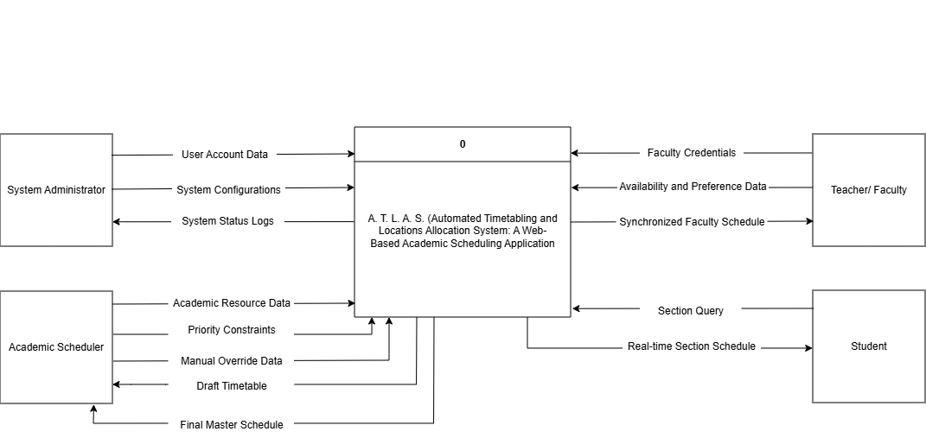
Data Flow Diagram (Level 1)
____________________________________

Figure n.
Data Flow Diagram (Level 1)
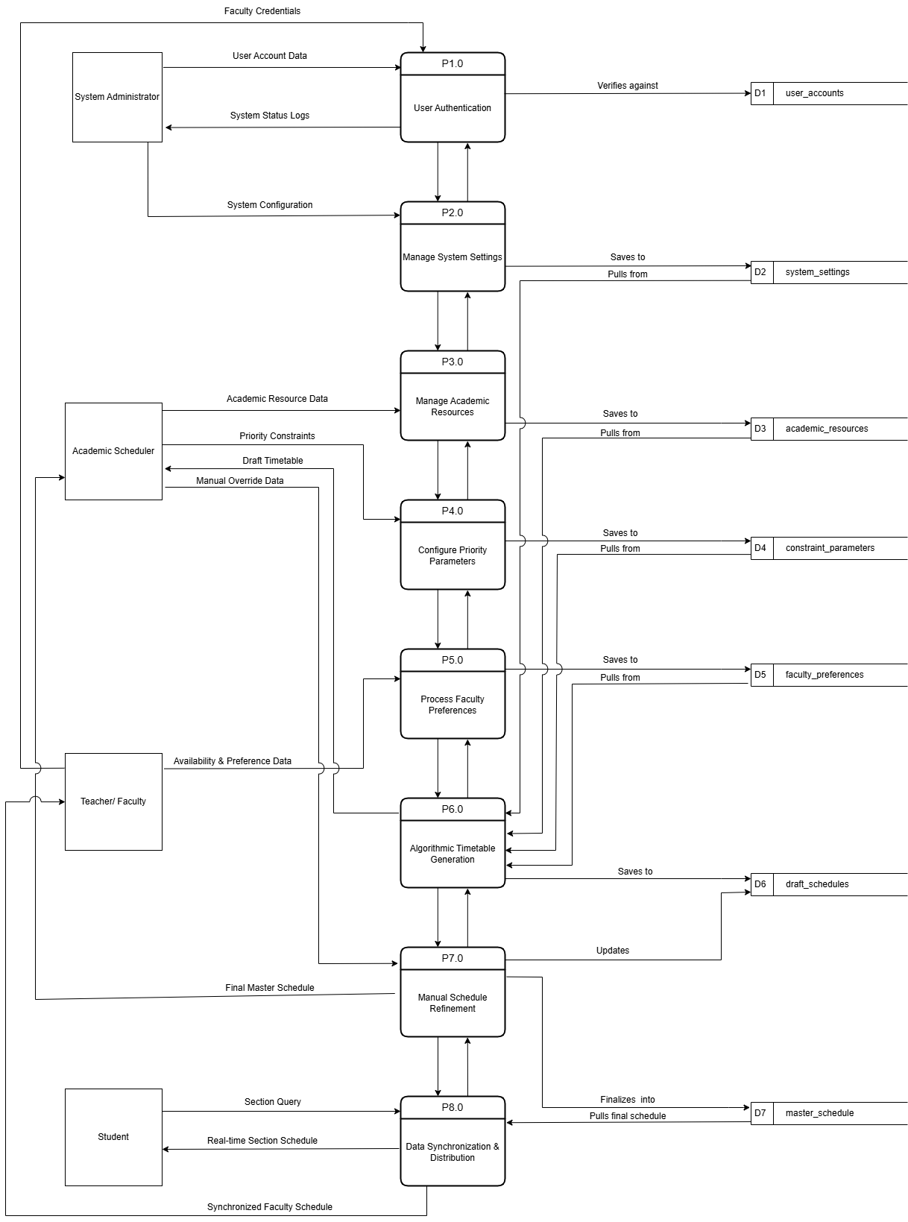

Entity Relationship Diagram
____________________________________

Use Case Diagram
Figure n illustrates how users interact with the system. It identifies four distinct primary actors, which includes the System Administrator, the Academic Scheduler, the Teacher/ Faculty, and the Student. It maps their specific, role-based privileges within the A. T. L. A. S. operation, identifying only those who actually has the direct interaction with the system.
The System Administrator is responsible for the overall technical maintenance of the web application. Upon successfully authenticating their account, they are granted access to manage user accounts to ensure secure, credentialed access to school staff.
The Academic Scheduler serves as the primary operator of the core scheduling engine. After authenticating their account, they prepare the system by managing academic resources, such as inputting room capacities and subject lists. They are also responsible in configuring priority parameters to dictate the specific rules the algorithm must follow. During the pre-generation phase, they monitor preference submissions to ensure all faculty data is collected. They the trigger the system to generate the automated timetable, utilize the visual interface to manually refine the timetable for edge-case conflicts, and finally publish the final schedule to the live databases.
The Teacher/ Faculty interacts with a secure, dedicated portal to provide critical data to the algorithm. By authenticating their accounts, they can securely submit their availability and preferences before the schedule is generated. Once the Academic Scheduler finalizes the allocations, teachers can log in to view their synchronized faculty schedule and download the schedule for offline reference.
Finally, the Student represents the end-user accessing the system's public-facing features. Because their dashboard is designed for maximum accessibility, they do not need to authenticate an account. Instead, they directly access the student public portal, where they can view the real-time section schedule specifically assigned to their class group and download the schedule to their local devices.

Figure n.
Use Case Diagram
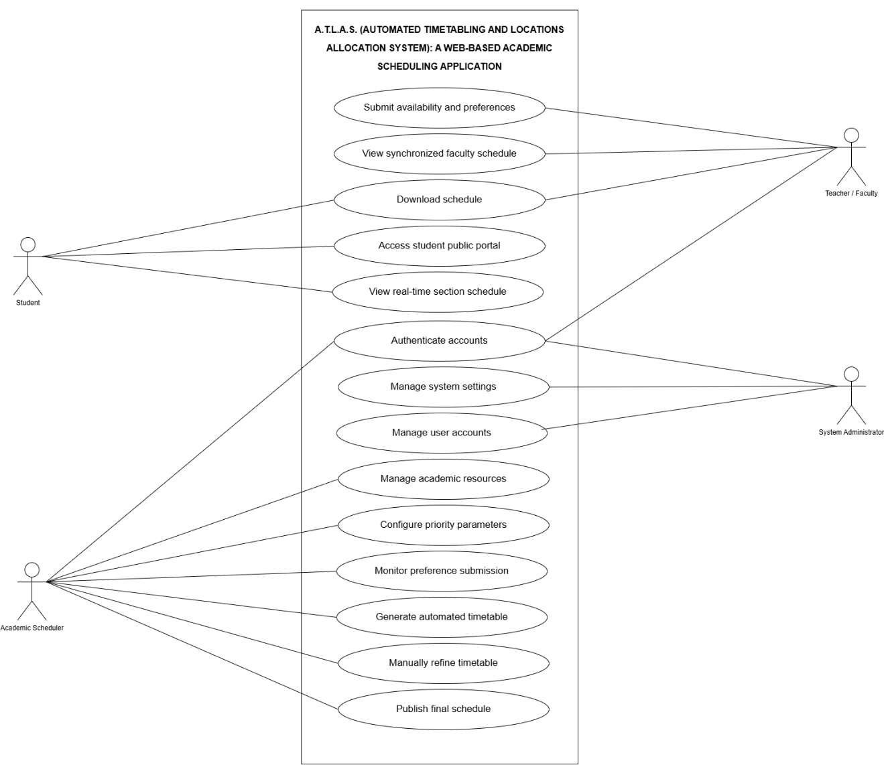

Data Dictionary
____________________________________

Hardware and Software Requirement
____________________________________

Gantt Chart
____________________________________
Figure n.
A. T. L. A. S. Gantt Chart
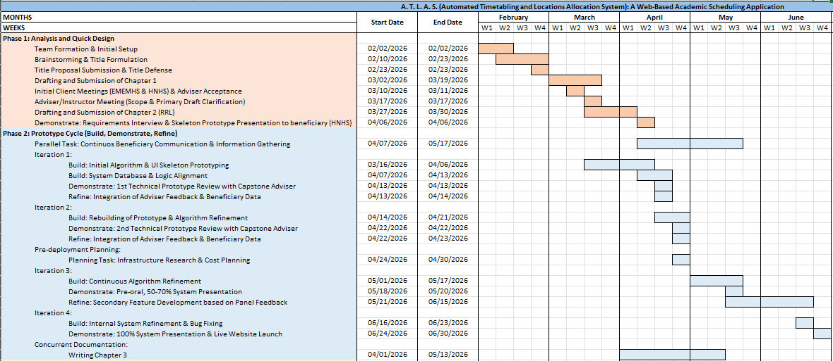
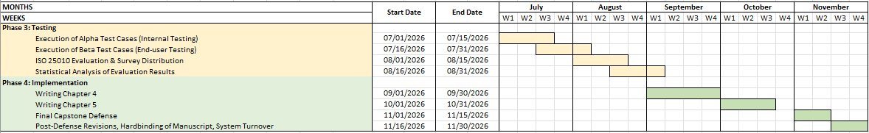

REFERENCES
Published Books/ Journals:
Almonteros, J. R., Pacot, M. P. B., & Pitogo, V. A. (2023, April 4). Automation of Curriculum-based Student-Subject Encoding: A Web Application. ICNCC '22: Proceedings of the 2022 11th International Conference on Networks, Communication and Computing. Pages 328 - 333
https://doi.org/10.1145/3579895.3579944
Austero, L. D., Sison, A. M., Matias, J. B., & Medina, R. P. (2022), May 25-26). Solving course timetabling problem using Whale Optimization Algorithm. Published in: 2022 8th International Conference on Information Technology Trends (ITT).
https://doi.org/10.1109/ITT56123.2022.9863951
Canlas, R. B., Piad, K. C., & Lagman, A. C. (2022, April 11). An ISO/IEC 25010 Based Software Quality Assessment of a Faculty Research Productivity Monitoring and Prediction System. Association for Computing Machinery.
https://doi.org/10.1145/3512576.3512619
Creswell, J. W., & Creswell, J. D. (2018). Research design: Qualitative, quantitative, and mixed methods approaches (5th ed.). SAGE Publications. https://www.ucg.ac.me/skladiste/blog_609332/objava_105202/fajlovi/Creswell.pdf
Dahlan, M. M., Jantan, S. R., Mohtaram, S., & Azmi, M. A. A. (2024, November 17). EffiESGen: A User-centric Web Application for Efficient Exam Scheduling and Collaboration in Education. Procedia Computer Science. Volume 245, 2024, Pages 1092-1100.
https://doi.org/10.1016/j.procs.2024.10.338
Ghazal, M., Yaghi, M., Salman, H., Gad, A., Alhalabi, M., & Yousaf, J.A. (2025, August 11-13). Real-Time Modular Scheduling System for Educational Operations. Published in: 2025 12th International Conference on Future Internet of Things and Cloud (FiCloud).
https://doi.org/10.1109/FiCloud66139.2025.00061
Ibrahim, A. A. (2016). Definition, purpose and procedure of developmental research: An analytical review. Asian Research Journal of Arts & Social Sciences, 1(6), 1-6. https://doi.org/10.9734/ARJASS/2016/30478
Keh, A. M. & Sarmiento, J. R., PhD (2025, February 2). Automated Class Scheduling System for Aemilianum College Inc.. GSJ: Volume 13, Issue 2, February 2025, Online: ISSN 2320-9186.
https://www.globalscientificjournal.com/researchpaper/AUTOMATED_CLASS_SCHEDULING_SYSTEM_FOR_AEMILIANUM_COLLEGE_INC_.pdf
Khorbotly, S. & White, D. (2024, June 23). A Preference-Based Faculty-Assignment Tool for Course Scheduling Optimization. 2024 ASEE Annual Conference & Exposition. doi: 10.18260/1-2—46476.
https://peer.asee.org/a-preference-based-faculty-assignment-tool-for-course-scheduling-optimization
Nsulangi, P. T., Ngongi, W. E., Likamba, M. R., Sarehe, O. B., & Mkwande, M. A. (2024, December 12). A Comparative Analysis of Manual and Automatic Timetabling Approaches for Resource Utilisation in Tertiary Higher Learning Institution. International Journal of Computer Science and Mobile Computing, Vol. 13, Issue. 12, December 2024, pg.65 – 76.
https://doi.org/10.47760/ijcsmc.2024.v13i12.007
Padshetty, S., Anas, A. J. K., Syed, A. R., & Kulkarni, H. (2025, December). Automated Time-Table Management System. JSRT Volume-3 Issue-12 December-2025.
https://doi.org/10.61808/jsrt398
Prakasa, T. A. D., Muklason, A., & Premananda, I. G. A. (2024, July 10-12). Automating School Timetabling: An Intelligent System Application Using Simulated Annealing. Published in 2024 International Seminar on Intelligent Technology and Its Applications (ISITIA).
https://doi.org/10.1109/ISITIA63062.2024.10668040
Ranolo, E., Gorro, K., Abella, P. A. G., Roble, L., Santillan, R. N., Ilano, A., Ociones, B., Vasquez, R., Balijon, D., Ariaso, D., Sr., Campita, R. A., & Angco, R. J. (2025). A Hybrid Approach to Automatic Timetabling Using Self-Organizing Maps, Secure Convex Dominating Sets, and Metaheuristics. (IJACSA) International Journal of Advanced Computer Science and Applications, Vol. 16, No. 8, 2025.
https://www.researchgate.net/profile/Robert-Jay Angco/publication/395044227_A_Hybrid_Approach_to_Automatic_Timetabling_Using_Self-Organizing_Maps_Secure_Convex_Dominating_Sets_and_Metaheuristics/links/68b2a6223391fb1a7a4c3fa2/A-Hybrid-Approach-to-Automatic-Timetabling-Using-Self-Organizing-Maps-Secure-Convex-Dominating-Sets-and-Metaheuristics.pdf
Richey, R. C. (1994). Developmental research: The definition and scope (Report No. ED373753). ERIC.
https://eric.ed.gov/?id=ED373753
Romaguera, D., Plender-Nabas, J., Matias, J., & Austero, L. (2024, April 29). Development of a Web-based Course Timetabling System based on an Enhanced Genetic Algorithm. Procedia Computer ScienceVolume 234, 2024, Pages 1714-1721.
https://doi.org/10.1016/j.procs.2024.03.177
Shomoye , M. A. & Mosaku, A. O. (Development and Implementation of an Automated Timetabling System for Tertiary Institution. International Research Journal of Modernization in Engineering Technology and Science (Peer-Reviewed, Open Access, Fully Refereed International Journal) Volume:07/Issue:01/January-2025 Impact Factor- 8.187.
https://www.researchgate.net/profile/Mariam-Shomoye/publication/388626064_Development_and_Implementation_of_An_Automated_Timetabling_System_for_Tertiary_Institution/links/679f460c4c479b26c9c9a324/Development-and-Implementation-of-An-Automated-Timetabling-System-for-Tertiary-Institution.pdf
Subhiyakto, E. R., & Astuti, Y. P. (2019). Design and development meeting schedule management application using the RAD method. 2019 International Conference of Artificial Intelligence and Information Technology (ICAIIT). https://doi.org/10.1109/ICAIIT.2019.8834522
Sun Z. & Wu, Q. (2023, March). Two-phase tabu search algorithm for solving Chinese high school timetabling problems under the new college entrance examination reform. Data Science and Management Volume 6, Issue 1, March 2023, Pages 55-63.
https://doi.org/10.1016/j.dsm.2023.02.001
Tan, J. S., Goh, S. L., Kendall, G., & Sabar, N. R. (2021, March 1). A survey of the state-of-the-art of optimisation methodologies in school timetabling problems. Expert Systems with Applications. Volume 165.
https://doi.org/10.1016/j.eswa.2020.113943
Tassopoulos, I. X., Iliopoulou, C. A., Katsaragakis, I. V., & Beligiannis, G. N. (2023, June 4). An Effective Local Particle Swarm Optimization-Based Algorithm for Solving the School Timetabling Problem. Algorithms, 16(6), 291.
https://doi.org/10.3390/a16060291
Tayong, A. A. & Roma, G. M., Dr. (2023, July). New Optimization/Automation Models for Hei Managerial Work: Grading, Registering Attendance, Examination Scheduling, Archiving, And Timetabling. Tianjin Daxue Xuebao (Ziran Kexue yu Gongcheng Jishu Ban)/ Journal of Tianjin University Science and Technology. Volume 56, Issue 07:2023.
https://doi.org/10.17605/OSF.IO/2XDUY
Techie-Menson, H., & Nyagorme, P. (2021). Design and implementation of a web-based timetable system for higher education institutions. International Journal of Computer Applications, 174(23), 1-8.
https://www.researchgate.net/publication/351359363
Uma, M., Jayapradha, J., Naharas, B., & Sharma, S. (2024, July 29). Automated timetable generation for academic institutions. AIP Conf. Proc. 3075, 020094 (2024).
https://doi.org/10.1063/5.0217280
Uysal, M., Ceran, O., Tanrıverdi, M., Ozdogan, E., Ustundag, M. T. (2025, June 13). A Web-based Decision Support System for Managing Course Timetabling in Online Education. Volume: 28 Issue: 3, 923 - 934, 13.06.2025.
https://doi.org/10.2339/politeknik.1517479
Vadivel, R., Kumar, H. K. S., Sreemitha, M., Reddy, M. M., Akshaya, B. S. (2025, November 3). (Campus Genie: A Secure, Offline NLP-Powered Assistant for College Students. Published in International Conference on Applications of Machine Intelligence and Data Analytics (ICAMIDA).
https://ieeexplore.ieee.org/abstract/document/11209668
Yavuz, S., Demirci, Z., Guven, B., Kuleli, Z., Yilmazer, B., & Eliiyi, D. T. (2023, March 2). A Course Timetabling Problem for Classroom Usage Minimization. In: Durakbasa, N.M., Gençyılmaz, M.G. (eds) Towards Industry 5.0. ISPR 2022. Lecture Notes in Mechanical Engineering. Springer, Cham.
https://link.springer.com/chapter/10.1007/978-3-031-24457-5_43
Yee, B. E. D., Bagorio, B. I., Cabo, J., & Garbes, M. V. (2025, January). Interactive Timetable Scheduling Matrix Incorporating Classroom Occupancy and Schedule Visualization Using Google Sheets. Philippine Journal of Interdisciplinary Research (PJIR) Volume I, Issue 1.
https://cca.edu.ph/assets/images/11-interactive%20time%20scheduling%20matrix.pdf

Computer Software:
FET (n.d.). Timetable Explorer. [Computer Software].
https://fetviewer.com/?fbclid=IwY2xjawQ2wGNleHRuA2FlbQIxMQBzcnRjBmFwcF9pZAEwAAEel6pH7wjLkenqTw0oS-AtBl6HXgBlIrGxYGK_kvINM8fsPJVVSlW8PPc-7tc_aem_6vSABfRjprdz-ZeA2_AC4Q
FET Forum (2025, October 20). Introducing FET Timetable Explorer — A Modern Web Interface for FET Timetable. [Computer Software].
https://lalescu.ro/liviu/fet/forum/index.php?topic=6649.0
Lantiv. (2026). Timetabling Turbo 2026 [Computer software].
https://timetabling-turbo.lantiv.com/
SchoolTracs. (2025, February 1). Easy drag-and-drop scheduling. SchoolTracs. [Computer Software].
https://www.schooltracs.com/us/blog/timetable_drag_and_drop/

Online Sources:
Garcia Yañez, J. A., Ramirez Saenz, F. D. J., Rios Saldaña, E. L., Rubio Aguilar, M. A., Barrios Flores, I. E., Garcia Flores, C. L., Hernandez Cerda, R. E., & Zacarias Ortiz, J. J. (2024, August). Development of a Web-Based Timetabling Software for a Mexican University.
https://www.tamiu.edu/cswht/documents/wp-2024-006-garcia-yanez.pdf
Katore, K., Lahane, R., Motewar, P., & Nakhate, C. (2024-2025). Dynamic Timetable Generator Using Genetic Algorithm. Department of Computer Science and Engineering Shri Sant Gajanan Maharaj College of Engineering, Shegaon – 444 203 (M.S.) Session 2024-2025. https://www.ssgmce.ac.in/uploads/UG_Projects/cse/202425/Proj.Gr.-09-Project_Report_2024-25.pdf
Li, M. (2025). User Experience Design and Evaluation of a Multi-Role School Management Platform.
https://urn.fi/URN:NBN:fi:amk-2025112529606
Pujan, M. (2025). Design and implementation of a cross-platform Student Management System app using OOP principles.
https://www.theseus.fi/handle/10024/895158
Salesforce. (n.d.). Rapid application development (RAD): Advantages, challenges, and when to use. Salesforce. Retrieved from
https://www.salesforce.com/platform/enterprise-app-development/rapid-application-development-guide/
Venzano Rodriguez, E. (2022). Web And Mobile Application Portfolio: Full-Stack and Native Implementations. Bachelor's thesis, Haaga-Helia University of Applied Sciences
https://www.theseus.fi/bitstream/handle/10024/752263/VenzanoRodriguez_Ernesto.pdf

Appendices

A.T.L.A.S. Functional Test Case Evaluation Document
Evaluator Profile:
Name (Optional): ___________________________
Role / Occupation: [ ] IT Consultant / Educator [ ] Systems Analyst [ ] Software Developer
Years of IT Experience: _____________________

General Instructions:
Please execute the following functional test cases within the A.T.L.A.S. system to validate its core technical features. For each scenario, ensure the Preconditions are met, carefully follow the Test Steps, and input the exact Test Data provided. After execution, observe the system's behavior and record it in the Actual Result column. Finally, compare the actual outcome against the Expected Result and evaluate the system's performance using the strict binary scale below:
- Pass: The system successfully executed the scenario, and the actual result perfectly matches the expected result.
- Fail: The system failed to execute the scenario, required unintended manual intervention, or the actual result deviated from the expected result.
Test Case ID | Test Scenario / Objective | Test Description | Preconditions | Test Steps | Test Data | Expected Result | Actual Result | Status | Remarks
TC-01 | Admin Portal (Obj 1.1) | Verify admin login to the web-based administrative portal | Admin account exists | 1. Open web portal  2. Enter username & password  3. Click Login | Username: admin  Password: password123 | User is successfully authenticated and redirected to the Admin Dashboard
TC-02 | Admin Portal (Obj 1.1) | Verify admin login failure with an invalid password | Admin account exists | 1. Open web portal  2. Enter username  3. Enter wrong password  4. Click Login | Username: admin  Password: wrongpass | System denies access and displays "Invalid credentials"
Test Case ID | Test Scenario / Objective | Test Description | Preconditions | Test Steps | Test Data | Expected Result | Actual Result | Status | Remarks
TC-03 | Priority Management (Obj 1.2) | Verify configuration of a specific scheduling priority | Admin is logged into the portal | 1. Navigate to 'Priority Management'  2. Set Max Teaching Hours  3. Click Save | Max Hours: 4 | The priority rule is saved successfully to the database
TC-04 | Priority Management (Obj 1.2) | Verify system rejects invalid priority configurations | Admin is logged into the portal | 1. Navigate to 'Priority Management'  2. Enter negative capacity  3. Click Save | Room Capacity: -5 | System refuses to save and displays an "Invalid Input" error
TC-05 | Faculty Auth (Obj 1.3) | Verify mobile faculty login with valid credentials | Teacher account exists | 1. Open mobile web view  2. Enter username & password  3. Click Login | Username: faculty1  Password: pass123 | Teacher is successfully authenticated to the mobile dashboard
TC-06 | Preference Submission (Obj 1.3) | Verify submission of faculty schedule preferences | Teacher is authenticated on mobile | 1. Open 'Preferences'  2. Select preferred teaching days  3. Submit form | Preference: No Afternoon Classes | Preferences are saved and queued for the generation algorithm
Test Case ID | Test Scenario / Objective | Test Description | Preconditions | Test Steps | Test Data | Expected Result | Actual Result | Status | Remarks
TC-07 | Timetable Generation (Obj 1.4) | Verify automated generation of a conflict-free schedule | Priorities and Preferences are saved | 1. Navigate to 'Generator'  2. Click 'Generate Timetable' | Complete dataset of teachers, subjects, and rooms | Algorithm outputs a draft schedule with zero double-booked rooms
TC-08 | Timetable Generation (Obj 1.4) | Verify algorithm response to missing critical parameters | Required data is incomplete | 1. Navigate to 'Generator'  2. Click 'Generate Timetable' | Missing Data: No teacher assigned to a subject | Algorithm halts generation and displays an error highlighting missing data
TC-09 | Drag-and-Drop (Obj 1.1) | Verify manual schedule refinement | Draft schedule is generated | 1. Open visual grid  2. Drag a class block to a vacant time slot  3. Release mouse | Moving Math 7 to a vacant slot | Schedule updates visually, and new time slot is saved without errors
TC-10 | Drag-and-Drop (Obj 1.1) | Verify drag-and-drop clash prevention | Draft schedule is generated | 1. Open visual grid  2. Drag a class block into an occupied room slot | Dragging Math 7 to an occupied room | System rejects the move, snaps block back, alerts "Conflict Detected"

