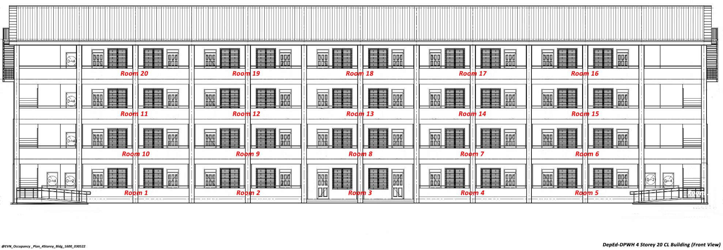

OCCUPANCY PLAN FOR SCIENCE BUILDING

Building No.: ______3______

Room No. | Section | Name of Adviser/ Room In-charge | Room No. | Section | Name of Adviser
1 | CHEM LAB | DAISY LIBO - ON | 11 | G11-STEM 1 | FLORAIDA NOLLEDO
2 | BIO LAB | REYART P. BEBOSO | 12 | DIOSCORO UMALI 8B | GERALD M. DEPALLO
3 | PHYSICS LAB | LOURDES F. BEREÑA | 13 | WILLIAM PADOLINA 8A | DAISY N. LIBO-ON
4 | STORAGE ROOM |  | 14 | RAYMUNDO SATIAGO 7B | CONNIE A. ABSIN
5 | EARTH SCI LAB | CONNIE A. ABSIN | 15 | ANACLETO DEL ROSARIO 7A | JOHN PAUL B. FARIS
6 | AGAPITO FLORES 10A | ERWIN L. SAMSON JR. | 16 | G12 – STEM 3 | RONIC GABITA
7 | FELIX MARAMBA 10B | REYART P. BEBOSO | 17 | G12- STEM 2 | KYLE DENEV VILLAFLOR
8 | TEACHER’S LOUNGE | SCIENCE/STEM TEACHERS | 18 | G12 – STEM 1 | CATHERINE B. CORRO
9 | FE DEL MUNDO 9A | RUSSEL ANN G. PEREZ | 19 | G11 – STEM 3 | CHRIZ JOY MARAMARA
10 | FRANCISCO QUISUMDING 9B | ZANE REY C. GAVILANGA | 20 | G11 – STEM 2 | PATALAGSA

Prepared by:
YVONNE V. BUENCOCHILLO, MT-I
___________________________
Name of Teacher



OCCUPANCY PLAN FOR GRADE 10 BUILDING

Building No.: ______9______

Room No. | Section | Name of Adviser | Room No. | Section | Name of Adviser
1 | RUBY (5) | MARICEL MAGALLANO | 11 | CORAL (13) | FLORENCE BUENAFE
2 | DIAMOND (1) | GEORGIE ENRILE | 12 | ALEXANDRITE (17) | ERLFRED FLORETE
3 | AMETHYST (12) | DOROTHY GRIJALDO | 13 | JADE (9) | CHERRYL GEAVIA
4 | SAPPHIRE (8) | STEPHANIE BUNDA | 14 | ONYX (11) | JO MARIE MONGCAL
5 | AQUAMARINE (15) | JOMELYN PANGANOHOY | 15 | AMBER (7) | OFELIA PARCON
6 | BERYL (19) | DESIRA NIERVES | 16 | CITRINE (20) | ERNIE GARCIA
7 | GARNET (3) | CHEENE SANTARITA | 17 | ZIRCON (14) | JOSE JAEPEE CANSON
8 | PEARL (2) | JUDITH PACHECO | 18 | EMERALD (4) | BOB HUILAR
9 | TOPAZ (10) | ROSE ANN ESCANER | 19 | QUARTZ (16) | MEG JASON MABALO
10 | AGATE (18) | MA. LOURDES JUGUAN | 20 | OPAL (6) | GLORY YAP

Prepared by:
YVONNE V. BUENCOCHILLO, MT-I
___________________________
Name of Teacher



OCCUPANCY PLAN FOR GRADE 7 BUILDING

Building No.: ______10______

Room No. | Section | Name of Adviser | Room No. | Section | Name of Adviser
1 |  |  | 11
2 |  |  | 12
3 |  |  | 13
4 |  |  | 14
5 |  |  | 15
6 |  |  | 16
7 |  |  | 17
8 |  |  | 18
9 |  |  | 19
10 |  |  | 20

Prepared by:

___________________________
Name of Teacher



OCCUPANCY PLAN FOR SHS TVL BUILDING

Building No.: ______17______

Room No. | Section | Name of Adviser | Room No. | Section | Name of Adviser
1 |  |  | 11
2 |  |  | 12
3 |  |  | 13
4 |  |  | 14
5 |  |  | 15
6 |  |  | 16
7 |  |  | 17
8 |  |  | 18
9 |  |  | 19
10 |  |  | 20

Prepared by:

___________________________
Name of Teacher



OCCUPANCY PLAN FOR GRADE 9 BUILDING

Building No.: ______18______

Room No. | Section | Name of Adviser | Room No. | Section | Name of Adviser
1 |  |  | 11
2 |  |  | 12
3 |  |  | 13
4 |  |  | 14
5 |  |  | 15
6 |  |  | 16
7 |  |  | 17
8 |  |  | 18
9 |  |  | 19
10 |  |  | 20

Prepared by:

___________________________

Name of Teacher

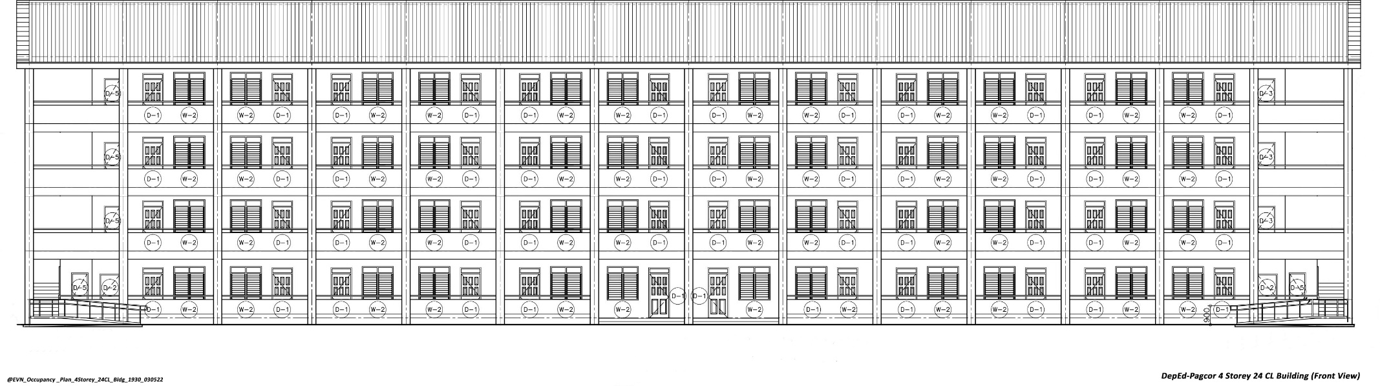

OCCUPANCY PLAN FOR SHS ACAD BUILDING (PAGCOR)

Building No.: ______4______

Room No. | Section | Name of Adviser | Room No. | Section | Name of Adviser
1 |  |  | 13
2 |  |  | 14
3 |  |  | 15
4 |  |  | 16
5 |  |  | 17
6 |  |  | 18
7 |  |  | 19
8 |  |  | 20
9 |  |  | 21
10 |  |  | 22
11 |  |  | 23
12 |  |  | 24

Prepared by:

___________________________
Name of Teacher

