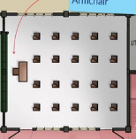






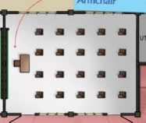







A B C D E F G H I J K
FRONT OF TLE OFFICE

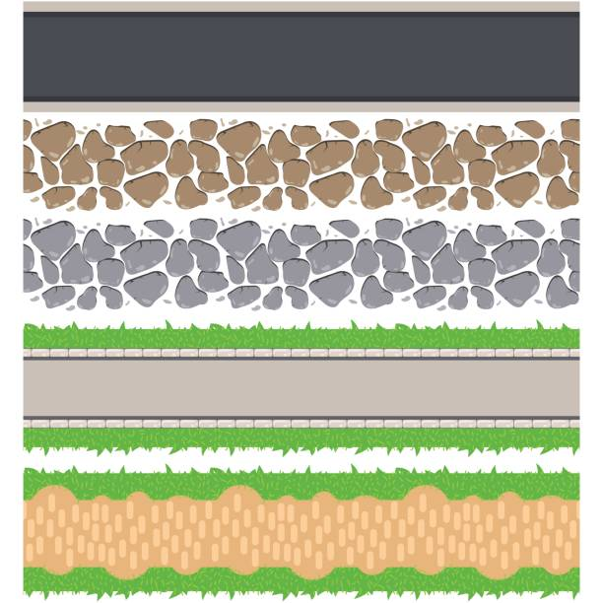

L M N

Rooms at the back of Bldg. 10
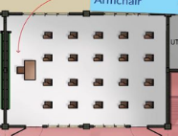






GRADE 8 OCCUPANCY PLAN

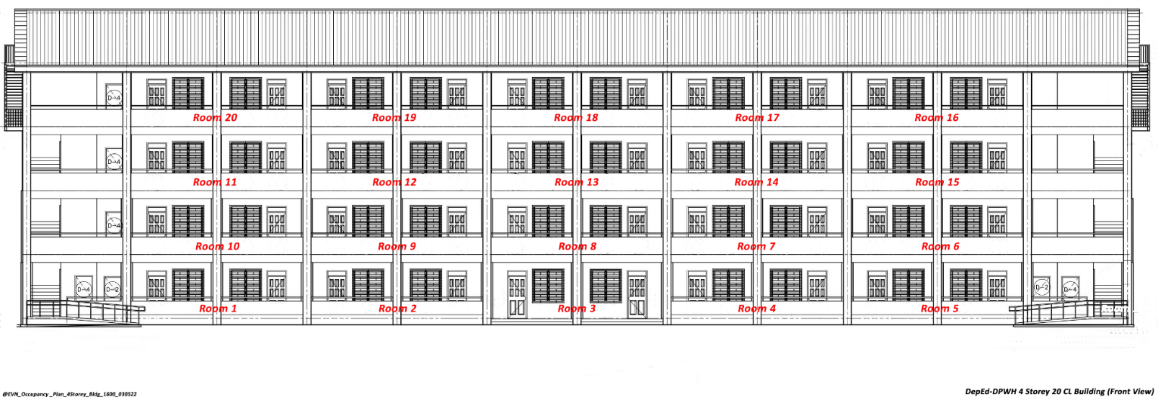








English Office O P Q
1 2 3

4 5 6 7

1 2 3 4
Room No. | Section | Name of Adviser | Room No. | Section | Name of Adviser
BLDG 3 RM 12 | STE8-DIOSCORO UMALI | GERLR M. DEPALLO | J | MASIPAG | SALEM G. TALAUGON
BLDG 3 RM 13 | STE8-WILLIAM PADOLINA | DAISY N. LIBO-ON | K | MAPAGKUMBABA | LYN TUBONGBANUA
PAGCOR BLDG RM 6 | SPA8-LUCRECIA KASILAG | BENCIE BUGA-AY | L | MAAGAP | JETHRO VILLAMOR
A | MATIYAGA | MARY JEAN B. REMETRE | M | MAPAGKATIAWALAAN | JOSIE ROPERO
B | MADASALIN | RUMALYN D. JUAREZ | N | MASAYAHIN | XERXES MANALO
C | MAGALING | DIANA P. FRANCISCO | O | SPA8-LUCRECIA KASILAG | GLADYS KATE M. GILA
D | MASUNURIN | JESSICA DELA PIEZA | P | MASINOP | APRIL ROSE SIANSON
E | MATULUNGIN | RITCHIE JOIE V. MARBA | Q | MAALALAHANIN | MARIEL MAESTRICAMPO
F | MABAIT | CHRISTINE MARIE S. DE LOS SANTOS | RM 3 @ THE BACK OF BLDG 10 | MAKAKALIKASAN | LABANON
G | MATAPAT | JIGILYN V. RIO
H | COOKERY
I | MAPAGMAHAL | RECEL JOY TRESMILLA
PAGCOR BUILDING
Building 3-STE/M

