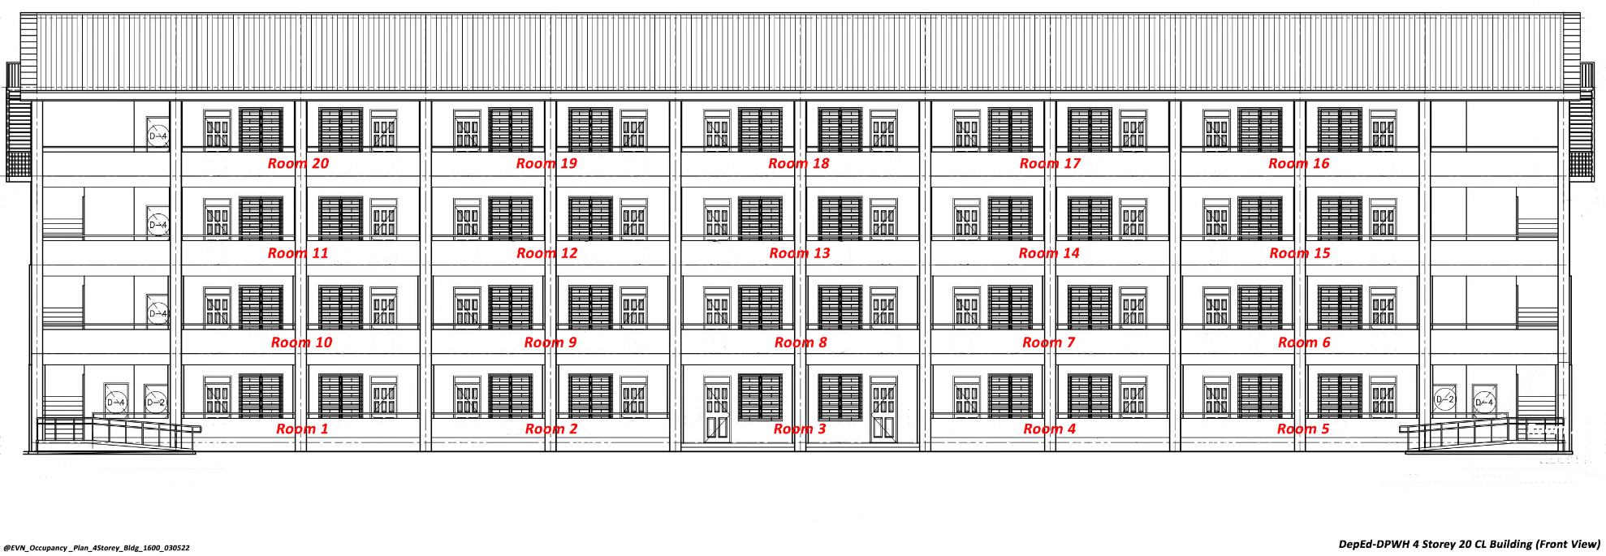

OCCUPANCY PLAN FOR SCIENCE BUILDING

Building No.: ______3______

Room No. | Section | Name of Adviser | Room No. | Section | Name of Adviser
1 |  |  | 11
2 |  |  | 12
3 |  |  | 13
4 |  |  | 14
5 |  |  | 15
6 |  |  | 16
7 |  |  | 17
8 |  |  | 18
9 |  |  | 19
10 |  |  | 20

Prepared by:

___________________________
Name of Teacher



OCCUPANCY PLAN FOR GRADE 10 BUILDING

Building No.: ______9______

Room No. | Section | Name of Adviser | Room No. | Section | Name of Adviser
1 |  |  | 11
2 |  |  | 12
3 |  |  | 13
4 |  |  | 14
5 |  |  | 15
6 |  |  | 16
7 |  |  | 17
8 |  |  | 18
9 |  |  | 19
10 |  |  | 20

Prepared by:

___________________________
Name of Teacher



OCCUPANCY PLAN FOR GRADE 7 BUILDING

Building No.: ______10______

Room No. | Section | Name of Adviser | Room No. | Section | Name of Adviser
1 |  |  | 11
2 |  |  | 12
3 |  |  | 13
4 |  |  | 14
5 |  |  | 15
6 |  |  | 16
7 |  |  | 17
8 |  |  | 18
9 |  |  | 19
10 |  |  | 20

Prepared by:

___________________________
Name of Teacher



OCCUPANCY PLAN FOR SHS TVL BUILDING

Building No.: ______17______

Room No. | Section | Name of Adviser | Room No. | Section | Name of Adviser
1 |  |  | 11
2 |  |  | 12
3 |  |  | 13
4 |  |  | 14
5 |  |  | 15
6 |  |  | 16
7 |  |  | 17
8 |  |  | 18
9 |  |  | 19
10 |  |  | 20

Prepared by:

___________________________
Name of Teacher



OCCUPANCY PLAN FOR GRADE 9 BUILDING

Building No.: ______18______

Room No. | Section | Name of Adviser | Room No. | Section | Name of Adviser
1 |  |  | 11
2 |  |  | 12
3 |  |  | 13
4 |  |  | 14
5 |  |  | 15
6 |  |  | 16
7 |  |  | 17
8 |  |  | 18
9 |  |  | 19
10 |  |  | 20

Prepared by:

___________________________

Name of Teacher

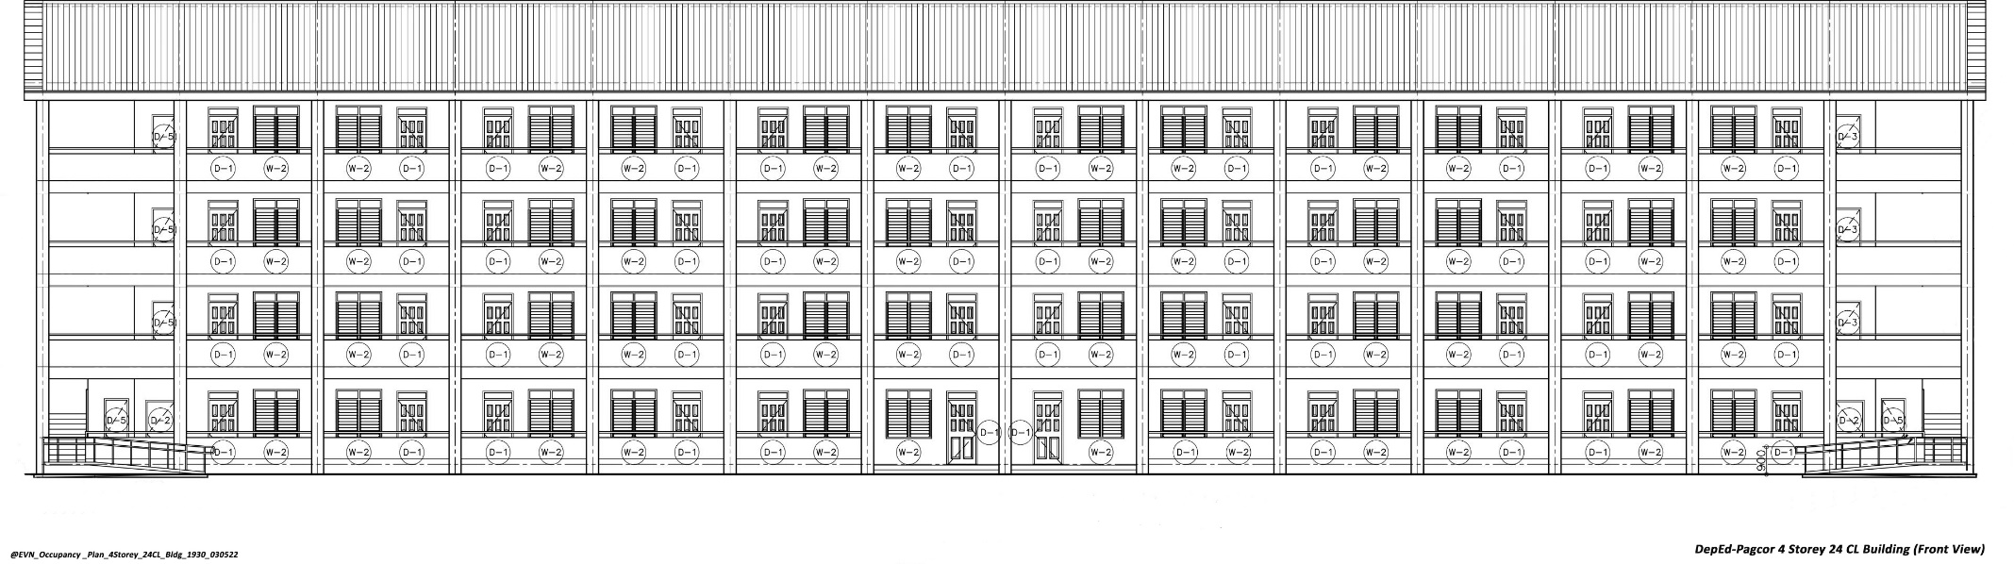

OCCUPANCY PLAN FOR SHS ACAD BUILDING (PAGCOR)

Building No.: ______4______

Room No. | Section | Name of Adviser | Room No. | Section | Name of Adviser
1 |  |  | 13
2 |  |  | 14
3 |  |  | 15
4 |  |  | 16
5 |  |  | 17
6 |  |  | 18
7 |  |  | 19
8 |  |  | 20
9 |  |  | 21
10 |  |  | 22
11 |  |  | 23
12 |  |  | 24

Prepared by:

___________________________
Name of Teacher

