Fix 7.1:
**UI / Visual Refactor: Prevent section name truncation and add subtle background track for vertical usage meters in Building Interior Map**
* **Location:** `Assign Home Room` modal -> `Building Interior View` floor layout grid (`/sections`).
* **Affected Elements:**
1. Assigned section title pills inside room cards (e.g., `G9 Room 401` truncating `"Sampaguita"` to `"Sampag..."`).
2. Vertical usage/period meter bars located on the room cards (currently visible only when active in `G9 Room 401`, missing entirely on empty cards like `G9 Room 402` and `G9 Room 403`).
* **Requested Fixes:**
1. **Resolve Section Name Truncation (Full Legibility):**
* Scale the section pill text size down to `text-[10px]` or `text-[11px]` with `font-medium` or `font-semibold` so longer labels fit comfortably on one line without truncating (`...`).
* Tighten inner horizontal padding (`px-1.5 py-0.5`) and relax restrictive max-width constraints on the inner label container so names with 12–14 characters (e.g., `"Sampaguita"`) display completely.
* Apply this sizing uniformly to all section chips across every floor (e.g., `Tulip`, `Orchid`, `Rose`).
* Ensure curriculum program badges (e.g., `[SPA]`) remain neatly positioned alongside or below the full section name without collision.
2. **Add Permanent Subtle Background Track for Vertical Utilization Meters:**
* Instead of a harsh border outline, render a permanent, soft neutral track across **all** room cards regardless of assigned status (e.g., `w-1.5 md:w-2 rounded-full bg-slate-200/70 dark:bg-slate-700/50 overflow-hidden`).
* **Empty Rooms (`0%` usage):** Rooms like `G9 Room 402` and `G9 Room 403` must keep this soft track visible so users clearly recognize the meter slot and understand the room is currently at zero utilization.
* **Utilized Rooms (`>0%` usage):** Render the colored fill inside this background track rising from the bottom based on the period share percentage (`h-[utilizationPercentage]%`).
* Include a hover tooltip on the track indicating current status (e.g., `"0% periods used"` or `"share of periods in use: X%"`).

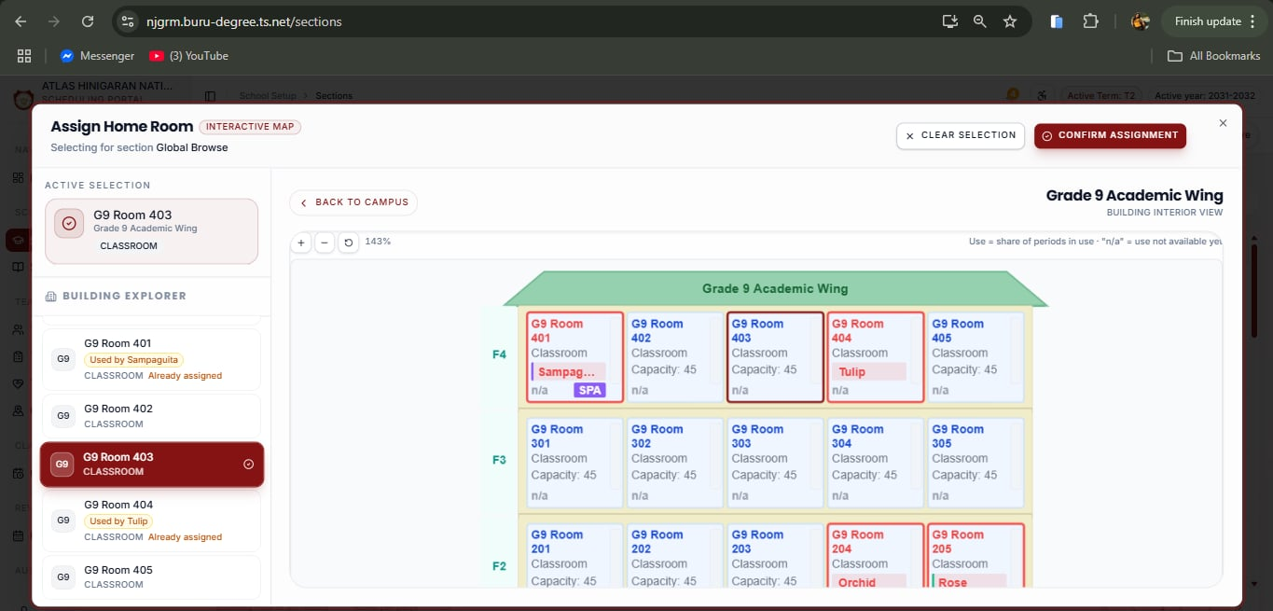

Fix (9.1):
**UI / UX Refactor: Remove EnrollPro banner, remove "More filters" trigger, and flatten filter toolbar on Subjects page**
* **Location:** `Subjects` page (`/subjects`).
* **Core Issues:**
1. The `EnrollPro year and terms verified live · S.Y. 2031-2032 · 3 ordered terms View terms ∨` banner takes up vertical space without providing active scheduling value.
2. The `[More filters]` button hides essential filters (`All Room Types`, `All Programs`) behind an extra click while `All Status` and `All statuses` duplicate each other on the main row.
* **Requested Fixes:**
1. **Completely Remove EnrollPro Notice Banner:**
* Remove the entire green notification strip (`EnrollPro year and terms verified live...`) from the DOM.
* Allow the table card to anchor directly beneath the filter bar, reclaiming vertical screen space.
2. **Remove "More filters" Button & Deduplicate Filters:**
* Remove the `[More filters]` toggle button entirely.
* Remove the redundant duplicate status filter (consolidate `All Status` and `All statuses` into one single `All Status` dropdown).
* Permanently expose all relevant filter selects directly in the interface without accordions or hidden containers.
3. **Clean Horizontal Toolbar Layout:**
* Organize the top filter section into a unified, responsive flex layout:
* **Row 1 / Primary Controls (`flex flex-wrap items-center gap-2.5`):**
* Search input: `Search name or code...` (flexible width: `flex-1 min-w-[240px]`).
* Filter 1: `All Status` (dropdown).
* Filter 2: `All Grades` (dropdown: `GR7`, `GR8`, `GR9`, `GR10`).
* Filter 3: `All Programs` (dropdown: `BEC`, `STE`, `SPA`, `SPS`, `Other`).
* Filter 4: `All Room Types` (dropdown: `Classroom`, `Science Lab`, etc.).
* Style all dropdown triggers with standard uniform dimensions (`h-9 text-xs px-3 rounded-xl border border-slate-200 bg-white hover:bg-slate-50 transition-colors`).
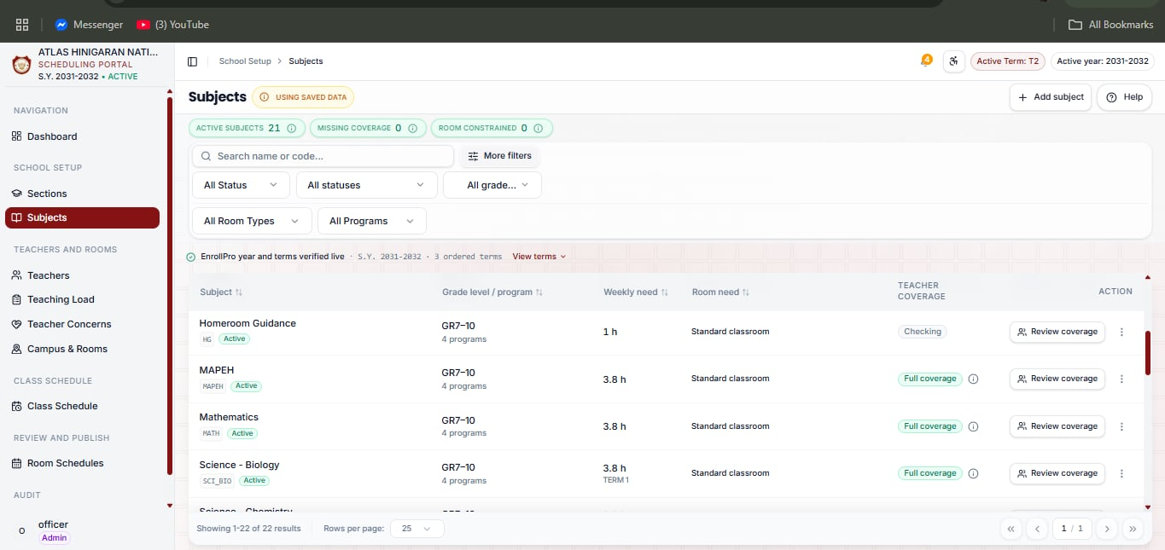
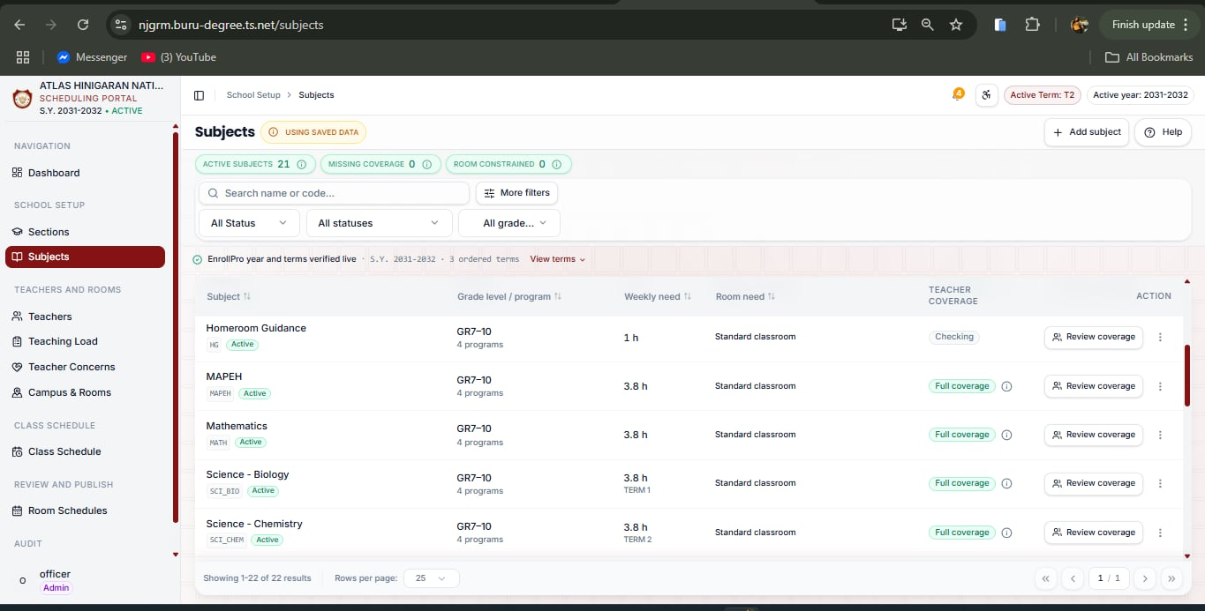
* Ensure filters wrap neatly on smaller viewports without overlapping or horizontal blowout.
fix 10.1:
**UI / Typography Refactor: Increase font size, weight, and contrast of Building Explorer list items in Assign Home Room modal**
* **Location:** `Assign Home Room` modal -> Left navigation sidebar (`BUILDING EXPLORER` list).
* **Affected Elements:** The accordion list items representing each building (e.g., `Admin and Learning Commons`, `MAPEH and Wellness Hub`, `Grade 7 Academic Wing`, `Grade 8 Academic Wing`, etc.).
* **Core Issue:**
* The building titles have a small font size and a washed-out/light-slate text color.
* There is excessive vertical padding and empty white space around each row, making the building labels appear undersized and hard to read compared to the section cards and room badges.
* **Requested Fixes:**
1. **Typography & Contrast Enhancement:**
* Increase the building item font size from `text-xs` (or `text-[11px]`) to `text-sm` (14px).
* Upgrade the font weight from normal to `font-medium` or `font-semibold`.
* Strengthen the font color for higher legibility (e.g., change from light muted gray to `text-slate-800` or `text-slate-900`).
2. **Row Spacing & Whitespace Balance:**
* Optimize the row height and padding (e.g., `py-2.5 px-3`) so each building trigger feels like a solid, well-proportioned clickable item rather than floating loose text.
* Ensure the right chevron arrow (`>`) aligns vertically centered with the larger text label.
* Maintain smooth hover states (e.g., `hover:bg-slate-100/70 hover:text-slate-900 rounded-lg transition-colors`).
3. **Expanded State Consistency:**
* When a building is selected/expanded (such as `Grade 7 Academic Wing` in the expanded view), ensure the parent title retains this stronger weight and size while room chips nest cleanly beneath it.

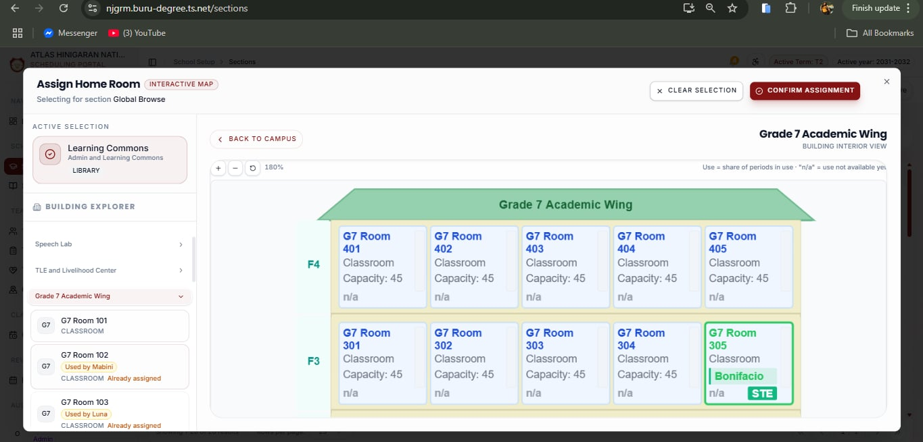

Fix 16.1:

**UI / UX Refactor: Replace detached floating "Review teachers" button with direct per-row "Review load" buttons**
* *Location:** `Teaching Load` page (`/teaching-load`), teacher list rows.
* **Core Issue:**
* Currently, reviewing a teacher requires a two-step process: clicking a teacher row to select them, then moving the cursor down to the detached floating button `[Review teachers]` in the bottom right corner.
* The wide empty space between the teacher's name/department and the workload metrics (`HOURS / WEEK`, `SUBJECTS`, `SECTIONS`) is underutilized.
* This floating button pattern adds unnecessary friction and duplicates the behavior already used cleanly on the `Teachers` page (where each row has an inline `[Review load]` button).
* **Requested Fixes:**
1. **Remove Floating "Review teachers" Button:**
* Remove the floating `[Review teachers]` button anchored at the bottom-right of the viewport.
* Eliminate the temporary row-selection state needed only to enable this button.
2. **Add Inline "Review load" Button to Every Teacher Row:**
* Place a dedicated action button directly on each row in the spacious gap to the right of the load metrics (or between the department name and `HOURS / WEEK`):
* Label: **`[Review load]`** (with an open/eye or clipboard icon, matching the Teachers menu styling).
* Styling: Compact secondary or outline button (`h-8 text-xs font-medium px-3 rounded-lg border border-slate-200 bg-white hover:bg-slate-50 text-slate-800 transition-colors`).
* Clicking `[Review load]` directly opens the centered `Teacher Workload` review modal for that specific teacher in a single click.
3. **Direct Row Interaction:**
* Alternatively, make clicking anywhere on the teacher card row or the right chevron (`>`) directly trigger the `Teacher Workload` review modal without requiring any intermediate selection state.

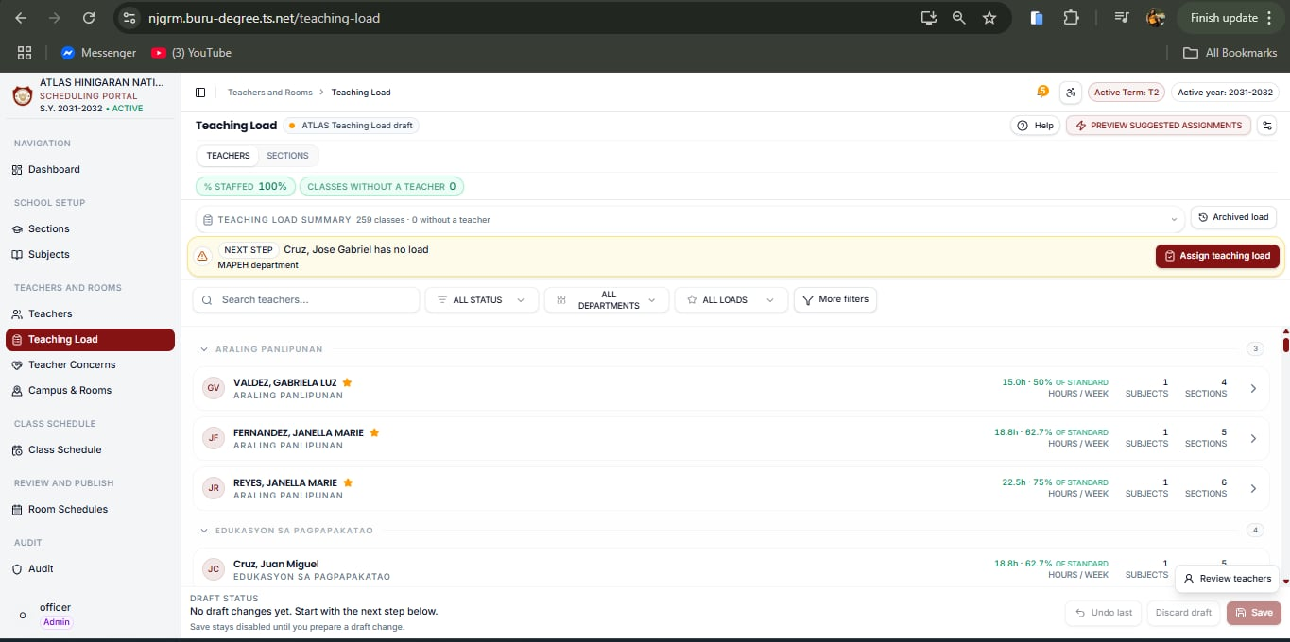

Fix 17.1:
**UI / UX Refactor: Make "Subject coverage" modal resizable and deduplicate teacher grade levels using inline section chips**
* **Location:** `Subjects` page (`/subjects`), `Subject coverage` modal (opened via `[Review coverage]` button).
* **Core Issues:**
1. The modal container has a fixed width and height, causing inner scrollbars and clipping content.
2. Grade levels are shown redundantly: once as color-coded badges under the teacher's name (`GR7`, `GR9`, `GR10`), and again prefixed inside each section chip (`GR7 Bonifacio`, `GR7 Luna`, etc.).
3. The uppercase label `"ASSIGNED SECTIONS"` wastes vertical padding.
* **Requested Fixes:**
1. **Make Modal Resizable While Centered:**
* Ensure the dialog remains centered on screen (`fixed inset-0 grid place-items-center` or flex center).
* Add resizable capabilities to the modal card container:
* CSS: `resize: both; overflow: hidden;` (with inner content `overflow-y-auto`).
* Set practical bounds: `min-w-[500px] max-w-[95vw] min-h-[420px] max-h-[90vh]`.
* Ensure the standard browser or custom resize grab handle in the bottom-right corner is clearly visible and functional without breaking dialog centering.
2. **Deduplicate Grade Levels in Teacher Cards:**
* **Remove Header Grade Badges:** Delete the row of grade chips (`GR7`, `GR9`, `GR10`) rendered below the teacher's name.
* **Keep Teacher Essentials:** Keep the teacher's full name (`FERNANDEZ, JANELLA MARIE`) and the workload badge (`79% Load`).
* **Remove Section Label:** Remove the `"ASSIGNED SECTIONS"` subheader text.
3. **Standardize Section Display Format (Adopt Image 3 Pattern):**
* Render the assigned sections inside a clean, rounded sub-container or flex-wrap row directly under the teacher's name:
* Structure each section item as: `[Color-coded Grade Pill] Section Name` (e.g., `[GR7] Bonifacio`, `[GR7] Luna`, `[GR9] Tulip`, `[GR10] Gold`, `[GR10] Silver`).
* Keep the grade level inside its distinct color badge (e.g., green for GR7, pink/red for GR9, blue for GR10).
* Display the section name in standard clean text (`text-xs font-medium text-slate-800`).
* Wrap items in a lightweight, modern badge or pill container:
```tsx
<div className="flex flex-wrap gap-2 pt-2">
{sections.map((sec) => (
<div key={sec.id} className="flex items-center gap-1.5 px-2.5 py-1 rounded-lg bg-slate-50 border border-slate-200/80">
<span className={`text-[10px] font-bold px-1.5 py-0.5 rounded-full ${gradeColor(sec.grade)}`}>
{sec.grade}
</span>
<span className="text-xs font-medium text-slate-700">{sec.name}</span>
</div>
))}
</div>
```
4. **Visual Uniformity:**
* Apply this exact card layout uniformly to all assigned teachers listed in the modal (`Fernandez, Janella Marie`, `Reyes, Janella Marie`, `Valdez, Gabriela Luz`).

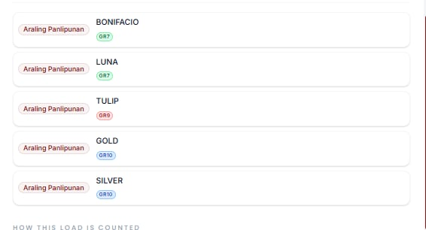
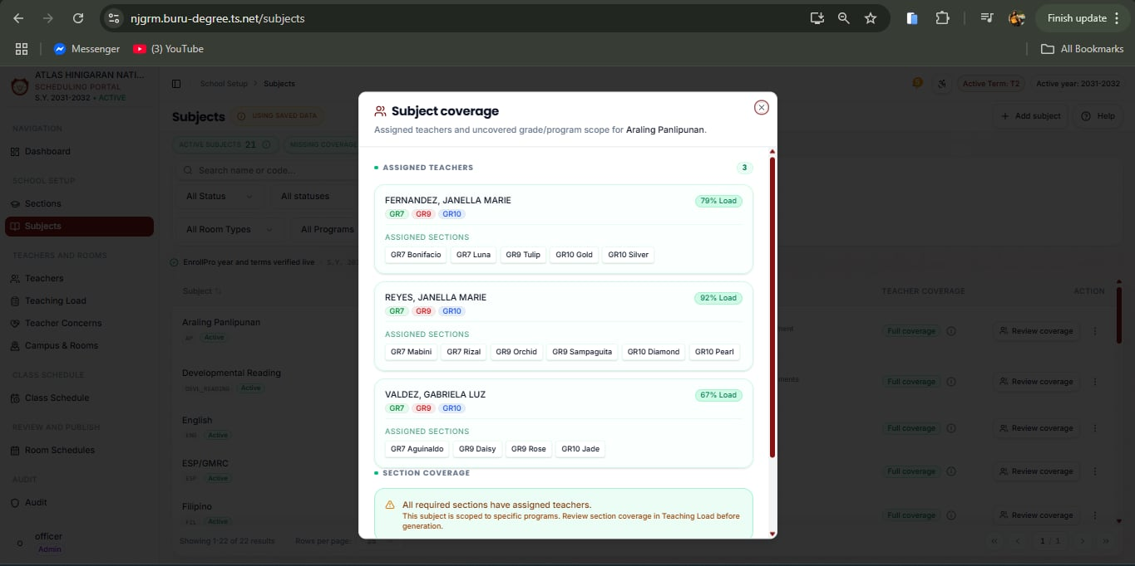

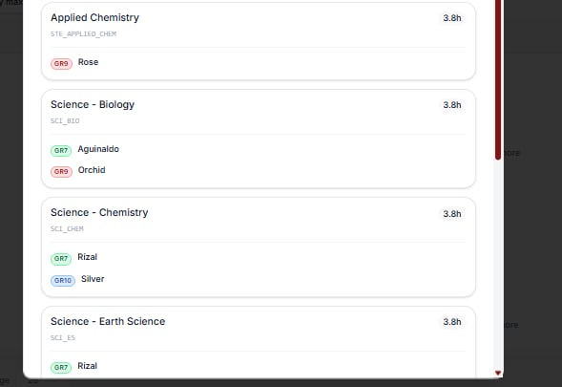

Fix 23.1:
**UI / UX Refactor: Make Teacher Profile modal resizable and increase contrast/size for subject codes**
* **Location:** `Teachers` page (`/teachers`), Teacher Profile modal (showing `ASSIGNED SUBJECTS AND SECTIONS`).
* **Core Issues:**
1. The modal is locked to a fixed dimension, forcing inner scrollbars instead of allowing the user to expand the view.
2. The subject codes underneath the subject titles (e.g., `FIL` under `Filipino`, `DEVL_READING` under `Developmental Reading`) are rendered in a very light, washed-out color with a small font size, causing them to blend into the background.
* **Requested Fixes:**
1. **Make Modal Resizable While Centered:**
* Ensure the dialog remains anchored in the center of the viewport (e.g., `fixed inset-0 flex items-center justify-center`).
* Apply resizable capabilities to the modal card container:
* CSS: `resize: both; overflow: hidden;` (with the inner content area set to `overflow-y-auto`).
* Set practical boundary constraints: `min-w-[500px] max-w-[95vw] min-h-[400px] max-h-[90vh]`.
* Ensure a standard resize drag handle is clearly visible in the bottom-right corner.
2. **Enhance Subject Code Typography & Contrast:**
* Target the subject code elements (e.g., `FIL`, `DEVL_READING`) located directly beneath the primary subject names.
* **Increase Font Size:** Bump the text size up from its current micro size to `text-xs` (12px) or `text-sm` (14px).
* **Darken Text Color:** Change the text color from the current light gray to a darker, legible shade (e.g., change `text-slate-300`/`400` to `text-slate-500` or `text-slate-600`).
* **Font Weight:** Apply `font-medium` to give the code slightly more structural weight without competing with the main subject title (which should remain darker, e.g., `text-slate-900`).

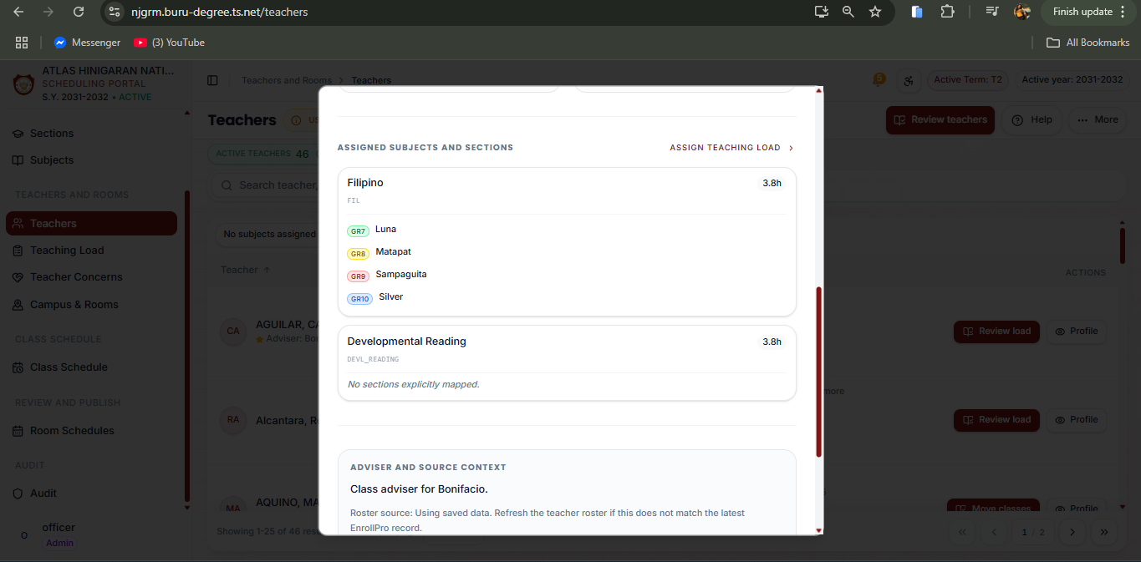

Fix 24.1:
**UI / Action Bar Refactor: Remove "Review teachers" header button, eliminate "... More" popover, and expose action buttons directly in header**
* **Location:** `Teachers` page (`/teachers`), top-right header action bar.
* **Core Issues:**
1. The top header includes a solid maroon `[Review teachers]` button, even though every teacher row already has an inline `[Review load]` button, making it redundant.
2. The `[... More]` button hides two key administrative functions (`+ Add temporary` and `Refresh roster`) inside an extra dropdown menu, despite plenty of horizontal white space in the header row.
* **Requested Fixes:**
1. **Remove "Review teachers" Header Button:**
* Remove the `[Review teachers]` solid button from the top-right header action bar.
* (Keep the individual `[Review load]` action buttons within each table row untouched).
2. **Eliminate "... More" Dropdown Menu:**
* Completely remove the `[... More]` button and its associated `TEACHERS ACTIONS` popover menu.
3. **Directly Expose and Rename Actions in the Header Action Row:**
* Render the two actions directly as standalone buttons in the top-right header group, aligned alongside `[Help]`:
* **Primary Action:** `[+ Create temporary teacher (Teacher X)]`
* Style as a primary solid button (e.g., solid maroon `bg-[#800000]` or brand solid with white text and `+` plus icon).
* Triggers the temporary faculty creation modal/workflow.
* **Secondary Action:** `[Update teacher list]`
* Style as an outline or secondary button (`border border-slate-200 bg-white hover:bg-slate-50 text-slate-700` with a sync/refresh icon).
* Retains the existing roster sync/refresh functionality (`Refresh roster`).
* **Utility Action:** `[Help]` (outline button with question mark icon).
4. **Header Layout Ordering:**
* Arrange the top-right button group in clean descending visual order:
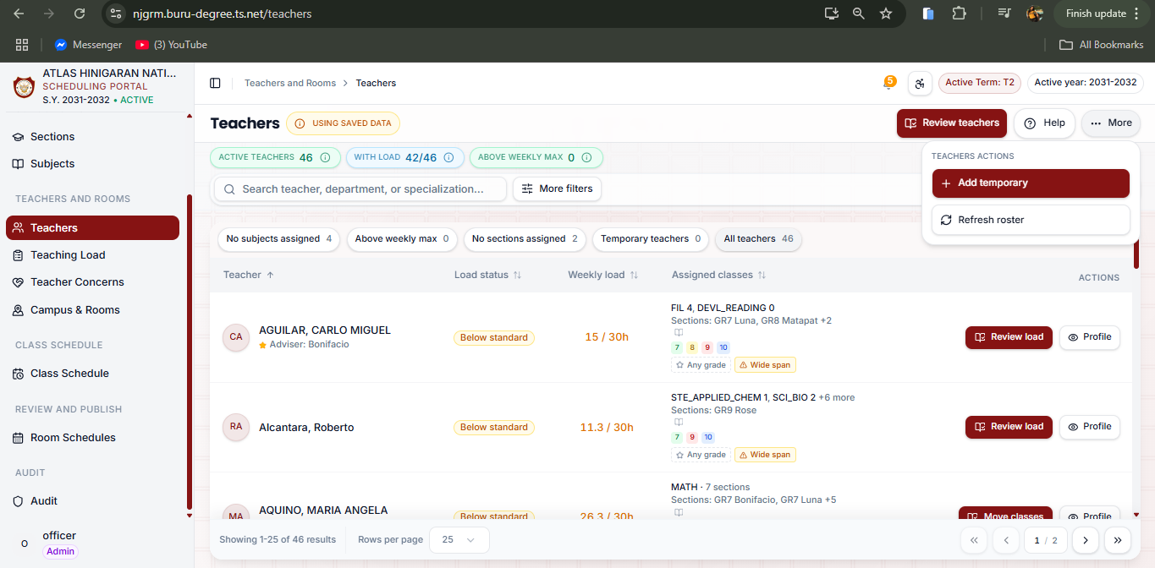
`[Update teacher list]` → `[+ Create temporary teacher (Teacher X)]` → `[Help]`.

