fix 34:
**Bug Fix: Fix clipped and illegible column header hover tooltips across data tables**
* **Scope:** Entire application — specifically `Sections` (`/sections`) and `Subjects` (`/subjects`) data tables, and any shared `DataTableHeader` / sortable column header components.
* **Observed Bugs:**
1. **Overflow Clipping:** Hovering over sortable column headers (`Section`, `Grade`, `Enrolled`, `Capacity`, etc.) triggers a hover tooltip (e.g., *"Click to sort ascending/descending"*), but the top boundary of the table container (`overflow-hidden` or `overflow-x-auto`) cuts the bubble in half.
2. **Blank / Invisible Content:** The tooltip element appears as an empty white pill that blends into the background, with the internal text completely unreadable.
* **Requested Fixes:**
1. **Resolve Tooltip Stacking & Portaling:**
* Render the column header tooltips via a Portal (e.g., Radix UI `TooltipPrimitive.Portal` or Floating UI) so they mount directly to `document.body` rather than inside the overflow-clipped table header.
* If a portal is not used, ensure the tooltip displays below the label (`side="bottom"`) or ensure the parent header wrapper does not clip top overflows (`overflow-visible` on the `thead` / header row).
* Set an explicit elevation: `z-50`.
2. **Standardize Tooltip Styling & Contrast:**
* Apply the application's standard dark tooltip style so it clearly contrasts against white table cards:
```css
bg-slate-900 text-white text-xs font-medium px-2.5 py-1 rounded-md shadow-md pointer-events-none whitespace-nowrap

```
* Ensure the tooltip text explicitly describes the sort action (e.g., `"Sort by Section"`, `"Sort ascending"`, etc.).
3. **Alternative (Remove if Redundant):**
* If the sort buttons (`↑`, `↓`, `↕`) already adequately communicate sorting via their icons, completely remove the hover tooltip listener from the table headers to eliminate visual noise.
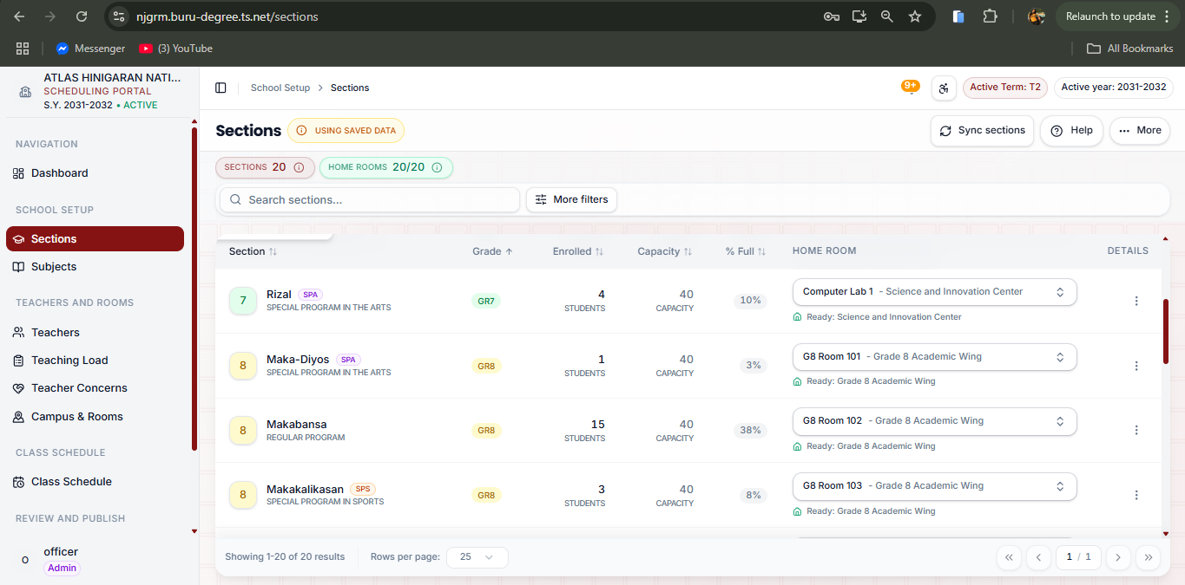

fix 35:
**Bug Fix: Prevent clipped column sort header tooltips on the Teachers table (and all shared data tables)**
* **Location:** `Teachers` page (`/teachers`), column headers (`Teacher ↑`, `Load status ⇅`, `Weekly load ⇅`, etc.), as well as any shared `DataTableHeader` component across the application.
* **Observed Defect:**
* When hovering over sortable headers like `Teacher ↑`, the descriptive tooltip (e.g., *"Sort by teacher, currently ascending"*) pops up above the header, but gets severely cut off by the top boundary of the table container (`overflow-hidden` / `overflow-x-auto`).
* The text is partially clipped and unreadable because the tooltip is rendering inside an overflow-constrained container.
* **Requested Updates:**
1. **Fix Tooltip Mounting / Portaling:**
* Render header tooltips via a Portal (e.g., `TooltipPrimitive.Portal` in Radix UI / shadcn/ui or Floating UI) so the tooltip mounts directly to `document.body` rather than inside the overflow-clipped table structure.
* If portaling is not used, position the tooltip **below** the header text using `side="bottom"` or `align="start"` so it displays within the visible table body instead of protruding past the top boundary.
* Apply explicit stacking elevation (`z-50`).
2. **Alternative (Remove Redundant Tooltips):**
* If the column arrows (`↑`, `↓`, `⇅`) already indicate sort direction clearly, remove the hover tooltip trigger on table header cells completely to eliminate unnecessary clutter and clipping bugs entirely.

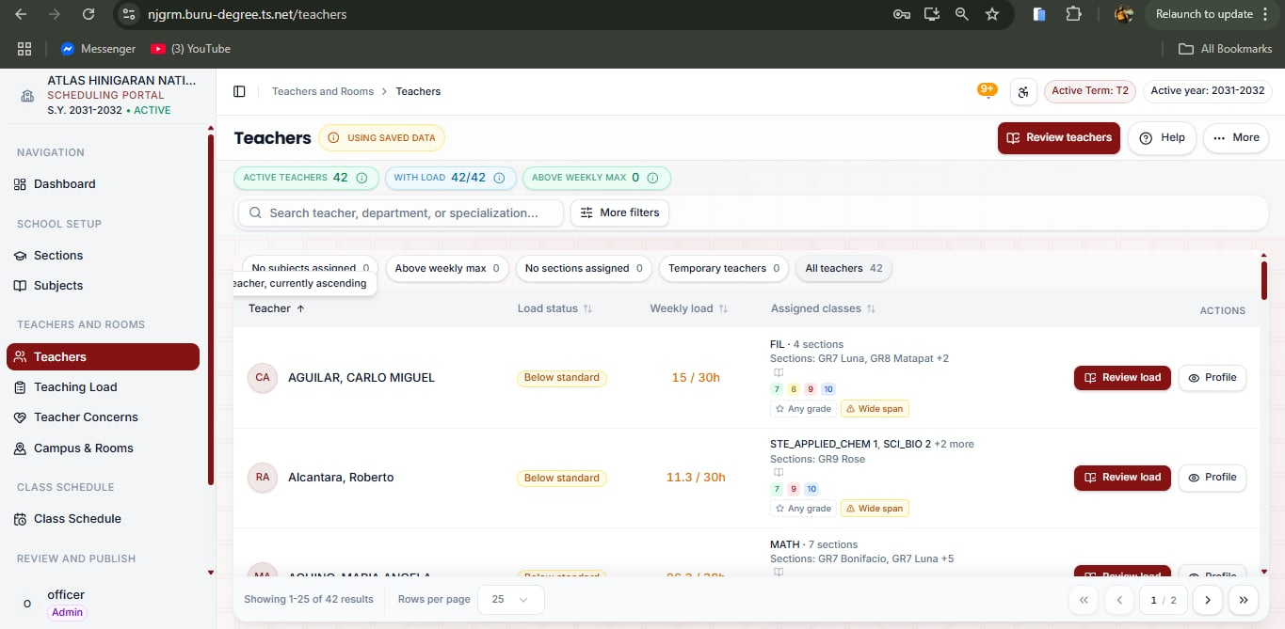

fix 36:

**Bug Fix: Enable dynamic bounds expansion (auto-grow) or full-width sizing for Campus Map Editor canvas**
* **Location:** `Campus & Rooms` -> `Campus map editor` (`/map?mode=editor`).
* **Core Issue:**
* The white canvas container (the map ground background) has a hardcoded/fixed dimension or constrained wrapper.
* When buildings are dragged, drawn, or positioned toward the perimeter (such as the blue room element placed toward the right), they overflow and float outside the white canvas into the pink/tan background grid.
* **Requested Fixes:**
1. **Dynamic Bounding Box Calculation (Auto-Grow):**
* If the white card is an SVG or styled canvas element representing the campus boundary, compute its dimensions dynamically from the elements:
```ts
const minCanvasWidth = Math.max(DEFAULT_WIDTH, maxBuildingX + PADDING_RIGHT);
const minCanvasHeight = Math.max(DEFAULT_HEIGHT, maxBuildingY + PADDING_BOTTOM);
```
* Ensure the white background automatically resizes and expands so all placed building nodes remain completely inside the canvas surface.
2. **Alternative: Responsive Full-Workspace Canvas:**
* If the canvas is intended to fill the viewable editor area, replace fixed width/height classes (e.g., `w-[700px] h-[500px]`) with responsive sizing:
* Set `w-full h-full min-h-[550px]` or use an infinite pannable/zoomable board layout so it spans the entire work area to the left of the detail panel.
3. **Containment & Drag Boundaries:**
* Enforce boundary checks or auto-scroll/auto-expand triggers during drag-and-drop so a building can never visually clip or break outside its designated canvas boundary.

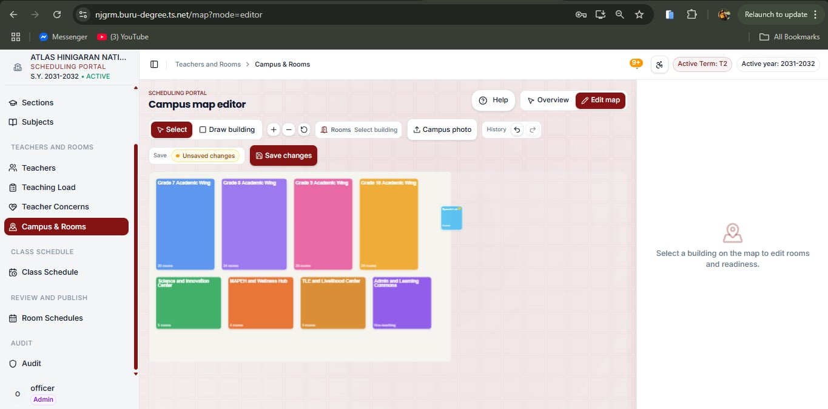

Fix 37:
**UI / Layout Refactor: Invert Campus & Rooms page order (Campus Explorer Map on top, Room Readiness below) and clean up floating overlays**
* **Location:** `Campus & Rooms` page (`/map` or `/campus-and-rooms`).
* **Core Issues:**
1. The floating overlay cluster (`Overview`, `Edit map`, `Help`) is mispositioned and floats over page elements.
2. The interactive map (`Campus Explorer`) is currently hidden behind an `[Open map]` button, pushing the primary visual layout below a large list of rooms.
* **Requested Fixes:**
1. **Remove Stray Floating Cluster:**
* Completely remove the floating cluster containing the `Overview`, `Edit map`, and `Help` buttons from this view.
* Eliminate the absolute/fixed positioning wrapper causing them to hover over the top-right corner.
2. **Remove "Open map" / "Hide map" Accordion Trigger:**
* Remove the `[Open map]` / `[Hide map]` button from the header action area.
* Remove the collapsible state logic that hides or toggles the campus map.
3. **Invert Page Layout Hierarchy (Map First, Readiness Below):**
* **Top Section:** Display the **`Campus Explorer`** container by default directly beneath the page title header:
* Left: The interactive campus map board (`Map View` / `Building Details` tabs, zoom toolbar, and building blocks).
* Right: The building stat cards (`BUILDINGS`, `TEACHING ROOMS`) and the `SELECTED BUILDING` inspector panel (`Inspect Rooms →`, `Review rooms in editor →`).
* **Bottom Section:** Render the **`Room readiness`** card container directly underneath the `Campus Explorer` section.
* Adjust the header subtext from *"Check room readiness first. Open the map only when you need room details."* to standard orientation text (e.g., *"Select a building on the map to inspect rooms, or review room readiness below."*).
4. **Header Clean-Up:**
* The top-right header action row should cleanly contain only the primary action button: **`[Edit maps]`** (solid maroon button).

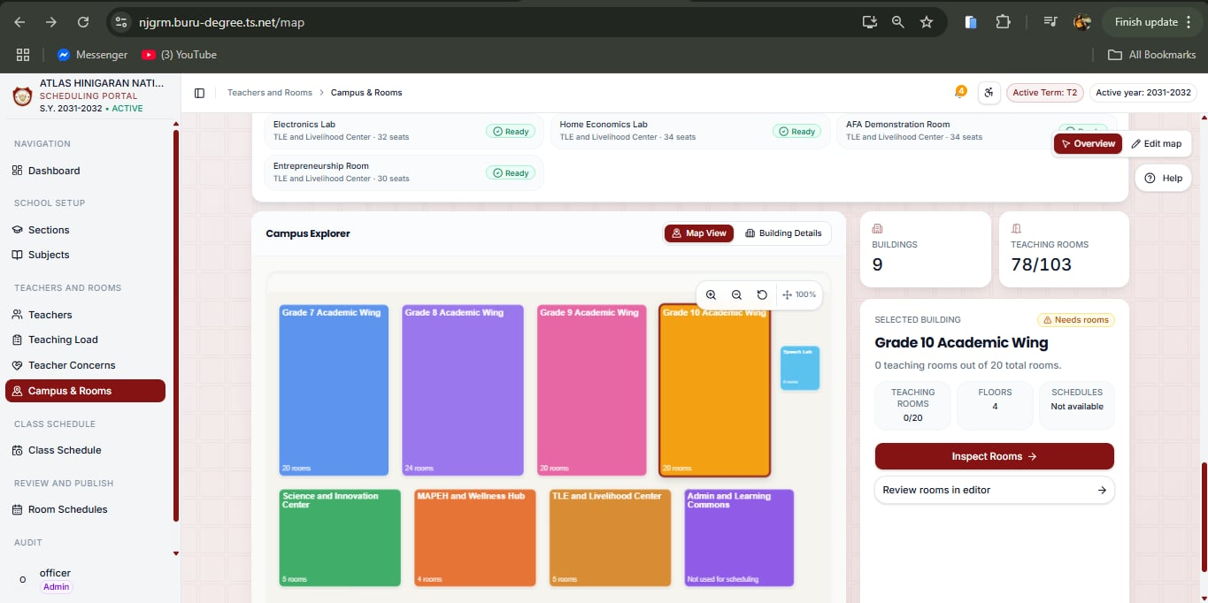
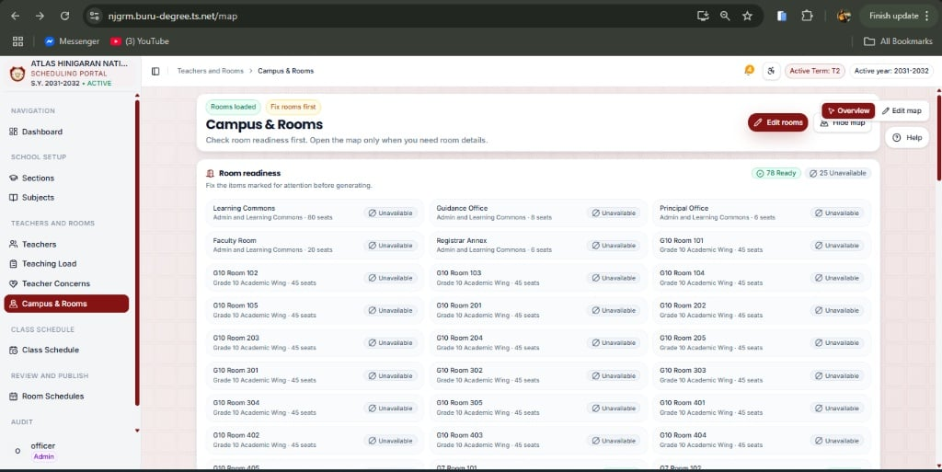

fix 38:
If you prefer **Option 1** (the cleanest way to eliminate clutter while keeping the data accessible):
**UI / UX Refactor: Replace inline expandable "TEACHING LOAD SUMMARY" with header modal trigger**
* **Location:** `Teaching Load` page (`/teaching-load`).
* **Core Issue:**
* The `TEACHING LOAD SUMMARY` card occupies excessive vertical height with 10+ wrapped metric pills, warning banners, and horizontal scrollbars, pushing the faculty list and filter controls below the fold.
* **Requested Updates:**
1. **Remove Inline Summary Card:**
* Remove the inline collapsible container `TEACHING LOAD SUMMARY` and its horizontal pill scroll area from the page body.
* Move the `[Archived load]` button into the page's top-right header actions row or overflow menu.
2. **Add Header Action Button for Summary:**
* In the top-right action area of the header (next to `[Help]`), add a secondary button: **`[Load summary]`** (or `[Summary metrics]`).
* Clicking this button opens a centered, accessible dialog modal containing the complete load breakdown:
* Overall class assignment breakdown (`Classes needing teacher`, `Total teaching hours`, etc.)
* Capacity metrics (`Standard load`, `School hard cap`, `Above standard`, `Hours available`)
* Any active system notes or authority warnings
3. **Result:**
* The page layout immediately pulls the search bar, department filters, and teacher rows into full view without scrolling.
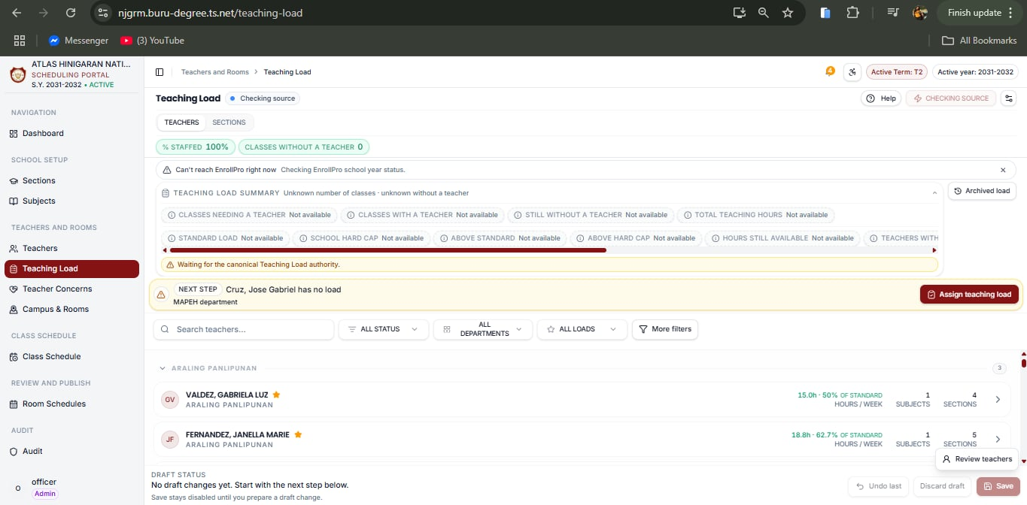

Fix 39:
**UI / Layout Refactor: Constrain search bar width, remove "More filters", and consolidate all filters into a single compact row on Teaching Load page**
* **Location:** `Teaching Load` page (`/teaching-load` or `/faculty/load`), filter toolbar above the table/list.
* **Core Issue:**
* The search bar currently expands too wide, forcing the `[More filters]` button to exist and hiding `LOWEST LOAD`, `CROSS-DEPT`, and `UNMAPPED SPECIALIZATION` onto an unnecessary second row.
* Users should be able to see and toggle all filters directly without extra clicks or row wraps.
* **Requested Fixes:**
1. **Shorten Search Input Width:**
* Remove unbounded expansion (`flex-1` or `w-full`) from the search input container.
* Set a fixed, practical width: `w-[240px]` (or `max-w-[260px]`) with `h-9` and `text-xs`, giving sufficient space to type full teacher names without claiming half the toolbar.
2. **Remove "More filters" Button & Expandable Second Row:**
* Completely remove the `[More filters]` trigger button from the DOM.
* Eliminate the collapsible second row wrapper holding `LOWEST LOAD`, `CROSS-DEPT`, and `UNMAPPED SPECIALIZATION`.
3. **Consolidate All Filter Controls into a Single Row:**
* Place all filter controls sequentially in one continuous horizontal bar (`flex flex-wrap items-center gap-2`):
1. **Search Input:** `Search teachers...` (`w-[240px]`)
2. **Select 1:** `ALL STATUS`
3. **Select 2:** `ALL DEPARTMENTS`
4. **Select 3:** `ALL LOADS`
5. **Select 4:** `LOWEST LOAD` (sort order select)
6. **Toggle 1:** `CROSS-DEPT` (compact toggle switch with text label)
7. **Toggle 2:** `UNMAPPED SPECIALIZATION` (compact toggle switch with text label)
4. **Styling & Alignment:**
* Ensure all dropdown selects share a uniform compact size (`h-9 text-xs px-2.5 rounded-xl border border-slate-200 bg-white hover:bg-slate-50 transition-colors`).
* Style the two toggle switches compactly so their labels and switch tracks fit neatly at the end of the row without wrapping on desktop screens.
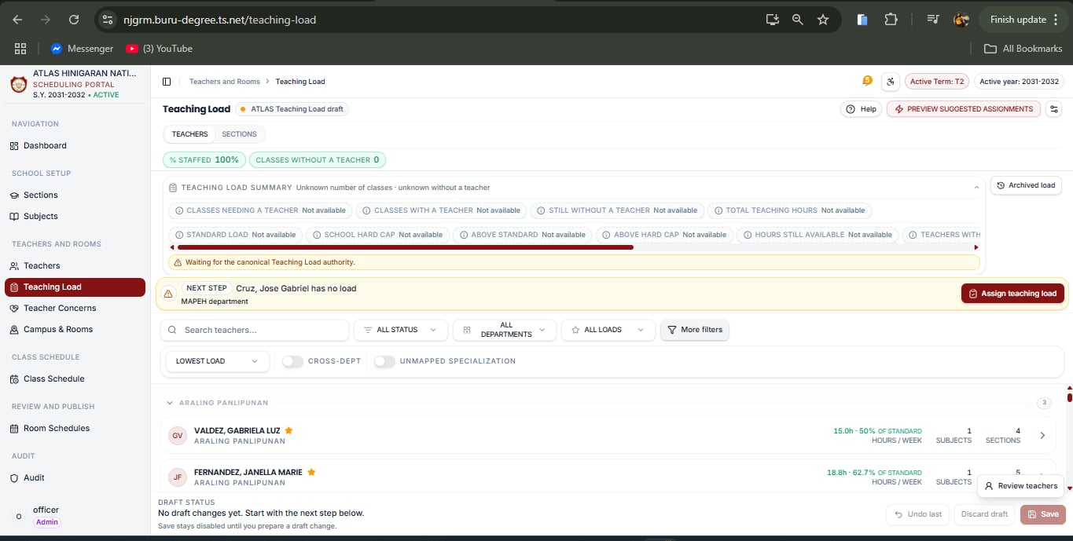
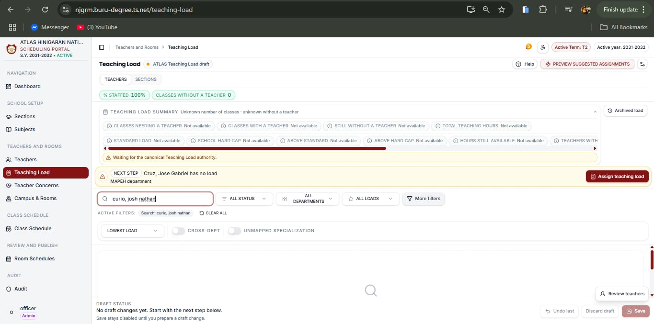

Fix 40:
**UI / UX Refactor: Eliminate bottom sticky footer, relocate Undo/Redo controls to filter toolbar, and add Save confirmation modal**
* **Location:** `Teaching Load` page (`/teaching-load` or `/faculty/load`).
* **Core Issues:**
1. The bottom footer (`DRAFT STATUS`, *"No draft changes yet..."*, `[Undo last]`, `[Discard draft]`, `[Save]`) camouflages into the background, creates visual dead space, and takes up vertical screen real estate.
2. Saving draft workload changes should be intentional and verified via a confirmation modal before committing to prevent accidental writes.
* **Requested Fixes:**
1. **Completely Remove the Bottom Sticky Footer:**
* Remove the entire bottom footer container (`DRAFT STATUS` notice, helper text, and its floating bar container).
* Free up the bottom viewport so the teacher list flows cleanly without overlapping footer elements.
2. **Relocate Undo / Redo & Draft Action Controls to the Filter Toolbar:**
* Move the history controls (`Undo` and `Redo` / `Discard` buttons) up into the primary filter toolbar row, positioning them cleanly on the far right (or alongside the filter dropdowns and toggles).
* Style `Undo` and `Redo` as compact icon buttons (with tooltips: *"Undo change"*, *"Redo change"*) or small secondary buttons that stay disabled when no draft actions exist.
* Add a prominent **`[Save changes]`** primary maroon button directly alongside the undo/redo group in the toolbar (or in the page header actions row).
* Keep `[Save changes]` disabled with low opacity when there are no pending changes (`isDirty === false`).
* Enable and highlight it as soon as a teacher assignment draft change occurs.
3. **Implement Save Confirmation Modal:**
* When the user clicks **`[Save changes]`**, do not commit directly; trigger a centered confirmation dialog:
* **Title:** `"Save Teaching Load Changes?"`
* **Body:** Summarize pending changes (e.g., *"You have X uncommitted load assignment changes for Term 2. This will update faculty workloads and sync with the scheduling engine."*).
* **Actions:**
* `[Cancel]` (outline button, closes modal without saving)
* `[Confirm & Save]` (solid maroon button, executes save mutation and displays success toast)

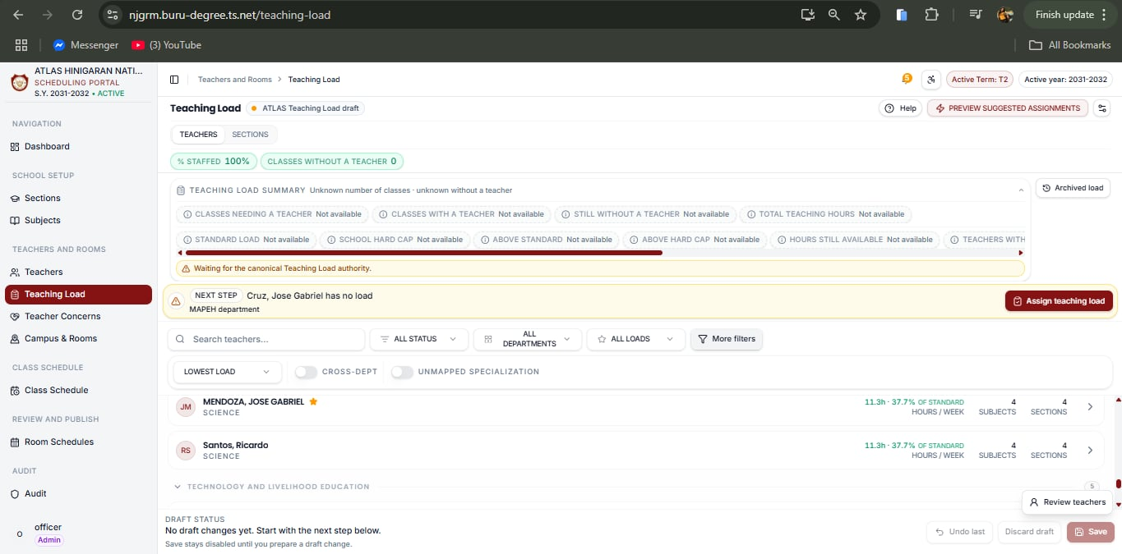

Fix 41:
**UI / Layout Refactor: Shorten search bar, remove "More filters", deduplicate status, and flatten all filters into a single compact row on Subjects page**
* **Location:** `Subjects` page (`/subjects`).
* **Core Issues:**
1. The filter section currently spans across three stacked vertical rows (search bar + `[More filters]`, first row of dropdowns, second row of dropdowns).
2. The search bar is unnecessarily wide, pushing controls into awkward line breaks.
3. `All Status` and `All statuses` duplicate each other.
4. The `[More filters]` button hides essential filters (`All Room Types`, `All Programs`), taking up excessive vertical screen space before reaching the table.
* **Requested Fixes:**
1. **Shorten Search Input Width:**
* Remove full/stretching width from the search bar.
* Set a fixed, compact width: `w-[240px]` (or `max-w-[260px]`) with `h-9` and `text-xs` (placeholder: `"Search name or code..."`).
2. **Remove "More filters" Toggle & Collapse Container:**
* Completely remove the `[More filters]` toggle button from the DOM.
* Remove the expandable/collapsible second-row container holding `All Room Types` and `All Programs`.
3. **Deduplicate Status Dropdowns:**
* Consolidate the duplicate `All Status` and `All statuses` dropdowns into a single clean `All Status` filter.
4. **Consolidate Everything into One Clean Horizontal Row:**
* Render the search bar and all four filter selects in a single inline container (`flex flex-wrap items-center gap-2.5`):
1. **Search Input:** `Search name or code...` (`w-[240px]`)
2. **Select 1:** `All Status` (options: `Active`, `Inactive`, etc.)
3. **Select 2:** `All Grades` (`All grade...` dropdown)
4. **Select 3:** `All Programs`
5. **Select 4:** `All Room Types`
* Style all select dropdown triggers uniformly with compact dimensions (`h-9 text-xs px-3 rounded-xl border border-slate-200 bg-white hover:bg-slate-50 transition-colors`).
5. **Vertical Space Optimization:**
* Ensure the filter toolbar sits compactly above the data table (and remove the green EnrollPro notification strip if still present), bringing the subjects table rows immediately into view without vertical scrolling.

