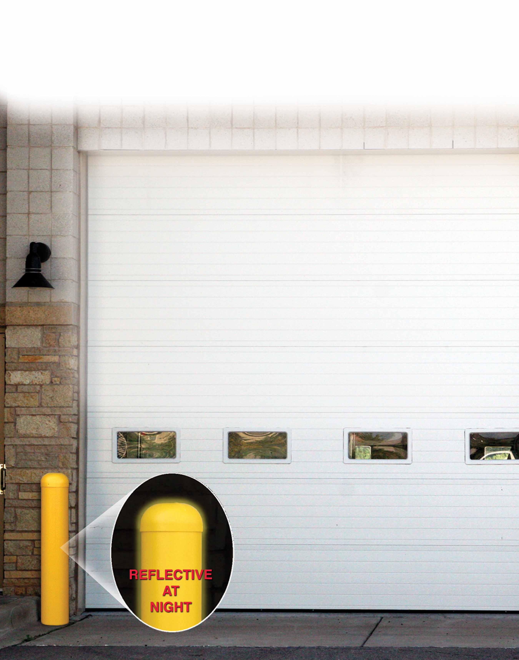

CEME-TUBE LLC
Jim Bradac- Owner
1293 County Road i
Hudson, WI. 54016

Phone- 715-377-2133
Fax- 715-377-2135
Cell- 612-730-6880
Web- www.cemetube.com
Email- info@cemetube.com
The Pour in Place Bollard CEME-TUBE

This Bollard model CEME-TUBE is designed to provide an easy installation of a maintenance free, pour in place Bollard. The Bollard CEME-TUBE is an 8” standard CEME-TUBE molded in night reflective, caution yellow throughout. A strong UV inhibitor will keep the CEME-TUBE from fading. After filling the Bollard CEME-TUBE with re-bar reinforced concrete, the installation is complete.

Installation is quick, simple, and 1/3 the price of using a steel pipe.
Unlike steel bollards, the Bollard Ceme-Tube will not rust, nor will it ever need painting.
The Bollard Ceme-Tube is finished upon installation and is very aesthetically pleasing to the customer.
Engineering Note: The 8" Ceme-Tube Bollard filled with concrete and 4 pieces of 3/4" rebar is equal in strength to a 5" schedule 40 steel pipe filled with concrete. Should more strength be desired, simply add more rebar.

Bollard Ceme-Tube Features:
- The Bollard Ceme-Tube is 8” in diameter, and 4’ in length.
- The standard black Ceme-Tube must be used below grade and below the Bollard Ceme-Tube to provide deeper footings and stability for the bollard.
- Upon filling with re-bar and concrete, the installation is complete.
- The reflective caution yellow color is molded throughout, not just applied.
- The reflective caution yellow color is highly visible, especially at night.
- Molded from partially recycled HDPE plastic and is flexible to -103 deg. F. The Bollard Ceme-Tube will not chip or crack when cold.
- Concrete or asphalt will not adhere to the sides of the Bollard Ceme-Tube which eliminates any friction frost heaving.
- The Bollard Ceme-Tube will provide a finished, maintenance free product upon installation, and will be very aesthetically appealing to the customer.
- The outside of the Bollard Ceme-Tube is smooth and seamless.
- The dome cap comes with stainless steel screws, and finishes the installation nicely.
- The Bollard Ceme-Tube is available in custom colors!

