
CEME-TUBE LLC
Jim Bradac- Owner
1293 County Road i
Hudson, WI. 54016

Phone- 715-377-2133
Fax- 715-377-2135
Cell- 612-730-6880
Web- www.cemetube.com
Email- info@cemetube.com
The Light Pole CEME-TUBE
(Now available in both safety yellow and architectural bronze.)

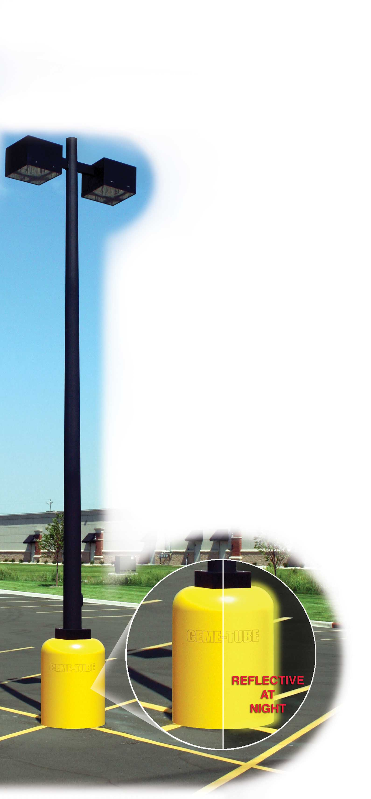

These specially designed 18”, 24”, and 30” diameter CEME-TUBE models will revolutionize the installation of light pole footings. This CEME-TUBE is manufactured in reflective caution yellow, or reflective architectural bronze. Both of which contain strong UV inhibitors to protect the CEME-TUBE from fading. To create aesthetic appeal and minimize installation labor, the top perimeter has an integral radius which will transition the sides of the CEME-TUBE to the top surface smoothly. This top radius also eliminates chamfering.
A 17” diameter Hole is provided on the top to facilitate pouring, finishing and light
pole installation. (14” hole on the 18” model) This CEME-TUBE is intended to remain
on which will save time and labor on stripping, painting, chamfering and concrete finishing.
Light Pole Footing Features:
- Available in 18”, 24”, and 30” diameters, all models are 4’ in length.
- An integral collar on all models allows the CEME-TUBE to be easily stacked onto
a standard black Ceme-Tube.
- The standard black CEME-TUBE must be used below grade, and below the Light Pole CEME-TUBE to provide deeper footings.
- The reflective yellow or bronze color is molded throughout, not just applied.
- The reflective yellow or bronze color is highly visible, especially at night.
- Concrete or asphalt will not adhere to the sides of the Light Pole CEME-TUBE which eliminates any friction frost heaving.
- The Light Pole CEME-TUBE will provide a finished product upon installation and will be very aesthetically appealing to the customer.
- The outside of the CEME-TUBE is smooth and seamless.
- The walls of the Light Pole CEME-TUBE are extremely heavy to handle the punishments of parking lot bumps.
- Molded from partially recycled HDPE plastic that remains flexible to -103 Deg. F. The Ceme-Tube will not chip or crack when cold.
- Significantly lower installation costs compared to cardboard.

No more stripping!
No more rotating lines!
No more visible air pockets in concrete
And, the Light Pole CEME-TUBE will never need painting!
The Light Pole Ceme-Tube is finished upon installation, and is very aesthetically pleasing to the customer.

