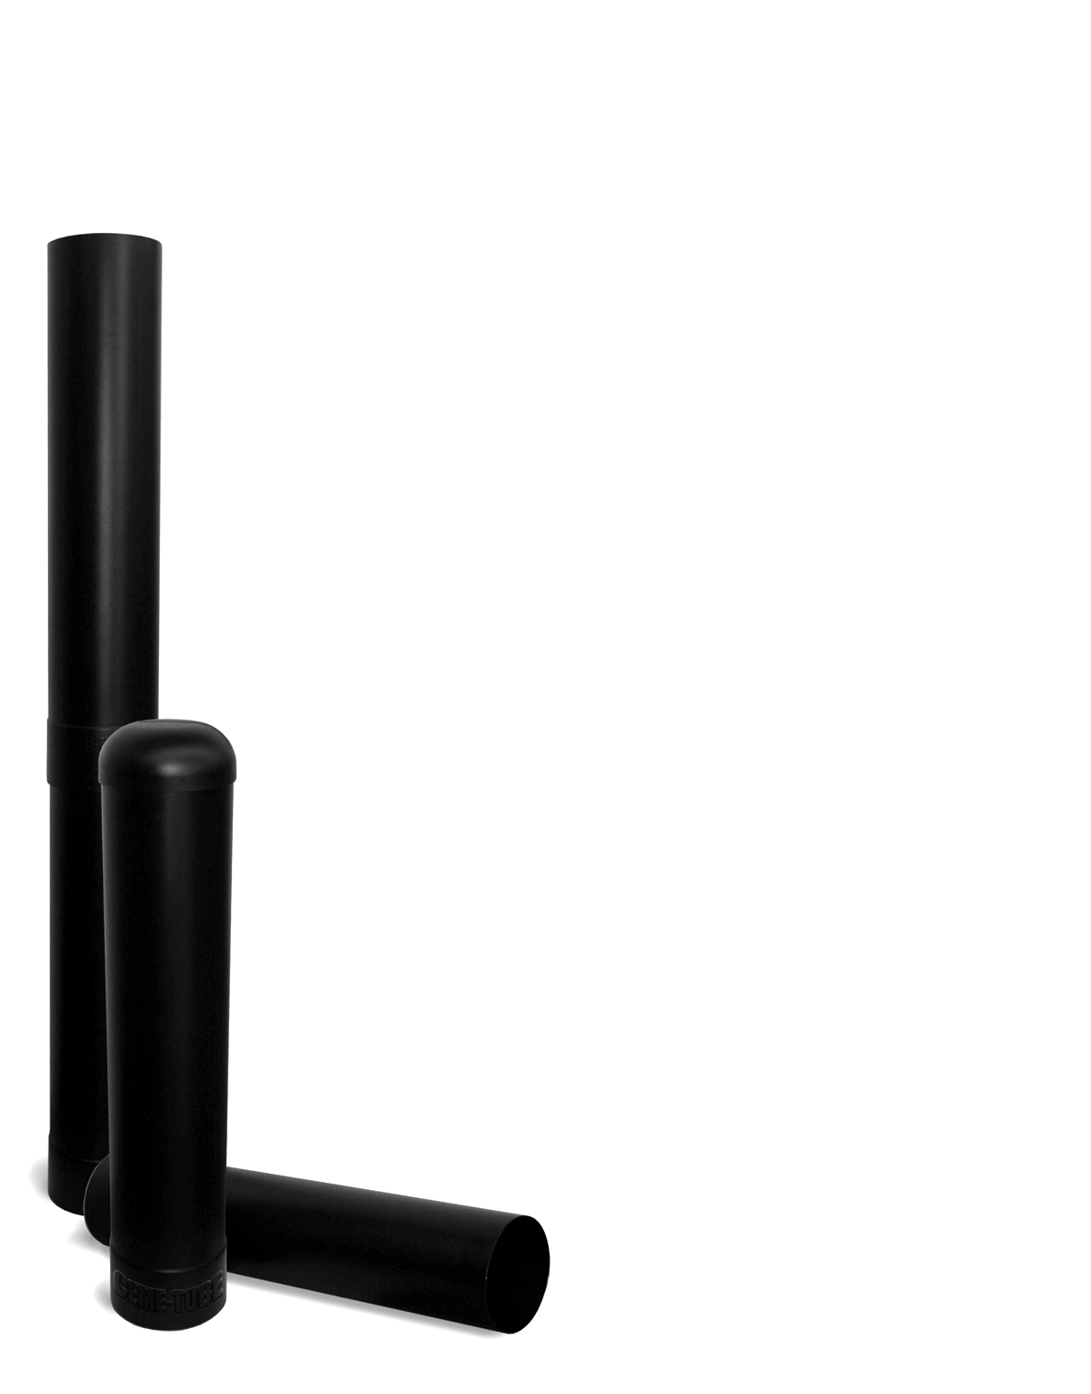

The Standard CEME-TUBE
An Innovative new product to replace the cardboard forming tube.

CEME-TUBE LLC
Jim Bradac- Owner
1293 County Road i
Hudson, WI. 54016

Phone- 715-377-2133
Fax- 715-377-2135
Cell- 612-730-6880
Web- www.cemetube.com
Email- info@cemetube.com

Made from partially recycled HDPE plastic, and available in 8”, 10”, 12”, 18”, 24”, and 30” diameters, the new CEME-TUBE will change the way footings and piers are made. This revolutionary new product will eliminate a multitude of problems found with using cardboard forming tubes. The CEME-TUBE will not only take job site and shipping abuse, but it can be installed, completely backfilled, and filled with concrete at any future date. All CEME-TUBEs are 4 foot in length, but with the integral collar on one end, can be stacked to produce piers up to 20’ tall in one pour. (12’ tall for 30” model) The finished pier will be round, smooth, equal in diameter, and of architectural grade for the entire length. An optional domed cap is available in all sizes to keep rain, dirt, children etc. out of the hole prior to pouring concrete.

- Impervious to moisture, before and after pouring.
- Eliminates “Friction frost heaving” in colder climates.
- Can be installed, completely backfilled, and then filled with concrete at any future date.
- Can easily handle jobsite and shipping abuse without losing integrity.
- All models are 4’ in length, but can be stacked to achieve 20’ tall piers and footings. (12’ tall for 30” model)
- Molded from partially recycled HDPE plastic and is flexible to -103 deg. F. The Ceme-Tube will not chip or crack when cold.
- Unlike cardboard tubes, the diameters are uniform from one Ceme-Tube to another.
- Easily cut with common power tools.
- Easily strippable using a grinder with any type of cutting or grinding wheel.
Note: When stripping, only cut Ceme-Tube approximately 90% through, score inside cut with a utility knife, and tube will split open with minimal effort.
- On above ground applications, tubes will not fade, and can be left on for an aesthetic appearance.
- Works well for underwater dock piers.
- Will work in conjunction with all
manufactured footing bells like Bigfoot.
- Optional domed top caps are available
for all sizes to keep dirt, rain,
children, etc. out of hole prior to pouring.
- Finished pier will be round, smooth,
and of architectural grade.
- No more rotating form lines as with
cardboard tubes.

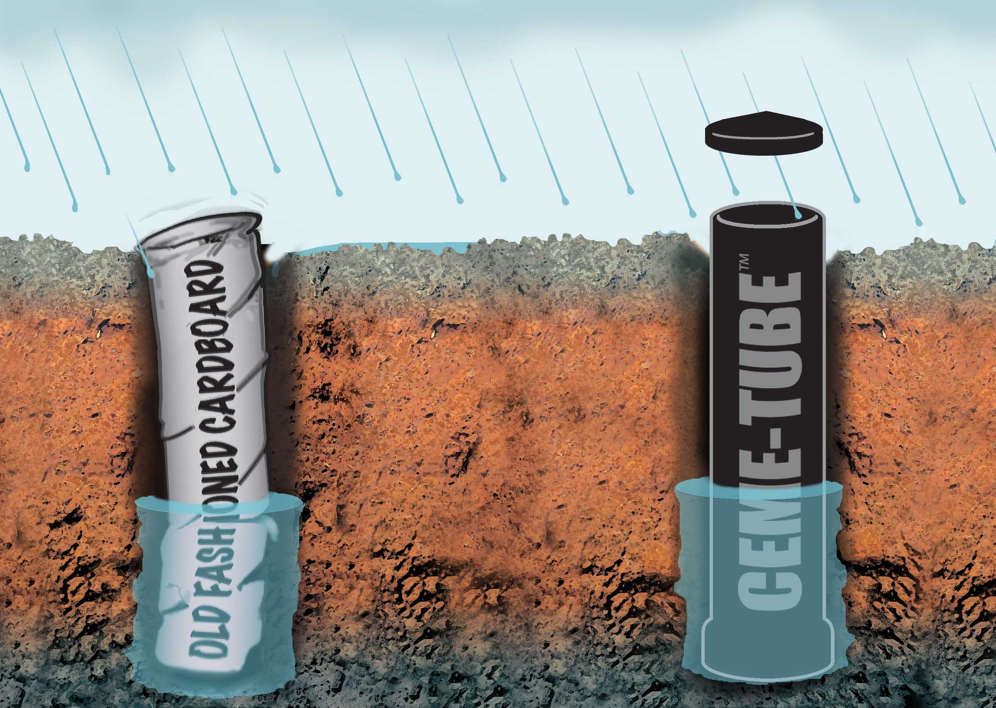
Optional
Top Cap
The Ceme-Tube is impervious to moisture!

