Joint estimation of neonatal mortality and vital registration completeness across Mexico

Nathaniel Henry

2021-09-19

# 1 Introduction

Proper surveillance of vital events and disease burden across a country is critical for national health planning, making it an important component of the right to proper medical care enshrined in the Universal Declaration of Human Rights.1,2 Many countries implement a system of civil registration that requires medical professionals to produce legal documents for vital events such as births and deaths; these records are compiled in nationwide vital statistics that provide the foundation for national strategic planning.3 However, despite their importance in setting national priorities for health care, local variation in the quality and completeness of these Civil Registration and Vital Statistics systems (CRVS) remains poorly understood.

Many geospatial studies investigating local variation in disease burden derive their estimates from cluster-level observations in household surveys and censuses.4,5 Routine health surveillance includes features that make it an appealing alternative or supplement to traditional geospatial data sources: most notably, the sample sizes associated with CRVS datasets are typically orders of magnitude larger than those collected in any household survey. While years may pass between two household surveys, functioning health surveillance systems provide an unbroken series of observations over time. Many surveillance systems already report health status at the administrative level that is most relevant to country-level financing and planning. More broadly, global health researchers have the opportunity to invest in, and advocate for, data sources that are fundamentally tied to the success of national health systems in the countries where our research is focused.6

However, critical issues must be resolved before CRVS data can be incorporated into geospatial analyses of health. The most pressing of these is the question of varying incompleteness in health surveillance in space and time. Previous analyses have shown that the completeness of CRVS data varies across countries, across states or provinces within countries, and over time;7 completeness is also generally lower for the registration of deaths among children than among adults.8 While completeness of death registration has improved in many countries since 2000, it remains low in many low- and middle- income countries where the global burden of child mortality is concentrated.9 While methods have been developed to account for incompleteness in health surveillance data at the national and state levels,10–12 these methods cannot be directly applied at more local levels due to the general geospatial problem of small sample sizes.

In this chapter, I demonstrate how household survey data and CRVS data can be incorporated into a novel geostatistical model that simultaneously estimates neonatal mortality and CRVS incompleteness at a local level. I present results for this model in the context of Mexico, which has a CRVS system that is considered near-complete at the national level but may be incomplete in marginalized municipalities.

## 1.1 Estimating completeness of birth and death registration across Latin America

Many Latin American countries are now facing challenges and opportunities associated with estimating mortality based on CRVS records that are increasing in quality each year. Most countries across the region first developed vital statistics programs during an international push for civil registration in the 1960s;13 however, by the early 2000s, many of these systems remained highly incomplete.9 In Mexico, a health reform policy called the Seguro Popular dramatically increased health system coverage and registration during the early years of the 21st century,14 while in Brazil, increased interest in health statistics performance produced a series of studies on CRVS completeness.15–18 Today, international statistical groups such as the UN Inter-agency Group on Mortality Estimation (UN IGME) and the Institute for Health Metrics and Evaluation (IHME) rate Argentina, Brazil, Chile, and Mexico as having some of the most complete CRVS systems in the world,19,20 while other countries in the region such as Ecuador and Colombia are transitioning towards a health surveillance system based on primarily CRVS data.21 Data sources for health are relatively plentiful across many Latin American countries, including both household surveys and vital records.

While the completeness of CRVS data is of great interest to ministries of health in these countries, estimating completeness of vital records for children at the subnational level remains challenging. For decades, capture-recapture analysis was the preferred method for estimating the completeness of vital records. This method was derived from ecology, where it is still used to estimate wildlife populations based on multiple surveys.22 The method relies on an assumption, shown graphically in Figure 1.1, that each event of interest has an independent and equal probability of being recorded by a particular data source, and data sources are therefore capturing independent samples of a total population. In 1949, health statisticians Chandra Sekar and Deming applied this method to estimate true underlying birth and death rates based on a combination of a government registry and a household survey in a neighborhood in Calcutta.23 Since then, the same basic approach has been extended to estimate disease incidence,24 cause-specific mortality, and prevalence of genetic disorders, to name a few examples.25 From the 1950s through the 1990s, the capture-recapture methods was widely used to estimate incompleteness of mortality data in middle-income countries.[Yip1995;]26 However, this method fell out of favor in the early 2000s given the weakness of its assumptions: under realistic circumstances, events captured by one survey are typically more likely to be captured by other surveys as well, meaning that the results from capture-recapture analysis are almost always under-estimates.27,28

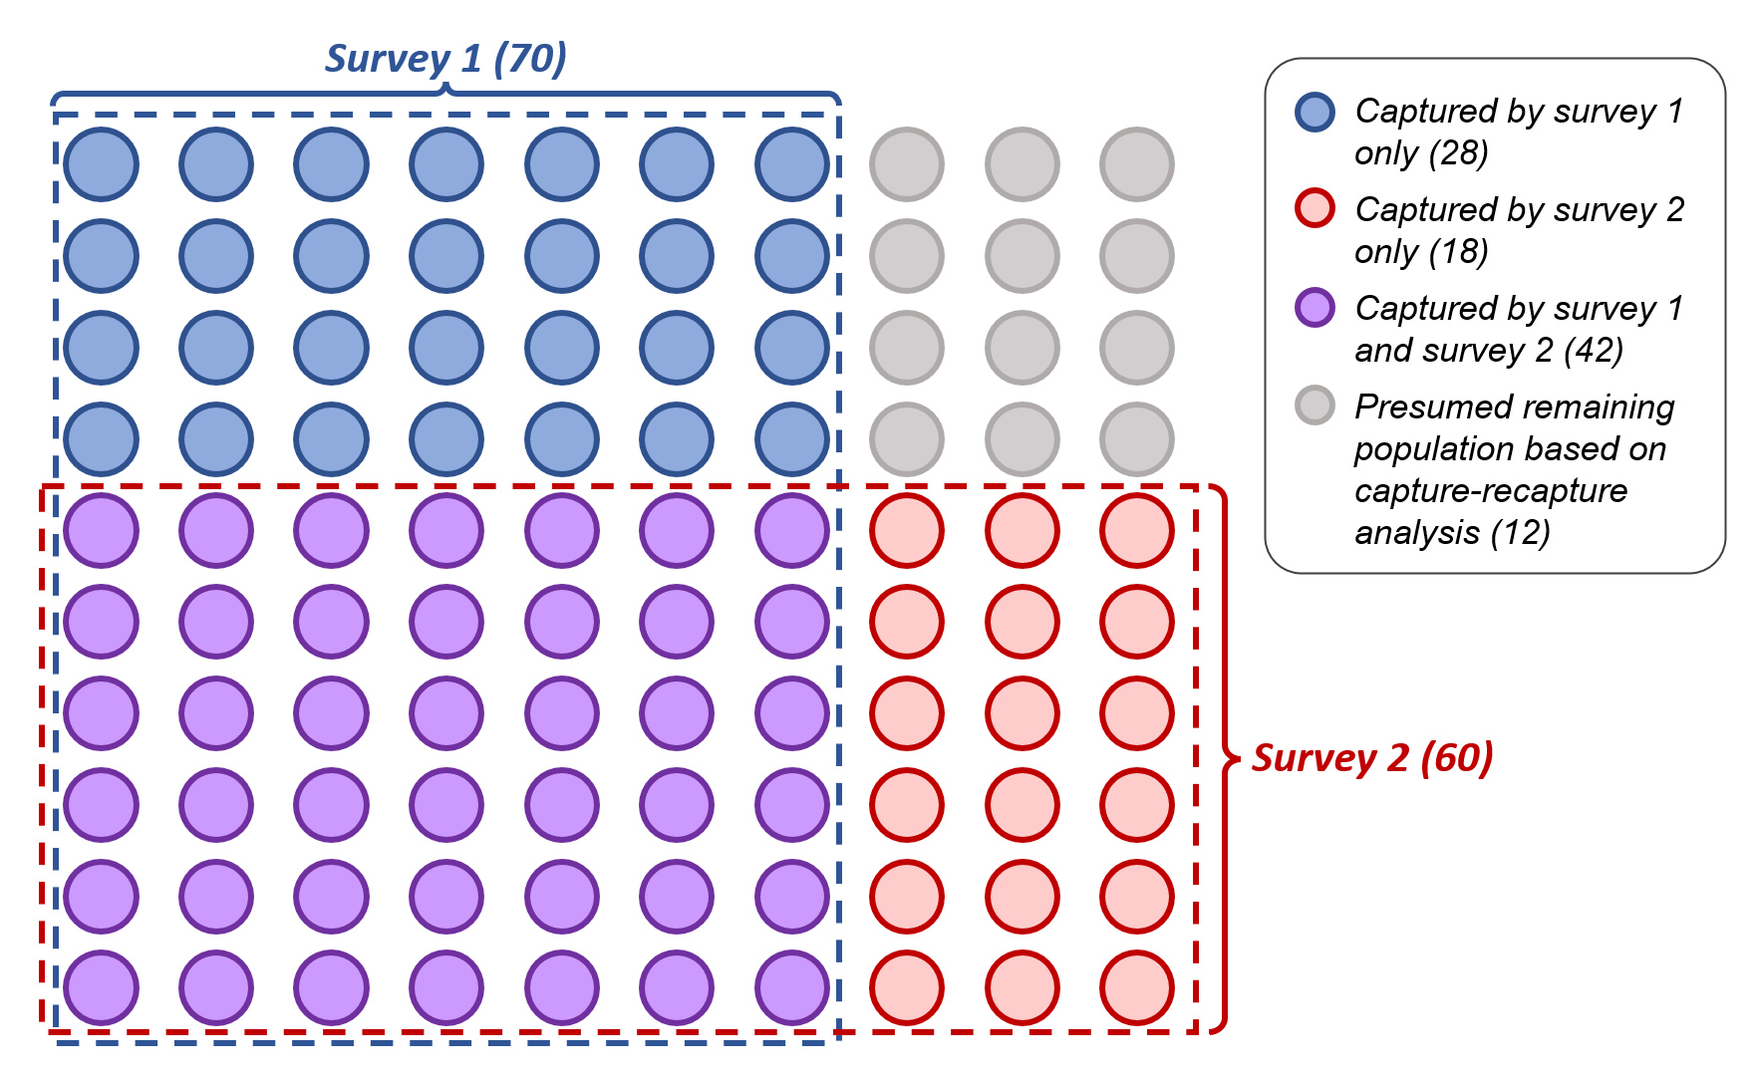

Figure 1.1: A visual demonstration of capture-recapture analysis using linked records from two surveys.

More recently, some countries have begun to implement small-scale audits to check the completeness of CRVS records for child mortality. These audits operate in a relatively small number of districts: within each district, a trained team of investigators develops an exhaustive record of mortality based on data from hospitals, churches, graveyards, and sometimes a household survey. These audits have been conducted in select regions of Brazil,16,17,29 Colombia,30 and Mexico.31 In Mexico, a 2009 audit of 101 municipalities with a low Human Development Index identified that 68% of births and 22% of deaths among children under 5 had not been entered into government registries, in contrast to relatively high coverage of birth and death registration across the rest of the country.31

A previous modeling study in Brazil combined CRVS records with completeness estimates from a series of local CRVS audits to estimate child mortality by Brazilian mesoregion.32 This study provided a novel Bayesian approach for estimating child mortality from incomplete CRVS data: the true under-5 mortality rate, , was fit indirectly to the data , where and are the under-5 population and deaths recorded by CRVS in a mesoregion, and is an incompleteness parameter with a strong prior based on previous CRVS audits. However, because the mortality rate was only fit indirectly using small-counts data, child mortality estimates were subject to wide uncertainty at the mesoregion level. Additionally, while the study was able to draw on a series of existing audits estimating the completeness of under-5 mortality records across the mesoregions of Brazil,16,17 the relative expense of these audits reduces their capacity to enumerate child mortality completeness across other Latin American countries.

A third approach to mortality estimation across Latin America has prioritized collating data from multiple sources to produce a unified estimate of mortality. Two classes of data have historically informed estimates of child mortality: birth history (BH) data, which retrospectively lists the life histories of all children born to a mother, and CRVS data, which attempts to enumerate all births and deaths in a given time period. At the national level, multi-source estimation methods have combined estimates from these two data types to estimate both mortality trends and CRVS completeness,20,33 but the methods deployed in these studies are problematic for subnational estimation due to the smaller sample sizes available at each observation. Most modeled subnational estimates of child mortality have relied solely on birth history data from household surveys, informed by spatial covariates.34–36 However, in countries with high-quality CRVS systems such as Mexico, vital records are a preferable data source for mortality estimation under most circumstances due to their greater spatial coverage, larger sample sizes, and integration into existing processes for health decision-making.37

In the following section, I will describe a small-area model to estimate neonatal mortality across Mexican municipalities by combining BH and CRVS data, with an emphasis on the interpretation of bias in CRVS data.

# 2 Methods

I developed a small area model that simultaneously estimates neonatal mortality rates and CRVS bias by municipality. This model incorporates two sources of data for neonatal mortality, both of which collect data about births and age-specific mortality: (1) birth histories collected from household surveys and (2) birth and death records from a civil registration system. To test the predictive validity of this joint estimation framework, I first fit a model using observations generated from simulated surfaces of neonatal mortality and CRVS bias, measuring the correspondence between the simulated underlying surfaces and the recovered model parameters. I then applied this model to estimate neonatal mortality and CRVS bias by Mexican municipalities in 2009-2010 using mortality data sources and covariates published by the Mexican Institute for Geography and Statistics (INEGI). By fitting multiple models with different priors on CRVS bias by municipality, I explored the effects of CRVS bias terms on municipal and state-level neonatal mortality estimates during the years 2009-2010.

## 2.1 Data preparation

The model incorporates birth and death data from civil registration, mortality data from household surveys, and areal-level covariates. I prepared data across two years, 2009 and 2010, in order to increase the sample sizes of observed births and to avoid CRVS reporting delays in single years while still capturing a relatively short time period within which neonatal mortality can be safely assumed to remain relatively stable. I downloaded publicly-available microdata on births and deaths by municipality from the INEGI website.38 While both birth and death records were anonymized, birth records contained information on the date of birth and municipality of residence at birth, while death records contained information on the date of death, municipality of residence at death, and age at death. I summed all deaths that occurred in the years 2009-2010 among neonates under 28 days of age by municipality, and summed all births by municipality over the same time period: these summed values comprise the CRVS observations that were used as input to the geostatistical model. Less than 0.1% of all birth and deaths were registered to a state of residence, but not a municipality of residence; these observations were distributed across municipalities within a state in proportion to the number of births and deaths registered to each municipality. Neonatal deaths were assumed to occur in the same municipality where a child was registered at birth.

I downloaded and prepared birth history (BH) data from the 2010 Mexican Population and Housing Census, which was conducted in May through June 2010. This census administered a household survey to a sample of census respondents: anonymized copies of these these survey responses were shared publicly online, along with the sample weights and municipality of residence corresponding with each household.39 The household survey asked all women over 12 about the date of birth of their most recent child, whether the child was still living, and if not, that child’s age at death. I censored these birth history observations to exclude all births prior to January 2009, corresponding to the first observed month in 2009-2010 CRVS data, and after April 2010, one month prior to the beginning of data collection. Among all remaining birth observations, neonatal mortality was coded as any death occurring under 28 days of age. To obtain the denominator for NMR observations from the census, I summed all births observed during this time period by municipality; to calculate the numerator, I multiplied birth denominators by a weighted mean of neonatal mortality observations across households in each municipality, weighting household-level mortality observations inversely to their sampling probabilities. I also estimated social and demographic covariates from census microdata by taking survey-weighted means of household responses by municipality.

All municipalities were matched to a shapefile, published by INEGI, which corresponds to the 2010 Population and Housing Census enumeration boundaries.40

### 2.1.1 Grouping of municipalities by social exclusion

Previous studies of CRVS completeness across Mexico suggest that while birth and death registration are close to complete across most municipalities, registration remains incomplete in a subset of municipalities where residents are unable to access government services due to social exclusion. Therefore, an index of social marginalization based on factors identified in previous studies of birth and death under-registration can be a useful method for informing prior estimates of CRVS bias in a joint mortality estimation model.31,41 While a previous study in Mexico used the Human Development Index (HDI) as a measure of social exclusion by municipality,31 the inclusion of mortality as one component of the HDI presents a circularity problem given that mortality is also a desired output of this model. Here, I group municipalities based on four dimensions of social exclusion measured by the 2010 Population and Housing Census: the literacy rate among adult women, the proportion of adults employed in the formal economy, the number of health clinics *per capita* within a municipality, and the proportion of residents who self-identify as indigenous. Of these indicators, the first two are associated with the “knowledge” and “standard of living” components of the HDI, while the latter two correspond to barriers specifically identified in previous studies of birth registration and maternal care in Mexico.41–43

I placed Mexican municipalities into one of three groupings based on these relevant dimensions of social marginalization. Municipalities with a majority of indigenous residents, no clinics, a formal employment rate of less than 25%, and a literacy rate of less than 75% among adult women were assigned to the most severe level marginalization grouping: this grouping covered 6.2% of municipalities (152/2,441). A second group of municipalities with a majority of indigenous residents, no clinics, a formal employment rate of less than 50%, and a literacy rate of less than 90% among adult women were assigned to a moderately marginalized group: this grouping covered 17.9% of municipalities (437/2,441). All other municipalities (75.9%, 1,852/2,441) were assigned to the least marginalized grouping, corresponding to the observation from previous studies that CRVS under-registration is concentrated within a relatively small number of municipalities.31 As shown in Figure 2.1, marginalized municipalities assigned using this standard are largely concentrated in the southern states of Guerrero, Oaxaca, Chiapas, and Yucatan.

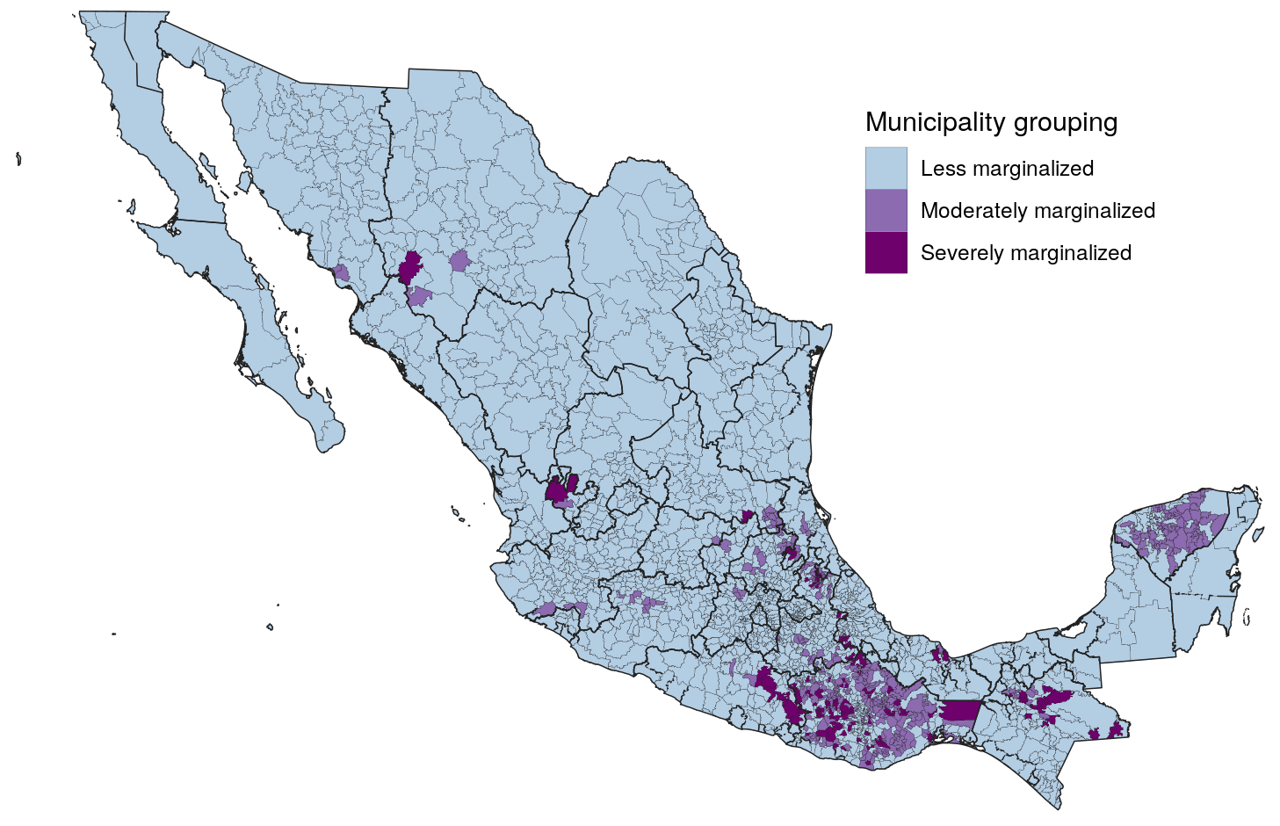

Figure 2.1: Grouping of municipalities into exclusion categories based on indigenous status, proximity to clinics, adult employment in the formal economy, and literacy rates among adult women.

## 2.2 Joint estimation of neonatal mortality and CRVS data completeness

Here, I present a new geospatial model that simultaneously estimates neonatal mortality and CRVS completeness across small spatial areas, using data from both BH and CRVS sources in a single country. The two outcomes of interest are the probability of death before reaching one month of age ( in demographic notation, which I will refer to as in the following definitions), and the ratio between birth and death underreporting that expresses itself as bias in CRVS estimates of neonatal mortality (which I will refer to as in the following definitions). Both of these terms are defined for each municipal unit across Mexico, with municipality *i* denoted as . The mortality surface of interest, , is defined as follows:

Here, is a logit-linear surface indexed by spatial unit . The estimated value for is centered around an intercept and varies according to covariate fixed effects , with known denoting predictive covariates that vary by municipality. The set of covariates include two binary-coded variables indicating whether a municipality is moderately or severely marginalized according to the groupings described in the previous section; the fixed effects associated with these covariates indicate the overall effect of social marginalization compared to the less-marginalized category after adjusting for all other fixed effects. Remaining variation not captured by covariates is fit by a structured random effect , which corresponds to the BYM2 spatial model formulation described by Riebler and colleagues.44 This model formulation has both spatial and independently, identically distributed (IID) components, with model parameters identifying the overall variance of as well as the proportion of excess variation associated with spatial autocorrelation. Spatial autocorrelation is fit using the neighborhood structure of municipalities identified from the INEGI shapefile.40

The probability of dying before 1 month of age in each municipality, , is fit to binomial observations of births and deaths from aggregated birth histories collected in the 2010 census. Because the census household survey only collected information about the most recent birth for each adult woman, this survey may exclude a small number of children born in 2009 and succeeded by a more recent birth in late 2009 to 2010. To account for the potential bias associated with this exclusion, all birth history observations are evaluated against the estimated underlying mortality multiplied by a bias term, :

Simultaneously, the same mortality surface is fit to birth () and neonatal death () observations from 2009-2010 Mexican CRVS data. Unlike the constant bias term applied to birth history observations, bias terms for CRVS are fit separately for each municipality and are therefore denoted :

While the separate completeness rates for birth certification and and neonatal death records are not identifiable from the model, the CRVS bias terms, , indicate the estimated ratio between the completeness of these two systems in a given municipality. A CRVS bias term of indicates that the under-reporting rates for births and deaths are identical in municipality A, but cannot distinguish between municipalities with complete birth and death registration as opposed to municipalities where birth and death registration both 80% complete. However, values of far from 1 suggest that one source is substantially less complete than another. For example, indicates that death registration is half as complete as birth certification in municipality B; conversely indicates that death registration is three times as complete as birth registration in municipality C.

Previous investigations have identified how Mexico’s indigenous communities face greater barriers to accessing delivery and postnatal health care, a form of structural violence leading to greater neonatal mortality as well as incomplete registration of births and neonatal deaths among these communities.41–43 Based on these findings, I pool information about the relative completeness of birth and death registration across the three social marginalization groupings, . The CRVS bias terms for municipalities within each marginalization group are assumed to vary according to a log-normal distribution centered around 1, with a pooled variance shared across the group:

Priors were set on each grouped standard deviation, reflecting past findings that birth and neonatal death registration are likely to be complete in most municipalities, and that reporting bias is more likely to arise in marginalized communities.20,31,41,43,45 I employed penalized complexity priors, which have an appealing interpretation taking the form:

In this specification, is the standard deviation of the lognormal distribution centered around 1 (no bias) for a particular marginalization group; is a researcher-defined upper threshold for likely values of this standard deviation, and is the researcher-defined estimate probability of the “tail event” that the standard deviation will exceed this threshold.46 The thresholds for each group can also be interpreted as the bounds within which most bias estimates are likely to fall for each marginalization group. Table ?? show the prior specifications for each of the three marginalization groups. This table shows that expected variablility in CRVS bias terms are expected to increase with marginalization.

I assigned priors to all model parameters and then fit the model using the Laplace approximation for mixed-effect parameter estimation47,48⁠. The model was fit in R v.4.0.3 using the package Template Model Builder v.1.7.1847,49.

## 2.3 Simulation model

To determine the model’s capacity to reconstruct true neonatal mortality and CRVS bias from two sources, I developed a simulation model under realistic conditions for neonatal mortality and CRVS bias in Mexico. First, I simulated neonatal mortality values by setting values for the intercept and five logit-linear covariate effects, all of which were estimated based on data from the 2010 Mexican Population and Housing Census:

Birth history and CRVS death observations were simulated as biased binomial draws from this surface, using the existing birth denominators set in the real data, with BH bias set to 0.2 and CRVS bias draws generated from the lognormal distributions specified above.

In small area spatial models, the correlated random effect is understood to account for latent variables that affect the outcome but are not directly observed.50 In the simulation model, the final two covariates used to simulate the mortality surface (rates of household electrification and refrigerator ownership) are excluded from the fixed effect terms available to the model, meaning that variation from these terms must be captured by the correlated random surface. I checked the model’s goodness of fit by comparing estimated parameters for covariate fixed effects, VR bias parameters by municipality, and predicted neonatal mortality by municipality to the underlying values generated from simulation.

## 2.4 Application to neonatal mortality data in Mexico

I fit two models for neonatal mortality across Mexican municipalities using births and deaths from the 2010 census as well as 2009-2010 CRVS records.38,39 I included six covariates observed at the municipality level, all of which came from the 2010 census: years of schooling among adult women, proportion of employed adults earning less than 2 times the minimum wage, proportion of adults without access to health care, proportion of electrified households, proportion of households owning a refrigerator, and proportion of households with piped water. Both model fits included a term for BH bias; the first model fit CRVS bias terms according to the model formulation described above, while the second model forced all CRVS terms to zero, essentially treating CRVS as an unbiased data source. The first model is reported below as the primary source of model results, while the no-CRVS-bias model is used as a baseline to explore the effect of the CRVS bias terms.

# 3 Results

## 3.1 Predictive validity from simulation

In general, the simulation model accurately estimated neonatal mortality across the municipalities of Mexico, and accurately recovered known parameters. Table ??, below, lists simulated values for fixed effects and the BH bias term along with the values recovered by the model. All covariate fixed effects and the BH bias term were accurately predicted by the model within the bounds of uncertainty.

Figure 3.1, below, shows simulated mortality rates (left) and CRVS bias terms (right) produced in the simulation on the x-axis, while the model estimates for these terms are displayed with uncertainty on the y-axis. As shown on the left side of this figure, the simulation model produced unbiased estimates of the neonatal mortality rate by municipality, with the true mortality value falling with the model’s 95% uncertainty bounds for 2434 of 2441 municipalities. The recovered estimates for the CRVS bias terms are more mixed: while the majority of mean estimates for CRVS bias match the direction (over-reporting or under-reporting) of the true term, and the 95% uncertainty intervals for CRVS bias encompass the true simulated value in 2326 of 2441 municipalities (95.2%), wide uncertainty intervals preclude confident estimation about the direction of CRVS bias.

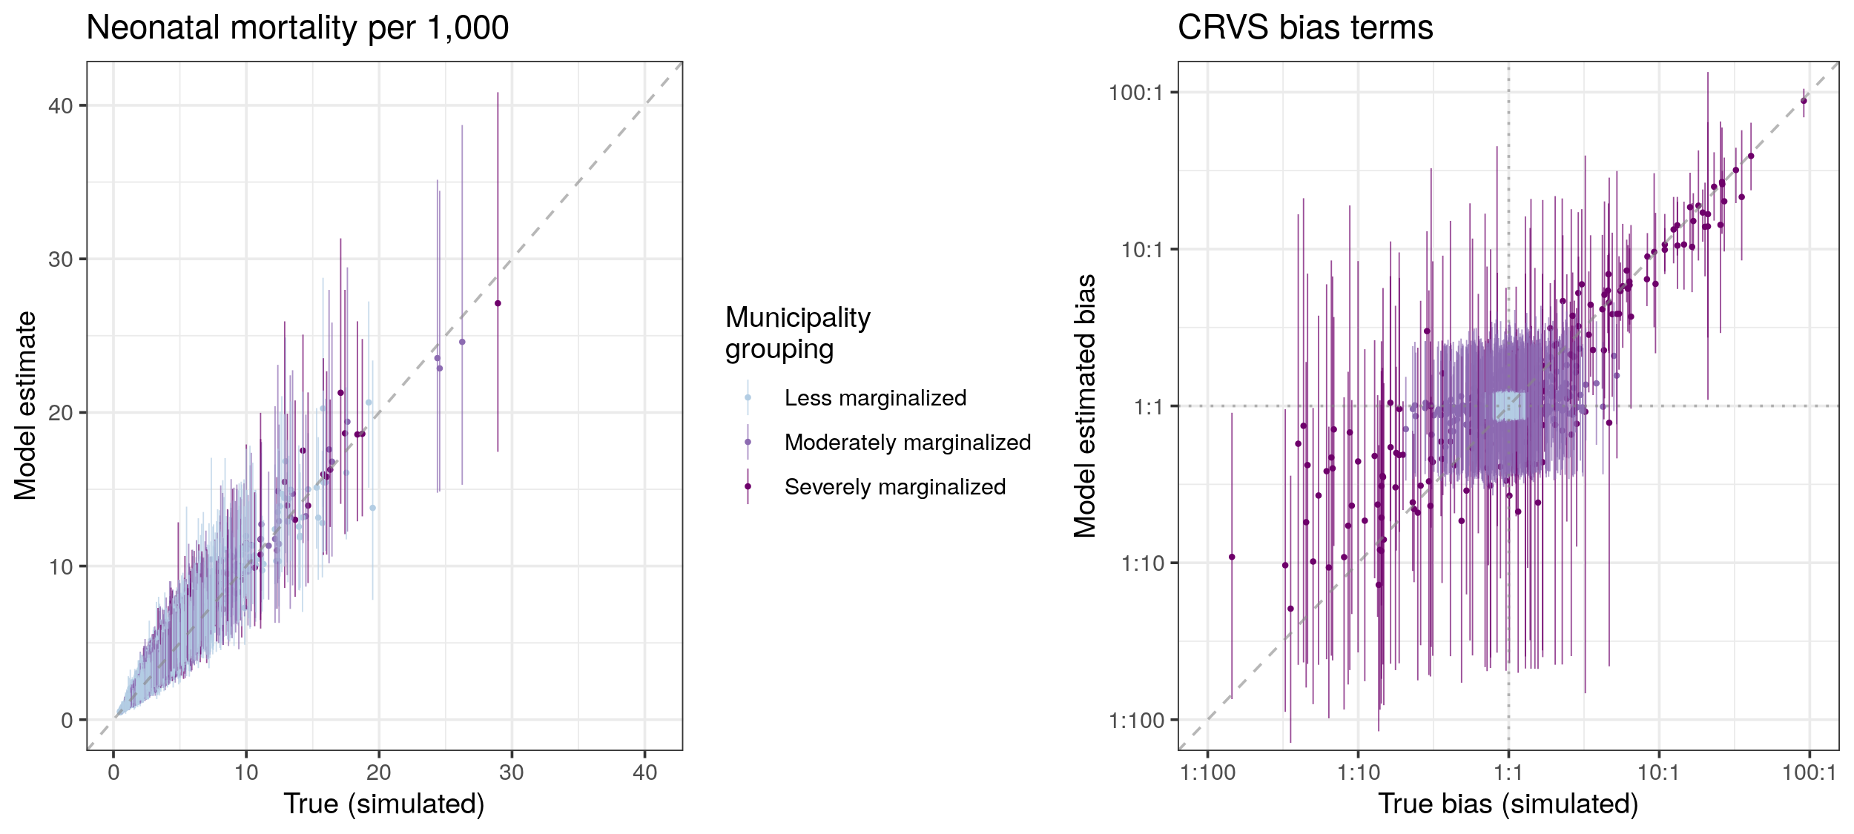

Figure 3.1: Simulated neonatal mortality rates across Mexican municipalities compared to neonatal mortality rates recovered from the spatial statistical model. Points indicate the mean NMR estimated by the model, while vertical line spans represent the 95% uncertainty intervals for NMR estimated by the model for each municipality. CRVS bias terms simulated for model input data, on the x-axis, compared to the mean and 95% uncertainty intervals for these bias parameters recovered by the spatial statistical model, on the y-axis.

## 3.2 Neonatal mortality across Mexico

### 3.2.1 Relationship between social marginalization and covariates predictive of mortality

Figure 3.2, below, shows the distribution of seven social and economic variables at the municipality level by marginalization group. By comparing the mean and inter-quartile range of values for municipalities in the “Less marginalized” and “Severely marginalized” groupings, it becomes apparent that the differences in these groups correlate not just to factors that may affect birth and death registration, but may also have an impact on neonatal mortality rates. These differences include rates of household crowding, with an IQR of 26.5% to 39.8% among less-marginalized municipalities and 45.4% to 59.0% among severely-marginalized municipalities; piped water access, with respective IQRs of 81.6%-98.4% versus 57.3%-92.0%; and maternal literacy, with respective IQRs of 93.0%-98.1% versus 67.5%-83.7%.

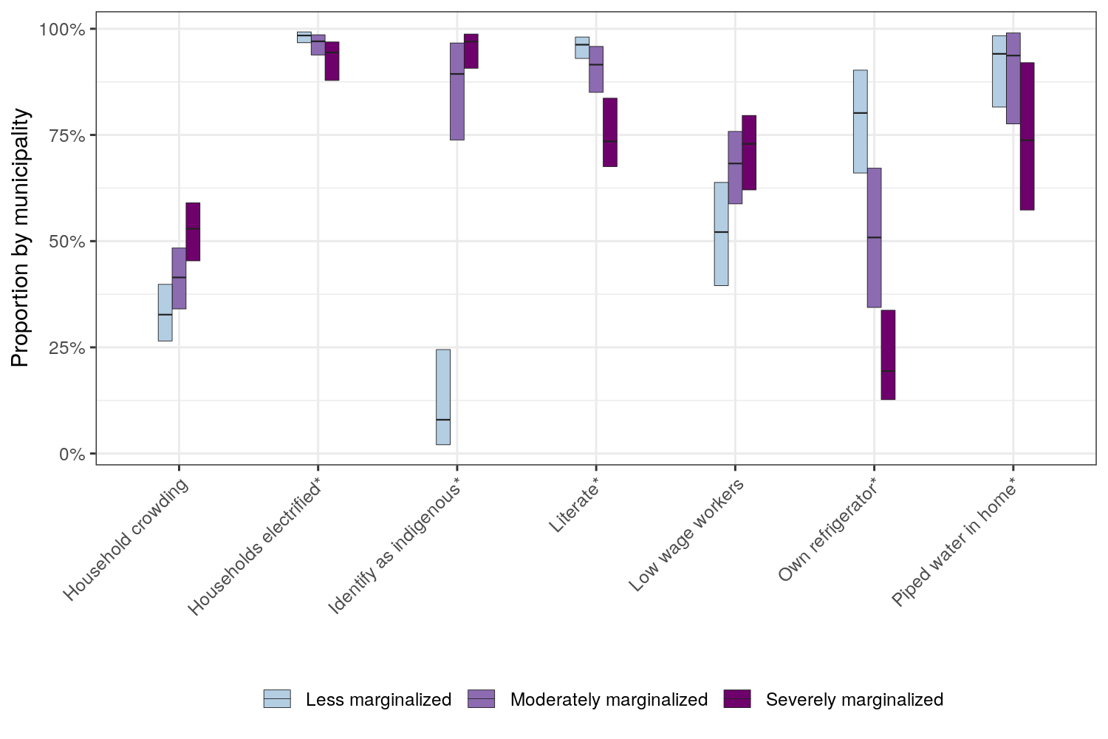

Figure 3.2: Distribution of socio-economic indicators across municipalities within each exclusion grouping. The center line of each bar represents the median value for each indicator across less marginalized (N=1852), moderately marginalized (N=437), and severely marginalized (N=152) municipalities across Mexico, while the vertical range of each bar represents the inter-quartile range of indicator values for each grouping.

### 3.2.2 Joint estimation model of neonatal mortality and CRVS bias

Figure 3.3 shows the mean estimated neonatal mortality rates across Mexican municipalities in 2009-2010. At the national level, the neonatal mortality rate was estimated to be 7.4 (7.3 to 7.5) deaths per 1,000 live births. This estimate falls slightly below the NMR estimate of 9.0 (8.4 to 9.6) produced by the UN IGME, although these differences may be due to additional data sources used by UN IGME to generate national mortality estimates.

At the municipal level, the neonatal mortality rate varied substantially, from 2.7 (1.6-4.3) in Oxchuc, Chiapas to 21.9 (11.0-38.3) in Maltrata, Veracruz. The state of Nayarit in central-west Mexico had the highest proportion of low-mortality municipalities, with three of its 20 municipalities measuring an NMR below 4. Conversely, the states of Mexico and Puebla in central-south Mexico, to the west and south of the Federal District, had the highest number of municipalities with mortality estimated above 10 per 1,000 (21 of 122 municipalities in Mexico state, and 37 of 217 in Puebla). Estimated counts of neonatal deaths are highly concentrated in the capitol regions of most states: of the approximately 35,000 neonatal deaths estimated in 2009-2010, 25% are concentrated in just 26 municipalities, of which 17 are state capitol regions.

Figure 3.4 shows estimated CRVS bias terms across the municipalities of Mexico. Estimated CRVS bias is highly heterogeneous within several states, with large numbers of municipalities estimated to be both over-reporting and under-reporting neonatal mortality across the states of Guerrero, Oaxaca, Chiapas, and Yucatan. Most municipalities with large estimated bias also rank highly on the index for social exclusion; within these; similar magnitudes of bias are observed across moderately-marginalized and severely-marginalized municipalities. Smaller bias corrections can also be observed in less-marginalized municipalities across Mexico state as well as the northernmost municipalities in the country.

By comparing these results to a baseline model formulation that does not include a term for municipality-specific CRVS bias, we can visualize how CRVS bias terms influence the results of the joint NMR estimation model. Figure 3.5, below, shows the difference in estimated mortality rate between the full joint model and a model where CRVS bias is forced to zero in all municipalities. At the state level, the addition of the CRVS bias term only has a minor affect, ranging from a decrease of .3 deaths per 1,000 live births in Chihuahua (with an NMR of 8.8 compared to 9.1 in the baseline) to an increase of .5 deaths per 1,000 live births in Chiapas (with an NMR of 5.9 compared to 5.4 in the baseline). These changes are relatively small compared to the inter-state variation in neonatal mortality, which ranges from 5.3 in Coahuila to 9.3 in Puebla. However, this stability at the state level masks large differences among municipalities. Of the 2441 municipalities, 143 exhibit absolute differences of greater than 1 death per 1,000 between the two models. These changes can dramatically change a municipality’s neonatal mortality ranking within a state: for example, in the state of Oaxaca, the municipality of San Miguel Quetzaltepec’s ranking fell by 300 after a CRVS term was incorporated in the model, while the municipality of Santiago Yaveo rose by 304 positions out of 570 municipalities total. A moderate correlation, with a Pearson’s coefficient of 0.61, is observed between estimated neonatal mortality and the absolute difference in neonatal mortality between the two model formulations.

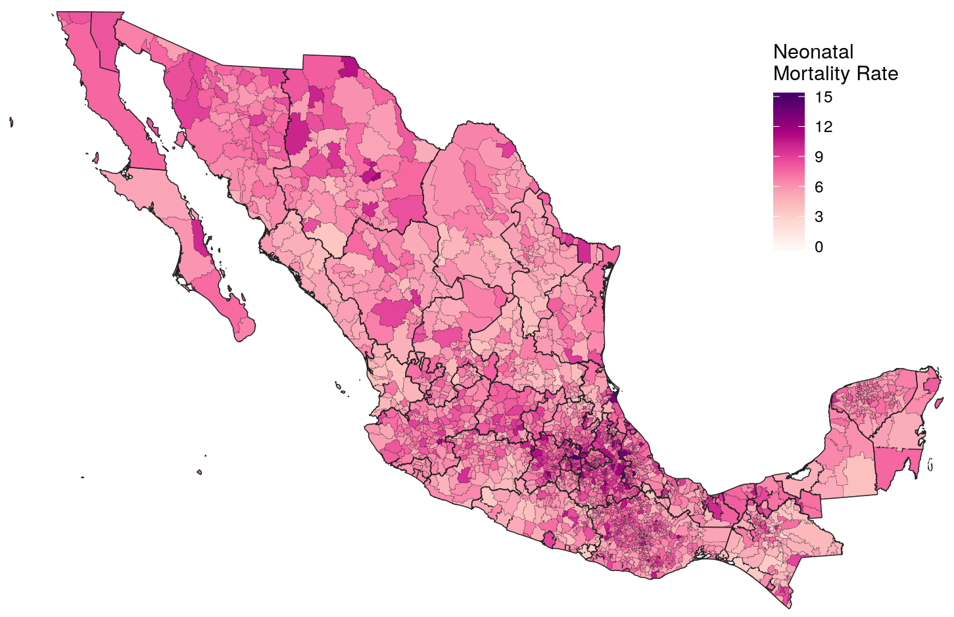

Figure 3.3: Neonatal mortality rate per 1,000 live births by Mexican municipality, 2009-2010, estimated by a joint model that incorporates both census and CRVS data.

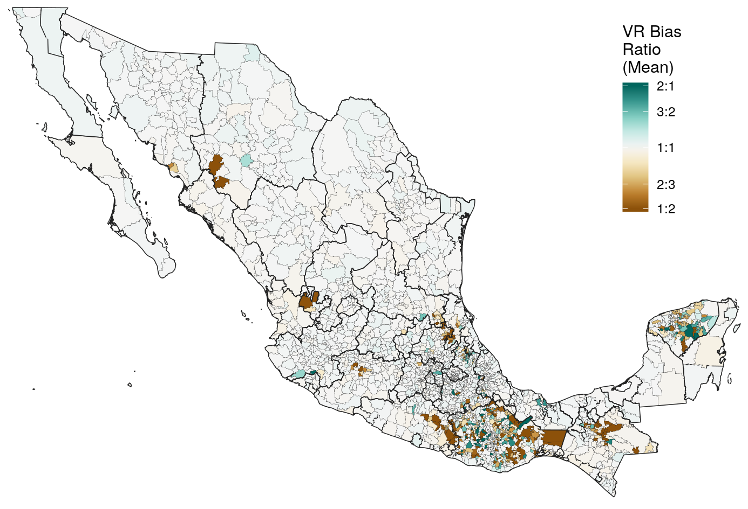

Figure 3.4: Mean estimates for CRVS bias terms predicted by the joint model for neonatal mortality. Municipalities shaded in green indicate under-registration of births relative to neonatal deaths, leading to inflated estimates of mortality based on raw CRVS data. Municipalities shaded in brown indicate under-registration of neonatal deaths relative to births, leading to under-estimation of mortality from raw CRVS data.

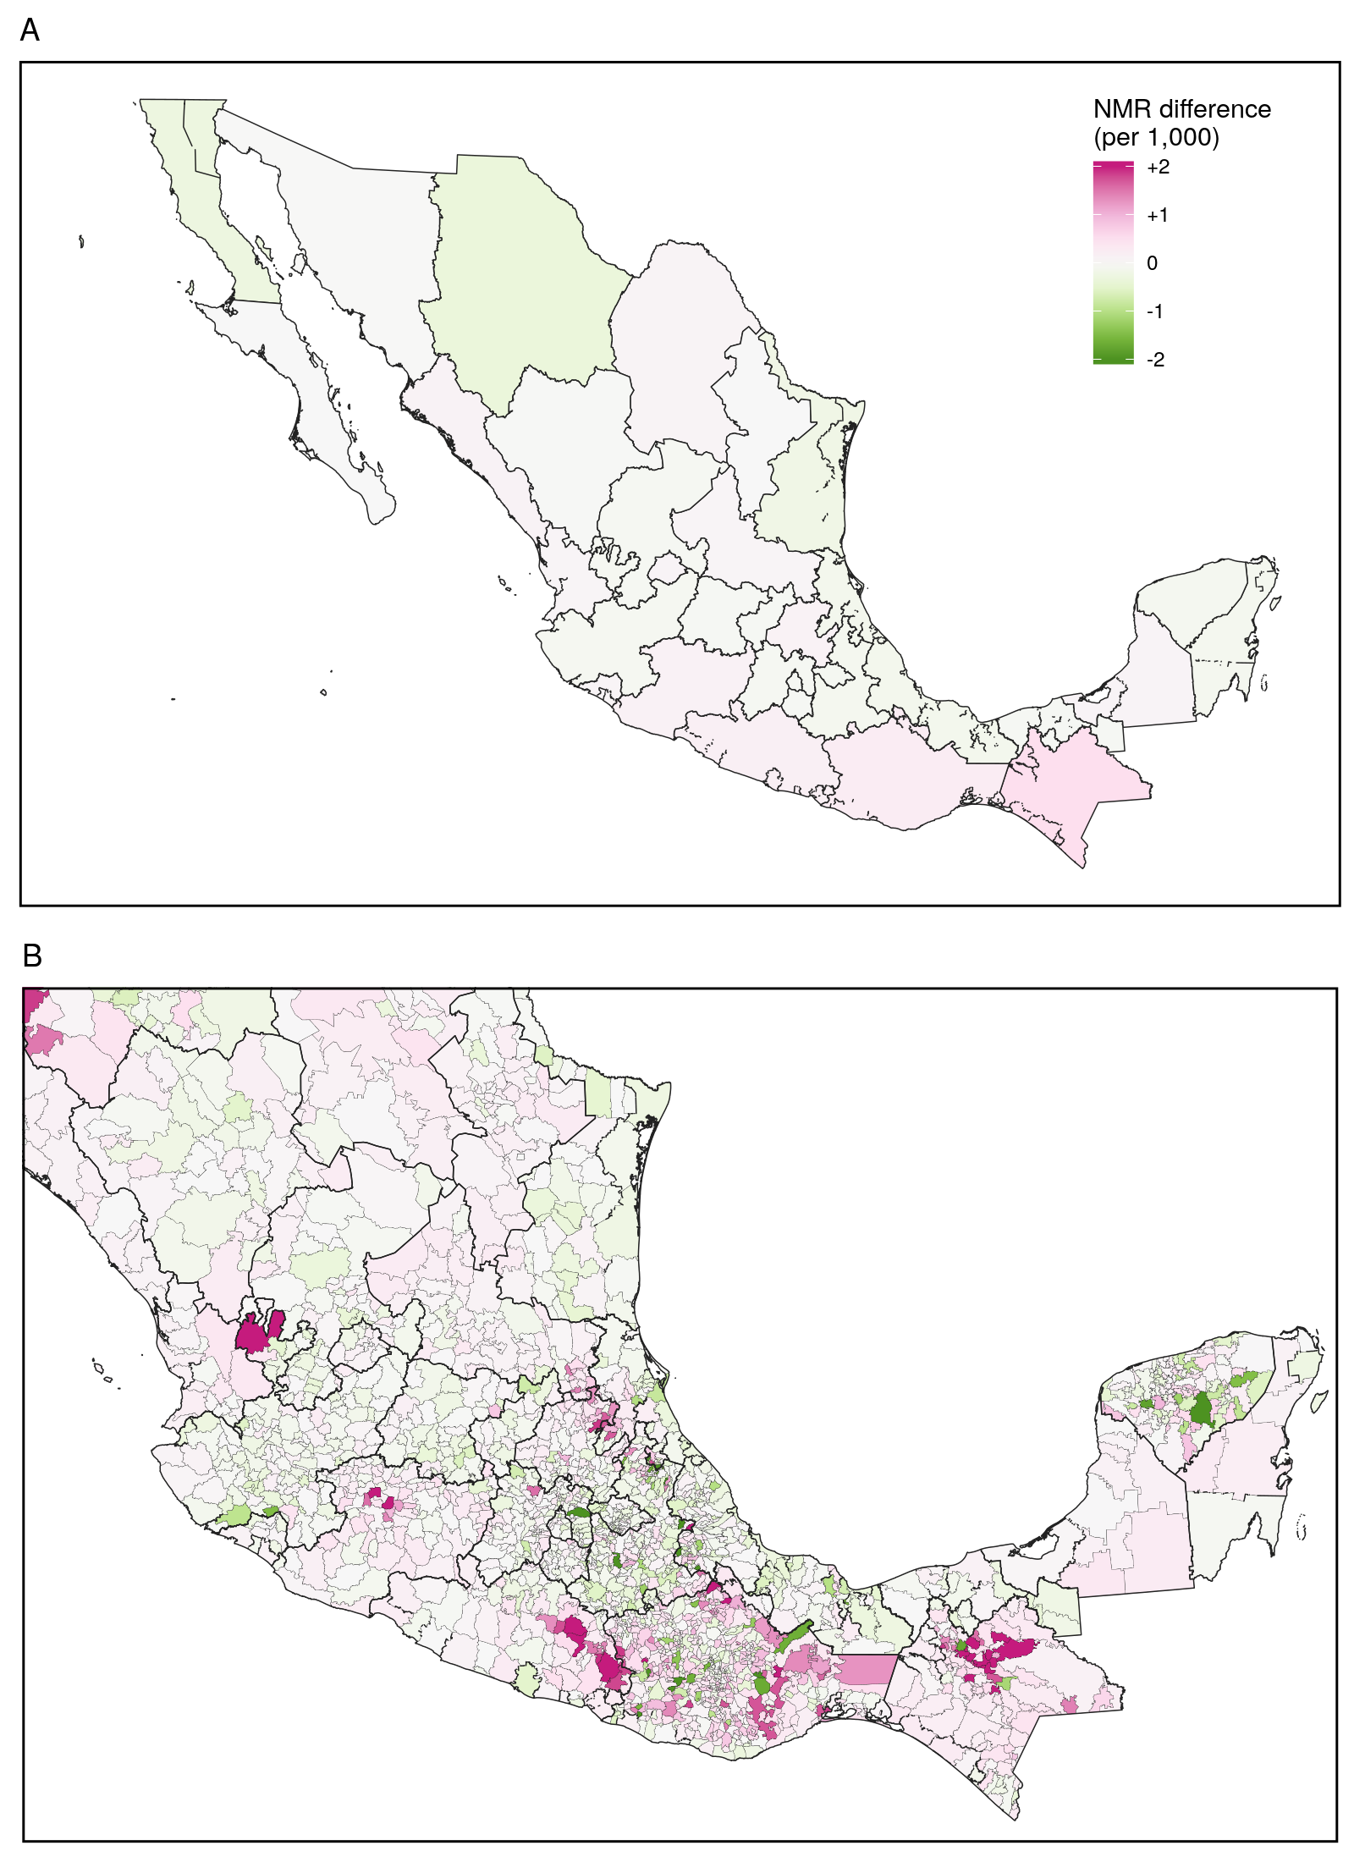

Figure 3.5: Comparison between a joint estimation model with CRVS bias terms and a baseline model where CRVS bias is set to zero. The two models estimate minor differences in the neonatal mortality rate by Mexican state, with overlapping 95% uncertainty intervals for all states. The two models generate substantially different and non-overlapping NMR estimates for municipalities in Guerrero, Oaxaca, and Chiapas states in the far south as well as Yucatan state in the far east.

# 4 Discussion

## 4.1 Performance of the simulation model

Simulation testing for this joint model formulations suggests a strong capacity to recover underlying estimates for neonatal mortality and relationships to predictive covariates under conditions that mimic the proposed data-generating process. Notably, the model generated unbiased estimates for mortality across all marginalization groups, with relatively conservative uncertainty intervals that overlapped the true simulated mortality estimates in 99.7% of municipalities.

While the model estimates of CRVS bias terms covered the simulated bias terms in 95% of municipalities, the uncertainty intervals surrounding the fitted estimates were so wide as to preclude interpretation in most municipalities. Notably, the model precisely fits bias terms that correspond to over-reporting greater than 5:1; conversely, the estimated CRVS bias term becomes more uncertain in municipalities where CRVS deaths have been substantially under-reported. This result can be explained by the relative rarity of neonatal mortality within the study area: under these circumstances, separating observations that are biased downwards from unbiased binomial draws yielding zero or very few deaths can be problematic. This suggests that in the case of Mexico, estimates of over-reporting can be more informative for policy. In other countries and for less rare outcomes, this model may be able to better identify downwards bias in routine surveillance data.

## 4.2 Relationship between neonatal mortality and vital statistics performance

Thanks to a history of health system reform and past investigations of vital statistics completeness, the Mexican CRVS system is widely considered to be one of the highest-quality registration systems across Latin America.9,14 Mexican CRVS data is used directly by international modeling consortia to estimate neonatal mortality at the state and national levels.19,20 This analysis demonstrates that while Mexican CRVS data estimates levels of neonatal mortality consistent with birth histories at the national and state levels, the relationship between these data sources is more heterogeneous at the municipality level. Any spatial model of neonatal, infant, or child mortality across Mexico should account not only for small-number variation and spatial autocorrelation, but also diverse sources of bias arising by data source and municipality. These sources of bias present both a challenge for mortality estimation as well as an opportunity to further improve access to civil registration.

Serving all Mexican citizens regardless of wealth, location, or ethnic background is a major challenge for the Mexican health system;14 this challenge extends to vital registration, which both enables service provision and is a human right in its own respect. Previous studies have identified multifarious barriers inhibiting access to formal health care among indigenous Mexican communities, including distance to health facilities, perceptions of low quality of care, limited human resources, language differences, and lack of trust between healthcare providers and recipients.42,43 This structural violence shapes the perinatal experiences of indigenous women, who are more likely to give birth at home, separated from supportive health services and from the vital registration system.31,41,45 In this chapter, I grouped municipalities into three categories associated with well-known dimensions of social and economic marginalization that could present barriers to civil registration. As demonstrated in Figure 3.2, these municipality groupings also exhibit wide variation in factors that can affect neonatal health and survival, such as access to health services and household water supply. The positive correlation between the magnitude of CRVS bias and neonatal mortality rates by municipality suggests that both issues are rooted in social marginalization: therefore, attempts to extend universal health care across the country must be linked to efforts to improve vital registration completeness, and vice versa.

## 4.3 Model limitations

Findings from this study should be interpreted with model and data limitations in mind. Because CRVS bias parameters are only estimated indirectly through the relationship between CRVS and BH estimates, these can suffer from wide uncertainty even when both BH and CRVS sample sizes are relatively high. This suggests that the CRVS completeness estimates should be treated with great caution, and this aspect of the results may need further refinement before it can be used to inform policy decisions. Other predictive factors could also be included to estimate the CRVS completeness surface: for example, estimates of participation in the *Seguro Popular* health insurance system as well as the *Prospera* conditional cash transfer program could be included as covariates predicting greater community integration with the formal health care system.

There are other methodological limitations to this model that should be considered in other country contexts. Because mortality estimates are primarily grounded by BH data, this model is not applicable to countries where death registration is complete but recent BH surveys have not been conducted. The current model also does not account for source-specific biases in particular BH surveys, although a larger regional model incorporating many surveys might be able to include a survey-specific random effect rather than the single BH bias term presented in this chapter.

## 4.4 Conclusions

The wide applicability of the joint BH and CRVS model makes it an appealing starting point for future research. Most major household surveys include BH questions as part of their standard questionnaire, making this method potentially usable in most low and middle income countries with a functioning CRVS system. This estimation approach also overcomes some limitations of BH-only geospatial modeling strategies, namely insufficient space-time coverage of data observations as well as relatively low sample sizes.35,36 In countries with high-quality CRVS data, high estimates from CRVS can push child mortality estimates upwards when BH estimates are uncertain or biased downwards.

Because this model generates estimates both of child mortality and of CRVS completeness, it can be used programmatically to target multiple aspects of health system performance. Finally, the Bayesian modeling framework captures uncertainty both in estimates of neonatal mortality and CRVS bias, allowing for appropriately cautious interpretations of the results.

Moving beyond mortality, the multi-source estimation approach described in this chapter can be extended to map disease prevalence and incidence. In many low- and middle-income countries, notifiable infectious diseases such as tuberculosis, malaria, and HIV offer similiar opportunities for spatial estimation based on a survey data source in conjunction with biased surveillance data sources.51,52 A growing set of countries have also implemented electronic health information systems, such as the District Health Information System 2, that capture records from medical institutions and reports from field workers in a unified web platform;53 records collected from these systems could serve as a valuable, if biased, source of health information across a growing number of countries. In the following chapter, I develop a multi-source mapping approach based on routine case notifications and a household survey to describe space-time variation in tuberculosis prevalence across Uganda.

# 5 References

1. Setel, P. W. *et al.* A scandal of invisibility: making everyone count by counting everyone. *Lancet* **370**, 1569–1577 (2007).

2. UN General Assembly. Universal declaration of human rights. vol. 2 (1948).

3. Abouzahr, C. & Boerma, T. Health information systems: the foundations of public health. *Bulletin of the World Health Organization* **83**, 578–583 (2005).

4. Diggle, P. J. & Giorgi, E. Model-based geostatistics for prevalence mapping in low-resource settings. *Journal of the American Statistical Association* **111**, 1096–1120 (2016).

5. Wakefield, J., Okonek, T. & Pedersen, J. Small Area Estimation for Disease Prevalence Mapping. *International Statistical Review* insr.12400 (2020) doi:[10.1111/insr.12400](https://doi.org/10.1111/insr.12400).

6. AbouZahr, C. *et al.* Towards universal civil registration and vital statistics systems: The time is now. *The Lancet* **386**, 1407–1418 (2015).

7. Adair, T. & Lopez, A. D. Estimating the completeness of death registration: An empirical method. *PLoS ONE* **13**, 1–19 (2018).

8. Målqvist, M. *et al.* Unreported births and deaths, a severe obstacle for improved neonatal survival in low-income countries; a population based study. *BMC International Health and Human Rights* **8**, 1–7 (2008).

9. Mikkelsen, L. *et al.* A global assessment of civil registration and vital statistics systems: Monitoring data quality and progress. *The Lancet* **386**, 1395–1406 (2015).

10. Murray, C. J. L., Rajaratnam, J. K., Marcus, J., Laakso, T. & Lopez, A. D. What can we conclude from death registration? Improved methods for evaluating completeness. *PLoS Medicine* **7**, (2010).

11. Silva, R. *A Preliminary Evaluation of the Completeness and Quality of Death Registration Data in Selected Arab Countries*. 1–20 (2015).

12. Bhat, P. N. M. Completeness of India’s sample registration system: An assessment using the general growth balance method. *Population Studies* **56**, 119–134 (2002).

13. Rao, C. Elements of a strategic approach for strengthening national mortality statistics programmes. *BMJ Global Health* **4**, 1–10 (2019).

14. Frenk, J. Bridging the divide: global lessons from evidence-based health policy in Mexico. *Lancet* **368**, 954–961 (2006).

15. Schmid, B. & Silva, N. N. da. Estimation of live birth underreporting with a capturerecapture method, Sergipe, northeastern Brazil. *Revista de Saude Publica* **45**, 1088–1098 (2011).

16. Frias, P. G. de, Szwarcwald, C. L., Souza, P. R. B. de, da Silva de Almeida, W. & Lira, P. I. C. Correcting vital information: Estimating infant mortality, Brazil, 2000-2009. *Revista de Saude Publica* **47**, 1048–1058 (2013).

17. Szwarcwald, C. L., Frias, P. G. de, Júnior, P. R. B. deSouza, da Silva de Almeida, W. & de Morais Neto, O. L. Correction of vital statistics based on a proactive search of deaths and live births: Evidence from a study of the North and Northeast regions of Brazil. *Population Health Metrics* **12**, 1–10 (2014).

18. Lima, E. E. C., Queiroz, B. L. & Zeman, K. Completeness of birth registration in Brazil: an overview of methods and data sources. *Genus* **74**, (2018).

19. UN Inter-agency Group on Mortality Estimation (UN IGME). *Levels and trends in child mortality report 2020*. <https://www.unicef.org/reports/levels-and-trends-child-mortality-report-2020> (2020).

20. Dicker, D. *et al.* Global, regional, and national age-sex-specific mortality and life expectancy, 1950–2017: a systematic analysis for the Global Burden of Disease Study 2017. *The Lancet* **392**, 1684–1735 (2018).

21. Ribotta, B. S., Acosta, L. M. S. & Bertone, C. L. Evaluaciones subnacionales de la cobertura de las estadísticas vitales. Estudios recientes en América Latina [Evaluations of the Vital Statistics Coverage at a Subnational Level. Recent Studies in Latin America]. *Revista Gerencia y Políticas de Salud* **18**, (2019).

22. Smith, P. J. Bayesian Methods for Multiple Capture-Recapture Surveys. *Biometrics* **44**, 1177–1189 (1988).

23. Chandra Sekar, C. & Deming, E. On a Method of Estimating Birth and Death Rates and the Extent of Registration. *Journal of the American Statistical Association* **44**, 101–115 (1949).

24. Tilling, K., Sterne, J. A. C. & Wolfe, C. D. A. Estimation of the incidence of stroke using a capture-recapture model including covariates. *International Journal of Epidemiology* **30**, 1351–1359 (2001).

25. Hook, E. B. & Regal, R. R. Capture-recapture methods in epidemiology: Methods and limitations. *Epidemiologic Reviews* **17**, 243–264 (1995).

26. Becker, S., Waheeb, Y., El-deeb, B., Khallaf, N. & Black, R. Estimating the Completeness of Under-5 Death Registration in Egypt. *Demograph* **33**, 329–339 (1996).

27. Tilling, K. Capture-recapture methods - Useful or misleading? *International Journal of Epidemiology* **30**, 12–14 (2001).

28. Cormack, R. M. Problems with using capture-recapture in epidemiology: An example of a measles epidemic. *Journal of Clinical Epidemiology* **52**, 909–914 (1999).

29. Almeida, W. D. S. de *et al.* Captação de óbitos não informados ao ministério da saúde: Pesquisa de busca ativa de óbitos em municípios brasileiros [Capturing deaths not informed to the Ministry of Health: proactive search of deaths in Brazilian municipalities]. *Revista Brasileira de Epidemiologia* **20**, 200–211 (2017).

30. National Adminstrative Department of Statistics (DANE). *La Mortalidad Materna y Perinatal en Colombia en los albores del siglo XXI. Estimación del subregistro de nacimientos y defunciones y estimaciones ajustadas de nacimientos, mortalidad materna y perinatal por departamentos*. 46 <http://docplayer.es/40107048-Estudio-la-mortalidad-materna-y-perinatal-en-colombia-en-los-albores-del-siglo-xxi.html> (2006).

31. Hernández, B. *et al.* Subregistro de defunciones de menores y certificación de nacimiento en una muestra representativa de los 101 municipios con más bajo índice de desarrollo humano en México. *Salud Pública de México* **54**, 393–400 (2012).

32. Schmertmann, C. P. & Gonzaga, M. R. Bayesian Estimation of Age-Specific Mortality and Life Expectancy for Small Areas With Defective Vital Records. *Demography* **55**, 1363–1388 (2018).

33. Fisker, A. B., Rodrigues, A. & Helleringer, S. Differences in barriers to birth and death registration in Guinea-Bissau: implications for monitoring national and global health objectives. *Tropical Medicine and International Health* **24**, 166–174 (2019).

34. Golding, N. *et al.* Mapping under-5 and neonatal mortality in Africa, 2000–15: a baseline analysis for the Sustainable Development Goals. *The Lancet* **390**, 2171–2182 (2017).

35. Burstein, R. *et al.* Mapping 123 million neonatal, infant and child deaths between 2000 and 2017. *Nature* **574**, 353–358 (2019).

36. Wakefield, J. *et al.* Estimating under-five mortality in space and time in a developing world context. *Statistical Methods in Medical Research* **28**, 2614–2634 (2019).

37. United Nations Statistics Division. *Principles and Recommendations for a Vital Statistics System Revision 3*. (2014).

38. National Institute of Statistics and Geography (INEGI) (Mexico). Mexico Vital Registration 2009-2010.

39. National Institute of Statistics and Geography (INEGI) (Mexico). Mexico Population and Housing Census 2010. (2010).

40. National Institute of Statistics and Geography (INEGI) (Mexico). Geostatistical framework 2010 version 5.0 (Population and Housing Census 2010). (2010).

41. Enciso, G. F., Del Pilar Ochoa Torres, M. & Hernández, J. A. M. The subsystem of information on births. Case study of an indigenous region of Chiapas, Mexico. *Estudios Demográficos y Urbanos* **32**, 451–486 (2017).

42. Paulino, N. A., Vázquez, M. S. & Bolúmar, F. Indigenous language and inequitable maternal health care, Guatemala, Mexico, Peru and the Plurinational State of Bolivia. *Bulletin of the World Health Organization* **97**, 59–67 (2019).

43. Gamlin, J. & Osrin, D. Preventable infant deaths, lone births and lack of registration in Mexican indigenous communities: health care services and the afterlife of colonialism. *Ethnicity and Health* **25**, 925–939 (2020).

44. Riebler, A. *et al.* An intuitive Bayesian spatial model for disease mapping that accounts for scaling. *Statistical Methods in Medical Research* **25**, 1145–1165 (2016).

45. Luis, N. B. El subregistro de nacimiento en los grupos vulnerables de México: análisis de las políticas públicas implementadas para abatirlo entre los años 2010 y 2014. 1–121 (INSTITUTO TECNOLÓGICO Y DE ESTUDIOS SUPERIORES DE MONTERREY, 2014).

46. Simpson, D., Rue, H., Riebler, A., Martins, T. G. & Sørbye, S. H. Penalising model component complexity: A principled, practical approach to constructing priors. *Statistical Science* **32**, 1–28 (2017).

47. Kristensen, K., Nielsen, A., Berg, C. W., Skaug, H. & Bell, B. M. TMB: Automatic Differentiation and Laplace Approximation. *Journal of Statistical Software* **70**, (2016).

48. Thorson, J. T. & Kristensen, K. Implementing a generic method for bias correction in statistical models using random effects, with spatial and population dynamics examples. *Fisheries Research* **175**, 66–74 (2016).

49. R Core Team. R: A Language and Environment for Statistical Computing. (2018).

50. Divino, F., Egidi, V. & Salvatore, M. A. Geographical mortality patterns in Italy: A Bayesian analysis. *Demographic Research* **20**, 435–466 (2009).

51. Rood, E. *et al.* A spatial analysis framework to monitor and accelerate progress towards SDG 3 to end TB in Bangladesh. *ISPRS International Journal of Geo-Information* **8**, 1–11 (2019).

52. Dwyer-Lindgren, L. *et al.* Mapping HIV prevalence in sub-Saharan Africa between 2000 and 2017. *Nature* **570**, 189–193 (2019).

53. Dehnavieh, R. *et al.* The District Health Information System (DHIS2): A literature review and meta-synthesis of its strengths and operational challenges based on the experiences of 11 countries. *Health information management : journal of the Health Information Management Association of Australia* **48**, 62–75 (2019).