What is active directory users and computers:

* Its also known as AD for short
* Its a live directory or database that stores user accounts and passwords, computers, printers, file shares and security groups
* Its found on window servers
* Its installed by default when a server has the active directory domain services installed
* When working with domain controller you should expect to see active directory installed on the server
* It can also be installed by installing the remote server admin tool set or RSAT

Security groups:

* User, computers, printers or file shares
* Groups are used in AD is frequently for security purposes
* You can use AD and group policy together to assign specific permission for objects within AD

Purpose of AD

* The purpose of AD are as follows:
* Security authentication: Only allowed authorized users to logon to network computers
* Centralized security management of network resources: User accounts are stored in one place (AD) instead of each individual computer.

Most common task with AD

* Reset password
* Create/delete user accounts

Life without AD

* Create user account for john for all computers he has to access. This can be cumbersome and doing so for multiple employees might not be feasible.

Life with AD

* Centralized management. The domain controller controls all the other computers by feeding them the employee's credentials so the admin doesn’t have to login to each computer to either create or reset the employee's passwords.
* The above example is not limited to users but also computers, printers and file shares as well
* To login to domain controller go to server manager
* Select tools and go to active directory
* 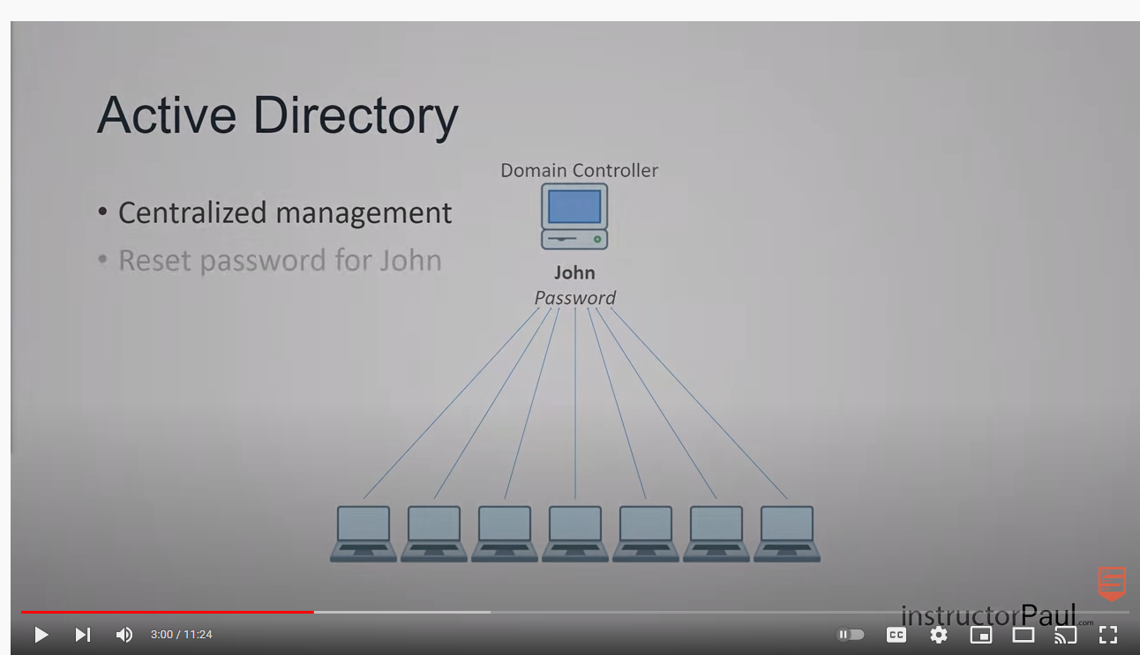

* Active directory is managed in server manager-> tool-> active directory, users and computers
* Left is the navigation pane and right is the content
* The action menu is the exact same menu when you right click on an object.
* The view column lets you add or remove columns so you can show or hide additional info as necessary.
* You can enable advanced features here too
* Saved queries can show you expired user accounts and more
* The find button in the domain is like the search button
* You can change domain by selecting the change domain function
* You can also change domain controller. The domain controller can be raised only if the domain functional level has been raised too. So you cant raise it to 2012 if most features still operate in 20110.

ACTIVE DIRECTORY TRAINING FOR ENTRY LEVEL HELP DESK

***Workgroup VS Domain***

* When you get a job you are in a domain environment.
* A server, called a domain controller is required
* The domain controller manages all your users, groups, printers etc
* User accounts are stored in active directory
* If you have a laptop at home and let you siblings use it then it is a workgroup environment.
* In a workgroup environment no server is required and user accounts are required on every machine

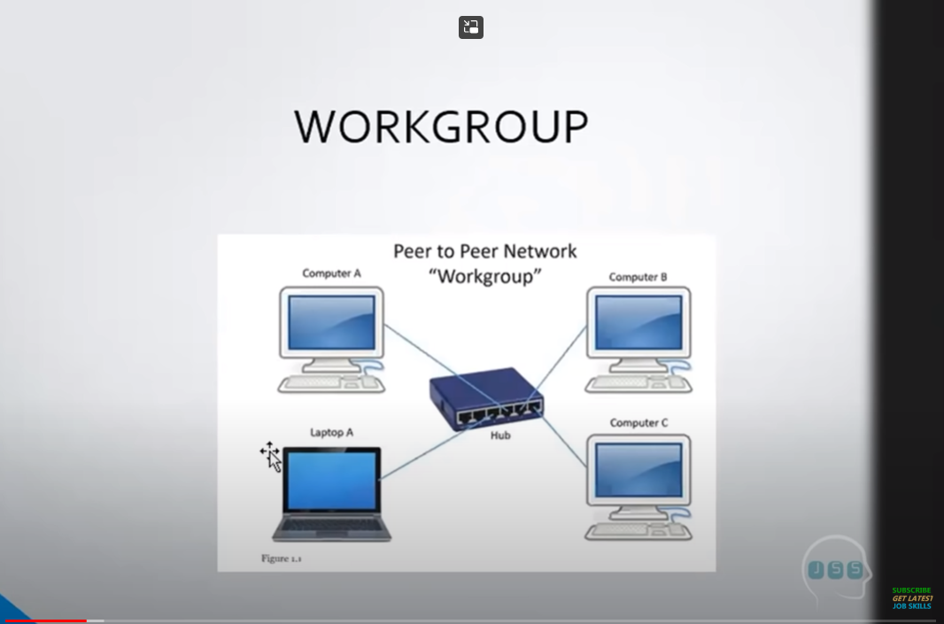

* 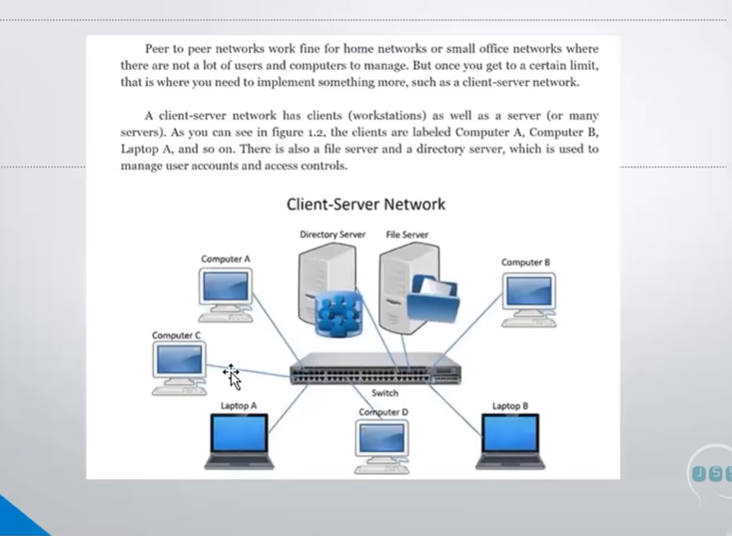

* The directory server is another name for domain controller.

***What is active directory***

* It’s a directory service available with windows servers platform. It stores information in a central database and allows users to have single account( called a domain user account) for the network.
* In IT 80% of your job as a help desk representative is how you close tickets
* Active directory technicians manage users, groups and computers etc.
* System admins operate at a higher level
* You can control almost everything from active directory such as users and computers
* Group policies is another part of active directory
* In this example jobskillshare.org was the domain and the groups assigned underneath the domain were the drop down menus
* The groups can be computers, users, and even the domain controller was here
* Workgroup computer doesn’t have any other option other than the administrator user name and password
* How do you login as local user into a computer. You use computer name /user name or you can do . \username
* To create a domain controller go to server manager-> manage-> add roles-> here we need a static IP address
* From there you go to active directory domain service. Click next, next and then install
* One domain controller is not best practice, its best to have several domain controllers
* After done you need to promote it to domain controller
* In server manager go to tools and active directory users and computers
* You can create an organizational unit underneath the domain
* To create an account in AD right click anywhere and select new and create the account. You can also right click on the user and select new and create the account.
* Always ensure that the user changes their password after the user is created
* To give a user more permission you can add them to an admin group
* To find out what group a user is in; right click on the user name and go to properties and then member of and you should be able to see what group that user is in
* To add this user to a group just go to add and then type the group name you want them in and add them to that group
* The last number on the IP address is the host
* The domain IP address is the first 3 numbers
* You have to know ipconfig /all. It’s a very important command
* To forcefully change the IP address for a server go to open network and internet settings-> ethernet-> change adapter options-> right click on ethernet again and go to properties. From there you should be able to add the ip address of the domain.

***HOW TO JOIN A COMPUTER TO A DOMAIN***

* Go to file manager-> right click on this pc and select properties-> change settings->computer name/domain-> then you add the domain for which the computer is going to belong to.
* From there its going to ask you for the username and password. The username is going to be the domain name\username and password is the password.
* To find out if the computer has been added go to computer under the domain in active directory and look for that computer name
* Before doing the above step you have to ensure to add that computer to the domain by adding the IP address as we did earlier
* The reason why we add the IP address above is because we are forcing that computer into our domain controller. This step is crucial
* To create a share go to C drive and add a new folder and name it share.
* What's the difference between sharing between a server and sharing inside a desktop? After creating the share go to properties, then advance sharing and you should be able to get people to log into that share. This can be done from a desktop. The difference between the server and the desktop is that the desktop has significantly less users accessing the share at once than the server that provides a lot more people accessing the share at once.
* What is RSAT and what does it do:

RSAT (Remote server administration tool) is **a tool that allows IT pros and system administrators to manage the roles and features that run on Windows Server remotely without having to be in front of the physical server hardware**.

***SECOND VIDEO***

***ACTIVE DIRECTORY TO PEOPLE WHO HAVE NO CLUE WHAT AD IS***

* AD is found in the windows administrative tools on a windows server
* From there go to active directory users and computers
* Is you are the user you will find your login ID under users
* You can go down the folder and look for your name within the folder or right click the folder and click on find. There you can type their name and they should come up
* To add users in your active directory
* A domain is a group of computers and users in an organization
* To add a new user right click the users directory and select new then user or go to create new user on the top pane.
* The user logon name is the name they are going to need to log into their server. Next is giving them a temporary password and ALWAYS let user change their password at next logon.
* After creation the user is simply put in the users directory but not in a particular group which indicates her department
* To create a group right click in the users folder and select new then group and name the group whatever you want
* To add users in that group double click on it and go to members. There you can enter the users you need for that group. Select add in members and select the user you are looking fo
* Your active directory needs to be organized