***WHY DO WE NEED CLOUD BASED MONITORING***

* Performance: Reduction is users on app. CloudWatch can tell you there is a reduction so you can make the necessary adjustments
* Cost: Can send you notification when the servers are ideal at a certain time of day so you can make adjustments to help reduce cost
* Detecting errors and troubleshooting: Error in your app during uptime can cause you to loose customers. This is where monitoring can come into play by notifying you if there's an issue.

***WHAT IS AMAZON CLOUDWATCH***

* This is a a component of AWS that provides real time monitoring of AWS resources and customer applications running on amazon infrastructure. It offers you the most reliable, scalable and flexible means of monitoring your resources or applications in AWS. It offers basic and detailed monitoring.
* Basic monitoring comes with the free tier and polls every 5 minutes with very few metrics
* Detailed monitoring on the other hand is charged and polls every 1 minute and as a wide range of metrics.
* 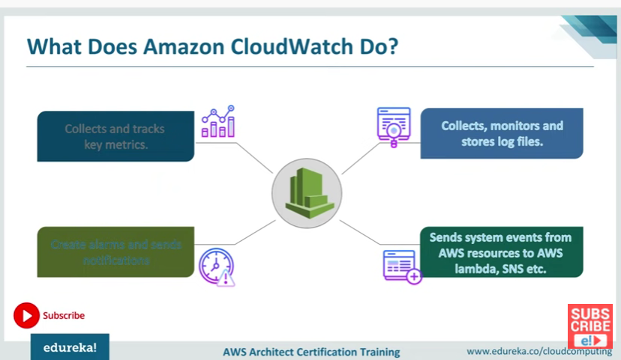

RESOURCES MONITORED BY CLOUDWATCH

* Some of the resources monitored by CloudWatch are EC2, RDS, data store in S3, ELB and others

AMAZON CLOUDWATCH CONCEPTS

* Metrics: Represents a time ordered sets of data points that are published to CloudWatch. Think of it as a variable to monitor and the data points represents the values of that variable over time.
* Dimension: Is a name/value pair that uniquely identifies a metrics. Can be considered as categories of characteristics that describe a metric. We can assign up to 10 dimensions to a metric. Here the variable x is identified with both y and z
* Statistics: These are specific data aggregations over a specific periods of time. They are made using the namespace metric name, dimensions within the time period you specify.
* Alarm: Can be used to automatically initiate an action on your behalf.

***HOW DOES CLOUDWATCH WORK***

* It has complete visibility and application to our AWS resources and applications.
* 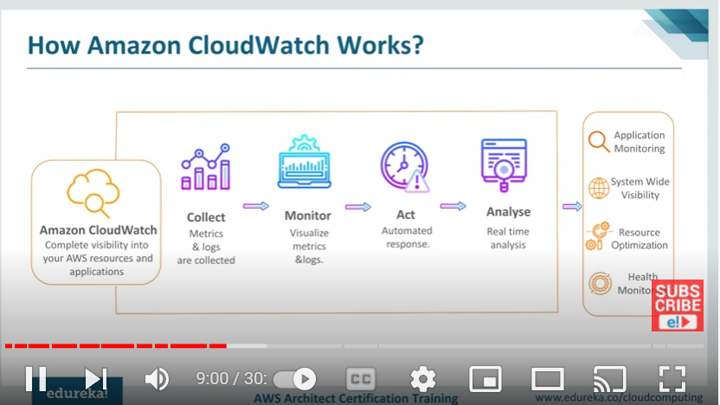

***HANDS-ON***

METRICS

* First go to SNS and create a topic and subscribe to it so that CloudWatch can send you notifications when needed
* Go to SNS->topics and create a new topic
* After creating the topic select the topic and go to create subscription in which you will provide an email to which you want to receive emails to.
* Now go back to CloudWatch and go to metrics. Select all metrics and then EC2.

***CLOUDWATCH EVENTS***

* It is a part of AWS CloudWatch which delivers a near real-time stream of system events that allows you to monitor and respond to the changes in your AWS resources by means of rules that route events to one or more targets
* 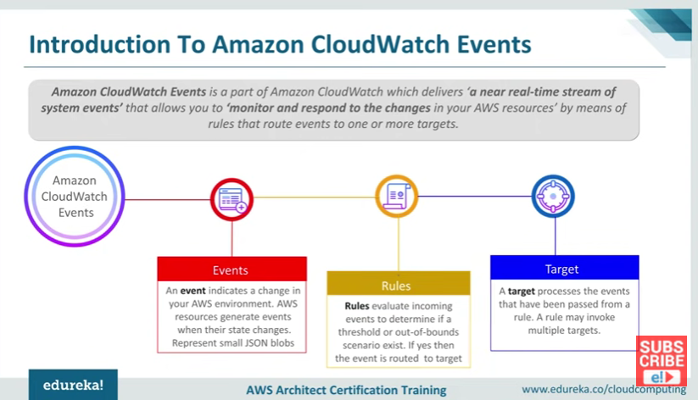

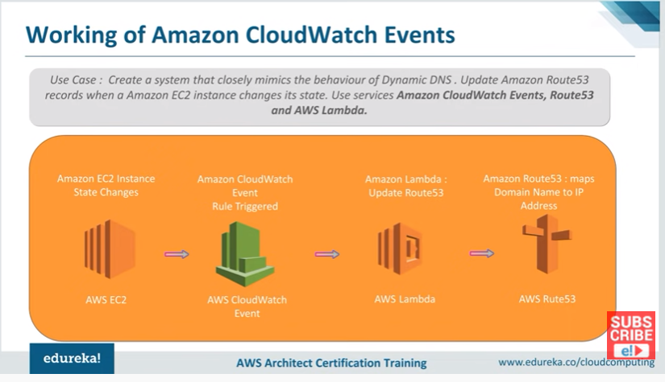

* Dynamic DNS is a service that automatically updates a name server in domain name systems. AWS uses route 53 for this.
* The above scenario is an example of a CloudWatch event and remediation by a lambda function which creates a new record in route 53.

***HANDS-ON***

* First create a lambda function. Start by creating a policy for the lambda function
* Go to IAM->Policies-> specify what service you want which in this case is EC2.
* Next the actions will be to start and stop instances and the resources will be ALL
* Give the policy a name and then create the policy
* Now the above created policy needs to be assigned to a lambda function. So to do so we go to roles-> create role and select lambda.
* Next in the add permission section select the policy we created earlier. Now click next and create the role
* Now go to lambda in the search bar and select lambda services and create a lambda function.
* Select create function-> author from scratch->select the role that we created above and create the function. See <https://aws.amazon.com/premiumsupport/knowledge-center/start-stop-lambda-eventbridge/> for lambda codes to start and stop instances
* To automate this process we need to bring in Amazon CloudWatch
* Go to CloudWatch and choose events-> create rule->schedule-> fill out the cron expression and select lambda function to create the event rule.

AMAZON CLOUDWATCH LOGS

* 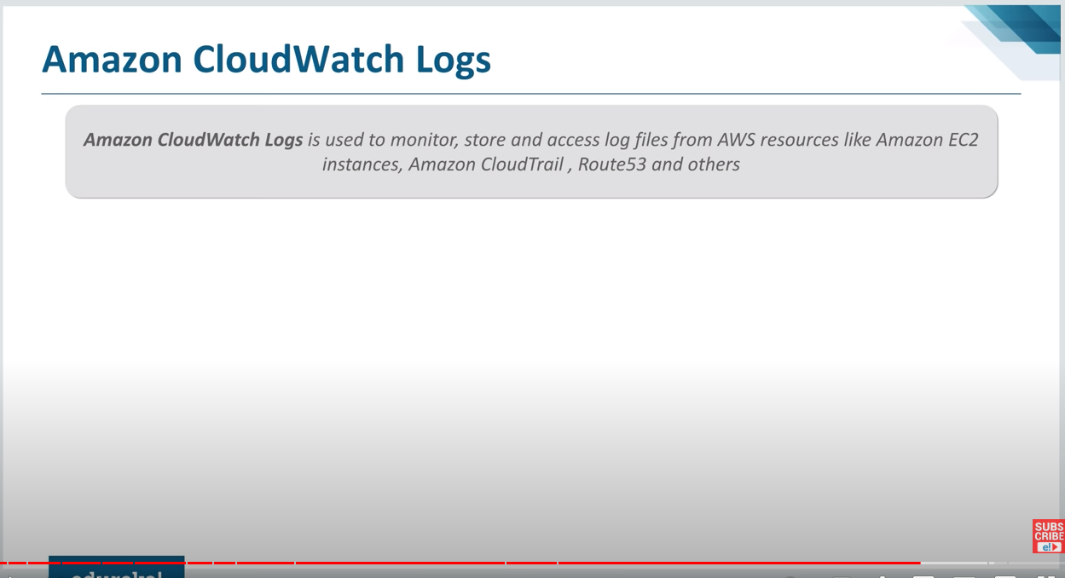

* Log files are detail record of events that occur in your AWS environment
* Can be considered as data repositories
* 