Fit5120_Tp28_Team Information
Name | Photo | Major | Email | Phone(option)
Steve Saji Philip | 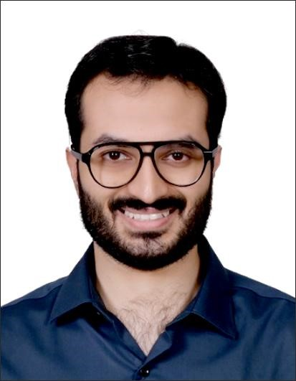 | Cybersecurity | sphi0032@student.monash.edu | 481341182
NuoJin (Ruby) | 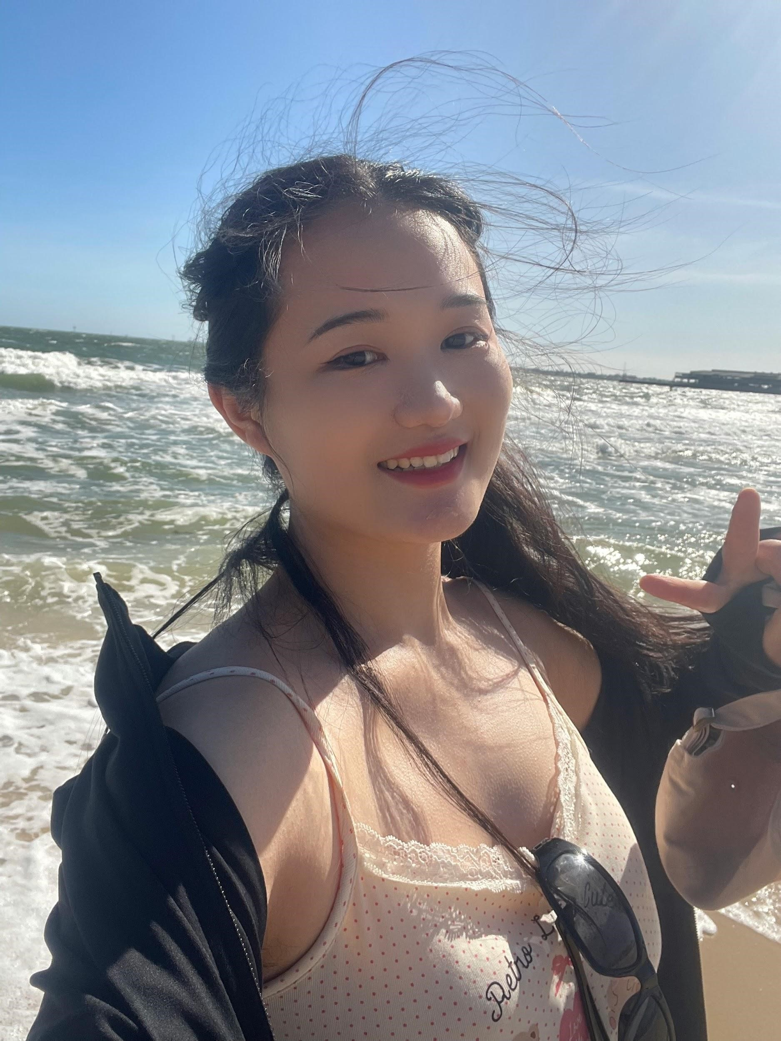 | Information Technology | njin0009@student.monash.edu | 466492426
Lee Kai Chun (Bill) | 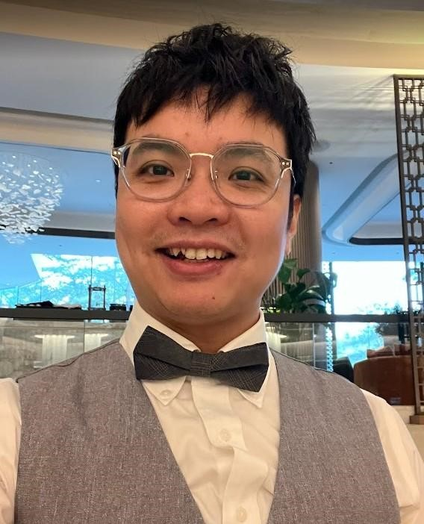 | Artificial  Intelligence | klee0171@student.monash.edu | 468706242
Yanqing Zhu (Sela) |  | Business  Information Systems | yzhu0215@student.monash.edu | 425187858

Prangige Peiris (Shavinthi) | 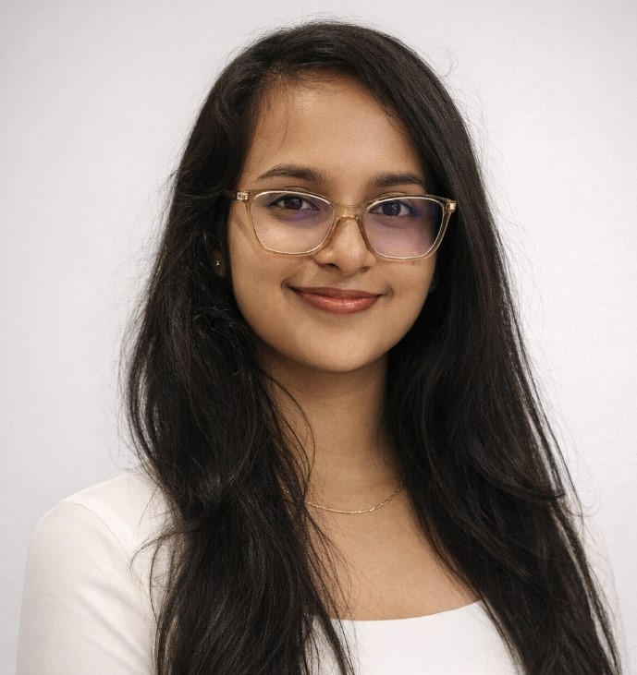 | Data Science | ppei0007@student.monash.edu | 481438204

