

KQC7016 DATA ANALYTICS
SEMESTER2，SESSION 2025/2026

ASSESSMENT TYPE (LAB)

NIE JING | 25069019
DAI FENFANG | 25069603

Department of Electrical Engineering
Universiti Malaya
Lab Report 1: Web Scraping
1. Introduction
Web scraping is an automated method used to extract data from websites.
In this lab, Python was used to retrieve webpage content, parse HTML, and extract useful information.
2. Objective
The objectives of this lab are:
- To study and run the original lab1.py code.
- To understand the function of each part of the code.
- To modify the code to scrape another website.
- To store the extracted data in a structured format.
3. Website Used
The website used in this modified program is:
https://quotes.toscrape.com/
This website was selected because it is designed for web scraping practice and contains structured quote and author information.
4. Libraries Used
The libraries used are:
- requests: used to send HTTP requests to the website.
- BeautifulSoup: used to parse HTML content.
- pandas: used to store the extracted data in table format and save it as CSV.
5. Code Explanation
Part 1: Sending request to website
The program sends a request to the website using requests.get(url).
The status code 200 shows that the webpage was successfully accessed.
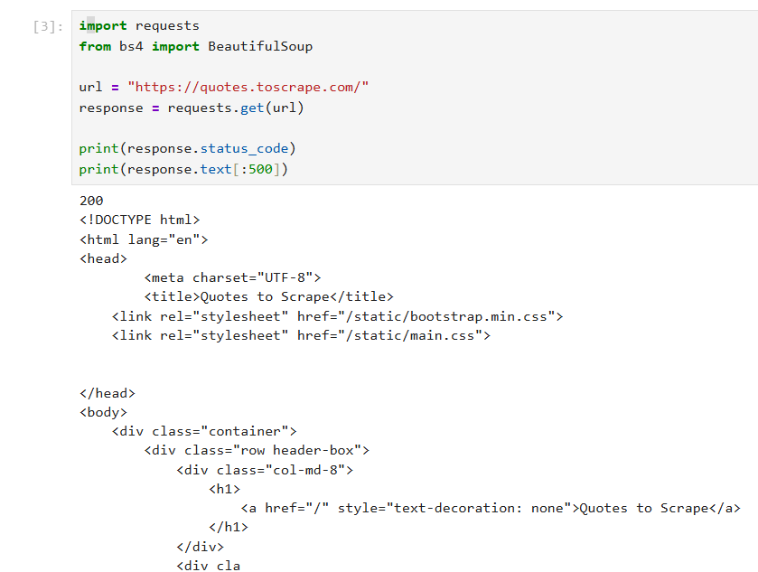
Figure 1: Successful website request and HTML output.
The status code 200 shows that the request to the website was successful. The HTML output shows the raw webpage content retrieved from the website.
Part 2: Parsing HTML
BeautifulSoup was used to parse the HTML content returned by the website.
Part 3: Extracting Quotes
The function find_all() was used to find all span tags with class "text".
These tags contain the quote texts.
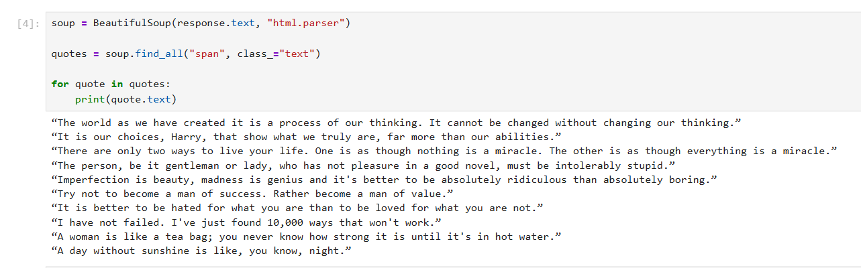
Figure 2: Extracted quote texts from the website.
BeautifulSoup was used to parse the HTML content.
The function find_all() searched for all span tags with class "text", which contain the quotes.
Finally, the program printed all extracted quotes.
Part 4: Extracting Authors
The authors were extracted from small tags with class "author".
Part 5: Saving Data
The extracted quotes and authors were stored in a Pandas DataFrame.
The data was then saved as quotes_with_authors.csv.
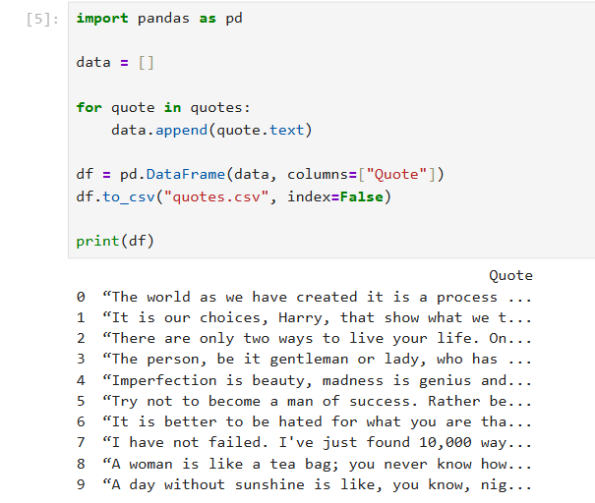
Figure 3: Extracted quotes stored in a Pandas DataFrame.
The program was further improved by extracting both quotes and authors from the website.
The quotes were extracted from the span tag with class "text", while the authors were extracted from the small tag with class "author".
The extracted data was stored in a Pandas DataFrame with two columns: Quote and Author.
6. Result
The final output contains two columns:
- Quote
- Author
The extracted data was successfully displayed in table format and saved as a CSV file named quotes_with_authors.csv.
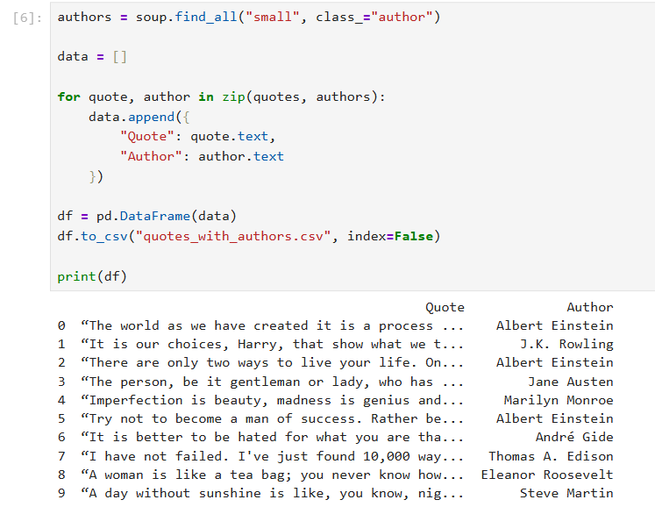
Figure 4: Final extracted data with Quote and Author columns.
Figure 4 shows the final extracted data in table format. The table contains two columns: Quote and Author. The data was also saved as a CSV file named quotes_with_authors.csv.
7. Discussion
This lab shows how unstructured webpage data can be converted into structured data using Python. The main challenge was identifying the correct HTML tags and class names.
By inspecting the webpage, the quote text and author names were located and extracted successfully.
Before scraping the website, the ethical issue of web scraping was considered. In general, robots.txt should be checked to determine whether the website allows web scraping.
8. Conclusion
In conclusion, this lab successfully demonstrated basic web scraping using Python.
The program was able to connect to a website, retrieve HTML content, extract useful data, and save the result into a CSV file.

