**1.Ping:** The Linux ping command is used to check whether a network is available and if a host is reachable. With this command, you can test if a server is up and running. It also helps with troubleshooting various connectivity issues.

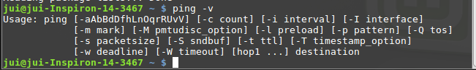

**2.Curl:** curl is a command-line utility for transferring data from or to a server designed to work without user interaction.

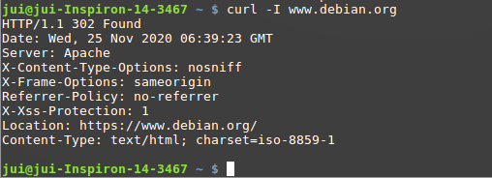

3.HTTPie: HTTPie is a command line HTTP client. Its goal is to make CLI interaction with web services as human-friendly as possible.

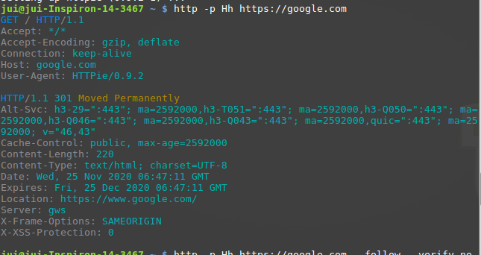

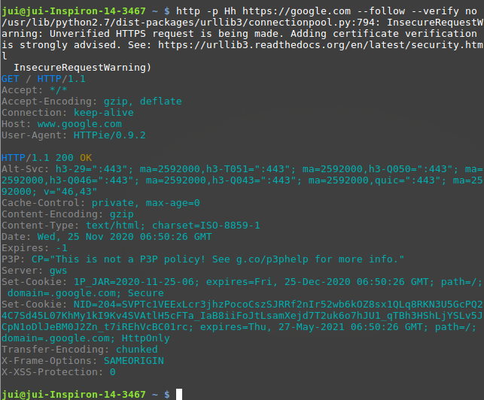

**4.wget:**  It supports downloading multiple files, downloading in the background, resuming downloads, limiting the bandwidth used for downloads and viewing headers.

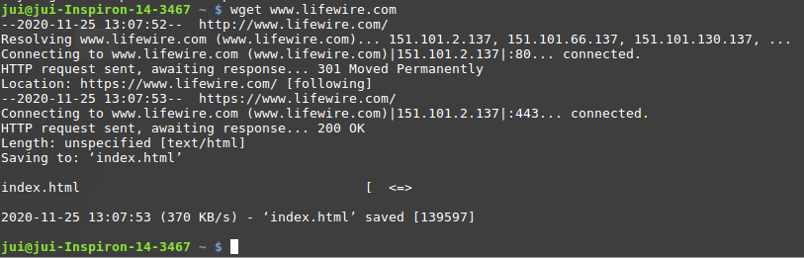

**5.TC:** Tc is used to configure Traffic Control in the Linux kernel.

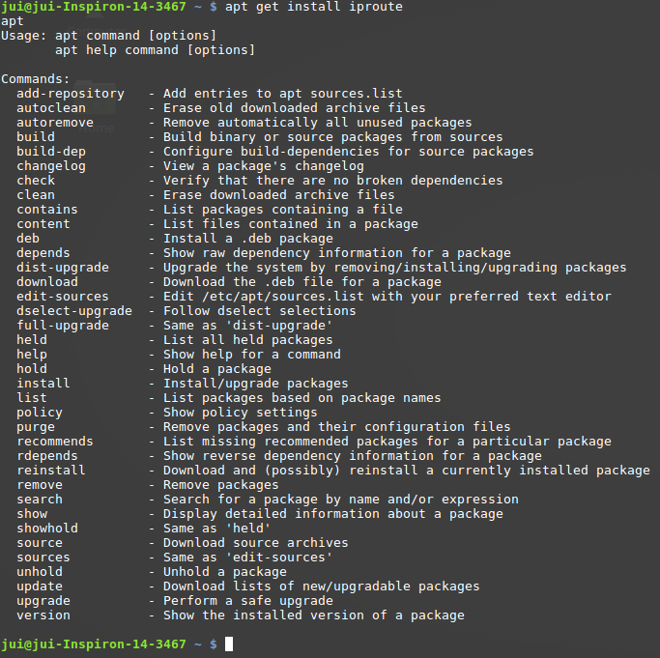

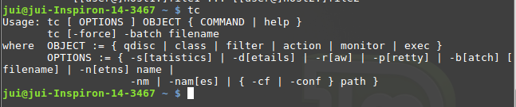

**6.nslookup:** It is a network administration tool for querying the Domain Name System (DNS) to obtain domain name or IP address mapping or any other specific DNS record.

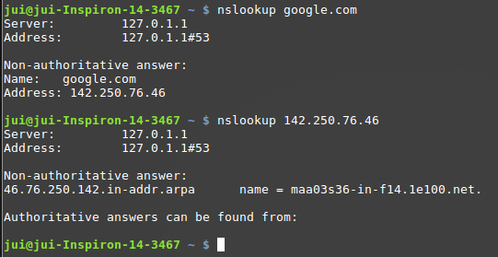

**7.whois:** The whois system is a listing of records that contains details about both the ownership of domains and the owners.

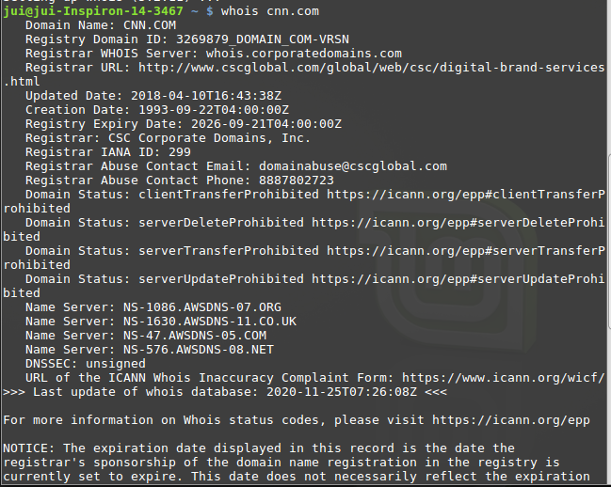

**8.ssh:** SSH, or Secure Shell, is a protocol used to securely log onto remote systems. It is the most common way to access remote Linux servers.

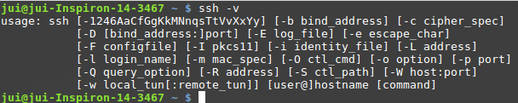

**9.scp: SCP** is used to copy file(s) between servers in secure way.

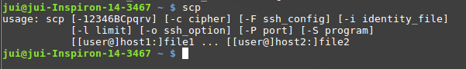

**10.rsync:** The rsync command synchronizes files from a source to a destination, on a local machine or over a secure network connection.

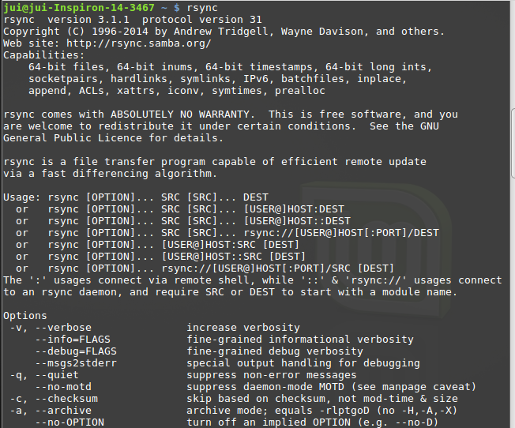

**11.ngrep:** This command can be used to debug plain text protocols interactions like HTTP, SMTP, FTP, DNS, among others, or to search for a specific string or pattern, using a grep regular expression syntax.

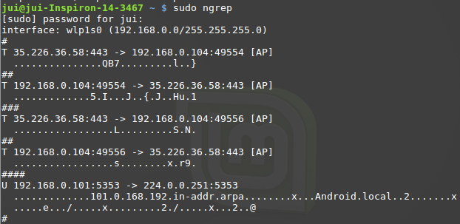

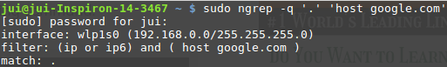

**12.tcpdump: tcpdump** is a command-line packets sniffer or package analyzer tool which is used to capture or filter **TCP/IP** packets that received or transferred over a network on a specific interface.

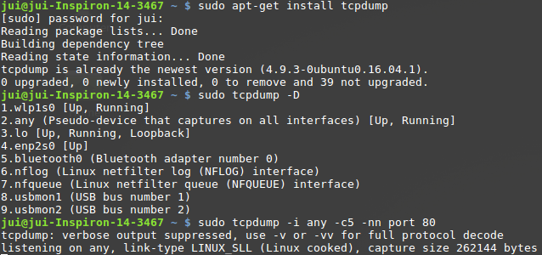

**13.wireshark:** Wireshark can capture traffic from many different network media types, including Ethernet, Wireless LAN, Bluetooth, USB, and more. It can open packet captures from a large number of capture programs.



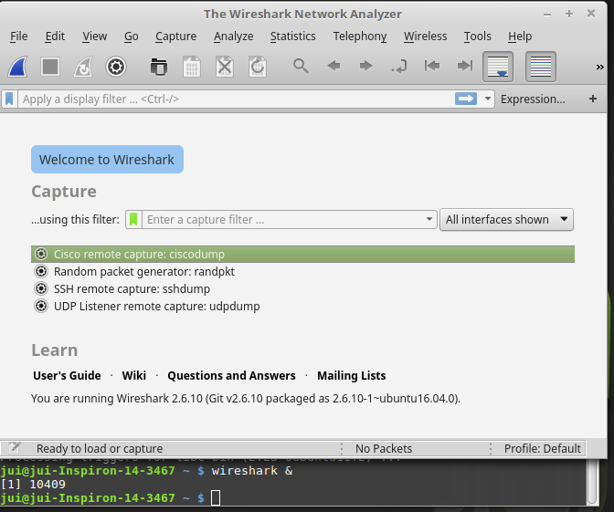

**14.tshark:** TShark is a network protocol analyzer. It lets you capture packet data from a live network, or read packets from a previously saved capture file, either printing a decoded form of those packets to the standard output or writing the packets to a file.

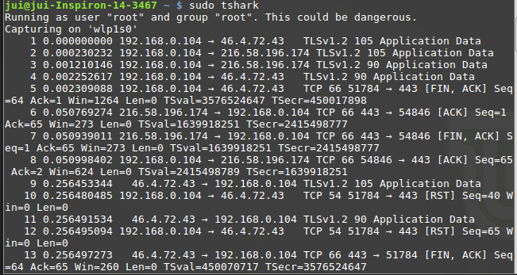

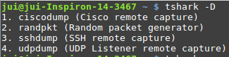

**15.tcpflow:** Capture and assembles TCP streams.

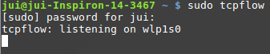

**16.ifconfig: ifconfig** command is used for displaying current network configuration information, setting up an ip address, netmask or broadcast address to an network interface, creating an alias for network interface, setting up hardware address and enable or disable network interfaces.

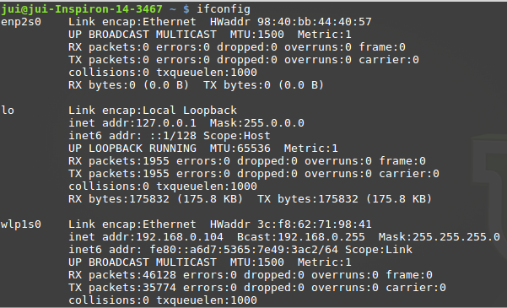

**17.route:** View and change the route table.

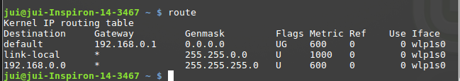

**18.IP:** Replaces ifconfig, route and more.

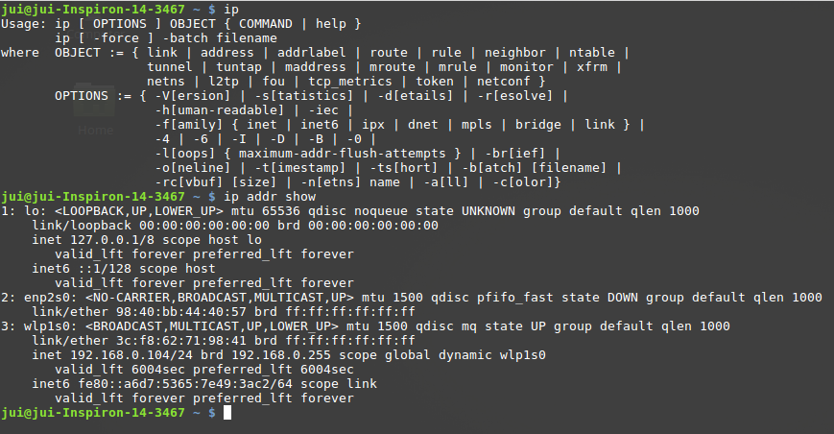

**19.arp:** This protocol is used by network nodes to match IP addresses to MAC addresses.



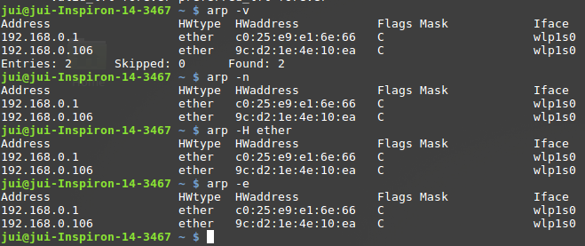

**20.mitmproxy:** mitmproxy is a proxy recorder that provides record-and-play functionality for **use** in mobile performance engineering.

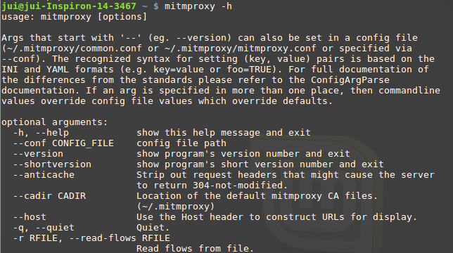

**21.nmap:** With Nmap, server administrators can quickly reveal hosts and services, search for security issues, and scan for open ports.

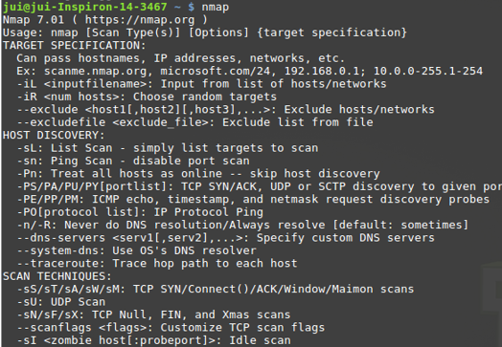

**22.zenmap:** Zenmap is a GUI the most popular network scanner called Nmap (Network Mapper).

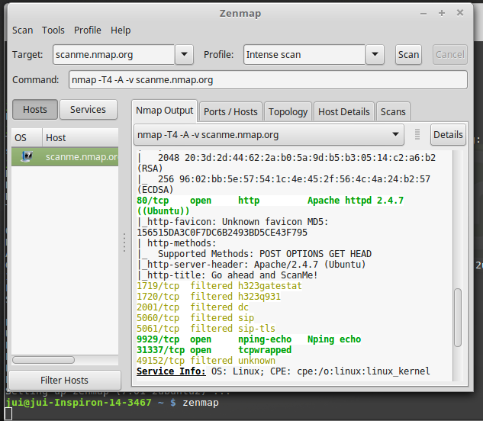

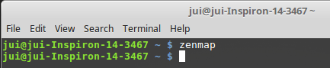

**23.p0f:** Identifies OS hosts connecting to you.

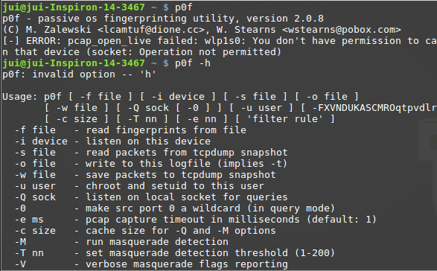

**24.nc(netcat): Netcat** (or **nc** in short) is a simple yet powerful networking command-line tool used for performing any operation in Linux related to **TCP**, **UDP**, or **UNIX**-domain sockets. Netcat is used for a command line chat server,to create basic web server.

