# Lab -4

### **TDDC17-Lab4**

# Task2 explanation:

1. We can see that in the comparison of heuristics in problem 02 as explained above, the FF heuristic was able to solve the visualization to time step 27 but the same problem with GC as heuristic needed 12222 steps in order to reach the goal node. Hence, from this example we can deduce that one configuration is better than other on some specific problems.

# **2)**

# 1: comparing heuristics, problem 03:

1,2

* FF-heuristic:

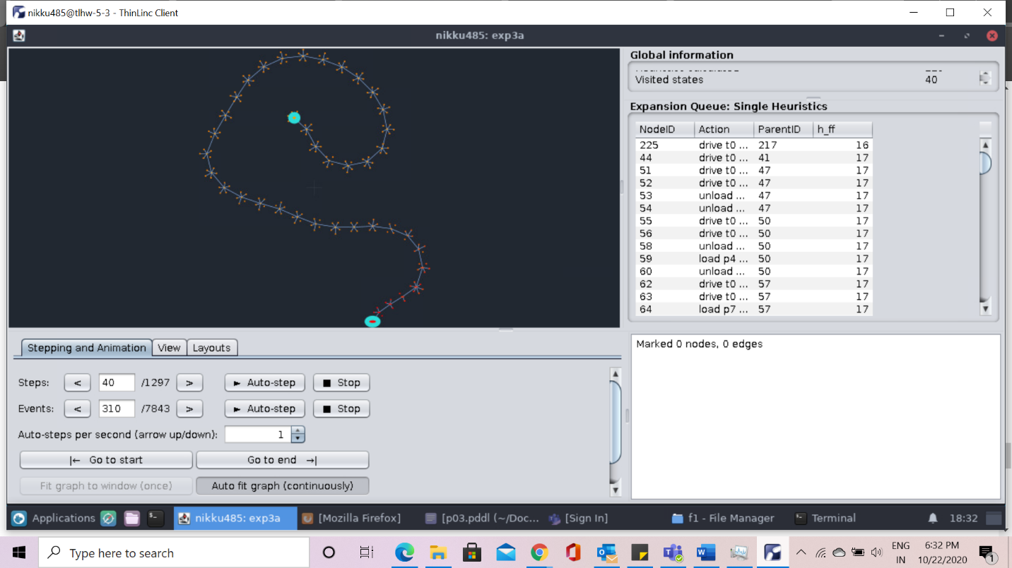

* goal count heuristics:

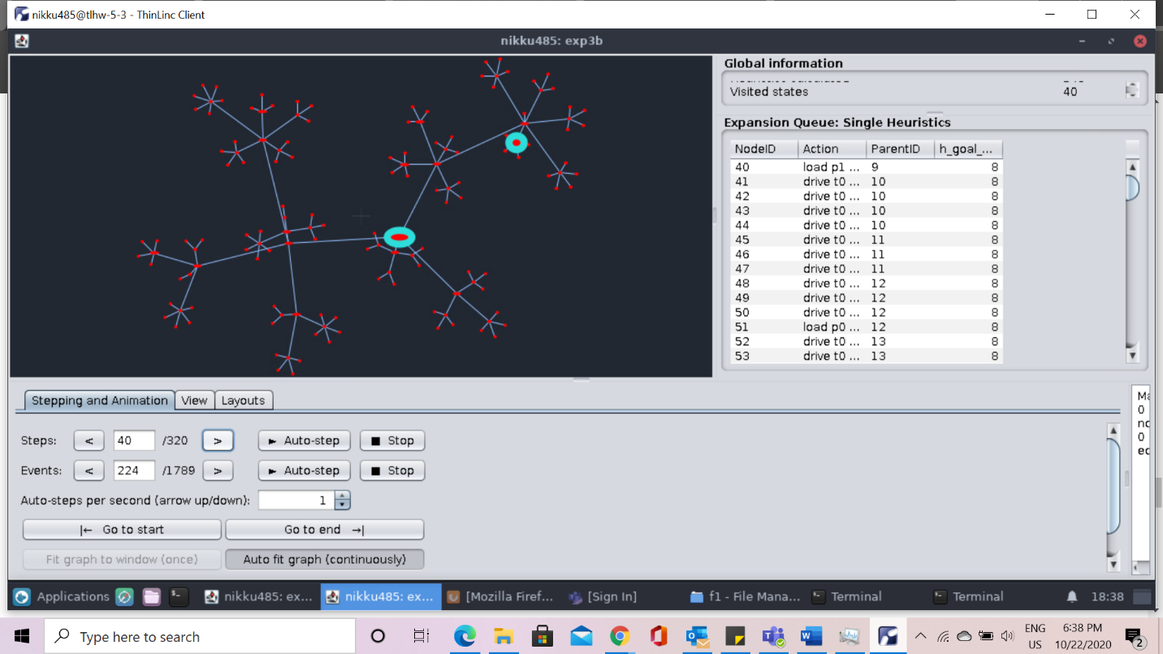

We can that when two different heuristics are applied to the same problem with same search method, as shown in the above graph both are different for the first graph we can see that its shape is like spiral as shown in the first heuristic approach, while on the other hand we can see the second graph shows the tree like shape.

3

* FF Heuristic

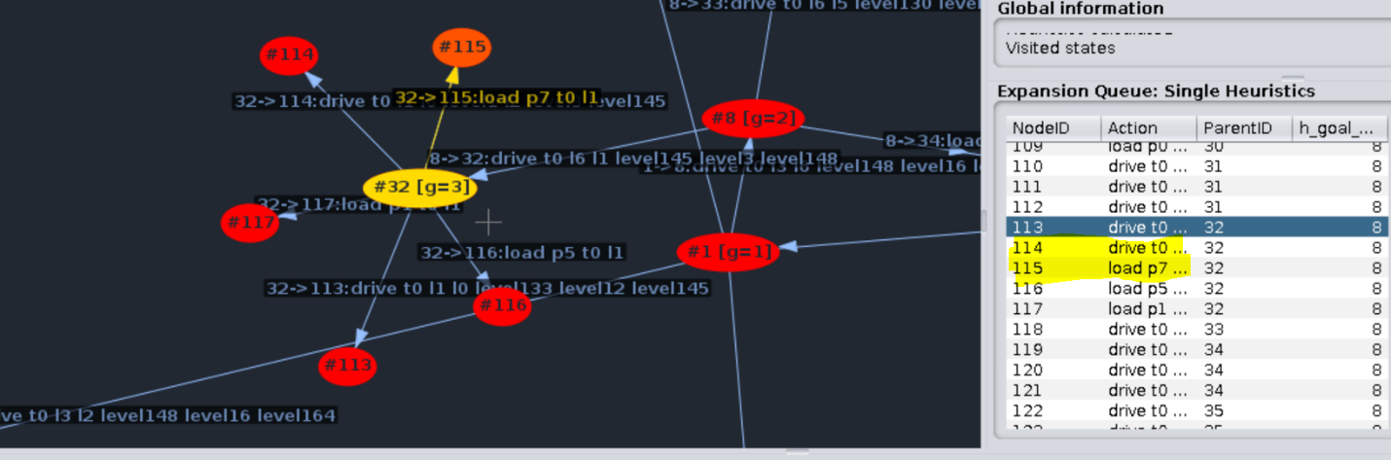

* Goal count heuristics

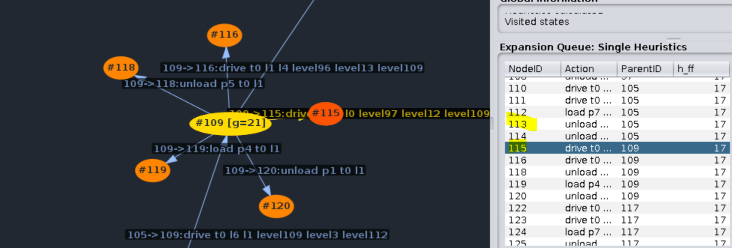

We can see from the above screen shots both configurations use different actions at the same nodes as we can see in the first node 113 does drive action while on the goal count heuristics 113 does unload action which is different.

4)

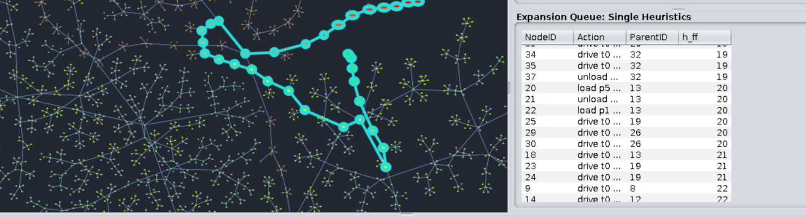

The dots are the numbers that can shows the path that final plan follows. Moreover we can see not all the nodes are used in the final plan.

# **2: comparing heuristics, problem 02:**

2) 1 and 2)

* FF Heuristic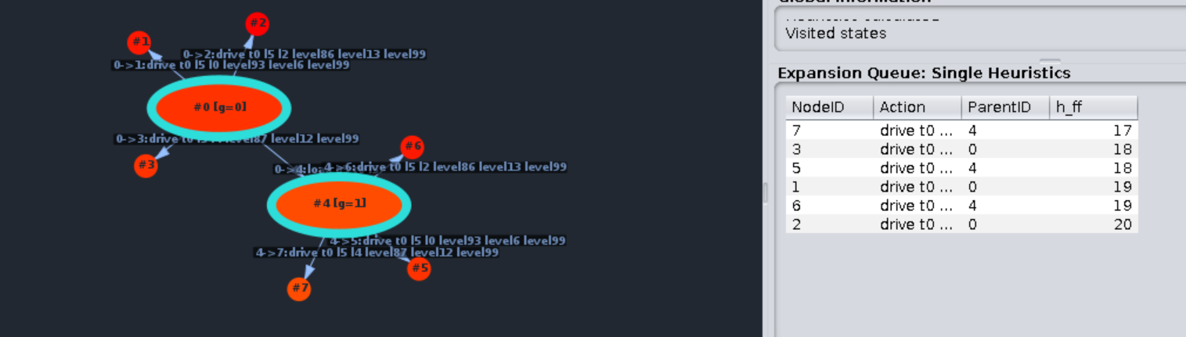

For ff we can see that the value heuristic function decreases from the first step itself.

* Goal count Heuristic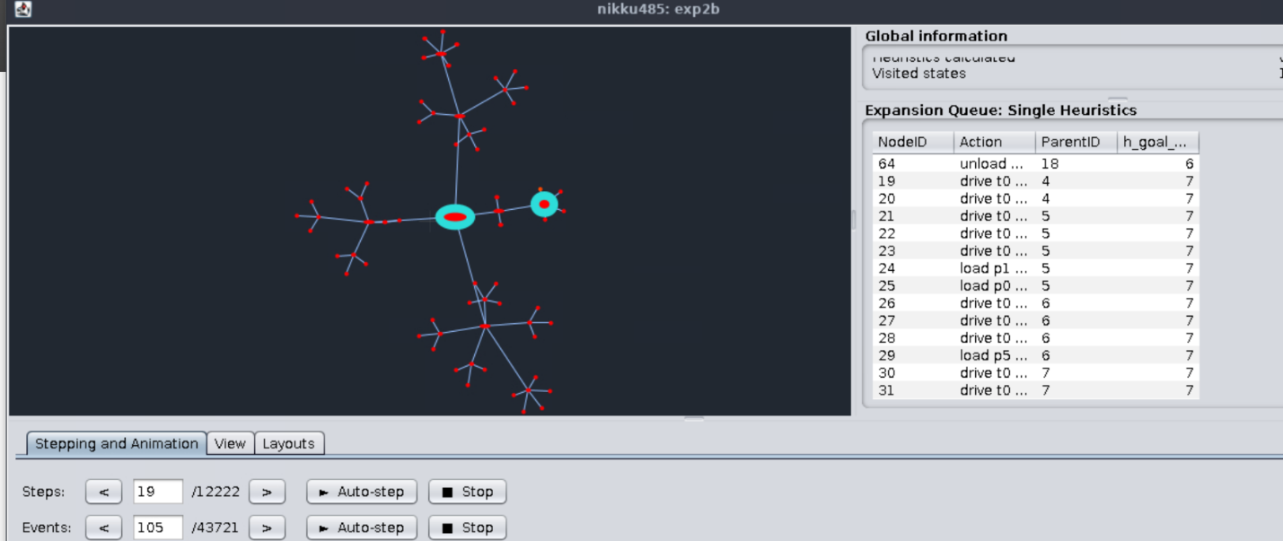

For the GC heuristics we can see the first lower value for the main heuristics function on step 19.

2) 3)

a)

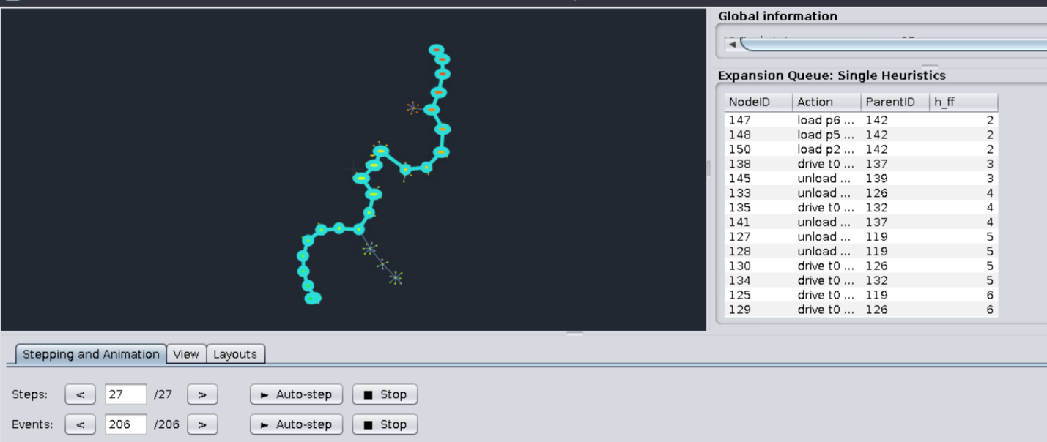

As mentioned we can see that the step 27 is the last time step for the configuration using FF.

b)

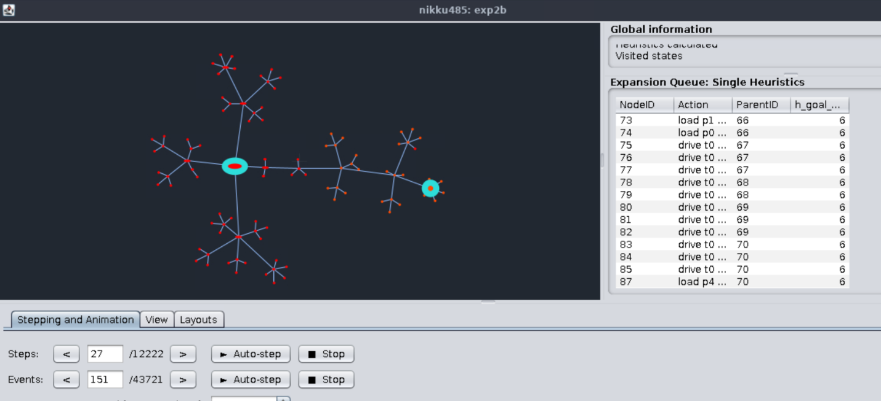

For GC configuration we left of with (12222-27) step to find the goal count configuration.

2) 4)

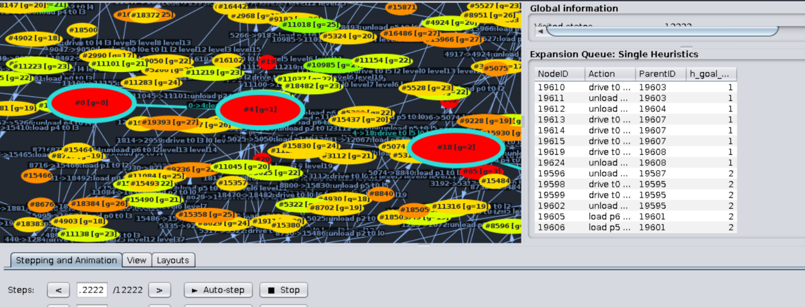

We can see from the above graph that the solution increases the with value of goal count heuristic between one state and the next state.

# 3:

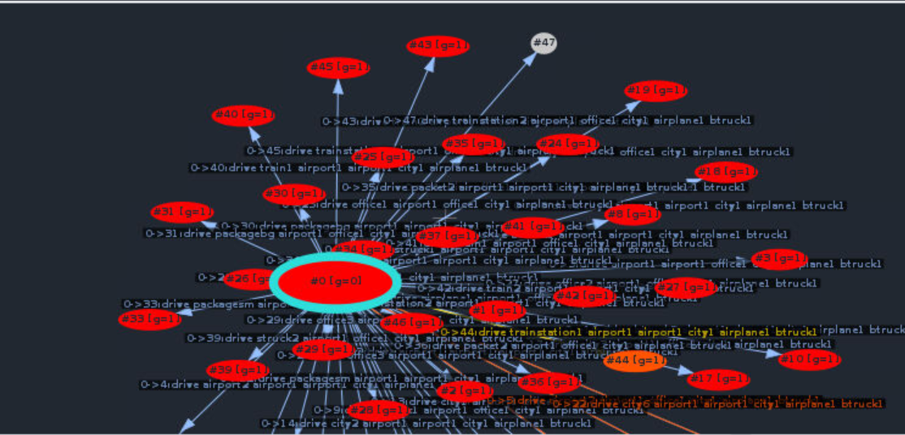

We can see that the graph visualization is different for different domains and problems and similarly in our case to the graphs have different structure.

**3)** The finding from the above examples shows that visualization depends on the domain problem and the heuristics function used. Different heuristics functions uses strategies like fast forward heuristics, Goal Count Heuristics. Hence the findings makes it obvious that, the FF heuristic might work more efficiently in some cases than the goal count.