SmartCare v0.3 - Domain Model Workbook
Week 6 student resource

Requirement-to-Concept Trace
Requirement | Concept | State/behaviour | Decision
FR-01 Register new patients | Patient | Stores Patient name + date of birth + contact and other details | Create a patient class
FR-02 Assign unique patient ID | Patient | Each patient has a unique patient ID | Add Patient ID attribute
FR-03 search, view and update patient records | Patient | Using the name or the ID, the patient records can be searched and update | Give patient Class’s record to the management responsibilities.
FR-04 generate medical certificates, receipts and prescriptions | Appointment/patient | Appointment and patient information can be used to generate required documents | Generating a document is a system function rather than a separate class
FR-05 Add, view, update and delete practitioner records | Practitioner | Stores practitioner name and availability information | Create practitioner class
FR-06 create an appointment | Appointment | Appointment links a patient, practitioner, date and time | Create appointment class
FR-07 prevent overlapping appointments | Appointment/practitioner | System checks whether the selected date and time overlaps another appointment | Add appointment conflict checking behavior
FR-08 Maintain appointment status | Appointment | Appointment status can be scheduled, completed or cancelled | Add status attribute to appointment
FR-09 Cancel appointment | Appointment | Appointment status changes to cancelled | Give appointment cancellation responsibility
FR-10 Reschedule appointments | Appointment/Practitioner | New appointment time is checked against practitioner availability | Give appointment rescheduling behavior and use practitioner availability
FR-11 view appointment details | Appointment | Stores and displays appointment details | Give appointment responsibility for appointment information
FR-12 Maintain chronological appointment history | Appointment/patients | Patient’s appointments are maintained in chronological order | Link patient to their appointment records
NFR-01 Simple and easy-to-use interface | All system concepts | Staff should be able to navigate with minimal training | Keep class responsibilities and interaction simple
NFR-02 retrieve records within 3 seconds | Patient/Appointment | Patient records and appointment schedules are retrieved efficiently | Use structured data and efficient retrieval
NFR-03 staff authentication and restricted access | System/Staff access | Only authorized staff can access patient and practitioner information | Treat authentication/access control as a system level concern
NFR-04 easy-to-maintain code | All classes | Code should be understandable and easy to update | Separate responsibilities between classes
NFR-05 keep confirmed patient and appointment records | Patient/Appointment | Patient and appointment records are retained | Store persistent patient and appointment information
NFR-06 patient identifies and no overlapping appointments | Patient/Appointment/Practitioner | Patient identifiers are unique and practitioner appointments cannot overlap | Enforce unique IDs and appointment conflict validation

CRC Cards

Patient
Responsibilities | Collaborators
Store patient ID, patient name, DOB and contact details  Register patient  Search patient records  View patient information  Maintain patient appointment history  Update patient information | Appointment

Practitioner
Responsibilities | Collaborators
Store practitioner name and availability  Add practitioner records  View practitioner records  Update practitioner records  Delete practitioner records  Check practitioner availability | appointment

Appointment
Responsibilities | Collaborators
Store appointment details  Link patient and practitioner  Store date and time  Create appointments  Check for overlapping appointments  Check practitioners’ availability  Reschedule appointments  Cancel appointments  Update appointment status  Display appointment details  Maintain appointment history | Patient  Practitioner

UML Class Diagram
Insert/draw UML here. Include defensible relationships and multiplicities
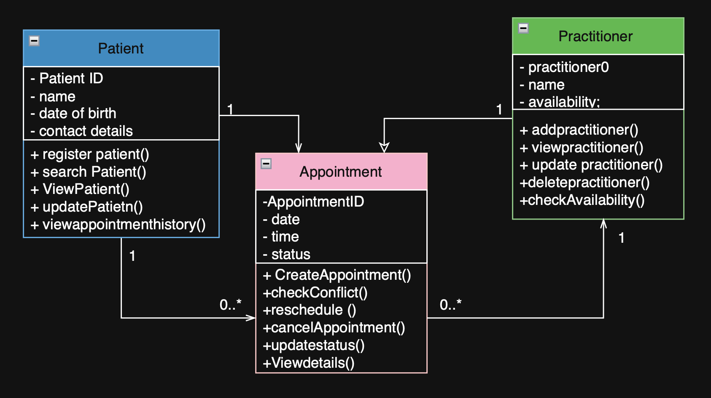

Design Rationale
Explain class selection, responsibility allocation and key relationships.
The SmartCare system has three main types: patient, practitioner and appointment. These classes were chosen because they show the main ideas from the functional requirements
The patient class is used to keep track of and handle patient information, such as the patient’s ID, full name, date of birth, and contact details. It also helps with looking up patient records, seeing and changing information, and checking past appointments.
The practitioner class holds information about practitioner, like their name and when they are available. It oversees keeping track of practitioner information and ensuring that availability is checked when appointments are made or changed.
The appointments class handles details about appointments, such as when they are scheduled, what time they take place, and whether they are confirmed, pending, or canceled. It handles making, seeing, changing, and removing appointments, and checks for any conflicts and updates the status of appointments.
A patient and a practitioner work together to set up an appointment because an appointment needs both a patient and a practitioner. A patient may have several appointments at different times, and a practitioner can also have more than one appointment. So, the relationship between patient and appointment is 1 to 0 or more, and the relationship between practitioner and appointment is also 1 to 0 or more.
The design splits up the responsibilities among the three classes. This makes the system simpler to understand and keep running, while keeping the number of classes low for a small community clinic system.

AI Design Review Record
AI suggestion | Evidence | Decision | Reason | Model change
Create an Appointment Status class | FR-08 identifies three appointment statuses: scheduled, complete and cancelled | Rejected | Creating a separate class would add extra complexity since status can be an attribute of the appointment | Added status attribute to appointment instead
Allow one patient to have multiple appointments | FR-12 requires chronological appointment history for each patient | Accepted | A patient needs to have multiple appointments over time for their regular checkup or next appointment | Patient -> appointment multiplicity set 1 to 0..*

Reflection
Creating the UML class diagram helped me see how the functional requirements can be turned into classes, their responsibilities, and how they relate to each other. The main ideas that came up were patient, practitioner, and appointment, which helped keep the design simple and centered on the needs of the SmartCare clinic. The CRC cards made it easier to figure out which tasks each should handle. For example, tasks like making an appointment, canceling one, changing the time, and checking for conflicts were give the appointment class. Patient details were handled by the patient class, and information about when a practitioner is available was managed by the practitioner class.
Using Ai during the design review helped find other possible classes and relationships. However, the suggestions were reviewed based on the functional requirements instead of being approved without any checks for example, an Appointment Status class was thought about but not used because the three statuses can be shown as an attribute of appointment without making things more complicated.
The modeling process showed how requirements can be followed through concepts, responsibilities, and UML relationships.

