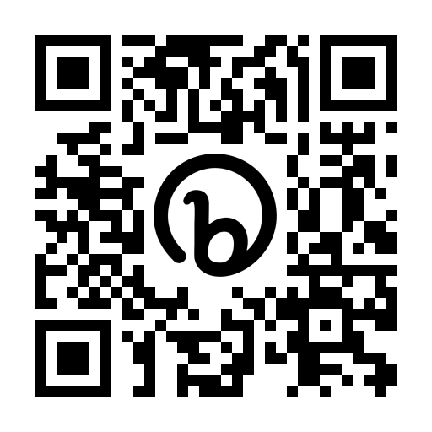

For Natasha, the love of my life, thank you for believing in me.

For Julianna, Logan, Isabella, and Calvin; Daddy loves you more then you will ever know.