CISS 346 – Secure Software Development

Assignment 05 – Part B

The Software Development Process

Messenger: Simple Message Protocol (SMP)

Overview

This assignment is designed to help you understand the software development process, the software development process lifecycle, and common software development process documents.
Keep in mind that the focus of this assignment is on the software development process and the supporting software development process documents. The focus should not be on programming in a particular programming language or programming in a particular application domain.

Project Description

Miss Pudding, the VP of Engineering for Reality Software, has contracted with Never Crash Software Services to develop a GUI feature that would allow a SMP client to register with a SMP server. The registration would consist of a user ID and password. Mr. Pumphrey, a senior project manager with Never Crash Software Services, has been tasked to oversee the implementation of this feature.
From SMP Messenger V2.0 that was completed by your team, add the SMP Messenger client registration feature. Roll the version number to V3.0 before deploying SMP Messenger V3.0. Update the Software Requirements Specification, the Software Project Interface Prototypes, and the Software Technical Specifications.

Deliverables

For this iteration of the project, the team should perform the following tasks:

- Implement Version 3.0
  - Implement a GUI-based client-side form that allows the client to enter a user ID and password field and register these credentials with the server. The user ID and password fields should be encrypted using the server’s public key before sending the credentials to the server. The server should save the user ID and encrypted password to a file. This form can be shown via a button on the producer form, or as a stand-alone project.
  - Implement a GUI-based server-side form that allows the SMP Messenger administrator to view all user IDs and passwords. The form should have option buttons to display only the user IDs, or to display the user IDs and passwords in clear text. The form can be shown via a command button on the SMP Message Server form.
  - Update the SMP protocol to validate client PutMessage and GetMessage requests using the user ID and password fields.
  - Update all associated source code files that are affected by this change.
  - Update any documents that are affected.

SMP Messenger – Client Registration GUI Form

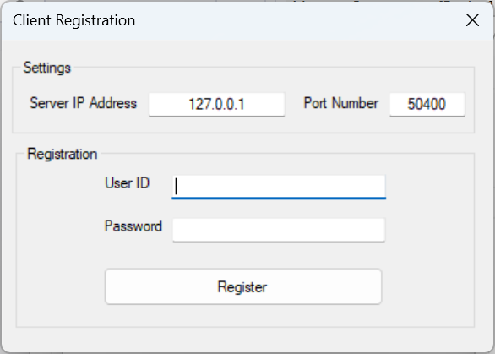

SMP Messenger – Message Server GUI Form Version 3.0

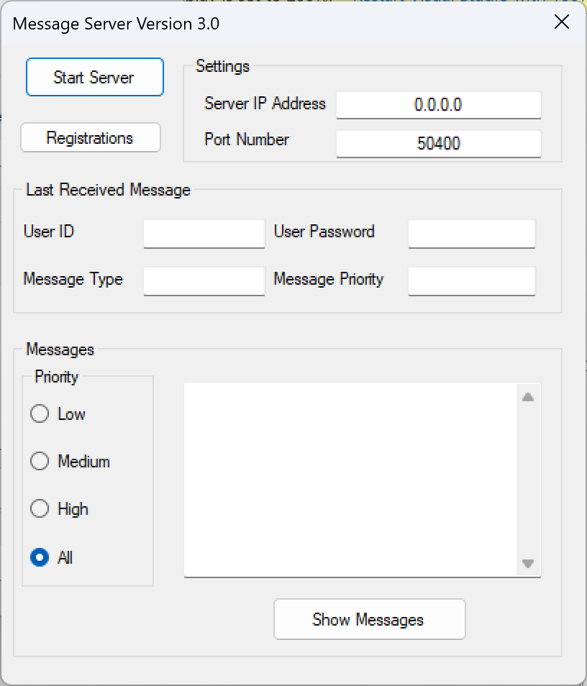

SMP Messenger – Registration GUI Form

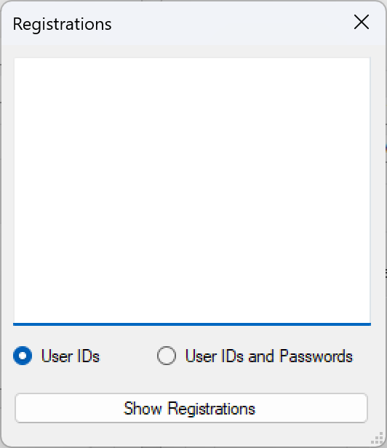

Submission

Upload the following files to Canvas:
- SMP Messenger Version 3.0 updates to the Software Requirements Specification, the Software Project Interface Prototypes, and the Software Technical Specifications.
- SMP Messenger Version 3.0 source code files.

