Software Project Interface Prototype

Messenger
Client – Server Application
Simple Message Protocol (SMP)
Team 8
Joseph Loreen, Nick Mayer, Nick Lipinski

Version 3

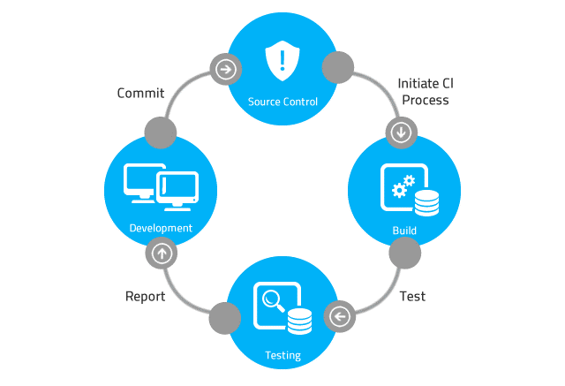

Table of Contents

Table of Contents 2
1 User Interfaces – GUI Versions 3
1.1 SMP Server Interface 4
1.1.1 Start Server Button 4
1.1.2 Show Messages Button 4
1.1.3 Registrations Button 4
1.2 Message Producer Client Interface 5
1.2.1 Send Message Button 5
1.3 Message Consumer Client Interface 5
1.3.1 Get Message Button 5

User Interfaces – GUI Versions
Software Application User Interface (UI)

User Interface (UI) Design focuses on anticipating what users might need to do and ensuring that the interface has elements that are easy to access, understand, and use to facilitate those actions.

The team developed the software application’s user interface (UI) based on the software requirements document. The UI is implemented as a graphical user interface (GUI).

Your team’s project manager should be prepared to present and discuss the software applications UI.

References

https://www.usability.gov/what-and-why/user-interface-design.html
https://en.wikipedia.org/wiki/Graphical_user_interface
https://www.w3computing.com/systemsanalysis/graphical-user-interface-gui-design/
https://www.interaction-design.org/literature/topics/ui-design

SMP Server Interface

Start Server Button
The Start Server button starts the SMP Server. An SMP message consists of a username, encrypted password, priority level, the encrypted message content, and the current date and time. The server adds the encrypted message to a text file. There is one text file for each of the priority levels. The text files serve as queues. Which text file the server writes to depends on the priority selected.

Show Messages Button
Depending on which option button is selected, the Show Messages button should read in records from the appropriate file and display the username, encrypted password, message date, message priority, and the decrypted message content for each of the messages in the file and list the messages in the Messages window.

Registrations Button
The registrations button brings up a new window that has a Show Registrations button and an option to toggle between just User Ids and both User Ids and Passwords.

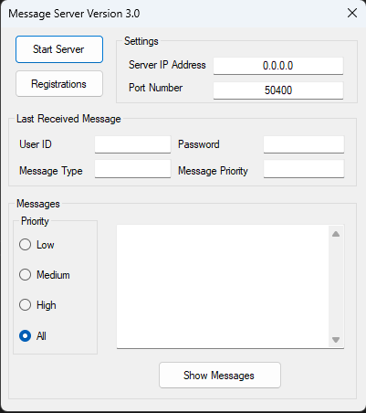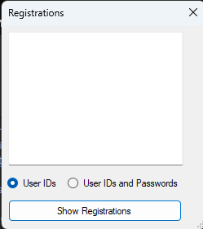

Message Producer Client Interface

Send Message Button
The SMP Message Producer client program is designed to send an SMP PUT request to the server.

When the Send Message button is clicked, an SMP message is sent to the server. The message sent to the server consists of a User ID, Password, date and time stamp, the message priority, and the encrypted message content. The server adds the record to the file associated with the message priority.

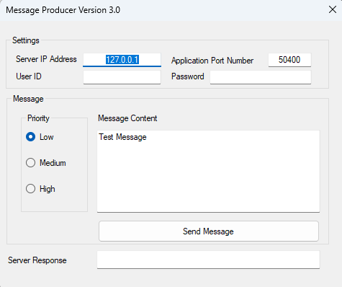

Message Consumer Client Interface

Get Message Button
The SMP Message Consumer client program is designed to send an SMP GET request to the server.

When the Get Message button is clicked, an SMP GET request is sent to the server with an associated User Id and Password. The server responds with an SMP message. Which message is sent back from the server depends on the priority selected, and if there is a matching username and password in the server Users.txt registry. The message sent back to the client consists of the message date and time stamp, message priority and decrypted message content. After the client acknowledges that it has received the message, the server deletes the record from the file.

