WEEKLY WRITE UP RTOS

Week 1:Diagram: See Diagram.

Test Plan and Results:

Week 1: Unit test Description

1. Button ISR-Test the ISR functionality

Status: Not Run

1. Slider-Test the slider functionality

Status: Not Run

1. Button FIFO-Test the functionality of the button FIFO

Status: Not Run

1. Gain Task-Test the functionality of the gain task specifically the pwm generation

Status: Not Run

1. SysTick ISR-Test the functionality of the SysTick ISR

Status: Not Run

1. Movement Task-Test the functionality of the movement task specifically that the base

of the pendulum moving and xmin and xmax.

Status: Not Run

1. Physics Task-Test the functionality of the physics task, specifically the physics

calculations and the updating of the physics data structure.

Status: Not Run

1. LCD Display Task-Test the functionality of the LCD display task. Specifically that it

displays the correct output clears and updates ion a reasonable amount of time

Status: Not Run

1. LED Output Task-Test the functionality of the leds, specifically that they turn on and

and off when they are supposed to.

Status: Not Run

1. Final Test-Test each task run and output what is expected based on the inputs, as well as working together with each other, and test responsiveness.

Status: Not Run

Week 2: Unit test Description

1. Fifo:

3 tests for push and pop variations

Finished and passed all

1. Gain:

3 tests for incrementing/ decrementing gain

Finished and passed all

1. Movement:

5 tests for each slider position and not touching the slider

Finished and passed all

1. Physics:

7 tests for checking physics computations are correct

Finished the tests but do not have physics functions written so has not passed them.

Total Pass = 11

Total Fail = 7

Week 3: Unit test Description

1. Fifo:

3 tests for push and pop variations

Finished and passed all

1. Gain:

3 tests for incrementing/ decrementing gain

Finished and passed all

1. Movement:

5 tests for each slider position and not touching the slider

Finished and passed all

1. Physics:

7 tests for checking physics computations are correct

Tests and physics function have changed and are being revised so some tests are commented out and some tests pass incidentally, will finish the physics function and have all tests revised and passed by next week.

Total Pass = 11

Total Fail = 7

Week 4: Unit test Description

1. Fifo:

3 tests for push and pop variations

Finished and passed all

1. Gain:

3 tests for incrementing/ decrementing gain

Finished and passed all

1. Movement:

5 tests for each slider position and not touching the slider

Finished and passed all

1. Physics:

7 tests for checking physics computations are correct

Finished and passed all

Total Pass = 18

Total Fail = 0

Final Submission: Unit test Description

1. Fifo:

3 tests for push and pop variations

Finished and passed all

1. Gain:

3 tests for incrementing/ decrementing gain

Finished and passed all

1. Movement:

5 tests for each slider position and not touching the slider

Finished and passed all

1. Physics:

7 tests for checking physics computations are correct

Finished and passed all

Total Pass = 18

Total Fail = 0

Week 3: Functional Test Description

1. PWM increases when gain increased.

Passed

1. PWM decreases when gain decreased.

Passed

1. Button0 increases gain and therefore PWM

Passed

1. Button1 decreases gain and therefore PWM

Passed

1. Slider left moves object left on LCD

Not Tested

1. Slider right moves object left on LCD

Not Tested

1. LCD updates image with new movement.

Not Tested

1. Physics Engine updates LCD correctly

Not Tested

1. Game ends as Expected

Not Tested

1. Image is static on LCD at beginning of game

Not Tested

Week 4: Functional Test Description

1. PWM increases when gain increased.

Passed

1. PWM decreases when gain decreased.

Passed

1. Button0 increases gain and therefore PWM

Passed

1. Button1 decreases gain and therefore PWM

Passed

1. Slider left moves object left on LCD

Not Tested

1. Slider right moves object right on LCD

Not Tested

1. LCD updates image with new movement.

Not Tested

1. Physics Engine updates LCD correctly

Not Tested

1. Game ends as Expected

Not Tested

1. Image is static on LCD at beginning of game

Passed

Final Submission: Functional Test Description

1. PWM increases when gain increased.

Passed

1. PWM decreases when gain decreased.

Passed

1. Button0 increases gain and therefore PWM

Passed

1. Button1 decreases gain and therefore PWM

Passed

1. Slider left moves object left on LCD

Passed

1. Slider right moves object right on LCD

Passed

1. LCD updates image with new movement.

Passed

1. Physics Engine updates LCD correctly

Passed

1. Game ends as Expected

Passed

1. Image is static on LCD at beginning of game

Passed

Statement of Where Project Stands:

Week 1:

This week I completed the project diagram, as well as the initial planning for unit tests and estimates on how long each part will take along with risk analysis.

Week 2:

This week I wrote all the unit tests and the fifo, movement and gain functions. I also began to think about physics implementation. I also set up all the tasks, mutexes, semaphores, and flags.

Week 3:

This week I wrote the basis for the physics engine and update unit tests accordingly. The Physics engine is more complex than anticipated and I was not able to complete all of it this week, and will also need to revise unit tests when it is completed.

Week 4:

This week I finished the physics engine, the physics engine unit tests and began work on the LCD implementation. I got the LCD to show the starting screen for the game and passed that functional test but I do not yet have the LCD reacting to the game controls and updating on the physics engine, but that is the last thing I need to complete for the project.

Final Submission:

This week I completed the entire project the game is playable and the all requirements are met. All functional and Unit tests have been passed and the game has been fully debugged so that it plays well.

Summary effort and estimate numbers:

Total estimated hours: 40hrs

Week 1:

I estimate I have completed 5% of my scope, estimated work (3hrs/40hrs) which is 7.5% of the initial estimated time. My best guess of my say/do ratio is 5/7.5 = 66.7%, so to unbias my estimates after this class I may want to multiply my estimates by 1.5 (100/66.7).

Given the scope changes I’ve made my original scope is 100% of my latest scope (40 hrs vs. 40 hrs)

Week 2:

I estimate I have completed 25% of my scope, estimated work (11hrs/40hrs) which is 27.5% of the initial estimated time. My best guess of my say/do ratio is 25/27.5 = 90.9%, so to unbias my estimates after this class I may want to multiply my estimates by 1.1(100/90.9).

Given the scope changes I’ve made my original scope is 88.88% of my latest scope (40 hrs vs. 50 hrs)

Week 3:

I estimate I have completed 40% of my scope, estimated work (20hrs/45hrs) which is 44% of the initial estimated time. My best guess of my say/do ratio is 40/44 = 90%, so to unbias my estimates after this class I may want to multiply my estimates by 1.1(100/90).

Given the scope changes I’ve made my original scope is 80% of my latest scope (40 hrs vs. 50 hrs)

Week 4:

I estimate I have completed 80% of my scope, estimated work (35hrs/50hrs) which is 70% of the initial estimated time. My best guess of my say/do ratio is 80/70 = 114%, so to unbias my estimates after this class I may want to multiply my estimates by 0.88(100/114).

Given the scope changes I’ve made my original scope is 80% of my latest scope (40 hrs vs. 50 hrs)

Final Submission:

I estimate I have completed 100% of my scope, estimated work (50hrs/50hrs) which is 100% of the initial estimated time. My best guess of my say/do ratio is 100/100 = 100%, so to unbias my estimates after this class I may want to multiply my estimates by 1(100/100).

Given the scope changes I’ve made my original scope is 80% of my latest scope (40 hrs vs. 50 hrs)

List of in-scope work Items:

Week1:

* Diagram

Completed

I’m glad my diagram is detailed because it will make the rest of the project easier and give me a good idea of the project overall as a whole.

* Btn ISR/Unit Test
* Btn FIFO/Unit Test
* SysTick ISR/Unit Test
* Touch Slider/Unit Test
* Movement Task/Unit Test
* Gain Task/Unit Test
* Physics Task/Unit Test
* LCD Task/Unit Test
* LED Task/Unit Test

List of in-scope work Items:

Week2:

* Diagram

Completed

I’m glad my diagram is detailed because it will make the rest of the project easier and give me a good idea of the project overall as a whole.

* Btn ISR
* Btn FIFO/Unit Test

Completed

I’m glad the fifo works well and passed all the unit tests

* SysTick ISR

Completed

I am glad that we got the systick interrupt working and it also drives our PWM

* Movement Unit Test

Completed

Checked the movement function in the movement task is working correctly and it was

* Movement Task

Completed

Completed the movement task based on lab 7

* Gain Unit Test

Completed

Checked to see that the gain function inside of the gain task is working correctly and it was

* Gain Task

Completed

Completed the gain task based on lab 7

* Physics Unit Test

Completed

Completed the Unit tests, but will need modifications as the physics function and tasks are not complete yet.

* Physics Task
* LCD Task
* LED Task

List of in-scope work Items:

Week3:

* Diagram

Completed

I’m glad my diagram is detailed because it will make the rest of the project easier and give me a good idea of the project overall as a whole.

* Btn ISR

Completed

The Btn works well and was very similar to lab 7

* Btn FIFO/Unit Test

Completed

I’m glad the fifo works well and passed all the unit tests

* SysTick ISR

Completed

I am glad that we got the systick interrupt working and it also drives our PWM

* Movement Unit Test

Completed

Checked the movement function in the movement task is working correctly and it was

* Movement Task

Completed

Completed the movement task based on lab 7

* Gain Unit Test

Completed

Checked to see that the gain function inside of the gain task is working correctly and it was

* Gain Task

Completed

Completed the gain task based on lab 7

* Physics Unit Test

In Progress

Need to modify the Tests because the Physics function turned out differently than anticipated.

* Physics Task

In progress

This is harder than I thought and I am still working on it.

* LCD Task
* LED Task

List of in-scope work Items:

Week4:

* Diagram

Completed

I’m glad my diagram is detailed because it will make the rest of the project easier and give me a good idea of the project overall as a whole.

* Btn ISR

Completed

The Btn works well and was very similar to lab 7

* Btn FIFO/Unit Test

Completed

I’m glad the fifo works well and passed all the unit tests

* SysTick ISR

Completed

I am glad that we got the systick interrupt working and it also drives our PWM

* Movement Unit Test

Completed

Checked the movement function in the movement task is working correctly and it was

* Movement Task

Completed

Completed the movement task based on lab 7

* Gain Unit Test

Completed

Checked to see that the gain function inside of the gain task is working correctly and it was

* Gain Task

Completed

Completed the gain task based on lab 7

* Physics Unit Test

Completed

Finished the Unit tests for the physics task.

* Physics Task

Completed

Finished the Physics task.

* LCD Task

In Progress

List of in-scope work Items:

Final Submission:

* Diagram

Completed

I’m glad my diagram is detailed because it will make the rest of the project easier and give me a good idea of the project overall as a whole.

* Btn ISR

Completed

The Btn works well and was very similar to lab 7

* Btn FIFO/Unit Test

Completed

I’m glad the fifo works well and passed all the unit tests

* SysTick ISR

Completed

I am glad that we got the systick interrupt working and it also drives our PWM

* Movement Unit Test

Completed

Checked the movement function in the movement task is working correctly and it was

* Movement Task

Completed

Completed the movement task based on lab 7

* Gain Unit Test

Completed

Checked to see that the gain function inside of the gain task is working correctly and it was

* Gain Task

Completed

Completed the gain task based on lab 7

* Physics Unit Test

Completed

Finished the Unit tests for the physics task.

* Physics Task

Completed

Finished the Physics task.

* LCD Task

Completed

Risk Register:

Week 1:

See XCEL spreadsheet

Week 2:

See XCEL spreadsheet

Week 3:

See XCEL spreadsheet

Week 4:

See XCEL spreadsheet

Final Submission:

See XCEL spreadsheet

Analysis of Solution:

RT Tasks- A screen shot of the priorities from simplicity are shown and 2 screen shots of Segger System view show the time line and runtime windows from Segger. Everythingis able to execute in time and the biggest time hog is actually the LCD display task and not the Physics task.

Priorities:

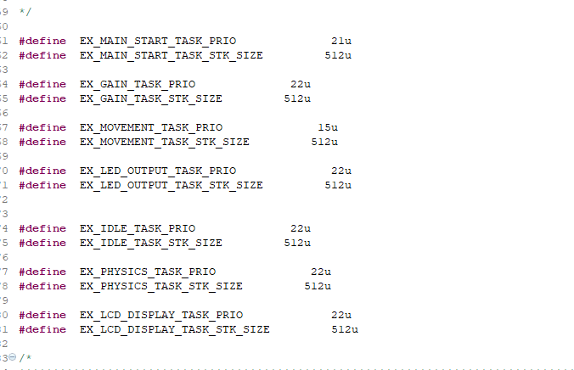

Segger SystemView:

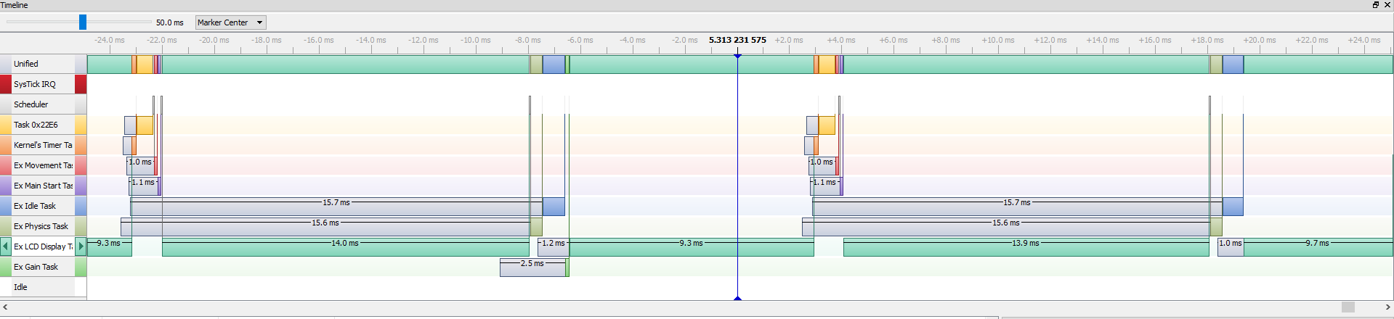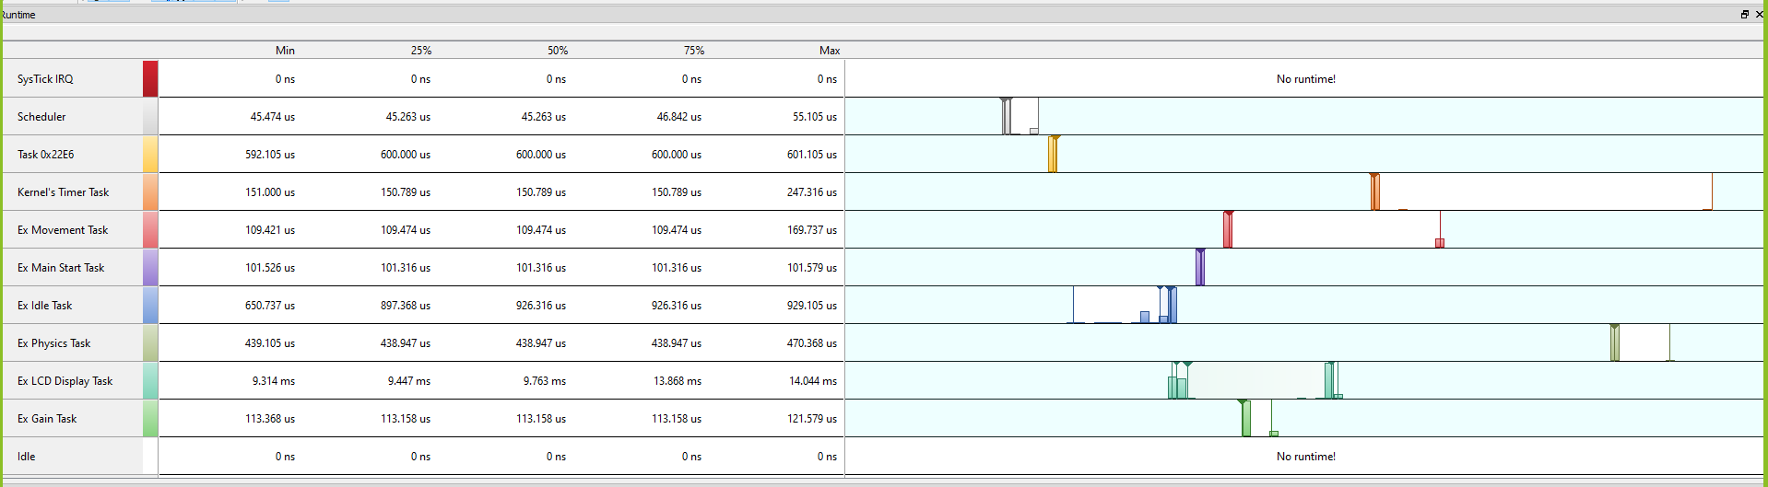

Code Space-This Snippet shows the usage of Flash and RAM by my project and then calculates the percent of the total available Flash and RAM on the Pearl Gecko.

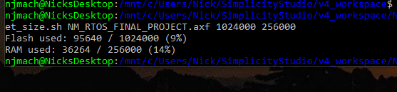

Evaluation of Approaches to Physics Requirements-I decided to use the non-ODE method that the Professor suggested. For this method I only looked at the forces on the ball and used basic trigonometry to commute them. I then summed all the forces in the horizontal direction and all the forces in the vertical direction. Then using essentially Eulers method I used the force to calculate the acceleration, velocity and position. Then using the position I calculated the angle to use for the next set of calculations. The limitations to this method are that when the pendulum passes through the theta equals zero point caused some problems. To overcome these problems I changed the physics and numbers in a way that made the game playable and so that it did not look bad on the LCD screen. This method I believe may have been easier than solving ODE’s but less physics accurate, especially around the theta equals zero point where I had to mess with the physics. However even with the less accurate physics the game plays well and looks like the physics are working properly.

Scaling of Variable Spaces-To make the game playable the gravitational force had to be relatively small. To accomplish this gravity’s acceleration needs to be smaller or the mass needs to be small. I decided to opt for a smaller mass using 0.05 kg, this made sense to me because a 50 gram ball makes sense in the real world and I wanted to leave gravity untouched. On the other had if the mass or gravity Is too small the game also becomes hard to play because the force from the cart completely overwrites the force from gravity. Some bounds I would give this project is that any combination of mass and gravity will work as long as mass times gravity’s acceleration is between .98 and 0.098 is best where both the edge cases makes the game very difficult to play. My current set up works very well for playability with gravity at 9.8m/s^2 and a mass of 0.05 kg which yields a gravitation force of 0.49.

Next Steps-Next steps I would take is to also try a more accurate physics task solving for ODE’s using a Runge Kuta method. Included in this I would try to come as close as I could to accurately modeling the physics including giving the cart mass and adding friction on the cart and the ground. Another next step I would explore is allowing customization of the game parameters by the user before the game started. This would allow the user to for mass, gravity, pole length, and other parameters.