Does Gamification Actually Change How Users Think?

Two controlled experiments on points, badges, and choice — and what they really buy you
Role: Sole researcher (M.S. thesis) · Timeline: Aug 2024 – Aug 2025 · Methods: Controlled experiments, survey design, behavioral data analysis · Tools: Python, JASP, PENS & PANAS scales · Participants: 161 recruited, 146 analyzed across two experiments

The problem
Products gamify constantly — points, badges, streaks, unlockables — usually on the assumption that game elements make users more engaged, more motivated, and even more creative. But most evidence for that assumption is correlational, and almost none of it tests how gamification changes cognition. I designed a two-experiment study to answer a question with direct product relevance: do gamification elements change how flexibly and creatively users think, or do they just change how users feel?

What I built
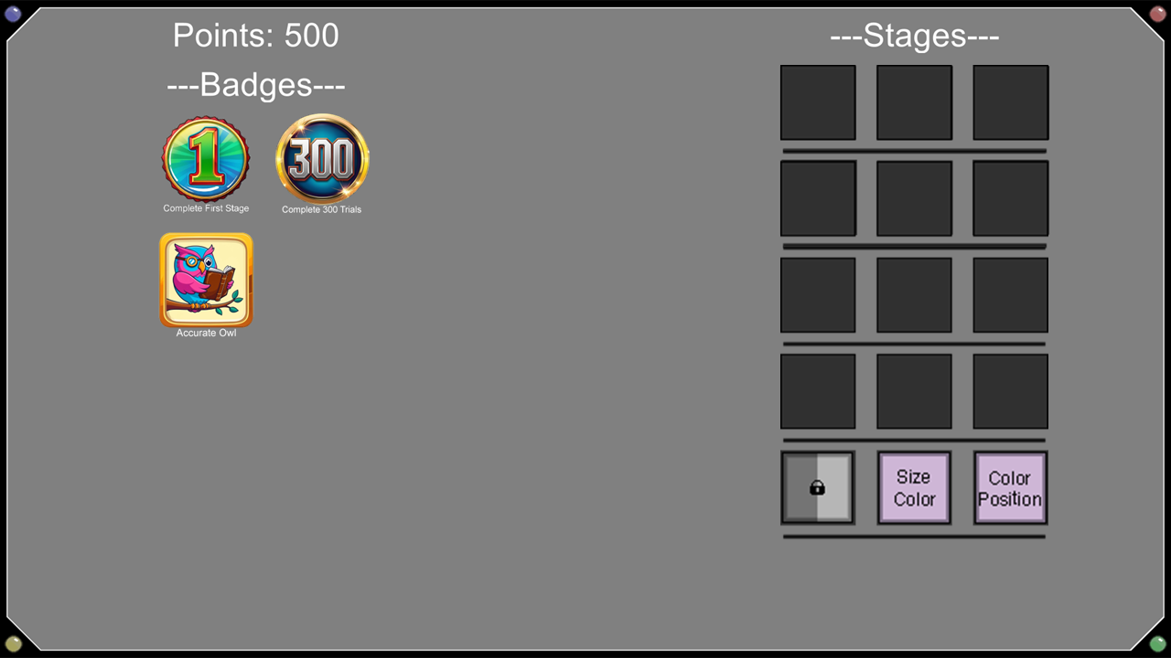
I developed a gamified task environment in Python from scratch: a “home screen” hub (see figure) where users spent earned points to unlock stages, chose which challenges to attempt, received performance feedback, and collected achievement badges (designed around Self-Determination Theory’s autonomy and competence needs). The core activity was a task-switching paradigm — a standard behavioral measure of cognitive flexibility — followed by an insight problem-solving task (the Compound Remote Associates Task) measuring close-ended creativity, and validated surveys (PENS, PANAS) measuring perceived autonomy, competence, and affect.
Users were randomly assigned to the gamified environment or a stripped-down control version of the identical task. I ran the full research operation end to end: IRB approval, recruitment of 161 participants, lab sessions, training and supervising research assistants, and statistical analysis (mixed-factor ANOVAs, t-tests, regression) in JASP.

What happened — Experiment 1
The first version placed all gamification between task blocks: finish a block, get feedback and badges, spend points, pick the next stage. The result was a genuine surprise: gamified users performed slightly worse on the flexibility measure (switch costs of 147 ms vs. 109 ms for controls), and no survey measure reached significance. My interpretation: game elements bolted onto the periphery of a task can compete for attention rather than enhance the experience — users were thinking about badges and points between blocks instead of settling into the task.

Iterating the design — Experiment 2
Treating Experiment 1 as a failed design rather than a failed idea, I redesigned the reward system to live inside the interaction loop: points now appeared trial-by-trial as animated coins, scaled to speed and accuracy, with the hardest actions (fast, accurate responses on switch trials) earning the most. This one design change reversed the results:
- Users in the gamified condition responded dramatically faster — mean response times of 617 ms vs. 888 ms for controls — and their switch costs shrank to 62 ms vs. 155 ms, a pattern consistent with a more flexible cognitive state.
- Perceived competence rose significantly (d = 0.69, p = .004) — the strongest motivational effect in either experiment.
- But speed came at a price. Accuracy dropped from 97.1% (control) to 92.1% (gamified) — a classic speed–accuracy trade-off. The point structure rewarded speed, and users gave the system exactly the behavior it paid for.
- Creativity didn’t move. Gamified users solved no more insight problems than controls in either experiment. The one intriguing exception: users who actively engaged with the game systems (measured by unlock behavior) solved 67% of problems vs. 47% for unengaged users — suggesting engagement, not gamification per se, may be the active ingredient.

What this means for product design
1. Placement beats presence. The same reward elements did nothing (or backfired) when placed between sessions, and substantially changed behavior when woven into the moment-to-moment interaction. If a reward system lives outside the core loop, expect it to distract, not motivate.
2. Incentives are a precision instrument — users optimize for exactly what you reward. Paying for speed bought speed and cost accuracy. Before shipping a point system, ask what behavior it literally pays for, because that is the behavior you will get.
3. Competence is the most movable lever. Of every motivational construct measured, perceived competence responded most strongly to immediate performance feedback. If a design goal is “make users feel capable,” trial-level feedback is a proven mechanism.
4. Choice has to be consequential to feel like autonomy. Users could choose their stages, but the choices barely changed their experience — and perceived autonomy barely moved. Superficial choice doesn’t register as freedom.
5. Averages hide the real story. Benefits concentrated in users who actually engaged with the game systems. Designing (and measuring) for engagement heterogeneity matters more than assuming a uniform effect.

What I’d do differently
I’d measure engagement directly with an instrument that works in both conditions rather than inferring it from badge behavior; I’d measure motivation and affect immediately after the manipulation instead of at the session’s end (effects may be transient); and I’d test immersive elements like narrative, which the literature suggests drive the positive affect my design never successfully moved.

Skills demonstrated
End-to-end study design and iteration based on evidence · building interactive experimental software in Python · behavioral and survey data analysis (ANOVA, regression, effect sizes) · participant recruitment and research operations · translating null and mixed results into honest, actionable design guidance.

