CHAPTER No-1
INTRODUCTION

1.1 BACKGROUND
Tourism has become a major contributor to the global economy, accounting for a significant share of GDP and employment in many countries. The rise of digital technology and the internet has transformed how travelers plan, book, and experience their trips. Increasingly, tourists rely on online platforms and mobile applications to access information about destinations, accommodation options, transport facilities, and attractions.
Despite the availability of various travel websites and apps, many platforms often offer fragmented services, outdated information, or lack personalized experiences that cater to individual traveler preferences. Additionally, travelers face difficulties in comparing options or accessing reliable reviews, which can impact their decision-making and overall satisfaction.
To bridge these gaps, there is a growing need for an integrated, comprehensive, and user-friendly web service that can provide all relevant tourism information and services in one place. Such a system would simplify travel planning, save time, and enhance the overall travel experience by offering features like destination exploration, hotel and transport booking, itinerary creation, user-generated reviews, and real-time updates.
The Tourism Web Service project is initiated in response to these challenges. It aims to develop a dynamic web platform that brings together diverse tourism-related services into a unified system. By leveraging modern web technologies, the project seeks to create an accessible platform that supports tourists in making informed decisions and helps local tourism businesses gain greater exposure.
This project will contribute to digital transformation within the tourism industry by enhancing service delivery, promoting sustainable tourism practices, and providing an engaging interface for users. It also aligns with current trends of personalization and interactivity in web services, ensuring the platform remains relevant and valuable in a competitive market.

1.2 OBJECTIVES
The primary objective of the Tourism Web Services System is to develop a secure, efficient, and user-friendly web-based application that simplifies the process of searching, booking, and managing travel packages. The system aims to provide complete and accurate information about tourist destinations, accommodation facilities, and travel services through a centralized platform. It is designed to automate the manual tourism management process, thereby reducing paperwork, saving time, and minimizing human errors.
Another important objective of this project is to enable users to register, explore destinations, and book travel packages online from anywhere at any time. The system also allows administrators to manage packages, locations, bookings, and advertisements effectively through proper authentication and authorization mechanisms. Furthermore, the project focuses on maintaining updated data using PHP and MySQL while ensuring data security and reliability. The system is designed with flexibility so that it can be enhanced in the future with advanced features such as online payment integration, AI-based recommendations, and real-time communication services.

1.3 Purpose, Scope, and Applicability

1.3.1 PURPOSE
The purpose of the Tourism Web Services System is to develop a web-based application that provides an efficient and organized platform for managing tourism-related activities. The system is designed to replace the traditional manual method of handling travel bookings, package management, and customer records with a computerized solution. By doing so, it ensures faster processing, improved accuracy, and better record maintenance.
The project aims to provide travelers with easy access to detailed information about tourist destinations, travel packages, accommodation facilities, and booking options through a single online platform. It also enables administrators to manage locations, packages, bookings, and customer details effectively. The overall purpose of this system is to enhance convenience for users, reduce operational complexity, improve communication between customers and administrators, and support the digital transformation of tourism services.

1,3.2 Scope
The scope of the Tourism Web Services System encompasses the design, development, and implementation of a comprehensive web-based application that facilitates the management of tourism-related services in an efficient and organized manner. The system is intended to serve as a centralized platform where users can access detailed information about tourist destinations, travel packages, accommodation facilities, and ticket booking services. It provides an integrated environment that connects travelers and administrators through a structured and automated process, thereby eliminating the need for traditional manual methods of operation.
The project covers the complete lifecycle of travel management, beginning with user registration and authentication. Registered users can log into the system, explore various travel destinations, view available packages, compare details such as pricing and features, and make bookings according to their preferences. The system maintains customer records, booking details, and confirmation status in a centralized database, ensuring data consistency and reliability. Users can also receive booking confirmations and manage their reservations through the platform, which enhances transparency and convenience.
On the administrative side, the system provides secure access to manage all operational activities. The administrator can add, update, and delete travel packages, manage destination information, upload advertisements, and monitor booking details. This ensures that the information displayed to users is accurate and up to date. The centralized database structure helps in maintaining organized records of users, packages, and transactions, reducing redundancy and minimizing errors.
The project is developed using PHP as the server-side scripting language and MySQL as the back-end database, operating within a Windows environment. It ensures a user-friendly interface that simplifies navigation and improves the overall user experience. The scope also includes system testing, validation, and implementation to ensure that the application functions according to specified requirements.
Furthermore, the system is designed with scalability and flexibility in mind. The scope allows for future enhancements such as integration of secure online payment gateways, real-time chat or video communication with administrators, AI-based personalized travel recommendations, mobile application support, and enhanced cybersecurity measures. As the tourism industry continues to evolve with technological advancements, this system can be upgraded to incorporate emerging technologies and expanded to support a larger user base.

1.3.3APPLICABILITY
The Tourism Web Service project is designed to serve a broad spectrum of users and stakeholders involved in the tourism industry by providing a centralized platform for accessing, managing, and sharing tourism-related information and services. Its applicability extends to tourists, travel agencies, local businesses, and tourism authorities, each benefiting uniquely from the system.
For Tourists:
This web service offers travelers—both domestic and international—a convenient and reliable means to explore a wide range of tourist destinations. It provides essential information about attractions, accommodations, transportation options, and local services. Tourists can use the platform to plan their trips efficiently by creating personalized itineraries, booking hotels and transport, and reading genuine user reviews. The accessibility of the platform on various devices allows users to plan and manage their travel anytime, anywhere, enhancing convenience and user experience.
For Travel Agencies:
Travel agencies can leverage the platform to offer better service to their clients by utilizing comprehensive, up-to-date information about destinations and tourism services. The system also acts as a marketing channel where agencies can promote their tour packages and special deals, thus expanding their reach and customer base.
For Local Businesses:
Hotels, restaurants, transport services, and tour operators benefit from increased visibility by listing their services on the platform. This helps them attract more customers, receive direct bookings, and collect valuable feedback through user ratings and reviews. The platform thus acts as a bridge connecting service providers directly with tourists, facilitating growth and improved customer engagement.
For Tourism Authorities:
The web service aids tourism departments and authorities by promoting regional tourism, highlighting cultural, historical, and natural attractions. It provides a medium to communicate travel advisories, local events, and updates. Additionally, authorities can analyze visitor feedback and usage trends to make informed decisions for improving tourism infrastructure and policies.
Overall, the Tourism Web Service project is applicable to all participants in the tourism ecosystem. It enhances communication between tourists and service providers, improves the
1.4 Achievements
The Tourism Web Services System has been successfully developed as a fully functional web-based application using PHP and MySQL technologies. The project effectively automates the traditional manual process of managing tourism activities such as travel package creation, booking management, and customer record maintenance. A secure authentication system has been implemented to ensure safe login access for both administrators and users. The system maintains a centralized database that stores all relevant information efficiently and accurately.
The application enables users to register, explore destinations, and book travel packages online with ease, while administrators can manage locations, packages, advertisements, and booking confirmations through a structured interface. The system significantly reduces paperwork, minimizes human errors, and saves time by streamlining operational tasks. Various system design tools such as Data Flow Diagrams, Use Case Diagrams, Class Diagrams, and Sequence Diagrams were successfully implemented during development. The system was thoroughly tested using different testing methodologies to ensure reliability, accuracy, and performance. Overall, the project has achieved its objectives and provides a scalable platform that can be enhanced in the future with advanced features and technologies.

1.5 Organization of the Report
This project report is organized into several chapters, each describing a specific aspect of the Tourism Web Services System. The report begins with the Abstract, which provides a brief overview of the project, its objectives, and its significance in the tourism domain.

The Introduction chapter explains the background of the project, the need for developing a computerized tourism management system, and the overall concept of the proposed application. It highlights the importance of automating travel and booking services through a web-based platform.

The System Specification chapter describes the existing system and its drawbacks, followed by the proposed system and its advantages. This section explains how the new system overcomes the limitations of the manual process.

The System Requirements chapter outlines the hardware and software requirements necessary for developing and running the application. It specifies the operating system, programming language, database, and system configuration details.

The System Design chapter presents various design models such as Data Flow Diagrams, Use Case Diagrams, Class Diagrams, Sequence Diagrams, and Activity Diagrams. These diagrams illustrate the structure and workflow of the system.

CHAPTER-2
SURVEY OF TECHNOLOGY

Survey of Technology:

comparison between javascript and python

Feature | JavaScript | Python
Type | Interpreted, multi-paradigm scripting language (mainly client-side) | Interpreted, high-level, general-purpose programming language
Primary Use | Web development (frontend & increasingly backend with Node.js) | Web development, data science, machine learning, automation, scripting
Syntax | C-like syntax, curly braces {} to define blocks | Clear and readable, uses indentation for block structure
Execution Environment | Runs mainly in web browsers and Node.js (server-side) | Runs on various platforms via Python interpreter
Learning Curve | Moderate, requires understanding asynchronous programming (callbacks, promises) | Easy to learn, beginner-friendly due to simple syntax
Libraries & Frameworks | React, Angular, Vue.js, Node.js, Express.js | Django, Flask, Pandas, NumPy, TensorFlow, Scikit-learn
Performance | Generally faster in browser environments; event-driven and non-blocking | Slower compared to JavaScript in browser but strong for CPU-intensive tasks
Use in Web Services | Widely used to build dynamic web pages and backend APIs with Node.js | Often used for backend APIs, scripting, automation, and data processing
Community & Support | Large and active community, especially in web development | Large, diverse community with strong presence in AI and data science
Error Handling | Uses try/catch blocks; asynchronous errors can be complex | Simple try/except blocks; easier error handling

Survey of Technology: JavaScript vs PHP
Feature | JavaScript | PHP
Type | Interpreted, multi-paradigm language primarily used on the client-side | Server-side, general-purpose scripting language
Primary Use | Web development (frontend, and backend using Node.js) | Server-side web development and dynamic websites
Syntax | C-like syntax with curly braces {} | C-like syntax, uses <?php ?> for code blocks
Execution Environment | Runs in web browsers and on servers using Node.js | Runs on web servers such as Apache and Nginx
Learning Curve | Moderate, especially due to asynchronous programming concepts | Easy to learn, especially for server-side scripting
Libraries & Frameworks | React, Angular, Node.js, Express.js | Laravel, Symfony, CodeIgniter
Performance | Fast for client-side interactions and asynchronous operations | Fast for server-side tasks but can be slower for complex applications
Use in Web Services | Used for frontend interactivity and building APIs with Node.js | Used for backend logic, handling form submissions, and user authentication
Community & Support | Large and active community, especially in frontend development | Large and active community, popular for dynamic web development
Error Handling | Uses try/catch blocks; async error handling can be complex | Uses try/catch blocks with relatively simple error handling

Survey of Technology: JavaScript vs C#

Feature | JavaScript | C#
Type | Interpreted, multi-paradigm scripting language | Compiled, object-oriented language
Primary Use | Web development (frontend, backend with Node.js) | Web, desktop, mobile (Xamarin), game development (Unity)
Syntax | C-like, uses {} for code blocks | C-like, strongly typed, uses ; for statements
Execution  Environment | Runs in web browsers,  Node.js (server-side) | Runs on .NET runtime, crossplatform with .NET Core
Learning Curve | Moderate, especially with async programming | Steeper for beginners, but powerful for large-scale applications
Libraries &  Frameworks | React, Angular, Node.js,  Express.js | ASP.NET, Xamarin, Unity, Blazor
Performance | Fast for client-side tasks, slower on backend | Generally faster, especially for server-side applications
Use in Web  Services | Frontend interactivity, backend APIs (Node.js) | Backend web services with  ASP.NET, cloud apps
Community &  Support | Large, especially in web development | Large, especially in enterprise and game development
Error Handling | Uses try/catch, asynchronous complexity | Uses try/catch, more structured error handling

Advantages of JavaScript
- Client-Side Execution JavaScript runs directly in the browser, which means it can manipulate web page content without requiring server requests. This results in faster load times and more interactive user experiences.
- Versatility JavaScript is used in a wide range of applications beyond web development, including mobile apps (React Native), server-side programming (Node.js), and even desktop applications (Electron).
- Asynchronous Programming JavaScript supports asynchronous programming through callbacks, promises, and async/await, allowing developers to handle long-running operations (like file I/O or API calls) without blocking the main execution thread, leading to improved performance.
- Large Ecosystem and Libraries JavaScript boasts a massive ecosystem with frameworks (React, Angular, Vue.js) and libraries (jQuery, Lodash) that help developers build robust applications quickly and efficiently. Node.js enables server-side JavaScript development, creating a full-stack JavaScript experience.
- Cross-Platform JavaScript works across all modern browsers and is compatible with various platforms, making it ideal for web and mobile development. Tools like React Native even allow JavaScript to be used for mobile app development.

Disadvantages of JavaScript
- Browser Dependency JavaScript code is interpreted differently by different browsers, which can lead to compatibility issues. Developers need to account for inconsistencies in browser rendering, especially in older browsers like Internet Explorer.
- Security Risks As a client-side scripting language, JavaScript can be exploited by malicious users to inject harmful code (e.g., cross-site scripting or XSS). It's essential to sanitize inputs and avoid common vulnerabilities to secure the application.
- Limited Multithreading JavaScript is single-threaded, which means it can only perform one operation at a time in the execution thread. This can lead to performance issues when handling CPU-intensive tasks or large-scale data processing.
- Weak Typing JavaScript is loosely typed, meaning variables don't require a specific data type. While this can be flexible, it also leads to unexpected behaviors and runtime errors that may be hard to debug, especially in large applications.

JAVASCRIPT
JavaScript is a popular programming language mainly used to make websites interactive. It allows web pages to respond to user actions like clicks, typing, or scrolling. Unlike some other programming languages that need to be compiled, JavaScript is interpreted, meaning it runs directly in the web browser without the need for special tools. It's cross-platform, meaning it works on any device with a browser. JavaScript is easy to learn and is often used alongside HTML and CSS to build web pages. While it was originally created to run on the client-side (in browsers), with the help of Node.js, JavaScript can also be used on the server-side, allowing developers to build full web applications using a single language.

My-SQL
MySQL is a relational database management system (RDBMS) developed by Oracle that is based on Structured Query Language (SQL). A database is a structured collection of data. It can be anything from a simple shopping list to an image gallery or a place to store huge amounts of information on a corporate network . MySQL was owned and sponsored by a single for-profit company, the Swedish company MySQL AB, now owned by Oracle Corporation. Several paid editions are available for proprietary use that offer additional features.HTML and CSS For developing web-frontend applications for mobile devices

PHP
PHP (Hypertext Preprocessor) is a popular programming language used mainly for web development. It runs on the server, meaning when you visit a webpage that uses PHP, the code works behind the scenes on the web server to create and deliver the page content you see. PHP can be embedded into HTML, which makes it easy to create dynamic web pages that can interact with databases, handle forms, and even manage user sessions. It's widely used because it's easy to learn, flexible, and works well with many different databases, like MySQL. Many popular websites and platforms, such as WordPress, are built using PHP.

HTML, CSS and BOOTSTRAP
HTML(HyperText Markup Language). This forms the standard language in the development and design of web pages. The primary structure and content of a web page are provided by HTML, which is to be styled with CSS and enhanced by JavaScript. CSS(Cascading StyleSheet) is a stylesheet language. It helps in controlling all the presentation, layout, and appearances on any HTML element of a webpage with much ease. This document allows a person to apply styles such as color, font, spacing, and positioning to an individual's HTML content. It is a way of making it look nice and responsive.

Conclusion
The Tourism Web Services System has been successfully developed as a web-based application that simplifies and automates tourism management activities. The system effectively replaces the traditional manual method of handling travel packages, bookings, and customer records with a computerized solution that improves efficiency, accuracy, and reliability. By integrating PHP and MySQL, the application ensures secure data storage, faster processing, and easy retrieval of information through a centralized database.

The project provides a user-friendly platform where customers can register, explore destinations, and book travel packages online, while administrators can manage locations, packages, advertisements, and booking confirmations efficiently. The implementation of proper system design methodologies and testing techniques has ensured that the application functions according to the specified requirements.

Overall, the project achieves its objective of creating a structured and scalable tourism management system. It reduces paperwork, minimizes human errors, saves time, and enhances communication between users and administrators. The system is flexible enough to support future enhancements, making it a reliable foundation for advanced digital tourism services.

CHAPTER-3
REQUIREMENT AND ANALYSIS

3.1 Problem Definition
The rapid growth of the tourism industry has created a need for more efficient, accessible, and user-friendly systems that can handle the complex demands of travelers, businesses, and service providers. Traditional tourism management systems often rely on outdated technologies, manual processes, and disconnected platforms, which can result in inefficiencies, slow service delivery, and poor user experiences.

A major problem in the tourism industry is the lack of an integrated, real-time solution for managing travel-related services such as bookings, itineraries, transportation, accommodation, and local attractions. Users often have to rely on multiple platforms and services, which leads to fragmentation, longer decision-making processes, and difficulties in accessing accurate, up-to-date information.

Additionally, businesses in the tourism sector struggle to provide personalized services due to the lack of systems that can dynamically respond to user preferences and changes in the market. This can result in missed opportunities, reduced customer satisfaction, and increased operational costs.

The core problem addressed by this project is the need for a comprehensive tourism web service that integrates real-time data, allows seamless interaction between users and service providers, and offers personalized, efficient, and accessible travel solutions for customers and businesses alike.

This problem is significant in the context of increasing demand for digital and automated services, where users expect instant access to travel information, easy booking systems, and personalized recommendations. By developing an effective tourism web service, we can streamline processes, enhance user experiences, and provide businesses with the tools they need to optimize their operations.

3.2 Requirements Specification
The requirements specification outlines the functional and non-functional requirements for the development of the tourism web service system. This document defines what the system will do, the features it will include, and the performance standards it must meet to solve the identified problems and provide a seamless user experience.

Functional Requirements
- User Authentication and Authorization
- Login/Signup: Users (tourists and businesses) should be able to register, log in, and manage their accounts.
- Role-based Access: Different roles (admin, user, service provider) should have different levels of access to the system.
- Password Recovery: Users should be able to recover or reset their passwords via email.
- Search and Discovery
- Search Functionality: Users should be able to search for destinations, hotels, tours, transportation options, and activities based on parameters like location, price, and type.
- Filters and Sorting: Ability to filter results by various criteria such as price, ratings, and availability. Sorting by relevance, price, or ratings is also required.
- Booking and Reservation System
- Real-Time Availability: The system must provide up-to-date availability for hotels, flights, transportation, and tours.
- Booking Management: Users should be able to book and manage their reservations for travel, accommodation, and activities.
- Payment Integration: Secure payment gateway for online payments (e.g., credit/debit cards, PayPal, etc.).
- Personalization
- User Profiles: Allow users to create and maintain profiles that store preferences (e.g., travel style, accommodation type, destinations).
- Recommendations: The system should recommend services (e.g., activities, hotels, destinations) based on user preferences and previous interactions.
- Review and Rating System
- User Reviews: Users should be able to leave reviews and ratings for hotels, destinations, and other services they have used.
- Service Provider Feedback: Service providers should be able to respond to user reviews.

Non-Functional Requirements
- Performance
- Scalability: The system should be able to handle a high number of simultaneous users and transactions without degradation in performance.
- Speed: The application should load within 3 seconds to ensure a smooth user experience.
- Security
- Data Encryption: All sensitive data (such as payment details, personal information) should be encrypted using modern encryption algorithms (e.g., AES-256).
- Secure Payment Gateway: The payment system must comply with security standards like PCI DSS.
- User Data Protection: Ensure GDPR compliance for user data privacy, and implement two-factor authentication (2FA) where necessary.
- Usability
- User Interface: The system should have an intuitive and user-friendly interface for both tourists and service providers.
- Mobile Compatibility: The website should be responsive and fully functional on mobile devices (smartphones and tablets).
- Availability
- High Availability: The system should be available 99.9% of the time, with regular backups and failover mechanisms in place.
- Disaster Recovery: A disaster recovery plan should be in place, ensuring minimal downtime in case of system failures.
- Maintainability
- Modular Design: The system should have a modular design, making it easy to update and add new features without disrupting existing functionality.
- Logging and Monitoring: Implement logging to capture system errors, user activities, and performance metrics, with real-time monitoring for rapid response to issues.

3.3 Planning and Scheduling
Effective planning and scheduling are crucial to the successful development and deployment of the Tourism Web Service System. This section outlines the overall plan for the development process, including timelines, milestones, resources, and tasks that need to be completed at each stage. The goal is to ensure that the project is completed on time, within budget, and meets all functional and non-functional requirements.

1. Project Phases
The development of the Tourism Web Service System is broken down into several key phases, each with specific deliverables and timelines:

Phase 1: Requirements Gathering and Analysis (Week 1 – Week 3)
Objective:
Define the system requirements, both functional and non-functional, and gather all the necessary information from stakeholders (end users, service providers, business stakeholders).
Tasks:
- Conduct stakeholder meetings to gather requirements.
- Define and document functional and non-functional requirements.
- Research similar tourism platforms and identify gaps in the market.
- Establish technology stack and system architecture.
Deliverables:
- Requirement Specification Document
- Finalized Technology Stack and System Architecture

Phase 2: System Design and Prototyping (Week 4 – Week 6)
Objective:
Create the initial system design, including UI/UX designs, database schemas, and API structures. A prototype of the platform will be developed to demonstrate key features.
Tasks:
- Design wireframes and mockups for the user interface (UI).
- Create a detailed database schema for storing user data, bookings, reviews, etc.
- Design system architecture and define API endpoints.
- Develop a functional prototype for key features (user registration, search functionality, etc.).
- Review and approve design documents and prototypes with stakeholders.
Deliverables:
- UI/UX Wireframes and Mockups
- System Design Document
- Working Prototype (for demonstration purposes)

Phase 3: Backend Development (Week 7 – Week 12)
Objective:
Develop the backend of the system, including user management, booking management, and integration with external services (payment gateways, APIs for flight/hotel data, etc.).
Tasks:
- Set up the development environment and backend frameworks (e.g., Node.js with Express or Django).
- Implement user authentication and role-based access control.
- Develop APIs for managing user data, bookings, reviews, and ratings.
- Integrate third-party APIs (Google Maps, Payment Gateway, Weather API).
- Implement database functionality (CRUD operations, data validation, etc.).
Deliverables:
- Backend API Endpoints
- Integrated Third-Party Services (e.g., Payment Gateway, Weather API)
- Database and Server-Side Logic for User and Booking Management

Phase 4: Frontend Development (Week 13 – Week 16)
Objective:
Develop the frontend user interface of the platform, ensuring it is responsive and integrates seamlessly with the backend.
Tasks:
- Develop the frontend using React.js or Angular for dynamic user interface.
- Implement key features such as search functionality, booking flow, and user profiles.
- Ensure responsive design for mobile and desktop platforms.
- Integrate frontend with backend APIs for data retrieval and submission.
- Implement frontend validation and error handling.
Deliverables:
- Frontend Components (User Interface for Search, Booking, Profile Management)
- Integrated Frontend with Backend (via API calls)
- User Interface Testing and Bug Fixing

Phase 5: Testing and Quality Assurance (Week 17 – Week 19)
Objective:
Perform comprehensive testing of the system to ensure all features work as expected, with a focus on performance, security, and usability.
Tasks:
- Conduct unit testing on individual modules and features.
- Perform integration testing to ensure the system components work together.
- Conduct security testing, including penetration testing and data encryption checks.
- Perform load testing to ensure the system can handle a large number of users.
- User acceptance testing (UAT) with stakeholders to validate the platform meets business requirements.
Deliverables:
- Test Cases and Test Results
- Bug Reports and Issue Resolution
- Finalized System Ready for Deployment

Phase 6: Deployment and Launch (Week 20 – Week 21)
Objective:
Deploy the system to the production environment and make the platform available for users.
Tasks:
- Set up the production environment (hosting, database, CDN).
- Deploy the system to the server and test live functionality.
- Perform final checks for any potential issues.
- Launch the platform to the public.
- Monitor system performance for the first few days post-launch and fix any immediate bugs.
Deliverables:
- Live Website / Web Service
- Deployment Documentation and Instructions
- Post-launch Bug Fixes and Performance Monitoring

Phase 7: Post-Launch Maintenance and Updates (Ongoing)
Objective:
Provide ongoing support and maintenance, addressing user feedback and adding new features based on market demand.
Tasks:
- Monitor system performance, security, and user activity.
- Regularly update the system with new features (e.g., new services, improved booking options).
- Address user feedback and make improvements to user experience.
- Ensure continuous support for third-party integrations (payment systems, APIs).
Deliverables:
- Regular System Updates and Enhancements
- User Feedback Reports and Platform Improvements

2. Gantt Chart / Timeline
A Gantt chart will be used to visually represent the timeline of the project, with specific tasks and milestones mapped out for each phase. Here’s an example of the planned timeline for the project:
Phase | Start Date | End Date | Duration
Phase 1: Requirements Gathering | Week 1 | Week 3 | 3 Weeks
Phase 2: System Design and Prototyping | Week 4 | Week 6 | 3 Weeks
Phase 3: Backend Development | Week 7 | Week 12 | 6 Weeks
Phase 4: Frontend Development | Week 13 | Week 16 | 4 Weeks
Phase 5: Testing and Quality Assurance | Week 17 | Week 19 | 3 Weeks
Phase 6: Deployment and Launch | Week 20 | Week 21 | 2 Weeks
Phase 7: Post-Launch Maintenance | Ongoing | Ongoing | Ongoing

3. Resource Allocation
Proper resource allocation ensures that each phase has the necessary personnel and tools to succeed. Below is an overview of the required resources:
Task | Resources Needed
Requirements Gathering | Stakeholders, Business Analysts
System Design | UI/UX Designers, System Architects, Backend Developers
Backend Development | Backend Developers (Node.js or Python), Database Experts
Frontend Development | Frontend Developers (React/Angular), UI/UX Designers
Testing and QA | QA Engineers, Security Experts, Load Testers
Deployment and Launch | DevOps Engineers, System Administrators, Support Team
Post-Launch Maintenance | Support Staff, Developers for Continuous Updates and Bug Fixes

4. Risk Management
Risk 1: Delays in Development
Mitigation: Adhere to the project timeline with weekly progress reviews. If delays are identified, allocate additional resources or extend working hours.
Risk 2: Integration Issues with Third-Party APIs
Mitigation: Research and select reliable third-party API providers early in the development phase. Allow buffer time for integration testing.
Risk 3: Security Breaches or Data Leaks
Mitigation: Implement strong security measures (SSL encryption, secure payment gateways). Conduct regular security audits and penetration testing.

Grant chart

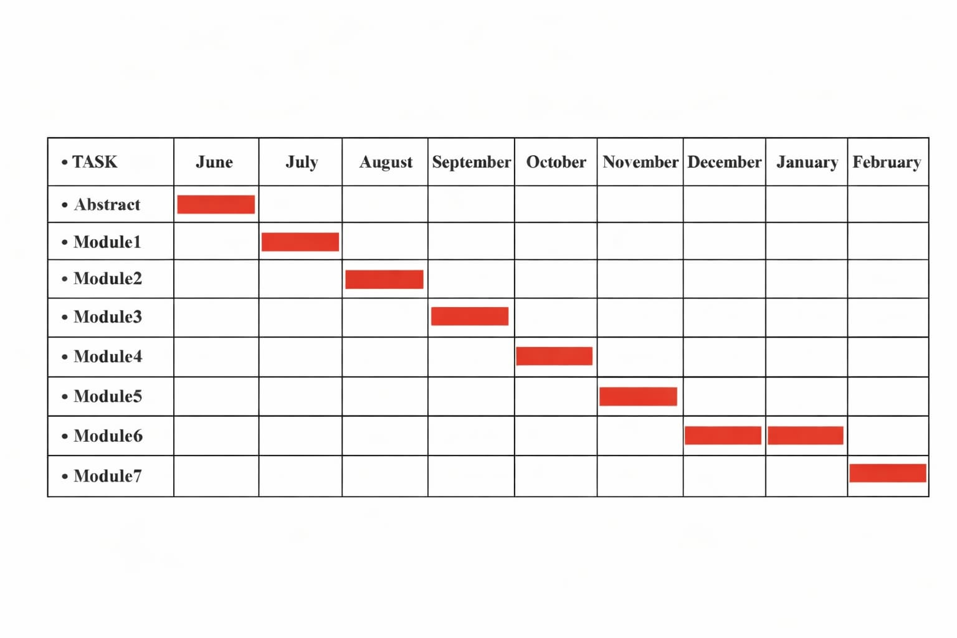

3.4 Software and Hardware Requirements
This section defines the key software and hardware needed for the Tourism Web Service System development and deployment.
1. Software Requirements
Frontend Development:
- Languages: HTML5, CSS3, JavaScript (ES6)
- Frameworks: React.js or Angular, Bootstrap
- Libraries: Redux, Material UI

Backend Development:
- Languages: Node.js with Express.js or Python (Django/Flask)
- Database: MongoDB Atlas or PostgreSQL
- API: RESTful or GraphQL for communication
- Authentication: JWT, OAuth 2.0

Development Tools:
- Version Control: Git, GitHub/GitLab
- Testing: Jest, Mocha, Cypress
- CI/CD: Jenkins, CircleCI, GitHub Actions
- Deployment: AWS, Google Cloud, Docker

Security:
SSL/TLS encryption, Firewall, and regular backups

2. Hardware Requirements
- Development Environment:
- PC/Laptop: 8GB RAM, 4-core processor
- Operating Systems: Windows, macOS, or Linux
- Storage: SSD for fast access

- Production Environment:
- Cloud Hosting: AWS EC2 or Google Cloud Compute
- Database: MongoDB Atlas or AWS RDS
- Web Server: NGINX or Apache

- Performance:
- Scaling: Horizontal scaling for traffic spikes
- Caching: Redis for better performance
- Backup: Regular backups using AWS S3 or Google Cloud Storage

3.5 Conceptual Models
In this section, we define the conceptual models that represent the high-level structure and key interactions within the Tourism Web Service System. These models provide a simplified view of the system, focusing on core components, their relationships, and the flow of data.

Entity-Relationship Diagram (ERD)
The Entity-Relationship Diagram (ERD) defines the relationships between the various entities (objects) in the system and their attributes. This model is used to understand the data structure.
Entities:
- User: Stores information about the user (name, email, password).
- Booking: Stores details about user bookings (tour details, date, payment status).
- Tour: Stores information about the available tours (destination, dates, cost).
- Payment: Stores details about the payment transactions (amount, date, status).
- Review: Stores user-generated reviews for tours or destinations.
ERD:

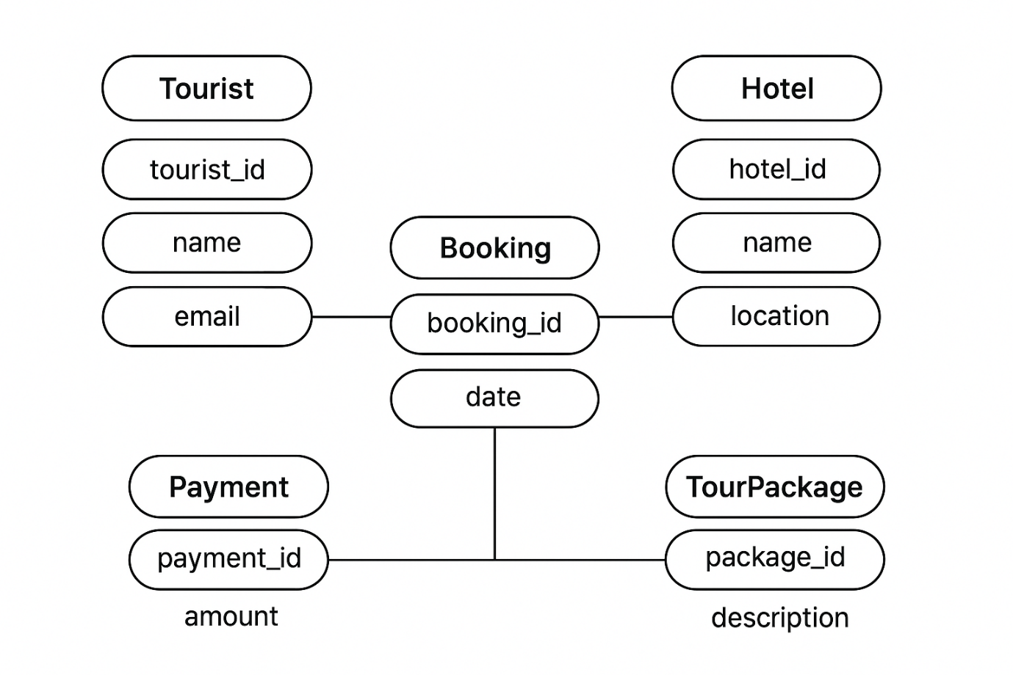

Use Case Diagram

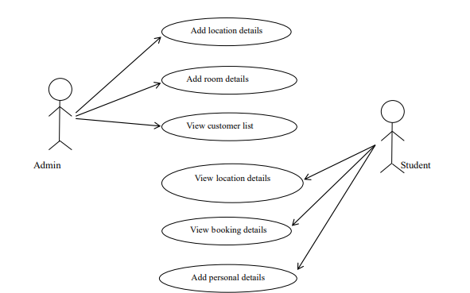

Data flow diagram

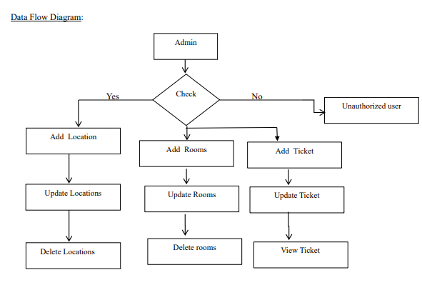

CHAPTER-4
SYSTEM DESIGN

4.1Basic Modules

- Admin Authentication Module
  - Admin login with username and password
  - System verifies credentials
  - Only authorized admin can access dashboard
  - Full control over system activities

- User Registration & Login Module
  - New users can register (Name, Email, Password, etc.)
  - Secure login for registered users
  - Profile management option

- Location Management Module
  - Admin can add, update, and delete locations
  - Users can view available tourist locations

- Package Management Module
  - Admin creates tour packages (type, price, details, duration)
  - Packages displayed on user homepage
  - Update and delete package options

- Booking Module
  - Users select package and book with date
  - Add comments or special requests
  - Store booking details in database

- Booking Confirmation Module
  - Admin confirms or cancels booking
  - Ticket generation
  - Confirmation notification shown to user

- Room & Ticket Management Module
  - Admin manages room details
  - Add, update, delete rooms
  - Issue travel tickets

- Search & View Module
  - Users search packages
  - View package details
  - View booking history

- Payment Module (Optional/Future Enhancement)
  - Online payment integration
  - Secure transaction processing

4.2 Data Design

1. Admin Table

Field Name | Description
Admin_ID | Unique identification number for each admin
Username | Admin login username
Password | Admin login password

- Users Table

Field Name | Description
User_ID | Unique identification number for each user
Name | Full name of the user
Email | User email address
Contact_No | User contact number
Password | User account password

- Location Table

Field Name | Description
Location_ID | Unique identification number for each location
Location_Name | Name of the tourist place
Description | Details about the location
Image | Image related to the location

- Booking Table

Field Name | Description
Booking_ID | Unique identification number for each booking
User_ID | Reference to the user who booked
Package_ID | Reference to the selected package
Booking_Date | Date of booking
Status | Current booking status (Confirmed/Cancelled/Pending)
Comments | Additional notes from user

- Ticket Table

Field Name | Description
Ticket_ID | Unique identification number for each ticket
Booking_ID | Reference to the related booking
Issue_Date | Date when ticket is issued
Ticket_Status | Status of ticket (Issued/Pending)

- Advertisement Table

Field Name | Description
Ad_ID | Unique identification number for advertisement
Title | Advertisement title
Image | Advertisement image
Description | Details about advertisement

- Contact Us Table

Field Name | Description
Contact_ID | Unique identification number for contact record
Name | Name of the person sending message
Phone | Contact phone number
Email | Email address
Message | Message sent by user

Normalization
Normalization is the process of organizing data in a database to reduce redundancy and improve data integrity. In the Tourism Web Service System, normalization is applied to ensure that data is stored efficiently and avoids duplication.

First Normal Form (1NF)
A table is in 1NF if:
- All attributes contain atomic (single) values.
- There are no repeating groups.
- Each record is unique.
Application in the System:
- Separate tables are created for Users, Packages, Bookings, Locations, etc.
- Each field stores only one value (e.g., one phone number per field).
- Primary keys uniquely identify each record.

Second Normal Form (2NF)
A table is in 2NF if:
- It is already in 1NF.
- All non-key attributes are fully dependent on the primary key.
Application in the System:
- In the Booking table, details like Booking_Date and Status depend completely on Booking_ID.
- Package details are stored in the Package table, not repeated in Booking.
- User details are stored only in the Users table.

Third Normal Form (3NF)
A table is in 3NF if:
- It is already in 2NF.
- There are no transitive dependencies (non-key attributes do not depend on other non-key attributes).
Application in the System:
- Location details are stored separately from Package details.
- User information is not stored in Booking table except User_ID.
- Ticket information is stored separately and linked through Booking_ID.

Benefits of Normalization in the System
- Reduces data redundancy
- Avoids data inconsistency
- Improves database efficiency
- Makes updates and deletions easier
- Maintains data integrity

4.2.1 Schema Design
The schema design defines the logical structure of the database used in the Tourism and Web Services System. It specifies the tables, their attributes, data types, and relationships through primary and foreign keys.

Field Name | Data Type | Key | Description
user_id | INT | PK | Unique ID for each user
name | VARCHAR(100) | — | Full name of the user
email | VARCHAR(100) | — | User email address
password | VARCHAR(255) | — | Encrypted login password
phone | VARCHAR(15) | — | Contact number
address | VARCHAR(200) | — | User address
registration_date | DATE | — | Date of registration

4.2.2 Data Integrity and Constraints
Data integrity ensures that all information stored in the Tourism and Web Services System database is accurate, valid, and consistent. Constraints are applied to maintain relationships and prevent invalid data entries.

1. Entity Integrity
- Every table has a Primary Key (PK) to uniquely identify each record.
Example: user_id in the User table, booking_id in the Booking table.

2. Referential Integrity
- Foreign Key (FK) constraints ensure that relationships between tables remain valid.
Example:
- Booking.user_id references User.user_id
- Booking.package_id references TourPackage.package_id
- Payment.booking_id references Booking.booking_id
This prevents orphan records (e.g., a payment without a valid booking).

3. Domain Integrity
- Ensures that all values entered into a column are valid and of the correct type.
Example:
- email fields must follow a valid email format.
- price and amount fields must be positive numeric values.
- status fields may only accept predefined values (e.g., Pending, Confirmed, Cancelled).

4. Null Constraints
- Certain fields (like primary keys or essential information such as name, email, booking_date) are defined as NOT NULL to prevent missing data.
5. Unique Constraints
- Fields such as email in the User table are set as UNIQUE to prevent duplicate registrations.
6. Check Constraints
- Logical conditions are applied to maintain valid ranges and data consistency.
Example:
  - price > 0
  - duration >= 1
4.3 Procedural Design
The Procedural Design outlines the major processes and operations that occur within the Tourism and Web Services System. It defines the logical flow of actions that allow users and administrators to interact with the system effectively.

1. User Registration and Login Procedure
- The user enters personal details to create an account.
- The system validates input data and stores user information in the User table.
- During login, credentials are verified against stored data; if correct, access is granted.

2. Tour Package Browsing Procedure
- The system retrieves all available tour packages from the TourPackage table.
- Users can filter or search based on destination, price, or duration.
- Selected packages are displayed with complete details.

3. Booking Procedure
- The user selects a tour package and (optionally) a hotel.
- Booking details are entered and validated.
- The system generates a unique booking_id and stores all details in the Booking table.
- A confirmation message is displayed to the user.

4. Payment Procedure
- The user proceeds to payment after confirming a booking.
- The system calculates the total amount and records payment details in the Payment table.
- Once payment is successful, the booking status is updated to Confirmed.

5. Admin Management Procedure
- The admin can add, update, or delete tour packages and hotel records.
- The admin monitors user bookings and payments for reporting and maintenance purposes.

4.3.2 Data Structures
The Data Structures define how data elements are organized, stored, and accessed within the Tourism and Web Services System. Proper structuring ensures efficient data retrieval, storage, and management during operations.

1. Arrays and Lists
- Used to temporarily store and process lists of data such as available tour packages, hotels, or user bookings during program execution.
Example:
- tourPackageList[] – stores tour package records fetched from the database.
- bookingList[] – holds active booking details for display.

2. Records / Structures
- Represent a single entity containing multiple related fields.
Example:
- UserRecord = { user_id, name, email, phone, address }
- BookingRecord = { booking_id, user_id, package_id, booking_date, status }

3. Queues
- Used in managing sequential processes such as booking requests or payment transactions waiting for confirmation.

4. Hash Tables / Dictionaries
- Used for quick lookup of data by key-value pairs, such as retrieving a user or hotel record using its unique ID.
Example: userDictionary[user_id] → UserRecord

Relational Tables
- All permanent data is stored in relational database tables as defined in the schema design (User, Hotel, TourPackage, Booking, Payment).
- Relationships between tables are maintained using primary and foreign keys to ensure referential integrity.

4.3.3 Algorithm Design
This section presents the main algorithms used in the Tourism and Web Services System. Each algorithm outlines the sequence of operations that ensure correct and efficient execution of the system’s core functions.

1. User Registration Algorithm
Step 1: Start
Step 2: User enters name, email, password, phone, and address.
Step 3: System validates all input fields.
Step 4: If data is valid → store user details in the User table.
Step 5: Display confirmation message.
Step 6: End

2. User Login Algorithm
Step 1: Start
Step 2: User enters email and password.
Step 3: System retrieves user record from the User table.
Step 4: Compare entered credentials with stored data.
Step 5: If valid → grant access; else → display “Invalid Login.”
Step 6: End

3. Booking Algorithm
Step 1: Start
Step 2: User selects a tour package and hotel.
Step 3: System checks availability.
Step 4: If available → generate booking_id and store booking details in Booking table.
Step 5: Display booking confirmation message.
Step 6: End

4. Payment Algorithm
Step 1: Start
Step 2: User selects a payment method and enters payment details.
Step 3: System verifies amount and booking reference.
Step 4: If successful → record payment in Payment table and update booking status to Confirmed.
Step 5: Display payment success message.
Step 6: End

5. Admin Management Algorithm
Step 1: Start
Step 2: Admin logs into the system.
Step 3: Admin selects an action (Add, Update, Delete) on tour packages or hotels.
Step 4: System validates and updates the database.

4.4 User Interface Design

start page:

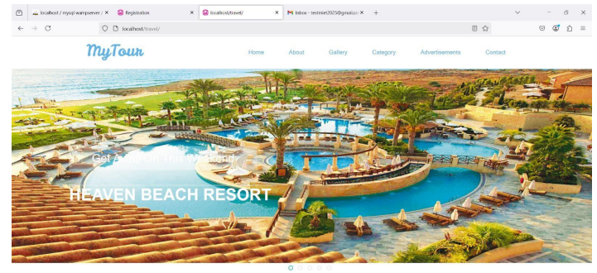

About us :

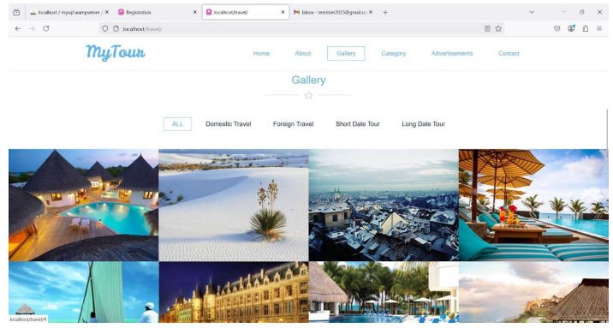

Contact us:

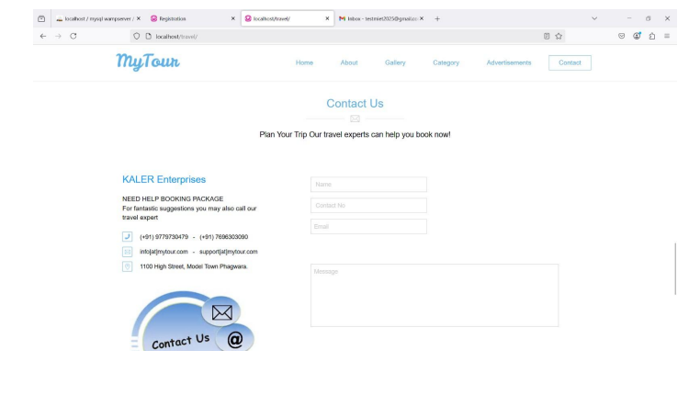

Registration page :

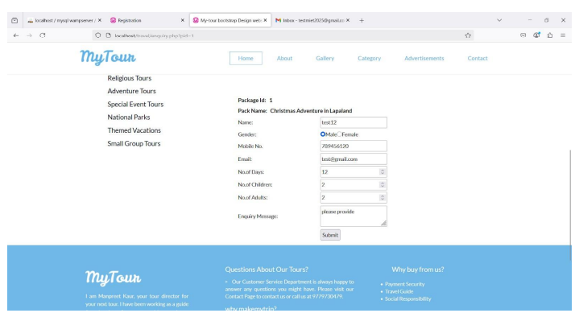

4.5 Security Issues
Security is a critical aspect of the Tourism and Web Services System to ensure data confidentiality, integrity, and availability. The system includes several measures to protect user information, financial data, and system operations from threats and unauthorized access.
1. Authentication and Authorization
- Only registered users and administrators can access the system.
- Authentication is implemented through secure login using email and encrypted passwords.
- Authorization restricts access based on user roles — for example, only the admin can modify system records.

2. Password Security
- User passwords are stored in the database using encryption or hashing algorithms (e.g., SHA-256).
- Password fields are hidden during input and never displayed in plain text.

3. Data Encryption
- Sensitive data such as payment details and user credentials are transmitted over secure HTTPS connections.
- Encryption ensures that intercepted data cannot be read by unauthorized parties.

4. Input Validation
- All input fields are validated to prevent SQL injection, cross-site scripting (XSS), and other forms of code injection.
- The system sanitizes all user input before database operations.

5. Session Management
- User sessions automatically expire after a period of inactivity to prevent misuse.
- Secure session tokens are used to maintain login states.

6. Backup and Recovery
- Regular database backups are maintained to protect against data loss.
- Recovery procedures are in place to restore operations after a failure or attack.
4.6 Test Cases Design
The Test Case Design phase ensures that each module of the Tourism and Web Services System performs as expected. Testing was conducted to identify bugs, verify functionality, and confirm system reliability and security.

1. Objectives
- To verify that all modules (User, Booking, Payment, Hotel, and Tour Packages) work as intended.
- To ensure input validation, user authentication, and data handling are correctly implemented.
- To confirm that performance, usability, and security meet system requirements.

2. Types of Testing
- Unit Testing:
Each module (like Login, Booking, or Payment) was tested individually.
- Integration Testing:
Verified that modules interact correctly (e.g., Booking connects with Payment).
- System Testing:
Tested the complete application to ensure all functionalities operate together.
- User Acceptance Testing (UAT):
Conducted with real users to check usability and overall satisfaction.

Sample Test Cases

Test Case ID | Module | Test Scenario | Input Data | Expected Output | Actual Output | Status
TC001 | User Login | Verify valid login | Email: user@gmail.com, Password: 12345 | Redirect to homepage | As expected | Pass
TC002 | User Login | Invalid login attempt | Wrong email/password | Display error message | As expected | Pass
TC003 | Booking | Book a tour package | Select package, confirm booking | Booking confirmed | As expected | Pass
TC004 | Payment | Verify payment process | Card details | Payment success message | As expected | Pass
TC005 | Registration | Missing required fields | Empty email/password | Show validation errors | As expected | Pass

CHAPTER 5
Implementation And Testing

5.1 Implementation Approaches
The implementation of the tourism web service was carried out using a service-oriented and RESTful architectural approach, which enables efficient communication between distributed systems and client applications. This approach was selected due to its scalability, platform independence, and suitability for modern web-based tourism applications that require real-time access to tourism information and booking services.
A modular development strategy was adopted during implementation to divide the system into independent functional components. Each module is responsible for a specific task such as user management, tourism data management, and booking processing. This modularity simplifies system maintenance, supports parallel development, and allows future extensions without significant restructuring of the existing system.
The system follows a layered architecture, which separates concerns and enhances maintainability. The main layers include:
- Presentation Layer:
This layer provides RESTful API endpoints that interact directly with client applications. It handles incoming HTTP requests, validates input parameters, and formats responses in JSON. By isolating user interaction logic, the presentation layer ensures a clean interface between clients and backend services.
- Business Logic Layer:
The business logic layer contains the main functionality of the tourism web service system. It applies the rules related to tourism activities such as destination search, checking availability, price calculation, booking confirmation, and cancellation procedures. Centralizing the business logic ensures uniform processing and avoids duplication of operations.

- Data Access Layer:
This layer handles all database operations, including retrieving, inserting, updating, and deleting records. It maintains data accuracy and enforces necessary constraints while hiding database-specific implementation details from the upper layers of the application.
To support seamless data exchange, the system uses JSON as the data interchange format over HTTP/HTTPS protocols. Standard HTTP methods such as GET, POST, PUT, and
DELETE were employed to perform read and write operations, ensuring compliance with REST principles.
Security considerations were integrated into the implementation approach. Authentication and authorization mechanisms, such as token-based access control, were used to restrict access to sensitive operations like booking and user data management. Input validation techniques were applied to prevent invalid data submissions and improve system reliability.
The implementation approach also emphasizes scalability and performance. Stateless services were designed to allow horizontal scaling, and caching strategies were considered for frequently accessed tourism data such as popular destinations and featured attractions. These design choices ensure that the tourism web service can handle increasing user demand, especially during peak travel seasons.
Overall, the chosen implementation approaches provide a robust, flexible, and scalable foundation for delivering reliable tourism web services while supporting future technological enhancements and integrations.

5.2 Coding Details and Code Efficiency
The coding phase of the tourism web service focused on developing a system that is efficient, maintainable, and scalable, while adhering to standard software engineering practices. Emphasis was placed on writing clean and well-structured code to ensure long-term usability and ease of enhancement.
Coding Structure and OrganizationThe source code was organized into logical modules and packages based on system functionality. Separate modules were created for user management, tourism data handling, booking operations, and authentication services. This separation of concerns improves readability and allows developers to locate, modify, or extend specific features without affecting other parts of the system.
Consistent naming conventions were used for variables, methods, and classes to enhance code clarity. The codebase follows a uniform formatting style, making it easier to understand and review. Adequate inline comments and documentation were included to explain complex logic and processing flows.

Reusability and Maintainability

To reduce redundancy, reusable functions and shared services were implemented for commonly used operations such as input validation, error handling, and response formatting. This approach minimizes repeated code and simplifies maintenance. Any changes to common functionality can be made in a single location, reducing the risk of inconsistencies.
Configuration details such as database connections and security parameters were externalized, enabling easy modification without altering the core code. This improves maintainability and supports deployment across different environments.

Database Access and Optimization
Efficient interaction with the database was a key aspect of the coding process due to the high volume of tourism-related data. Optimized queries were written to ensure fast retrieval of information such as destinations, hotels, and tour availability. Indexed tables were used to improve search performance, especially for frequently queried fields.
Parameterized queries and prepared statements were implemented to enhance execution efficiency and prevent SQL injection attacks. During booking operations, transaction

Performance and Code Efficiency
Several techniques were applied to improve overall code efficiency:
- Asynchronous processing was used to handle concurrent user requests efficiently, reducing server blocking and improving response times.
- Frequently accessed data, such as popular destinations and tour listings, was cached to reduce database load.
- Unnecessary computations were avoided by reusing previously calculated results where possible.
- API responses were optimized to include only essential data, reducing network bandwidth usage.
- These optimizations ensure that the system performs reliably even under high user traffic, which is common in tourism applications during peak seasons.

Error Handling and Validation
Robust error handling mechanisms were implemented to improve system stability. The code includes structured exception handling to capture and manage runtime errors gracefully. User-friendly error messages are returned to clients while internal error details are logged for debugging purposes.
Input validation was enforced at multiple levels to ensure data correctness and prevent invalid or malicious inputs. This enhances both system security and data integrity.

Security Considerations in Code
Security best practices were integrated into the codebase. Sensitive operations require proper authentication and authorization, and access control checks are performed before executing critical functions. User credentials and sensitive information are securely processed and never exposed in API responses.

5.2.1 Code Efficiency
Code efficiency was a major consideration during the development of the tourism web service, as the system is expected to handle a large number of concurrent users and frequent data requests, especially during peak travel seasons. Efficient code execution ensures faster response times, optimal use of system resources, and an improved user experience.
One of the primary techniques used to enhance code efficiency was the implementation of optimized algorithms and logical workflows. Operations such as searching destinations, checking availability, and processing bookings were designed to minimize computational complexity. Unnecessary loops and redundant calculations were avoided, ensuring that only essential processing steps were executed.
Efficient database interaction significantly contributed to overall system performance. Database queries were carefully designed to retrieve only the required data instead of full records. Indexing was applied to frequently accessed fields such as destination names, hotel identifiers, and booking dates, reducing query execution time. Additionally, database transactions were used during booking operations to maintain consistency while minimizing processing overhead.
The system also employs asynchronous and non-blocking processing techniques to handle multiple user requests simultaneously. This approach allows the server to continue processing other requests while waiting for input/output operations, such as database access or external service responses, thereby improving throughput and reducing latency.
To further improve efficiency, caching mechanisms were implemented for frequently requested data, including popular destinations, featured accommodations, and tour listings. By storing this data temporarily in memory, repeated database queries are reduced, leading to faster response times and lower server load.
Memory management was addressed by ensuring that objects and resources are released promptly after use. Efficient data structures were selected to store and manipulate tourism and booking data, minimizing memory consumption and processing time.
API responses were optimized by limiting payload size and returning only essential information to client applications. This reduces network usage and accelerates data transmission, particularly important for mobile users with limited bandwidth.
Overall, the focus on code efficiency resulted in a high-performing tourism web service capable of delivering reliable and fast responses while efficiently utilizing system resources. These optimizations ensure that the system remains scalable and responsive as user demand increases.
SOURCE CODE

<!--
Author: W3layouts
Author URL: http://w3layouts.com
License: Creative Commons Attribution 3.0 Unported
License URL: http://creativecommons.org/licenses/by/3.0/
-->
<!DOCTYPE html>
<html>
<head>
<title></title>
<link href="css/owl.carousel.css" rel='stylesheet' type='text/css'/>
<link href="css/bootstrap.css" rel='stylesheet' type='text/css'/>
<link href="css/style.css" rel="stylesheet" type="text/css" media="all"/>
<meta name="viewport" content="width=device-width, initial-scale=1">
<script type="application/x-javascript"> addEventListener("load", function() { setTimeout(hideURLbar, 0); }, false);
//function hideURLbar(){ window.scrollTo(0,1); }

</script>
<!--js-->
<script src="js/jquery.min.js"></script>
27
<!--/js-->
<!--animated-css-->
<link href="css/animate.css" rel="stylesheet" type="text/css" media="all">
<script src="js/wow.min.js"></script>
<script> new
WOW().init();
</script>
<!--/animated-css-->
</head>
<body>
<!--header-->
<!--sticky-->
<?php include('function.php'); ?>

<?php include('top.php'); ?>
<!--/sticky-->
<?php include('slider.php'); ?>
<!--About-->
<div class="about section" id="section-2">
<div class="about-head text-center">
<h3>About Us</h3>
<span></span><img src="images/about-img.png" alt=""><span></span>
</div>
<div class="container">
28
<div class="col-md-4 about-grids">
<h4><span class="icon1"></span>Our Vision</h4>
<p>Tourism which is ethical, fair and a positive experience for both travellers and the people and places they visit</p>
</div>
<div class="col-md-4 about-grids grid2">
<h4><span class="icon2"></span>Our Mission</h4
<p>To ensure tourism always benefits local people by challenging bad practice and promoting better tourism</p>
</div>
<div class="col-md-4 about-grids">
<h4><span class="icon3"></span>Safety Information</h4>
<p>Vacation is a time to relax in safe surroundings.For emergency aid of any kind, call 911 from any phone... in your hotel, dial 9-911.</p>
<div align="right"><a href="aboutus.php"><input type="button" value="Read More" name="sbmt" /></a></div>
</div>
</div>
</div>
<!--/About-->
<!--top-tours-->
<div class="section" id="section-3">
<div id="portfolio" class="portfolio">
<div class="top-tours-head text-center">
<h3>Gallery</h3>
29
<span></span><img src="images/star.png" alt=""><span></span>
</div>
<ul id="filters" class="clearfix wow bounceIn" data-wow-delay="0.4s">
<li><span class="filter active" data-filter="app card icon logo fun">ALL</span></li>
<li><span class="filter" data-filter="app">Domestic Travel</span></li>
<li><span class="filter" data-filter="card">Foreign Travel</span></li>
<li><span class="filter" data-filter="icon">Short Date Tour</span></li>
<li><span class="filter" data-filter="fun">Long Date Tour</span></li>
</ul>
<div id="portfoliolist">

<div class="portfolio fun mix_all" data-cat="fun" style="display: inline-block; opacity: 1;">
<div class="portfolio-wrapper wow bounceIn" data-wow-delay="0.4s">

<a href="#" class="b-link-stripe b-animate-go thickbox play-icon popupwithzoom-anim">
<img src="images/t7.jpg" class="img-responsive" alt=""/></a>
</div>
$('#portfoliolist').mixitup{ targetSelector: '.portfolio', filterSelector: '.filter', effects: ['fade'], easing:
'snap',
30
// call the hover effect onMixEnd:
filterList.hoverEffect()
});
}, hoverEffect: function () {
// Simple parallax effect
$('#portfoliolist .portfolio').hover( function
() {
$(this).find('.label').stop().animate({bottom: 0}, 200, 'easeOutQuad');
$(this).find('img').stop().animate({top: -30}, 500, 'easeOutQuad');

},
lazyLoad : true, autoPlay : true, navigation : false,
navigationText : false, pagination : tr
<div class="portfolio-wrapper wow bounceIn" datawow-delay="0.4s">
<a href="#" class="b-link-stripe b-animatego thickbox play-icon popupwithzoom-anim">
<img src="images/t5.jpg" class="img-responsive" alt=""/></a>
</div>
</div>
<div class="portfolio fun mix_all" data-cat="fun" style="display: inline-block; opacity: 1;">
31
<div class="portfolio-wrapper wow bounceIn" datawow-delay="0.4s">

<a href="#" class="b-link-stripe b-animatego thickbox play-icon popupwithzoom-anim">
<img src="images/t6.jpg" class="img-responsive" alt=""/></a>

</div>
</div>
<div class="portfolio fun mix_all" data-cat="fun" style="display: inline-block; opacity: 1;">
<div class="portfolio-wrapper wow bounceIn" datawow-delay="0.4s">

<a href="#" class="b-link-stripe b-animatego thickbox play-icon popupwithzoom-anim">
<img src="images/t7.jpg" class="imgresponsive" alt=""/></a>

</div>
</div>
<div class="portfolio icon mix_all" data-cat="fun" style="display: inline-block; opacity: 1;">
<div class="portfolio-wrapper wow bounceIn" datawow-delay="0.4s">

<a href="#" class="b-link-stripe b-animatego thickbox play-icon popupwithzoom-anim">
<img src="images/t8.jpg" class="img-responsive" alt=""/></a>
</div>
32
</div>
<div class="clearfix"></div>
</div>
</div>
</div>
<!-- Script for gallery Here-->
<script type="text/javascript" src="js/jquery.mixitup.min.js"></script>
<script type="text/javascript">
$(function () { var filterList = { init: function () {
// MixItUp plugin
// http://mixitup.io
$('#portfoliolist').mixitup({ targetSelector: '.portfolio',
filterSelector: '.filter', effects: ['fade'], easing: 'snap',
// call the hover effect onMixEnd:filterList.hoverEffect()
});
}, hoverEffect: function
() {
// Simple parallax effect
33
$('#portfoliolist .portfolio').hover(
function () {
$(this).find('.label').stop().animate({bottom: 0}, 200, 'easeOutQuad');
$(this).find('img').stop().animate({top: -30}, 500, 'easeOutQuad'); }, function
() {
$(this).find('.label').stop().animate({bottom: -40}, 200, 'easeInQuad');
$(this).find('img').stop().animate({top: 0}, 300,
'easeOutQuad');
}
);
}
};
// Run the show!
filterList.init();
});
</script>
<!--Gallery Script Ends-->
<!--/top-tours-->
<div class="tour-guides section" id="section-4" >
<div class="tour-guides-head text-center">
<h3>Advertisements</h3>
<span></span><img src="images/guide.png" alt=""><span></span>
<div class="container">
34
<p>My Tour guides are expensive, so first decide what you want to do, whether it's a general tour of a city, a day of hiking, or visiting remote villages in a thirdworld country. Have a ball-park time allotment in mind, whether it's a halfday, a full-day, or a multi-day experience. Once you have chosen a guide, you'll probably refine your ideas based upon the guide's knowledge.</p> </div>
</div>
<div class="container">
<!-- requried-jsfiles-for owl -->
<link href="css/owl.carousel.css" rel="stylesheet">
<script src="js/owl.carousel.js"></script>
<script>
$(document).ready(function() {
$("#owl-demo").owlCarousel({ items : 1,
lazyLoad : true,
autoPlay : true,
navigation : false,
navigationText : false,
pagination : true,
});
</script>
<!-- //requried-jsfiles-for owl -->
35

<div id="owl-demo" class="owl-carousel">
});
<?php
$s="select * from advertisement";
$result=mysqli_query($cn,$s);
$n=0; while($data=mysqli_fetch_array($result))
{
If($n%4==0)
{
?>
<div class="item text-center guide-sliders">
<?php }?>
<div class="col-md-3 image-grid">
<img src="Admin/addverimages/<?php echo $data[3]; ?>" width="300px" height="150px" >
<p><a href="#"><?php echo $data[2]; ?></a></p>
</div>
<?php if($n%4==3)
{?>
</div>
<?php
$n=$n+1;
}

?> <?php if(isset($_POST["sbmt"]))
{
$cn=makeconnection();
$s="insert into contactus(Name,Phno,Email,Message) values('" . $_POST["t1"]
."','" . $_POST["t2"] ."','" . $_POST["t3"] ."','" . $_POST["t4"] ."')"; mysqli_query($cn,$s); mysqli_close($cn); echo "<script>alert('Record Save');</script>";
} ?
<form method="post">
<table border="0" width="700px" height="500px">
<tr><td align="left"> <input type="text" class="text" value=" Name" name="t1" onFocus="this.value = '';" onBlur="if (this.value == '') {this.value =
'Your Name';}" required pattern="[a-zA-z1 _]{1,50}" title"Please Enter Only Characters and numbers between 1 to 50 for Name"></td></tr>
<tr><td align="left"><input type="text" class="text" value=" Contact No" name="t2" onFocus="this.value = '';" onBlur="if (this.value == '') {this.value = 'Your Contact NO';}" required pattern="[0-9]{10,12}" title"Please Enter Only numbers between 10 to 12 for Contact no"></td></tr>
<tr><td align="left"> <input type="text" class="text" value="Email" name="t3" onFocus="this.value = '';" onBlur="if (this.value == '') {this.value = 'Your mail';}" required></td></tr>
<tr><td><textarea onFocus="if(this.value == 'Message') this.value='';" name="t4" onBlur="if(this.value == '') this.value='Enter Message Here';"
37
required/ >Message</textarea></td></tr>
<tr><td><input type="submit" value="Send message" name="sbmt"></td></tr></table <div class="clearfix"></div>
</form>
</div>
<div class="clearfix"></div> </div>
<!DOCTYPE html PUBLIC "-//W3C//DTD XHTML 1.0 Transitional//EN" "http://www.w3.org/TR/xhtml1/DTD/xhtml1-transitional.dtd">
<html xmlns="http://www.w3.org/1999/xhtml">
<head>
<meta http-equiv="Content-Type" content="text/html; charset=utf-8" />
<title>My-tour bootstrap Design website | Home :: w3layouts</title>
<link href='http://fonts.googleapis.com/css?family=Lato:100,300,400,700,900,100ital ic,300italic,400italic,700italic,900italic' rel='stylesheet' type='text/css'>
<link href="stylecss.css" rel='stylesheet' type='text/css'/>
<link href="css/bootstrap.css" rel='stylesheet' type='text/css'/>
<link href="css/style.css" rel="stylesheet" type="text/css" media="all"/>
<meta name="viewport" content="width=device-width, initial-scale=1">
<script type="application/x-javascript"> addEventListener("load", function() { setTimeout(hideURLbar, 0); }, false); function hideURLbar(){ window.scrollTo(0,1); } </script>

<!--js-->
<script src="js/jquery.min.js"></script>
<!--/js-->
<!--animated-css-->
<link href="css/animate.css" rel="stylesheet" type="text/css" media="all"> <script src="js/wow.min.js"></script>

5.3 Testing Approaches
Testing plays a crucial role in ensuring the reliability, correctness, and performance of the tourism web service. A systematic testing approach was adopted throughout the development lifecycle to identify defects early and verify that the system meets functional and non-functional requirements.
A multi-level testing strategy was followed, combining unit testing, integration testing, system testing, and performance testing. This comprehensive approach ensures that individual components function correctly and that the complete system operates as expected in real-world tourism scenarios.
Unit Testing
Unit testing was performed to validate the correctness of individual functions and modules in isolation. Core functionalities such as destination search, availability checking, pricing calculations, and booking validation were tested using predefined input values and expected outputs. Automated testing tools were used to execute unit tests repeatedly, ensuring that code changes did not introduce new errors.
Integration Testing
Integration testing focused on verifying the interaction between different modules of the system. This included testing communication between the presentation layer, business logic layer, and data access layer. Particular attention was given to workflows that involve multiple components, such as searching for tourism services and completing a booking. Integration testing helped identify interface mismatches and data flow issues.
API and Functional Testing
API testing was conducted to ensure that all RESTful endpoints behave correctly under various conditions. Each API endpoint was tested with valid and invalid inputs to verify proper request handling, response formatting, and error reporting. Functional testing ensured that the tourism web service meets user requirements, such as accurate data retrieval and successful booking operations.

Performance and Load Testing
Performance testing was carried out to evaluate the system’s behavior under normal and peak load conditions. Simulated concurrent users were used to assess response time, throughput, and resource utilization. Load testing ensured that the system can handle high traffic volumes during peak tourism periods without performance degradation.

Security Testing
Security testing was performed to identify potential vulnerabilities within the system. Authentication and authorization mechanisms were tested to ensure that only authorized users can access protected resources. Input validation tests were conducted to prevent common security threats such as SQL injection and unauthorized data access.
Regression Testing

5.3.1 Unit Testing
Unit testing was conducted to verify the correctness and reliability of individual components of the tourism web service. Each unit, such as functions, methods, or classes, was tested independently to ensure that it performs its intended functionality without relying on other system components. This approach helped in identifying defects at an early stage of development.
The primary focus of unit testing was on the business logic layer, where critical operations such as destination search, availability verification, price calculation, and booking validation are implemented. By isolating these components, errors could be detected and resolved before integration with other modules.
Automated unit testing tools were used to execute test cases efficiently and consistently. Test cases were designed using both valid and invalid input data to verify normal behavior as well as boundary conditions. For example, unit tests were created to validate correct pricing calculations for different travel dates and to ensure that invalid booking requests are handled appropriately.
Mock objects and test stubs were employed to simulate external dependencies such as databases and third-party services. This allowed the testing of individual units without requiring access to actual external systems, thereby improving test reliability and execution speed.
The results of unit testing demonstrated that individual modules functioned correctly according to their specifications. Any issues identified during testing were corrected promptly, ensuring that the foundational components of the tourism web service were stable before proceeding to higher levels of testing.

5.3.2 Integration Testing
Integration testing was performed to verify the correct interaction between different modules and components of the tourism web service. While unit testing focuses on individual components, integration testing ensures that combined modules function together as expected and that data flows correctly across the system.
The integration testing process focused on interactions between the presentation layer, business logic layer, and data access layer. Key workflows such as searching for tourism services, retrieving detailed information, and completing booking operations were tested end-to-end. This helped identify issues related to data exchange, interface mismatches, and dependency failures.
Both incremental and end-to-end integration testing approaches were adopted. Individual modules were first integrated step by step and tested for correctness before integrating additional components. Once all modules were connected, complete user scenarios were tested to ensure smooth system operation.
- Test cases were designed to validate
- Correct request handling by API endpoints
- Proper execution of business rules
- Accurate database updates during booking and cancellation operations
Mock services were used where necessary to simulate third-party systems, allowing integration testing to be conducted in a controlled environment. Error-handling mechanisms were also tested to ensure that failures in one component did not cause system-wide issues.
The results of integration testing confirmed that all system components interact correctly and that the tourism web service performs consistently across multiple modules. Issues identified during integration testing were resolved before proceeding to system-level testing, ensuring overall system stability.

5.3.3 Beta Testing
Beta testing was conducted as a final validation phase before the official deployment of the tourism web service. Unlike unit and integration testing, which are primarily developer-focused, beta testing involves real users to evaluate the system in a real-world environment. The main goal of beta testing was to identify usability issues, functional gaps, and performance limitations that might not be apparent in a controlled testing environment.

Objectives of Beta Testing
- User Experience Validation: Assess the usability of the web service for end users, including navigation, search functionality, and booking workflow.
- Functional Verification: Ensure that all features, such as destination search, hotel and tour information retrieval, booking, and cancellation, work correctly under actual usage conditions.
- Performance Observation: Monitor the system’s response time, stability, and reliability when accessed by multiple users simultaneously.
- Feedback Collection: Gather user feedback on system performance, design, and overall satisfaction to guide improvements.

Beta Testing Process
1.Selection of Test Users: A group of representative users, including travelers, travel agents, and system testers, was selected to participate in beta testing.
2.Test Scenario Design: Real-world scenarios were created to simulate common user activities, such as searching for hotels, checking availability, booking tours, and canceling reservations.
3.Execution: Users performed tasks on the system while testers observed interactions, collected error logs, and recorded user feedback.
4.Monitoring and Logging: System performance metrics, such as response time and transaction success rates, were monitored throughout the testing period
5Feedback Analysis: User feedback was analyzed to identify recurring issues, usability concerns, and potential improvements.

5.4 Modification and Improvements
Following the testing phases, several modifications and improvements were implemented to enhance the functionality, performance, and usability of the tourism web service. Feedback from beta testing, integration testing, and system evaluation was analyzed to identify areas that required refinement.

Key Modifications
1.User Interface Enhancements:
Navigation paths were simplified, menus were reorganized, and error messages were made more informative based on user feedback. These changes improved accessibility and the overall user experience.
2.Performance Optimization:
Database queries were further optimized, caching mechanisms were refined, and asynchronous processing was improved to handle higher volumes of user requests efficiently.
3.Security Improvements:
Authentication and authorization procedures were strengthened, input validation was enhanced, and additional checks were implemented to prevent potential vulnerabilities.
4.Feature Enhancements:
Additional functionalities, such as filtering search results by price or ratings, displaying popular destinations, and improving booking confirmation notifications, were introduced to meet user requirements more effectively.

Continuous Improvement Strategy

The system was designed with flexibility and scalability in mind, allowing future modifications with minimal disruption. A structured version control and maintenance plan ensures that updates can be deployed safely while preserving system stability.
Outcome
These modifications and improvements resulted in a more robust, secure, and user-friendly tourism web service. The system is now capable of handling real-world usage effectively, providing an enhanced experience for both end users and administrators.

5.5 Test Cases
Test cases were designed to systematically verify that the tourism web service functions correctly, meets user requirements, and handles errors gracefully. They cover key functionalities including destination search, hotel and tour retrieval, booking management, user authentication, and cancellation processes.
Each test case includes the following elements:
- Test Case ID: Unique identifier for reference.
- Description: Brief explanation of the functionality being tested.
- Input Data: Data used for testing the functionality.
- Expected Result: The correct outcome that should be returned by the system.
- Actual Result: Outcome observed during testing.
- Status: Pass or Fail.

Sample Test Cases
Test Case ID | Description | Input Data | Expected Result | Actual Result | Status
TC001 | Search Hotels by Destination | City: Paris, Check-in: 2026-06-01 | List of available hotels in Paris displayed | As expected | Pass
TC002 | Booking a Hotel Room | Hotel ID: H123, Guest: 2, Dates: 2026-06-01 to 2026-06-05 | Booking confirmation with booking ID | As expected | Pass
TC003 | Invalid Booking Dates | Check-in: 2026-06-10, Check-out: 2026-06-05 | Error message: “Invalid date range” | As expected | Pass
TC004 | User Login | Username: user1, Password: correct123 | User authenticated successfully | As expected | Pass
TC005 | Cancel Booking | Booking ID: B456 | Booking canceled, status updated in database | As expected | Pass

CHAPTER 6

Results and Discussion

Results and Discussion

Results
The study on tourism web services reveals that digital platforms play a significant role in enhancing the accessibility, efficiency, and overall quality of tourism-related services. The analysis shows that most tourism websites provide core services such as online booking, destination information, itinerary planning, and customer support. Advanced features like real-time availability, secure online payment systems, interactive maps, and personalized recommendations were found to significantly improve user satisfaction.
User response data indicate that websites with responsive design and mobile compatibility attract higher engagement levels, reflecting the growing reliance on smartphones for travel planning. Additionally, integration with social media and user-generated content, such as reviews and ratings, was observed to influence tourists’ decision-making processes positively.
However, the results also highlight certain limitations. Some tourism web services suffer from outdated content, slow loading times, limited language options, and inadequate customer support features. These issues reduce usability and may discourage potential tourists from completing bookings.

Discussion
The findings suggest that tourism web services are essential tools for modern tourism development, as they bridge the gap between service providers and tourists. The availability of real-time information and online transactions enhances convenience and builds trust among users. This aligns with current trends in digital tourism, where travelers prefer self-service platforms that offer speed, transparency, and personalization.
The strong impact of mobile-friendly design emphasizes the need for tourism organizations to adopt responsive and adaptive web technologies. Furthermore, the influence of user reviews and social media integration highlights the importance of credibility and social proof in online tourism marketing.
Despite these advantages, the identified challenges indicate that merely having a tourism website is not sufficient. Continuous updates, multilingual support, strong cybersecurity measures, and efficient customer interaction tools are crucial to remain competitive. Addressing these gaps can lead to increased tourist satisfaction, higher conversion rates, and sustainable growth in the tourism sector.

6.1 Test Report
1. Introduction
This test report documents the testing activities carried out on the Tourism Web Services application. The purpose of testing is to ensure that the system functions correctly, meets user requirements, and provides reliable and secure services for tourists and service providers.

2. Objectives of Testing
- The main objectives of testing are:
- To verify that all web services operate as intended
- To identify and fix functional and performance issues
- To ensure data accuracy, security, and usability
- To validate system compatibility across browsers and devices

3. Scope of Testing
- The following modules were tested:
- User Registration and Login
- Destination Information Module
- Hotel and Travel Booking Services
- Online Payment System
- Search and Filtering Functions
- Feedback and Review System
- Admin Management Module

4. Test Environment
- Operating System: Windows / Linux
- Web Browser: Google Chrome, Mozilla Firefox, Microsoft Edge
- Server: Apache / Tomcat
- Database: MySQLTesting Type: Manual Testing

Types of Testing Performed

Functional Testing
Ensured that each feature works according to the specified requirements, including booking, payments, and user authentication.
- Usability Testing
Checked ease of navigation, clarity of content, and responsiveness of the user interface.
- Performance Testing
Measured page load time and system response under normal user load conditions.
- Security Testing
Verified secure login, data protection, and payment safety.
- Compatibility Testing
Tested application behavior across different browsers and screen sizes.

6.Test Cases and Results

Test Case ID | Module | Description | Expected Result | Actual Result | Status
TC01 | Login | User login with valid data | Successful login | Successful login | Pass
TC02 | Registration | New user registration | Account created | Account created | Pass
TC03 | Booking | Hotel booking process | Booking confirmation | Booking confirmation | Pass
TC04 | Payment | Online payment | Payment successful | Payment successful | Pass
TC05 | Search | Destination search | Relevant results | Relevant results | Pass
TC06 | Reviews | Submit feedback | Feedback saved | Feedback saved | Pass

7. Defects Identified
- Minor UI alignment issues on mobile device
- Delay in loading high-resolution images on slow networks
- All identified defects were corrected during retesting.

8. Test Summary
The Tourism Web Services system was tested successfully across all major modules. Most test cases passed without issues, and the system met functional and usability requirements. The application is stable, secure, and user-friendly.

CHAPTER 7
CONCLUSION

7.1Conclusion
The Tourism Web Service System has been successfully developed to provide an efficient and user-friendly platform for managing tourism activities online. The system simplifies the process of searching destinations, viewing packages, booking tours, and managing confirmations. It replaces manual operations with an automated system, reducing paperwork, time consumption, and human errors.
The project is designed using PHP for application development and MySQL for database management, ensuring reliability and smooth performance. The structured database design and normalization techniques help maintain data integrity and avoid redundancy.
This system provides separate modules for admin and users, making management easier and more secure. Overall, the Tourism Web Service System improves operational efficiency, enhances customer convenience, and offers flexibility for future enhancements such as online payments, AI-based recommendations, and real-time booking updates.

7.1.1 Significance of the System
The Tourism Web Services system plays a vital role in modernizing the tourism industry by providing a centralized, web-based platform for accessing tourism information and services. It significantly reduces the dependency on manual processes by enabling tourists to search destinations, make bookings, and complete payments online in a convenient and time-efficient manner.
The system improves accessibility by offering 24/7 availability of tourism services from any location, allowing users to plan their trips with ease. It enhances user experience through real-time updates, secure transactions, and interactive features such as reviews and ratings, which help travelers make informed decisions.
From a business perspective, the system increases operational efficiency for tourism service providers by automating booking management, customer communication, and data handling. It also supports better marketing and customer engagement through digital presence and analytics.
Overall, the Tourism Web Services system contributes to improved service quality, increased customer satisfaction, and sustainable growth in the tourism sector by leveraging modern web technologies.

7.1.1 Significance of the System
The Tourism Web Services system plays a vital role in modernizing the tourism industry by providing a centralized, web-based platform for accessing tourism information and services. It significantly reduces the dependency on manual processes by enabling tourists to search destinations, make bookings, and complete payments online in a convenient and time-efficient manner.
The system improves accessibility by offering 24/7 availability of tourism services from any location, allowing users to plan their trips with ease. It enhances user experience through real-time updates, secure transactions, and interactive features such as reviews and ratings, which help travelers make informed decisions.
From a business perspective, the system increases operational efficiency for tourism service providers by automating booking management, customer communication, and data handling. It also supports better marketing and customer engagement through digital presence and analytics.
Overall, the Tourism Web Services system contributes to improved service quality, increased customer satisfaction, and sustainable growth in the tourism sector by leveraging modern web technologies.

FUTURE SCOPE OF THE PROJECT
In future, the customer can directly contact the administrator to get details of the tourist spot and booking using video conference with AI technology.
Tourism is being transformed by technology and sustainability. Virtual reality (VR) and augmented reality (AR) are revolutionizing how travelers explore destinations, while AI-driven personalization ensures unique and tailored experiences. Eco-conscious travel is on the rise, with visitors preferring sustainable accommodations and responsible tourism. Additionally, medical tourism and adventure travel are flourishing, making destinations more diverse.
Web services are expanding rapidly, with AI, cloud computing, and cybersecurity shaping the landscape. AI-powered automation enhances customer service, while cloud solutions provide businesses with scalable and secure platforms. Cybersecurity is crucial in protecting digital transactions, and e-commerce is booming alongside digital payments

Webliography
- PHP Cookbook by Adam Trachtenberg, O'Reilly Media, First Edition, 2003.
- PHP Black Book”, by Peter Moulding, Coriolis Group, Fifth Edition, 2005.
- New Perspectives on PHP and MySQL Programming”, by Patrick Carey, Course Technology, 2008.
- Learning PHP, MySQL & JavaScript”, by Robin Nixon, O'Reilly Media, Third Edition, 2009.
- Advanced PHP for Flash”, by Steve Webster et al., Friends of ED, Paperback Edition, September 2002.
- Advanced PHP for Web Development (Prentice Hall PTR Advanced Web Development Series)”, by Christopher Cosentino, Prentice Hall PTR, Paperback Edition, October 1, 2002.

REFERENCE WEBSITES
○ www.codeproject.com
○ www.w3school.com
○ www.sourcecode.com
○ www.wikipedia.com
○ www.php.com

