Data Gaps identified:

Mental Health
Mental health information is currently limited to a small number of self-rated questions, such as asking users to rate their mental wellbeing on a scale from 1 to 10. While this provides a quick indication of how someone feels, it is not based on a validated assessment.
Why this matters?
Current clinical guidance (including the 2024 JAMA review and recommendations from ASCO and the APA) recommends using validated screening tools when assessing common mental health conditions. Single self-rating questions can miss symptoms of depression or anxiety and are less reliable for monitoring changes over time.
Suggestions:
A practical improvement would be to include brief validated questionnaires such as the WHO-5 Well-Being Index, PHQ-2/PHQ-9 for depression, and GAD-2/GAD-7 for anxiety. These questionnaires are short, easy to complete, and can be scored automatically, making them suitable for both onboarding and regular follow-up assessments.

Social and Behavioural Health
Current state
Very little information is collected about a person's social circumstances or daily behaviours outside of physical activity and smoking. Data such as living arrangements, social support, loneliness, dietary habits, hydration, and sedentary behaviour are currently not recorded.
Why this mattes?
Research has shown that social isolation and loneliness have a measurable impact on health outcomes. American Heart Association reports and large cohort studies have found that people experiencing loneliness have a higher risk of mortality and dementia. Lifestyle behaviours such as diet, alcohol consumption, and prolonged sitting are also well-established contributors to chronic disease risk. Without this information, it becomes difficult to understand the wider factors influencing an individual's health.

Suggestions
Adding a short, validated loneliness measure, such as the UCLA 3-Item Loneliness Scale, together with a few simple questions about alcohol intake, diet, hydration, and time spent sitting each day would provide valuable context without making the onboarding process too long.

Nutrition
Current state
The platform currently does not collect any structured information about users' dietary habits.
Why this matters
The evidence suggests that overall eating patterns are much better predictors of long-term health than focusing on individual nutrients. Studies have shown that greater adherence to Mediterranean-style diets is associated with lower rates of cardiovascular disease and improved long-term health outcomes.
Suggestions
Rather than asking users to record every meal, which often results in poor long-term engagement, a short dietary adherence questionnaire would be a more practical option. A Mediterranean Diet Adherence Score, for example, would provide useful information while keeping the amount of data collection manageable.

Protein Intake:
Protein intake is worth capturing separately from general diet because it is closely linked to muscle health, recovery, and physical performance. This is particularly relevant for users who are doing resistance training or trying to improve strength and body composition. However, asking users to manually record the exact amount of protein they consume each day is unlikely to work well in a mobile app, as it can become time-consuming and difficult to maintain. A more practical approach would be to ask simple questions about their usual eating habits, such as how often they include a protein source in their meals, their current fitness goals, and how regularly they do strength-based exercise. Another possible option is to use food image recognition, where users can upload pictures of their meals and the system estimates the types of food and potential protein sources. Although this would not provide a perfect measurement, it could make dietary tracking easier and encourage better engagement. Combining simple questionnaires with image-based dietary insights would provide useful context alongside wearable data and allow the platform to give more personalized recommendations.
https://proteinscreener.nl/ - /

Environmental and Socioeconomic Factors
Current state
Information relating to education, employment, housing, financial situation, and access to outdoor spaces is currently not included in the available datasets.
Why this matters
These factors are recognised as important social determinants of health and can influence both health outcomes and a person's ability to follow lifestyle advice. For example, recommending regular outdoor exercise may not be realistic for someone without access to safe green spaces or who has unstable housing circumstances.
Suggestions
This gap could be addressed by including a small number of optional onboarding questions covering employment status, housing stability, financial strain, and access to safe outdoor spaces. Collecting a small amount of information in these areas would provide useful context without becoming overly intrusive.

1. Employment status
What best describes your current work situation?
- Employed full-time
- Employed part-time
- Self-employed
- Unemployed, looking for work
- Unable to work
- Retired
- Student
- Prefer not to say
2. Housing stability
Which of these best describes your housing situation right now?
- I have stable housing
- I'm worried about losing my housing
- I'm currently without stable housing
- Prefer not to say
3. Financial strain
How hard is it for you to cover your usual monthly expenses ?
- Not hard at all
- Somewhat hard
- Very hard
- Prefer not to say
4. Access to safe outdoor space
Do you have easy access to a safe place nearby like a park, a garden where you'd feel comfortable walking or spending time outdoors?
- Yes, easily
- Somewhat / limited access
- No
- Prefer not to say

Adding a few simple questions about employment, housing, financial strain, and access to safe outdoor spaces would provide useful context that wearable data alone cannot capture. These factors can have a significant influence on a person's health behaviours and ability to follow lifestyle recommendations. For example, a consistently low step count may be linked to limited access to a safe place to walk rather than a lack of motivation. Including this information would help the platform interpret wearable data more accurately and deliver more personalised recommendations,

AI Readiness
Current state
Although the platform collects a large amount of wearable data, much of it is still stored within nested JSON metadata rather than in structured database fields. At the same time, the available information is heavily focused on physical health, with much less data relating to mental, social, behavioural, and environmental health.
Why this matters
The quality of AI recommendations depends on the quality and balance of the data being used. If most of the available information relates only to physical health, then the recommendations produced by the AI are also likely to focus mainly on physical health. This reflects a limitation in the available data rather than a limitation of the AI model itself.
Suggestions
Improving the structure of wearable data while expanding data collection across mental health, nutrition, social wellbeing, behaviour, and environmental factors would create a more balanced health profile. This would strengthen the platform's AI readiness and provide a better foundation for generating personalised and holistic health recommendations.

WHO-5: (recommended once in 2 weeks)
The WHO-5 is a self-report instrument measuring mental well-being. It consists of five statements relating to the past two weeks. Each statement is rated on a 6-point scale, with higher scores indicating better mental well-being. The instrument has been translated into over 30 languages.
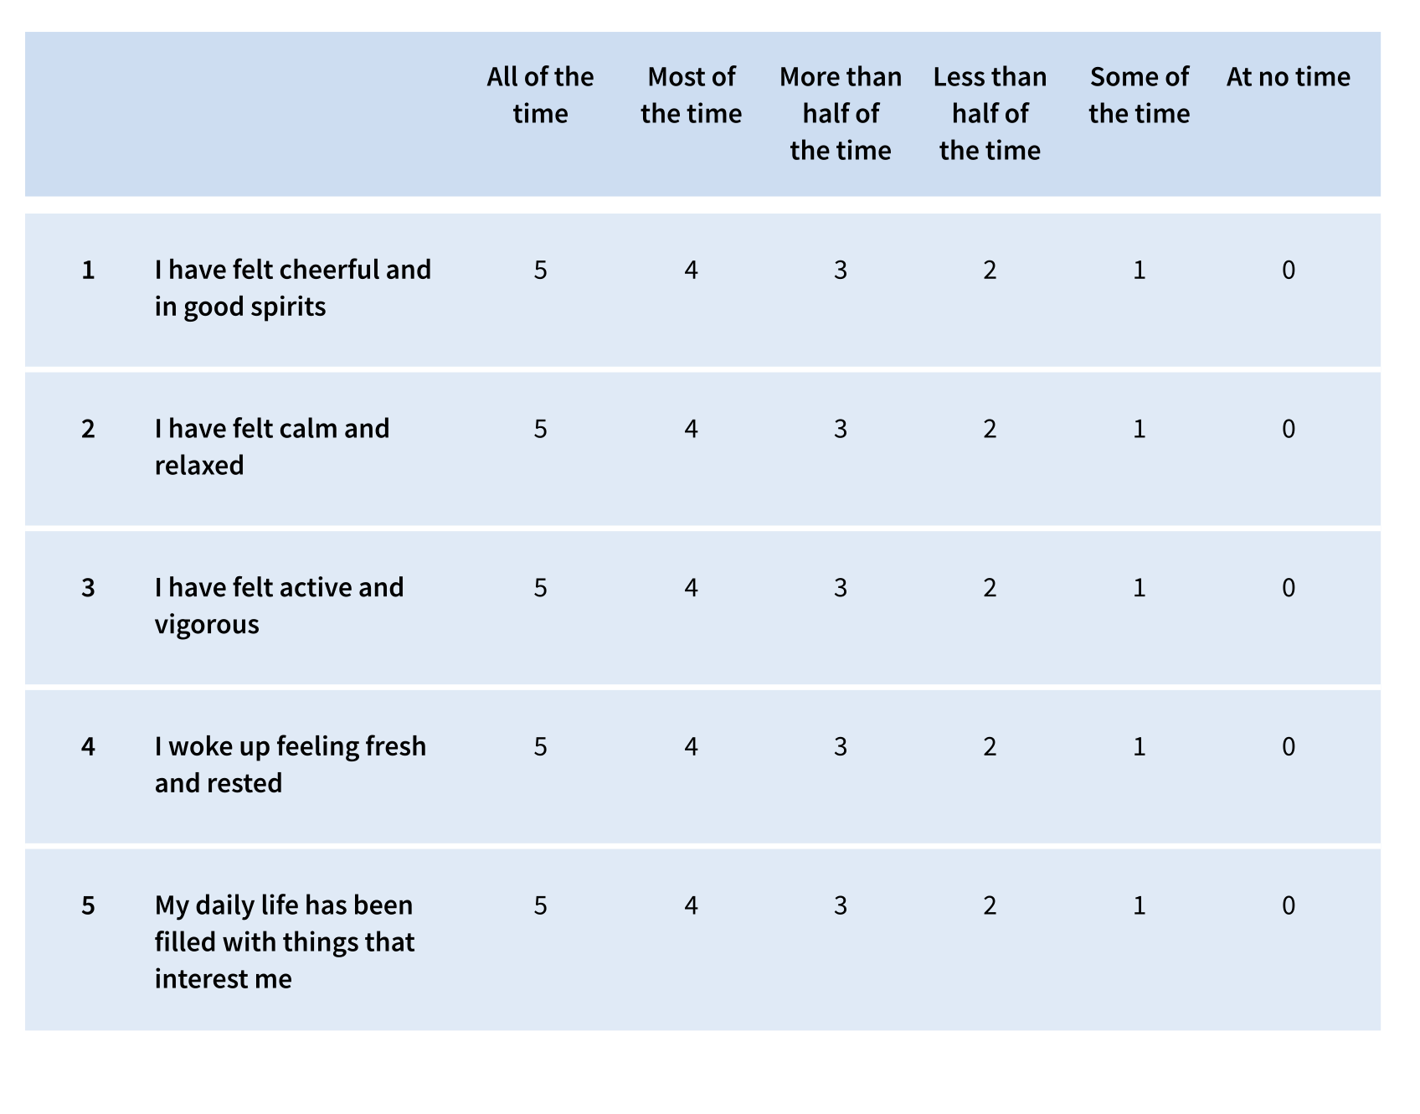

Scoring:

The raw score is calculated by totalling the scores on each of the five questions. The
raw score ranges from zero to 25, zero representing worst possible mental well-being
and 25 representing best possible mental well-being.
To get a percentage score ranging from zero to 100, the raw score is multiplied by four.
A percentage score of zero represents worst possible mental well-being; a score of 100
represents best possible mental well-being.

Comment:

A percentage score below 50 (or a raw score below 13) has been suggested as a cut-off
for poor mental well-being and as an indication for further assessment.

PHQ-2 : for depression

universally accepted and considered the global standard for depression screening in primary care.

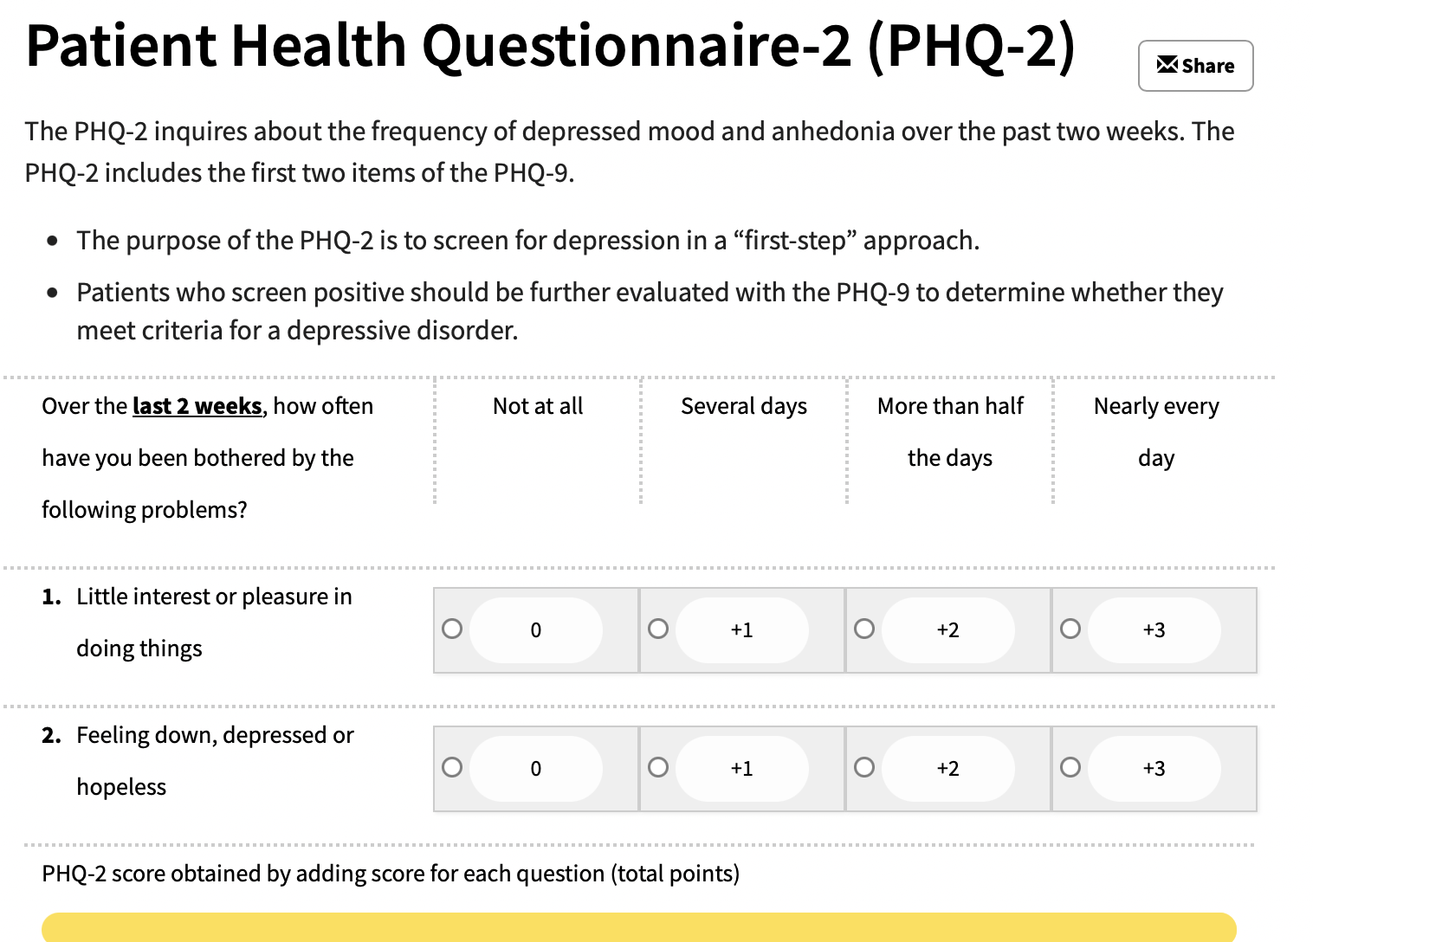

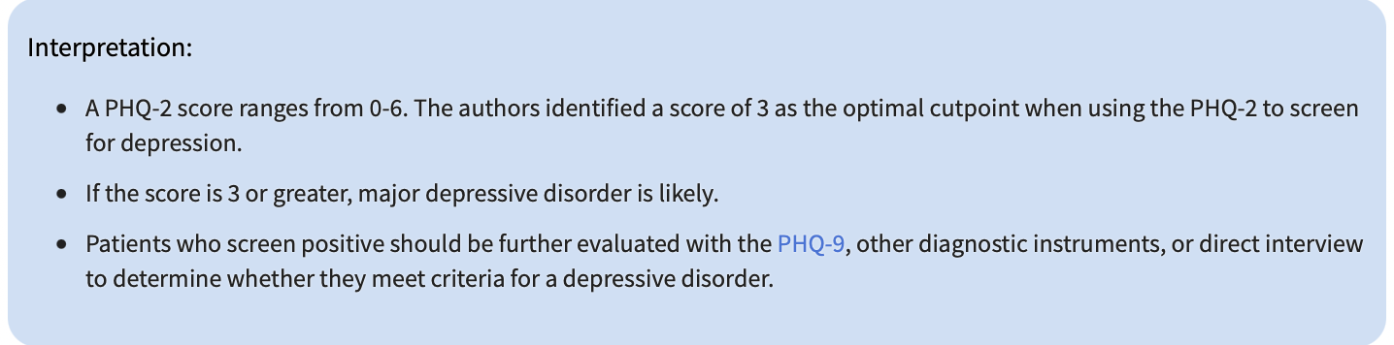

PHQ – 9
https://www.hiv.uw.edu/page/mental-health-screening/phq-9

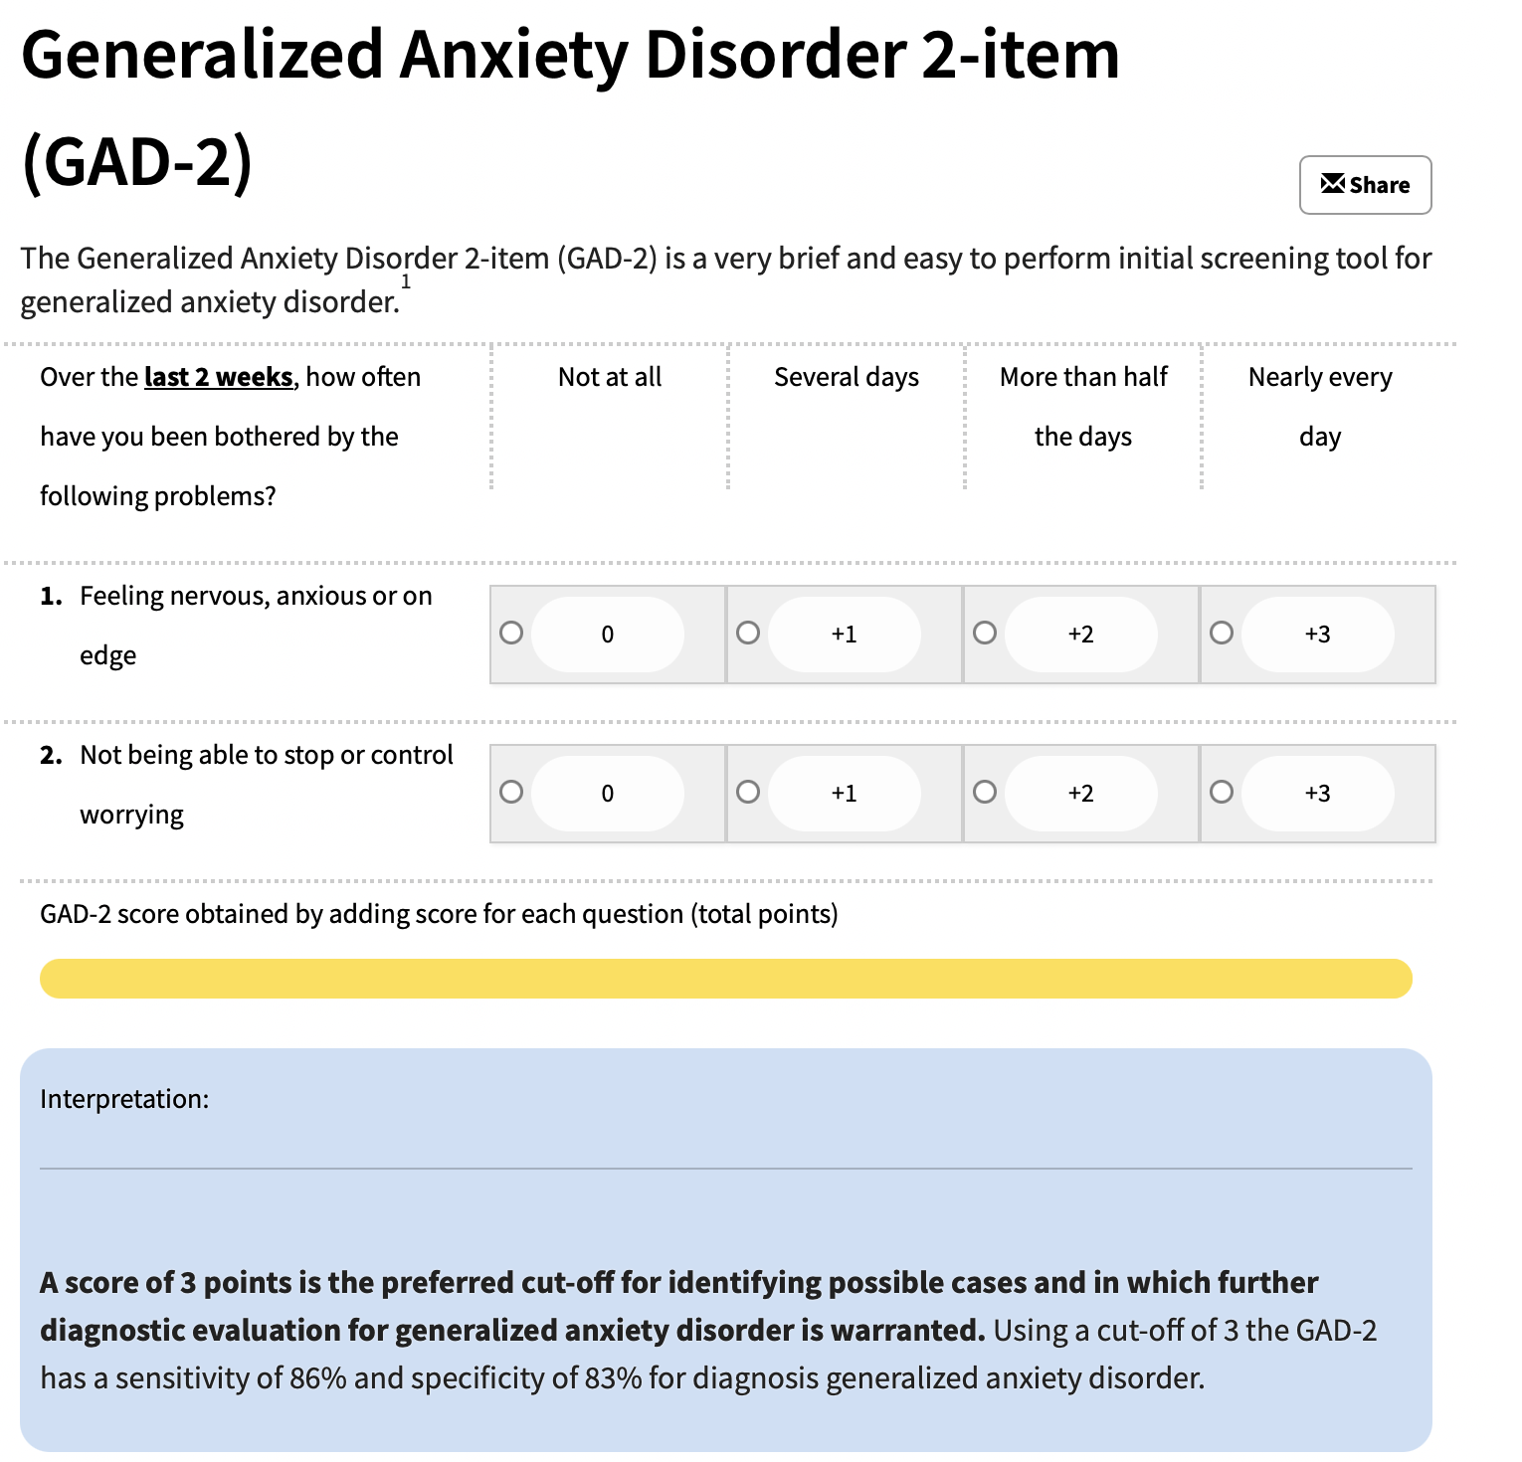

GAD- 7:

https://www.hiv.uw.edu/page/mental-health-screening/gad-7

Recommended frequency of the questionnaires:
These questionnaires ask users to think about how they have been feeling over the last two weeks, so repeating it every 14 days aligns with how it was designed to be used. Asking the questions more often is unlikely to provide meaningful new information, as people may simply remember their previous responses rather than report any real changes in their symptoms. Keeping the assessment at a two-week interval also reduces survey fatigue, making users more likely to stay engaged and complete the questionnaire consistently over time.

UCLA loneliness scale:

https://www.icmha.org/wp-content/uploads/2020/02/UCLA-Loneliness-Scale.pdf

The UCLA 3-Item Loneliness Scale should be completed during onboarding to establish a baseline, followed by fortnightly or monthly check-ins. The questionnaire could also be triggered when wearable data indicate potential changes in wellbeing, such as a sustained drop in daily step count or other signs of reduced activity, allowing the app to check whether the user's feelings of loneliness have changed.

Standardizing clinical information:

Clinical information is currently difficult to analyze when conditions and medications are entered as free text, as the same information can be recorded in many different ways. Using standardized categories such as ICD-10 or SNOMED CT for conditions, alongside a structured medication lookup system, would make the data more consistent and easier to use. This would allow the platform to identify patterns across patients and support more advanced analysis, such as checking whether certain medications may relate to changes in wearable measurements or health outcomes. An “other” option can still be included to capture information that does not fit within the predefined categories.

