November 2026
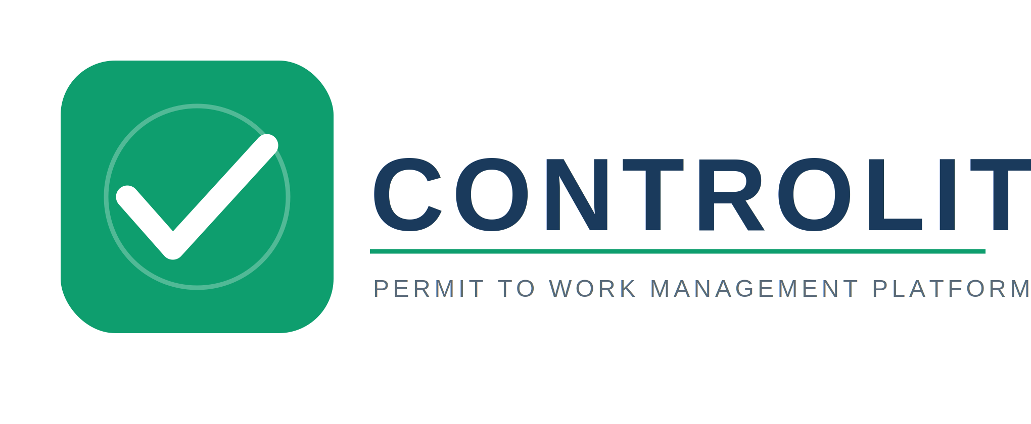

CONTROLIT – Service Profile & Proposal
Version 1.1 | November 2026 | getcontrolit.com
KINDNESS NJOKU
OWNER & DEVELOPER
CONTROLIT — Permit to Work Management Platform
0

CONTROLIT – Service Profile & Proposal

1. Introduction

CONTROLIT is an enterprise-grade, cloud-based digital Permit to Work (PTW) management platform built for HSE professionals, site managers, area authorities, safety officers, and operations teams working in Oil & Gas, Construction, Petrochemical, Energy, Mining, and Marine environments.

It replaces fragmented, paper-based PTW workflows — physical permit books, WhatsApp approvals, and manual audit trails — with a single structured, auditable, mobile-first system that mirrors international PTW standards including the ADNOC PTW framework.

2. What CONTROLIT Solves

Most site HSE teams currently operate with:
- Paper-based permits that are slow to approve, easy to lose, and impossible to audit remotely
- No real-time visibility of active permits or SIMOPS conflicts across work zones
- Manual approval chains with no enforcement — stages skipped, signatures missing
- No mandatory field verification before work commences — a leading cause of incidents
- Compliance gaps during regulatory inspections due to incomplete or missing permit records

CONTROLIT eliminates all of the above with a structured, enforced digital workflow.

3. Key Features

- Multi-Stage Approval Workflow
Requester → Area Authority → HSE Manager → HSE Officer. Every stage digitally signed with timestamp and role verification. No stage can be bypassed.

- Mandatory Field Verification
The HSE Officer must physically verify all site controls on a permit-specific checklist before the permit can go live. Completion is enforced — no shortcut available.

- SIMOPS Conflict Detection
Automatically detects conflicting active permits in the same zone in real time. Hot Work, Confined Space, Excavation, Lifting — all cross-checked simultaneously.

- AI-Powered Risk Assessment
Claude AI generates key hazards, precautionary controls, and emergency procedures for every permit type. Safety officers get a head start; they review and confirm.

- 7 Permit Types — Full Coverage
Hot Work, Cold Work (Critical), Confined Space Entry, Electrical Isolation (LOTO), Working at Height, Excavation & Ground Disturbance, Critical Lifting Operations.

- Immutable Audit Trail
Every action — approval, rejection, extension, revocation — is timestamped and logged. Full permit history available for inspections and incident investigations.

- Role-Aware Notifications & Escalation
Approvers are alerted when permits reach their stage. Escalation alerts fire for overdue permits. Expiry warnings issued before validity lapses.

- Branded Permit Printout
Once issued, a professional permit document is generated instantly and ready to print for posting at the job site — as required by HSE regulations.

- Mobile-First PWA
Designed for field use on any device — no app store required. Installable on Android and iOS. Built for low-connectivity environments and low-literacy field teams.

4. How It Works

- An organisation is onboarded and an Admin user is configured with full platform access
- The Admin invites team members via email, assigning each user a specific role
- The Requester submits a permit with full job details, hazard information, and AI-assisted risk assessment
- The Area Authority confirms zone readiness and checks for SIMOPS conflicts
- The HSE Manager reviews HSE compliance, PPE requirements, and risk controls before forwarding
- The HSE Officer, usually the Safety Officer or Safety Supervisor, goes to site, verifies all physical controls via the mandatory field checklist, signs digitally, and issues the permit
- Work commences. The permit is printed and posted at the job site as required
- Extensions (up to 2) or closure are processed digitally. The full audit trail is preserved permanently

5. Security & Data Handling

- All data is stored securely on Supabase — enterprise PostgreSQL hosted on Amazon Web Services (AWS)
- Application is hosted on GitHub Pages with Cloudflare DNS — global CDN, automatic SSL, 99.9% uptime target
- Access is restricted to explicitly invited users only — no public self-registration
- Each organisation's data is completely isolated at the database level using Row-Level Security (RLS)
- All data is encrypted in transit (TLS 1.3) and at rest (AES-256)
- AI risk assessment uses the Anthropic API — permit data is never stored or used for model training
- Incident notification within 72 hours in the event of any security event

6. Deployment & Onboarding

- Organisation setup takes under 15 minutes — no installation or IT infrastructure required
- Fully web-based access — works on any browser, any device, from any location
- Admin users can onboard their entire team independently via email invitations
- Role-based access is configured at setup — each user only sees and acts on what their role permits
- CONTROLIT's team provides personalised onboarding support and a demo walkthrough for every new organisation
- Training documentation and support resources are available throughout the subscription

7. Proposed Pilot Engagement

We propose starting with a structured pilot to demonstrate full platform value with zero commitment risk:

- Duration: 30-day pilot on one active project or work site
- Scope: Full use of CONTROLIT across all 7 permit types with your actual team and workflow
- Access: Up to 25 users — Requesters, Authorities, Safety Officers, and Issuers
- Support: Dedicated onboarding session, live demo, and direct support channel throughout the pilot
- Outcome: A full audit trail and permit history demonstrating compliance and operational improvement

8. Commercial Proposal

Option A – Subscription Plans (Recommended)

Plan | Price (USD) | Users | Ideal For
Starter | $199 / month | Up to 25 | Smaller teams getting started with digital PTW
Professional | $499 / month | Up to 100 | Growing organisations with multiple sites or zones
Enterprise | Custom | Unlimited | Large organisations with complex, multi-site requirements

What's Included in Every Plan

Feature | Starter | Professional | Enterprise
All 7 permit types | ✓ | ✓ | ✓
Full 4-stage approval workflow | ✓ | ✓ | ✓
AI risk assessment | ✓ | ✓ | ✓
Audit trail | ✓ | ✓ | ✓
Mobile PWA (Android & iOS) | ✓ | ✓ | ✓
Branded permit printout | ✓ | ✓ | ✓
SIMOPS conflict detection | – | ✓ | ✓
Advanced notifications | – | ✓ | ✓
Custom branding | – | ✓ | ✓
Multi-site management | – | – | ✓
SSO / LDAP integration | – | – | ✓
Custom permit types | – | – | ✓
Dedicated support + SLA | – | – | ✓
On-premise option | – | – | ✓

Option B – Project-Based License (Short-Term Use)

Duration | Price (USD) | Ideal For
30 days | $149 | Inspections, audits, short project cycles
3 months | $399 | Medium-term construction or maintenance projects
6 months | $699 | Long-term projects without a recurring subscription

9. Benefits to Your Organisation

- Eliminated paper permit backlogs — approvals happen in real time from any device, anywhere
- Zero permit stage skipping — the workflow enforces every approval before work can start
- Real-time visibility of all active permits, pending approvals, and SIMOPS conflicts across your site
- Complete audit trail for every permit — ready for regulatory inspection at any moment
- Reduced incident risk through mandatory physical field verification before every permit is issued
- Faster onboarding — new team members are up and running within minutes
- AI-assisted risk assessment reduces the time required to complete HSE permit forms
- Full compliance documentation generated automatically — no manual report preparation

10. Next Steps

We would be pleased to schedule a short demo session (15–20 minutes) to walk through a live CONTROLIT workflow and answer any compliance or technical questions specific to your organisation.

Contact
Kindness C. Njoku
CONTROLIT — Permit to Work Management Platform
+971 523 216 061
hello@getcontrolit.com
getcontrolit.com

Demo and onboarding requests are acknowledged within one business day.

This document was prepared by CONTROLIT and is accurate as of November 2026.
CONTROLIT — Permit to Work Management Platform | getcontrolit.com | hello@getcontrolit.com

