

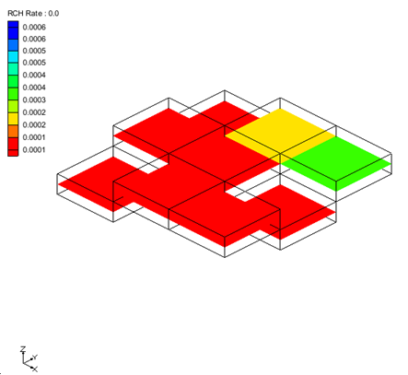
GMS 10.4 Tutorial
MODFLOW-USG – Recharge
Recharge package in MODFLOW-USG
Objectives
Learn about inputs to the MODFLOW Recharge package specific to MODFLOW-USG.
Prerequisite Tutorials
- MODFLOW – Recharge
Required Components
- Grid Module
- Map Module
- MODFLOW
Time
- 25–40 minutes

v. 10.4
1 Introduction 2
1.1 Getting Started 2
2 Importing the Project 2
3 Viewing Recharge Data 3
4 Converting to MODFLOW-USG 3
4.1 Viewing the Recharge Data 4
5 Non-Stacked MODFLOW-USG Model 5
5.1 Effect of IBOUND 6
6 USG Newton Solver with Recharge 11
7 Conceptual Model 12
8 Conclusion 16

Introduction
This tutorial is a continuation of the “MODFLOW – Recharge” tutorial. Complete that tutorial prior to doing this tutorial. This tutorial will use a very simplistic model to illustrate the various ways that recharge can be specified. This tutorial is recommended for users who want to explore in depth all of the options available in the recharge package. This tutorial is not meant to demonstrate common work flows for implementing recharge in a typical ground water model.

Getting Started
Do the following to get started:
- If necessary, launch GMS.
- If GMS is already running, select File | New to ensure that the program settings are restored to their default state.

Importing the Project
First, to import the modeling project:
- Click Open to bring up the Open dialog.
- Select “Project Files (*.gpr)” from the Files of type drop-down.
- Browse to the usg_recharge\ directory and select “mf2k_recharge_trans.gpr”.
- Click Open to import the project and close the Open dialog.
The imported project should appear similar to Figure 1.
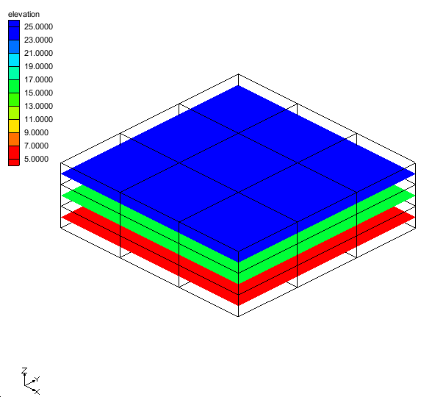
Figure 1 Initial screen after importing the project
This is a 3 layer, transient MODFLOW model with 9 cells in each layer. The model has one specified head cell and recharge. The NRCHOP option in the recharge package is set to (2) Recharge at specified vertical cells.

Viewing Recharge Data
Now to look at the recharge data.
- Select the “ RCH Rate” item in the Project Explorer.
- Cycle through the times steps by selecting each one in the Time Step Window.
Notice how the cells where recharge is applied change with the time steps.

Converting to MODFLOW-USG
Now, to convert the MODFLOW-2000 model to a MODFLOW-USG model.
- Right click on the “ MODFLOW” item in the Project Explorer and select the Convert to MODFLOW-USG Simulation command.
- Select OK at the prompt about the PCG package.
- Right click on the “ 3D Grid Data” item in the Project Explorer and select the Delete command.

Viewing the Recharge Data
- In the Project Explorer, under “ ugrid”, select “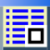 RCH Rate”.
- Select Display Options  to open the Display Options dialog.
- Turn Face contours on.
- Select OK to exit the Display Options dialog.
The display will look like Figure 2. Notice that the display is similar to the 3D Grid except that all of the UGrid cells are still visible. Recharge is applied at the cells that are contoured (colored). Unlike the 3D Grid, UGrid cells are not hidden if the data set is not active at the particular cell.
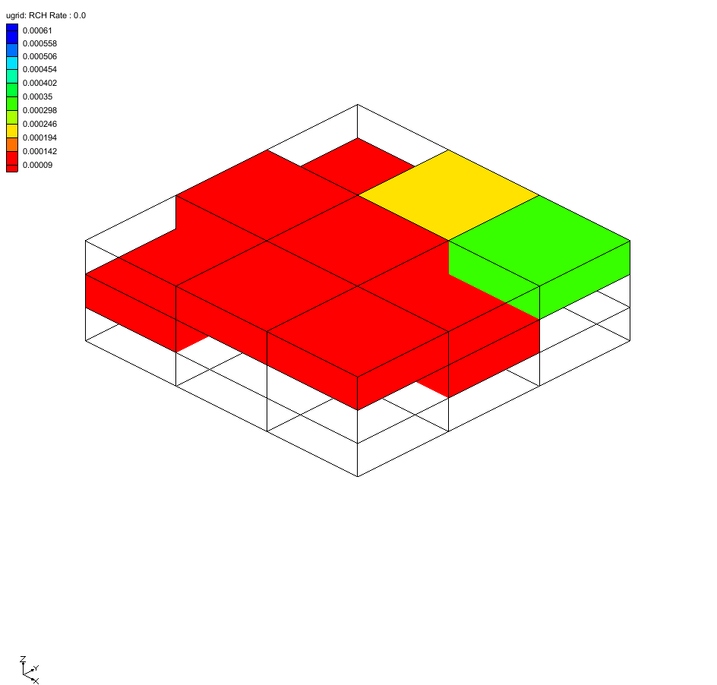
Figure 2 UGrid Contours of RCH Rate
- Cycle through the times steps by selecting each one in the Time Step Window.
The current MODFLOW-USG model uses a grid that can be referred to as a “Stacked” grid. This means that each layer of the grid has the same number of cells and that the cells in layer 2 are exactly below the corresponding cells in layer 1. When MODFLOW-USG has a stacked grid the recharge package functions the same way as MODFLOW-2000 or MODFLOW-2005.

Non-Stacked MODFLOW-USG Model
Now to explore how recharge works with a non-stacked grid in MODFLOW-USG.
- Select the File | New command and select Don’t Save at the prompt.
- Click Open to bring up the Open dialog.
- Select “Project Files (*.gpr)” from the Files of type drop-down.
- Browse to the usg_recharge\ directory and select “usg_recharge.gpr”.
- Click Open to import the project and close the Open dialog.
The graphics window will look like Figure 3. This is a three layer, steady state MODFLOW model. Notice that the top layer of the grid is missing two cells that would overlap the second grid layer. There is also a refined cell in the top layer as well as a refined cell in layer 2.
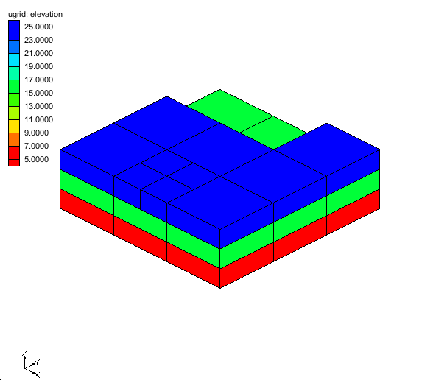
Figure 3 Initial screen after importing the project
- Select the “ RCH Rate” item in the Project Explorer.
The view will look like Figure 4.
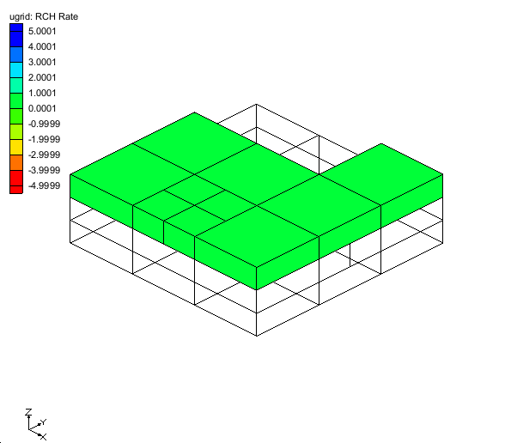
Figure 4 RCH Rate contours
Only the top layer of the grid is visible because recharge is only applied to the top of the grid. The color is the same because the recharge values are constant.
- Double-click on the “ RCH” item in the Project Explorer to bring up the MODFLOW Recharge Package dialog.
Notice that the Recharge option (NRCHOP) is set to “(3) Recharge at highest active cell”.
- Click OK to exit the MODFLOW Recharge Package dialog.
With a non-stacked MODFLOW-USG grid, the option for Recharge at highest active layer is only applied at cells on the grid that are in layer 1 or below layer 1. For this reason there is no recharge applied at the two cells in layer 2 that do not have layer 1 cells above them.

Effect of IBOUND
Now to see how changing the IBOUND affects where recharge is assigned with refined cells.
- Make sure the Select Cells  tool is selected. Select the cell shown in Figure 5.
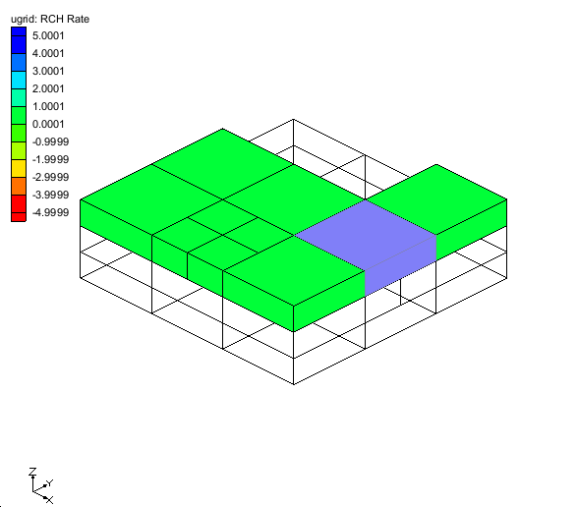
Figure 5 Select the cell indicated by the arrow
- Right-click on the selected cell and choose Properties… to bring up the UGrid Cell Properties dialog.
- In the IBOUND row, change the value in the drop-down box to “Inactive”.
- Select OK to exit the UGrid Cell Properties dialog.
The view will update and appear similar to Figure 6.
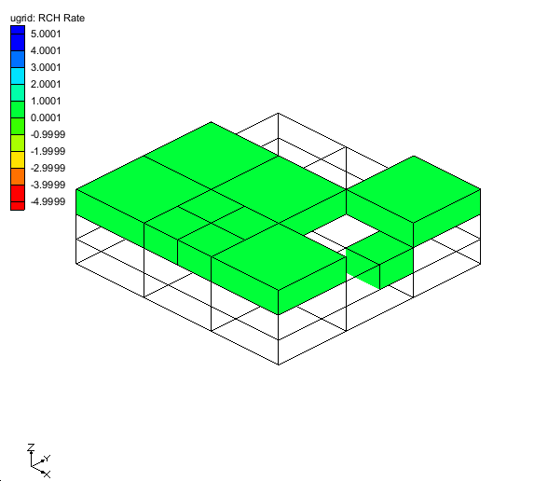
Figure 6 RCH Rate Contours
There are 4 cells below the cell that was set to be inactive. In MODFLOW-USG when a cell has multiple cells below it, the recharge is assigned to the first connected cell listed in the DISU file that is below the inactive cell. The cell that is contoured in layer 2 is assigned the recharge.
- Select the cell shown in Figure 7.
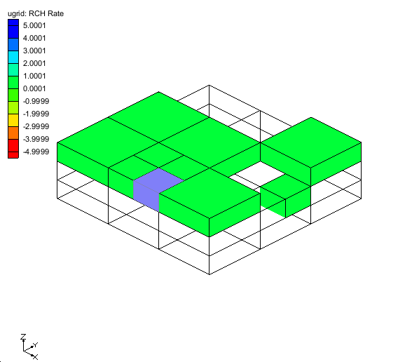
Figure 7 RCH Rate Contours
- Right-click on the selected cell and choose Properties… to bring up the UGrid Cell Properties dialog.
- In the IBOUND row, change the value in the drop-down box to “Inactive”.
- Select OK to exit the UGrid Cell Properties dialog.
The view will update and appear similar to Figure 8.
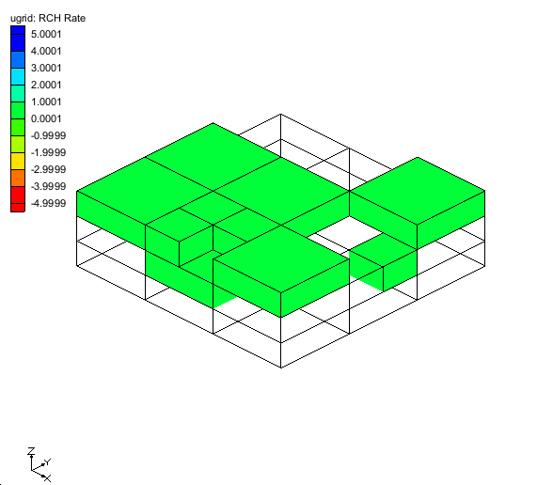
Figure 8 RCH Rate Contours
There is 1 larger cell in layer 2 that is below the 4 smaller cells in layer 1. One of the smaller cells has been inactivated and its recharge is assigned to the lower cell.
- Select the cell shown in Figure 9.
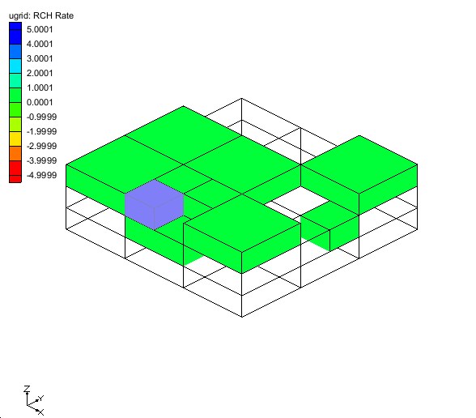
Figure 9 RCH Rate Contours
- Right-click on the selected cell and choose Properties… to open the UGrid Cell Properties dialog.
- In the IBOUND row, change the value in the drop-down box to “Inactive”.
- Select OK to exit the UGrid Cell Properties dialog.
The view will update and appear like in Figure 10.
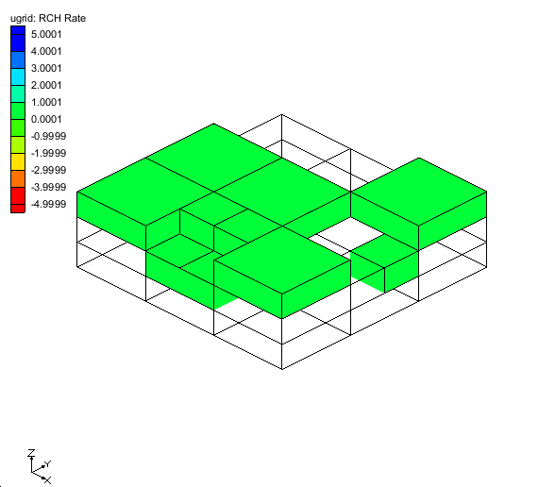
Figure 10 RCH Rate Contours
The recharge from both of the smaller cells in layer 1 has been assigned to the larger cell in layer 2. The volume of recharge assigned to the cell in layer 2 will be determined by MODFLOW-USG at runtime because recharge is specified as a rate and the volume is determined by the cell area multiplied by the rate. So the recharge volume from both of the smaller cells in layer 1 will be assigned to the cell in layer 2. GMS will not compute this final volume but does show that the cell is assigned recharge.
- Select the cell shown in Figure 11.
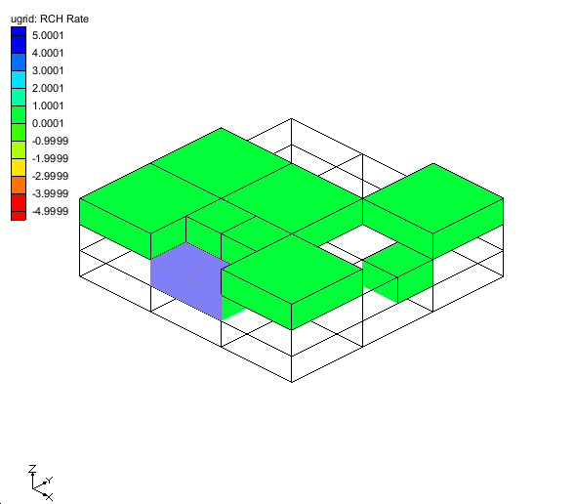
Figure 11 RCH Rate Contours
- Right-click on the selected cell and choose Sources/Sinks… to bring up the MODFLOW Sources/Sinks dialog.
- Choose Recharge (RCH) from the list on the left side of the dialog.
Notice that recharge is not available to edit. Because of the complexity associated with MODFLOW-USG recharge, the recharge may only be edited by selecting the cell where the recharge is actually assigned or by editing values in the Recharge Package dialog.
- Click OK to exit the MODFLOW Sources/Sinks dialog.

USG Newton Solver with Recharge
Another way for recharge to be transferred from an upper cell to a lower cell is when the Newton solver is used with the upstream options in the flow package. This type of model will now be investigated.

Conceptual Model
Using the conceptual model to define recharge is shown in various other GMS tutorials. Here, the focus will be on how Map→MODFLOW is designed to work with recharge.
- Select the File | New command and select Don’t Save at the prompt.
- Click Open to bring up the Open dialog.
- Select “Project Files (*.gpr)” from the Files of type drop-down.
- Browse to the usg_recharge\ directory and select “usg_recharge_con_mod.gpr”.
- Click Open to import the project and close the Open dialog.
The view will look like Figure 12. The active coverage has a single polygon with recharge assigned to it. The MODFLOW model currently does not include the recharge package.
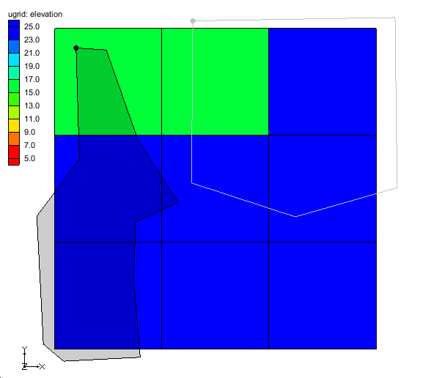
Figure 12 Initial screen after importing the project
- In the Project Explorer, right-click on “ recharge 1” and select Map To | MODFLOW/MODPATH.
Notice in the Project Explorer that the Recharge (RCH) package is now part of the MODFLOW simulation. The values from the polygon in the coverage have been transferred to the associated cells in the grid. Now to view where the values have been assigned.
- Select the “ RCH Rate” item in the Project Explorer.
The view will look like Figure 13. The green cells have been assigned a value for recharge; no other cells in the grid have been assigned a value for recharge. Notice that the cell in the center of the grid was assigned a recharge value even though it is only slightly overlapped by the polygon. Each cell is given the same recharge value even though the area of overlap with the polygon is different for each cell.
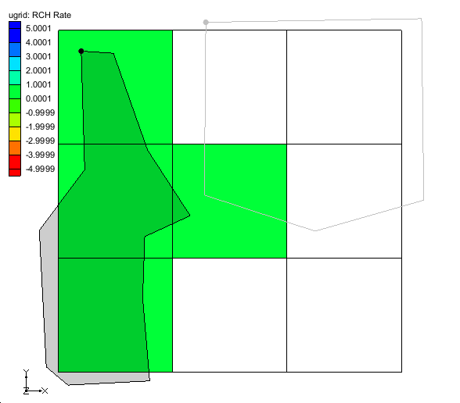
Figure 13 RCH Rate Contours
- Click the Oblique View  macro on the top GMS toolbar.
The view will look like Figure 14. Notice that 3 of the cells that have been assigned recharge are in layer 1 and 1 of the cells is in layer 2. When the Map→MODFLOW command is executed, GMS will assign recharge to the highest active cell in the UGrid. Also, the Recharge Option (NRCHOP) will be changed to (2) Recharge at specified vertical cells. In MODFLOW-USG this option really means recharge at specified cells, not just specified vertical cells. Recharge can be assigned to any cell in the grid by referencing the cell id.
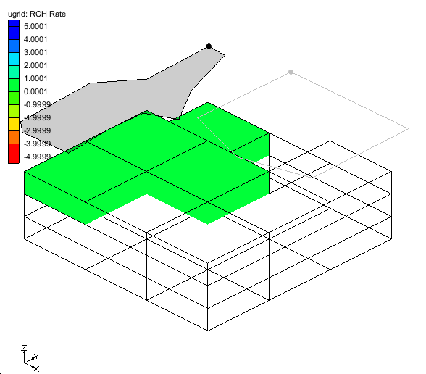
Figure 14 RCH Rate Contours
- Double-click on the “ RCH” item in the Project Explorer to bring up the MODFLOW Recharge Package dialog.
Notice that the Recharge option (NRCHOP) is set to (2) Recharge at specified vertical cells.
- Change the item in the View/Edit dropdown list to “IRCH. Cell ID”.
Notice that the spreadsheet shows the cell id and not the layer id. Also notice that there is a blank row in the spreadsheet. Cell IDs can be manually added to the recharge package by entering the ids in the blank row or by pasting a list of ids into the blank row (example: copy/paste ids from Excel into the Recharge package).
- Click OK to exit the MODFLOW Recharge Package dialog.
- Click the Plan View  macro.
- Select the “ recharge 2” coverage in the Project Explorer to make it the active coverage.
This coverage has 2 polygons. Notice that both polygons overlap with the cell in the center of the grid.
- Right-click on the “ recharge 2” coverage and select the Map To | MODFLOW/MODPATH command.
The view will look like Figure 15. The blue cells were assigned recharge from the polygon on the right and the red cells were assigned recharge from the polygon on the left. Notice that the center cell is blue; the polygon on the right has a larger overlapping area so the center cell is associated with the polygon on the right
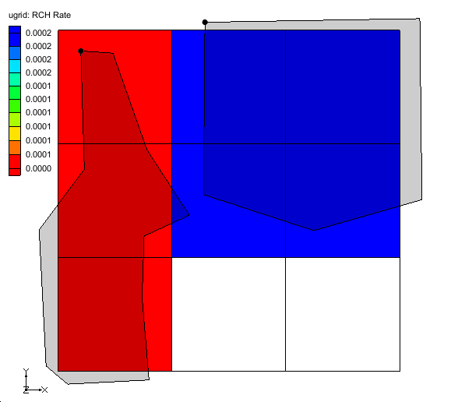
Figure 15 RCH Rate Contours
- Right-click on the “ recharge 1” coverage and select the Map To | MODFLOW/MODPATH command.
The recharge contours should look like Figure 13. Notice that the center cell has been assigned a value from the polygon in the recharge 1 coverage and all of the other cells are not assigned a recharge value. When the Map→MODFLOW command is executed with a recharge coverage, the recharge is initially set to zero and then the values from the polygons are applied.
- Right-click on the “ Conceptual Model” item in the Project Explorer and select the Map To | MODFLOW/MODPATH command to bring up the Map→ Model dialog.
- Select OK to accept the defaults and exit the Map → Model dialog.
The view will look like Figure 16. Notice that the center cell is blue and has a value of 0.0003 assigned. This is because the recharge 1 coverage assigned a value of 0.0001 and the recharge 2 coverage added a value of 0.0002. So the final value in the cell is the sum of values from each coverage that was mapped.
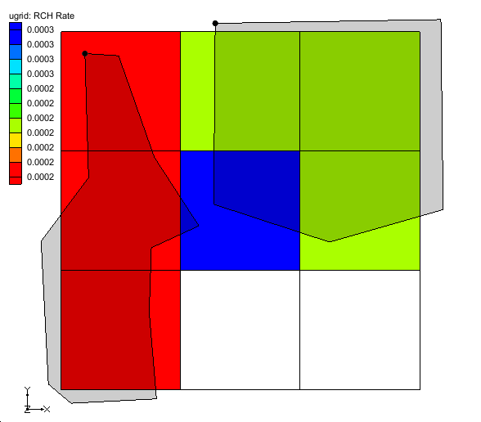
Figure 16 RCH Rate Contours

Conclusion
This concludes the “MODFLOW – Recharge” tutorial. The following key topics were discussed and demonstrated:
- Recharge package inputs.
- How to visualize the data in the Recharge package.
- The effect of IBOUND on recharge.
- The effect of the specified layer option on recharge.
- How the Map→MODFLOW command works with recharge.
- How parameters affect the display of recharge.

