

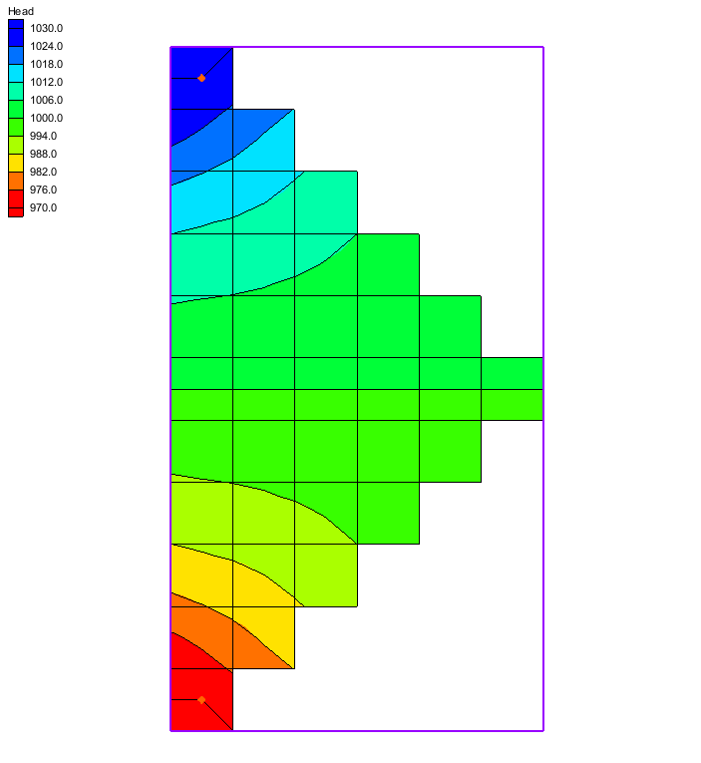
GMS 10.3 Tutorial
Exporting for TOUGH2
Create a five-spot Geothermal Production/Injection
Objectives
This tutorial will show how to create and populate a five-spot geothermal production/injection using a grid. Then it will demonstrate how to export a TOUGH2 mesh file and other necessary files to run in TOUGH2.
Prerequisite Tutorials
- Getting Started
Required Components
- MODFLOW

Time
- 10–20 minutes

v. 10.3
1 Introduction 2
2 Getting Started 3
2.1 Set the Units 3
2.2 Save the Project 4
3 Creating the Grid Frame 4
4 Creating the Computing Grid 5
5 Creating a New MODFLOW Simulation 6
5.1 Setting the Global Options 6
5.2 Setting the Layer Property Flow Options 7
5.3 Defining the Materials 7
6 Creating a New Conceptual Model 7
6.1 Creating a Model Boundary Coverage 7
6.2 Creating the Geology Coverage 8
6.3 Creating the Constant Head Coverage 8
7 Creating the Active Modeling Area 8
7.1 Creating the Geologic Model 9
7.2 Creating the Constant Heads 11
8 Mapping the to the Grid 12
9 Check and Run MODFLOW 13
10 Export as Native Format 14
11 Export and Rename the Head File 15
12 Use a Pre-Processor for TOUGH2 15
13 Conclusion 15

Introduction
TOUGH2 is 3D groundwater and heat transport model capable of simulating the coupled transport of water, vapor, non-condensible gas, and heat in porous and fractured media.
This tutorial discusses and demonstrates creating and populating a five-spot geothermal production/injection using a grid (Figure 1). The example is from the TOUGH2 User’s Guide, Version 2.0 published by the Earth Sciences Division of the Ernest Orlando Lawrence Berkley National Laboratory.
A grid with various materials will be created and exported as a TOUGH2 mesh file. Other necessary TOUGH2 files will be and exported for use in TOUGH2. This tutorial will not cover using TOUGH2.
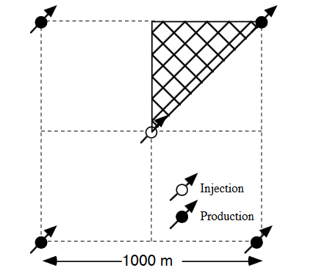
Figure 1 Five-spot well pattern with grid for modeling a ⅛ symmetry domain

Getting Started
Do the following to get started:
- If necessary, launch GMS.
- If GMS is already running, select File | New to ensure that the program settings are restored to their default state.

Set the Units
Before setting up the TOUGH2 simulation, set the appropriate units using the Units dialog.
- Select Edit | Units… to bring up the Units dialog.
- Click the to the right of Length to bring up the Display Projection dialog.
- In the Horizontal section, select No projection and select “Meters” from the Units drop-down.
- In the Vertical section, select “Meters” from the Units drop-down.
- Click OK to close the Display Projection dialog.
- Select “s” from the Time drop-down.
- Select “kg” from the Mass drop-down.
- Select “N” from the Force drop-down.
- Select “mg/l” from the Concentration drop-down.
- Click OK to close the Units dialog.

Save the Project
Now save the project before proceeding.
- Select File | Save… to bring up the Save As dialog.
- Select “Project Files (*.gpr)” from the Save as type drop-down.
- Enter “rfp.gpr” as the File name.
- Click Save to save the project and close the Save As dialog.
It is recommended to regularly Save  while progressing through a project.

Creating the Grid Frame
First, create a new grid frame.
- Right-click in the Project Explorer and select New | Grid Frame.
A new grid frame should appear in the Main Graphics Window (Figure 2).

Figure 2 A basic grid frame
- Using the Select Objects tool, double-click on the grid frame to bring up the Grid Frame Properties dialog.
- Enter the values in the following table into the appropriate rows in the Value column:
Item | Value
Origin x | 0.0
Origin y | 0.0
Origin z | 0.0
Dimension x | 300.0
Dimension y | 550.0
Dimension z | 200.0
Rotation angle | 0.0
- When done, click OK to close the Grid Frame Properties dialog.
- Frame  the project.
The grid frame should now appear similar to Figure 3.
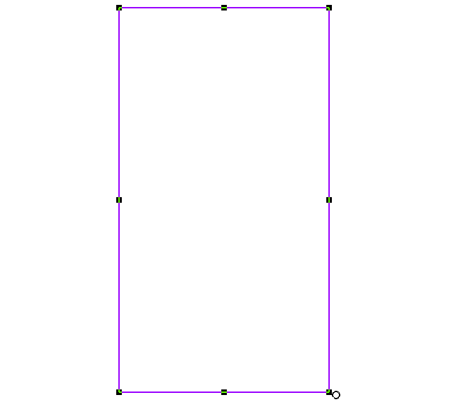
Figure 3 The grid frame is now taller

Creating the Computing Grid
Now create the computing grid.
- Right-click in the Project Explorer and select New | 3D Grid… to bring up the Create Finite Difference Grid dialog.
- In the X-Dimension section, enter “6” as the Number of cells.
- In the Y-Dimension section, enter “11” as the Number of cells.
- In the Z-Dimension section, enter “1” as the Number of cells.
- Click OK to close the Create Finite Difference Grid dialog.
The new grid should appear similar to Figure 4.
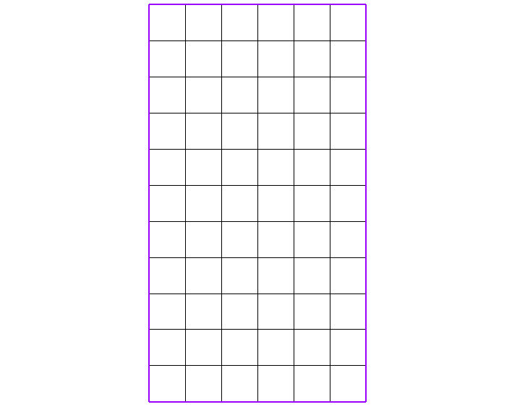
Figure 4 The computing grid

Creating a New MODFLOW Simulation
Now to create the MODFLOW simulation.

Setting the Global Options
- Switch to the 3D Grid  module.
- Select MODFLOW | New Simulation… to bring up the MODFLOW Global/Basic Package dialog.
- At the bottom of the dialog, turn off Starting heads equal grid top elevations.
- Click Packages… to bring up the MODFLOW Packages / Processes dialog.
- In the Optional packages / Processes section, turn on GHB1 – General-Head Boundary and click OK to close the MODFLOW Packages / Processes dialog.
- Click Starting Heads… to bring up the Starting Heads dialog.
- Click Constant → Grid… to bring up the Grid Value dialog.
- Enter “1000.0” as the Constant value for grid and click OK to close the Grid Value dialog.
This sets the starting heads to 1000 m above the geothermal reservoir.
- Click OK to close the Starting Heads dialog.
- Click OK to close the MODFLOW Global/Basic Package dialog.

Setting the Layer Property Flow Options
- Right-click on “MODFLOW” in the Project Explorer and select LPF – Layer Property Flow… to bring up the LPF Package dialog.
- In the Layer property entry method section, select Use material IDs.
- In the Layer data section, select Confined as the Layer type.
- Click OK to close the LPF Package dialog.

Defining the Materials
Next, define the materials to be used in the simulation.
- Select Edit | Materials… to bring up the Materials dialog.
- On the MODFLOW tab, define the materials using the data in the following table:
Name | Color/Pattern | Horizontal k (m/s)
Reservoir | red | 1.0e-007
Production | yellow | 1.0e-006
Injection | blue | 1.0e-006
- Click OK to accept all other default values and close the Materials dialog.

Creating a New Conceptual Model
- Right-click in the Project Explorer and select New | Conceptual Model… to bring up the Conceptual Model Properties dialog.
- Enter “5-wells geothermal” as the Name.
- Click OK to close the Conceptual Model Properties dialog.
A new “ 5-wells geothermal” conceptual model should appear under the “ Map Data” folder in the Project Explorer.

Creating a Model Boundary Coverage
A coverage for the model boundary needs to be created.
- Right-click on “ 5-wells geothermal” and select New Coverage… to bring up the Coverage Setup dialog.
- Enter “model boundary” as the Coverage name.
- In the Areal Properties column, turn on Color.
- Near the bottom of the dialog, turn on Use to define model boundary (active area).
- Click OK to close the Coverage Setup dialog.

Creating the Geology Coverage
- Right-click on “ 5-wells geothermal” and select New Coverage… to bring up the Coverage Setup dialog.
- Enter “geology” as the Coverage name.
- In the Areal Properties column, turn on Color and Material.
- Click OK to close the Coverage Setup dialog.

Creating the Constant Head Coverage
In TOUHG2, it is common to simulate wells via constant head cells. In many cases with complex simulations, this choice tends to make the computation more stable.
- Right-click on “ 5-wells geothermal” and select New Coverage… to bring up the Coverage Setup dialog.
- Enter “constant heads” as the Coverage name.
- In the Sources/Sinks/BCs column, turn on Specified Head (IBOUND).
- In the Areal Properties column, turn on Color.
- Click OK to close the Coverage Setup dialog.

Creating the Active Modeling Area
- Select “ model boundary” to make it active.
- Using the Create Arc tool, draw a triangle as shown in Figure 5.
- Select Feature Objects | Build Polygons.
The triangle will now be shaded, indicating it is a polygon (Figure 5). The triangle is the active area of the model. This active area now needs to be mapped to the model.
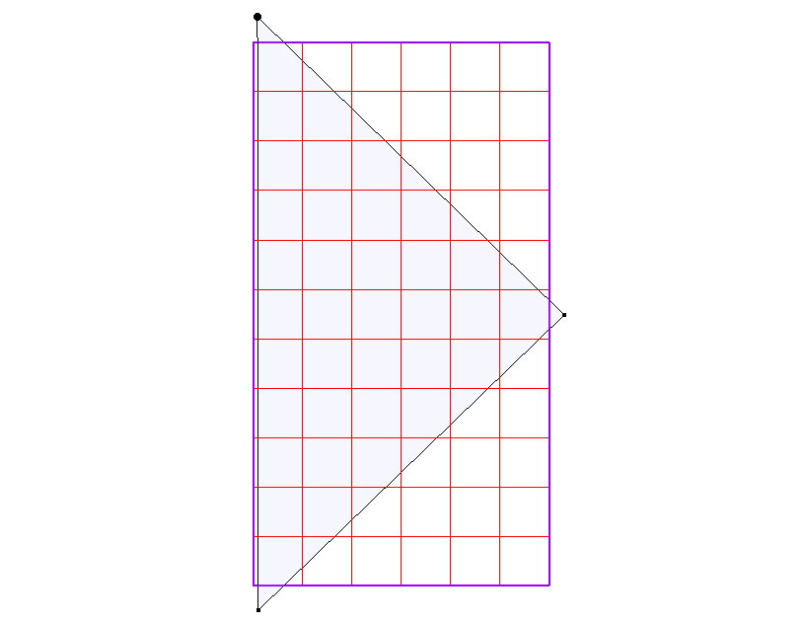
Figure 5 Draw this triangle
- Select Feature Objects | Activate Cells in Coverage(s).
The grid should now appear similar to Figure 6.
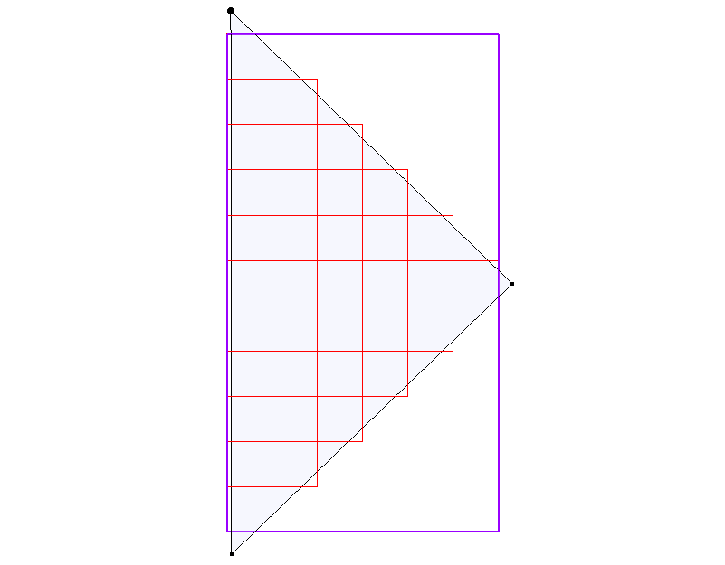
Figure 6 Only the active cells are visible

Creating the Geologic Model
- Select “ geology” to make it active.
- Using the Create Arc  tool, trace the triangle from the “ model boundary” coverage and then create the two smaller triangles shown in Figure 7 by creating the arcs enclosing the corners.
- Select Feature Objects | Build Polygons.
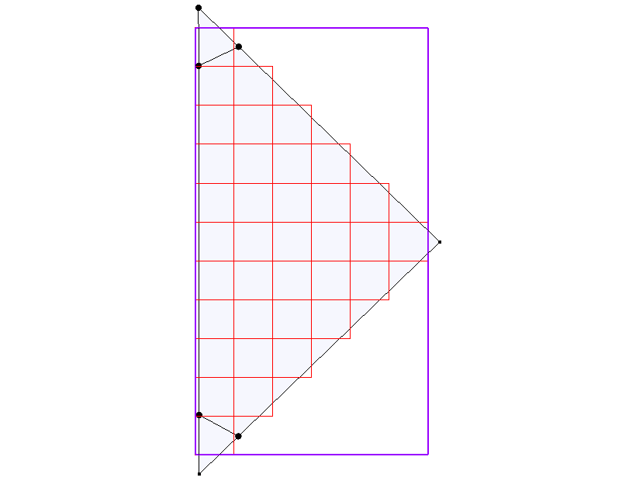
Figure 7 Corner triangles
- Using the Select Polygons  tool, double-click on the largest polygon to bring up the Attribute Table dialog.
- In the Color column in the spreadsheet, select “Red” from the drop-down.
- Select “Reservoir” from the drop-down in the Material column.
- Click OK to close the Attribute Table dialog.
- Repeat steps 4–7 for the lower corner triangle, selecting “Yellow” for the Color and “Production” for the Material.
- Repeat steps 4–7 for the upper corner triangle, selecting “Blue” for the Color and “Injection” for the Material.
- Click outside the triangles to deselect all polygons.
The project should now appear similar to Figure 8.
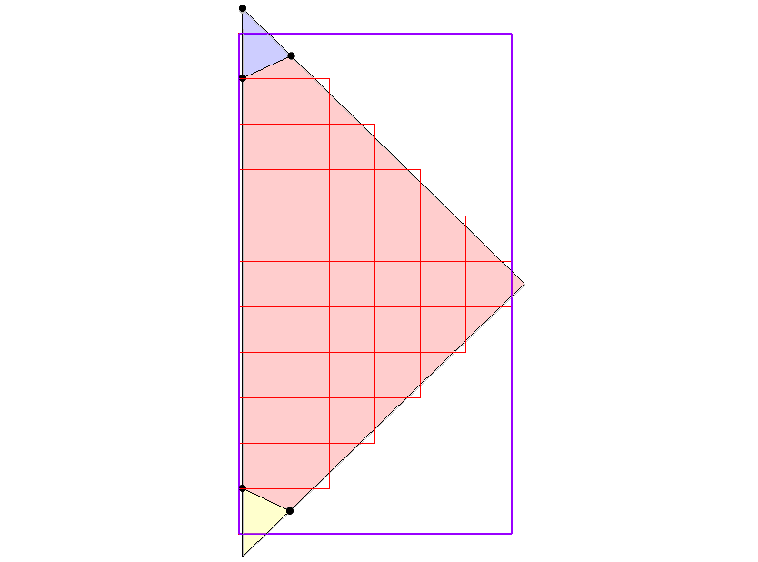
Figure 8 Polygons with assigned materials

Creating the Constant Heads
The constant heads for the injection and production wells need to be created.
- Select “ constant heads” to make it active.
- Using the Create Arc tool, draw a triangle within the boundaries of the upper corner triangle (Figure 9). It should fit inside without touching the edges.
- Repeat step 2 for the lower corner triangle (Figure 9).
- Select Feature Objects | Build Polygons.
- Using the Select Polygons tool, double-click on the upper triangle to bring up the Attribute Table dialog.
- In the spreadsheet, select “Blue” from the drop-down in the Color column.
- Select “spec. head (IBOUND)” from the drop-down in the Type column.
- Enter “1030.0” in the Head-Stage (m) column.
- Click OK to close the Attribute Table dialog.
This gives the injection well an over-pressure of 3 bars (30 m) above the ambient pressure of 100 bars (1000 m).
- Repeat steps 5–9 for the lower triangle, selecting “Yellow” for the Color, “spec. head (IBOUND)” for the Type, and entering “970.0” in the Head-Stage (m) column.
- Click anywhere outside the two triangles to deselect all.
This gives the production well an under-pressure of 3 bars (30 m) below the ambient pressure. The project should appear similar to Figure 9.
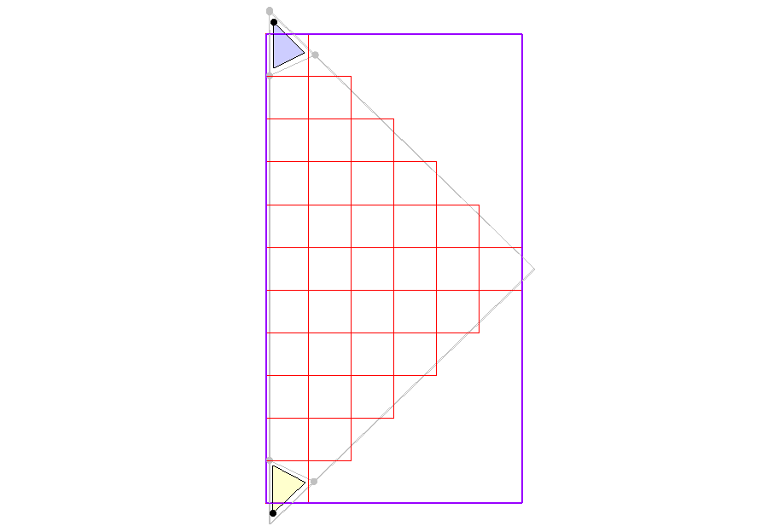
Figure 9 Corner injection and production wells

Mapping the to the Grid
- Right-click on “ 5-wells geothermal” and select Map To | MODFLOW/MODPATH to bring up the Map → Model dialog.
- Select All applicable coverages and click OK to close the Map → Model dialog.
Notice that a point has appeared in each of the two small triangles (Figure 10).
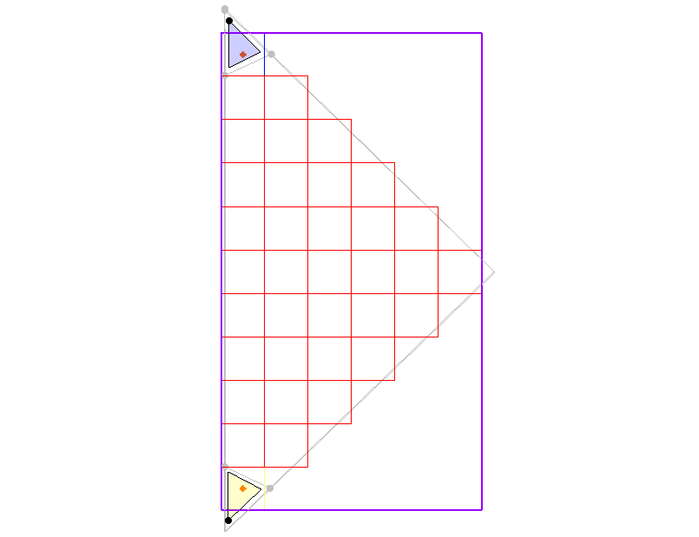
Figure 10 Points at the location of the wells
Now verify that the conceptual model was mapped correctly.
- Click Display Options  to bring up the Display Options dialog.
- Select “3D Grid Data” from the list on the left.
- On the 3D Grid tab, turn on Cell edges and Cell faces.
- Select “Auto” from the Color drop-down below Cell edges.
- On the MODFLOW tab, turn on Constant head and click OK to close the Display Options dialog.
The project should appear similar to Figure 11. Note the different colors for the different materials. Notice also the small orange diamonds indicating constant heads at the center of the injection (blue) and production (yellow) cells.
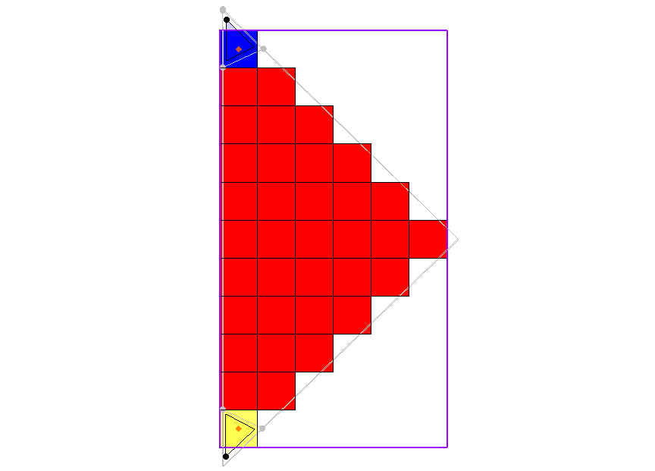
Figure 11 Cell edges and cell faces turned on

Check and Run MODFLOW
Before running MODFLOW, it is recommended to save the project and check the model for errors and warnings.
- Save the project.
- Select MODFLOW | Check Simulation… to bring up the Model Checker dialog.
- Click Run Check.
- There should be no errors (though there may be warnings). If there are any errors, follow the directions to correct them and run the model check again to make sure there are no errors.
- Once there are no errors, click Done to close the Model Checker dialog.
- Click Run MODFLOW  to bring up the MODFLOW model wrapper dialog.
- When MODFLOW finishes, turn on Read solution on exit and Turn on contours (if not on already).
- Click Close to exit the MODFLOW model wrapper dialog.
- Turn off “ model boundary”, “ geology”, and “ constant heads”.
- Click Display Options to bring up the Display Options dialog.
- Select “3D Grid Data” from the list on the left.
- On the 3D Grid tab, click on Options… in the Active dataset section to bring up the Dataset Contour Options – 3D Grid – Head dialog.
- In the Contour method section, select “Color Fill and Linear” from the first drop-down and click OK to close the Dataset Contour Options – 3D Grid – Head dialog.
- Click OK to close the Display Options dialog.
The project should appear similar to Figure 12. This shows the piezometric head plotted in Plan View .
Figure 12 Color fill with linear

Export as Native Format
- Save the project.
- Select MODFLOW | Advanced | Export Native Text… to bring up the Select MODFLOW Name File dialog.
- Select “MODFLOW Name Files (*.mfn;*.nam)” from the Files of type drop-down.
- Double-click on the “rpf_MODFLOW” folder to open it.
- Select “rpf.mfn” and click Open to exit the Select MODFLOW Name File dialog and bring up the DOS prompt window.
- Once the output files finish exporting, press the Enter key to exit the DOS prompt window.

Export and Rename the Head File
The MODFLOW head solution file must be exported and renamed.
- Right-click on “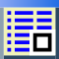 Head” under the “ rpf (MODFLOW)” solution in the Project Explorer and select Export… to bring up the Dataset Filename dialog.
- Select “Binary Dataset File (*.dat)” from the Save as type drop-down.
- Enter “Head.dat” as the File name.
- Click Save to export the file and close the Dataset Filename dialog.
- In Windows Explorer, browse to the TOUGH2\rpf_MODFLOW\ folder.
- Right-click on “Head.dat” and select Rename.
- Enter “rpf.hed” and press Enter to set the new name.
- Click Yes when advised that the file might become unstable if the extension is changed.

Use a Pre-Processor for TOUGH2
The files exported from GMS are not immediately ready for use in TOUGH2. A pre-processor program will have to be used to convert the files so they can be used with TOUGH2.
This tutorial was originally designed to work with the TMT2 conversion software. Steps for using TMT2 or other pre-processor software are beyond the scope of this tutorial.
A list of available pre-processors, including TMT2, can be found at:
esd1.lbl.gov/research/projects/tough/software/processors.html

Conclusion
This concludes the “Exporting for TOUGH2” tutorial. The following key concepts were discussed and demonstrated in this tutorial:
- Creating a MODFLOW project with a 3D grid, defined materials, and constant heads.
- Running MODFLOW and exporting the solution to Native Text format.

Pruess, Karston; Oldenburg, Curt; and Moridis, George (November 1999). TOUGH2 User’s Guide, Version 2.0, pp.99-103. http://esd1.lbl.gov/files/research/projects/tough/documentation/TOUGH2_V2.0_Users_Guide.pdf.
Pruess, et al (1999).

