GMS 10.9 Tutorial

***Annotation Tools***

Use scale bars, North arrows, floating images, text boxes, lines, and shapes.

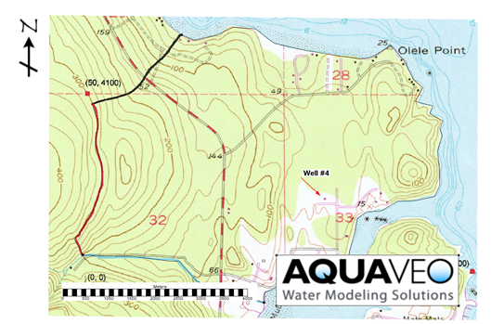

GMS 10.9

Objectives

GMS includes a number of annotation tools that can be used to visually enhance a project. These are often used to help prepare images and print copies for reports. This tutorial introduces these tools and shows how they work.

Time

* 10–20 minutes

Required Components

* GMS Core

Prerequisite Tutorials

* Getting Started

|  |
| --- |
| 1 Introduction 2  1.1 Getting Started 2  2 Working with Annotations 2  2.1 Images 3  2.2 North Arrow 4  2.3 Scale Bar 4  2.4 Lines, Shapes, and Text 5  3 Importing and Exporting Annotations 6  4 Conclusion 7 |

# Introduction

The annotation tools in GMS support the creation and display of annotation objects used to document, highlight, and enhance data presentations. Available annotation objects include screen space images, north arrows, scale bars, text, and shapes.

This tutorial demonstrates how the various annotation objects can be used in a project:

* Use an annotation image to add a logo to the Graphics Window
* Add a north arrow to the Graphics Window
* Add a scale bar to the Graphics Window
* Add text, lines, arrows, and shapes to the Graphics Window
* Create a project file with annotations and then import those annotations into another project

## Getting Started

To get started, do the following:

1. If necessary, launch GMS.
2. If GMS is already running, select *File |* **New…** to ensure that the program settings are restored to their default state.
3. If a dialog appears asking to save the current project and settings, click **Don’t Save** to close the dialog.
4. Select *File* | **Open…** to bring up the *Open* dialog.
5. Select “Project Files (*.gpr)” from the *Files of type* drop-down.
6. Browse to the *\annotations\annotations* directory.
7. Select “start.gpr” and click **Open** to import the file and close the *Open* dialog.

A map showing Olele Point will appear in the Graphics Window.

# Working with Annotations

A variety of annotation objects can be added, including images, north arrows, scale bars, text, and shapes. Annotation data is stored in a dedicated folder in the Project Explorer and organized into layers. Each annotation object belongs to a layer, which can be either “screen space” and “world space”.

Objects created in **Screen Space** https://www.xmswiki.com/images/thumb/4/47/Annotation_Screen_Icon.svg/56px-Annotation_Screen_Icon.svg.png layers are fixed to specific locations in the main Graphics Window and remain stationary during zoom, pan, or rotate operations.

In contrast, objects created in **World Space** https://www.xmswiki.com/images/thumb/4/40/Annotation_World_Icon.svg/60px-Annotation_World_Icon.svg.png layers are anchored to real-world spacelocations and move accordingly when the display is panned or zoomed.

## Images

An annotation image is an image that is anchored in screen space. This is useful for adding various images to a project, such as a company logo. Multiple annotation images can be added, and common image file formats (BMP, JPG, TIF, PNG) are supported.

Add an annotation image for a company logo at the top right of the graphic by doing the following:

1. Right-click in the Project Explorer and select *New |* **Annotation Layer – Screen Space**.

Note that an “https://www.xmswiki.com/images/thumb/0/08/Annotations_Folder.svg/60px-Annotations_Folder.svg.png Annotation Data” folder appears in the Project Explorer, with “https://www.xmswiki.com/images/thumb/4/47/Annotation_Screen_Icon.svg/56px-Annotation_Screen_Icon.svg.png Layer #1” listed beneath it. A screen space layer was created because annotation images are only anchored in screen space and are not supported in world space layers.

1. Using the **Add Annotation Image** GMS Add Annotation Image tool icon tool, drag a box anywhere in the main Graphics Window. An *Open* dialog will appear.
2. Make sure *Files of type* is set to “Images” or “PNG File.”
3. Select “Aquaveo.png” and click **Open** to close the *Open* dialog.

The imported image appears and is anchored to the screen coordinates where the box was created. The image can be moved, stretched, and resized by selecting the image and editing the properties. Since the annotation is a company logo, it may look best anchored to the lower right corner of the screen.

To move and adjust the image, do the following:

1. Using the **Select Annotation Objects** File:WMS SelectDrawingObjectsTool.svg tool, select the Aquaveo logo and drag it to the lower right corner of the Graphics Window.
2. Resize the image by dragging a corner.
3. With the image selected, right-click on it and select **Properties…** to bring up the *Image Properties* dialog.

By default, the aspect ratio of an annotation image is fixed. To allow stretching in one direction, the *Fixed aspect ratio* option can be turned off. Transparency settings can also be adjusted, which is useful when the image background color doesn’t match the background color of the main Graphics Window.

1. In the *Transparency options* section, turn on *Use transparency* and *Specify color*.
2. Click on the *Specify color* drop-down menu to reveal the color palette of the logo image.

The palette is dynamic and populated with colors from the selected annotation image. In this case, a range of colors is shown from white to light blue to black.

1. Select the first dark black color.

Note that the black letters in the logo are now transparent, allowing the Graphics Window background to show through. However, since the logo’s background color already closely matches the Graphics Window, the transparency options are not necessary in this case.

1. Click **Cancel** to close the *Image Properties* dialog without making any changes.

## North Arrow

North arrows are used to orient data displayed in the Graphics Window. As the display is rotated, the north arrow will always align with the Y-axis. To add a north arrow as seen in Figure 1, do the following:

1. Using the **Create Annotation North Arrow** https://www.xmswiki.com/images/thumb/9/9d/North_Arrow_Annotation_Tool.svg/52px-North_Arrow_Annotation_Tool.svg.png tool, drag a box in the upper left-hand corner to open the *Open* dialog.
2. Select “north-arrow.jpg” and click **Open** to import the image and close the *Open* dialog.
3. Use the **Rotate** https://www.xmswiki.com/images/thumb/7/7f/Rotate_Tool.svg/60px-Rotate_Tool.svg.png tool to rotate the display, noting that the north arrow is fixed to the Y-axis.
4. Click the **Plan View** https://www.xmswiki.com/images/thumb/e/ec/Plan_View_Macro.svg/60px-Plan_View_Macro.svg.png macro to return the display to its original orientation.

The Graphics Window should appear as in Figure 1.

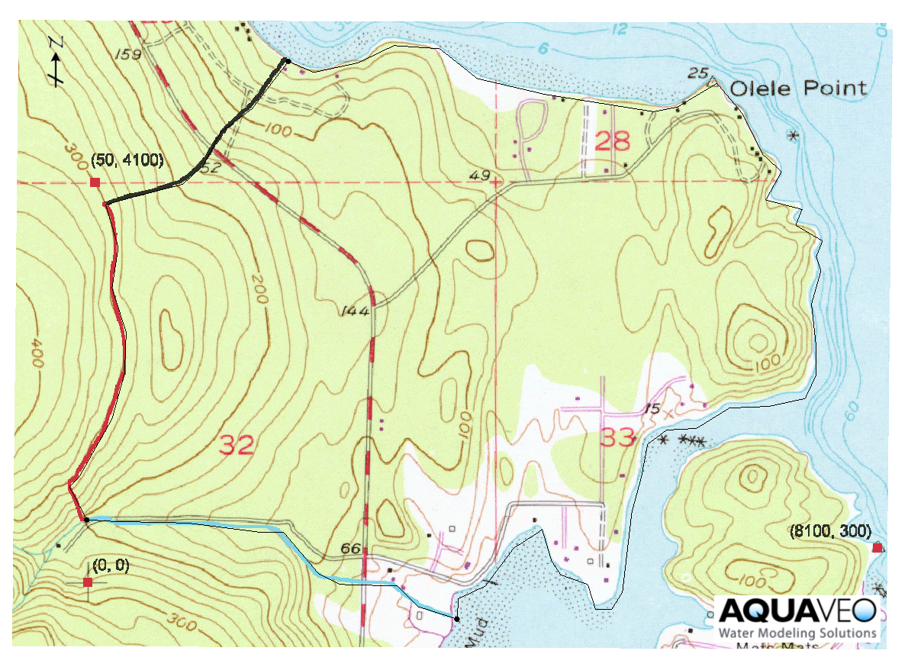

Figure 1 Inserting a logo and a north arrow

## Scale Bar

Scale bars are used to provide context for world space in the Graphics Window. The units will automatically correspond with the current project units (meters). To create a scale bar, follow these steps:

1. Using the **Add Annotation Scale Bar** https://www.xmswiki.com/images/thumb/c/ca/Annotation_Scale_Icon.svg/60px-Annotation_Scale_Icon.svg.png tool, drag a box near the lower left corner of the screen to bring up the *Scale Bar Properties* dialog.

Various settings can be adjusted that affect the appearance of the scale bar, font type, division widths, and background fills.

1. Click **OK** to accept the default settings and close the *Scale Bar Properties* dialog.

A scale bar will appear in the space where the box was drawn. As with other annotation objects, scale bars can be moved and resized as needed.

## Lines, Shapes, and Text

Annotation text and shapes are used to add labels and descriptions to a project and can be created either in screen space or world space layers. For this example, a world space layer is used, as the objects will label specific locations within the view. As with other annotation objects, shapes can be moved and edited with the **Select Annotations Object** File:WMS SelectDrawingObjectsTool.svg tool.

To create a line object, do the following:

1. Right-click on “https://www.xmswiki.com/images/thumb/0/08/Annotations_Folder.svg/60px-Annotations_Folder.svg.png Annotation Data” in the Project Explorer and select **Create World Space Layer** from the menu.
2. Select “File:Annotation World Icon.svg Layer #2” to make it active.
3. Using the **Create Line Object** File:Annotation Line Icon.svg tool, click once to start the line and double-click to end it, pointing to any desired location in the image. This will bring up the *Line Properties* dialog (Figure 2).
4. In the *Line* section, enter “3” in the *Width* field.
5. Click the drop-down arrow next to the *Line color* button and select “Red”.
6. In the *Arrowheads* section, select “End” from the drop-down to place an arrowhead at the end of the line.
7. Click **OK** to exit the *Line Properties* dialog.

To create a circle or oval, follow these steps:

1. Using the **Create Oval Object** Create Oval Object tool, click and hold the left mouse button, then drag the cursor over the desired area to bring up the *Rectangle/Oval Properties* dialog.
2. In the *Line* section, select *Dashed*.
3. Enter “3” as the *Width*.
4. Click the drop-down arrow next to the *Line color* button and select “Blue”.
5. In the *Fill* section, select *Fill*.
6. Click the drop-down arrow next to the *Fill* button and select “Green”.
7. Click **OK** to close the *Rectangle/Oval Properties* dialog.

To create a rectangle, do the following:

1. Using the **Create Rectangle Object** Create Rectangle Object tool, click and hold the left mouse button, then drag the cursor over the desired area to bring up the *Rectangle/Oval Properties* dialog.
2. In the *Line* section, select *Dashed*.
3. Enter “3” as the *Width*.
4. Click the drop-down arrow next to the *Line* *color* button and select “Blue”.
5. In the *Fill* section, select *No fill*.
6. Click **OK** to close the *Rectangle/Oval Properties* dialog.

To add annotation text to the project as seen in Figure 2, do the following:

1. Using the **Create Text Object** Create Text Object tool, click near the line arrow created previously to bring up the *Text Properties* dialog.
2. Enter “Location A” in the *Text* field.
3. Click on the *Font* button (**AaBb**) to open the *Font* dialog.

The font, font style, and font size can be changed here.

1. Select “Bold” in the *Font style* field and “14” in the *Size* field.
2. Click **OK** to close the *Font* dialog.
3. Click the drop-down arrow next to the *Color* button and select “Green”.
4. Click **OK** to exit the *Text Properties* dialog.

The Graphics Window will appear similar to Figure 2.

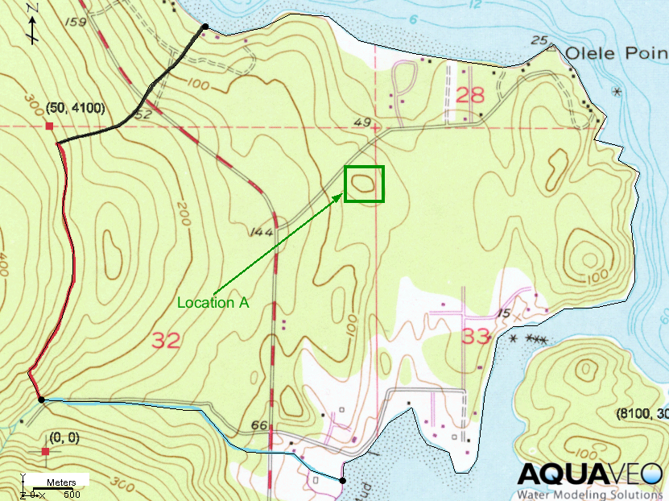

Figure 2 Project with annotation objects

# Importing and Exporting Annotations

Once annotations are set up in a project, they can be reused in other projects. This is done by saving a file that contains only the annotation data, then importing that file into another project. The steps below demonstrate how to export the newly added annotation file and import them into an existing project file.

1. Select *File* **| Save As*…*** to bring up the *Save As* dialog.
2. Enter “annoImport.anno” for the *File name*.
3. From the *Save as type* drop-down, select “Annotation Save/Load Files (*.anno)”.
4. Click **Save** to save the new annotation file and close the *Save As* dialog.

Now this project file’s annotations can be imported into other projects. The next step is to open another project file into which the annotations can be imported.

1. Click **New** https://www.xmswiki.com/images/thumb/b/b8/New_Macro.svg/45px-New_Macro.svg.png to close the current project.
2. If it asks to save the project, click **Don’t Save**.
3. Click **Open** https://www.xmswiki.com/images/thumb/5/5d/Open_Macro.svg/60px-Open_Macro.svg.png to bring up the *Open* dialog.
4. Select “start.gpr” and click **Open** to open the project and close the *Open* dialog.
5. Click **Open** https://www.xmswiki.com/images/thumb/5/5d/Open_Macro.svg/60px-Open_Macro.svg.png to bring up the *Open* dialog again.
6. From the *Files of type* drop-down, select “Annotation Save/Load Files (*.anno)”.
7. Select “annoImport.anno”.
8. Click **Open** to import the annotations file and close the *Open* dialog.

All the previously created annotations will now appear on the image.

# Conclusion

This concludes the “Annotation Tools” tutorial. Key concepts in this tutorial included the following:

* Creating both types of annotation layers
* Learning the difference between types of layers
* Using annotation objects to document points of interest in the Graphics Window
* Editing using the Annotation toolbar
* Saving and exporting the annotation layers for use in other projects