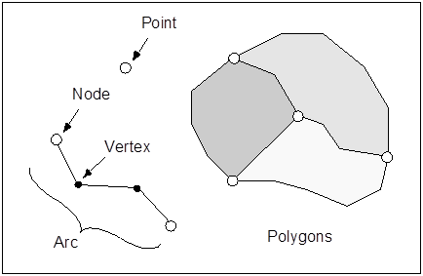

GMS 10.9 Tutorial

***Feature Objects***

Use points, arcs, and polygons to make grid independent conceptual models

GMS 10.9

Objectives

This tutorial demonstrates how to use feature objects—points, nodes, vertices, arcs, and polygons—to make grid-independent conceptual models.

Time

* 10–15 minutes

Required Components

* GMS Core

Prerequisite Tutorials

* Getting Started

|  |
| --- |
| [1 Introduction 2](#_Toc169693029)  [1.1 Starting GMS 2](#_Toc169693030)  [2 Feature Objects 2](#_Toc169693031)  [2.1 Definitions 3](#_Toc169693032)  [2.2 Project Explorer 3](#_Toc169693033)  [2.3 Creating Feature Objects 5](#_Toc169693034)  [2.4 Selecting Feature Objects 6](#_Toc169693035)  [2.5 Modifying Feature Objects 6](#_Toc169693036)  [2.6 Grid Frames 7](#_Toc169693037)  [3 Conclusion 8](#_Toc169693038) |

# Introduction

This tutorial gives an introduction to feature objects: points, nodes, vertices, arcs, and polygons. The following key topics are discussed and demonstrated:

* Creating coverages
* Creating conceptual models
* Creating feature objects
* Selecting and modifying feature objects
* Creating grid frames

## Starting GMS

To get started, do the following:

1. Launch GMS.
2. If GMS is already running, select *File* | **New…** to ensure that the program settings are restored to their default state.

# Feature Objects

Feature objects are patterned after Geographic Information Systems (GIS) objects and include points, nodes, vertices, arcs, and polygons (Figure 1). Feature objects are used in many ways in GMS, and they are used in most tutorials.



Figure 1 Examples of feature objects

## Definitions

**Points** are *xy* locations that are not attached to an arc. Points have unique IDs and can be assigned properties. Points are typically used to represent wells.

**Arcs** are sequences of line segments or edges that are grouped together as a single polyline entity. Arcs have unique IDs and can be assigned properties.

**Nodes** are the two end points of an arc. Nodes have unique IDs and can be assigned properties.

**Vertices** are the intermediate points between nodes on an arc. Vertices are used solely to define the geometry of the arc and cannot be assigned properties.

A **polygon** is a group of connected arcs that form a closed loop. A polygon can consist of a single arc or multiple arcs. If two polygons are adjacent, the arc forming the boundary between the polygons is shared (not duplicated).

A **coverage** represents a particular set of objects and the attributes associated with those objects. Feature objects are grouped into coverages.

## Project Explorer

Both coverages and conceptual models require certain steps to be created. Coverages are created by following these steps:

1. In the *Project Explorer*, right-click to bring up the context menu, and select *New |* **Coverage…** to add a new coverage under the “Map Data folder Map Data” folder in the Project Explorer.
2. Right-click on “File:Coverage Active Icon.svg new coverage” and select the **Coverage Setup…** context menu item to bring up the *Coverage Setup* dialog.

Notice that this is where *Sources/Sinks/BCs*, *Areal Properties*, and *Observation Points* attributes can be turned on and off. For this project, all options should be grayed out.

1. Nothing needs to be changed in the *Coverage Setup* dialog, so click the **Cancel** buttonto exit the dialog.

The “File:Coverage Active Icon.svg new coverage”item is now the active coverage, meaning that feature objects are created in this coverage. Coverages can be duplicated. All the feature objects and attributes from the original coverage are copied to the new coverage.

1. Right-click on “File:Coverage Active Icon.svg new coverage”and select the **Duplicate…** context menu item to create a new coverage named “File:Coverage Active Icon.svg Copy of new coverage”.

Notice that the icon next to “File:Coverage Inactive Icon.svg new coverage” is now grey indicating that “File:Coverage Inactive Icon.svg new coverage” is no longer the active coverage.

1. Right-click on “File:Coverage Active Icon.svg Copy of new coverage” and select the **Delete** context menu item to remove it from the Project Explorer.

A conceptual model in GMS is an object that can be used to associate one or more related coverages. Conceptual models are created by doing the following:

1. Right-click in the *Project Explorer* and select the *New |* **Conceptual Model…** context menu item to bring up the *Conceptual Model Properties* dialog (Figure 2).

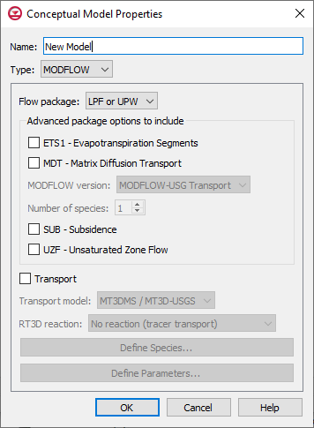

Figure 2 Conceptual Model Properties dialog

Conceptual models have a name and a type. The type corresponds with the type of model being created (MODFLOW, FEMWATER, etc.). The type determines the options available in the spreadsheet section of the dialog.

1. Click the **OK** button to accept the defaults and close the *Conceptual Model Properties* dialog.
2. In the *Project Explorer* field, drag the “File:Coverage Active Icon.svg new coverage” below the “File:Conceptual Model Icon.svg New Model” conceptual model. A line will appear showing the drop location.
3. Click the **Yes** button, if a dialog appears regarding attributes.

The attributes in a coverage depend on the settings in the conceptual model that the coverage is associated with. The coverage should now appear below “File:Conceptual Model Icon.svg New Model” (Figure 3).

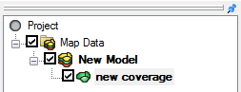

Figure 3 The Project Explorer showing a new coverage below a conceptual model

## Creating Feature Objects

The next step is to create some feature objects on the coverage.

1. Using the **Create Point** File:Create Points Tool.svg tool, click with the mouse to create several points in any location in the graphics window.
2. Using the **Create Arc** File:GMS Create Arc Tool.svg tool, create several arcs by clicking with the mouse. Single-click to create arc vertices and double-click to end the arc.

Although one or more closed loop arcs may have been created, GMS does not recognize a closed loop arcs as a polygon until the **Build Polygons** command is used.

1. Using the **Create Arc** File:GMS Create Arc Tool.svg tool, create one or more closed loop arcs.
2. From the menu bar, select *Feature Objects |* **Build Polygons**.

Any closed-loop arcs now have a gray fill, indicating they are polygons (Figure 4).

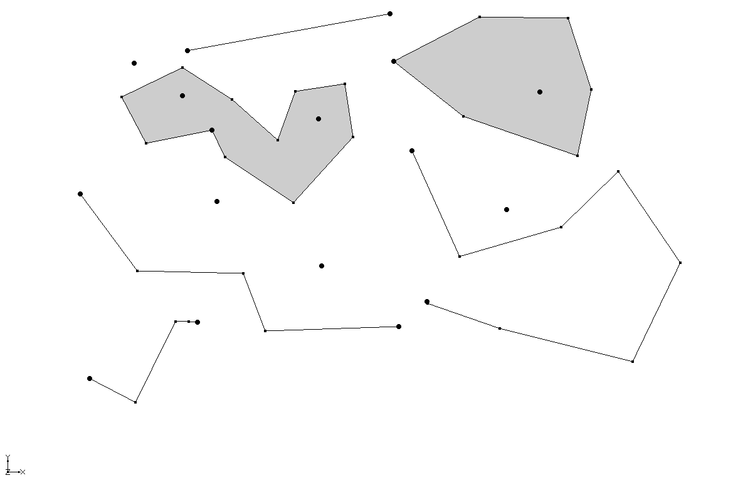

Figure 4 Points, nodes, vertices, arcs, and polygons

## Selecting Feature Objects

There are three different tools for creating feature objects and seven different tools for selecting feature objects (Figure 5). The different selection tools select different types of objects. The default location for the feature object dynamic tools toolbar is vertically between the Project Explorer and the Graphics Window. It is shown horizontally here for convenience.

GMS 10_4 - FeatureObjects - Selection and creation tools

Figure 5 Seven selection tools (left) and three creation tools (right)

1. Hold the mouse cursor over a tool for a couple of seconds until the tool name appears as shown in Figure 6.

This can be used to identify the correct tool.

GMS - Tool Tip

Figure 6 Context sensitive help for tools

The **Select** File:Select Object Tool.svg tool can be used to select any feature object. Each type of feature object also has a specific tool that will select only that type of feature object. The specific tools can be used when necessary, such as when different types of objects are close to each other.

1. Use the**Select** File:Select Object Tool.svg tool to select different types of feature objects.
2. Try out the other selection tools to select different types of feature objects.

## Modifying Feature Objects

There are several ways that feature objects can be modified using GMS. Some feature objects, like points and vertices, can be moved to other locations by dragging them with the mouse. Other objects, like arcs and polygons, cannot be dragged, but it is possible to move arcs and polygons by moving the nodes and vertices that are on them.

To drag points and nodes, do the following:

1. Use the**Select Points\Nodes** File:GMS Select Node Tool.svg tool to select one of the isolated points created earlier.
2. While holding down the left mouse button, drag the point to a different location.
3. Use the same **Select Points\Nodes** File:GMS Select Node Tool.svg tool to drag a node on the arc created earlier.

The vertices may not be visible. To make them visible, do the following:

1. Click the **Display Options** File:Display Options Macro.svg macro to bring up the *Display Options* dialog.
2. Select “Map Data” from the list on the left.
3. On the *Map* tab, turn on *Vertices*.
4. Click the **OK** button to close the *Display Options* dialog.

Vertices should now be visible in various locations along each arc.

1. Using the **Select Vertices** File:GMS Select Vertex Tool.svg tool, select and drag a vertex on one of the arcs created earlier.

Arcs can be modified by adding more vertices.

1. Switch to the **Create Vertex** File:GMS Create Vertex.svg tool.
2. Click on one of the arcs to add one or more vertices to it.

By adding vertices and dragging them where they are needed, it is possible to refine how the arc looks. It is also possible to right-click on an arc and redistribute the vertices. This is a faster way to create many vertices and space them evenly along the arc.

1. Using the **Select Arcs** https://www.xmswiki.com/images/thumb/8/80/GMS_Select_Arc_Tool.svg/60px-GMS_Select_Arc_Tool.svg.png tool, select any arc.
2. Right-click on the selected arc and choose the **Redistribute Vertices…** context menu item to bring up the *Redistribute Vertices* dialog.
3. From the *Specify* drop-down, select “Specified spacing”.
4. For *Average spacing,* enter “10.0”.
5. Click the **OK** button to close the *Redistribute Vertices* dialog.

The arc should now have a number of vertices evenly spaced along its length.

## Grid Frames

Grid frames are used to build 2D and 3D grids. A grid frame defines the rectangular extent of the grid. Grid frames can be rotated and moved to better fit the desired modeling area.

1. From the menu bar, select *Feature Objects |* **New Grid Frame** to create a purple grid frame rectangle on the screen.
2. Using the **Select Grid Frame** File:Select Grid Frame Tool.svg tool, click on one of the borders of the grid frame to select it.
3. Click and drag on the interior of the grid frame to move it to a new location.



Figure 7 Grid frame with handles

Notice the handles in the corners and the middle of the edges of the grid frame. In the bottom right corner, notice the circular handle used for rotation.

1. Click on the handles of the grid frame to resize it and on the circular handle to rotate it.

The properties of the grid frame can also be entered manually.

1. Double-click on the grid frame in the Project Explorer to open the *Grid Frame Properties* dialog.
2. For the *Dimension x* attribute enter “100”, and for *Dimension y* enter “50”.
3. Click the **OK** button to close the *Grid Frame Properties* dialog.

The grid frame has now been resized to be 100 by 50.

# Conclusion

This concludes the “Feature Objects” tutorial. Topics covered in this tutorial include:

* Creating coverages
* Creating conceptual models
* Creating feature objects
* Selecting and modifying feature objects
* Creating grid frames.