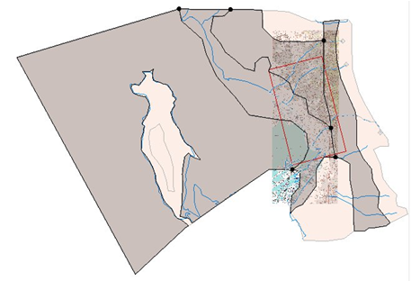

GMS 10.9

GMS 10.9 Tutorial

***GIS Module***

Importing, displaying, and converting shapefiles.

Objectives

Learn how to import and display shapefiles in GMS. Learn how to convert the shapefiles to GMS feature objects.

Time

* 15–20 minutes

Required Components

* GMS Core

Prerequisite Tutorials

* Getting Started

|  |
| --- |
| 1 Introduction and Getting Started 2  2 Importing the Shapefile 2  3 Viewing the Shapefile 3  4 Viewing the Attribute Table 4  5 Converting a Shapefile to 2D Scatter Points 4  6 Converting a Shapefile to Feature Objects 5  6.1 Creating the Conceptual Model 5  6.2 Mapping the GIS Data 6  7 Conclusion 6 |

# Introduction and Getting Started

This tutorial introduces the GIS module and shows some of the available features. The GIS module can be used to display data from a GIS database directly in GMS without having to convert that data to GMS data types. Native GMS data such as grids and boreholes can be displayed along with the GIS data.

The GIS module can also be used to select a portion of the GIS data and convert it to GMS data types to be used in constructing a groundwater model. Currently, the GIS module can only be used for steady state data. For a full list of the features available in the different modules, refer to [GMS Help](https://www.xmswiki.com/wiki/GMS:GMS).

In this tutorial, the following topics are discussed:

* Opening a shapefile
* Viewing the attribute table
* Converting the shapefile to scatter points
* Converting the shapefile into feature objects

To get started, do the following:

Launch GMS.

If GMS is already running, select *File* | **New…** to ensure that the program settings are restored to their default state.

After starting GMS, this tutorial will begin with importing a point shapefile containing well data. This makes it possible to create scatter points from the shapefile points. Next, a GMS MODFLOW conceptual model will be created in the Map module, and a coverage with well attributes will be created. The shapefile will then be converted to GMS wells useful in building a model. This will illustrate how GIS data can be imported and converted to GMS data.

# Importing the Shapefile

Import the shapefile by doing the following:

1. Click **Open** File:Open Macro.svg to bring up the *Open* dialog.
2. Select “Shapefiles (*.shp)” from the *Files of type* drop-down.

Browse to the *gis\gis* directory and select “arcmap.shp”.

Click **Open** to import the shapefile and close the *Open* dialog.

# Viewing the Shapefile

A number of points representing wells are now visible in the Main Graphics Window (Figure 1). These are contained in the “File:GIS Scatter Point Shapefile.svg arcmap.shp” shapefile listed in the File:GIS Folder.svg GIS Layers folder in the Project Explorer. GMS provides a limited set of options for displaying the shapefile.

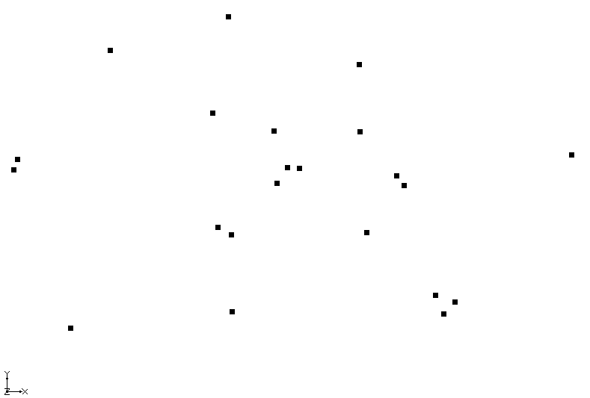

Figure 1 Well points imported from the arcmap shapefile

1. Select the File:GIS Folder.svg GIS Layers folder in the Project Explorer*.*

Click the **Display Options** File:Display Options Macro.svg macro to bring up the *Display Options* dialog.

Select “GIS Data” from the list on the left.

On the *GIS* tab, click the wide button to the right of *Points* to bring up the *Point Properties* dialog.

Enter “10” in the *Radius* field.

From the down-arrow menu for *Color*, select “Red”.

Click **OK** to close the *Point Properties* dialog.

Click **OK** to close the *Display Options* dialog.

Notice that the size and color of the points have changed (Figure 2).

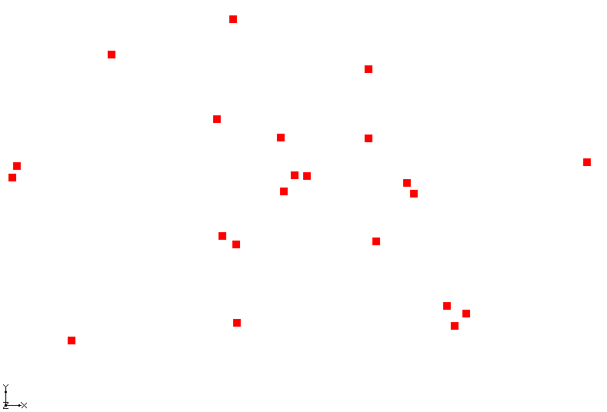

Figure 2 Well points now colored red

# Viewing the Attribute Table

The shapefile has a number of attributes associated with each point. To view these attributes, do the following:

1. In the Project Explorer, right-click on “File:GIS Scatter Point Shapefile.svg arcmap.shp” and select **Attribute Table…** to bring up the *Attributes* dialog.
2. Resize the *Attributes* dialog by dragging the bottom right corner out so that more of the data is visible.

A number of attributes (columns) are associated with each point. Notice the data is not editable here.

Click **OK** to close the *Attributes* dialog.

# Converting a Shapefile to 2D Scatter Points

The GIS data can be converted to 2D scatter points which can be used to perform interpolations.

1. In the Project Explorer, right-click on “File:GIS Scatter Point Shapefile.svg arcmap.shp” and select *Convert To* **| 2D Scatter Points**. This converts the shapefile points to 2D scatter points which appear on top of the shapefile points (Figure 3).

If necessary, expand the “File:2D Scatter Folder.svg 2D Scatter Data” folder and the “File:2D Scatter Icon.svg arcmap.shp” scatter set.

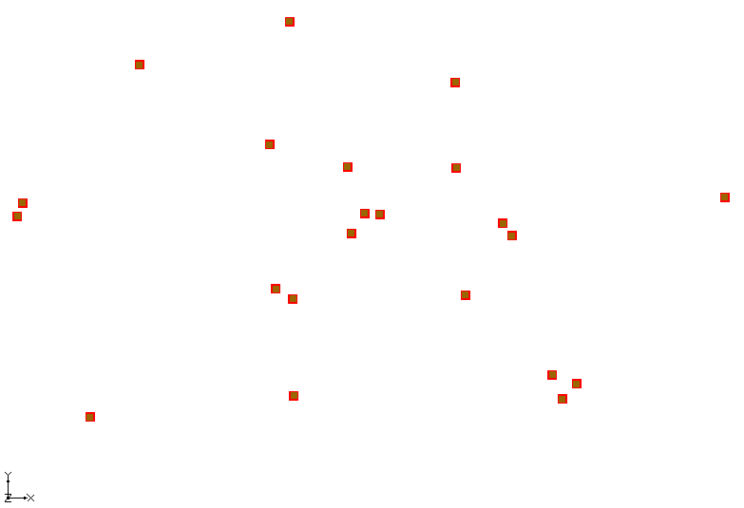

Figure 3 Well points converted to scatter points

Notice that GMS automatically created a dataset from each numeric attribute in the attribute table. This procedure can be used to create scatter points, and then interpolate from the scatter points to a grid. Using water level information for each point, for example, a starting head dataset could be created for the model.

This tutorial won’t do anything more with the scatter points, so it’s time to delete them.

In the Project Explorer, right-click on “File:2D Scatter Folder.svg 2D Scatter Data” and select **Delete**.

# Converting a Shapefile to Feature Objects

Now it is possible to convert the GIS data to GMS feature objects that could be used in building a conceptual model. The first step is to create a default conceptual model and coverage with the appropriate attributes.

## Creating the Conceptual Model

1. Right-click on an empty space in the Project Explorer and select *New |* **Conceptual Model…** to bring up the *Conceptual Model Properties* dialog.

Enter “Model1” in the *Name* field.

Select “MODFLOW” from the *Type* drop-down.

Click **OK** to close the *Conceptual Model Properties* dialog.

In the Project Explorer, right-click on “File:Conceptual Model Icon.svg Model1” under File:Map Folder.svg Map Data and select **New Coverage…** to bring up the *Coverage Setup* dialog.

Enter “coverage1” in the *Coverage name* field.

Turn on *Wells* in the list of *Sources/Sinks/BCs*.

Click **OK** to close the *Coverage Setup* dialog.

## Mapping the GIS Data

1. Select the File:GIS Folder.svg GIS Layers folder in the Project Explorer to make it active.
2. Make certain no points are selected in the Graphics Window. If any points are selected, only those points will be converted to feature objects.

Select the *GIS |* **Shapes → Feature Objects** command.

The first page of the *GIS to Feature Object Wizard* allows for selecting which shapefile in the GIS module to use and selecting which coverage will receive the shapefile data. Since there is only one coverage and one shapefile in the project, no changes need to be made.

Click **Next** to bring up the *GIS to Feature Objects Wizard – Step 2 of 3* page of the dialog.

In the *WELLNAME* column, select “Name” from the *Mapping* drop-down.

In the *PUMPRATE* column, select “Flow rate” from the *Mapping* drop-down.

Click **Next** to bring up the *GIS to Feature Objects Wizard – Step 3 of 3 (Finished)* page of the dialog.

Click **Finish** to close the *GIS to Feature Objects Wizard – Step 3 of 3 (Finished)* dialog.

This creates feature points in the same location as the GIS shapefile points. Depending on the settings, they may or may not be visible.

Uncheck “File:GIS Scatter Point Shapefile.svg arcmap.shp” in the Project Explorer. This hides the shapefile points in the Graphics Window.

In the Project Explorer, right-click on “File:Coverage Active Icon.svg coverage1” and select **Attribute Table…** to bring up the *Attribute Table* dialog.

This dialog shows the properties of all the feature points in the coverage. Notice that the names and flow rates were transferred from the GIS attributes, just as specified. However, the type for all points is “NONE.” It is necessary to make them into wells.

Select “well” from the drop-down in the *Type* column of the *All* row. Since this is the *All* row, all of the points are changed to wells.

Click **OK** to close the *Attribute Table* dialog. All of the feature points are now wells.

At this point, the well points could be used to construct a MODFLOW conceptual model. This topic is discussed more thoroughly in the tutorial entitled “MODFLOW – Conceptual Model Approach 2” and will not be discussed further here.

# Conclusion

This concludes the “GIS Module” tutorial. The following topics were covered:

* Importing shapefiles into GMS
* Viewing shapefile attributes
* Converting shapefile data to GMS scatter points or feature objects

If desired, additional shapefiles have been included in this tutorial for additional exploration of the GIS features in GMS.