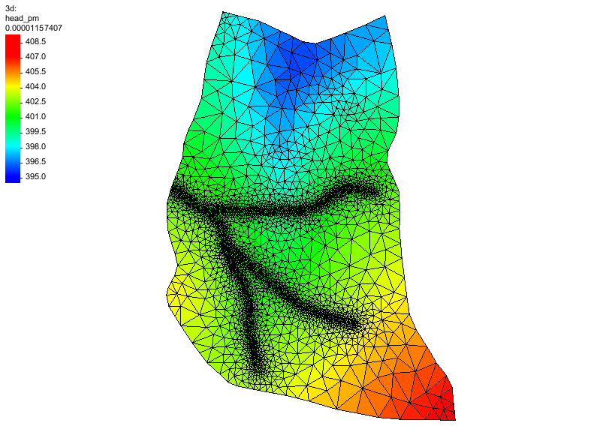

GMS 10.9

GMS 10.9 Tutorial

***HydroGeoShere – Post-Processing***

Review a HydroGeoSphere model in GMS

Objectives

This tutorial demonstrates post-processing options for a HydroGeoSphere model in GMS.

Time

* 15–25 minutes

Required Components

* GMS Core
* HydroGeoSphere Model & Interface

Prerequisite Tutorials

* Getting Started
* HydroGeoSphere – Porous Media Domain

|  |
| --- |
| 1 Introduction 2  2 Basic Workflow 3  3 Getting Started 4  4 Model Output 5  4.1 Observations 5  4.2 Hydrographs 5  5 Save the Project and Simulation 6  6 Run Grok 7  7 Run Phgs 7  8 Examine the Solution 7  8.1 Read the Solution 7  8.2 3D Datasets 7  8.3 3D Datasets Vectors 8  8.4 2D Datasets 9  8.5 Solution Plots 10  9 Conclusion 11 |

# Introduction

This tutorial demonstrates post-processing options for a HydroGeoSphere (HGS) model in GMS. It is based off the *Intro to HydroGeoSphere[1]* tutorial from Aquanty. Refer to that tutorial and the *HydroGeoSphere Reference Manual* as needed.

In the *Intro to HydroGeoSphere* tutorial, the “R5 Catchment” model is developed. From that tutorial:

The model is quite simple compared to many ‘real world’ models that you may build. But it contains sufficient complexity that it is perfectly suited to demonstrate the overall HydroGeoSphere workflow. The intention of this tutorial is not to perfectly recreate the catchment, but to teach the process of creating a small watershed model in HGS. In fact, several of the inputs for the R5 model are completely arbitrary (e.g. the delineation of soil types and associated hydraulic properties, boundary condition values, etc.).

The R5 catchment covers a small (approximately 0.1 km2) rangeland catchment near Oklahoma City (Figure 3). The defined model includes basic flow in the porous medium and surface/overland flow domains, and includes evapotranspiration.[2]

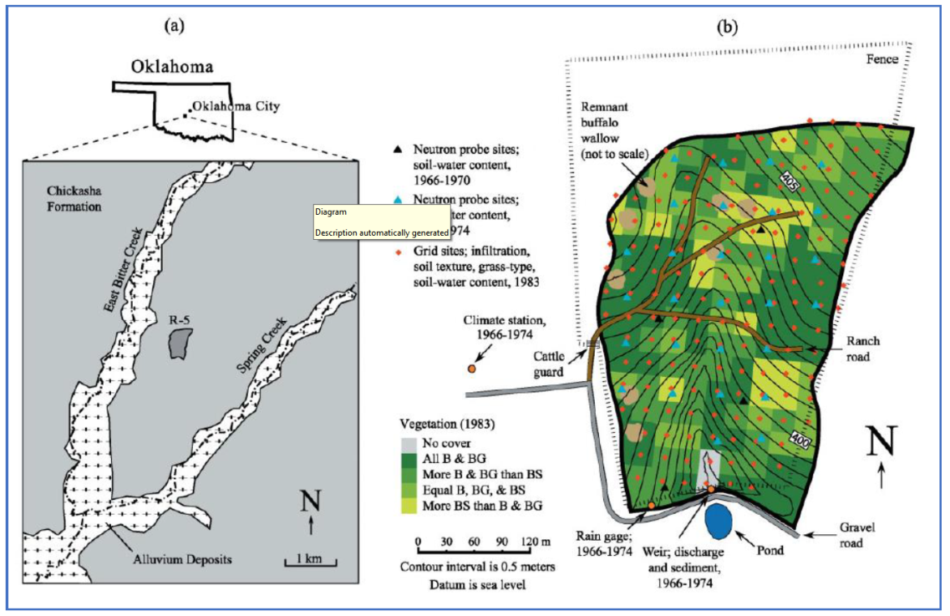

Figure HydroGeoSphere Intro Tutorial, figure 3, pg. 14

# Basic Workflow

From the *Intro to HydroGeoSphere* tutorial, the basic HGS workflow consists of 5 steps:

1. Prepare data inputs (e.g. various GIS files, 2D grid/mesh files, etc.).
2. Configure an input data file (the GROK file) for the model pre-processor….
3. Use executables (*.exe) to generate the model input files and solve the simulation….
   1. Grok.exe – compiles the GROK file, generates input files for the numerical simulator
   2. Phgs.exe – reads model input files, performs the numerical simulation (i.e. it ‘solves’ the model)
   3. Hsplot.exe OR hgs2vtu.exe – reformats model outputs for visualization
4. Visualize, analyze and interpret model results….
5. Iterate on the model to add complexity, perform scenario analysis, calibrate, etc….[3]

Note that a GROK file is prepared and then the grok.exe runs. During the run, grok.exe reads the GROK file and prepares the actual model input files. Only then can the model (phgs.exe) be run.

The HydroGeoSphere workflow is followed pretty closely when using GMS. The basic steps to build an HGS model in GMS, and how these steps relate to the HydroGeoSphere workflow, are as follows:

1. Create the conceptual model (HGS step 1).
2. Create a 3D UGrid for the porous media domain (HGS step 1).
3. Create a 2D UGrid for the 2D domains: surface flow, ET (HGS step 1).
4. Save the simulation to create the GROK file (HGS step 2).
5. Run grok.exe on the GROK file to prepare input files for phgs.exe (HGS step 3a).
6. Run phgs.exe (HGS step 3b).
7. Read the solution and visualize the results (HGS step 4).
8. Iterate on the model to add complexity, perform scenario analysis, calibrate, etc… (HGS step 5, not covered in this tutorial).

# Getting Started

Do as follows to get started:

1. If necessary, launch GMS.
2. If GMS is already running, select *File |* **New** command to ensure that the program settings are restored to their default state.
3. Click **Open** File:Open Macro.svg to bring up the *Open* dialog.
4. Select “Project Files (*.gpr)” from the *Files of type* drop-down.
5. Browse to the *\hgs-post\hgs-post* folder and select “start.gpr”.
6. Click **Open** to import the project and exit the *Open* dialog.

The project should be visible in the Graphics Window (Figure 2). The project contains a HydroGeoSphere simulation that has already been set up to include a 3D UGrid. Boundary conditions, materials, and the model control parameters have been set.

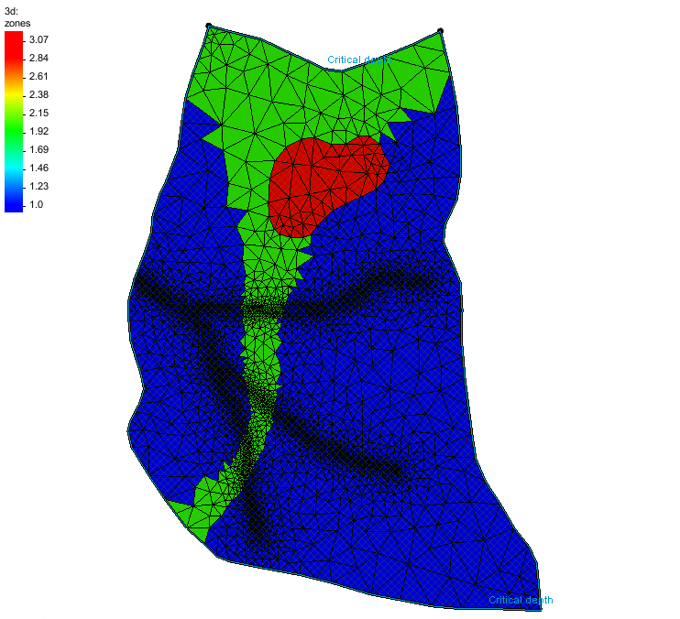

Figure The initial project

Before continuing, it is recommended to save the project with a new name.

1. Select *File |* **Save As…** to bring up the *Save As* dialog.

Browse to the directory for this tutorial*.*

Select “Project Files (*.gpr)” from the *Save as type* drop-down.

Enter “hgs_post.gpr” as the *File name*.

Click **Save** to save the project and close the *Save As* dialog.

# Model Output

GMS allows recording both observation and hydrograph data from the HydroGeoSphere model run. Doing this requires creating map coverages that can then be added to the simulation.

## Observations

Create an observation coverage by doing the following:

1. Turn off the “File:Ugrid lock 3D.png 3d” UGrid.
2. Right-click in the Project Explorer and select *New*| **Coverage…** to generate a new coverage.
3. Right-click on “File:Coverage Active Icon.svg new coverage” and select **Rename**.
4. Enter “observations” for the new name.
5. Right-click on the “File:Coverage Active Icon.svg observations” coverage and select *Coverage Type* | *HydroGeoSphere* | **Observations**.
6. Using the **Create Point** File:Create Points Tool.svg tool, create a point anywhere in the model area.
7. Keeping the new point selected, enter following coordinates:

* *X* = 360.0
* *Y* = 295.0
* *Z* = 398.0

1. Using the **Select Points\Nodes** File:GMS Select Node Tool.svg tool, double-click the point to open the *Point Properties* dialog.
2. In the list on the left, turn on *Observation point*.
3. For the *Name* enter “point1”.

The *Interpolate* option causes computed values from nearby points to be interpolated to the observation point (corresponding to the “Make interpolated observation point” command). If off, computed values from the nearest point are used (corresponding to the “Make observation point” command). For this example, leave it off.

1. Click **OK** to close the *Point Properties* dialog.
2. Right-click on the “File:Coverage Active Icon.svg observations” coverage and select *Apply to* | **HydroGeoSphere Simulations → R5**.

## Hydrographs

Create a hydrograph coverage by doing the following:

1. Right-click on the “File:Coverage Active Icon.svg surface flow BCs” coverage and select **Duplicate**.
2. Right-click on “File:Coverage Active Icon.svg Copy of surface flow BCs” and select **Rename**.
3. Enter “hydrographs” for the new name.
4. Right-click on the “File:Coverage Active Icon.svg hydrographs” coverage and select *Coverage Type* | *HydroGeoSphere* | **Hydrographs.**
5. Using the **Select Arc** File:GMS Select Arc Tool.svg tool, double-click the top arc to open the *Arc Properties* dialog.
6. In the list on the left, turn on *Hydrograph*.
7. Set the *Name* to “Outlet”.
8. Turn on the *Map to grid boundary* option.
9. Click **OK** to close the *Arc Properties* dialog.
10. Right-click on the “File:Coverage Active Icon.svg hydrographs” coverage and select *Apply to* | **HydroGeoSphere Simulations → R5**.

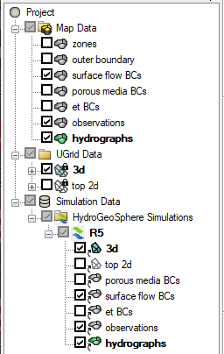

Figure The HydroGeoSphere simulation in the Project Explorer

# Save the Project and Simulation

Before continuing, complete the following:

1. **Save** File:Save Macro.svg the project.
2. Right-click on the “ R5” simulation and select **Save Simulation** to open the *Saving HydroGeoSphere Simulation* dialog.
3. When finished, click **OK** to close the *Saving HydrogGeoSphere Simulation* dialog.

Saving the simulation creates the GROK file and the other files that it refers to. To view these files:

1. Right-click on the “ R5” simulation and select **Open Containing Folder** to open a Windows File Explorer.

The opened file explorer shows the directory where GMS saved the model files.

1. In a separate Windows File Explorer dialog, browse to the *\hgs-post\hgs-post* folder.
2. Drag the file “R5o.hgs_output_files.txt” file from the “hgs-post” folder and drop it in the “R5” folder.
3. Close both Windows File Explorer dialogs and return to GMS.

# Run Grok

1. Right-click the “ R5” simulation and select the **Run grok** command to open a run dialog.

The “Running grok.exe” dialog appears. The output from grok.exe is displayed. It should only take a few seconds for grok.exe to finish. When it is done, there may be some warnings at the bottom of the output, but there should not be any errors.

1. When the process finishes, click **OK**.

# Run Phgs

Now that the input files have been prepared by running grok.exe, the model is ready to be run.

1. Right-click the “ R5” simulation and select the **Run phgs** command.

The “Run phgs.exe” dialog appears. The progress dialog shows a plot of the residual error versus time, and the output from phgs.exe. It will take a few minutes for phgs.exe to finish.

1. When the process finishes, click **OK**.

# Examine the Solution

## Read the Solution

1. Right-click the “ R5” simulation and select **Read Solution** to start the *Read Solution* progress dialog.

When GMS is done reading the solution, the *Read Solution* progress dialog should disappear automatically if there are no errors.

A new Solution folder was added under the R5 simulation, with subfolders “pm” and “olf”. These contain links to datasets that were added under “R5 (HydroGeoSphere)” folders under the “3d” and “top 2d” UGrids. Let’s look at some of the datasets.

## 3D Datasets

1. Turn off all “File:Map Folder.svg Map Data”.
2. Turn on the “File:Ugrid lock 3D.png 3d” UGrid.
3. Under the “File:Ugrid lock 3D.png 3d” UGrid, expand the “File:Generic Folder.svg R5 (HydroGeoSphere)” and “File:Generic Folder.svg pm” folders, select the “File:Dataset Cells Active.svg head_pm” dataset.
4. In the *Time Step* window below the Project Explorer, select the **Options** button to open the *Time Settings* dialog.
5. Change the *Relative* option to “seconds”.
6. Click **OK** to close the *Time Settings* dialog.
7. Select different time steps and see that the contours change a little with time.

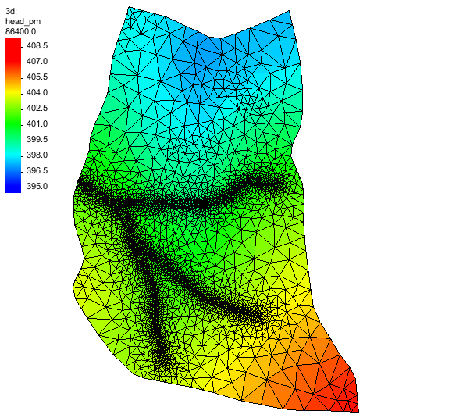

Figure 3D “head_pm” dataset

## 3D Datasets Vectors

1. Under the “File:Generic Folder.svg pm” folder, select the “File:Vector Dataset Active.svg q_pm” dataset.
2. Click the **Display Options** File:Display Options Macro.svg macro to open the *Display Options* dialog.
3. Turn off *Cell edges* and turn on *Vectors*.
4. Click **OK** to close the *Display Options* dialog.
5. Select different time steps and see that the vectors change a little with time.

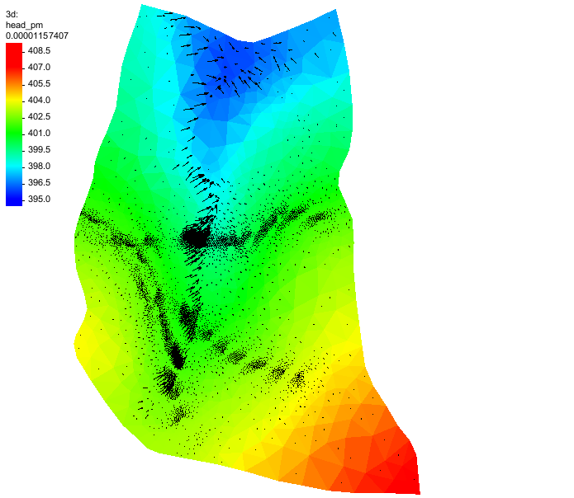

Figure 3D “q_pm” vectors

## 2D Datasets

1. Turn off the “File:Ugrid lock 3D.png 3d” UGrid and turn on and select the “File:Ugrid lock 3D.png top 2d” UGrid.
2. Under the “File:Ugrid lock 3D.png top 2d” UGrid, expand the “File:Generic Folder.svg R5 (HydroGeoSphere)” and “File:Generic Folder.svg olf” and “File:Generic Folder.svg BCs” folders and select the “C:\Users\mkennard\Documents\xms icons\dataset-points.png CritDepth_outlet-Flux (nodal)” dataset.

All the datasets in the “File:Generic Folder.svg BCs” folder were created by boundary conditions. The “C:\Users\mkennard\Documents\xms icons\dataset-points.png CritDepth_outlet-Flux (nodal)” dataset was created by the critical depth boundary condition on the top arc. The dataset has meaningful values at the points where the boundary condition arc is defined and null values at all other points.

1. Click the **Display Options** File:Display Options Macro.svg macro to open the *Display Options* dialog.
2. Turn off *Face contours* and *Vectors* then turn on *Cell edges* and *Point contours*.
3. Click **OK** to close the *Display Options* dialog.
4. Select the last time step and see that the point contours change.

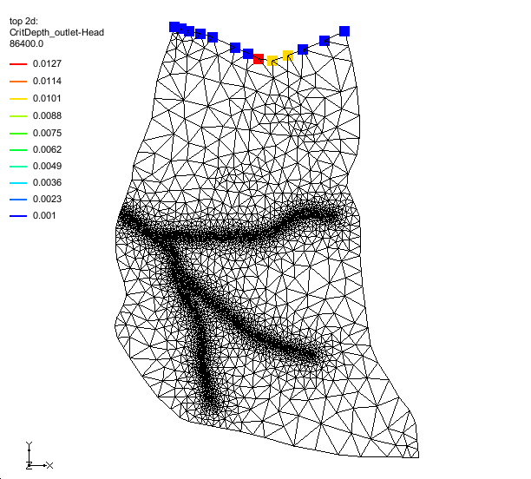

Figure 2D “CritDepth_outlet-Flux (nodal)” dataset

## Solution Plots

In addition to datasets on the UGrids, GMS also read in a number of plots when the solution was read.

1. Right-click the “ R5” simulation and select the **Solution Plots** command to open the *Solution Plots* dialog.

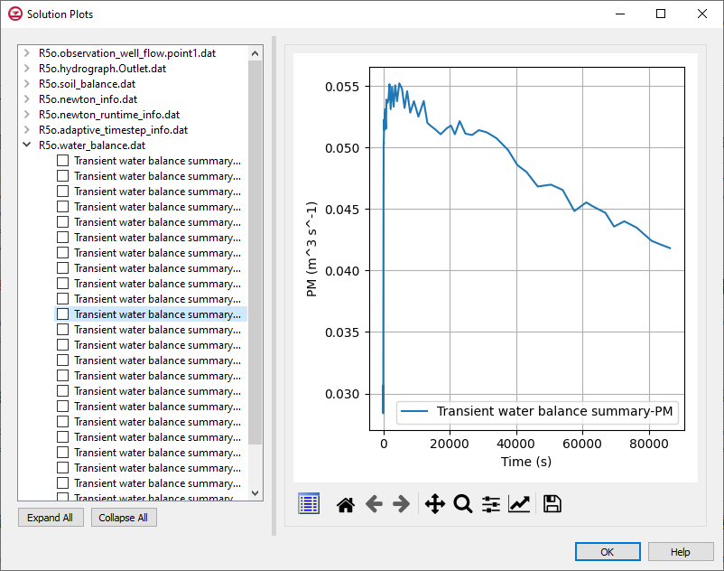

Figure HydroGeoSphere solution plots

The window on the left of the dialog lists the plots that can be displayed. They are grouped by the file that they came from. The currently selected item is displayed in the plot window on the right. Multiple plots can be displayed simultaneously by toggling them on this list. Notice there are plots for the boundary conditions (“Transient water balance summary-Well”, etc.), the observation point (under “R5o.observation_well_flow.point1.dat”) and the hydrograph (under “R5o.hydrograph.Outlet.dat”). The water balance file plots are displayed by default.

1. Expand other files and click on different plots to see the plot data generated by HydroGeoSphere.
2. Click on the **View Data** File:Scalar Dataset Active.svg button to open the *Plot Data* dialog to see the plot data values.

# Conclusion

This concludes the “HydroGeoSphere Post-Processing” tutorial.

1. Aquanty Guide for New Users, Intro to HydroGeoSphere Tutorial download at <https://www.aquanty.com/s/HGS_Intro_Tutorial.zip>
2. HydroGeoSphere Intro Tutorial, pg. 13
3. HydroGeoSphere Intro Tutorial, pg. 13