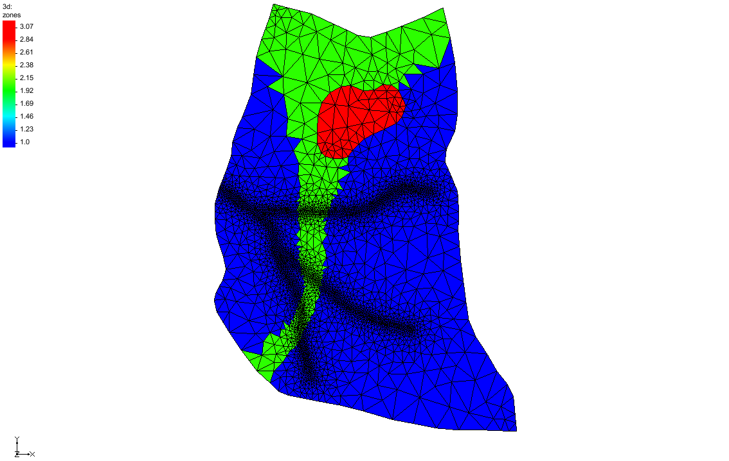

GMS 10.9

GMS 10.9 Tutorial

***HydroGeoSphere – Porous Media Domain***

Build a HydroGeoSphere model in GMS

Objectives

This tutorial demonstrates how to set up a HydroGeoSphere model with a porous media domain in GMS.

Time

* 25–45 minutes

Required Components

* GMS Core
* HydroGeoSphere Model & Interface

Prerequisite Tutorials

* Getting Started

|  |
| --- |
| 1 Introduction 2  2 Basic Workflow 3  3 Getting Started 4  3.1 Domains 5  4 Create a HydroGeoSphere Simulation 5  5 Simulation Control 6  5.1 Time Stepping 6  5.2 Output 7  5.3 Initial Conditions 7  6 Zones 7  6.1 Use a Polygon to Create Zone 3 9  6.2 Set the Porous Media Zone 11  7 Material Properties 11  7.1 Create the “Medium Sand” material 12  7.2 Create the “Coarse Sand” material 12  7.3 Create the “Clay” material 13  8 Boundary Conditions 13  9 Save the Project and Simulation 14  10 Run Grok 15  11 Run Phgs 15  12 Read the Solution 15  13 Conclusion 16 |

# Introduction

This tutorial demonstrates how to build a HydroGeoSphere (HGS) model in GMS. It is based off the *Intro to HydroGeoSphere[1]* tutorial from Aquanty. Refer to that tutorial and the *HydroGeoSphere Reference Manual* as needed.

In the *Intro to HydroGeoSphere* tutorial, the “R5 Catchment” model is developed. From that tutorial:

The model is quite simple compared to many ‘real world’ models, that you may build. But it contains sufficient complexity that it is perfectly suited to demonstrate the overall HydroGeoSphere workflow. The intention of this tutorial is not to perfectly recreate the catchment, but to teach the process of creating a small watershed model in HGS. In fact, several of the inputs for the R5 model are completely arbitrary (e.g. the delineation of soil types and associated hydraulic properties, boundary condition values, etc.).

The R5 catchment covers a small (approximately 0.1 km2) rangeland catchment near Oklahoma City (Figure 3). The defined model includes basic flow in the porous medium and surface/overland flow domains, and includes evapotranspiration.[2]

The *Intro to HydroGeoSphere* tutorial includes groundwater flow, evapotranspiration, and surface flow, but this tutorial only covers groundwater flow. Evapotranspiration and surface flow are covered in the *HydroGeoSphere – Surface Flow and Evapotranspiration* tutorial.

Note: the HGS executables should be downloaded from Aquanty’s website before running the HGS simulation: <https://www.aquanty.com/hgs-download>.

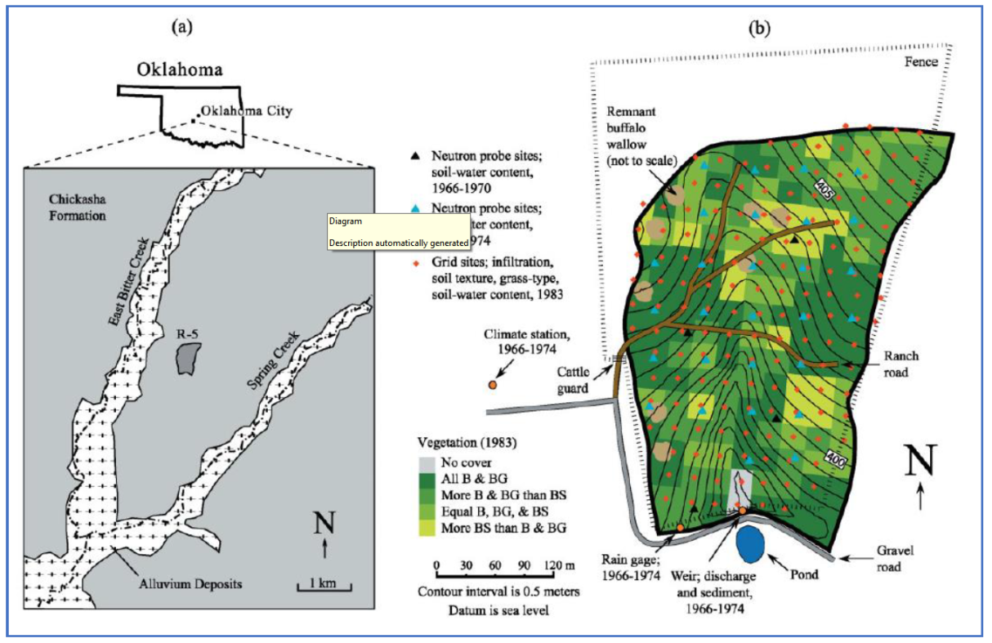

Figure HydroGeoSphere Intro Tutorial, figure 3, pg. 14

# Basic Workflow

From the *Intro to HydroGeoSphere* tutorial, the basic HGS workflow consists of 5 steps:

1. Data inputs are prepared (e.g. various GIS files, 2D grid/mesh files, etc.).
2. Configure an input data file (the GROK file) for the model pre-processor….
3. Use executables (*.exe) to generate the model input files and solve the simulation….
   1. Grok.exe – compiles the GROK file, generates input files for the numerical simulator
   2. Phgs.exe – reads model input files, performs the numerical simulation (i.e. it ‘solves’ the model)
   3. Hsplot.exe OR hgs2vtu.exe – reformats model outputs for visualization
4. Visualize, analyze and interpret model results….
5. Iterate on the model to add complexity, perform scenario analysis, calibrate, etc.…[3]

Note that a GROK file is prepared and then the grok.exe runs. During the run, grok.exe reads the GROK file and prepares the actual model input files. Only then can the model (phgs.exe) be run.

The HydroGeoSphere workflow is followed pretty closely when using GMS. The basic steps to build an HGS model in GMS, and how these steps relate to the HydroGeoSphere workflow, are as follows:

1. Create the conceptual model (HGS step 1).
2. Create a 3D UGrid for the porous media domain (HGS step 1).
3. Create a 2D UGrid for the 2D domains: surface flow, ET (HGS step 1).
4. Save the simulation, which creates the GROK file (HGS step 2).
5. Run grok.exe on the GROK file to prepare input files for phgs.exe (HGS step 3a).
6. Run phgs.exe (HGS step 3b).
7. Read the solution and visualize the results (HGS step 4).
8. Iterate on the model to add complexity, perform scenario analysis, calibrate, etc… (HGS step 5, not covered in this tutorial).

# Getting Started

Do as follows to get started:

1. If necessary, launch GMS.
2. If GMS is already running, select *File |* **New** command to ensure that the program settings are restored to their default state.
3. Click **Open** File:Open Macro.svg to bring up the *Open* dialog.
4. Select “Project Files (*.gpr)” from the *Files of type* drop-down.
5. Browse to the *\hgs-pm\hgs-pm* folder and select “start.gpr”.
6. Click **Open** to import the project and exit the *Open* dialog.

The project should be visible in the Graphics Window (Figure 2). The project contains a 3D UGrid, a couple map coverages, and a raster.

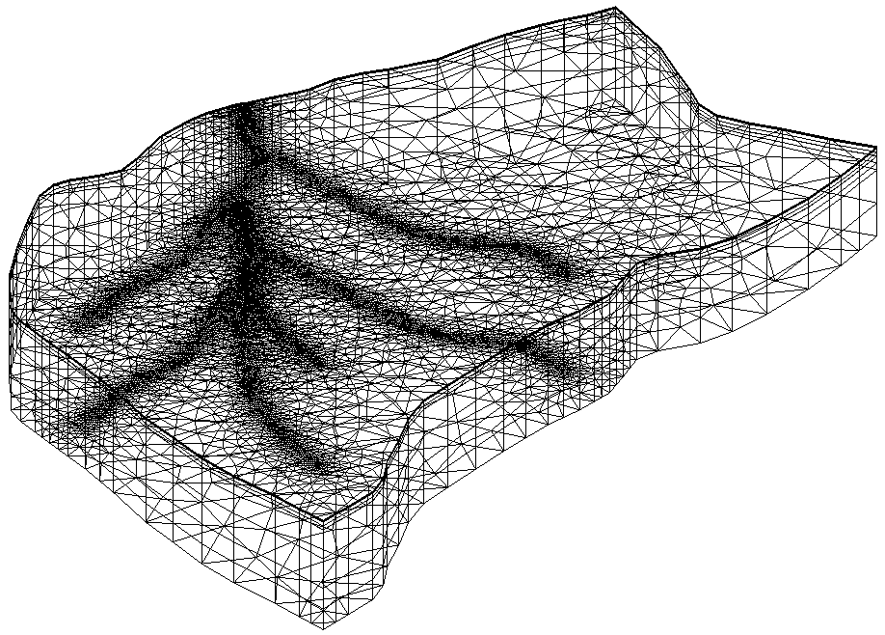

Figure The initial project

Before continuing, it is recommended to save the project with a new name.

1. Select *File |* **Save As…** to bring up the *Save As* dialog.

Browse to the directory for this tutorial*.*

Select “Project Files (*.gpr)” from the *Save as type* drop-down.

Enter “hgs_pm.gpr” as the *File name*.

Click **Save** to save the project and close the *Save As* dialog.

## Domains

HydroGeoSphere uses “domains” to describe the different parts of the hydrosphere. The domains currently supported by GMS are:

* Porous media (“pm”): variably-saturated flow in the subsurface
* Surface flow (or overland flow “olf”): fluid flow on the surface
* ET (“et”): evapotranspiration

Only the porous media domain is used in this tutorial.

# Create a HydroGeoSphere Simulation

Now to create the HGS simulation in GMS, do the following:

1. In the Project Explorer, right-click and select *New Simulation* | **HydroGeoSphere**.
2. Right-click on “ Sim” and select **Rename**.
3. Enter “R5” for the new name.

The UGrid needs to be added to the simulation. To do that, drag and drop it below the simulation.

1. Drag the “File:Ugrid lock 3D.png 3d” UGrid below the “ R5” simulation.

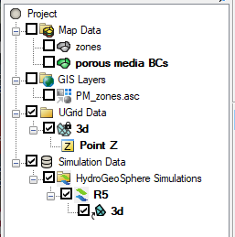

Figure HydroGeoSphere simulation in the Project Explorer

# Simulation Control

With the simulation created, simulation parameters can now be assigned.

1. Right-click the “ R5” simulation and select **Simulation Control…** to open the *Simulation Control* dialog.

Many HydroGeoSphere inputs are set in the *Simulation Control* dialog. Besides parameters that are traditionally associated with HydroGeoSphere simulation control, this dialog also includes time stepping, output, zones, and initial conditions.

1. Select the *General* tab and enter the following:
   1. For the *Description*, enter “R5 model from ‘Intro to HGS’ tutorial”.
   2. Turn on the following options:
      1. *Transient flow*
      2. *Unsaturated*
      3. *Finite difference mode*
2. Select the *Units* tab.
   1. Ensure the *Units* option is set to “kilogram-metre-second”.
3. Select the *Saturated flow* tab.
   1. Turn on *Flow solver maximum iterations* and enter “1000”.
4. Select the *Variably saturated flow* tab.
   1. Make certain the *No nodal flow check* option is on.

## Time Stepping

1. Select the *Time stepping* tab.
2. In the *General timestep settings* section, turn on the following options and set them to the correct value:
   1. *Initial timestep*: “0.5”
   2. *Maximum timestep*: “4000”
   3. *Minimum timestep multiplier*: “0.5”
   4. *Maximum timestep multiplier*: “1.2”
   5. *Jacobian epsilon*: “1e-6”
   6. *Newton maximum iterations*: “12”
   7. *Newton absolute convergence criteria*: “5e-3”
   8. *Newton residual convergence criteria*: “1e-3”
3. In the *Adaptive timestep settings* section, turn on the following options and set them to correct value:
   1. *Head control*: “10”
   2. *Saturation control*: “0.5”
   3. *Newton iteration control*: “8”

## Output

1. Select the *Output* tab.
2. Click the **Add Row** File:GMS MODFLOW 6 - Add Row button.png button to add a row in the table.
3. Enter or copy/paste the following times (in seconds) into the *Output Times* table:

|  |
| --- |
| 1 |
| 60 |
| 600 |
| 3600 |
| 7200 |
| 14400 |
| 28800 |
| 57600 |
| 86400 |

## Initial Conditions

1. Select the *Initial conditions* tab.
2. In the *Head* section, select *Initial head depth to water table* and enter “1.0”.
3. Click the **OK** button to close the *Simulation Control* dialog.

# Zones

HydroGeoSphere uses the idea of “zones” to divide the model domain into different areas. Properties such as hydraulic conductivity are associated with one or more zones and thus can vary spatially. Each model domain (e.g. porous media, surface/overland flow, evapotranspiration) must have its own zonation associated with it.

In GMS, zones are defined using cell-based datasets. These datasets can be created in a variety of ways. Hydraulic conductivity and other properties are defined on “materials”, and materials are assigned to one or more zones.

This tutorial will demonstrate zone datasets for the porous media domain.

The porous media domain will have three zones. Most cells will be in zone 1 and will be assigned to the “Medium Sand” material. Zone 2 consists of a narrow band of cells in the middle, which widens at the top. These cells will be assigned to the “Coarse Sand” material. Zone 3 will be some cells in the middle of layer five and assigned to the “Clay” material. A dataset with values of 1, 2, and 3—where 1 indicates zone 1, 2 indicates zone 2, etc.—will be created in this section.

Use a raster to create zones 1 and 2:

1. Switch to **Plan View** File:Plan View Macro.svg.
2. In the Project Explorer, turn on the “File:GIS Raster Icon.svg PM_zones.asc” raster.

The raster should appear similar to Figure 4. The raster consists of only two values: blue is 1 and red is 2.

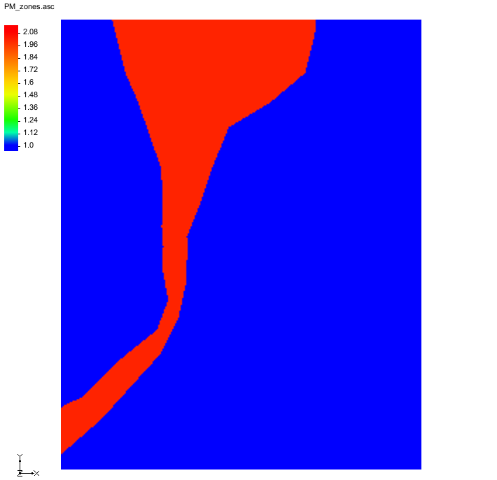

Figure Imported raster

To run a tool that will interpolate the raster to the UGrid and create a new dataset:

1. Right-click on the “File:Ugrid lock 3D.png 3d” UGrid and select **Z Values → Cell Dataset**.

A new cell-based dataset named “File:Dataset Cells Active.svg elevation” will appear in the Project Explorer.

1. Right-click the “File:GIS Raster Icon.svg PM_zones.asc” raster and select *Interpolate To* | **UGrid** to open the *Interpolate Priority Rasters* tool dialog.
2. In the *Interpolate Priority Rasters* tool, set the following options:
   1. *Grid*: “UGrid Data/3d”
   2. *Default dataset*: “UGrid Data/3d/elevation”
   3. *Output data set name*: “zones”
   4. *Resample algorithm*: “nearest_neighbor”
   5. *Raster 1 (highest priority)*: “GIS Layers/PM_zones.asc”
   6. Leave *Raster 2* as “-- None Selected --”
3. Click **OK** to run the *Interpolate Priority Rasters* tool.
4. When the tool finishes, click **OK** to close the *Interpolate Priority Rasters* dialog.
5. In the Project Explorer, turn off the “File:GIS Raster Icon.svg PM_zones.asc” raster.

To see how the elevation values were interpolated, turn on UGrid face contours.

1. Select the “File:Ugrid lock 3D.png 3d” UGrid to make it active.
2. Click the **Contour Options** File:Contour Options Macro.svg macro to open the *Dataset* *Contour Options* *– UGrid – elevation* dialog.
3. Change the *Contour method* to “Block Fill”.
4. Click **OK** to close the *Dataset* *Contour Options* *– UGrid – elevation* dialog dialog.
5. Click **Yes** at the message to turn on contours.
6. Select the “File:Dataset Cells Active.svg zones” dataset to make it active.

The contour colors indicate that the zone dataset matches the raster. Moving the mouse around the grid will show the F values at the bottom of the Graphics Window. Note that the blue contours are where the dataset values are 1 and the red is where the values are 2. The interpolation is the same for all layers of the grid. If desired, turn on “Single layer” view and switch layers to see that the zonation is the same in every layer.

## Use a Polygon to Create Zone 3

The example currently has two zones. Using a different method, this tutorial will show how to add a third zone to the HGS simulation.

Start with assigning the cells in a polygon to be zone 3.

1. Right-click on the “File:Ugrid lock 3D.png 3d” UGrid and select **Lock / Unlock Editing**.
2. Select the “File:Dataset Cells Active.svg zones” dataset to make it active.
3. Turn on *Single layer* above the Graphics Window.
4. Change the *Layer* to “5”.
5. Select the “File:Coverage Active Icon.svg zones” coverage to make it active.
6. Click the **Display Options** File:Display Options Macro.svg macro to open the *Display Options* dialog.
7. For the *Objects* row, click the  button to open the *Line Properties* dialog.
8. Change the *Width* to “3.0”.
9. Click **OK** to close the *Line Properties* dialog.
10. Click **OK** to close the *Display Options* dialog.
11. Using the **Select Polygons** File:GMS Select Polygon Tool.svg tool, select the clay lens polygon (Figure 5).

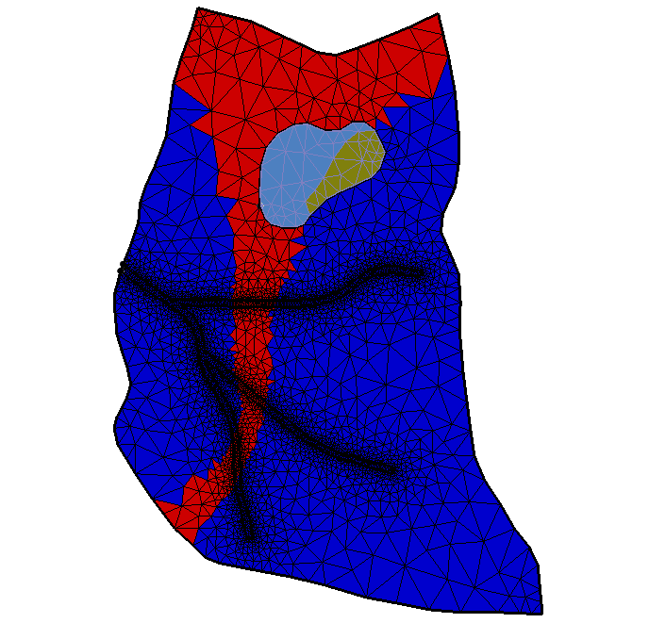

Figure The clay lens polygon selected

1. Right-click on the polygon and select the **Select Intersecting Objects…** command to open the *Select Objects of Type* dialog.
2. Select the *Active UGrid cells* option and click **OK** to close *Select Objects of Type* dialog.
3. Above the Graphics Window, change dataset value *S* to “3.0”.
4. Deselect the polygon.

Now the zones dataset has values of 3 for the all of cells inside the polygon in layer 5 (Figure 6).

1. Turn off *Single layer*.

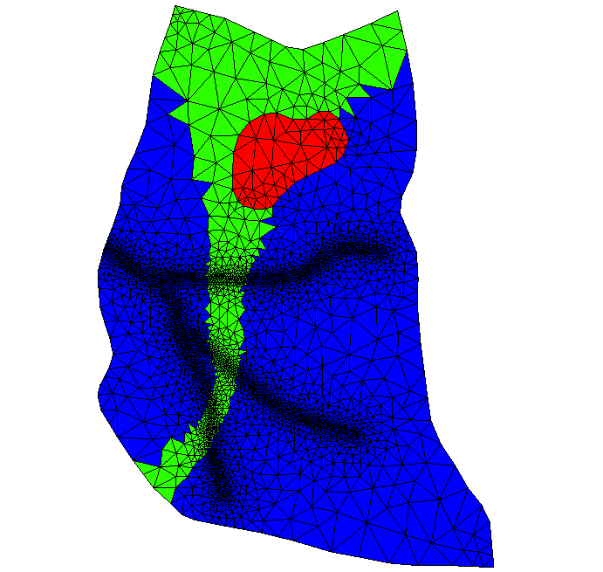

Figure Set zone values on layer 5 of the UGrid

## Set the Porous Media Zone

1. In the Project Explorer, double-click on the “ R5” simulation to open the *Simulation Control* dialog.
2. Select the *Zones* tab.
   1. Turn on the *Read porous media zones from file* option.
   2. Click the **Select Dataset…** button to open the *Select Dataset* dialog.
   3. Select the “File:Dataset Cells Active.svg zones” dataset under the “A blue and black logo

      AI-generated content may be incorrect. 3d” UGrid.
3. Click **OK** to close the *Select Dataset* dialog.
4. Click **OK** to close the *Simulation Control* dialog.

# Material Properties

Properties such as hydraulic conductivity are associated with HydroGeoSphere materials. This idea is similar to traditional GMS materials, but HydroGeoSphere materials are completely separate from the traditional GMS materials. Multiple HydroGeoSphere materials can be defined, and materials are assigned to domains and to one or more zones. Note that if material property values are not assigned, then a default value will be applied. This example will create three materials. In this case, each material will be assigned to one zone, but a material can be assigned to multiple zones.

Start with defining three materials with a porous media domain.

1. Right-click on the “ R5” simulation and select **Materials…** to open the *Materials* dialog.

## Create the “Medium Sand” material

1. Click **Add Row** File:GMS MODFLOW 6 - Add Row button.png to add a material.
2. Change the material name to “Medium Sand”.
3. Leave *Domain* as “Porous media” and *Zones* at “1”.
4. Select the *K isotropic* option and enter “1e-5”.
5. Turn on the *Specific storage* option and enter “1.2e-7”.
6. Turn on *Porosity* and set it to “0.34”.
7. Make sure *Unsaturated tables or functions* is set to “Tables”.
8. Turn on *Saturation-relative k* and click the **Table…** button to open the *XY Series Editor* dialog.
   1. Click the **Import…** button to bring up an *Open* dialog.
      1. Change the filter list to “CSV (Comma delimited) Files (*.csv)”.
      2. Browse to the directory for the tutorial files (*hgs-pm*) and select the “medium-sand-sat-krw.csv’ file.
      3. Click **Open** to close the *Open* file.
   2. Click **OK** to close the *XY Series Editor* dialog.
9. Turn on *Pressure-saturation* and click the **Table…** button to open the *XY Series Editor* dialog.
   1. Click the **Import…** button to bring up an *Open* dialog.
      1. Browse to the directory for the tutorial files and select the “medium-sand-p-sat.csv’ file.
      2. Click **Open** to close the *Open* dialog.
   2. Click **OK** to close the *XY Series Editor* dialog.

## Create the “Coarse Sand” material

1. Click **Add Row** File:GMS MODFLOW 6 - Add Row button.png to add a new material.
2. Change the new material name to “Coarse Sand”.
3. Leave *Domain* at “Porous media” and change *Zones* to “2”.
4. Select the *K isotropic* option and enter“5e-5”*.*
5. Turn on the *Specific storage* option and enter “1.2e-7”.
6. Turn on *Porosity* and set it to “0.34”.
7. Turn on *Saturation-relative k* and click the **Table…** button to open the *XY Series Editor* dialog.
   1. Click **Import…** button to bring up an *Open* dialog.
      1. Browse to the directory for the tutorial files and select the “coarse-sand-sat-krw.csv’ file.
      2. Click **Open** to close the *Open* file.
   2. Click **OK** to close the *XY Series Editor* dialog.
8. Turn on *Pressure-saturation* and click the **Table…** button to open the *XY Series Editor* dialog.
   1. Click **Import…** button to bring up an *Open* dialog.
      1. Browse to the directory for the tutorial files and select the “coarse-sand-p-sat.csv’ file.
      2. Click **Open** to close the *Open* dialog.
   2. Click **OK** to close the *XY Series Editor* dialog.

## Create the “Clay” material

1. Click **Add Row** File:GMS MODFLOW 6 - Add Row button.png to add a new material.
2. Change the new material name to “Clay”.
3. Leave *Domain* at “Porous media” and change *Zones* to “3”.
4. Select the *K isotropic* option and enter “1e-6”*.*
5. Turn on the *Specific storage* option and enter “1.2e-7”.
6. Turn on *Porosity* and set it to “0.51”.
7. Switch *Unsaturated tables or functions* to “Functions”.
8. Ensure “brooks-corey” is selected in the drop-down in the *Unsaturated functions* section.
9. Turn on *Residual saturation* and enter “0.183”.
10. Turn on *Air entry pressure* and enter “-0.016”.
11. Turn on *Exponent* and enter “2.12”.
12. Click **OK** to close the *Materials* dialog.

# Boundary Conditions

Boundary conditions are defined on feature objects in GMS coverages. When the model is saved, GMS intersects the features with the UGrid to find the grid components (nodes, cells, faces, or segments) that should be associated with the boundary conditions and writes the boundary conditions to the GROK file.

The boundary conditions in the porous media domain consist of four wells. The well points are defined in the “File:Coverage Active Icon.svg porous media BCs” coverage.

1. Turn off the “File:Ugrid lock 3D.png 3d” UGrid and the “File:Coverage Active Icon.svg zones” coverage.
2. Turn on the “File:Coverage Active Icon.svg porous media BCs” coverage and select it to make it active.
3. Right-click on the “File:Coverage Active Icon.svg porous media BCs” coverage and select *Coverage Type* | *HydroGeoSphere* | **Boundary Conditions**.

To assign the well boundary conditions:

1. Using the **Select Nodes** File:GMS Select Node Tool.svg tool, drag a box to select all four points representing wells.
2. Right-click and select **Assign Properties…** to open the *Point Properties* dialog.
3. From the list on the left, turn on *Flux nodal*.
4. Change the name to “Well”.

The wells will all be assigned to node sheet 2. A node sheet is the layer of nodes between two cell layers.

1. Set Maximum sheet to “2”.
2. Set *Minimum sheet* to “2”.
3. Change *Input type* to “Time series”.
4. Click the **Edit XY Series…** button to open the *XY Series Editor* dialog.
5. Enter the following:

|  |  |
| --- | --- |
| **Time** | **Flux** |
| 0 | -0.0000277778 |
| 21600 | 0 |
| 43200 | -0.0000277778 |
| 64800 | 0 |

1. Click **OK** to close the *XY Series Editor* dialog.
2. Click **OK** to close the *Point Properties* dialog.

The boundary conditions for the porous media domain are now defined.

# Save the Project and Simulation

Before continuing, complete the following:

1. **Save** File:Save Macro.svg the project.

This saves the GMS project files but not the HydroGeoSphere simulation files. To create the files for the HydroGeoSphere simulation, the simulation needs to be saved.

1. Right-click on the “ R5” simulation and select **Save Simulation** to open the *Saving HydroGeoSphere Simulation* dialog.
2. When finished, click **OK** to close the *Saving HydroGeoSphere simulation* dialog.

Saving the simulation creates the GROK file and the other files that it refers to. The data in the files is based on the parameters set for the simulation in GMS. To view these files:

1. Right-click on the “ R5” simulation and select **Open Containing Folder** to open a Windows File Explorer.

The opened file explorer shows the directory where GMS saved the model files.

1. In a separate Windows File Explorer dialog, browse to the *\hgs-pm\hgs-pm* folder.
2. Drag the file “R5o.hgs_output_files.txt” file from the “hgs-pm” folder and drop it in the “R5” folder.
3. Close both Windows File Explorer dialogs and return to GMS.

# Run Grok

1. Right-click the “ R5” simulation and select the **Run grok** command to open a run dialog.

The “Run grok.exe” dialog appears. The output from grok.exe is displayed. It should only take a few seconds for grok.exe to finish. When it is done, there may be some warnings at the bottom of the output, but there should not be any errors.

1. When the process finishes, click **OK**.

# Run Phgs

Now that the input files have been prepared by running grok.exe, the model is ready to be run.

1. Right-click the “ R5” simulation and select the **Run phgs** command.

The “Run phgs.exe” dialog appears. The progress dialog shows a plot of the residual error versus time, and the output from phgs.exe. It will take a few minutes for phgs.exe to finish.

1. When the process finishes, click **OK**.

# Read the Solution

1. Right-click the “ R5” simulation and select **Read Solution** to start the *Read Solution* progress dialog.

When GMS is done reading the solution, the *Read Solution* progress dialog should disappear automatically if there are no errors.

A new Solution folder was added under the R5 simulation with links to datasets that were added under a “R5 (HydroGeoSphere)” folder under the “3d” UGrid. The *HydroGeoSphere – Post-Processing* tutorial has more information about how to examine the solution.

# Conclusion

This concludes the “HydroGeoSphere – Porous Media Domain” tutorial. Note that this tutorial only demonstrates the process of defining domains for a HydroGeoSphere model. It does not demonstrate a finished model. See additional GMS tutorials for more information on creating a complete HydroGeoSphere model.

1. Aquanty Guide for New Users, Intro to HydroGeoSphere Tutorial download at <https://www.aquanty.com/s/HGS_Intro_Tutorial.zip>
2. HydroGeoSphere Intro Tutorial, pg. 13
3. HydroGeoSphere Intro Tutorial, pg. 13