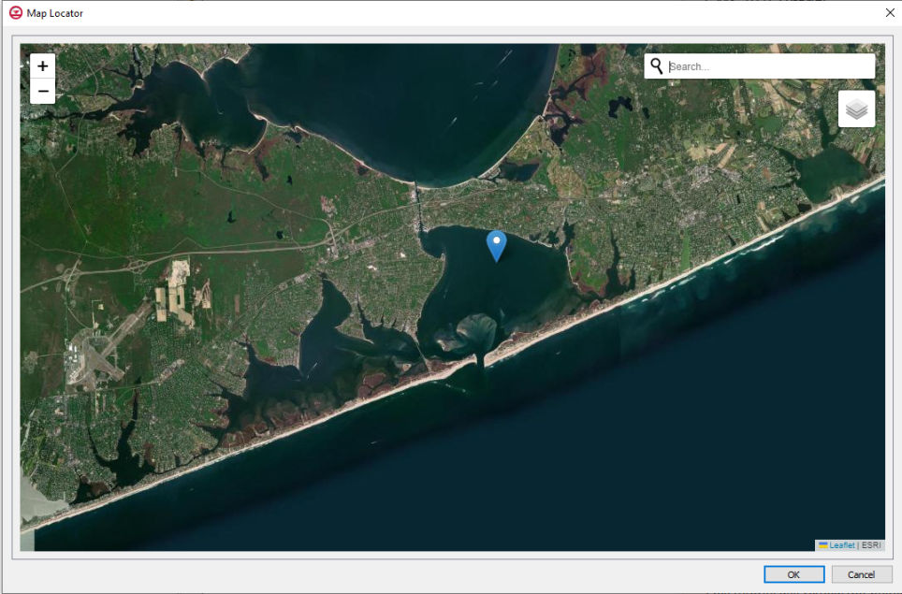

GMS 10.9

GMS 10.9 Tutorial

***Import from Web***

Download images from a web database

Objectives

This tutorial gives an overview of the **Import From Web** option offered by GMS. This option connects GMS to a web based program that adds additional functionality to the GMS program. The two programs interact through an internet connection and allow accessing satellite photographs easily and quickly.

This tutorial will review the basic skills concerning how to use the **Import From Web** option.

Time

* 10–20 minutes

Required Components

* GMS Core
* Internet Connection

Prerequisite Tutorials

* None

|  |
| --- |
| 1 Introduction 2  2 GMS User Interface 2  2.1 Selecting the Location of the Aerial Photo 2  2.2 Saving the Image 3  3 Importing a World Topographic Image 4  3.1 Selecting the Location for the Topographic Image 4  3.2 Saving the Image 4  4 Conclusion 5 |

# Introduction

The **Import From Web** option adds an easier way to obtain images from the internet to use as backgrounds for GMS projects. GMS is able to connect to a data server then retrieve selected photographs or maps of just about any location desired. Two specific file types can be obtained through using this option:

* Aerial photo
* World topographical map

# GMS User Interface

An aerial photo can be imported into GMS and saved as a background image for a project.

## Selecting the Location of the Aerial Photo

To open the project in GMS, do the following:

1. Select *File* | **New** to clear all previous data.
2. If asked to confirm deletion of all data, click **Don’t Save**.
3. Select *File* | **Import From Web...** to bring up the *Map Locator* dialog.

For this tutorial, use the following location: Shinnecock Bay, Long Island, NY.

1. Enter “Shinnecock Bay” in the *Search* field and click ***Enter***.
2. Drag the image to center the bay in the window.
3. Zoom in to a comfortable view where the entire bay fits the screen (Figure 1).

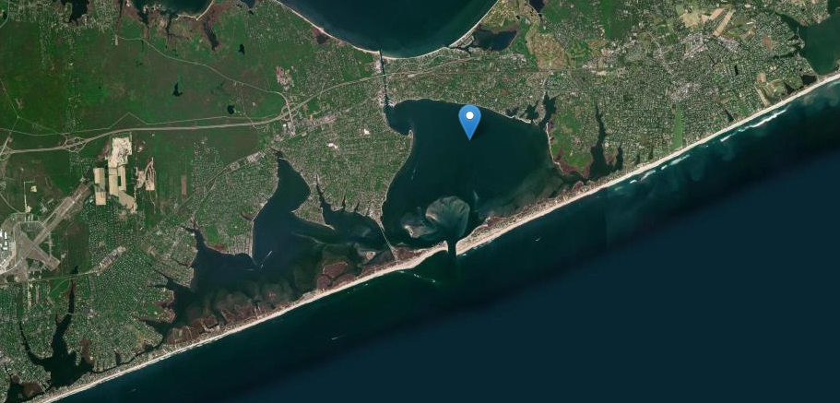

Figure 1 Shinnecock Bay aerial photo

1. Click **OK** button to close the *Map Locator* dialog.
2. Click **OK** at message stating a projection needs to be set.
3. Accept the projection in the *Display Projection* dialog and click **OK** to bring up the *Data Service Options* dialog.

GMS then takes the last image that was in the dialog and allows for saving it in a few ways.

## Saving the Image

In the *Data Service Options* dialog, there are multiple file options (scroll right to view all of them).

1. Select *World Imagery* and click **OK** to close the *Data Service Options* dialog and open the *Save Web Services Data File(s)* dialog.
2. Select “Web Services Files (*.tif;*.gml;*.jpg;*.zip)” from the *Save as type* drop-down.
3. Browse to the desired location to save the file and enter “shinnecock_bay” as the *File name*.
4. Click **Save** to close the *Save Web Services Data File(s)* dialog.
5. When asked to confirm the creation of the file, click **Yes** to bring up the *Raster Cell Size* dialog.

The confirmation dialog shows the complete path of the file and shows the extension of the file. Since this file is an aerial file, it ends with “*_w_imagery.tif”. Other image types have unique file extensions to help in differentiation.

A suggested scale is already provided in the *Raster Cell Size* dialog, but a different scale can be selected if desired. Remember that the lower the scale the more detailed the image and the more time it will take to save.

1. Click **OK** to accept the default size and exit the *Raster Cell Size* dialog.

GMS then creates the file and loads the image into the Graphics Window.

# Importing a World Topographic Image

A world topographic image can be imported into GMS and saved to serve as a background for a project.

## Selecting the Location for the Topographic Image

To open a new project in GMS, do the following:

1. Select *File* | **New** to clear all previous data.
2. If asked to confirm deletion of all data, click **Don’t Save**.
3. Select *File* | **Import From Web...** to bring up the *Map Locator* dialog.

The location from the previous section has been saved by the *Map Locator*, so there is not a need to search for the same location again. However, if the location was changed, follow step 4 in section 2.1.

1. Zoom in to a view where the entire bay fits the screen nicely (Figure 2).
2. Change the drop-down set to “ESRI World Topo Map”.
3. Click **OK** button to close the *Map Locator* dialog.
4. Click **OK** at message stating a projection needs to be set.
5. Accept the projection in the *Display Projection* dialog and click **OK** to bring up the *Data Service Options* dialog.

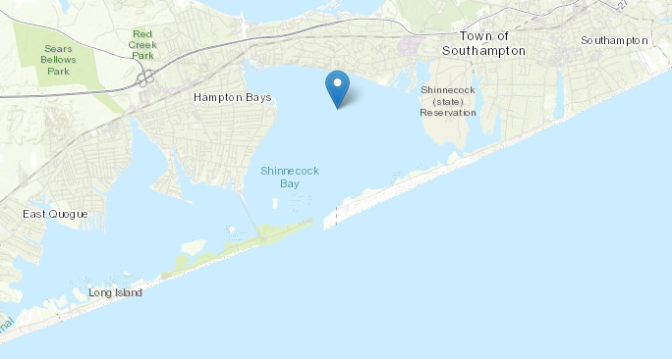

Figure 2 Shinnecock Bay topographical image

## Saving the Image

1. Scroll to the right to select *World Topo Map* and click **OK** to close the *Data Service Options* dialog and bring up the *Save Web Services Data File(s)* dialog.
2. Select “Web Services Files (*.tif;*.gml;*.jpg;*.zip)” from the *Save as type* drop-down.
3. Browse to the desired location to save the file and enter “shinnecock_bay_topo” as the *File name*.
4. Click **Save** to close the *Save Web Services Data File(s)* dialog.
5. When asked to confirm the creation of the file, click **Yes** to bring up the *Raster Cell Size* dialog.
6. Click **OK** to accept the default size and exit the *Raster Cell Size* dialog.

GMS then creates the file and loads the image into the Graphics Window.

# Conclusion

This concludes the “Import from Web” tutorial. Feel free to continue to experiment with this part of GMS, or exit the program.