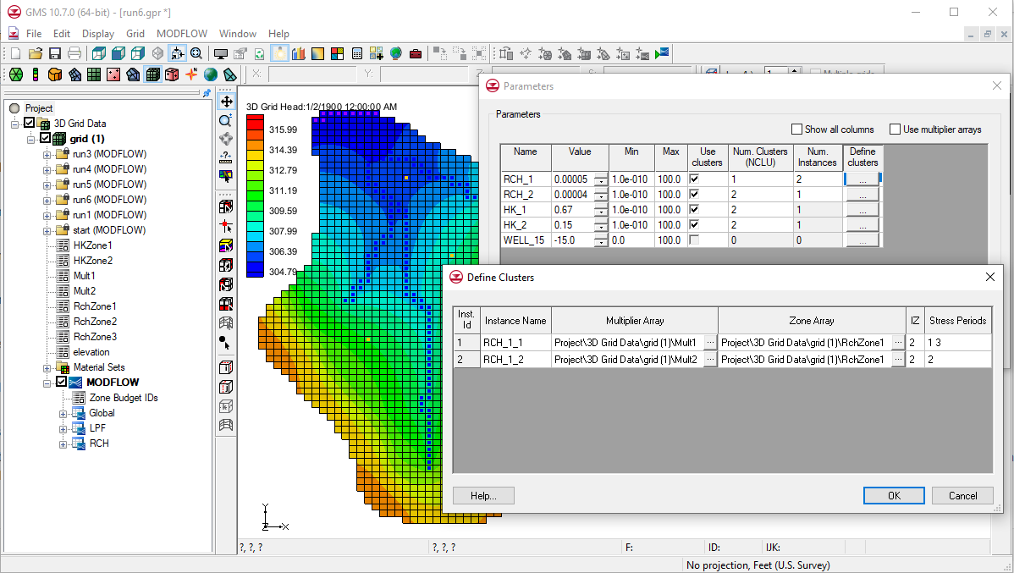

GMS 10.9

GMS 10.9 Tutorial

***MODFLOW – Advanced Parameter Options***

GMS support for native MODFLOW parameters, instances, and clusters

Objectives

This tutorial shows how to use some of the advanced features associated with MODFLOW parameters including instances and clusters. It also demonstrates how to define array-based parameters using clusters and discusses parameter factors.

Time

* 25–40 minutes

Required Components

* GMS Core
* MODFLOW Interface

Prerequisite Tutorials

* MODFLOW – Automated Parameter Estimation

|  |
| --- |
| 1 Introduction 2  1.1 Getting Started 3  2 Importing the Project 3  3 Creating a Recharge Parameter with a Cluster 3  3.1 The Define Clusters Dialog 4  3.2 Running MODFLOW 6  4 Creating a Recharge Parameter with Multiple Clusters 7  4.1 Running MODFLOW 8  5 Creating a Transient Model 8  5.1 Setting up the Stress Periods 8  5.2 Editing the Specific Yield 9  5.3 Editing the RCH Parameters 9  5.4 Running MODFLOW 9  6 Using Parameter Instances 10  6.1 Running MODFLOW 10  7 LPF Parameters 10  7.1 Running MODFLOW 11  8 Parameter Factors 12  8.1 Editing Parameter Factors 13  8.2 Running MODFLOW 13  9 Conclusion 14 |

# Introduction

This tutorial illustrates how to use some of the advanced features associated with MODFLOW parameters. This tutorial assumes an understanding of how to use the parameter estimation tools available in GMS. It is therefore recommended to complete the “MODFLOW – Automated Parameter Estimation” tutorial before starting this tutorial. It is also important to understand how to define array-based parameters using clusters and the concept of parameter instances. Learn more about these concepts by reading the MODFLOW documentation.

The model in this tutorial is the same model featured in the “MODFLOW – Automated Parameter Estimation” tutorial. For most cases, array-based parameters can be defined using the key value approach used in that tutorial. However, this approach is not completely compatible with the native MODFLOW parameter formats.

MODFLOW array-based parameters are defined using clusters. A cluster is a multiplier array, a zone array, and an IZ value (key values associated with the zone array). The key value approach used in GMS usually creates an array-based parameter defined by a single cluster. MODFLOW supports parameters that are defined by multiple clusters and GMS supports this feature.

In addition to clusters, MODFLOW also supports defining parameter instances for parameters associated with a transient MODFLOW model. This feature allows creating a single parameter, then associating multiple sets of clusters with instances of that parameter. This allows each instance to be specified with a stress period.

To prevent confusion, this tutorial presents an example where RCH parameters are defined using clusters in a steady state model. The tutorial then changes the model to be transient and creates more than one instance for one of the recharge parameters.

This tutorial discusses and demonstrates opening a parameterized MODFLOW model and solution, defining RCH parameters using clusters, and then running MODFLOW. The model will be changed to be transient, the parameters will be changed to use instances, and MODFLOW will be run again. LPF parameters will be defined using clusters, MODFLOW will be run, the parameter factors will be adjusted, and MODFLOW will be run a final time.

## Getting Started

Do the following to get started:

If necessary, launch GMS.

If GMS is already running, select *File* | **New** to ensure that the program settings are restored to their default state.

# Importing the Project

First, import the modeling project:

1. Click **Open** File:Open Macro.svg to bring up the *Open* dialog.
2. Select “Project Files (*.gpr)” from the *Files of type* drop-down.

Browse to the *advparam\advparam* directory and select “start.gpr”.

Click **Open** to import the project and close the *Open* dialog.

A MODFLOW model with a solution and map coverages should appear (Figure 1).

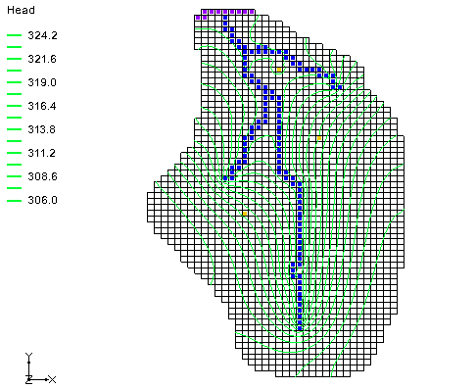

Figure 1 The initial model

In the Project Explorer, expand the “File:3D Grid Folder.svg 3D Grid Data” folder and the “File:3D Grid Icon.svg grid” item. Notice the seven datasets below the 3D grid: “File:Dataset Cells Active.svg HKZone1,” “File:Dataset Cells Active.svg HKZone2,” “File:Dataset Cells Active.svg Mult1,” “File:Dataset Cells Active.svg Mult2,” “File:Dataset Cells Active.svg RchZone1,” “File:Dataset Cells Active.svg RchZone2,” and “File:Dataset Cells Active.svg RchZone3”. These datasets will be used to define the RCH and LPF parameters.

# Creating a Recharge Parameter with a Cluster

The next step is to create a recharge parameter defined by a single cluster. Once that is done, MODFLOW can be run.

1. Select *MODFLOW |* **Parameters…** to open the *Parameters* dialog.

In the *Parameters* section, turn on *Show all columns*.

Click **New** to create a new parameter.

In the *Name* column, enter “RCH_1”.

In the *Type* column, select “RCH” from the drop-down.

In the *Value* column, enter “0.00005”.

In the *Use clusters* column, check the box.

In the *Num. Clusters (NCLU)* column, enter “1”*.*

In the *Num. Instances* column, enter “1”.

The dialog should appear as in Figure 2 at this point.

In the *Define clusters* column, click the http://www.xmswiki.com/w/images/0/02/Narrow_dot_dot_dot_button.png button to bring up the *Define Clusters* dialog (Figure 3).

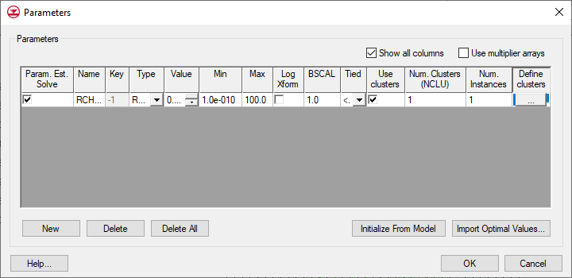

Figure 2 Parameter instances dialog

## The Define Clusters Dialog

Clusters and parameter instances are defined in the *Define Clusters* dialog. Since this is a steady state model, the example has only one instance and one cluster, and only one editable row is available in the dialog (Figure 3).

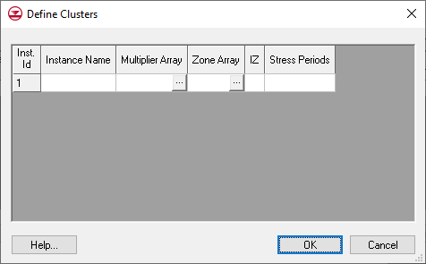

Figure 3 Define Clusters dialog with one instance and one cluster

1. Click **Cancel** to close the *Define Clusters* dialog.

In the *Num. Clusters (NCLU)* column, enter “2”.

Click the http://www.xmswiki.com/w/images/0/02/Narrow_dot_dot_dot_button.png button in the *Define clusters* column to open the *Define Clusters* dialog.

Notice that the spreadsheet now has two editable rows (Figure 4). Normally, two multiplier arrays, two zone arrays, and two *IZ* values need to be defined to successfully define the clusters.

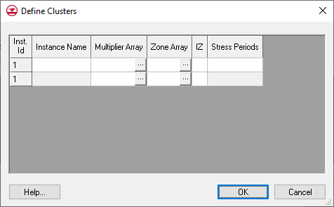

Figure 4 Define Clusters dialog with two clusters and one instance

Click **Cancel** to close the *Define Clusters* dialog.

In the *Num. Instances* column, enter “2”.

Click the http://www.xmswiki.com/w/images/0/02/Narrow_dot_dot_dot_button.png button in the *Define clusters* column to open the *Define Clusters* dialog.

The spreadsheet now has four editable rows (Figure 5). Normally, two clusters have to be defined for each instance. Notice an instance name must be specified, and the stress periods where the instance is used must be defined. For a transient model with three stress periods, one of the instances could be used for stress periods 1 and 2, and the other instance could be used with stress period 3. If defining an RCH or EVT parameter using clusters and instances, it is necessary to make sure at least one parameter instance is assigned to every stress period in the model.

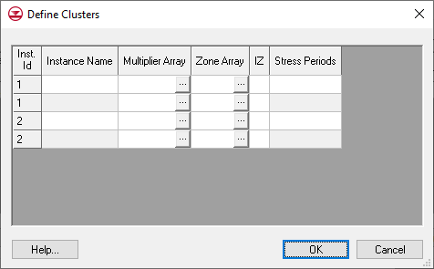

Figure 5 Define Clusters dialog with two clusters and two instances

Click **Cancel** to close the *Define Clusters* dialog.

In both the *Num. Clusters (NCLU)* column and *Num. Instances* column, enter “1”.

Click the http://www.xmswiki.com/w/images/0/02/Narrow_dot_dot_dot_button.png button to bring up the *Define Clusters* dialog.

For the *Instance Name,* enter “RCH_1_1”.

Note: MODFLOW limits the length of an instance name to 10 characters.

In the *Multiplier Array* column, click the http://www.xmswiki.com/w/images/0/02/Narrow_dot_dot_dot_button.png button to bring up the *Select Dataset* dialog.

From the *Solution* section, select “Mult1”.

Click **OK** to close the *Select Dataset* dialog.

In the *Zone Array* column, click the http://www.xmswiki.com/w/images/0/02/Narrow_dot_dot_dot_button.png button to open the *Select Dataset* dialog.

From the *Solution* section, select “RchZone1”.

Click **OK** to close the *Select Dataset* dialog.

In the *IZ* column, enter “2”.

The *IZ* field specifies where the parameter is active in the MODFLOW grid. RchZone1 has values of “0” and “2”. Specifying “2” as the *IZ* will cause the parameter to only be used when the zone array has a value of “2” when MODFLOW runs.

In the *Stress Periods* column, enter “1”.

Click **OK** to exit the *Define Clusters* dialog.

Click **OK** to exit the *Parameters* dialog.

A parameter using clusters has now been defined.

## Running MODFLOW

Now to save the project and run MODFLOW:

1. Select *File* | **Save As…** to bring up the *Save As* dialog.
2. Select “Project Files (*.gpr)” from the *Save as type* drop-down.

Enter “run1.gpr” as the *File name* and click **Save** to save the project under the new name, which will close the *Save As* dialog.

Select *MODFLOW* | **Run MODFLOW** to bring up the *MODFLOW* model wrapper dialog.

Once MODFLOW is done running, turn on *Read in the solution* and *Turn on contours (if not on already)* and click **Close**to close the *MODFLOW* model wrapper dialog.

The head contours from the MODFLOW solution should now be visible (Figure 6).

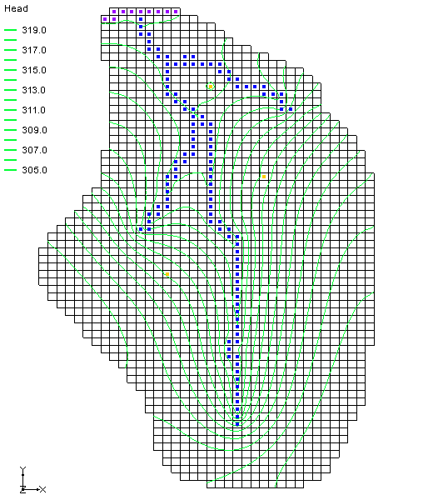

Figure 6 Model with solution contours

# Creating a Recharge Parameter with Multiple Clusters

The tutorial will now cover how to create another recharge parameter defined by two clusters before running MODFLOW again.

1. Select *MODFLOW |* **Parameters…** to open the *Parameters* dialog.

Click **New** to add a new row in the spreadsheet.

In the *Name* column on the new row, enter “RCH_2”.

In the *Type* column, select “RCH” from the drop-down.

In the *Value* column, enter “0.00004”.

Check the box in the *Use clusters* column.

In the *Num. Clusters* *(NCLU)* column, enter “2”.

In the *Num. Instances* column, enter “1”.

In the *Define clusters* column, click the http://www.xmswiki.com/w/images/0/02/Narrow_dot_dot_dot_button.png button to open the *Define Clusters* dialog.

Enter the values for the clusters as shown in the table below.

Note: Only the selected dataset names are shown for the *Multiplier* and *Zone Array* columns below, but it is necessary to use the http://www.xmswiki.com/w/images/0/02/Narrow_dot_dot_dot_button.png button to select the datasets so the full path to the datasets is displayed. The *IZ* values should be separated by spaces.

|  |  |  |  |  |  |
| --- | --- | --- | --- | --- | --- |
| Inst. Id | Instance Name | Multiplier Array | Zone Array | IZ | Stress Per. |
| 1 | RCH_2_1 | Mult2 | RchZone2 | 4 5 3 | 1 |
| 1 |  | Mult2 | RchZone3 | 6 7 |  |

When finished, click **OK** to exit the *Define Clusters* dialog.

Click **OK** to exit the *Parameters* dialog.

Since two RCH parameters are defined for stress period 1, the final value of the recharge rate will be the sum of the two parameters. MODFLOW computes this internally.

## Running MODFLOW

Now to save the project and run MODFLOW:

1. Select *File* | **Save As…** to bring up the *Save As* dialog.
2. Select “Project Files (*.gpr)” from the *Save as type* drop-down.

Enter “run2.gpr” as the *File name* and click **Save** to save the project under the new name and close the *Save As* dialog.

Select *MODFLOW* | **Run MODFLOW** to bring up the *MODFLOW* model wrapper dialog.

Once MODFLOW is done running, turn on *Read solution on exit* and *Turn on contours (if not on already)*.

Click **Close**to exit the *MODFLOW* model wrapper dialog.

The contours will have changed slightly. Switch between the “File:Generic Folder Locked.svg run1 (MODFLOW)” and “File:Generic Folder Locked.svg run2 (MODFLOW)” solutions to see the difference.

# Creating a Transient Model

In addition to defining parameters using clusters, parameter instances for transient models can also be defined.

## Setting up the Stress Periods

To change the model to be transient and make three stress periods:

1. Select *MODFLOW* | **Global Options…** to open the *MODFLOW Global/Basic Package* dialog.

In the *Model type* section, change the option to *Transient*.

Click **Stress Periods…** to open the *Stress Periods* dialog.

For the *Number of stress periods,* enter “3”.

In the *Num Time Steps* column on rows *1–3,* enter “1”.

Click **OK** to exit the *Stress Periods* dialog.

Select **OK** to exit the *MODFLOW Global/Basic Package* dialog.

## Editing the Specific Yield

Since this is an unconfined model, it is necessary to edit the specific yield value in the LPF package.

1. Select the **Select Cells** File:Select 3D Cell Tool.svg tool.

Select *Edit |* **Select All** to select all of the cells in layer 1 of the grid.

Select *Edit |* **Properties…** to open the *3D Grid Cell Properties* dialog.

In the *Value* column of the *Specific yield* row, enter “0.01”*.*

Select **OK** to exit the *3D Grid Cell Properties* dialog.

## Editing the RCH Parameters

Now to update the parameters to be compatible with the stress periods:

1. Select *MODFLOW |* **Parameters…** to open the *Parameters* dialog.

In the *Define clusters* column of the “RCH_1” row, click the http://www.xmswiki.com/w/images/0/02/Narrow_dot_dot_dot_button.png button to bring up the *Define Clusters* dialog.

In the *Stress Periods* column, enter “1 2 3” (separated by spaces).

Click **OK** to exit the *Define Clusters* dialog.

Repeat steps 2–4 for the “RCH_2” row.

Click **OK** to exit the *Parameters* dialog.

## Running MODFLOW

Now to save the project and run MODFLOW:

1. Select *File* | **Save As…** to bring up the *Save As* dialog.
2. Select “Project Files (*.gpr)” from the *Save as type* drop-down.

Enter “run3.gpr” as the *File name* and click **Save** to close the *Save As* dialog.

Select *MODFLOW* | **Run MODFLOW** to bring up the *MODFLOW* model wrapper dialog.

Once MODFLOW is done running, turn on *Read solution on exit* and *Turn on contours (if not on already)*.

Click **Close**to close the *MODFLOW* model wrapper dialog.

There should be no visible change in the model shown in the Graphics Window.

# Using Parameter Instances

Next to change one of the recharge parameters to use instances:

1. Select *MODFLOW |* **Parameters…** to open the *Parameters* dialog.

For the “RCH_1” parameter, change the *Num. Instances* to be “2”.

In the *Define clusters* column on the “RCH_1” row, click the http://www.xmswiki.com/w/images/0/02/Narrow_dot_dot_dot_button.png button to open the *Define Clusters* dialog.

In the *Stress Periods* column on row *1* (*Instance Name* of “RCH_1_1”),

enter “1 3” (separated by spaces).

On row *2*, in the *Instance Name* column, enter “RCH_1_2”.

In the *Multiplier Array* column, click the http://www.xmswiki.com/w/images/0/02/Narrow_dot_dot_dot_button.png button to bring up the *Select Dataset* dialog.

In the *Solution* section, select the “Mult2” dataset.

Click **OK** to close the *Select Dataset* dialog.

In the *Zone Array* column, click the http://www.xmswiki.com/w/images/0/02/Narrow_dot_dot_dot_button.png button to bring up the *Select Dataset* dialog.

In the *Solution* section, select the “RchZone1” dataset.

Click **OK** to close the *Select Dataset* dialog.

In the *IZ* column, enter “2”.

In the *Stress Periods* column, enter “2”.

Select **OK** to exit the *Define Clusters* dialog.

Select **OK** to exit the *Parameters* dialog.

## Running MODFLOW

Now to save the project and run MODFLOW:

1. Select *File* | **Save As…** to bring up the *Save As* dialog.
2. Select “Project Files (*.gpr)” from the *Save as type* drop-down.

Enter “run4.gpr” as the *File name* and click **Save** to close the *Save As* dialog.

Select *MODFLOW* | **Run MODFLOW** to bring up the *MODFLOW* model wrapper dialog.

Once MODFLOW is done running, turn on *Read solution on exit* and *Turn on contours (if not on already)*.

Click **Close**to exit the *MODFLOW* model wrapper dialog.

There should be no visible changes to the model in the Graphics Window.

# LPF Parameters

GMS supports parameters with the LPF and HUF packages. The LPF package is being used in this tutorial, with horizontal conductivity changed to use parameters. When entering parameters for the LPF package, a layer number is used in place of an instance name.

1. Select *MODFLOW |* **Parameters…** to open the *Parameters* dialog.

Click **New** to add a third parameter entry to the spreadsheet.

On the third row in the *Name* column, enter “HK_1”.

From the *Type* column drop-down, select “HK”.

In the *Value* column, enter “0.67”.

In the *Use clusters* column check the box.

In the *Num. Clusters* *(NCLU)* column, enter “2”.

In the *Define clusters* column click the http://www.xmswiki.com/w/images/0/02/Narrow_dot_dot_dot_button.png button to open the *Define Clusters* dialog.

Enter the values for the cluster shown in the table below then click **OK** to close the *Define Clusters* dialog.

Note: The numbers in the *IZ* column have a space between them.

|  |  |  |  |
| --- | --- | --- | --- |
| Layer | Multiplier Array | Zone Array | IZ |
| 1 | Mult1 | HKZone1 | 1 2 |
| 2 | Mult1 | HKZone1 | 1 2 |

Click **New** to add a fourth parameter entry to the spreadsheet.

Repeat steps 3–7 for the fourth entry with the following values: a *Name* of “HK_2”, a *Type* of “HK”, and a *Value* of “0.15”

In the *Define clusters* column, click the http://www.xmswiki.com/w/images/0/02/Narrow_dot_dot_dot_button.png button to open the *Define Clusters* dialog.

Enter the values for the cluster shown in the table below.

|  |  |  |  |
| --- | --- | --- | --- |
| Layer | Multiplier Array | Zone Array | IZ |
| 1 | Mult1 | HKZone2 | 3 4 |
| 2 | Mult1 | HKZone2 | 3 4 |

When finished, click **OK** to exit the *Define Clusters* dialog.

Click **OK** to exit the *Parameters* dialog.

## Running MODFLOW

Now to save the project and run MODFLOW:

1. Select *File* | **Save As…** to bring up the *Save As* dialog.
2. Select “Project Files (*.gpr)” from the *Save as type* drop-down.

Enter “run5.gpr” as the *File name*.

Click **Save** to close the *Save As* dialog.

Select *MODFLOW* | **Run MODFLOW** to bring up the *MODFLOW* model wrapper dialog.

Once MODFLOW is done running, turn on *Read solution on exit* and *Turn on contours (if not on already)*.

Click **Close**to exit the *MODFLOW* model wrapper dialog.

The “File:Generic Folder Locked.svg run5 (MODFLOW)” solution will show slight changes in the contour lines on the model (Figure 7). Switch back and forth between the five solutions to see the differences.

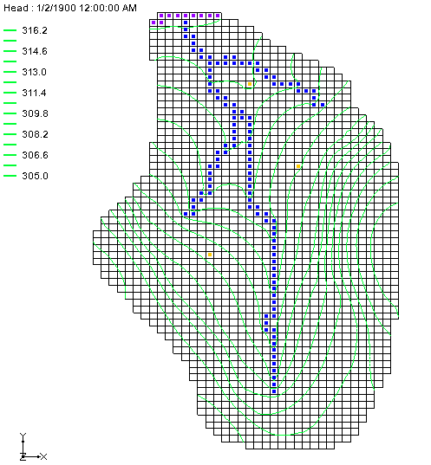

Figure 7 The contours changed slightly after the fifth run

# Parameter Factors

The MODFLOW list-based packages (WEL, DRN, GHB, RIV, CHD, STR) allow parameter factors to be defined along with the parameters. For example, when creating a river boundary condition in GMS using the map module, GMS will store the length of the arc in the grid cell that is associated with each river boundary condition. Then if wanting to parameterize river conductance, the parameter can be conductance per unit length, and the parameter factor will be the length of the arc.

The final conductance for a particular river boundary condition will be the product of the parameter value and the parameter factor. Because MODFLOW allows this parameter factor to vary per stress period, there can be multiple parameters stored for each grid cell (one for each stress period).

Now to create a parameter in the WEL package, then change the parameter factor on one of the stress periods.

1. Select *MODFLOW |* **Parameters…** to bring up the *Parameters* dialog.

Click **New** to create a fifth parameter.

In the *Key* column, enter “-15”.

From the drop-down in the *Type* column, select “WELL”.

In the *Value* column, enter “-15.0”.

Click **OK** to exit the *Parameters* dialog.

## Editing Parameter Factors

By default, the parameter factors are 1.0 (which will have no effect on the final value that the parameter represents). It is necessary to change the parameter factor for the second stress period for the parameter that was just created.

1. Select *MODFLOW* | *Optional Packages* | **WEL – Well…** to open the *MODFLOW Well Package* dialog.

In *Stress period,* enter “2”.

Turn off *Use previous*.

In the *Q factor* column of the spreadsheet for *cell ID* “1613”, enter “10.0”. This is the parameter factor.

This causes the second stress period to have a pumping rate for this well that is 10.0 times greater (or “-150.0” instead of “-15.0”). *Q factor* is only used by parameters.

Click **OK** to exit the *MODFLOW Well Package* dialog.

## Running MODFLOW

Now to save the project and run MODFLOW:

1. Select *File* | **Save As…** to bring up the *Save As* dialog.
2. Select “Project Files (*.gpr)” from the *Save as type* drop-down.

Enter “run6.gpr” as the *File name* and click **Save** to close the *Save As* dialog.

Select *MODFLOW* | **Run MODFLOW** to bring up the *MODFLOW* model wrapper dialog.

Once MODFLOW is done running, turn on *Read solution on exit* and *Turn on contours (if not on already)*.

Click **Close**to close the *MODFLOW* model wrapper dialog.

Notice the changes in the contours around the well on the left side of the model when switching to the second time step on the MODFLOW solution (Figure 8).

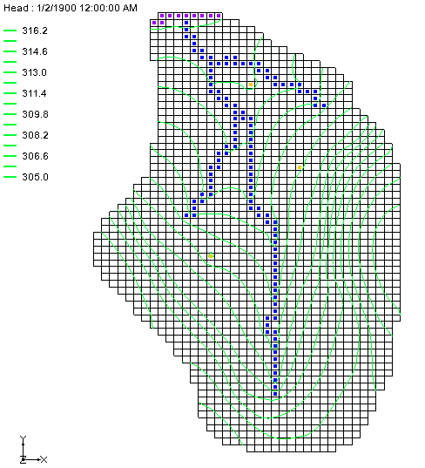

Figure 8 The contours changed slightly after changing the parameters

# Conclusion

This concludes the “MODFLOW – Advanced Parameters Options” tutorial. The following key concepts were discussed and demonstrated:

* Array-based parameters can be defined using clusters.
* Parameter instances can be defined for array-based parameters for transient models.
* Parameter factors can be defined for list-based packages in GMS.