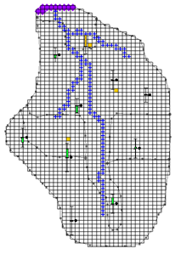

GMS 10.9

GMS 10.9 Tutorial

***MODFLOW – Automated Parameter Estimation***

Model calibration with PEST

Objectives

Learn how to calibrate a MODFLOW model using a zonal approach with PEST.

Time

* 25–40 minutes

Required Components

* GMS Core
* MODFLOW Interface
* PEST

Prerequisite Tutorials

* MODFLOW – Model Calibration

|  |
| --- |
| 1 Introduction 2  1.1 Getting Started 2  2 Importing the Project 3  3 Model Parameterization 4  4 Defining the Parameter Zones 4  4.1 Setting up the Hydraulic Conductivity Zones 4  4.2 Setting up the Recharge Zones 5  4.3 Mapping the Key Values to the Grid Cells 6  5 Setting Parameter Data 6  5.1 Turn on Parameter Estimation 6  5.2 Starting Head 7  5.3 Editing the Parameter Data 7  5.4 Maximum Iterations 8  6 Saving the Project and Running PEST 8  6.1 Viewing the Solution 9  7 Loading Optimal Parameter Values 10  8 Viewing Parameter Sensitivities 11  9 Conclusion 12 |

# Introduction

The “MODFLOW – Model Calibration” tutorial—which should have been completed prior to beginning this tutorial—described the basic calibration tools provided in GMS. It illustrated how head levels from observation wells and observed flows from streams could be entered into GMS and how these data could be compared to model computed values. It also described how a trial-and-error method could be used to iteratively adjust model parameters until the model computed values matched the field-observed values to an acceptable level of agreement.

In many cases, calibration can be achieved much more rapidly with an inverse model. An inverse model is a utility that automates the parameter estimation process. The inverse model systematically adjusts a user-defined set of input parameters until the difference between the computed and observed values is minimized.

GMS contains an interface to an inverse model called PEST. This tutorial illustrates how to calibrate a MODFLOW model using PEST. The model in this tutorial is the same model featured in the “MODFLOW – Model Calibration” tutorial. The model includes observed flow data for the stream and observed heads at a set of scattered observation wells. The conceptual model for the site consists of a set of recharge and hydraulic conductivity zones. These zones will be marked as parameters and an inverse model will be used to find a set of recharge and hydraulic conductivity values that minimize the calibration error.

This tutorial discusses and demonstrates opening a MODFLOW model and solution, defining conditions, running PEST, and loading optimal parameter values.

## Getting Started

Do the following to get started:

If necessary, launch GMS.

If GMS is already running, select *File |* **New** to ensure that the program settings are restored to their default state.

# Importing the Project

First, import the modeling project:

1. Click **Open** File:Open Macro.svg to bring up the *Open* dialog.
2. Select “Project Files (*.gpr)” from the *Files of type* drop-down.

Browse to the *Tutorials\MODFLOW\inverse* directory and select “bigval.gpr”.

Click **Open** to import the project and close the *Open* dialog.

The imported project should appear similar to Figure 1.

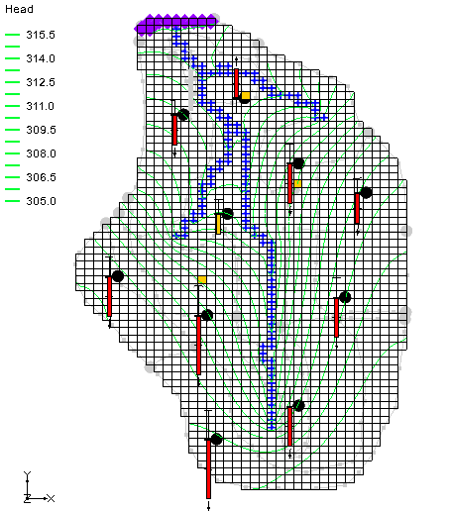

Figure 1 Initial screen after importing the project

Right-click on a blank spot in the Project Explorer and select **Expand All**.

Notice there is now a MODFLOW model with a solution and a set of map coverages (Figure 2). Three of the coverages are the source/sink, recharge, and hydraulic conductivity coverages used to define the conceptual model. The active coverage contains a set of observed head values from observation wells. When switching to the source/sink coverage, notice that an observed flow value has been assigned to the stream network.

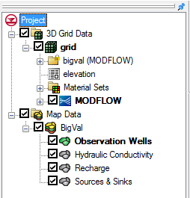

Figure 2 Initial appearance of the Project Explorer

# Model Parameterization

The first step in setting up the inverse model is to “parameterize” the input. This involves identifying which parts of the model input the inverse model utility will optimize. There are two approaches for parameterization: zonal and pilot points. The tutorial entitled “MODFLOW – Pest Pilot Points” covers the pilot point approach. In this tutorial, the zonal approach will be used.

This involves identifying polygonal zones of hydraulic conductivity and recharge, marking the zones as parameters, and assigning a starting value for each zone. PEST will then adjust the K or recharge values assigned to the zones as it attempts to minimize the residual error between computed vs. observed heads and flows.

# Defining the Parameter Zones

For the first attempt at parameter estimation, define a set of parameter zones. The conceptual model approach utilized in GMS is ideally suited for this task since the conceptual model consists of recharge and K zones defined with polygons. Mark the polygons as parameter zones by assigning a “key value” to each polygon. The key value should be a value that is not expected to occur elsewhere in the MODLOW input file. A negative value typically works well.

Use seven parameter zones consisting of four hydraulic conductivity zones and three recharge zones. The number of observations is eleven, consisting of ten observation wells and one stream flow value. Note that the number of parameters being estimated should always be less than the number of observations when using parameter zones.

## Setting up the Hydraulic Conductivity Zones

Start with setting up the hydraulic conductivity zones. The hydraulic conductivity polygons are shown in Figure 3. The five polygons will be used to define five parameter zones. The key values associated with each of the five zones are shown on the polygons in Figure 3.



Figure 3 Hydraulic conductivity zones and parameter key values

To assign the key values to the polygons:

1. Select the “File:Coverage Active Icon.svg Hydraulic Conductivity” coverage in the Project Explorer to make it active.
2. Using the **Select Polygons** File:GMS Select Polygon Tool.svg tool, double-click on the central polygon with the value of “-60” (see Figure 3) to open the *Attribute Table* dialog.
3. In the *Horizontal K* (m/d) column in the spreadsheet, enter “-60”.
4. Click **OK** to close the *Attribute Table* dialog.
5. Repeat steps 2–4 for the remaining four polygons, entering the parameter key values as indicated in Figure 3.

## Setting up the Recharge Zones

Next, it is necessary to set up the recharge zones. The recharge polygons are shown in Figure 4. The five polygons will be used to define four parameter zones. The polygon at the top end of the model is relatively small; it is isolated from the majority of the observation wells, and it is down gradient from the wells. As a result, it is not a good candidate for parameter estimation. This tutorial will fix the recharge in this zone at zero. The key values will be associated with the other four polygons to define four parameter zones as shown.



Figure 4 Recharge zones and parameter key values

To assign the key values to the polygons:

1. Select the “File:Coverage Active Icon.svg Recharge” coverage to make it active.

Using the **Select Polygon** File:GMS Select Polygon Tool.svg tool, double-click on the top center polygon as shown in Figure 4 to open the *Attribute Table* dialog.

In the *Recharge rate (m/d)* column of the spreadsheet, enter “0”.

Click **OK** to close the *Attribute Table* dialog.

Repeat steps 2–4 for the remaining four recharge polygons, entering the appropriate values from Figure 4.

## Mapping the Key Values to the Grid Cells

Once the key values are assigned to the polygons, they must be mapped to the cells in the MODFLOW grid.

1. Select *Feature Objects |* **Map → MODFLOW** to bring up the *Map → Model* dialog.

Click **OK** to accept the defaults and close the *Map → Model* dialog.

# Setting Parameter Data

## Turn on Parameter Estimation

Before editing the parameter data, it is necessary to turn on the *Parameter Estimation* option by doing the following:

1. Select “File:3D Grid Folder.svg 3D Grid Data” in the Project Explorer to make the module active.

Select *MODFLOW* | **Global Options…** to open the *MODFLOW Global/Basic Package* dialog.

In the *Run options* section, select *Parameter Estimation*.

## Starting Head

The head contours currently displayed on the grid are from a forward run of a MODFLOW simulation using the starting parameter values. Before running PEST, copy the computed heads to the starting heads array. This will ensure that each time PEST runs MODFLOW, the starting head values will be reasonably close to the final head values and MODFLOW should converge quickly.

1. Turn off *Starting heads equal grid top elevations.*

This allows the starting heads to be set manually.

Click **Starting Heads…** to open the *Starting Heads* dialog.

Click **3D Dataset → Grid…** to bring up the *Select Dataset* dialog.

Expand the “File:Generic Folder Locked.svg bigval (MODFLOW)”folder and select the “File:Dataset Cells Active.svg Head” dataset.

Click **OK** to close the *Select Dataset* dialog.

Click **OK** to exit the *Starting Heads* dialog.

Click **OK**to exit the *MODFLOW Global/Basic Package* dialog.

Note: If PEST fails during the process between two successive Jacobian runs, this could be due to the nonconvergence of the model. Such nonconvergence can be due to a set of initial heads too far from the solution to be calculated into PEST process. To verify this, import the last optimal parameters (see Section 7), run a forward model, and use the calculated heads as new "starting heads".

## Editing the Parameter Data

Next to create a list of parameters and enter a starting, minimum, and maximum value for each.

1. Select *MODFLOW* | **Parameters…** to open the *Parameters* dialog.

The *Parameters* section is used to manage a list of parameters used by the inverse model. Each parameter has several properties, including a name, a key value, a type, a starting value, a minimum value, a maximum value, a usage field, and a log-transform field.

Rather than creating each parameter individually, the parameter list can be automatically generated by GMS in most cases by using the **Initialize From Model** button. GMS then searches the MODFLOW input data for likely key values and creates a list of parameters. If a parameter is not automatically found by GMS, it can be added using the **New** button.

Click **Initialize From Model** to load data from the existing model.

Note that all seven parameters were automatically found. Also note that each parameter has been given a default name. The next step is to enter a starting, minimum, and maximum value for each parameter. Special care should be taken when selecting the starting values. In most cases, using arbitrary starting values will cause the inverse model to fail to converge. The closer the starting values are to the final parameter values, the greater the chance that the inverse model will converge. The starting values to be used were found after a few iterations of manual (trial-and-error) calibration.

For all parameters, check on the boxes in both the *Param. Est.* *Solve* and *Log Xform* columns.

Enter the following data into the parameters spreadsheet:

|  |  |  |  |
| --- | --- | --- | --- |
| Name | Value | Min Value | Max Value |
| HK_30 | 1.2 | 0.003 | 30 |
| HK_60 | 2.4 | 0.003 | 30 |
| HK_90 | 0.6 | 0.003 | 30 |
| HK_120 | 0.2 | 0.003 | 30 |
| RCH_150 | 0.0001 | 1e-10 | 0.0001 |
| RCH_180 | 0.00008 | 1e-10 | 0.0001 |
| RCH_210 | 0.00006 | 1e-10 | 0.0001 |

Select **OK** to exit the *Parameters* dialog.

## Maximum Iterations

Finally, increase the maximum number of iterations used by the solver package. This will increase the likelihood that MODFLOW will converge at each iteration.

1. Select *MODFLOW* | **PCG – Pre. Conj.–Gradient Solver…**to open the *MODFLOW PCG Package* dialog.

For the *Maximum number of outer iterations (MXITER*), enter “100”.

For the *Number of* *inner iterations* *(ITER1),* enter “100”.

Click **OK**to close the *MODFLOW PCG Package* dialog.

# Saving the Project and Running PEST

It is now possible to save the project and run PEST.

1. Select *File* | **Save As…** to bring up the *Save As* dialog.
2. Select “Project Files (*.gpr)” from the *Save as type* drop-down.

Enter “mfpest_zones.gpr” as the *File name*.

Click **Save** to save the project under the new name and close the *Save As* dialog.

Click **Run MODFLOW** File:Run MODFLOW Macro.svg to bring up the *MODFLOW/PEST Parameter Estimation* model wrapper dialog.

PEST is now running. The spreadsheet in the top-right-hand corner of the dialog shows the error and parameter values for each iteration of the parameter estimation process. The plot on the left shows the error for each iteration. When PEST is finished running, review the optimum parameter values in the spreadsheet. Once PEST has found the optimum parameter values, MODFLOW will run a forward run with the optimum values and output the head solution. This will be the solution that will be imported.

Note: If there is room on the screen, consider resizing the output window by dragging the handle in the lower right corner of the window.

## Viewing the Solution

Once MODFLOW is done running, import the solution.

1. Turn on *Read solution on exit* and *Turn on contours* *(if not on already).*

Click **Close**to exit the *MODFLOW/PEST Parameter Estimation* model wrapper dialog.

The contours currently shown on the 3D grid are the heads from the MODFLOW run with the optimum parameter values. Now look at the observation targets in the map module and the error associated with this model run.

Select the “File:Coverage Active Icon.svg Observation Wells” coverage. Notice that the residual error has been greatly reduced for all monitoring wells (Figure 5).

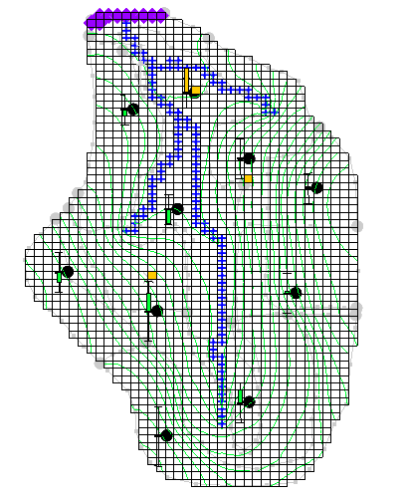

Figure 5 Each well shows a reduced residual error

Select the “File:Coverage Active Icon.svg Sources & Sinks” coverage. Notice that the observation target (located near the top of the stream) shows very little residual error (red circle in Figure 6).

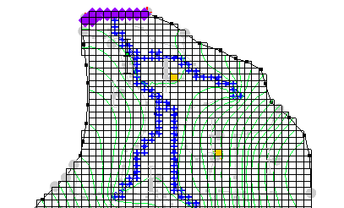

Figure 6 Observation target shows very small residual error

Using the **Select Arc Group** File:GMS Select Arc Group Tool.svg tool, select the arc group by clicking on a river arc. Notice in the edit strip at the bottom of the Graphics Eindow the computed and observed flow is reported (Figure 7).



Figure 7 Edit strip showing computed, observed, and residual flows

Next, look at some global error norms.

Expand the “File:3D Grid Folder.svg 3D Grid Data” and “File:3D Grid Icon.svg grid” items if necessary.

Right-click on “File:Generic Folder Locked.svg mfpest_zones (MODFLOW)”and select **Properties…** to open the *Properties* dialog.

This command brings up a spreadsheet showing the residual error (computed-observed) from this model run. The spreadsheet shows the error from the head observations, the flow observations, and the combined weighted observations. If desired, compare the values from this run to the “bigval” MODFLOW solution.

Click **OK** to exit the *Properties* dialog.

# Loading Optimal Parameter Values

When finished using the inverse model, it is often desirable to load and view the optimal parameter values. Now load the optimal parameters.

1. Select the “File:3D Grid Folder.svg 3D Grid Data” folder in the Project Explorer to make it active.

Select *MODFLOW* | **Parameters…** to open the *Parameters* dialog.

Click **Import Optimal Values** to bring up the *Open* dialog.

Select “PAR File (*.par,*.bpa)” from the drop-down to the right of the *File name* field.

Browse to the *Tutorials\MODFLOW\inverse\mfpest_zones_MODFLOW* directory and select “mfpest_zones.par”.

Click **Open** to import the parameters file and close the *Open* dialog.

Notice that the starting values for all of the parameters have now been changed to the optimal value computed by the inverse model.

Click **OK** to exit the *Parameters* dialog.

# Viewing Parameter Sensitivities

In addition to computing the optimal parameter values, PEST will compute the sensitivities of each parameter. This information is printed to the SEN file at each parameter estimation iteration. Use the *Plot Wizard* in GMS to create a plot of this information.

1. Click **Plot Wizard** File:Plot Wizard Macro.svg to bring up the *Step 1 of 2* page of the *Plot Wizard* dialog.

In the *Plot Type* section, select *Parameter Sensitivities* from the list on the left.

Click **Next>** to go to the *Step 2 of 2* page of the *Plot Wizard* dialog.

Click **Finish** to close the *Plot Wizard* dialog.

The plot should be similar to the one in Figure 8.

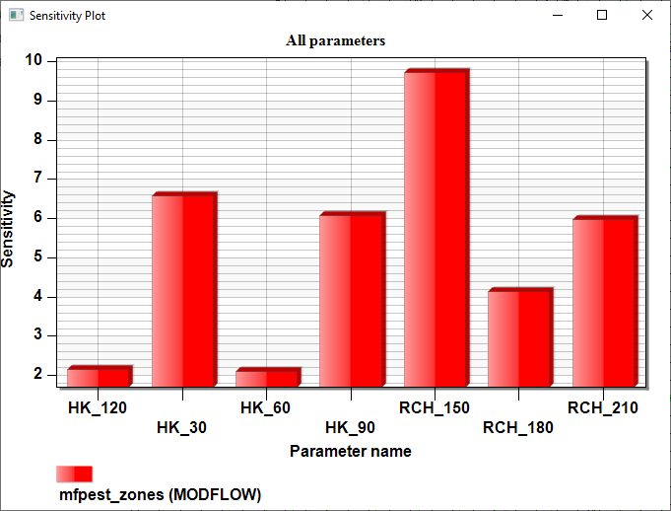

Figure 8 Parameter sensitivity plot

For a more in-depth explanation of the calculations used to create this file, refer to the PEST documentation (section 5.3.2 of the PEST Manual). The parameter sensitivity information is useful in identifying the parameters that have the greatest effect on the model and those parameters that have a little or no effect on the model. If desired, remove or hold constant the “insensitive” parameters in another PEST model run.

# Conclusion

This concludes the “MODFLOW *–* Automated Parameter Estimation” tutorial. The following key topics were discussed and demonstrated:

* Use the zonal approach or the pilot point approach with PEST. When using pilot points, there may be more parameters than observations because regularization is included in the parameter estimation.
* When PEST finishes, the solution imported into GMS corresponds to the optimal input values. However, the input values in GMS are still the starting values. The **Import Optimal Values** button must be used to replace the starting values with the optimal values.
* View the parameter sensitivities by creating a sensitivity plot using the *Plot Wizard*.